Report ITU-R SM.2523-0
(06/2023)
SM Series: Spectrum management
Assessment of spectrum efficiency and economic value

Foreword
The role of the Radiocommunication Sector is to ensure the rational, equitable, efficient and economical use of the radio-frequency spectrum by all radiocommunication services, including satellite services, and carry out studies without limit of frequency range on the basis of which Recommendations are adopted.
The regulatory and policy functions of the Radiocommunication Sector are performed by World and Regional Radiocommunication Conferences and Radiocommunication Assemblies supported by Study Groups.

Policy on Intellectual Property Right (IPR)
ITU-R policy on IPR is described in the Common Patent Policy for ITU-T/ITU-R/ISO/IEC referenced in Resolution ITU-R 1. Forms to be used for the submission of patent statements and licensing declarations by patent holders are available from http://www.itu.int/ITU-R/go/patents/en where the Guidelines for Implementation of the Common Patent Policy for ITU-T/ITU-R/ISO/IEC and the ITU-R patent information database can also be found.

Series of ITU-R Reports
(Also available online at https://www.itu.int/publ/R-REP/en)
Series | Title
BO | Satellite delivery
BR | Recording for production, archival and play-out; film for television
BS | Broadcasting service (sound)
BT | Broadcasting service (television)
F | Fixed service
M | Mobile, radiodetermination, amateur and related satellite services
P | Radiowave propagation
RA | Radio astronomy
RS | Remote sensing systems
S | Fixed-satellite service
SA | Space applications and meteorology
SF | Frequency sharing and coordination between fixed-satellite and fixed service systems
SM | Spectrum management
TF | Time signals and frequency standards emissions

Note: This ITU-R Report was approved in English by the Study Group under the procedure detailed in Resolution ITU-R 1.

Electronic Publication
Geneva, 2023
© ITU 2023
All rights reserved. No part of this publication may be reproduced, by any means whatsoever, without written permission of ITU.

REPORT ITU-R SM.2523-0
Assessment of spectrum efficiency and economic value
(2023)

TABLE OF CONTENTS
Page

1 Scope 2
2 Background 2
3 Assessment of the spectrum efficiency 2
3.1 Case study 1 2
3.2 Case study 2 8
4 Assessment of the economic value of spectrum 8
4.1 Examples of factors influencing the value of spectrum 9
4.2 Models may be used to assess value of spectrum (for information only) 11
5 Summary 11
Annex 1 – Case study on the assessment of spectrum value via GDP 12
1 GDP direct economic contribution analysis 12
2 GDP extra economic contribution analysis 12
Annex 2 – Case study on the assessment of spectrum value via systems’ parameters 14
Annex 3 – Case study on the assessment of spectrum value based on the results of spectrum auctions 15
Attachment 1 to Annex 3 – Detailed procedure of spectrum auctions 16
1 Factors affecting auctions 16
2 Spectrum auction models 19
3 Methodology for determination of starting price for auctioned spectrum lots 32
Attachment 2 to Annex 3 – National experiences of Spectrum auctions 35
1 United States of America 35
1.1 One-round sealed-bid auction 35
1.2 Multi-round ascending auction 35
1.3 Clock auction 35
1.4 Incentive auction 35
Annex 4 – Case study in China on the assessment of spectrum efficiency 38

1 Scope
This Report contains a description of methods for quantifying spectrum efficiency (SE) and economic value, considers factors that affect the economic value of the spectrum, and describes models for assessment of the economic value of the spectrum.
Please be noted that whenever in this Report reference is made to economic value, it is understood that it should be limited to strategies in economic approaches to national spectrum management. Assessment of spectrum efficiency and economic value depends on many different factors (such as radio services, bandwidth, services areas, frequency band, location of the frequency band, economic status of the country in which the evaluation is going to be made, etc.) as well as criteria which would be difficult to be included in an overall manner applicable to all countries. Thus, those elements and information merely reflect the viewpoints of the contributing member, and may not be necessary to cover the situation of other countries. Consequently, these Annexes are considered for information purpose only.

2 Background
In order to make full use of the limited spectrum resources and meet the ever-increasing demand for spectrum usage, improving the spectrum efficiency will help to resolve the shortage of spectrum resources. Administrations can objectively grasp the use of spectrum resources based on the evaluation of spectrum efficiency, and make corresponding measures and decisions to improve the scientific level of spectrum management.
Meanwhile, the spectrum is a limited natural resource of great economic value. Economic value can be divided into direct economic and extra economic. The evaluation of the economic value of the spectrum itself is a very complicated thing. There are many studies on the manifestations and influencing factors of the economic value of spectrum. The economic value of spectrum reflects the value of spectrum resources in the economic market. It supports the competent authority to regulate spectrum allocation and the pricing of spectrum resources, and is also an important part of national spectrum management.

3 Assessment of the spectrum efficiency
Spectrum efficiency is important to the spectrum management. In this section, a case study about the assessment of spectrum efficiency is introduced in § 3.1, while in § 3.2 another case study is carried out on the assessment of spectrum utilization efficiency by means of measuring and calculating frequency band occupancy, annual time occupancy, area coverage rate and user carrying rate.

3.1 Case study 1
Spectrum utilization is the quantified extent to which useful information is conveyed through transmitters and receivers via the use of frequency bandwidth, space and time. Spectrum utilization involves the use of transmitters and receivers which block or limit use of spectrum by other receivers and transmitters. Thus, any spectrum utilization inevitably causes some quantifiable amount of spectrum blocking.
Because any spectrum utilization by any user blocks (i.e. denies or limits) spectrum utilization for other users, it is both obvious and compelling to study the extent to which spectrum could be more utilized by users in general by understanding the extent to which such blocking can be reduced. The ratio of the amount of useful information transferred through a radio link, system or network to the amount of blocking caused by that same information transfer is the spectrum use (or utilization) efficiency (SUE) of that system or network. This ratio is also referred to as spectrum efficiency. It is usually an absolute quantity. The blocking, however, can be computed in at least three ways:
1) In absolute terms as a comparison to a theoretical minimum blocking amount.
2) As a comparison between the blocking of a real-world radio system and an arbitrary reference radio system.
3) As a comparison of the blocking between two real-world radio systems.
So blocking, and hence any overall SE ratio that includes the blocking term, can be either relative or absolute. But since SE ratios only make sense to the extent that they allow comparisons between similar systems or else between a given system and a theoretical construct (say, against a theoretical maximum SE), all SE results are in some sense always relative.
To put it another way, SE can in principle be an arbitrary number (say, 225) that is compared to another arbitrary number (1032). Such pairs of SEs can be compared as the ratio of their arbitrary values (here, 225/1032). Alternatively, every SE can be referenced to a theoretical limit that can itself be normalized to unity; in this case all SEs would always be valued between 0 and 1. But even both cases SE values will ultimately be compared between systems. SEs, even when stated in absolute terms, are always effectively relative because comparisons must always be made between pairs of them.
SE is a numerical quantification; it is a metric based on the possible characteristics of radio systems.

3.1.1 Goals and objectives
Having defined terms, the problem to be addressed in possible future SE work:
– takes into account the results of past and present SE studies and recommendations;
– considers currently available and likely near-future radio technologies that might affect the SE of radio systems (including the potential of some systems for spectrum sharing);
– develops an approach for determining the SE of any given radio system, so that the relative SE metrics of any two similar radio systems can be compared to each other.
SE metrics should be realistic, understandable by non-specialists, and implementable for applicable radio systems and band efficiency studies. Implementations might include software tools.
Possible future SE work may include the development of SE metrics for a variety of radio services. That work would not include the economics of implementing various SE approaches and their impacts on mission effectiveness (how well or how efficiently a radio system works).
SE metrics should be developed in forms that allow application to specific types of radio systems and services.

3.1.2 Spectrum efficiency approaches
The assessment of SE in the presence of sharing between systems and services in entire bands needs to be readdressed. Increasing demands for access to radio frequency spectrum have renewed high-level national interest in improving the efficiency of spectrum usage and providing more overall spectrum access. A comprehensive review and assessment of characteristics of spectrum-dependent systems, and spectrum management practices and policies are necessary to establish an acceptable set of SE criteria. The review particularly needs to focus on new SE methods and metrics that may be applied to spectrum use. It should also include an examination of the efficiency of new and emerging technologies that might offer efficiency improvements. This needs to include spectrum sharing as an important new component.
A set of versatile spectrum efficiency metrics should be developed with implementations for specified types of radio systems and bands that are cost-effective and practical for regulatory implementation by spectrum users. Specific SE metrics need to be developed in a way that they could be applied to technical standards for radio systems used by agencies.
It is recognized that SE metrics occupy only one axis of a radio system three-space for efficiency, mission effectiveness and cost. Ultimately, all three components must be considered for all radio systems, as it is entirely possible to design and develop radio systems with high SE but which might be either impractically costly to implement or not very mission-effective.
All tasking should include:
– For each study area, a detailed proposal including the elements below.
– Collaboration with agencies to identify approaches for achieving improved spectrum efficiencies, including agency information pertinent to previous work relating to those agencies’ respective radio systems and services.
– Publication of a technical report containing the following elements:
• an overview of the SE work that has been undertaken;
• a thorough review of available literature for previous SE study results;
• analysis of previous SE study results.

3.1.3 Example of the construction of technical SE metrics
As the SE literature shows, it is fairly easy to write SE metrics and not at all easy to implement them for individual radio systems and services. Recommendation ITU-R SM.1046 provides a starting point, in the form of guidance for the basics of SE metric construction. When it comes to constructing actual SE assessments for systems and services, including on the basis of service bands, the following radio system parameters will be used in future SE metrics:
– Transmitter power and power control
– Transmitter frequency agility and multi-band operational features
– Transmitter bandwidth
– Transmitter modulation
– Transmitter pulse width and pulse repetition rate (i.e. duty cycle) for pulsed systems
– Transmitter out-of-band (OoB), spurious and harmonic emissions
– Transmitter antenna configurations and performance
– Transmitter software defined control
– Transmitter dynamic control for spectrum sharing
– Receiver overload characteristics
– Receiver bandwidth
– Receiver sensitivity
– Receiver agility
– Receiver interference rejection capabilities
– Receiver antenna performance
– Receiver software defined control including factors of location awareness, environmental sensing and database information.

3.1.3.1 Transmitter parameters to be considered in SE metrics
Transmitters and receivers play equivalent roles in blocking spectrum and reducing SE. Transmitter and receiver characteristics that will likely be included in SE metric development are described below.

3.1.3.1.1 Transmitter power and power control
Transmitter power blocks other users; lower power tends to be associated with less blocking and higher SE, if all other factors are held constant. Power control can be an important factor in overall SE and should be accounted for in future SE metric development.

3.1.3.1.2 Transmitter frequency agility and multi-band operational features
Frequency agility is the ability to change frequencies in response to varying conditions within a radio system and in response to external radio-environmental factors. Frequency agility can improve SE. Some systems can operate in more than one radio band, changing bands to avoid interference to some receiver systems. Multi-band operational options can improve SE and need to be included in future SE metric development.

3.1.3.1.3 Transmitter bandwidth
Bandwidth is a primary blocking factor in the accepted definition of spectrum efficiency. Narrower bandwidths are generally preferred for better SE. But many modern systems require substantial bandwidths to operate. Within these wide bandwidths, however, there are opportunities to operate at low duty cycles and in relatively narrow resource blocks that may allow more users to share in time-dependent overlays. Future SE metric development should take into account these opportunities for wider-bandwidth radio systems.

3.1.3.1.4 Transmitter modulation
Modulation is related to but not the same as bandwidth; modulation should be an important consideration in any SE metric. Although some modulation schemes may be ostensibly more efficient than others, there can be an inverse relationship between the SE of a modulation scheme and the robustness of the modulation to interference. This inverse relationship can mean that a more efficient modulation scheme requires a higher transmitted power level to mitigate or prevent interference, which tends to then lower SE. The trade-offs associated with the selection of modulation should be addressed in future SE metric development.

3.1.3.1.5 Transmitter pulse width and pulse repetition rate (duty cycle) for pulsed systems
Pulsed systems (usually radars but sometimes beacons) use combinations of pulse width and pulse repetition rate; the ratio of pulse width to pulse repetition rate is called duty cycle. Lower duty cycles tend to share better with other radios than higher duty cycles. But a dominant design trend in recent years has been to use higher duty cycles because solid state transmitters cannot manage their mission requirements very well with low duty cycle transmissions; old-style, high-power tube transmitters that use lower duty cycles can often share spectrum better than their newer solid-state counterparts. Examination of duty cycle factors should be a feature of future SE metric development.

3.1.3.1.6 Transmitter out-of-band, spurious and harmonic emissions
In information theory, bandwidth is whatever channel width is needed to push a certain amount of data on a per-unit-time basis. This definition can be (and is) applied to radio systems. But SE should address more than just data bandwidth. It must also address how much bandwidth is pre-empted by one system before another system (or even another channel in the same system) can use another, adjacent channel. That bandwidth is not really related to Shannon’s limit, or at least it is only loosely related. This is the out-of-band and spurious-emission bandwidth of a radio system. While this is not often found as a reported characteristic of most radio systems, it can be a key factor in determining the SE of any given radio system. Harmonic emissions likewise play a role in SE.
It is extremely important to understand that OoB, spurious, and harmonic emission levels are not the same as regulatory mask limits placed on those levels. Most radio systems’ OoB, spurious, and harmonic levels are well below (often tens of decibels) lower than the applicable mask limits. Thus, mask limits should not be used in SE studies. Actual OoB, spurious, and harmonic levels need to be determined and used in future SE metric development wherever possible.

3.1.3.1.7 Transmitter antenna configurations and performance
Tighter antenna beams with higher gain levels tend to be associated with better SE. Electronically formed and steered antenna patterns may provide more SE than static antenna patterns. Accurate characterization of antenna patterns should be an important part of future SE metric development.

3.1.3.1.8 Transmitter software defined control
Software defined control (SDC) of transmitters may allow for dynamic modifications of transmitter configurations which may in turn improve the SE of transmitters. SDC of transmitter modes can play an important role in better sharing between radio systems and should be included in future SE metric development wherever it is applicable.

3.1.3.1.9 Transmitter dynamic control for spectrum sharing
SE metrics have traditionally included factors such as bandwidth per user per unit area served. They have also included factors for channel-to-channel bandwidth (e.g. how narrow can the communication channels be, and how closely can the channels be spaced from one to the next). But in this era, an entirely new factor needs to be considered: the potential for sharing (or not) between different types of systems. It is conceivable, for example, that a System A that is in some sense highly spectrum efficient does not share, or does not share well, with another type of system, System B. So, System A itself does an excellent job of using spectrum, but it demands an exclusive or near-exclusive spectrum allocation for itself in order to do so. Consider, however, that a third system, System C, is comparatively less efficient than System A, but that Systems B and C can share well with each other. They do not demand exclusive spectrum allocations or assignments for themselves, as each shares with the other. How is to be considered the efficiency of System A (high when considered for itself, stand-alone, but having little or no sharing potential), to Systems B and C, each less efficient individually but which share well with each other? This question of how to account for dynamic control in spectrum sharing between different sorts of radio systems needs to be addressed in future SE metric development.

3.1.3.2 Receiver parameters to be considered in SE metrics
Receivers are equally important to transmitters for SE assessments. Most transmitter characteristics that should be assessed in SE studies are mirrored by analogous (or inversely analogous) receiver SE characteristics. These are described below.

3.1.3.2.1 Receiver overload characteristics
Every receiver overload at some input power level. Lower overload thresholds may be associated with less SE. The overload characteristics (such as 1 dB compression and ultimate dynamic saturation power levels) should be assessed for all receivers in future SE studies. Since these often are not known, they may need to be determined through measurement campaigns that support future SE metric development.

3.1.3.2.2 Receiver bandwidth
In elementary electrical engineering theory, receiver bandwidths should be matched to transmitter bandwidths for optimal SE operation. However, there are cases in which receiver bandwidths must substantially exceed the ostensible requirement of a given modulation. An example is a receiver that must achieve excellent phase characteristics; doing so requires that sharp, brick-wall filtering must not be used, and that receiver bandwidth must exceed that of the signal being received. Such characteristics and requirements should be assessed, reported, and used in future SE metric development.

3.1.3.2.3 Receiver sensitivity
Receiver sensitivity is the closeness to which receiver noise approaches the theoretical limits imposed by the laws of thermodynamics. While high sensitivity (a close approach to a thermodynamic limit) is ordinarily considered a good thing in radio design, it can also cause undesired signals and noise to adversely affect receiver design at relatively low received power levels. (But note that sometimes the receiver sensitivity is not of so much concern as is the ratio of desired signal power to a receiver’s inherent internal noise level.) Receiver sensitivity is a crucially important factor in knowing at what levels harmful interference from undesired signals and noise will occur. This may in many cases need to be measured as it is not always known for all receiver systems. In any event, this parameter needs to be characterized for all subject receivers in the course of development of future SE metrics.

3.1.3.2.4 Receiver frequency agility
Receiver frequency agility should mirror transmitter agility; more agility is associated with higher SE. Capabilities for frequency agility should be included for every radio system in the development of future SE metrics.

3.1.3.2.5 Receiver interference rejection capabilities
Receiver RF front end and intermediate frequency (IF) response curves can significantly affect interference resistance and therefore SE. Unfortunately, these response curves are not ordinarily available for many, perhaps most, radio receivers. Actual response curves should be used wherever possible in future SE metric development.

3.1.3.2.6 Receiver adjacent channel filtering and rejection characteristics
Up to a point, the better (tighter) a receiver’s adjacent channel filtering and rejection characteristics are, the better its SE. But there have been cases in which narrower-bandwidth receiver performance (e.g. 12.5 kHz LMR channels being superseded by 6.25 kHz channels) has provided illusory SE benefits because the adjacent-channel rejection of such radios was so poor that the radios’ actual channelization implementation had to be confined to a channel spacing of 12.5 kHz. So, while this parameter should be included in future SE metric development, it should not be included at its face value. It should be included along with a de-rating factor of unity or more (e.g. a de-rating factor of 1.8 multiplied by the channel width) to reflect the actual channel spacing that can be achieved.

3.1.3.2.7 Receiver antenna performance
The higher the gain (directionality) of receiver antennas, the better a system’s SE usually is. Electronic beam forming and steering to track transmitted signals can provide better SE, although at the cost of more system complexity. Electronically controlled beam steering and gain control can significantly improve the SE of receivers by providing for more gain on desired signals while rejecting energy from unwanted signals and noise. Future SE metrics should include factors accounting for antenna beam forming and performance and should account for the advantages of electronic antenna beam control.

3.1.3.2.8 Receiver software defined control including factors of location awareness, environmental sensing and database information
SDC of receivers can allow for dynamically controlled configuration modifications which may improve the SE of transmitters. This feature of some modern receivers may hold great potential for improved SE. There are two fundamental SDC environments to consider: sharing between radios and services in which both sides of the sharing arrangement use SDC, versus sharing in which only one side of the sharing uses SDC radios. The first case would be applicable to bands in which there are no legacy systems and the sharing engineering is being done from the ground up. The second case, which is more likely to generally occur, is one in which legacy systems that do not have SDC features are to share with newer systems that do have SDC. In this more common situation, the SDC features of the newer radios can be used to allow them to work around the legacy systems in the same band. In both cases, SDC may include factors of location awareness, environmental sensing, and database information. Future SE metrics should prominently consider the use of SDC as a factor, especially for sharing scenarios.

3.2 Case study 2
As recommended by Recommendation ITU-R SM.1046-3, the composite bandwidth-space-time domain should be used as a measure of spectrum utilization – the “spectrum utilization factor”; and the basis for calculating spectrum utilization efficiency (SUE), or spectrum efficiency in short, should be the determination of the useful effect obtained by the radio systems through the utilization of the spectrum and the spectrum utilization factor. Obviously, spectrum (utilization) efficiency is related to useful effects. Some administrations carried out studies on the key factors for spectrum efficiency evaluation, and more details could be found in Annex 4 to this Report.

4 Assessment of the economic value of spectrum
In this section, examples of factors which may influence the value of spectrum were briefly analysed. Some case studies had been provided for information only, and had been placed in Annex 2 to this Report.
Radio spectrum resources are an important production factor that promotes social development. With the deepening of economic reforms in various countries and the rapid development of the radio industry, the notion that radio frequency has resource value has gradually been recognized by the public. The way of spectrum resource management through administrative intervention means is unbalanced in spectrum utilization efficiency and unreasonable business distribution, etc. The contradiction has become more and more prominent, which has seriously affected the development of related industries. Some countries began to study the marketization theory and methods of spectrum resources as early as the 1970s, and now they have formed an efficient spectrum resource auction mechanism.
The evaluation of the economic value of spectrum is very complicated. There are many methods for evaluating the economic value of spectrum, but there is no standard that can be applied to all countries. There are many factors that affect the value of the spectrum. This section focuses on the two aspects of market-based influencing factors and non-market-based influencing factors. The market-based influencing factors mainly consider incumbent users, clearing costs, duration of license, location, radio frequency bang, and use. The non-market-based influencing factors mainly consider policy factor, frequency characteristic factor, industry maturity factor, industry type and scale of users, as well as social and indirect benefits. At the same time, some models of the economic value of spectrum proposed by the competent authorities are listed.

4.1 Examples of factors influencing the value of spectrum

4.1.1 Market-based influencing factors
The price of a resource in the open market is determined by the demand for it and the available supply.
In considering whether to reallocate spectrum one must consider factors such as incumbent uses, clearing costs, frequency band and potential new uses. These factors are described below.

4.1.1.1 Incumbent uses
By incumbent uses are meant systems that are already operating in the frequency band under consideration. In considering whether to reallocate spectrum, one must assess the value of a band in its current use relative to other possible uses.

4.1.1.2 Clearing costs
In considering whether to reallocate a band, one must consider the cost of clearing whether by relocating incumbents or paying them to discontinue operating.

4.1.1.3 Duration of license
The time factor includes the spectrum license period. Different radio technologies have different optimum license periods. During the license period, the longer the duration is, the spectrum utilization will be more sufficient as the technology is relatively stable. The spectrum will show a greater value in that case.

4.1.1.4 Location
The number of potential users of a radio service in a license area is one of the major factors determining demand for spectrum in that area. The demographics of the population and level of economic development matter as well. On the supply side, the cost of system deployment depends on topography, the availability of inputs such as fibre and electricity, and cost of acquiring tower sites.

4.1.1.5 Radio frequency band
The different frequency bands have different characteristics of coverage, wall penetration and suitability for different uses.
Moreover, each frequency band has its own radio wave propagation characteristics. Lower frequency bands allow larger service areas of radio systems and, accordingly, the operator would require fewer tower sites to cover the territory compared to higher frequency bands. The wider the frequency bandwidth, the more information can be transmitted at a given cost, which can bring more value.
The frequency factor can be measured by frequency, bandwidth and adjacent channel interference.

4.1.1.6 Use
Potential uses of a band depend on regulatory and commercial issues in addition to frequency and bandwidth. Spectrum regulations can allocate spectrum for flexible use (allowing both mobile and fixed services) or narrowly for a single purpose such as television broadcasting. Broader permissible uses increase spectrum value other things equal. The availability and cost of devices that can operate on a band also affects its value. For example, the value of a band would be greater to the extent a band is used internationally for mobile service and mobile devices are widely available at low cost. New radio technologies can improve the spectrum utilization, increase the spectrum efficiency, or can create new innovative services which can yield a high economic value. The technology factor plays a part in the assessment of spectrum efficiency and economic value of spectrum.

4.1.1.7 Spectrum surrender option
Spectrum Auction across various countries have adopted instalment payment as it gives scope of enhanced capital expenditure by the operator. With the rapid change of technologies, it has become difficult to forecast the utility of a band in long run. This has generated a requirement where operators can exit the acquired spectrum and save on future instalment payments. Such provisions may affect the economic value of spectrum.

4.1.1.8 Spectrum lease option
With the advent of 5G technology, there is enhanced demand of spectrum from industry for private use. Spectrum leasing option by the Telecom Service Providers (Mobile Network Operators) to Industrial private users will open up an additional revenue stream for Telecom Service Providers. This option will also benefit the Industrial private user to meet their spectrum requirements for their automation, etc. Such provision may affect the spectrum efficiency and economic value of spectrum.

4.1.2 Non-market-based influencing factors/Beauty contests or comparative hearings
In a comparative process, the qualifications of each of the competing spectrum applicants are formally compared based on established and published national criteria. (Typically, these criteria might include population to be served, quality of service, and speed of service implementation.) The spectrum management authority determines who is the best qualified applicant to use the spectrum and awards the licence.
Through the spectrum award, the most important work is for a national administration to determine a licence fee. There are several influence factors.

4.1.2.1 Policy
The spectrum licence fee will be influenced by the policy factor. The greater or higher the flexibility of the license conditions, the higher the value of the spectrum. The more flexibility license holders are granted to apply new techniques, and to launch new applications, the higher value of the license (and spectrum).

4.1.2.2 Frequency characteristic
Different frequency band have different characteristics, such as different propagation and different path loss. For different services, there are different characteristics influencing the fee calculation.

4.1.2.3 Industry maturity
During award of a spectrum licence, the industry maturity factor should be considered to determine an appropriate licence fee.
The industrial maturity reflects the completeness of the industrial development and can be divided into four stages, namely the embryonic stage, the incubation stage, the development stage and the mature stage. The embryonic stage is the stage of the industry dominated by technology research and development. The main activity is to carry out basic research and development of technology; the incubation stage is the technology-led industry cultivation stage, which indicates whether the product or service of the industry has achieved commercial application. With the promotion of commercial applications, the advantages of products or services in terms of performance and cost have been confirmed; the development stage is a stage of rapid market-led industry development. After successful large-scale market promotion and demonstration, when it attracts a large number of competitors enter the market, the sales volume of products or services can maintain a relatively high growth rate for a period of time; the mature stage is the stage of industrial development dominated by the industrial chain, marking the basic formation of the industrial chain, the application of industrial standards and the improvement of industrial chain.
In the embryonic stage of the industry, it is mainly to carry out technical research work, and it can be considered to promote the development of technology through the use of test frequency. In the industrial incubation stage, the scale of the industry is relatively small. In order to promote the formation of the industry, the spectrum license fee can be appropriately reduced to stimulate the development of the industry. In the industrial development stage, the rapid development of the industry has increased the economic value of the spectrum, and spectrum license fees can be appropriately increased to improve the efficiency of spectrum utilization. In the industrial mature stage, industrial standards are applied, and the spectrum is closely related to the supply and demand of products or services, and the economic value of the spectrum is determined by considering the value of the industry.

4.1.2.4 Industry type and scale of users
Different industries have different needs and applications for spectrum resources. Some industries have a high degree of reliance on spectrum resources, such as public mobile communications, civil aviation and shipping vessels. A distinguishing feature of these industries is the high degree of association with radio frequencies. Other industries use less spectrum resources and have wired communication means other than radio communication, and the degree of association is not high. In the field of radio applications, different bidders may come from different industries.
Therefore, the size of the users is also different. Some bidders only have fewer users, but they need more spectrum resources. In this case, the size of the user needs to be considered to determine its competitive advantage.

4.1.2.5 Social and indirect benefits
Social and indirect benefits are important factors in evaluating the importance of the radio spectrum authorization. These factors are reflected in the socio-economic development, the feelings of happiness and convenience of the people. But these benefits are difficult to calculate and present with quantitative indicators. It is known that social and indirect benefits are important reference factors for the radio administration to authorize the spectrum. Especially in the case of beauty contest or bidding, management departments need to evaluate the social and indirect benefits of the allocated spectrum resources.

4.2 Models may be used to assess value of spectrum (for information only)
During the study, some Models (for more detail, please see Annexes to this Report) were proposed by administrations which may be used to assess the value of spectrum.
However, the models used to assess the spectrum economic value depend on many different factors (such as radio services, bandwidth, services areas, frequency band, location of the frequency band, economic status of the country in which the evaluation is going to be made, etc.) as well as criteria which would be difficult to be included in an overall manner applicable to all countries. Thus, those elements and information merely reflect the viewpoints of the contributing member and thus may not be necessary to cover the situation of other countries.
Consequently, these Annexes to this Report are considered for information purpose only.

5 Summary
This Report carried out relevant case studies on spectrum efficiency evaluation and spectrum economic value evaluation, for providing information for various competent authorities to improve their usages of scarcity of spectrum resources, to measure the boosting effect of spectrum on the national economy, and to formulate and plan national spectrum. It is of course necessary to take into account that different countries may have different evaluation mechanisms for spectrum efficiency and spectrum economic value.

Annex 1
Case study on the assessment of spectrum value via GDP

1 GDP direct economic contribution analysis
As the communication service and broadcasting service can achieve turnover, the GDP direct economic contribution mainly refers to these two services.
For the communication service, the companies’ income includes fixed local communication service, mobile communication service and satellite communication service. Among them, the mobile communication service and satellite service are based on radio spectrum. The communication service for GDP direct economic contribution is defined as given below:
C1: (mobile communication service income + satellite communication service income)/
GDP in same year X 100% (A1-1)
where:
C1: GDP direct contribution for communication service.
For the broadcasting service, the GDP direct economic contribution can be defined as below:
C2: broadcasting income/GDP in same year X 100% (A1-2)
where:
C2: GDP direct contribution for broadcasting service.

2 GDP extra economic contribution analysis
For the communication and broadcasting services, it is assumed that the industry contribution influence function to GDP as Y = f(X, Con). In the function, the Y means GDP, the Con means the influence factor for GDP except the communication and broadcasting service, the X means the GDP contribution by the communication service and broadcasting service. The mathematical equations given below can be used:
$\ln{Y}=Con+β\ln{X}+ε$ (A1-3)
Through unitary linear regression analysis and the annual data of the communication and broadcasting services income and GDP in the same year, the coefficients β and ε can be obtained. By the unitary linear regression analysis, the relationship between the communication and broadcasting service and GDP can be revealed.
In order to calculate the economic benefits contributed by implementation of new wireless technologies in traditional industries, the promotion of production volume of such traditional industries where the new wireless technologies had been implemented can be valued. The detailed methodology is as follows.
A universal equation is often used in the field of economy for calculating the amount of output, i.e. the amount of the output within period t can be expressed as:
${OTP}_{t}={HA}_{t}×f({CAP}_{t}^{WTA}, {CAP}_{t}^{NWTA}, {LAB}_{t}, {MID}_{t})$ (A1-4)
where:
${OTP}_{t}$: the output of t period
WTA: wireless technology application
${HA}_{t}$: technical progress factor in t period
${CAP}_{t}^{WTA}$: the capital of WTA aspect invested into traditional industries during t period (detailed amount in Chinese Yuan, US Dollar, Swiss Francs, etc.)
${CAP}_{t}^{NWTA}$: the capital of non-WTA aspect invested into traditional industries during t period
${LAB}_{t}$: the capital of labour aspect invested into traditional industries
${MID}_{t}$: the capital of middle products aspect invested into traditional industries.
After relevant mathematical equation transformation, equation (A1-4) is turned into:
${d(OTP}_{t})={d(HA}_{t})+ {α_{{CAP}_{t}^{WTA}}×d(CAP}_{t}^{WTA})+{α_{{CAP}_{t}^{NWTA}}×d(CAP}_{t}^{NWTA})+α_{{MID}_{t}}{×d(MID}_{t})+α_{{LAB}_{t}}{×d(LAB}_{t})$ (A1-5)
where:
${d(OTP}_{t})$: the differential of the economic output scale of the whole society in t period
$α_{xx}$: the contribution factor, indicating the change of the amount of total output caused by the shift of input for every unit of capital within the xx aspect of production factors.
For example, $α_{{CAP}_{t}^{WTA}}$ indicates the change of the amount of total output caused by the shift of input for every unit of capital within the WTA aspect.
$α_{xx}$: can be obtained by the transformation of Leontief inverse matrix in the input-output table.
After making discrete integral to equation (A1-5), the corresponding change of total output caused by implementing the WTA into traditional industries can be obtained, which can be expressed as:
${OTP}_{t}^{WTA}=\sum_{t}^{T}{{CAP}_{t}^{WTA}×α_{{CAP}_{t}^{WTA}}×PPI}$ (A1-6)
Here, within equation (A1-6), the production price index (PPI) had been considered to reflect the actual situation of the inflation's factors.
${OTP}_{t}^{WTA}$ : corresponding change of total output caused by implementing the WTA into traditional industries
T: maximum service life of the equipment belonging to the invested capital.
In order to use equation (A1-6) practically, the specific ${CAP}_{t}^{WTA}$ should be calculated.
Here, based on the theory of “perpetual inventory method” in the field of economy, ${CAP}_{t}^{WTA}$ can be reached by adding a hyperbolic time-efficiency function, and finally be expressed as:
${CAP}_{t}^{WTA}=\sum_{x=0}^{T}{{I_{t-x}h}_{x}F\left(x\right)}$ (A1-7)
where:
$I_{t-x}$: capital investment of WTA during t-x period, in traditional industries
$h_{x}$: a hyperbolic time-efficiency function, which can reflect the loss of production capacity of WTA capital investment vs time:
$h_{x}=(T-x)/(T-0.8x)$ (A1-8)
x: duration of the usage of equipment belonging to the capital invested within WTA aspect into traditional industries
F(𝑥): probability distribution function of normal distribution:
$F_{i}\left(x\right)=\int_{0}^{x}{\frac{1}{\sqrt{2π}×0.5}e^{\frac{{(x-u_{i})}^{2}}{0.5}dx}}$ (A1-9)
𝜇: expected service life of equipment, and the maximum service life is 1.5 times of $u_{i}$, and the variance of this distribution is 0.25
i: represent various types of equipment, which can be 1,2,3… representing computer hardware, software and communication equipment.

Annex 2
Case study on the assessment of spectrum value via systems’ parameters
Fees for the public land mobile service for example may be represented by the general functional forms:
$F=f(B, C, S, E, FR, FP, FI)$ (A2-1)
where:
F: fee charged to land mobile service licensee
B: bandwidth
C: coverage area
S: site location
E: exclusivity of use
FR: frequency
FP: administration’s policy coefficient
FI: industry maturity coefficient.

Annex 3
Case study on the assessment of spectrum value based
on the results of spectrum auctions
The auction allows allocating the spectrum to those market participants for whom it is of the greatest value.
The detailed procedure of spectrum auctions can be found in Attachment to the Annex.
Figure A3-1 shows the general organizational procedure for the auction.
Figure A3-1
General organizational procedure for the spectrum auction
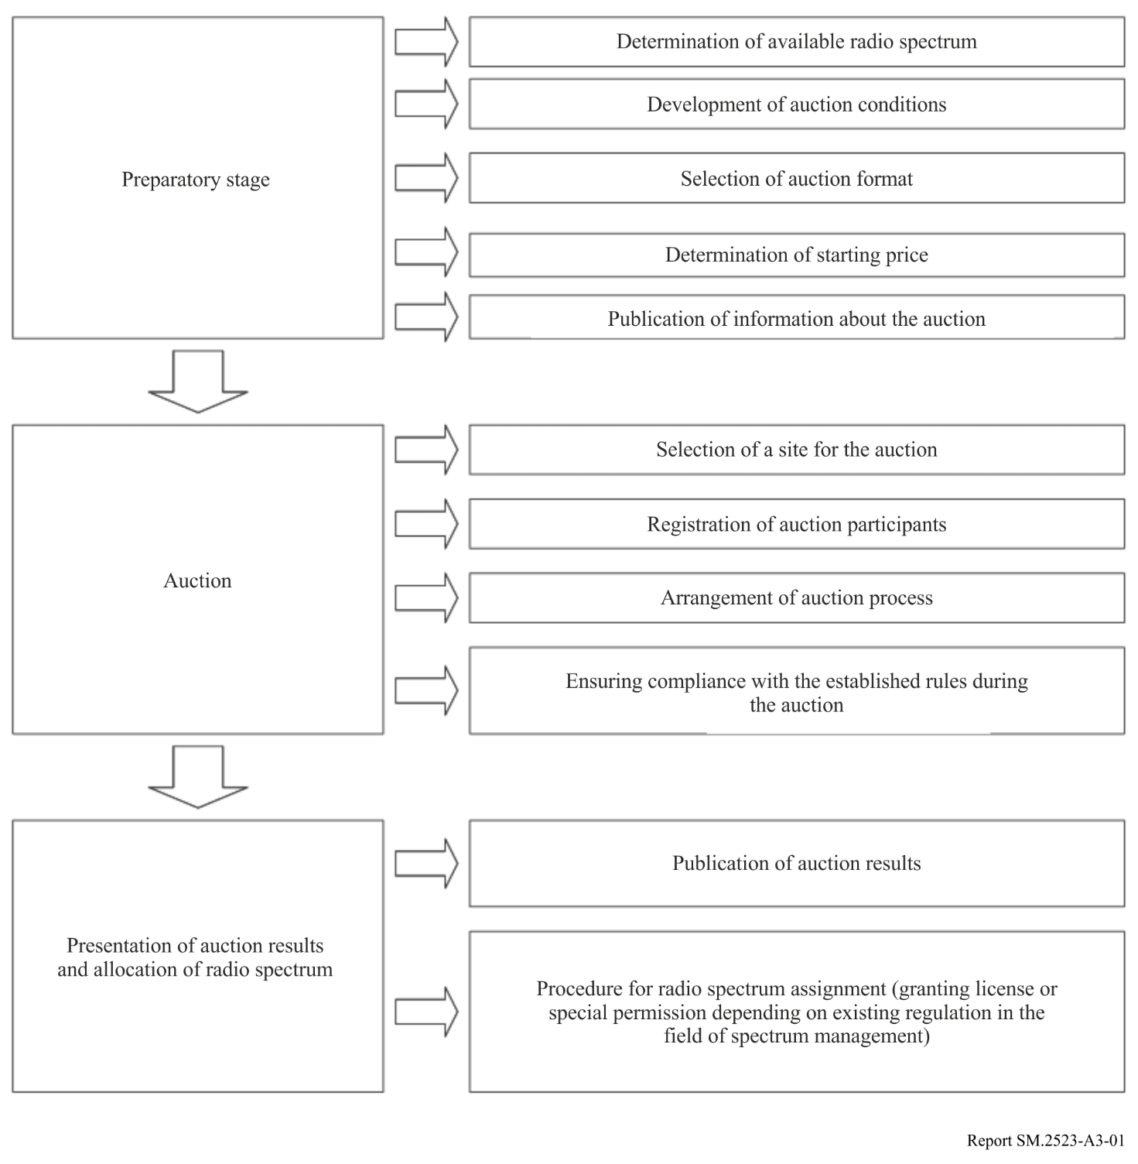
The auction procedure includes three stages.
The first stage is preparatory. At this stage, the auction organizer determines the amount of available radio spectrum resource that could be auctioned. Available radio spectrum is determined taking into account the Radio Regulations, the national Table of Frequency Allocations and plans for future use (if available).
Further, the auction organizer establishes the auction conditions: composition of lots, determination of the starting price, auction step size. More details about possible conditions can be found in § 1 of Attachment 1 to this Annex.
At this stage, the auction format is also determined. The auction formats are described in § 2 of Attachment 1 to this Annex.
The established auction conditions are made publicly accessible by the auction organizer.
The second stage is the auction itself.
Then, the electronic marketplace should be selected for the auction. (The cost of renting the marketplace shall be compensated from the income of the auction.)
The auction organizer registers participants, verifies their solvency, accepts deposits (if they are provided for by the auction rules), organizes the auction process and ensures compliance with its rules during the process.
At the third stage, the organizer presents and publishes the results of the auction, announces the winner and the won lot value, returns the deposits (if this is provided for by the auction rules) and awards authorization documents for spectrum usage.

Attachment 1
to Annex 3
Detailed procedure of spectrum auctions

1 Factors affecting auctions
Auction conditions could have a strong impact on the auction results.
When preparing for an auction, it is reasonable to consider specifics and conditions for a particular auction type.
It is possible to highlight the following factors determining a selection of a particular type of spectrum auction, which should be taken into account [P. Crampton, Auctioning the Digital Dividend, 2009; P. Crampton, Spectrum Auctions, University of Maryland, 2001; R. Preston McAfee, The Greatest Auction in History, 2009; P. Cramton, Spectrum Auction Design, 2012]:
– availability of information about each other's bids for auction participants;
– the need to determine the sequence of placing lots for bidding;
– possibility to make bids for a set of lots;
– discreteness of rounds;
– determination of the number of lots;
– determination of the maximum amount of spectrum that could be purchased by one participant;
– determination of the starting price, the size of the deposit, the step of the auction, the number of rounds;
– payment rules;
– special conditions for individual participants;
– conditions for bid cancellation;
– rules for participation in auction;
– rules for completing the auction.
Auctions could be organized in the format of sealed or open information depending on the availability of information on the bids of other participants.
An auction in the format of sealed information assumes that each company makes only one bid, and bid information is not available to other participants. This helps to prevent collusion between participants. This type of auction can bring large revenue, when supposed participants are a priori not equal. A large company can win a lot only by placing a very high bid.
An auction with open information assumes that participants know each other's bids. As a result, they could analyse the behaviour of competitors during the auction. This allows awarding licenses more efficiently, since participants have a large amount of information to make a decision. However, the risk of collusion between companies in order to reduce the price is higher.
From the viewpoint of sequence of placing licenses for auction, an auction could be organized in a consecutive or simultaneous format.
A consecutive format assumes that licenses are arranged and sold one after one during a series of auctions. This format has several disadvantages.
First, the main difficulty in arranging consecutive auctions is determination of the order for selling licenses. Arranging lots by any criterion can give advantages to some participants and this leads to a loss of objectivity in the awarding of licenses.
Second, with the consecutive selling of licenses, the information available to the participant and possibilities of using it are limited. When a company is bidding for a lot, it is important to forecast prices for those lots that will be auctioned later. This greatly complicates the strategies of participants and reduces the effectiveness of the auction. In this regard, a consecutive auction can be ineffective, when identical or complementary lots are auctioned.
Third, there is a limitation of the amount of information received by operators during the auction itself. This is due to the fact that when buying licenses for radio spectrum usage, companies happen to make and change decisions about their bids worth hundreds of million dollars. Such decisions generally require several days or even weeks for analysis by the top management. Since the arrangement of a consecutive auction involves selling several licenses during the day, participants do not have the opportunity to quickly use the information received. As a result, companies have to use a set of pre-determined strategies, and this could negatively affect the auction results.
Simultaneous format of the auction involves simultaneous selling of several lots.
The main advantage of this auction type is that it allows participants to quickly receive and use information, as well as change between lots. When the price of a license becomes too high for a buyer, he can switch his attention to another license, with a small penalty in the worst case.
Next important condition for auction is a possibility to make a bid for a set (package) of lots. Auction, where a participant can make a bid for a set of licenses rather than for an individual license, is identified as combinatorial. It was initially proposed:
1) to allow bidding for any number of licenses and change the bid through multi-round simultaneous auction till the end of auction, or
2) to allow bidding for several regional and one national licenses.
Such a form of auction allows bidders directly expressing their wishes – a company makes a bid for a number of licenses it needs as a single lot. At the same time, combinatorial auctions are more complex due to a great number of possible combinations.
An important reason in favour of this auction format is the fact that the price that a participant is ready to pay for the license could depend on other possibly won licenses. For example, if a company wins a license in one area, licenses in other area will be more expensive. Thus, a possibility to make bids for a set of licences rather than for individual licenses is more important for companies. In this case they get everything or nothing, and it would be improbable for participating company to complete the auction after winning only a part of what it desires. When individual licenses are auctioned, it may happen that a company could not buy primary lots but will buy secondary lots. Otherwise, to buy the lots required, it will have to pay more than it was ready to pay.
A lack of possibility to make bids for a set of lots may lead to a lesser auction efficiency.
The difficulty in arranging such a form of an auction is in the fact that, when there are many lots and bidders and any combinations are acceptable, identification of allocations which would maximize the benefit becomes practically impossible. Restriction of acceptable options for arranging lots in one set could be a solution for this challenge, but many desired combinations could be unintentionally excluded.
The term discreteness of rounds is understood as a limitation of time during which a participant can make its bid. According to this parameter, auctions could be divided by auctions with discrete and continuous rounds.
In the first case, the time assigned to participants for making bids is fixed. In the second case the time is not fixed, and companies control the time themselves. In one case they could make bids quickly, but in the complicated situation – within larger time interval. Discrete rounds are simpler organized, and they give a schedule for the participants to follow, so companies know exactly when new information will appear and the time they must response.
In spectrum auctions an important moment is a number of auctioned lots. Amount of spectrum and frequency bands, which will be auctioned, define the number of companies that will participate in the auction, in other words, competitiveness and efficiency of the auction.
Limitation of the spectrum amount that a participant could win allows preventing the monopoly on the communication services market. It is possible to limit currently auctioned spectrum or the overall spectrum belonging to an operator taking into account the spectrum already allocated before. In the latter case, new companies on the market have the opportunity to buy greater amount of spectrum compared to incumbent companies.
Starting price, amount of a deposit, auction steps, a number of rounds have a significant effect on the auction process. Thus, a starting price and amount of a deposit restrict the number of companies which could participate in an auction. An auction step is an increment of a lot price compared to the previous round. It determines the duration of the auction process. The lesser the auction step – the longer the auction. A number of rounds also affect the duration of auction process. An auction can have one or several rounds. Generally, a sealed-bid auction has one round. The second option is more preferable for open-bid auctions.
Payment rules are extremely important for sealed-bid auctions. There are three options possible:
– The winner pays a sum he had offered during the auction (first price).
– The winner pays the second highest bid for a lot (Vickrey price or Alternative price).
– Winners pay minimum of won bids (the option is applicable only for three and more similar lots – Universal price).
A choice of a payment rule could significantly affect the motivation of companies and potentially become an incentive for participation of new market payers in auctions. When using the first-price rule, participants estimate the difference between their bids and the price they are ready to pay and, accordingly, estimate the risk of a loss. Lesser the difference, lower the risk of losing an auction. Such a situation may give an advantage for new players wishing to enter the market and replace incumbent companies. On the contrary, the rule of second-highest price allows participants making real bids, knowing that they would not pay more than the first of losers. This approach is beneficial for strong players. The rule of universal price has advantages (and disadvantages) of both approaches.
Special conditions for participants. Auction organizer may establish special conditions for individual groups of participants. Generally, this is a discount ranging from 10% to 40%, that is, in case of winning the winner pays 10% – 40% less than his bid. Reservation of spectrum for a specific group of participants may be another option of special conditions.
Bid cancellation conditions. In case a participant cancels his bid, he generally pays a fee and leaves the auction. He is replaced by a participant with the next highest bid.
Rules for active participation. Rules for active participation allow controlling the speed of auction by establishing a minimum number of lots for which a participant may make bids in each specific round.
Many formats of auctions give ample opportunities for managing rules for active participation in order to influence behaviour of participants. Differentiated rules could be used to limit opportunities for existing market players to make bids and encourage new companies to play on the market. In addition, participation rules have strong effect on the process of multi-round auctions.
Auction completion rule allows users to win maximum needed spectrum. An example of such a rule is the following: auction is completed when there is no new bid for any lot during the round.

2 Spectrum auction models
Depending on the combination of previously described conditions, it is possible to distinguish between the following types (formats) of auctions:
– one-round sealed-bid auction;
– multi-round ascending auction;
– multi-round descending auction;
– clock auction;
– combinatorial auction;
– combined auction;
– incentive auction.
Selection of the auction format in each specific case is affected by:
– Expected number of participants and auctioned lots. The ratio between a number of participants and a number of lots determines a competition of the auction. Open-bid auction is a preferable format with high competition, and sealed-bid auction is a preferable format with low competition. In these cases, auctions would be more efficient.
– The target set by the regulator when organizing the auction. Depending on the target set by an auction organizer, he may modify auction rules. For example, he may establish preferential conditions for certain participants (for new market players or small operators) to strengthen the competitive environment.
– Type of auctioned license. In some cases, the license could specify the technology which shall be developed by the operator in the indicated frequency band. In other cases, technology neutral licenses are auctioned. The type of license defines the number of companies potentially interested in the auction.
One-round sealed-bid auction
Figure A3-2 presents the procedure for this type of auction and its specifics: participants are not aware of a bid (or some bids) made by other participants; results are announced only after the completion of the auction; and the license is granted to the participant which proposes the maximum price.
Figure A3-2
Procedure for a sealed-bid auction
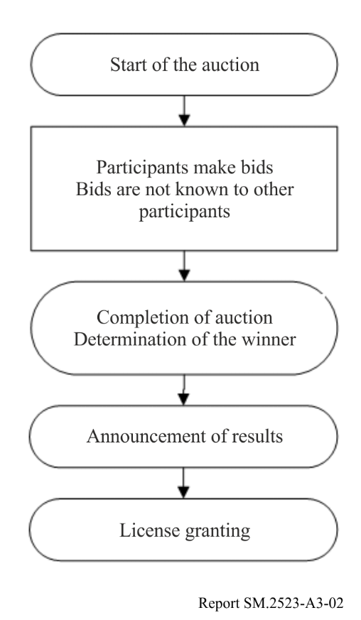
Advantages:
– Simple, quick, easily managed format of the auction.
– Auctions could be used for selling both single and multiple licenses.
– There is no need in gathering participants in one place and using complicated paper or electronic procedures for auction.
– Results of the auction are simply interpreted.
– Collusion between participants is prevented.
Disadvantages:
– Generally, participants have no opportunities to analyse each other’s actions. This leads to a complexity in deciding which lot is to bid for when several equally ranking licenses are auctioned.
– Lack of confidence in winning one or another lot if several lots complementing each other are auctioned.
– Efficiency of allocation is lower.
From the viewpoint of spectrum allocation, this type of auction could be reasonable when:
– The auctioned portion of spectrum has low value (or a cost of organizing another type of auction is higher than the value of the specified spectrum).
– There are many spectrum portions and there is a need in their prompt allocation.
– Efficiency of spectrum allocation is of minor importance.
– Risk of collusion is high.
This format of the auction was selected in Denmark to allocate licenses for 3G services.
Multi-round simultaneous ascending auction (English auction)
This type of the auction is widely used to sell licenses. It has the following specifics: several simultaneously auctioned licenses are involved in multi-round process; participants increase their bids in each round, and the auction is completed when there are no new bids; a lot is won by the participant with maximum bid (Fig. A3-3).
When organizing multi-round simultaneously ascending auction, different rules could be applied. Standard option of this format of the auction implies selling several lots, the price of each is increased only when any participant makes a bid. Thus, during the auction, prices for individual lots are subject to change. In addition, participants could correct their bids, i.e. make bids for the lots with lower prices.
Simultaneous ascending auction is efficient when several licenses are auctioned and there is uncertainty in the estimation of their price.
Figure A3-3
Procedure for multi-round simultaneous ascending auction
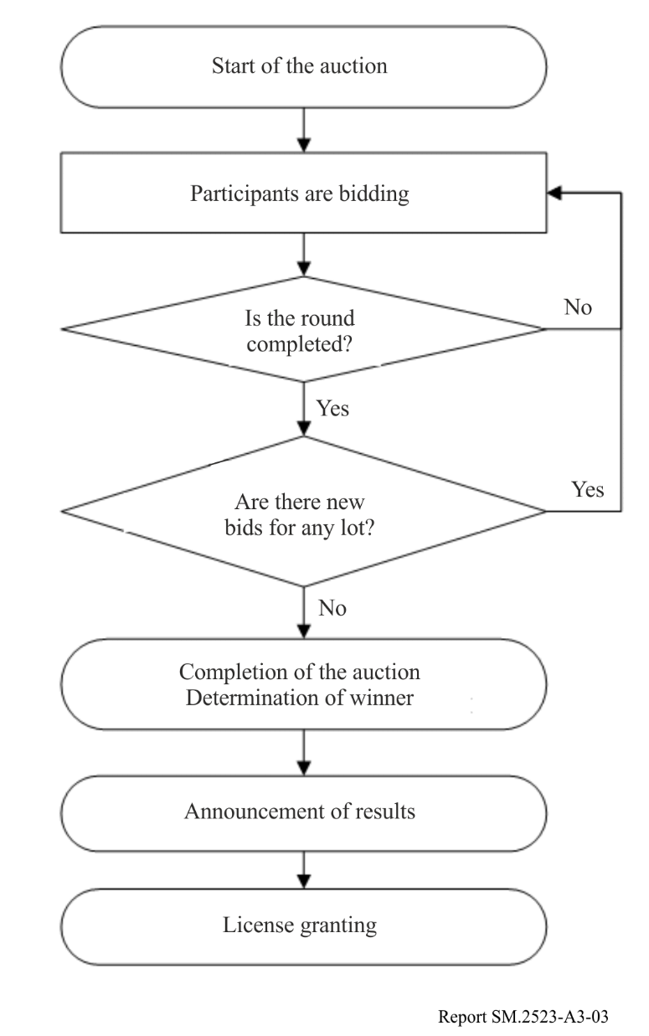
Advantages:
– Participants have opportunities to analyse behaviour of the competitors and correct their bids depending on the modification of license price.
– Lower risk of overpayment for the winner.
– Lower risk of not receiving the desired license for the participant.
– Lower risk of not receiving the desired license from the package for the participant.
Disadvantages:
– There is a possibility of collusion between participants. The number of participants could be fixed before the start of the auction. Moreover, incumbent companies could impede participation of new players in the auction.
– Complexity. The rules and procedures of such an auction are more complicated than in the case of simple sealed-bid auction despite that the development of electronic auction systems has made the simultaneous auctions less expensive, and simpler.
– Unequal conditions for participants. In this format of the auction, participants requiring only one lot have a sort of advantage. Participants, requiring several lots for efficient operation of their networks, have the higher risk of not winning them.
– Auction could take a lot of time.
The multi-round ascending auction and successive allocation of lots have been widely applied in Europe, particularly in Germany, Great Britain and Switzerland for granting licenses for 3G services delivery, in Norway for frequency allocations in 3.5 GHz band as well as for granting spectrum licenses for fixed broadband wireless access, local radio communications, and etc.
Multi-round descending auction (Dutch auction)
This type of a multi-round auction has the following specifics: before the start of the auction the auctioneer announces the starting price for a lot that is deliberately overstated; if there are no participants ready to buy the lot at the price indicated, the auctioneer decreases the price; the auction is stopped when there is a participant ready to buy the lot (Fig. A3-4).
Figure A3-4
Procedure for the multi-round descending auction
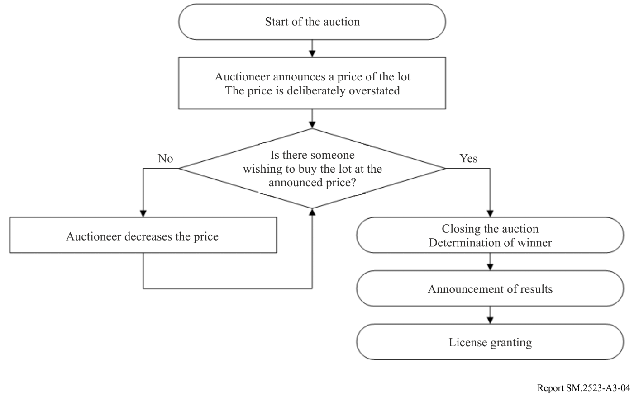
Advantages:
– Simplicity of implementation and transparency of the auction procedure.
– Compared with sealed-bid format, participants have the opportunity to analyse behaviour of competitors, thus increasing efficiency of their decisions.
– The auction could be efficient when the purpose of the auction is to sell the lot at the minimum price.
Disadvantages:
– The auction organizer can loss some income, if a maximum price participants are ready to pay is unknown, and the purpose of the auction is to sell the lot at the maximum possible price.
Clock auction
Clock auction is the version of multi-round simultaneous ascending auction. It is used for selling lots with equal prices when participants cannot prefer one lot to the other. In this auction format all lots have a single price which is ascended every round until the number of participants will be decreased to the number of lots.
In another version of such the auction, lots are aggregated into groups so that the lots in one group were equivalent for participant. In this case price is set for one lot in every group.
Clock auction is the cyclic procedure when auctioneer at the start of the round announces the price for one lot in every group of lots (see Fig. A3-5). Then the participants announce how many lots of every group they are ready to buy at the announced price. For the group of lots where demand is higher than supply the price for one lot is increased. The participants again announce how many lots they are ready to buy at the announced prices. The process is repeated unless demand would be equal to supply for all groups of lots.
Figure A3-5
Procedure for the clock auction
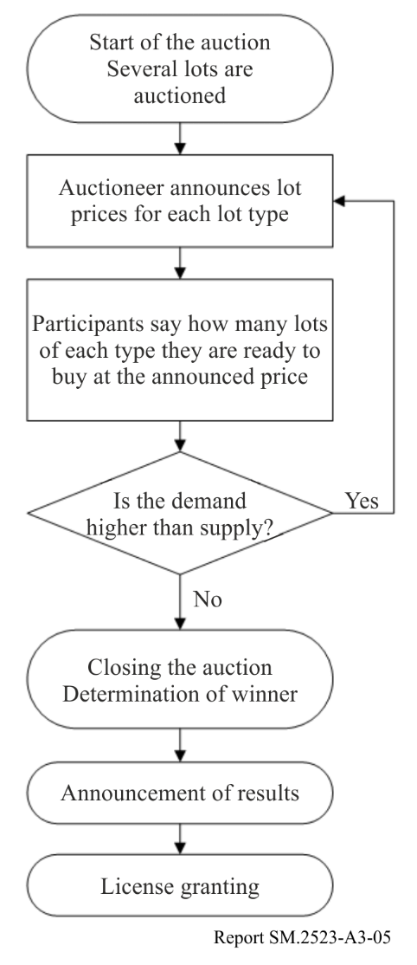
Advantages:
– Simple for participants. In each round participant announces the spectrum amount he is ready to buy at the stated price.
– Eliminates possible participant collusion. The restriction of available information for participants about difference between demand and supply does not allow developing collusion strategy. Signs of bidding intentions are excluded because participants have no information on bids from individual participants.
– High efficiency of the auction. With every round, participants have more and more information about the price of this or that portion of spectrum and use it for decision-making. As a result, the cost of participation in the auction is decreased, and the efficiency is higher.
Disadvantages:
– Linear pricing to the end of the auction. Linear pricing leads to decreasing participant demands resulting in decrease of the auction efficiency.
This version was applied in Hungary for allocation of licenses for local radio communications, in Nigeria for allocation of licenses for 2G networks, in Great Britain for allocation of frequencies in 800 MHz and 2.6 GHz bands, in Ireland for allocation of licenses in 800 МHz, 900 МHz and 1 800 МHz bands.
Combinatorial open multi-round auction
Such type of the auction is used when auctioned lots are complemented each other. As opposed to the standard auction, participants can make several bids, one for every combination of lots. In other words, bids could be made both for an individual lot and for arbitrary combination of lots (see Fig. A3-6).
Winners are determined by the following way: for all participants and for all lots, a combination of bids is defined, where the sum of bids has maximum value. The participants are recognized as winners when their bids have been included in such a combination.
The auction could be arranged both with one round and also with several rounds. Such an approach could serve as a complement to any other auction format.
With the transition to liberalization of spectrum use, a probability of the participation in the same auction of companies with different needs in the frequency resource will grow. In connection with this, the risk of not receiving the desired set of licenses will also grow. As a result, the interest to combinatorial auction format also will grow.
Figure A3-6
Procedure for the combinatorial auction
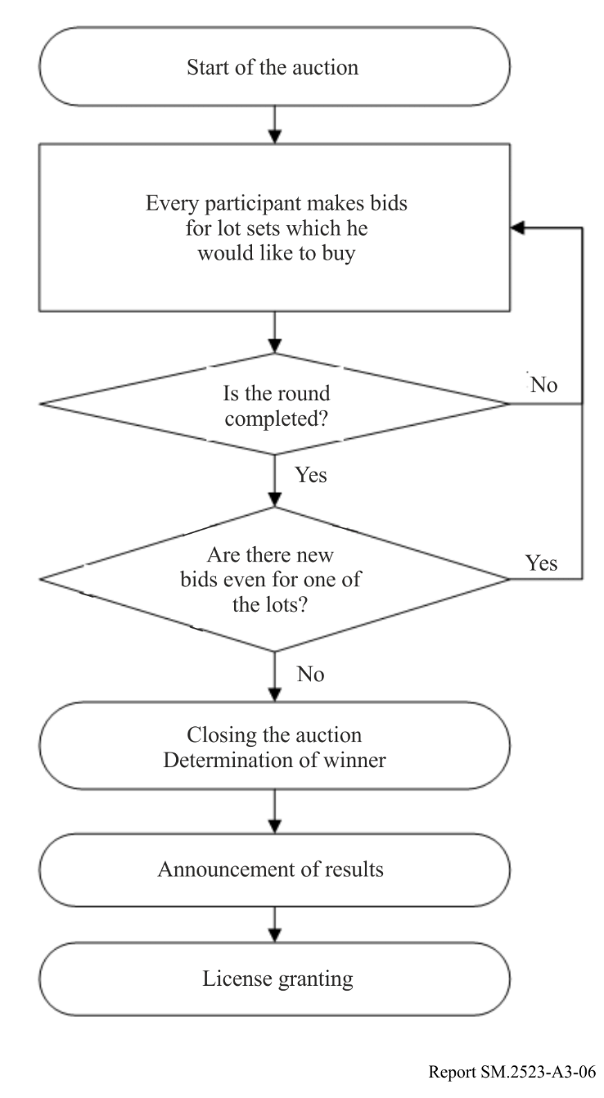
Advantages:
– There is a possibility to decrease risks for participants. The possibility to make bids for a number of licenses allows them avoiding the situation when participants will not obtain the portion of the needed spectrum. It serves the interests both of those who desire to obtain several licenses and those who desire to obtain one license.
Disadvantages:
– High costs and complexity of winner determination algorithm. Combinatorial auction can be significantly more complex both for organizers and participants. When more than 4 lots are auctioned and many participants are played, a computer algorithm could be required to determine a winner, because of large number of possible combinations of winners and lots considered. Even with small number of lots determination of winner is not a simple task.
– Low transparency. Results of such type of auctions are not always transparent for participants and observers especially when using a computer algorithm for determination of the winner.
– Complexity of decision-making. Such a format of the auction can result in a new risk for participants desiring to obtain certain license or a small package of licenses. For these participants it is hard to take right decisions competing with those who bid for a large package of licenses and can make bids restricting possibilities of the smaller players.
Such auction format was used in Norway in 2001 during the auction for GSM-1800 and GSM-900 licenses. Combinations of abstract spectrum portions were auctioned in the sealed-bid one-round format.
In 2002 in Nigeria during allocation of licenses for fixed wireless access there were arranged five combinatorial sealed-bid auctions, where participants could make several unique bids for licenses in 4 to 5 regions. The process was divided in five auctions for each of the regions.
Combinatorial sealed-bid one-round auction was used in Great Britain during allocation of four 500 kHz spectrum portions in 412-414/422-424 МHz bands for professional radio communications.
Combined auction
Any auction integrating parameters of several auction types is called combined, for example, English-Dutch auction, Clock auction with a possibility to make bids for a package of lots.
English-Dutch format integrates standard simultaneous multi-round auction and closed auction (see Fig. A3-7). Such a format could be useful when the number of large players and the number of licenses are the same.
Figure A3-7
Procedure for the Anglo-Dutch auction
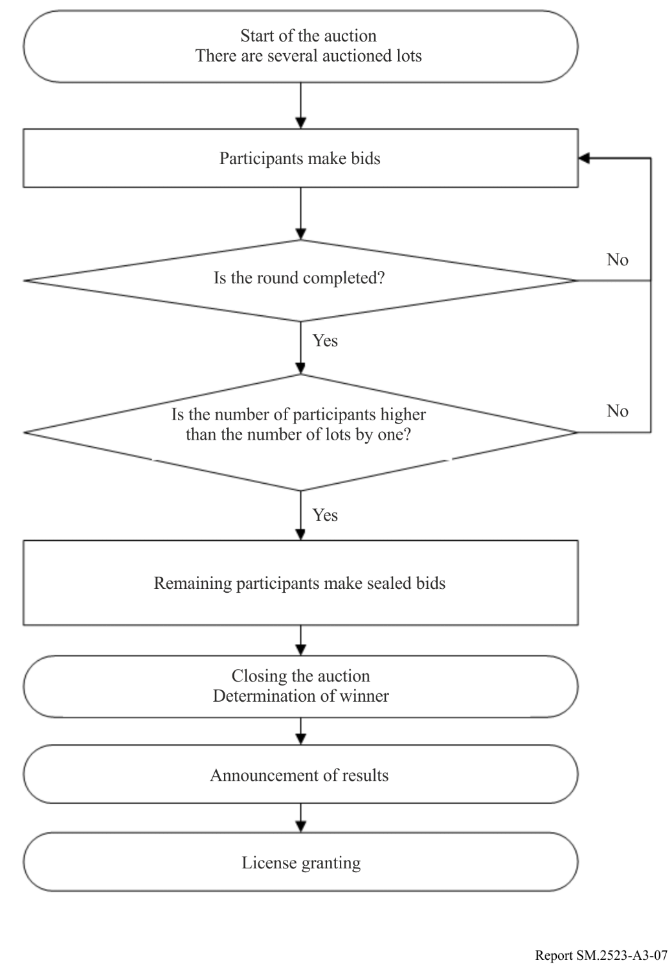
Clock auction with a possibility to bid for a package of lots. It is a combination of standard clock auction and the combinatorial auction with ascending bids (see Fig. A3-8). In this option the clock auction is completed with an additional round where participants make additional bids.
Figure A3-8
Procedure for the clock auction with a possibility to bid for a package of lots
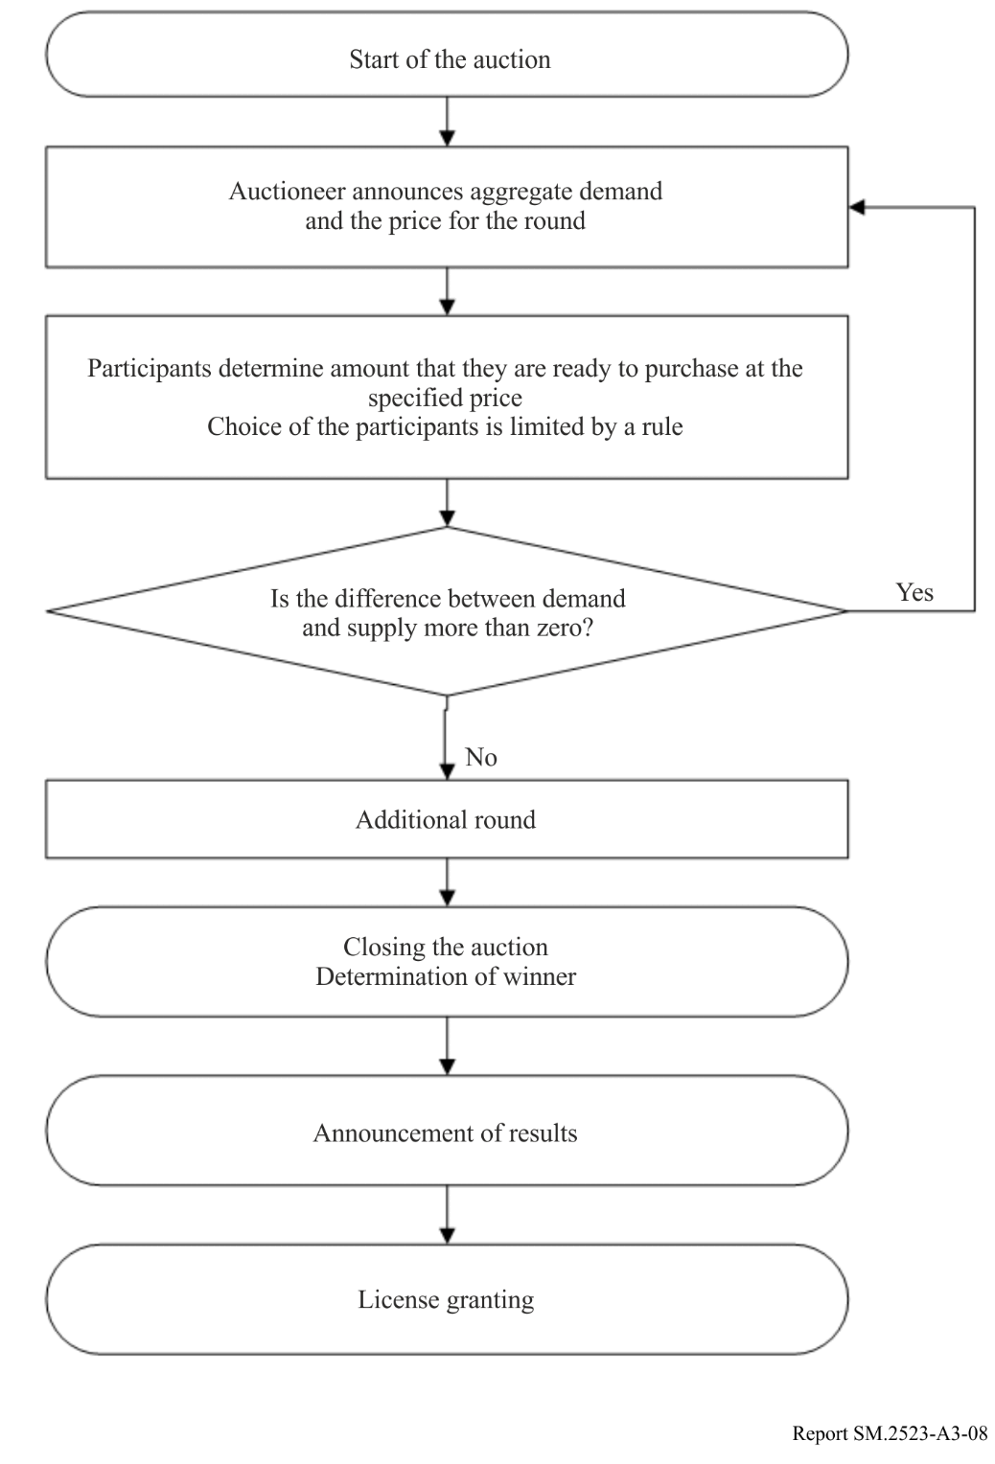
Table A3-1 shows advantages and disadvantages for different types of auctions and their possible use in the Russian Federation.
Incentive auction
A two-sided or “incentive” auction integrates spectrum supply and demand to determine the amount of spectrum sold, who uses it, the prices buyers receive and sellers pay and, as in the case of the Federal Communications Commission’s (FCC) Broadcast Incentive auction, how it is used.
The FCC’s Broadcast Incentive Auction was the world’s first two-sided auction to repurpose spectrum. It concluded in 2017, reallocating 84 MHz of television broadcast spectrum nationwide to meet the growing demand for mobile broadband services. In previous reallocations, the FCC determined the amount of spectrum reallocated administratively. In the Broadcast Incentive Auction, the amount of spectrum repurposed was determined by the supply from television broadcasters and the demand by wireless carriers.
The auction format consisted of a series of stages, each stage consisting of a reverse auction followed by a forward auction. The descending clock reverse auction offered television broadcasters the opportunity to relinquish spectrum usage rights. While broadcasters operate in three bands, UHF, upper VHF and lower VHF, only UHF spectrum is of interest to mobile broadband providers. The reverse auction cleared UHF spectrum by paying broadcasters to discontinue broadcasting or to move to a lower band. Broadcasters in VHF spectrum who discontinued operation also cleared UHF spectrum if some UHF broadcasters were willing and able to move to a vacated VHF channel.
While a broadcaster’s decision whether to participate in the Broadcast Incentive Auction was voluntary, the Commission was empowered to require broadcasters who remain on the air to move to an equivalent channel within their current band (UHF, upper VHF or lower VHF). This authority was essential to creating a competitive reverse auction. Without it, every broadcaster in the portion of the UHF band targeted for clearing could demand a non-competitive price to relinquish its spectrum rights.
Wireless carriers in the ascending clock forward auction bid for generic spectrum blocks within 416 geographic license areas. The first stage of auction started at the largest feasible spectrum clearing target given the broadcasters who were not willing to clear at the opening prices and therefore needed to be assigned a channel.
If the auction could not be closed at a given clearing target, another stage was conducted at the next lower target until the “final stage rule” conditions were met. The final stage rule for determining the stage in which the auction would close had both a gross revenue and a net revenue test. After the close of the forward auction in the final stage, an assignment phase auction was conducted to assign specific frequency blocks to the winners of the generic blocks in each geographic area.

TABLE A3-1
Comparative analysis of different auction types
Auction type | Advantages | Disadvantages | Use cases
Single-round sealed-bid auction | Simple, fast and easily managed format of the auction.  Could be used for any number of licenses.  Eliminates possible participant collusion. | Lower efficiency of license granting.  The winner overpays in most cases. | Low spectrum price.  High number of spectrum portions and there is a need in their fast allocation.  Spectrum allocation efficiency is not important.  High risk of participant collusion.
Multi-round simultaneous ascending auction | High efficiency of the auction.  Lower risk of overpayment for the winner.  Lower risk of not receiving the desired license for the participant. | Possible participant collusion.  Complexity.  Unequal terms for participants.  Could take a lot of time. | Several licenses are auctioned.  Complex determination of license price.  For licenses in the most valuable frequency bands (for example, digital dividend).
Multi-round descending auction | Simple implementation.  Transparent auction procedure. | Complexity of starting price determination.  Risk of overpayment for the winner.  Low efficiency.  Could be used only sequentially in reality. | Auctioned spectrum portions have equal value for participants; and it is not relevant for the operator which portion he wins.  Spectrum price is known or could be based on the experience of the previous auctions.  Low spectrum price.  Fast allocation of licenses is important.
Clock auction | Simple for participants.  Eliminates possible participant collusion.  High efficiency. | Linear pricing at the end of the auction. | Auctioned spectrum portions are equal.
Open combinatorial multi-round auction | The same advantages as for the open simultaneous multi-round ascending auction plus maximum efficiency for complementary frequency bands. | Complex implementation.  Highest organizational cost. | Several licenses are auctioned.  Complex determination of license price.  For licenses in the most valuable frequency bands (for example, digital dividend).

Analysis of auction conditions and formats leads to the conclusion that the choice of auction type in each specific case is mainly defined by:
– Supposed number of participants and the number of auctioned lots. The ratio of the number of participants and the number of lots determines the auction competition. When the competition is high it is reasonable to prefer open bidding, and when the completion is low it is reasonable to prefer sealed bidding. In these cases, the auction will be the most effective.
– The target pursued by the regulator when organizing the auction. Depending on the target set by the auction organizer, the bidding rules can be changed. For example, in order to improve the competitive environment, the organizer can provide preferential terms to certain participants (new market players or small operators).
– Type of auctioned license. In one case, the license can specify technology which operator must develop in the specified frequency band. In the other case, technology neutral licenses are auctioned. The type of license determines the number of companies potentially interested in the auction.
These criteria, considered when choosing auction format and developing auction terms for spectrum portions in the specific frequency bands, also impact the level of the auction starting price.

3 Methodology for determination of starting price for auctioned spectrum lots
Starting price is the minimum price which participant has to pay for a lot. Starting price determines efficiency of all auction formats. The higher the starting price, the fewer the number of possible participants. This increases the risk of the license unsold. At the same time, very low starting price can lead to a collusion of participants, which in its turn will diminish the auction income. In this case, the auction income could be insufficient even to cover costs of the regulator for the auction.
Several possible approaches to determine the starting price for a license for using the radio spectrum can be distinguished in the international practice:
– Economic and mathematical modelling. Implies drawing economic-mathematical models for activity indicators of the potential participants. In terms of the increase in operator’s income from using additional spectrum, based on results of operator income and costs modelling, potential price which operator is ready to pay for spectrum portion is determined. This value could also be used to determine the upper level of the possible starting price.
– Cost compensation approach. The starting price of the auctioned lot is set at the level of administration’s costs for radio spectrum management.
– Comparative approach. Studies and analysis of the existing international experience are carried out, namely collecting data on the starting prices and auction results for frequencies in the same band in other countries, with their subsequent adjustment for a country where an auction is planned.
Economic and mathematical modelling
Advantages of this method allow:
– Determination of the maximum price which company is ready to pay for the spectrum. Increase in company’s income and profit from the additional spectrum, derived on the basis of mathematical modelling, allows determination of the maximum price that the company could pay for the spectrum.
– Identification of the impact of the starting price on the number of auction participants, i.e. identification of those participants who will refuse to participate in the auction if the starting price is inadequate. In addition, the method allows determination of the price at which spectrum will never be sold.
The following disadvantages should be highlighted:
– Essential difference between business models of different users. This difference becomes very significant in auctions for technology neutral licenses. In this case the value of the spectrum will depend on the services which a participant plans to provide and on the technology which he supposes to use. Development of business models can be more complicated when new market players plan to participate in the auction.
– Large organizer’s efforts in the development of economic and mathematical models for activity indicators of potential participants.
– Ambiguity of the obtained results.
– Complexity to ensure transparency of calculations since most of the information required to develop business models is private.
Cost compensation approach
Advantages of the administrative cost compensation approach for determination of the starting price are as follows:
– The minimum value of the starting price. Increase in the costs for spectrum management, specified in the license, determines the lowest starting price.
– Compensation of the regulator costs for the spectrum management.
Disadvantages of this method are:
– Low income when a demand for auctioned lots is low.
– Possible participant collusion.
– Complexity of collecting initial data. Retrieving data on the costs for a certain frequency band from the whole data set on frequency management costs is complicated.
– There is a probability that the real price of the spectrum will be much higher.
Comparative approach
The approach is based on studies and comparative analysis of the existing international experience in auction pricing.
Advantages of this method are as follows:
– Flexibility of the approach. Different data samples and methods for data processing could be used.
– No need in obtaining private information.
– Transparency.
– Consideration of different demand scenarios.
– Availability of the initial data. There is a large volume of empirical data in the free access, which allows evaluating the spectrum price for users, and reflecting it in a starting price.
Analysis of the existing practice has the following disadvantages:
– Dependency of the result on the initial data and the method of data processing. The result depends on initial data collected in the certain period of time, country and frequency band.
– Large number of factors impacting the spectrum price in different counties, including population size and density, income per capita, competition at the telecommunication market, competition within a specific auction, auctioned spectrum type, technical conditions/limitations of licenses.
– Large volume of initial data is required.
The above-mentioned information is summarized in Table A3-2.
TABLE A3-2
Analysis of existing methods for determination of the starting price
Method | Advantages | Disadvantages
Economic and mathematical modeling | Allows determination of the spectrum price for each specific user.  High informativeness. | Essential difference between business models of different users.  Efforts required to develop business models are high.  Ambiguity of results.  Privacy of the initial data.
Cost compensation approach | Minimum starting price.  Compensation of spectrum management and auction costs for the regulator. | Low income when the demand is low.  Possible participant collusion.  Complexity of collecting initial data.  The real price of the spectrum can be much higher.
Comparative approach | Flexible approach.  No need in private information.  Transparency.  Consideration of different demand scenarios.  Availability of initial data. | Dependency of the result on initial data (period of time, frequency band) and method of data processing.  Large number of factors impacting spectrum price in different countries.  Needs high volume of initial data.

Following the results of the auction, spectrum price shall compensate costs of the auction and costs of spectrum management according to legislation of the country.

Attachment 2
to Annex 3
National experiences of Spectrum auctions

1 United States of America

1.1 One-round sealed-bid auction

1.1.1 Closed Cellular Unserved https://www.fcc.gov/auction/77, Mobility Fund Phase I https://www.fcc.gov/auction/901

1.2 Multi-round ascending auction

1.2.1 700 MHz Band https://www.fcc.gov/auction/73

1.3 Clock auction

1.3.1 Ascending clock auction, broadcast incentive forward auction https://www.fcc.gov/auction/1002

1.3.2 Descending clock auction, e.g. Auction 1001, broadcast incentive reverse auction https://www.fcc.gov/auction/1001

1.4 Incentive auction

1.4.1
The incentive auction is a new tool authorized by Congress to help the Commission meet the nation’s accelerating spectrum needs in high value services such as mobile broadband. A two-sided or “incentive” auction integrates the supply of and demand for spectrum to determine the amount sold, who uses it, the prices buyers receive, and sellers pay, and, as in the case of the Federal Communications Commission’s (FCC) Broadcast Incentive auction, how it is used.
In 2012, Congress granted the Commission general authority to conduct Incentive Auctions as well as specific direction with respect to a Broadcast Incentive Auction. In 2014, the FCC adopted a Report and Order for the Broadcast Incentive Auctions. The auction began on 29 March 2016 with broadcaster commitments at the opening prices. It successfully concluded in 2017, reallocating 84 MHz of television broadcast spectrum nationwide.
Broadcasters were given the opportunity in the “reverse auction” phase of the incentive auction to return some or all of their broadcast spectrum usage rights in exchange for incentive payments. By facilitating the voluntary return of spectrum usage rights and reorganizing the broadcast television bands, the FCC could recover a portion of ultra-high frequency (“UHF”) spectrum for a “forward auction” of new, flexible-use licenses suitable for providing mobile broadband services. By making more spectrum available for mobile broadband use, the incentive auction will benefit consumers by easing congestion on the nation’s airwaves, expediting the development of new, more robust wireless services and applications, and spurring job creation and economic growth.
The Broadcast Incentive Auction was comprised of two separate but interdependent auctions – a reverse auction, which determined the price at which broadcasters voluntarily relinquished their spectrum usage rights; and a forward auction, which determined the price companies were willing to pay for flexible use wireless licenses. The joining the reverse and the forward auctions was the “repacking” process. Repacking involved reorganizing and assigning channels to the remaining broadcast television stations to create contiguous blocks of cleared spectrum suitable for flexible use. Each of the components worked together. The reverse auction required information about how much bidders are willing to pay for spectrum licenses in the forward auction; and the forward auction requires information regarding what spectrum rights were tendered in the reverse auction, and at what price; and each of these depended on efficiently repacking the remaining broadcasters.
The Broadcast Incentive Auction was conducted in a series of stages. Each stage consisted of a reverse auction and a forward auction. Prior to the first stage, the initial spectrum clearing target was determined. Broadcasters indicated through the pre-auction application process their willingness to relinquish spectrum usage rights at the opening prices. Based on broadcasters’ collective willingness, the initial spectrum clearing target was set at the highest level possible (126 megahertz of spectrum) without exceeding a pre-determined national aggregate cap on the interference between wireless providers and TV stations (“impairments”) created when TV stations must be assigned to the wireless band. Then the reverse auction bidding process was run to determine the total amount of incentive payments to broadcasters required to clear that amount of spectrum.
A forward auction followed the reverse auction in each stage until the “final stage rule” was satisfied. The final stage rule is a set of conditions that must be met to close the auction at the current clearing target; failure to satisfy the rule would result in running a new phase at the next lowest clearing target. When the “final stage rule” is satisfied bidding in the forward auction continues until there is no excess demand, and then the incentive auction closes. The Broadcast Incentive Auction closed in the fourth stage.
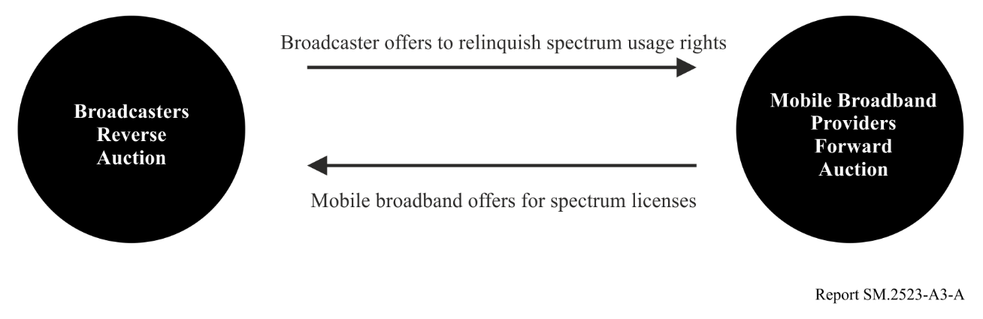
A key element of the Broadcast Incentive Auction was that a broadcaster’s decision to participate in the reverse auction was wholly voluntary. In the descending clock auction format, if at any point a broadcaster decided a price was too low, it could drop out of the reverse auction. No station was compensated less than the total price that it indicated it was willing to accept.
The FCC also recognized the importance of broadcasters that chose not to participate in the reverse auction and followed Congress’s directive to make all reasonable efforts to preserve, the coverage area and population served of remaining broadcast licensees. The reorganization (or “repacking”) approach FCC adopted also avoids unnecessary disruption to broadcasters and consumers.

1.4.2 Band plan
Prior to the auction the FCC established a wireless-license band plan for each possible clearing target. The “600 MHz Band Plan” the FCC adopted consisted of an uplink band that begins at channel 51 (698 MHz), followed by a duplex gap, and then a downlink band. Each wireless license is 10 MHz comprised of a 5 MHz uplink paired with a 5 MHz downlink. The figure below shows the band plan associated with each potential spectrum clearing target. The potential amount of spectrum cleared ranged from 126 MHz to 42 MHz. The corresponding wireless licenses in a geographic area ranged from ten to two.
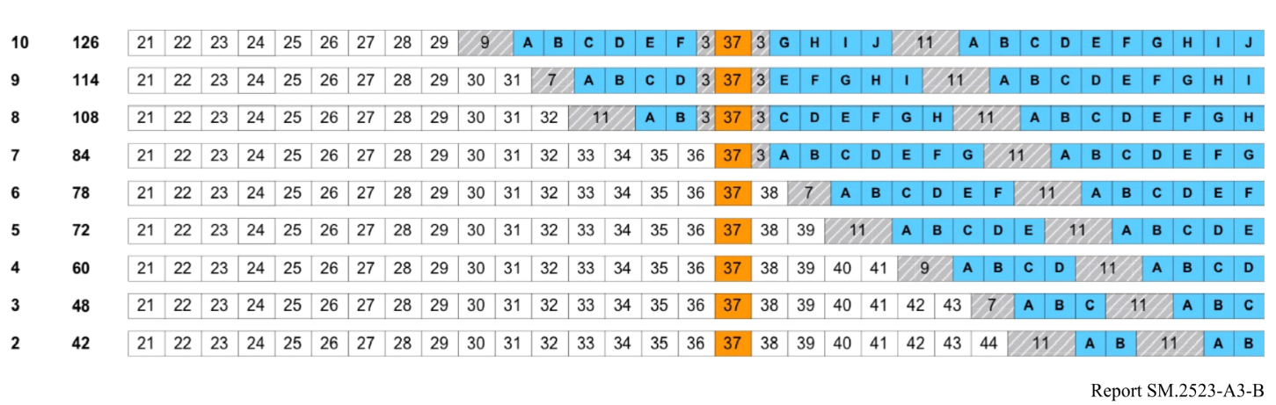
The band plan in the Incentive Auction also allowed for the possibility that the same amount of spectrum might not have been cleared in every geographic area. If for a given clearing target all televisions stations that needed to be repacked could not be assigned a channel in the lower part of the band, the packing optimization software determined channel assignments in the upper part of the band that minimized interference-related impairment to wireless operations. The 84 MHz band plan at which the auction closed had no such impairments.

1.4.3 Repurposing for mobile use
The Broadcast Incentive Auction successfully reallocated 84 MHz of television broadcast spectrum. Of the 84 MHz reallocated, 70 MHz was awarded for flexible licensed uses, including mobile broadband, and 14 MHz was made available for unlicensed use and wireless microphones. Of the $19.8 billion in gross revenue bid in the forward auction, $10.1 billion went to winning television broadcast stations and $7.3 billion to the federal treasury.
The auction created a first-of-its-kind market for repurposing commercially held spectrum for new uses. The model is part of the foundation of the future of U.S. spectrum reallocations. In previous reallocations, the FCC determined the amount of spectrum reallocated administratively. In the Broadcast Incentive Auction, by contrast, the amount of spectrum repurposed was determined in a two-sided auction by the supply from television broadcasters and the demand by wireless carriers.
Following the conclusion of the incentive auction, the transition to the reorganized UHF band will be as rapid as possible without causing unnecessary disruption. Broadcast stations that relinquished their licenses in the incentive auction were required to turn in their licenses and cease operating. Relinquishing stations were permitted to continue broadcasting by entering into an agreement to share a channel with a non-relinquishing station.
Stations reassigned to a new channel are required to move from their pre-auction channels to new channels in the reorganized broadcast television bands (Channels 2-36) according to a phase transition schedule that assigned repacked stations to one of ten transition phases. Each transition phase has a deadline by which stations are permitted to commence testing and operation on their post-auction channel (testing period) and a date by which each station must cease operating on their pre-auction channels (phase completion date). No station will be permitted to continue operating on its pre-auction channel after 13 July 2020.

Annex 4
Case study in China on the assessment of spectrum efficiency
This reflects the views of the contributing administration.
From the perspective of radio spectrum regulators, some administrations have already implemented four factors to evaluate spectrum efficiency, the radio regulator use the following four factors to evaluate the frequency utilization efficiency of the authorized spectrum, and characterize the actual usage of the licensed spectrum by actual measurement and data. With this, there is another dimension to portray the spectrum utilization efficiency, i.e. through the measurement result on four indicators: frequency band occupancy, annual time occupancy, area coverage rate, and user carrying rate.
Frequency band occupancy refers to the ratio of the actual usable frequency range to the frequency range approved by the administration.
Annual time occupancy refers to the ratio of the number of days (or hours) actually used in a year to the number of days (or hours) of one year. According to the actual usage, the daily and monthly time occupancy be used for evaluation, or combined with the actual usage of users and radio services.
Area coverage rate refers to the ratio of the actual use area (in km²) of the licensed frequency to the area of the frequency usage approved by the administration.
User carrying rate refers to the ratio of the number of users actually served by using licensed frequency to the number of the served users which has been evaluated and demonstrated by experts.
The above-mentioned four indicators may be further studied accordingly, as these indicators are easier to achieve and measure, and may be more intuitive for evaluation of spectrum (utilization) efficiency.

Report ITU-R SM.2012 can be used as reference which analyses principles of assessing the spectrum’s economic benefits, mainly introduces the practice of licence fees of relevant countries, and briefly describes the experience with spectrum auction, using alternative resources, etc.
Reference: Sun Linlin, Zheng Haitao, Ren Ruoen. The Contribution of Informatization to China's Economic Growth: Empirical Evidence from Industry Panel Data [J]. World Economics, 2012, 000(002): 3-25.
Reference: See also above reference.
See: https://en.eustat.eus/documentos/elem_15552/definicion.html.
See: https://en.wikipedia.org/wiki/Input–output_model.
PPI: The production price index, which is generally announced by the governments of various countries.
This section is based on “Economics at the FCC, 2016–2017: Auction Designs for Spectrum Repurposing and Universal Service Subsidies,” Evan Kwerel, Paroma Sanyal, Katja Seim, Martha Stancill and Patrick Sun. Review of Industrial Organization. (2017) 51:451–486; and “Economics at the FCC, 2011-2012: Spectrum Incentive Auctions, Universal Service & Intercarrier Compensation Reform, and Mergers,” Evan Kwerel, Paul LaFontaine and Marius Schwartz. Review of Industrial Organization (2012).
https://www.fcc.gov/about-fcc/fcc-initiatives/incentive-auctions/how-it-works
United States Code (U.S.C.). (2012). Middle Class Tax Relief and Job Creation Act of 2012, Pub. L. No. 112-96, 117 Stat 2066 (“Spectrum Act”).
https://www.fcc.gov/document/fcc-adopts-rules-first-ever-incentive-auction
Broadcasters were required to commit to a preferred relinquishment option, and could commit to additional “fallback” options, for each of their stations participating in the reverse auction. Procedures PN, FCC 15-78, 11 August 2015, § IV.A.1.
Bidding concluded on 30 March 2017. The official completion of the auction was marked by the release of the Closing and Channel Reassignment Public Notice, DA 17-314, 13 April 2017.
The 11 MHz duplex gap and the guard bands separating different services are show in grey with diagonal white stripes. Channel 37 shown in orange is allocated for Radio Astronomy and Wireless Medical Telemetry. The UHF television channel numbers are indicated for each 6 MHz television channel in the lower part of the band. Incentive Auction R&O, 29 FCC Rcd at 6585, para. 45.
The initial set of band plans developed by the FCC also included a 138 MHz and a 144 MHz plan. These plans were not considered in setting the initial clearing target to better harmonize the U.S. and Canadian 600 MHz Band Plans. See Auction 1000 Bidding Procedures PN, 30 FCC Rcd at 8986, para. 16 n. 52; Canadian Coordination at 2 n. 4.
Proceeds in the forward auction net of bidding credits were $19.3 billion. Proceeds will also go to reimbursing non-winning broadcasters and the costs of conducting the auction.

