Resolution ITU-R 56*
Naming for International Mobile Telecommunications
(2007)

Introduction
International Mobile Telecommunications-2000 (IMT-2000) systems provide access to a wide range of telecommunication services, supported by the fixed telecommunication networks (e.g. PSTN/ISDN/IP), and to other services which are specific to mobile users.
To meet the ever increasing demands for wireless communication, and the expected higher data rates needed to meet user demands, IMT-2000 is being continually enhanced and systems beyond IMT-2000 are envisaged. The framework and overall objectives of the future development of IMT-2000 and systems beyond IMT-2000 are described in Recommendation ITU-R M.1645.
Resolution 228 (Rev.WRC-03) notes that appropriate naming is to be developed for the future development of IMT-2000 and systems beyond IMT-2000. Thus the term “systems beyond IMT-2000” has been used as a temporary name. This Resolution clarifies the relationship between the terms “IMT-2000” and “the future development of IMT-2000” and gives the new name to those systems, system components, and related aspects that include new radio interface(s) that support the new capabilities of systems beyond IMT-2000. Additional Recommendations and Reports will be developed to address other issues related to these systems in more detail.

Related Recommendations
Recommendation ITU-R F.1399: Vocabulary of terms for wireless access.
Recommendation ITU-R M.1224: Vocabulary of terms for International Mobile Telecommunications-2000 (IMT-2000).
Recommendation ITU-R M.1457: Detailed specification of the radio interfaces of International Mobile Telecommunications-2000 (IMT-2000).
Recommendation ITU-R M.1645: Framework and overall objectives of the future development
of IMT-2000 and systems beyond IMT-2000.
ITU-T Recommendation Q.1702: Long-term vision of network aspects for systems beyond IMT-2000.

The ITU Radiocommunication Assembly,
considering
a) Resolution 228 (Rev.WRC-03) noting d), which states “that ITU-R has already begun considering appropriate naming for the future development of IMT-2000 and systems beyond IMT-2000, for a decision in advance of WRC-07”;
b) the framework for the future development of IMT-2000 and systems beyond IMT-2000 is described in Recommendation ITU-R M.1645, and Fig. 1 below, copied from this Recommendation, illustrates the capabilities of IMT-2000 and systems beyond IMT-2000;
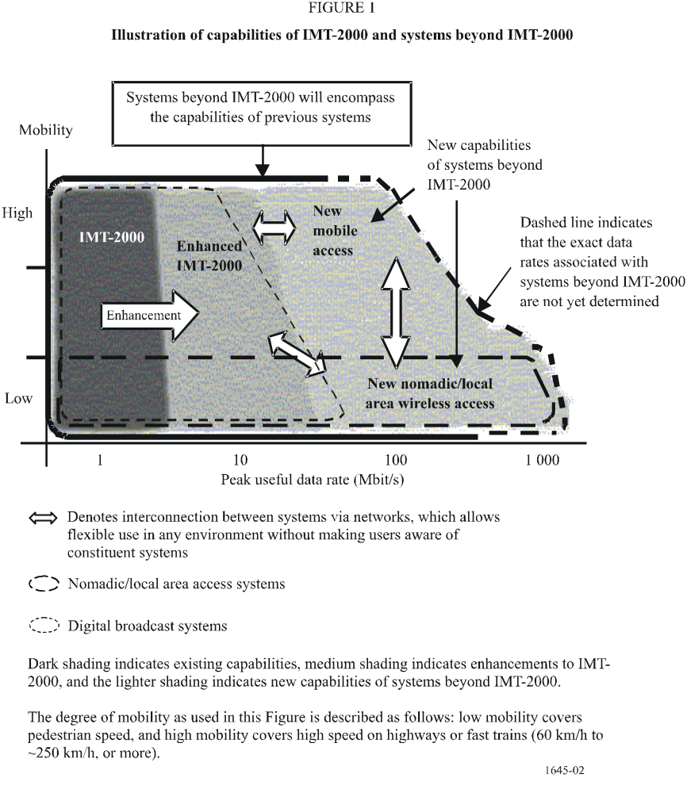
c) that there is a need for a root name to cover the capabilities of “IMT-2000, future development of IMT-2000 and systems beyond IMT-2000”;
d) that the use of “IMT-2000” remains the designation appropriate to describe IMT-2000;
e) that developing a new term to identify the enhancements or future developments of IMT-2000, without any time limitation, would create confusion and is unnecessary;
f) that the new name would benefit from not being time limited or date specific,
recognizing
a) that ITU is the internationally recognized entity that has sole responsibility to define and to recommend the standards and frequency arrangements for IMT systems, with the collaboration of other organizations such as standard development organizations, universities, industry organizations and with partnership projects, forums, consortia and research collaborations;
b) that wireless access technologies that may address some of the capabilities of systems beyond IMT-2000 have been or are being developed for deployment within or prior to the timeframes expressed in Recommendation ITU-R M.1645;
c) that ITU works globally in accordance with Resolution ITU-R 9-2 to create a unified wireless mobile communications future;
d) that ITU may specify its processes and principles for the development of systems beyond IMT-2000;
e) that the detailed specifications of the radio interfaces of International Mobile Telecommunications (IMT-2000) are defined in Recommendation ITU-R M.1457 and that future revisions of this Recommendation will also define the future development of IMT-2000;
f) that Recommendations and Reports will be developed to define the radio interfaces of systems beyond IMT-2000, taking into consideration the framework established in Recommendation ITU-R M.1645, “Framework and overall objectives of the future development of IMT-2000 and systems beyond IMT-2000”,
resolves
1 that the term “IMT-2000” encompasses also its enhancements and future developments1;
2 that the term “IMT-Advanced” be applied to those systems, system components, and related aspects that include new radio interface(s) that support the new capabilities of systems beyond IMT-20002; and
3 that the term “IMT” be the root name that encompasses both IMT-2000 and IMT-Advanced collectively.

____________

* This Resolution should be brought to the attention of ITU-T Study Group 19.
1 The detailed specifications of the IMT-2000 radio interfaces are in Recommendation ITU-R M.1457.
2 As described in Recommendation ITU-R M.1645, systems beyond IMT-2000 will encompass the capabilities of previous systems, and the enhancement and future developments of IMT-2000 that fulfil the criteria in resolves 2 may also be part of IMT-Advanced.

