Process
(Extract from Doc. IMT-ADV-SAT/2(Rev.2))

General
Resolution ITU-R 57 on the “Principles for the process of development of IMT-Advanced” outlines the essential criteria and principles that will be used in the process of developing the Recommendations and Reports for IMT-Advanced, including Recommendation(s) for the radio interface specification.

Detailed procedure
The detailed procedure is illustrated in Figure A2-2 and is described below. Some activities are external to ITU-R and others are internal.
Figure A2-2
IMT-Advanced satellite component radio interface development process
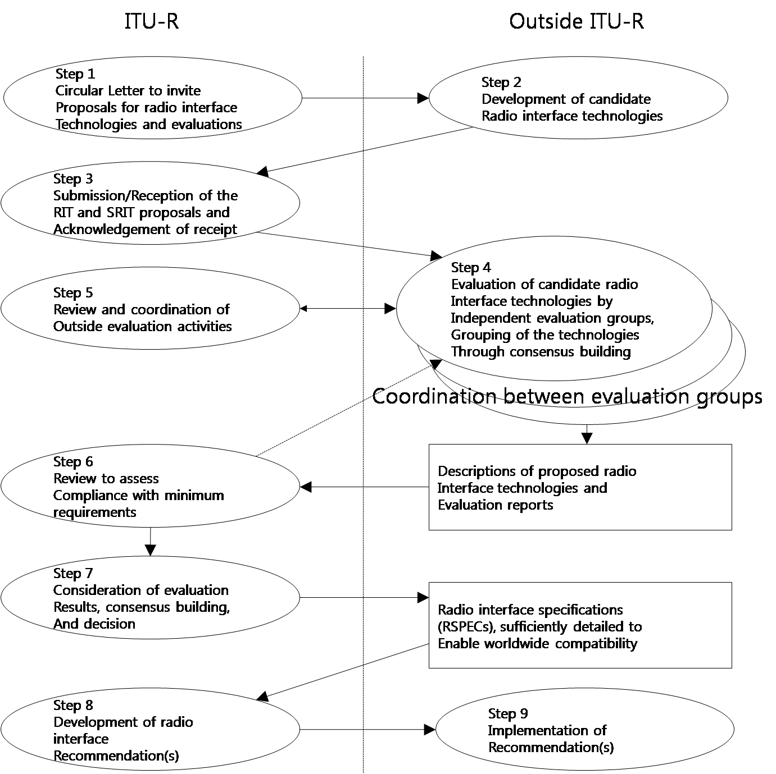

- Step 1 – Circular Letter to invite proposals for radio interface technologies and evaluations
The Radiocommunication Bureau, through Circular Letter 4/LCCE/102 and its Addenda, invites the submission of candidate RITs or SRITs addressing the satellite component of IMT-Advanced.
Circular Letter 4/LCCE/102 and its Addenda also invites subsequent submission of evaluation reports on these candidate RITs or SRITs by any evaluation groups in addition to the initial evaluation report endorsed by the proponent.
Step 2 – Development of candidate RITs or SRITs
In this step, which is typically external to ITU-R, candidate satellite component RITs or SRITs are developed to satisfy a version of the minimum technical requirements and evaluation criteria of IMT-Advanced currently in force (as defined in Resolution ITU-R 57, resolves 6 g)) as described in Report ITU-R M.2176 - Vision and requirements for the satellite radio interface(s) of IMT-Advanced, as announced in Circular Letter 4/LCCE/102 and its Addenda.
An RIT needs to fulfill the minimum requirements for at least one test environment. Furthermore, an SRIT is defined as a number of RITs each individually fulfilling the minimum requirements for at least one test environment and complementing each other.
This can be summarized as:
– an RIT meets the minimum requirements of at least one test environment;
– an RIT may meet the minimum requirements of all required test environments;
– an SRIT meets the minimum requirements of more than one test environment;
– an SRIT may meet the minimum requirements of all required test environments.
Step 3 – Submission/reception of the RIT and SRIT proposals and acknowledgement of receipt
The proponents of RITs or SRITs may be Member States, Sector Members, and Associates of ITU-R Study Group 4, or other organizations in accordance with Resolution ITU-R 9-3.
The submission of each candidate RIT or SRIT must include completed templates (these templates are provided in Report ITU-R M.2176 as announced in Circular Letter 4/LCCE/102 and its Addenda), together with any additional inputs which the proponent may consider relevant to the evaluation. Each proposal must indicate the version of the minimum technical requirements and evaluation criteria of the IMT-Advanced currently in force that it is intended for and make reference to the associated requirements.
The entity that proposes a candidate RIT or SRIT to the ITU-R (the proponent) shall include with it either an initial self-evaluation or the proponent’s endorsement of an initial evaluation submitted by another entity. The submission will not be considered complete without an initial self-evaluation or the proponent’s endorsement of an initial evaluation submitted by another entity.
Proponents and IPR holders should indicate their compliance with the ITU policy on intellectual property rights (see Annex 1 of Resolution ITU-R 1-5), as specified in the Common Patent Policy for ITU-T/ITU-R/ISO/IEC available at http://www.itu.int/ITU-T/dbase/patent/patent-policy.html.
The Radiocommunication Bureau (BR) receives the submission of technical information on the candidate RITs and SRITs and acknowledges its receipt.
Submissions should be addressed to the Counsellor for ITU-R Study Group 4, Mr. Nelson Malaguti (nelson.malaguti@itu.int). These submissions will be prepared as inputs to ITU-R Working Party 4B (WP 4B) and will also be made available on the ITU web page for the IMT-Advanced-Satellite evaluation process (http://www.itu.int/ITU-R/go/rsg4-imt-adv-sat/).
Step 4 – Evaluation of candidate RITs or SRITs by evaluation groups
Candidate RITs or SRITs will be evaluated. The ITU-R membership, standards organizations, and other organizations are invited to proceed with the evaluation. The evaluation groups are kindly requested to submit evaluation reports to the ITU-R. The evaluation reports will be considered in the development of the ITU-R Recommendation(s) describing the radio interface specifications.
The evaluation guidelines, including criteria and test models, are provided in Report ITU-R M.2176 as announced in Circular Letter 4/LCCE/102 and its Addenda.
In this step the candidate RITs or SRITs will be assessed based on Report ITU-R M.2176 as announced in Circular Letter 4/LCCE/102 and its Addenda. If necessary, additional evaluation methodologies may be developed by each independent evaluation group to complement the evaluation guidelines in Report ITU-R M.2176 as announced in Circular Letter 4/LCCE/102 and its Addenda. Any such additional methodology should be shared between evaluation groups and sent to the BR for information to facilitate consideration of the evaluation results by ITU-R.
Coordination between evaluation groups is strongly encouraged to facilitate comparison and consistency of results, to assist ITU-R in developing an understanding of differences in evaluation results achieved by the independent evaluation groups and to form some preliminary consensus on the evaluation results. Consensus building is encouraged, such as grouping and/or syntheses by proponents in order to better meet the requirements of IMT-Advanced.
Each evaluation group will report its conclusions to the ITU-R. Evaluation reports should be addressed to the Counsellor for ITU-R Study Group 4, Mr. Nelson Malaguti (nelson.malaguti@itu.int). The evaluation reports will be prepared as inputs to WP 4B and will also be made available on the ITU web page for the IMT-Advanced evaluation process (http://www.itu.int/ITU-R/go/rsg4-imt-adv-sat/).
The technical requirements and evaluation criteria for IMT-Advanced are subject to reviews which may introduce changes to the technical requirements and evaluation criteria for IMT-Advanced. Proponents may request evaluation against any of the existing versions of the technical requirements and evaluation criteria that are currently in force.
Step 5 – Review and coordination of outside evaluation activities
Working Party 4B will act as the focal point for coordination between the various evaluation groups. In this step, WP 4B monitors the progress of the evaluation activities, and provides appropriate responses to problems or requests for guidance to facilitate consensus building.
Step 6 – Review to assess compliance with minimum requirements
In this step, WP 4B makes an assessment of the proposal as to whether it meets a version of the minimum technical requirements and evaluation criteria of IMT-Advanced currently in force as described in Report ITU-R M.2176 as announced in Circular Letter 4/LCCE/102 and its Addenda.
In this step, the evaluated proposal for an RIT/SRIT is assessed as a qualifying RIT/SRIT, if any one of the following is met:
– an RIT meets the minimum requirements of at least one test environment;
– an RIT may meet the minimum requirements of all required test environments;
– an SRIT meets the minimum requirements of more than one test environment;
– an SRIT may meet the minimum requirements of all required test environments.
Such a qualified RIT/SRIT will go forward for further consideration in Step 7.
According to the decision of the proponents, earlier steps may be revisited to complement, revise, clarify and include possible consensus-building for candidate RITs or SRITs including those that initially do not fulfill the minimum requirements of IMT-Advanced.
Working Party 4B will prepare a document on the activities of this step and assemble the reviewed proposals and relevant documentation. WP 4B will keep the proponents informed of the status of the assessment.
- Such documentation and feedback resulting from this step can facilitate consensus building that might take place external to the ITU-R in support of Step 7.
Step 7 – Consideration of evaluation results, consensus building and decision
In this step WP 4B will consider the evaluation results of those RITs or SRITs that have satisfied the review process in Step 6.
Consensus building is performed with the objective of achieving global harmonization and having the potential for wide industry support for the satellite radio interfaces that are developed for IMT-Advanced. This may include grouping of RITs or modifications to RITs to create SRITs that better meet the objectives of IMT-Advanced.
An RIT or SRIT will be accepted for inclusion in the standardization phase described in Step 8 if, as the result of deliberation by ITU-R, it is determined that the RIT or SRIT meets the requirements of Resolution ITU-R 57, resolves 6 e) and f) for at least the required number of test environments. These requirements are specified in Report ITU-R M.2176.
Step 8 – Development of radio interface Recommendation(s)
In this step a (set of) IMT-Advanced satellite component radio interface Recommendation(s) is developed within the ITU-R on the basis of the results of Step 7, sufficiently detailed to enable worldwide compatibility of operation and equipment, including roaming.
This work may proceed in cooperation with relevant organizations external to ITU in order to complement the work within ITU-R, using the principles set out in Resolution ITU-R 9-3.
Step 9 – Implementation of Recommendation(s)
In this step, activities external to ITU-R include the development of supplementary standards (if appropriate), equipment design and development, testing, field trials, type approval (if appropriate), development of relevant commercial aspects such as roaming agreements, manufacture and deployment of IMT-Advanced infrastructure leading to commercial service.

______________

Provides the confirmation to the sender that the submission was received by the BR and that the submission will be forwarded to WP 4B for subsequent consideration.

