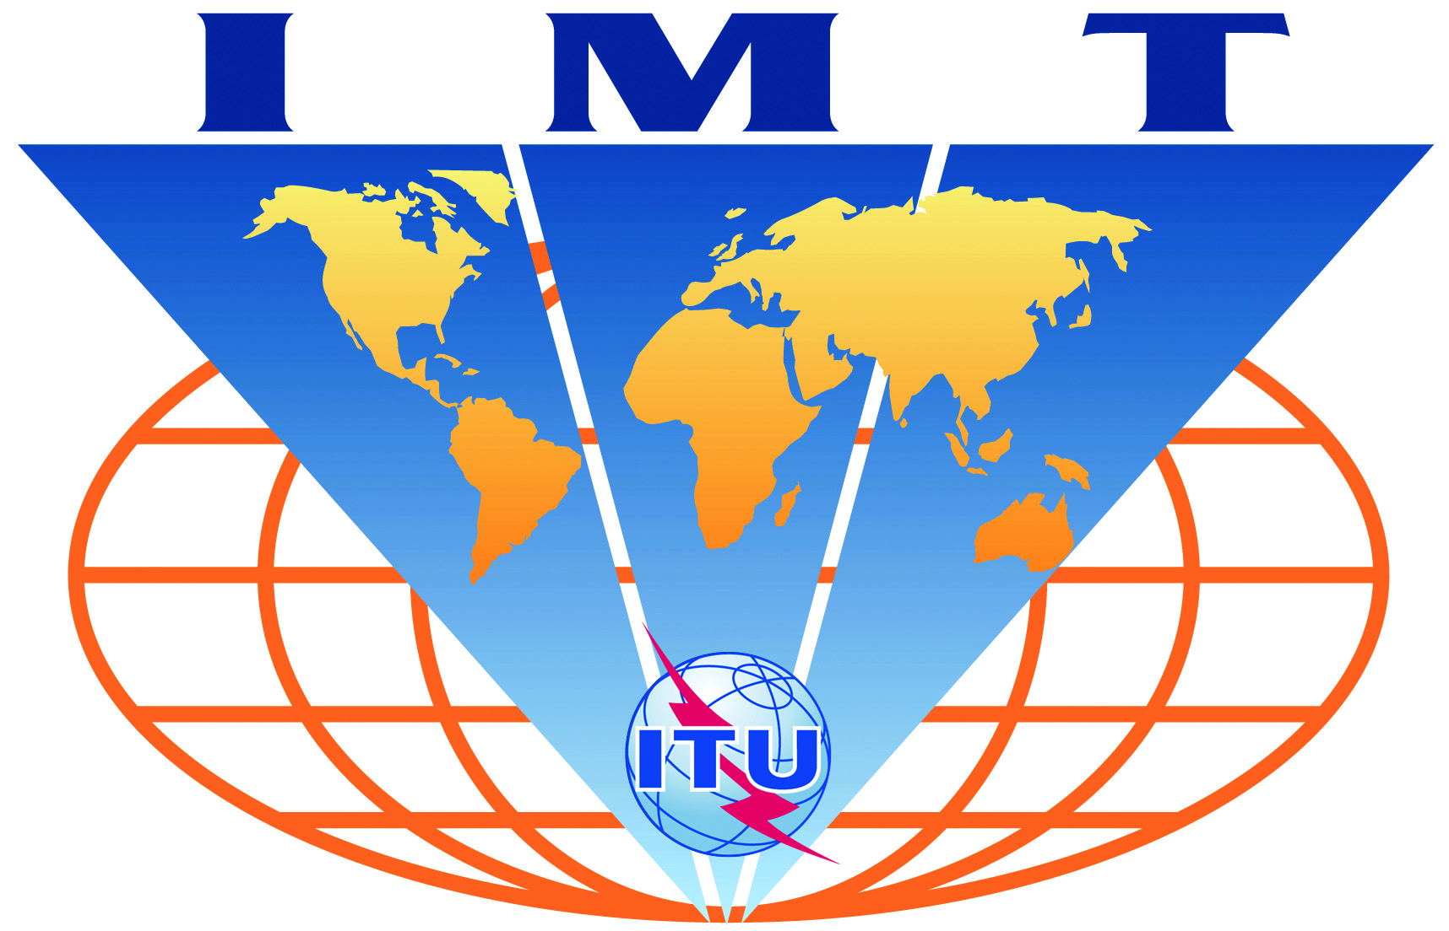

IMT-Advanced
Evaluation Group Registration Form

Name of the Evaluation Group:

WINNER+

Organizations participating in the Group's evaluation activities:

Members of the WINNER+ project consortium

Contact person(s):
- name: Dr. Werner Mohr (Coordinator of WINNER+ project)
- telephone: Office: +49-89-636-75117
Mobile: +49-171-3340 788
- email: werner.mohr@nsn.com
- related web site (if available): http://projects.celtic-initiative.org/winner+/

