Radiocommunication Study Groups
Source: Document 7C/TEMP/275
Subject: WRC-12 Agenda item 1.6
Working Party 7C
Preliminary Sharing StUdy between EESS and
active services in the 275 to 1 000 GHz band

1 Introduction
The document provides information regarding studies of Earth exploration-satellite service (EESS) systems that may operate in the 275 to 3 000 GHz frequency range. These studies were conducted to examine possible interference to the EESS from hypothetical terrestrial active services, both Earth-to-space, and ground-to-ground in the 275 to 1 000 GHz band.

2 Background
The Radio Regulations Edition of 2008 do not include any allocations to radiocommunication services or the radio astronomy service for frequency bands above 275 GHz, but passive service requirement above 275 GHz are addressed through RR No. 5.565 which specifies the frequency bands used by passive services between 275 and 1 000 GHz and urges administrations to take all practicable steps to protect these passive uses of the spectrum.
As far as EESS (passive) requirements are concerned for the 275 to 1 000 GHz frequency range, the frequency bands given in RR No. 5.565 are generally consistent with the “Frequency bands and bandwidths used for satellite passive sensing” specified in Recommendation ITU-R RS.515-4.

3 Primary EESS measurement classes
There are two primary EESS measurement “classes”, namely meteorology/climatology and atmospheric chemistry.
The meteorology/climatology measurements mainly focus around the water vapour and oxygen resonance lines and the associated windows to retrieve necessary physical parameters, such as humidity, pressure, cloud ice and temperature (there is a direct correlation between the temperature and the sub-millimetre emissions from oxygen).
The atmospheric chemistry sensing measures the many smaller spectral lines of the various atmospheric chemical species.
An important difference between the 2 classes is in the geometry of the measurement. Most meteorology/climatology measurements are performed using vertical nadir sounders at lower frequencies (typically below 600 GHz) and limb sounders at higher frequencies whereas atmospheric chemistry measurements are mostly performed using limb sounding across the whole frequency range.
In some cases, apparent redundant coverage (a single molecule is observed in several different bands) is needed for several reasons, such as different bands being sensitive to different altitudes.

3.1 Meteorology/climatology
Figure 1 below shows the sensitivity of millimetre and sub-millimetre frequencies to atmospheric temperature and water vapour variations between 2 and 1 000 GHz. The water vapour and oxygen resonance spectral lines are indicated in the figure as well.
The figure shows the increasing atmospheric attenuation at higher frequencies and the sizable variability of the attenuation due to water vapour.
For this reason the low frequencies (below 200 GHz) are the most suitable for vertical nadir measurements of the lower layers of the atmosphere, while the higher frequencies are better suited for the higher layers of the atmosphere. Above 600 GHz the oxygen lines are only visible over regions with very dry atmosphere. Measurements at these frequencies are therefore typically from limb sounders and, in any case, exclusively for the top atmospheric layers.
Among these bands, it has to be stressed that ranges around the water vapour resonance at 325 and 380 GHz and the oxygen at 424 and 487 GHz are unique in their opacity and high enough in frequency to permit practical antennae to be used at geosynchronous altitudes, yet low enough for technology to provide practical, sensitive instrumentation. Use of the 380 GHz water vapour band helps avoid false alarms over super-dry air masses. Adding channels in the 380 GHz band to operational polar-orbiting satellites allows the retrieval of precipitation over snow-covered mountains and plains and in the driest polar areas where even the most opaque 183 GHz channels become transparent. The only remedy for transparency is a more opaque water vapour band and 380 GHz seems to be a uniquely good choice.
Among oxygen lines, one can also note that the resonance line at 368 GHz is not considered since it is masked by the nearby 380 GHz water vapour resonance line.
Cloud ice and water vapour are two components of the hydrological cycle in the upper troposphere, and both are currently poorly measured. The hydrological cycle is the most important subsystem of the climate system for life on the planet and its understanding is of the utmost importance. The use of passive sub millimetre-wave measurements to retrieve cloud ice water content and ice particle size was suggested years ago by Evans and Stephens (Evans KF, Stephens GL. 1995. Microwave radiative transfer through clouds composed of realistically shaped ice crystals. Part II: Remote sensing of ice clouds. J. Atmos. Sci. 52: 2058–2072) and refined in subsequent publications. Since then, a number of missions have been proposed that focus on this technique to measure cloud ice water path, ice particle size and cloud altitude to US and European space agencies.
Figure 1
The sensitivity of millimetre and sub-millimetre frequencies to atmospheric
temperature and water vapour variations
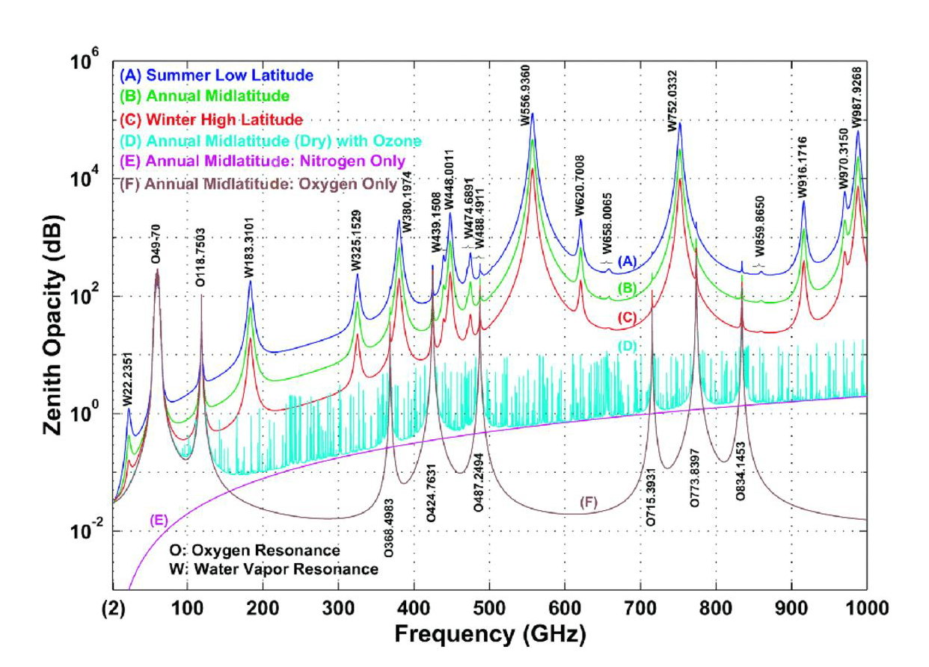
Currently, these measurements focus on the 183 GHz, 243 GHz, 325 GHz, 340 GHz, 380 GHz, 425 GHz, 448 GHz, 664 GHz and 874 GHz. The vertical water vapour and oxygen sounding measurements are typically performed using a set of channels, composed of so-called “wings” and associated “window”.
The “window” corresponds to a frequency range where the effect of the resonance line is minimal. Corresponding measurements are used to determine the component that are not linked to the specific resonance line under investigation and that will then be eliminated from the “wings” measurements.
The vertical sounding measurements along the “wings” of the resonance curve under investigation are performed in frequency slots (with a given bandwidth BW) at symmetrical distance (Offset) from the central resonance frequency. This allows characterizing the resonance curve slope at the various atmospheric heights and providing therefore the water vapour and oxygen vertical profiles.
The measurements on the wings around the main resonance lines are sometimes presented individually, while in other cases the frequency requirement is expressed as the whole range needed to cover all the individual measurements. Indeed, for a given resonance curve, there is not always consistency in the definition of the offsets needed for these wing measurements, depending on the different instruments characteristics (bandwidth, offset and number of slots) or investigation strategies. To cover all cases, the required total frequency band can hence be defined as the maximum bandwidth (BW) plus twice the maximum offset, centred on the resonance frequency.
It should be noted that the frequency band corresponding to the “wings” measurements is not necessarily contiguous to the associated “window”.
The retrieval of atmospheric properties (e.g., ice cloud content, ice cloud altitude, rain rate, rain profiles, etc.) requires the use of simultaneous multiple frequency observations for better accuracy as demonstrated in Jimenez et al. (Performance simulations for a submillimetre wave cloud ice satellite instrument, Q. J. R. Meteorol. Soc , Vol. 133, No. S2, p. 129-149, 2007), Mech et al. (Information content of millimetre observations for hydrometeor properties in mid-latitudes, IEEE Trans. Geosci. Remote Sens., 45, 2287-2299, 2007) or Defer et al. (Development of precipitation retrievals at millimetre and sub-millimetre wavelengths for geostationary satellites, J. Geophys. Res., 113, D08111, doi:10.1029/2007JD008673, 2008).

3.2 Atmospheric chemistry
Atmospheric chemistry measurements are typically made with limb sounders, scanning the atmosphere layers at the horizon as viewed from the satellite orbital position. These measurements relate to a large number of chemical species in the atmosphere and refer to spectral lines that are much narrower and larger in numbers than the water vapour and oxygen resonance lines.

4 Sharing feasibility with active services
In applications between 275 and 1 000 GHz, there can be communications as well as scientific applications. This study examines the geometries of example systems to illustrate the frequency sharing feasibility, between an inter-satellite service (ISS) system and an Earth exploration-satellite service (EESS) system.

4.1 Atmospheric absorption between 275-1 000 GHz
The 275-1 000 GHz frequency range is characterized by windows of transparency interlaced with windows of opacity. Strong absorption peaks exist due to the presence of diatomic oxygen (O₂) and water vapour (H₂O) in the atmosphere. The windows of transparency are in frequency regions between these widely separated peaks. In these bands, atmospheric attenuation is about equal to free space loss.
The 275-1 000 GHz frequency range should be considered as a distinct band from the frequency range above 1 000 GHz regarding propagation. Short range radio systems can be designed with center frequencies in frequency windows of transparency. Such designs can neglect noise contributions due to adjacent band interference (if such adjacent bands exist in absorption peaks). In the 275-1 000 MHz bands, if the frequencies are between absorption peaks, consideration of sharing with other services or systems may be required.
Earth-space link budgets have two loss components: free space loss and atmospheric loss. Free space loss extends over the entire path length between Earth and space. Atmospheric loss occurs mostly within the troposphere. Slant range is a function of elevation angle. The slant range d to the upper reach of the troposphere has been modeled as
d = r_{eff}² sin²(E) + r_{eff} (r_{eff} + r_{T})² - r_{eff} sin(E)
where d is the slant range through the troposphere in kilometers, r_{eff} is the effective earth radius, in kilometers, r_{T} is the nominal height of the troposphere, usually taken as 10 km, and E is the elevation angle. The effective earth radius is 4/3 times the earth radius, which is approximately 8 500 km. The atmospheric loss is equal to the specific attenuation times the slant range.

4.2 Sharing in the 275-1 000 GHz Region
Within Section 3.1, there are several frequencies between 275 and 1 000 GHz that are utilized for measurements, 325 GHz, 340 GHz, 380 GHz, 425 GHz, 448 GHz, 664 GHz, and 874 GHz. These frequencies have been selected for sharing analysis.

4.2.1 Sharing criteria
The sharing criteria with the EESS (passive) is specified in Recommendation ITU-R RS.1029-2. Within this Recommendation, the reference bandwidth, maximum interference level, and the permissible percentage of area or time that the interference level may be exceeded are specified for both nadir and limb instruments. The pertinent data from Recommendation ITU-R RS.1029-2 is presented below in Table 1.

TABLE 1
Selected EESS(passive) interference criteria
Frequency band(s)(1)  (GHz) | Total bandwidth required  (MHz) | Reference bandwidth  (MHz) | Maximum interference level  (dBW) | Percentage of area or time permissible interference level may be exceeded(2)  (%) | Scan mode (N, L)(3)
316-334 | 18 000(4) | 200/3(5) | −158/−194(5) | 0.01/1(5) | N, L
342-349 | 7 000(4) | 200/3(5) | −158/−194(5) | 0.01/1(5) | N, L
371-389 | 18 000(4) | 200 | −158 | 0.01 | N
416-434 | 18 000(4) | 200 | −157 | 0.01 | N
442-444 | 2 000(4) | 200/3(5) | −157/−194(5) | 1 | N, L
659-661 | 2 000 | 3 | −194 | 1 | L
684-692 | 8 000(4) | 3 | −194 | 1 | L
730-732 | 2 000(4) | 3 | −194 | 1 | L
851-853 | 2 000 | 3 | −194 | 1 | L
951-956 | 5 000(5) | 3 | −194 | 1 | L
⁽1) P: Primary allocation, shared only with passive services (No. 5.340 of the Radio Regulations); p: primary allocation, shared with active services; s: secondary allocation.
(2) For a 0.01% level, the measurement area is a square on the Earth of 2 000 000 km2, unless otherwise justified; for a 0.1% level, the measurement area is a square on the Earth of 10 000 000 km2 unless otherwise justified; for a 1% level, the measurement time is 24 h, unless otherwise justified.
(3) N: Nadir, Nadir scan modes concentrate on sounding or viewing the Earth’s surface at angles of nearly perpendicular incidence. The scan terminates at the surface or at various levels in the atmosphere according to the weighting functions. L: Limb, Limb scan modes view the atmosphere “on edge” and terminate in space rather than at the surface, and accordingly are weighted zero at the surface and maximum at the tangent point height.
(4) This bandwidth is occupied by multiple channels.
(5) Second number for microwave Limb sounding applications.

The criteria for 340, 448, 664, and 874 GHz frequencies are not given, but it can be reasonably assumed that the parameters within the 342-349 GHz band’s criteria could apply to 340 GHz and the 442-444 GHz band’s criteria could apply to 448 GHz. And identical interference criteria exists for all bands greater 659 GHz in Recommendation ITU-R RS.1029, so these criteria can be applied to the 664 and 874 GHz frequencies in this study.

4.2.2 System parameters
A typical fixed service system was chosen to examine the atmospheric effects within the 275 to 1 000 GHz range. Assumptions into the operational characteristics were made and included in Table 2.
Table 2
Fixed service assumptions in the 275 GHz to 1 000 GHz range
Maximum transmit power | 20 mW
Receiver noise temperature | 6 000 K
Antenna pointing accuracy | 0.5º
Bandwidth | 1 GHz
C/N Requirement | 10 dB

Based on these assumptions, a fixed service system can be configured. The 3 dB beamwidth can be assumed to be 3 times the antenna pointing accuracy, and from the beamwidth the antenna’s D/λ can be determined. The maximum antenna gain is a function of D/λ. The required carrier to noise ratio, C/N, was set at a typical value of 10 dB in order to give a performance constraint to the FS system.
Using the following equations, maximum and minimum link distances between FS stations can be calculated, and are shown in Table 4.
C/N = P_{T} + G_{T} + G_{R} – L_{FS} – L_{ATM} – N
L_{ATM} = α · d
L_{FS} = 92.44 +20 log₁₀(d) + 20 log₁₀(f)
Where C/N is the required carrier to noise ratio to provide acceptable communications link performance at an acceptable level of bit error rate in dB, P_{T} is the transmit power (dBW), G_{T} is the transmit antenna gain (dBi), G_{R} is the receive antenna gain (dBi), L_{FS} is the free space loss (dB), L_{ATM} is the loss due to atmospheric absorption (dB), N is the receiver noise power (dBW), α is the atmospheric specific attenuation (dB/km) as determined from Figure 1, d is the distance between FS transmitter and receiver (km), and f is frequency (GHz).
Table 3
Fixed service link distances in the 275 GHz to 1 000 GHz range
Frequency  (GHz) | Minimum link distance d_{max} (km) | Maximum link distance d_{min}  (km)
325 | 1.04 | 4.2
340 | 3.4 | 8.2
380 | 0.17 | 1.0
425 | 0.95 | 3.7
448 | 0.16 | 1.14
664 | 0.82 | 2.8
874 | 0.9 | 2.4

None of the distances within Table 3 exceed 8.2 km and most are less than 1 km in length when considering the higher atmospheric absorption rates at each frequency. These distances are much smaller than the altitude of a typical EESS or SRS satellite which typically fly at an altitudes around 700 km.

4.2.3 Sharing analysis

4.2.3.1 EESS and terrestrial systems
Using the link information in Section 4.2.3, the power flux density of such FS transmitters can be calculated at an orbit altitude. Assuming of a typical satellite altitude of 780 km, and FS transmitter pointed at a maximum elevation angle (zenith) a worst case sharing scenario would exist the FS transmitter pointed directly at a satellite at its closest range. The interference power flux density for this scenario is calculated and presented in Table 4, along with the Recommendation ITU-R RS.1029-2 criteria resolved into a 1 Hz reference bandwidth for comparison.
Table 4
FS Interference power flux density at 780 km
Frequency  (GHz) | Maximum permitted interference power flux density  (dBW/Hz) | Calculated interference power flux density  (dBW/Hz)
325 | –241 | –282
340 | –241 | –266
380 | –241 | –464
425 | –240 | –285
448 | –259 | –415
664 | –259 | –289
874 | –259 | –291
Under these circumstances, there are wide margins between the permitted interference power flux density and the maximum calculated the narrowest margin in the frequencies studied is 23 dBW/Hz at 340 GHz.

4.2.3.2 EESS and Earth-to-space systems
Another possible scenario to consider is an Earth-to-space link in the EESS bands specified. A simple static analysis was used to determine the power flux density at an EESS sensor from an earth station. The EESS sensor is orbiting at an altitude of 780 km in a circular orbit. The interferer a station located at the sub-satellite point with a zenith pointing transmitter communicating with another satellite also with an altitude of 780 km.
Several assumptions are made in order to create a possible link for the interferer. The earth station is located at 2 km above mean sea level, shortening the link; and the most favourable of atmospheric conditions are considered. The transmitting antenna gain is 45 dB, and the transmit bandwidth is 100 kHz.
The EESS sensor receiver is also assumed to have a 45 dB gain antenna and have a receiver bandwidth of 1 GHz.
The slant range between the earth station and the satellite is 780 km. Total signal loss is the sum of free space loss plus the atmospheric loss. The atmospheric loss is equal to the specific attenuation times the distance through the earth's atmosphere, which is 10 km. The specific attenuation is frequency dependent and can vary by an order of magnitude due variations in water content in the atmosphere (and other factors). The attenuation is obtained from Figure 1, and the dry air conditions are selected for the most favourable conditions. Table 5 summarizes the results.
Table 5
Earth-to-space uplink sharing with EESS (at 780 km altitude)
Frequency  (GHz) | Specific attenuation (10 km tropopause)  (dB/km) | Transmit power required for link  (W) | Maximum permitted interference power flux density  (dBW/Hz) | Calculated interference power flux density  (dBW/Hz)
325 | 2 | 1x10¹⁴ | –241 | Not calculated
340 | 0.3 | 1 | –241 | –179.1
380 | 20 | 1x10¹⁶⁰ | –241 | Not calculated
425 | 2 | 1x10¹⁴ | –240 | Not calculated
448 | 15 | 1x10¹²⁰ | –259 | Not calculated
664 | 2 | 1x10¹⁵ | –259 | Not calculated
874 | 2 | 1x10¹⁵ | –259 | Not calculated

Due to the high atmospheric attenuation, the amount of power required to achieve a viable link even in the most favourable considerations is extremely high in all but one of the frequencies studied. The power flux density within the main beam of the interfering signal is –179.1 dBW/Hz which exceeds the criteria found in Recommendation ITU-R RS.1029-2 of –241 dBW/Hz. But the interference criteria also considers time and area components. Either a 0.01% level, the measurement area is a square on the Earth of 2 000 000 km²; or 0.1% level, the measurement area is a square on the Earth of 10 000 000 km² unless otherwise justified; or a 1% level, the measurement time is 24 h, unless otherwise justified. Considering the highly dynamic nature of satellites, there is a low probability that the victim and target satellites will be in such close proximity to create this level of interference.

5 Summary
In the 275 to 1 000 GHz band, there are scientific uses that employs the EESS additionally, there is potential for other active services to use this band. Preliminary studies using hypothetical fixed service parameters indicate that sharing between these services is feasible.

“The sensitivity of millimeter and sub-millimeter frequencies to atmospheric temperature and water vapour variations”, Journal of Geophysical Research-Atmospheres, 13, from A.J. Gasiewski and M. Klein.

