Below are examples of the formatting problems that may occur when
documents with revision marks and track changes are edited using Word 2007.
The problems become visual only after the documents have been edited, closed and reopened.
For information the same problems do not occur when using Word 2003 or Word 2010.

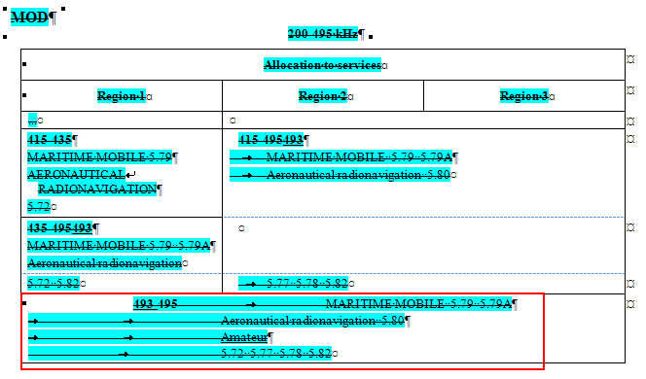

Text moving in tables like this.
(1st line “Center” instead of “Align left”)
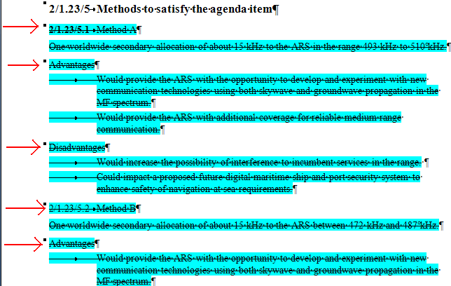
Bold disappearing on headings like this

