|  |  |
| --- | --- |
| **Radiocommunication Study Groups** |  |
|  |  |
|  |  |
| Source: Document 3M/TEMP/43 | **Revision 1 to Document 3M/FAS/6-E** |
| **3 April 2017** |
| **English only** |
| Working Party 3M | |
| FASCICLE | |
| Application, validation and data processing of atmospheric path length standard deviation statistics for ground-based antenna array performance predictions | |

Table of Contents

1 Introduction 2

2 Array loss due to atmospheric turbulence: Derivation 2

3 Validation of assumptions 4

4 Experimental setup and data processing procedure 5

5 Validation of measurements with collocated water vapour radiometers 7

[6 Validation of array loss model with separate interferometer measurements   
on different baselines 9](#_Toc478543532)

[7 Validation of STI phase data with concurrent NASA Deep Space Network   
array phase data of interplanetary spacecraft 10](#_Toc478543533)

8 Example predicted array loss due to atmospheric turbulence statistics 12

9 References 15

# 1 Introduction

This document contains background information and data processing techniques for the application of atmospheric-induced path length statistics provided in Table II-11 in the Recommendation  
ITU-R P.311 Databanks. A preliminary model is provided to compute the average array loss for an antenna array of arbitrary geometry due to fluctuations of water vapour resulting from atmospheric turbulence. This represents the dominant dynamic path length variation component. Validation of the assumptions required for the use of the proposed model, as well as the measurements themselves, are also provided.

The model takes as input, the atmospheric-induced path length variation statistics defined in Table II-11 to derive the array loss factor (in dB) for an arbitrary geometry array at a given elevation angle and operational frequency. The basis of this model is derived from well accepted atmospheric frequency scaling parameters and Kolmogorov turbulence theory.

Section 2 describes the problem statement and provides a proposed procedure for translating path length statistics to array loss factor. Section 3 provides some data to validate the assumptions needed for use of the proposed model. Section 4 describes an example experimental setup and the data processing techniques employed to measure path length turbulence. Section 5 provides validation of the measurement of the site test interferometer with two collocated water vapour radiometers. Section 6 provides validation of the phase statistics scaling procedure via comparison of two separate STIs on two unique baseline separations at the same site. Section 7 provides validation comparisons of the STI phase measurements with those from downlink Deep Space Network array demonstration passes. Section 8 provides estimates of the expected array loss due to the atmospheric path length variations for a 3-element antenna array located at the Goldstone Deep Space Communications Complex (GDSCC). References dealing with these derivations and further validation of the approach are listed in Section 9 of this document.

# 2 Array loss due to atmospheric turbulence: Derivation

For the purposes of (1) generating statistical models, and (2) predicting the performance of communications systems in a widely distributed ground-based antenna array architecture, it becomes necessary to define the impact of path length (phase) turbulence, as induced by the atmosphere, on array combining losses. Atmospheric-induced path length variations are directly correlated with the spatiotemporal variations in tropospheric water vapour that occur along the line of sight path for individual antenna elements comprising an array. Turbulence in the troposphere result in short timescale variations of the refractive index of the atmospheric channel which can be unique to each antenna element and directly impact the array combining efficiency of a   
ground-based antenna array via distortions of the phase front received and transmitted, as indicated in the diagram of Figure 1, for the transmit case.

The *average loss* of an array in the presence of atmospheric turbulence integrated over a finite time interval can be described by a generalized form of the Ruze equation,

$〈G_{loss}〉=\frac{1}{N^{2}}\sum_{m=1}^{N}{\sum_{n=1}^{N}{e^{\frac{{-σ}_{ϕ_{mn}}^{2}}{2}}}}$

where,

$〈G_{loss}〉$ is the average loss of the array due to atmospheric phase turbulence;

$N$ is the number of elements in the array;

$σ_{ϕ_{mn}}^{2}$ is the phase variance (in radians) between elements *m* and *n* in the array.

Figure 1

Distortion of phase front of transmitted wave induced by variation in water vapour content along the line of  
sight path of each element of an antenna array.

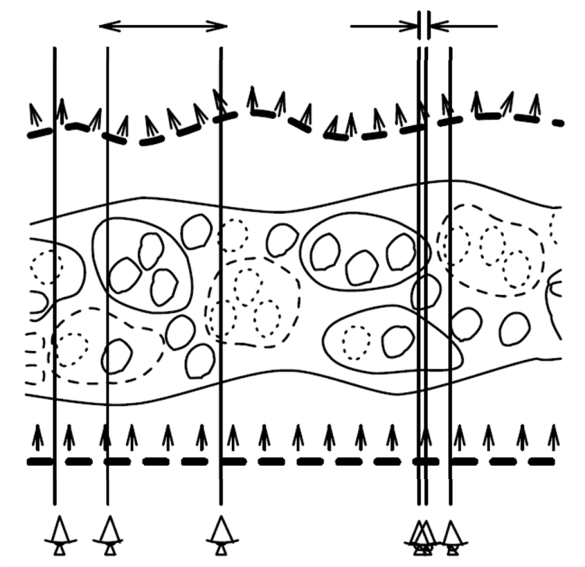

Therefore, the primary parameter of interest for determining array loss in the presence of atmospheric turbulence is the phase variance term, $σ_{mn}^{2}$, which is a function of elevation angle, frequency, and separation distance between antenna elements m and n.

For a given set of measured path length statistics, at a fixed elevation angle and separation distance, the phase variance (in radians) can be scaled to other frequencies, separation distances,  
and elevation angles via,

$σ_{ϕ}^{2}\left(θ,f,r\right)=σ_{l}^{2}(θ_{0},f_{0},r_{0}){\left(2π\frac{f}{c}\right)}^{2}{\left(\frac{r}{r_{0}}\right)}^{β}{\left(\frac{\sin\left(θ_{0}\right)}{\sin\left(θ\right)}\right)}^{γ}×{10}^{-6}$

where,

$σ_{l}^{2}$ is the square of the path length standard deviation provided in Table II-11 of the Recommendation ITU-R P.311 databanks (in mm2);

is the desired frequency and the measurement frequency, respectively (in Hz);

$c$ is the speed of light (m/s);

$θ,θ_{0}$ is the desired elevation angle and the measurement elevation angle, respectively;

$r,r_{0}$ is the desired baseline and the measurement baseline, respectively;

$β$ is the phase structure function exponent (given by Kolmogorov turbulence theory);

$γ$ is an exponent equal to 1 for thick screen approximation and 2 for thin screen.

The linear scaling parameter for the rms phase is due to the fact that the atmosphere can be considered as non-dispersive away from absorption line centres. The exponents $β$ and $γ$ are necessary for scaling of the phase variance term to different baseline separations and elevation angles, respectively, and are dependent on the dimensionality and outer scale of the turbulence process occurring (and hence, the local site climatology). Typical theoretical values for $β$ and $γ$ are given by Kolmogorov turbulence theory, as described in Table 1, and are recommended for general application of the phase statistics table. For baseline separation distances longer than the scale height of the turbulent layer (defined as *H* in Table 1), $β$ approaches a value of unity. In reality,  
the true scaling parameters may lie between these extremes and may possess some seasonal variation for a given site. The inclusion of statistical site-dependent scaling parameters will be investigated in future work.

Table 1

Bounded values of β and γ for scaling of phase variance for array combining loss

|  |  |  |
| --- | --- | --- |
| Parameter | Thick Screen Model (3D Turbulence – warm, humid climates) | Thin Screen Model (2D Turbulence – high altitude, dry climates) |
| β | 5/3 (for *d* < *H*) | 2/3 (for *d* >*H*) |
| γ | 1 | 2 |

# 3 Validation of assumptions

For application of interferometric-measured phase statistics converted to array loss prediction via the Ruze equation, it must be assumed that the phase statistics can be described by a zero-mean Gaussian process. Validation of this assumption is shown in the probability density function (PDF) of measured site test interferometer data at the Venus site located in Goldstone, CA, as shown in Figure 2. For various time scales, it is evident that this assumption holds. Slight deviations of this assumption at the shortest time scales is due to the reduced number of samples available.

Figure 2

PDF's of phase fluctuations for 1 hr (top left, 1), 30 mins (top right, 2), and 10 mins (bottom centre, 6)  
at (a) 02:00 - 03:00 GMT and (b) 12:00 - 13:00 GMT on 9/1/07

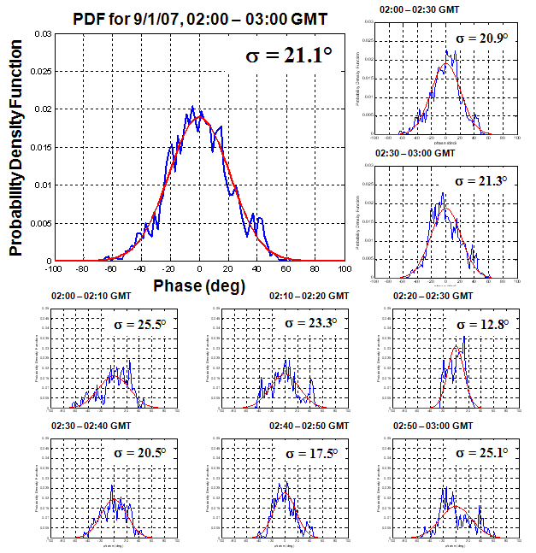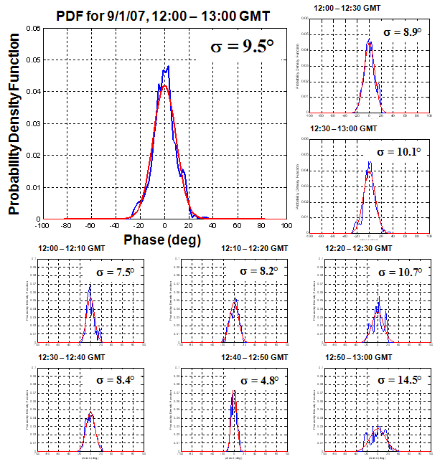

(a) (b)

The plot of Figure 3 shows the comparison between the predicted array loss for a given rms phase and the measured time-averaged array loss for the two-element array at Goldstone, CA, for an entire year. From the plot, we observe excellent agreement between the two curves, indicating the correctness of the theoretical derivation for array loss in the presence of atmospheric-induced phase fluctuations and the justification to utilize differential phase statistics to predict overall array performance for an arbitrary geometry. Deviations from the theoretical curve are likely due to the lack of resolution to effectively determine a normal distribution over the particular time scale.

Figure 3

Measured vs. theoretical array loss for varying rms phase as recorded from May 2007-May 2008   
at Goldstone, CA.

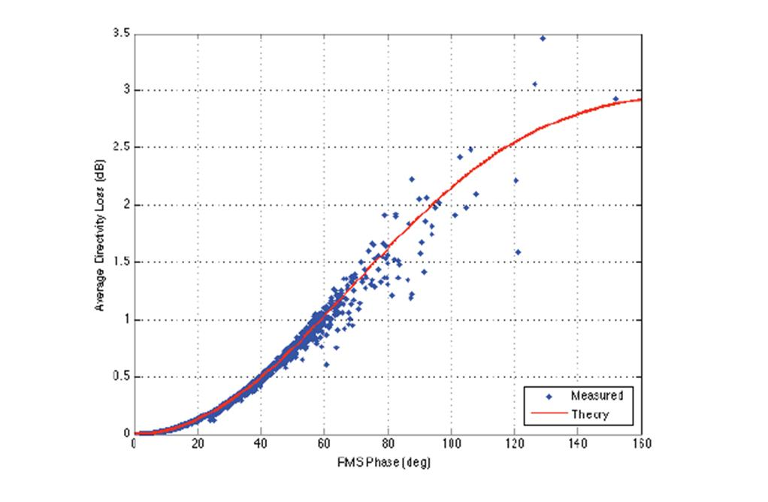

# 4 Experimental setup and data processing procedure

A typical method to measure path length turbulence statistics is through the use of a site test interferometer (STI). An example setup is the STI located at the Venus Site (35.248 °N, 116.791 °W) of the Goldstone Deep Space Network Tracking Complex which is comprised of a two‑element beacon receiver separated on a 256-m E-W baseline and is shown in the photographs of Figure 4. The system utilizes two 1.2-m offset-fed reflector antennas to receive an unmodulated beacon signal broadcast from the geostationary satellite, Anik F2 (longitude 248.9 E), at 20.2 GHz. The receivers perform time-synchronous Fast Fourier Transforms to measure the in-phase and quadrature (I/Q) components of the receive signal every second. From this information, the differential phase, between the two STI elements is derived in post-processing. The noise floor of this system was tested via a zero-baseline test and resulted in a phase (path length) rms noise floor of 1.8° (0.0742 mm ). A detailed description of the STI hardware and receiver operations can be found in [6].

FIGURE 4

Goldstone Venus Site STI layout (left) and close-up of individual receiver element of the STI (right)

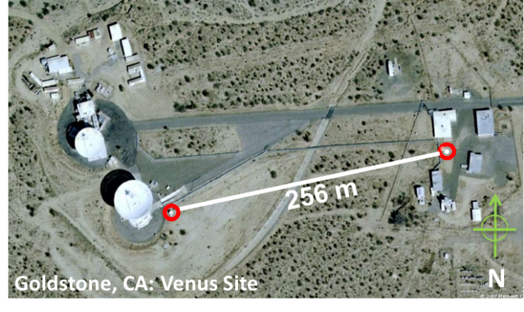 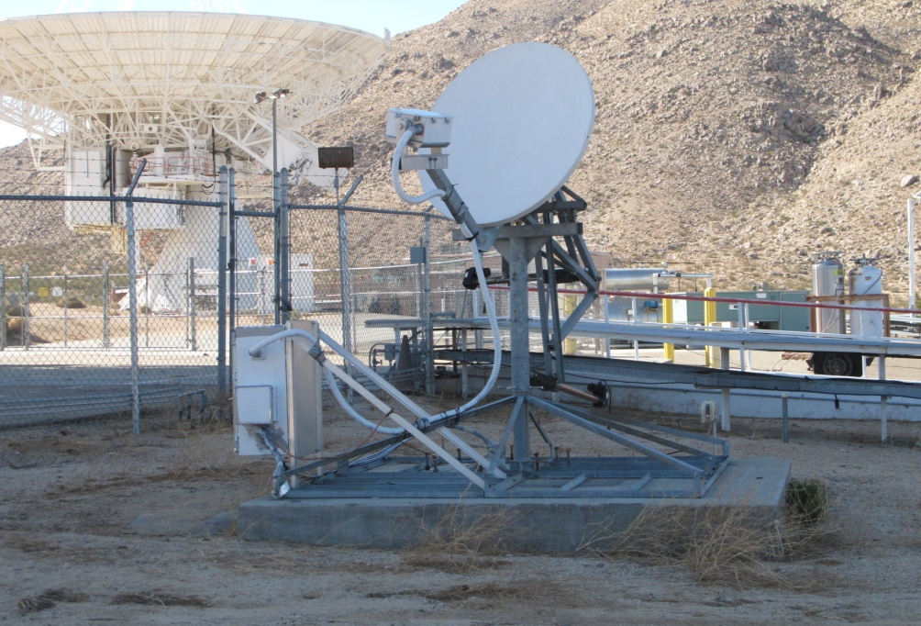

Fundamentally, the measurement of differential phase as recorded by the STI includes the relative motion of the satellite, as well as slow-varying system effects (i.e., thermal variations, instrument drift), which are removed via a second order polynomial fit over 10-min blocks on the unwrapped phase. The calibration process has been validated and shown to have negligible impact in the processed data [7]. Once these effects are removed, only the dynamic variations due solely to the atmosphere remain. Over the 10-min blocks, the standard deviation of the phase variations is calculated. This process is shown pictorially in Figure 5 and described completely in [7-8].

Figure 5

Data calibration procedure

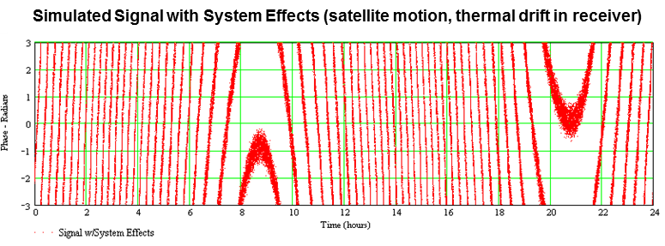

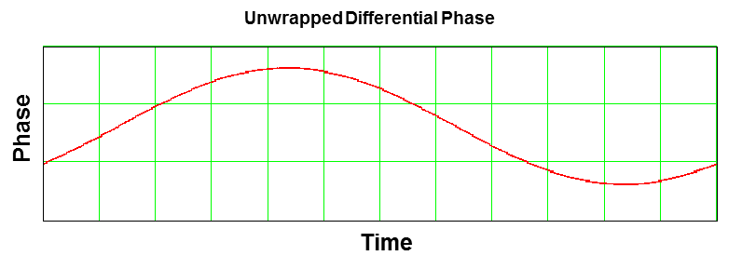

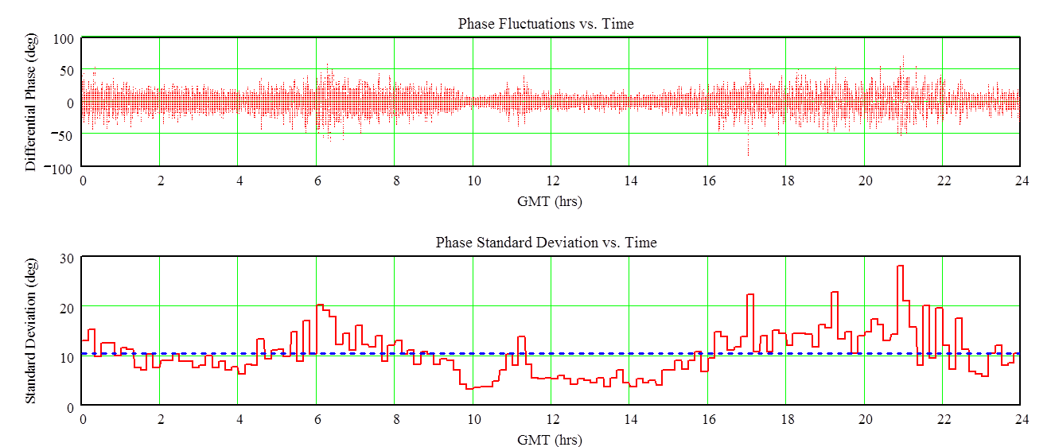

Data is stored locally on a central site computer and bad data blocks are removed in post-processing utilizing the following conditions. For a given 10-min block of data,

– Data is flagged and removed if the rms value over that block is less than or equal to the measured zero-baseline phase rms noise floor.

– Phase rms values greater than 180° are removed

– During routine maintenance activities, data blocks are flagged and removed.

– Blocks in which the individual receiver FFT bins differed from each other were recorded by the receivers are flagged and removed.

# 5 Validation of measurements with collocated water vapour radiometers

In August 2008, two water vapour radiometers (WVRs) were collocated with the two-element site test interferometer (STI) located at the Venus site of the Goldstone Deep Space Communications Complex (GDSCC) described in Section 4. The differenced path delay between the two WVR units forms an additional data type that can be used to validate the STI phase fluctuations and confirm the atmospheric nature of these fluctuations. The use of two WVRs allows estimation of their differenced path delay, which produces a data type that could be correlated directly against the STI phase difference fluctuations. The details of this experiment are more fully described in [9].   
A comparison of the rms temporal delay (which is directly related to the rms path delay) for the differenced WVRs and the STI on the same baseline for the month of August 2008 is shown in Figure 6 and a zoomed-in view for a one week period in August 2008 is shown in Figure 7.

Figure 6

Goldstone Venus STI and DWVR zenith differenced path delay scatter (standard deviation in 1200-s blocks) for August 2008 (thermal noise estimates removed)



Figure 7

Expanded view of STI and DWVR zenith differenced path delay standard deviation (in 1200-s blocks) time series for the selected several-day period of August 17–25, 2008



# 6 Validation of array loss model with separate interferometer measurements on different baselines

Considering that two independent measurements of atmospheric phase turbulence were collected at the Goldstone Deep Space Communications Complex at two different baselines and at two different physical locations, validation of the array loss model can be performed. The data utilized for this comparison are provided in Table II-11 in the Recommendation ITU-R P.311 Databanks.

The Venus STI (described in Section 4) utilizes a 250 m baseline and a measurement frequency of 20.2 GHz, while the Apollo STI has a baseline of 190 m and a measurement frequency of 12.45 GHz. The elevation angles of the two instruments are comparable. Following the scaling procedure of the STI-measured statistics and the array loss model described in this document, we can derive the expected attenuation for the two-element array on a common baseline and common frequency. Figure 8 shows a comparison of the derived monthly cumulative distribution curves for the Apollo and Venus STIs, scaled to 7.15 GHz (DSN operational frequency), 20 degree elevation angle, and 190-m baseline. The comparison of the curves implementing the scaling and array loss models show reasonably good agreement between the two separate STI instruments. Differences in the two curves are hypothesized to be due to differences in the relative altitudes of the two sites, which is not directly considered in the currently proposed phase statistics scaling model. Details of this study as well as description of models used to adjust the STI data can be found in [10].

Figure 8

Monthly comparison of predicted two-element array loss from two STIs in operation at GDSCC scaled to a common 7.15 GHz frequency, 20 deg elevation angle, and 190-m separation distance



# 7 Validation of STI phase data with concurrent NASA Deep Space Network array phase data of interplanetary spacecraft

This section summarizes published results showing good agreement between adjusted STI phase fluctuations (using the models described above) with those obtained from demonstrations of DSN arrays tracking interplanetary spacecraft over a wide range of elevation angles and baseline projections against spacecraft line-of-sight. Between 2012 and 2015, several downlink array demonstrations at 32 GHz Ka-band frequencies were conducted using arrays consisting of pairs of 34-m diameter DSN antennas. These included demonstrations involving the Cassini spacecraft in orbit around Saturn [11] and the Kepler spacecraft in an Earth-trailing heliocentric orbit [12].

The top two plots of Figure 9 display a comparison of the phase residuals from two arrayed 34-m diameter antennas DSS-25 and DSS-26 tracking the Kepler spacecraft (red) with those from adjusted STI phase residuals for two successive 1-h periods on December 27, 2015 [12]. The STI data were processed to extract interferometer phase which were then adjusted to the conditions of the Kepler array in frequency, elevation angle and baseline projection (black) for each data point. We see from the top panel of plots in Figure 9 that the phase excursions of the two instruments are of similar magnitude. As can be seen in the respective plots in the bottom panel, the cumulative distribution of the array phase (red) agrees quite well with that of the adjusted STI phase (black).

Figure 9

The top two plots display the phase residuals from two arrayed 34-m diameter antennas DSS-25 and DSS-26 tracking the Kepler spacecraft (red) and from adjusted STI phase residuals (black) for two successive 1-h periods: 02:00 – 03:00 UTC and 03:00 – 04:00 UTC. The corresponding plots in the bottom panel, display the cumulative distributions of the array phase (red) and the adjusted STI phase (black) [12]

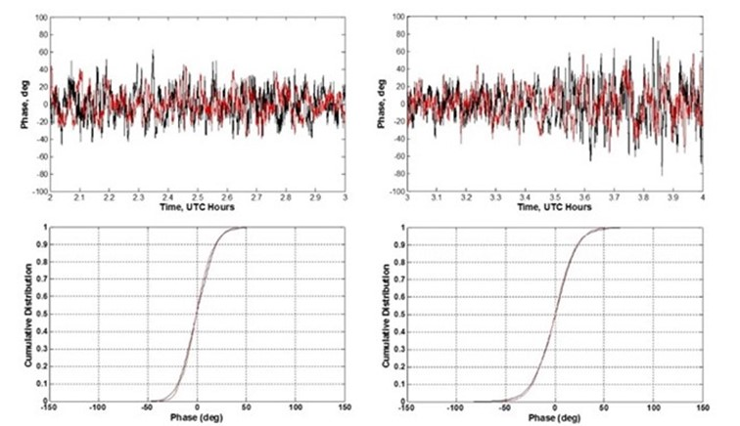

Another array demonstration conducted on December 27, 2015 was performed using two Ka-band downlink capable 34 m antennas DSS-54 and DSS-55 in Madrid, Spain. Figure 10 displays the phase residuals for a 10-minute period for the DSN array (red) and the adjusted STI (black). As one can see, there is a very high degree of correlation between this STI baseline’s adjusted phase time series (black) and the array phase time series (red).

The data were taken from the Madrid STI baseline involving STI elements 2 and 3 which are located very near the DSN antennas DSS-54 and DSS-55, respectively, as can be seen from the aerial image of the site in Figure 11. During this 10-minute period, the line-of-sight of the Kepler spacecraft as viewed by the 54/55 array is only ~1deg from line-of-sight of the geostationary satellite as viewed by the STI. The slow features in Figure 10 match well between the two instruments, and correspond to large-scale irregularities in the turbulent flow moving across the antennas with the wind aloft. The fast features in Figure 10 do not match as well as the slow ones as they correspond to smaller scale irregularities in turbulent flow. The STI antennas, although adjacent to the DSN antennas, are not coincident as they are separated by ~ 21-35-m. When looking in the same direction, the signal paths are parallel but separated by that same distance. The two instruments thus see the same large scale features but different small scale features. The several second delays inferred from the dominant feature in Figure 10 (near time 15.7 h) are consistent with the element separations and the range of wind speeds/directions obtained from the surface meteorological data. The cumulative distribution for each of the two phase time series lie on top of each other.

These array demonstrations provided significant additional evidence that the models used in the adjustments of the STI data are valid, as well as evidence that the phase observations from which the STI statistics are packaged are valid.

Figure 10

Madrid DSS-54 and DSS-55 array phase time series (red) and adjusted STI phase time series (black) for 10-min segment from December 27, 2015 pass occurring between 15:40 and 15:50 UTC [12]

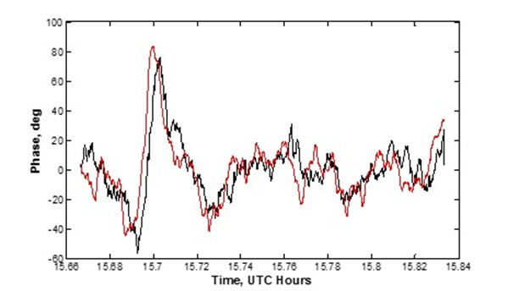

Figure 11

Aerial view of the Madrid tracking site showing the locations of the 34-m diameter antennas DSS-54 and DSS-55 and the locations of the site test interferometer (STI) elements [12]

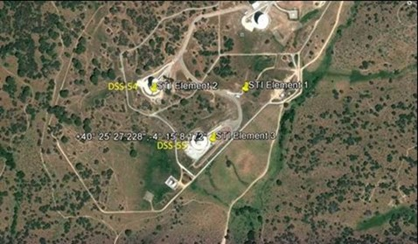

# 8 Example predicted array loss due to atmospheric turbulence statistics

The annual cumulative distribution function (CDF) for the path length rms as measured by the GDSCC Venus site data from Table II-11 is plotted in Figure 12, with the statistics of the mean year, and an example monthly CDF for 2009‑ plotted in Figure 13. We observe that, on a yearly basis, the statistics appear to be very well behaved and agree with expectations based on our knowledge of the physics governing atmospheric turbulence. Furthermore, on a monthly basis, we observe that summer months possess higher path length variability than winter months, which agrees precisely with expectations.

The geometry of the 3-element array at the Goldstone Deep Space Communications Complex is shown in the aerial photograph of Figure 14. Figure 15 shows the predicted array loss employing the proposed array loss model for two specific frequencies as a function of elevation angle for the 3-element array shown in Figure 14.

Figure 12

Plot of annual path length rms CDF for Goldstone, CA

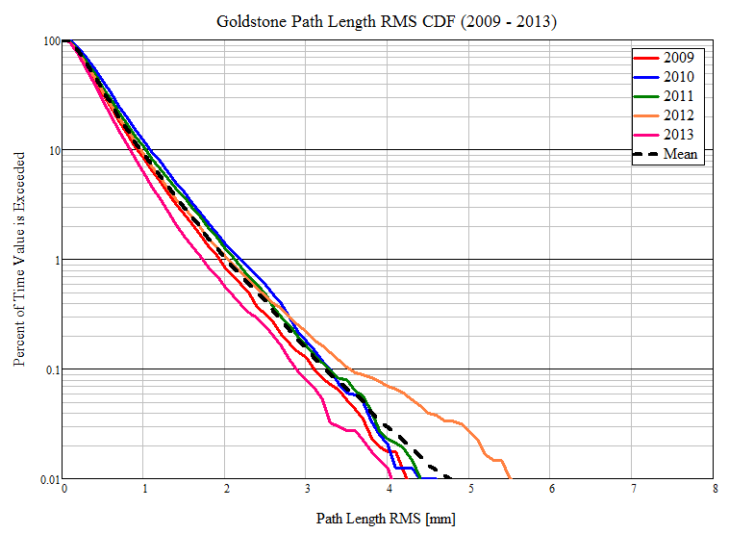

Figure 13

Plot of monthly path length rms CDFs for Goldstone, CA for 2009

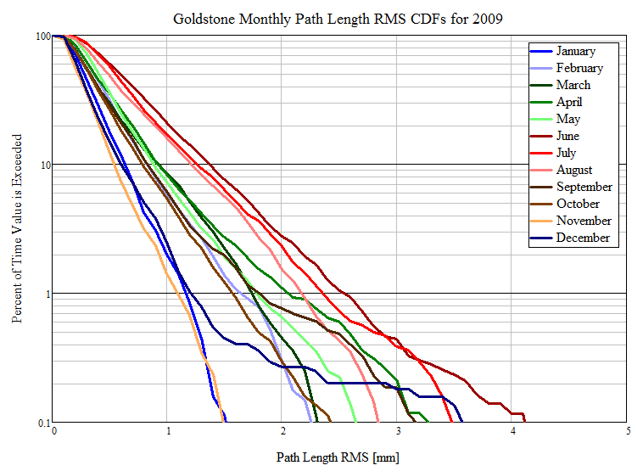

Figure 14

Geometry of the 3-element array at the Goldstone Deep Space Communications Complex

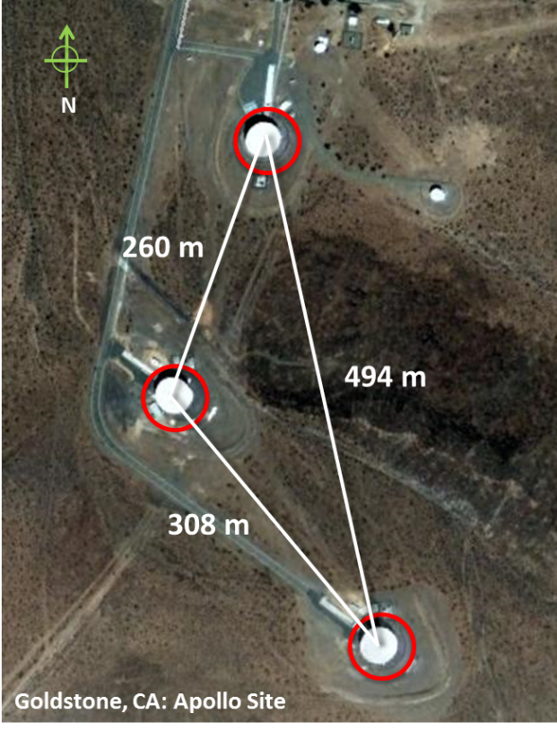

Figure 15

Predicted average array loss as a function of elevation angle for two operational frequencies for 90% (1 mm rms) and 99% (2 mm rms) average annual phase statistics from the Venus STI measured data for  
the 3-element array geometry shown in Figure 14

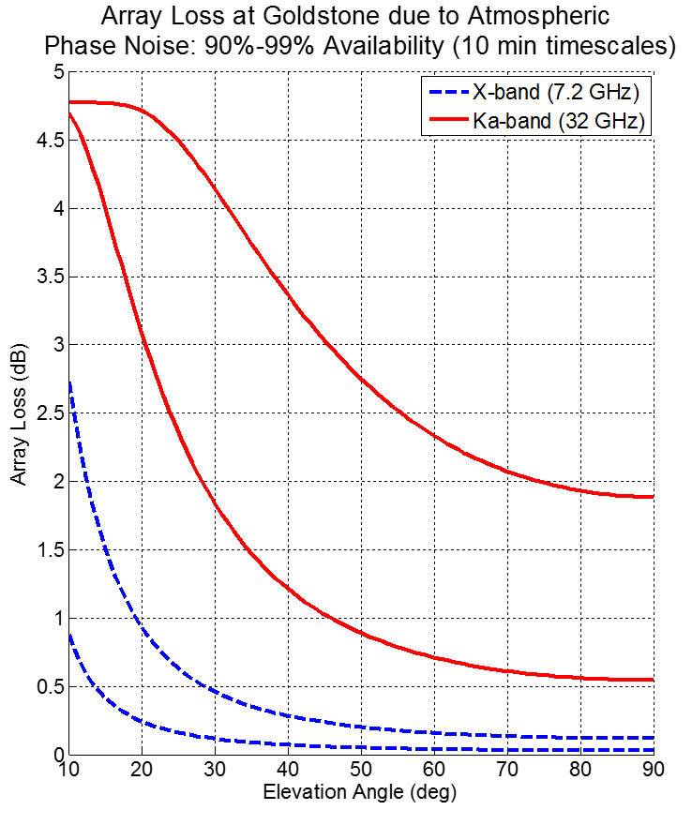

# 9 References

[1] D. Morabito, L. D’Addario, “Atmospheric Array Loss Statistics for the Goldstone and Canberra DSN Sites Derived from Site Test Interferometer Data,” IPN Progress Report 42-196, February 15, 2014.

[2] J. Nessel, R. Acosta, “Predicting Sparse Array Performance from Two-Element Interferometer Data,” IEEE Transactions on Antennas and Propagation, Vol. 60, No. 2, p. 886-894, February 2012.

[3] L. D’Addario, “Combining Loss of a Transmitting Array due to Phase Errors,” IPN Progress Report 42-175, November 15, 2008.

[4] D. Morabito, L. D’Addario, R. Acosta, and J. Nessel, “Goldstone Site Test Interferometer Atmospheric Decorrelation Statistics Use in Spacecraft Link Budgets: First year of STI Data,” Proceedings of 14th Ka and Broadband Communications Conference, Matera, Italy, September 24-26, 2008.

[5] L, D’Addario, “Estimates of Atmosphere-Induced Gain Loss for the Deep Space Network Array,” IPN Progress Report 42-160, February 15, 2005.

[6] R. Acosta, B. Frantz, J. Nessel, D. Morabito, "Goldstone Site Test Interferometer", 13th Ka and Broadband Communications Conference, Turin, Italy, September 24-26, 2007.

[7] J. Nessel, R. Acosta, D. Morabito, “Goldstone Site Test Interferometer Phase Stability Analysis,” 13th Ka and Broadband Communications Conference, Turin, Italy, September 24-26, 2007.

[8] J. Nessel, R. Acosta, D. Morabito, “Phase Fluctuations at Goldstone Derived from  
One-Year Site Testing Interferometer Data,” 14th Ka and Broadband Communications Conference, Matera, Italy, September 24-26, 2008.

[9] D. Morabito, L. D’Addario, S. Keihm, S. Shambayati, “Comparison of Dual Water Vapor Radiometer Differenced Path Delay Fluctuations and Site Test Interferometer Phase Delay Fluctuations Over a Shared 250-Meter Baseline,” IPN Progress   
Report 42-188, February 15. 2012.

[10] D. Morabito, L. R. D'Addario, R. J. Acosta, and J. A. Nessel (2013), Tropospheric delay statistics measured by two site test interferometers at Goldstone, California, Radio Sci., 48, doi:10.1002/2013RS005268.

[11] D. Morabito, L. D’Addario, and S. Finley (2016), A comparison of atmospheric effects on differential phase for a two-element antenna array and nearby site test interferometer, Radio Sci., 51, doi:10.1002/2015RS005763.

[12] D. Morabito, L. D’Addario, and S. Finley, “Comparison of Atmospheric Delay Statistics from Deep Space Network Arrays and nearby Site Test Interferometers”, Proceedings of 22nd Ka- and Broadband Conference, Cleveland, Ohio, October  
17-20, 2016.

______________