|  |  |  |  |
| --- | --- | --- | --- |
|  | **Radiocommunication Study Groups** | |  |
| **INTERNATIONAL TELECOMMUNICATION UNION** | |  | |
|  | |  | |
| Source: Document 3J/TEMP/23  Subject: Fascicle on Rec. ITU-R P.840-6 | | **Document 3J/FAS/6-E** | |
| **4 July 2016** | |
| **English only** | |
| Working Party 3J | | | |
| fascicle | | | |
| STATISTICAL DISTRIBUTIONS OF REDUCED INTEGRATED CLOUD LIQUID WATER AND PREDICTION OF THE ASSOCIATED ATTENUATION (RECommendation ITU-R P.840-6) | | | |

Scope

This document provides reference information on the methods in Recommendation ITU-R P.840-6 used to predict statistical distributions of reduced integrated liquid water included and on a proposed update of the cloud attenuation prediction method currently included in Recommendation ITU-R P.840-6.

Table of Contents

Part 1: Statistical distributions of reduced integrated liquid water (P.840-6) 3

1 Introduction 3

2 Review of NWP products and ITU-R recommendations 3

3 New maps derived from the ERA-40 product 5

3.1 Reduced cloud liquid columnar content 5

4 Validation of ERA-40 derived maps using RAOBS data 6

5 Accuracy assessment of the ERA 40 data using ground measurements 8

5.1 Comparison between ERA-40 and radiometric retrievals 9

6 Probabilistic modelling for ERA-40 cloud maps 10

7 Acknowledgments 12

8 References 13

Part 2: Proposed update for the cloud attenuation prediction method in P.840-6 16

1 Introduction 16

2 Calculation of cloud attenuation 16

2.1 Exact methodology 16

2.2 Approximate solution 17

2.3 Alternative approximate approach 18

3 Performance assessment 21

4 Acknowledgments 22

5 References 22

Part 1

Statistical distributions of reduced integrated liquid water (Recommendation ITU-R P.840-6)

# 1 Introduction

The accuracy of modelling of propagation effects due to atmospheric components depends on the accuracy, the resolution (both statistical and spatial) and the statistical range of applicability of the radio-climatological input parameters, in particular with regard to water vapour, clouds and rain.

Study Group 3 activities put in evidence that the maps derived from long-term global re‑analysis products of Numerical Weather Prediction (NWP) systems, provide an improvement of prediction models accuracy, with particular regard to the atmospheric attenuation for radio systems operating at millimetric wavelengths. Hence ITU-R Recommendations initiated to provide NWP derived maps since 1998 [1].

At the same time, the NWP systems experienced a fast evolution in terms of period of observation, spatial resolution and quality products, as an effect of an increasing number of Earth Observation systems, better atmospheric models and the adoption improved assimilation and forecast numerical techniques. As a result, new re-analysis products characterized by a longer observation period, higher spatial resolution and increased accuracy of meteorological quantities, have been made available to the scientific community (e.g. ECMWF ERA-15 [2] and ERA-40 [3]).

WP 3J activities also benefited from this trend and in 2007 Recommendation ITU-R P.837-5 was updated to include maps of rain parameters derived from the ECMWF ERA-40 product [4]. SG 3 also recommended to participants to pursue the analysis of NWP products also for water vapour and cloud attenuation.

This document describes the new statistical maps for reduced cloud liquid water content derived from the ECMWF ReAnalysis project ERA-40, in response to the SG 3 work plan. The validation of the new maps has been performed using radiosonde observations from a selected number of stations distributed worldwide.

Measurements of integrated cloud liquid water content using ground based radiometers confirms the improvement of accuracy provided by the ERA-40 derived maps.

The results and the discussion contained in this document provide the background and the rationale for the modification of the Recommendations ITU-R P.840-3.

This document is divided into the following chapters:

• Review of NWP products and ITU-R recommendations

• New maps derived from the ERA-40 product

• Validation of ERA-40 derived maps using RAOBS data

• Accuracy assessment of the ERA 40 data using ground measurements

• Probabilistic modelling for ERA-40 Cloud Maps

• Conclusions.

# 2 Review of NWP products and ITU-R recommendations

In this chapter a brief introduction on the use of NWP products in ITU-R SG 3 activities is given. An introduction on general use of meteorological, NWP and experimental data for propagation modelling can be found in [4].

NWP systems generate weather spatial fields at regular interval of times by means of two separate analysis and forecast processes (see Fig. 1 from [1]).

Figure 1

Example of NWP data assimilation using a 6 hour cycles

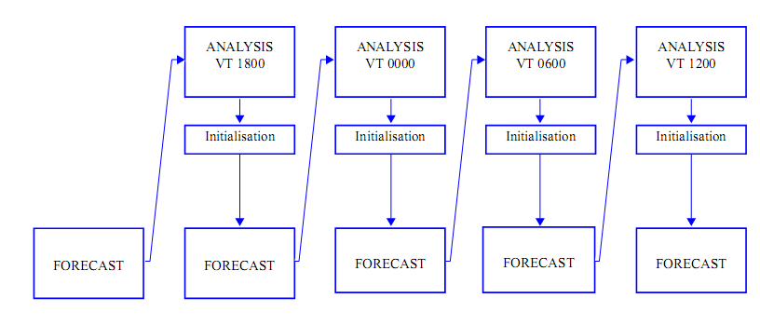

The analysis process assimilates observations (e.g. from radiosonde or satellite observations of the earth) and previous forecast data into a numerical atmospheric model using 3D/4D-Var techniques [6] to produce an estimate of the state of the atmosphere on a regular 3 dimensional grid and fixed intervals of time. The output parameters of this process are also characterized by the reduction of the original instrumental biases at the cost of a reduced spatial and temporal resolution.

Therefore analysis products are intended to provide the best estimate of the atmospheric model even if they can be characterized by issues like the degradation of accuracy results along the land and sea separation.

NWP systems can be distinguished between operational and re-analysis activities. In NWP operational systems improved processes for assimilation, modelling and spatial resolution are regularly introduced to increase of accuracy fields but at the cost of having temporal discontinuities into spatial fields. Therefore re-analysis products, in which all the observations over collected over a long-period (i.e. more than 10 years) are reprocessed using consistent analysis, are usually preferred over operational data for climatological analyses.

Atmospheric profiles of air total pressure, specific humidity and air temperature (*P*, *q* and *T*) are generated by the assimilation process, while parameters related to precipitation are generated by the forecast process. The cloud vertical profile of cloud water can be estimated from the atmospheric profiles of *P*, *q* and *T* using a cloud detection algorithm [7], commonly used also with radiosonde observations. Thanks to the assimilation process the NWP atmospheric vertical profiles of *P*, *q* and *T* are applicablealso in presence of atmospheric precipitationbutthe validity of the used cloud detection algorithm in rainy conditions remains to be verified.

The maps provided by Recommendation ITU-R P.840-3 have been derived from two years (the NA4 ECMWF dataset covering 1992-1993) of initialization data of the numerical weather forecast of the European Centre for Medium-range Weather Forecast (ECMWF). After the NA4 dataset, ECMWF produced two additional complete re‑analyses products, the ERA15 [1] and the ERA-40 [2]. ECMWF used for every new product new assimilation and forecast procedures and increased the number of input observations, the observation period and the horizontal and vertical resolution of global weather fields. The precipitation data of the ERA-40 project have been already used to generate the rainfall map currently described in Recommendation ITU‑R P.837-5.

Each product is characterized by its specific accuracy and characteristics, e.g. the land/sea mask, the topography of ground reference levels etc. It is therefore advisable to use for propagation prediction models like the ones described in Recommendation ITU‑R P.618-12, coherent set of input climatological maps, in particular for atmospheric precipitation, water vapour content and cloud liquid content.

The characteristics of the ERA-40 dataset used for the maps presented in this document are described in Table 1.

Table 1

Main characteristics of NA4, ERA15 and ERA-40 ECMWF   
products used for ITU-R SG 3 activities

|  |  |  |  |
| --- | --- | --- | --- |
|  | NA4 | ERA15 | ERA-40 |
| Period of Observations | 1992-1994 | 1978-1992 | 1959-2001 (Precip Forec) |
| 1985-2000  (P,q,T) Analysis |
| Horizontal Resolution (lat long) (deg) | 1.5 × 1.5 | 1.5 × 1.5 | 1.125 × 1.125 |
| Number of  model vertical levels | 23 | 31 | 47 |

# 3 New maps derived from the ERA-40 product

## 3.1 Reduced cloud liquid columnar content

The maps of the values of the normalized total columnar content of cloud liquid water, *Lred*  (kg/m2), or (mm), have been calculated for the following exceedance percentages of the year : 0.1, 0.2, 0.3, 0.5, 1, 2, 3, 5, 10, 20, 30, 50, 60, 70, 80, 90, 95 and 99%, derived from ERA-40.

Cloud vertical profiles have estimated using the same Salonnen-Uppal cloud detection algorithm. The algorithm is described in Annex 2.

The spatial distribution of difference and relative difference of ERA-40 reduced cloud liquid columnar content with respect to Recommendation ITU-R P.840-3 for 1% of the annual time are given in Figure 2 and Figure 3, respectively.

Figure 2

Difference between ERA-40 and Recommendation ITU-R P.840-3 reduced   
cloud liquid columnar content at 1% of the year

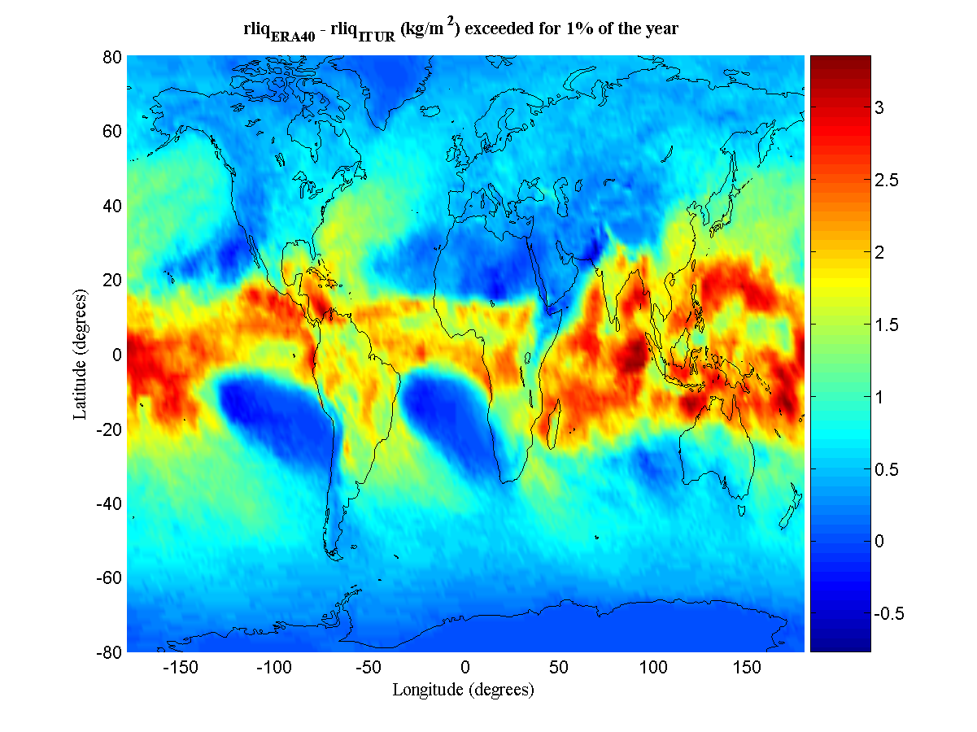

Figure 3

Relative difference between ERA-40 and Recommendation ITU-R P.840-3   
reduced cloud liquid columnar content at 1% of the year

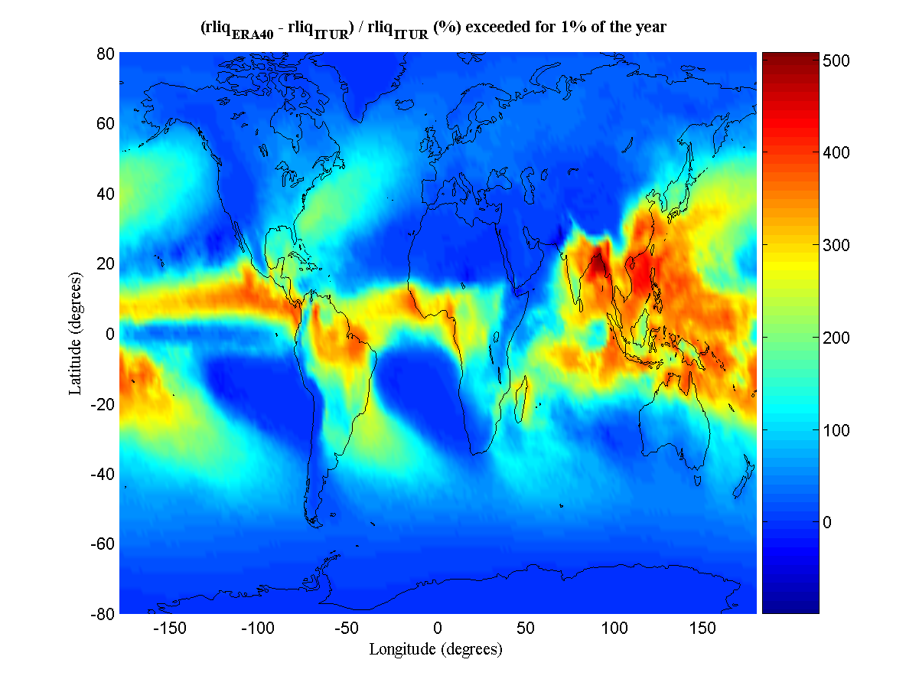

# 4 Validation of ERA-40 derived maps using RAOBS data

The validation of the new maps derived from ERA-40 has been performed by using a dataset of radiosonde observations (RAOBS) performed in 24 stations. Those stations are a subset of the ESA RAOBS FERAS database covering the world for an observation period of 10 years starting from 1980. The FERAS database includes both ground and upper air meteorological. The validation stations, listed in Annex 1, have been selected according to data availability and quality selection criteria. The station number reported in Annex 1 is used as station reference in the abscissa of the following diagrams. Cloud liquid profiles from RAOBS observations have been estimated using the Salonen-Uppala cloud detection algorithm (see Annex 2).

The mean and rms of the difference between Recommendation ITU‑R P.840-3, ERA-15 data (previously distributed in SG 3), ERA-40 and FERAS data are given in Figures 4 and 5.

It is to be noted that Recommendation ITU‑R P.840-3 contains values to normalized 0 °C and are plotted only for validation purposes. Nevertheless, differences between normalized and not-normalized values are usually small.

Figure 4

Mean value of the difference between FERAS RAOBS data and ERA-40, ERA15   
and Recommendation ITU-R P.840-3 values of total of integrated cloud water content

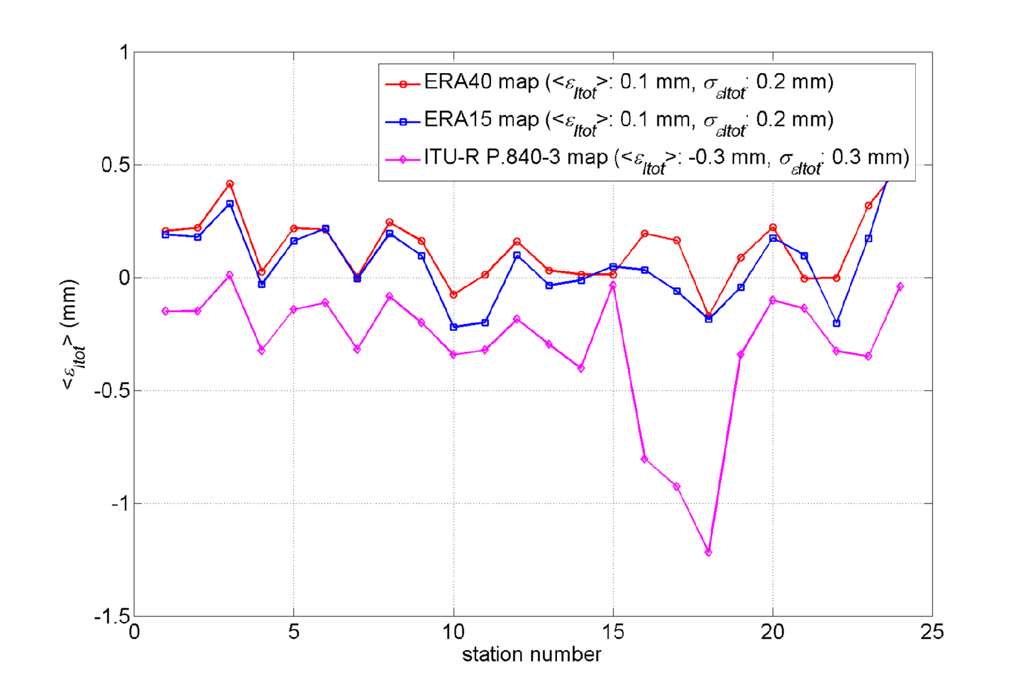

Figure 5

rms value of the difference between FERAS RAOBS data and ERA-40, ERA15 and   
Recommendation ITU-R P.840-3 values of integrated cloud water content

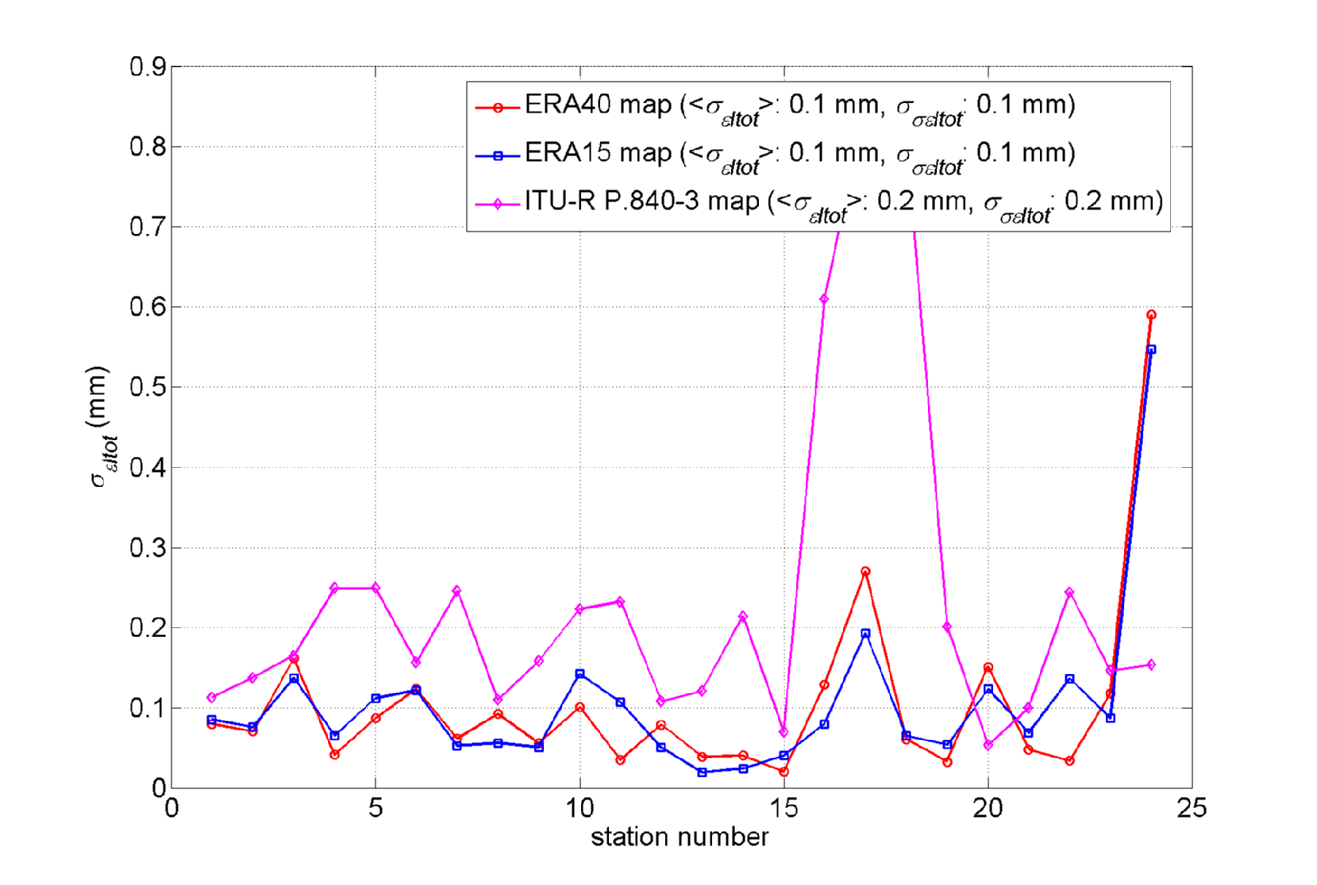

# 5 Accuracy assessment of the ERA 40 data using ground measurements

The testing of ERA-40-derived maps of *Vtot* and *Lred* has been conducted with data collected at Spino d’Adda (latitude 45.4°N, longitude 9.5°E, altitude a.m.s. l.84 m). The ground station located at Spino d'Adda received since 1993 the signals of the three ITALSAT beacons (at 18.7, 39.6 and 49.5 GHz) with an offset of 3.5 m diameter antenna equipped with de-icing and tracking systems. These signals were coherently detected, sampled at the rate of 1 Hz, stored, edited and analysed off‑line by the Centro di Studio sulle Telecomunicazioni Spaziali (CSTS-CNR) at Politecnico di Milano. The station was equipped since 1994 with a set of noise injection radiometers at 13.0 GHz, 23.8 GHz and 31.65 GHz to evaluate liquid water and water vapour atmospheric content. A set of traditional meteorological instruments (thermometer, hygrometer, barometer and tipping bucket rain gauge) was also available.

Data from different sources have been exploited. Specifically:

• FERAS (FUB-ESA Radiosonde, being FUB the acronym for Fondazione Ugo Bordoni) radiosoundings provided by the European Space Agency (ESA), which have been derived from a NCAR (National Center for Atmospheric Research) database: vertical profiles of pressure, temperature and relative humidity, collected routinely twice a day (0 and 12 Coordinated Universal Time UTC) for ten years (1980-1989) in non rainy condition at Milano/Linate airport (45.26° N; 9.17° E, 122 m amsl), which is 20 kilometres West of Milano/Linate. The complete FERAS database can be found in Rec. ITU-R P.835-4.

• radiometric measurements: 1-s sampled brightness temperatures collected at Spino d’Adda in the period 1992-2001 by a dual-channel radiometer (23.8 GHz and 31.6 GHz, 37.7° elevation angle) manufactured by Elecktronic Centralen. The instrument was calibrated weekly with the tip curve procedure [2] and once a year with a cold reference load [3]. The radiometric resolution is about 0.1 K and the radiometric precision is estimated to be lower than 2 K. This corresponds to a precision of radiometric retrieval of about 0.1 mm and 3 mm for cloud liquid and total vapour content, respectively.

## 5.1 Comparison between ERA-40 and radiometric retrievals

FERAS RAOBS were assumed as the reference data set for characterizing the non-precipitating atmosphere in the Milan area. Vertical profiles of pressure, temperature and relative humidity were used as input to the Liebe MPM93 [5] mass absorption models in order to calculate the specific attenuation at each altitude layer consequently, the total path attenuation due to gases and clouds through simple linear integration along the vertical profile. The Salonen-Uppala cloud detection algorithm has been used to estimate cloud vertical profiles from RAOBS observations. The profiles of atmospheric specific attenuation were used together with the radiative transfer model (in non-scattering conditions) to simulate sky brightness temperatures at radiometric frequencies and then to derive radiometric retrieval coefficients for cloud attenuation, *AC*, and columnar cloud liquid content, *Ltot*. As well, cloud mass absorption coefficients for the radiometric channels have been calculated and are provided for reference in Table 2.

Table 2

Oxygen attenuation and mass absorption   
coefficients zenithal path

|  |  |  |
| --- | --- | --- |
|  | Radiom. Channel | |
| 23.8 GHz | 31.6 GHz |
| *aL* (dB/mm) | 0.536 | 0.898 |

Figure 6 shows a comparison between the statistical distribution of *L*tot: the black curve with circles is obtained from FERAS RAOBS, while the blue and red curves are obtained from ERA-40 map and from Recommendation ITU-R P.840-6, respectively. It is to be noted that *L*tot is the total content of water in the clouds and is different from the cloud liquid water content reduced to the temperature of 0 °C provided by Rec. ITU-R P.840-3. For comparison in Figure 6, the distribution of *L*red for ERA-40, ERA15 are also plotted. It is to be recalled that the only experimental measurement of cloud liquid content is done by the ground microwave radiometer, whereas both radiosonde (FERAS) or NWP (ERA15 or ER40) estimates are performed using a cloud detection algorithm. It is clear from the comparison that the most accurate prediction is provided by ERA-40 data, which is in agreement with radiometric data within the estimated retrieval precision.

Figure 6

Statistical Distribution of *L*tot (continuous line) and *L*red (dashed line) derived from radiometric   
measurements (black curve), FERAS RAOBS (black solid curve with circles, *Ltot*), ERA-40 (blue curve), Recommendation ITU-R P.840‑3 (red dashed curve, only *L*red) and ERA15 (green dashed curve, only *L*red)



# 6 Probabilistic modelling for ERA-40 cloud maps

The development of channel models for total atmospheric attenuation (e.g. synthetic time series generators) requires a probabilistic model for the statistical model distribution of the climatological parameter. Such a model can be derived by regression analysis of NWP tables like the ERA-40 maps discussed in this document. It has to be stressed that the probabilistic modelling constitutes actually an additional processing step, in addition to the one originally performed by the NWP system on the actual observations. As such, it can increase the final error of the prediction with respect to the local distribution.

The statistical distribution of the reduced cloud water columnar content can be described by a combination of a Dirac with a log-normal distribution [8].

 (1)

Therefore, the reduced cloud water columnar content is:

 (2)

where: 

The coefficients of the distribution model of Equation 1, *P*(*L*> *0*), ** and ** derived by least square analysis of ERA-40 data are provided in Figure 7, Figure 8 and Figure 9.

FIGURE 7

Spatial distribution of the probability of liquid water cloud   
derived from ERA-40 maps

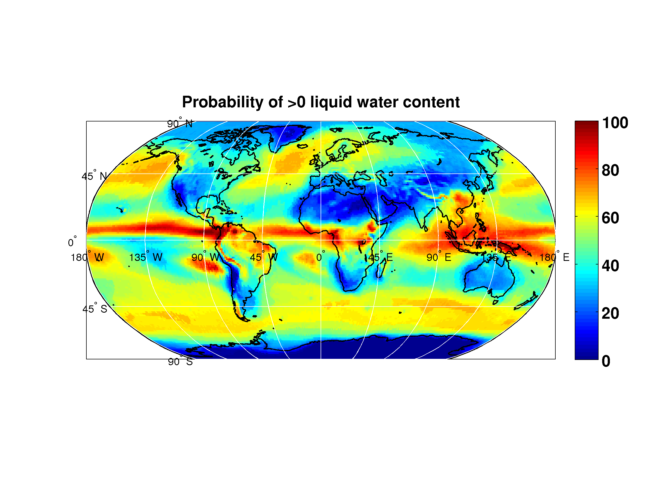

Figure 8

Spatial distribution of the ** parameter of the model for reduced cloud   
liquid distribution derived from ERA-40 maps

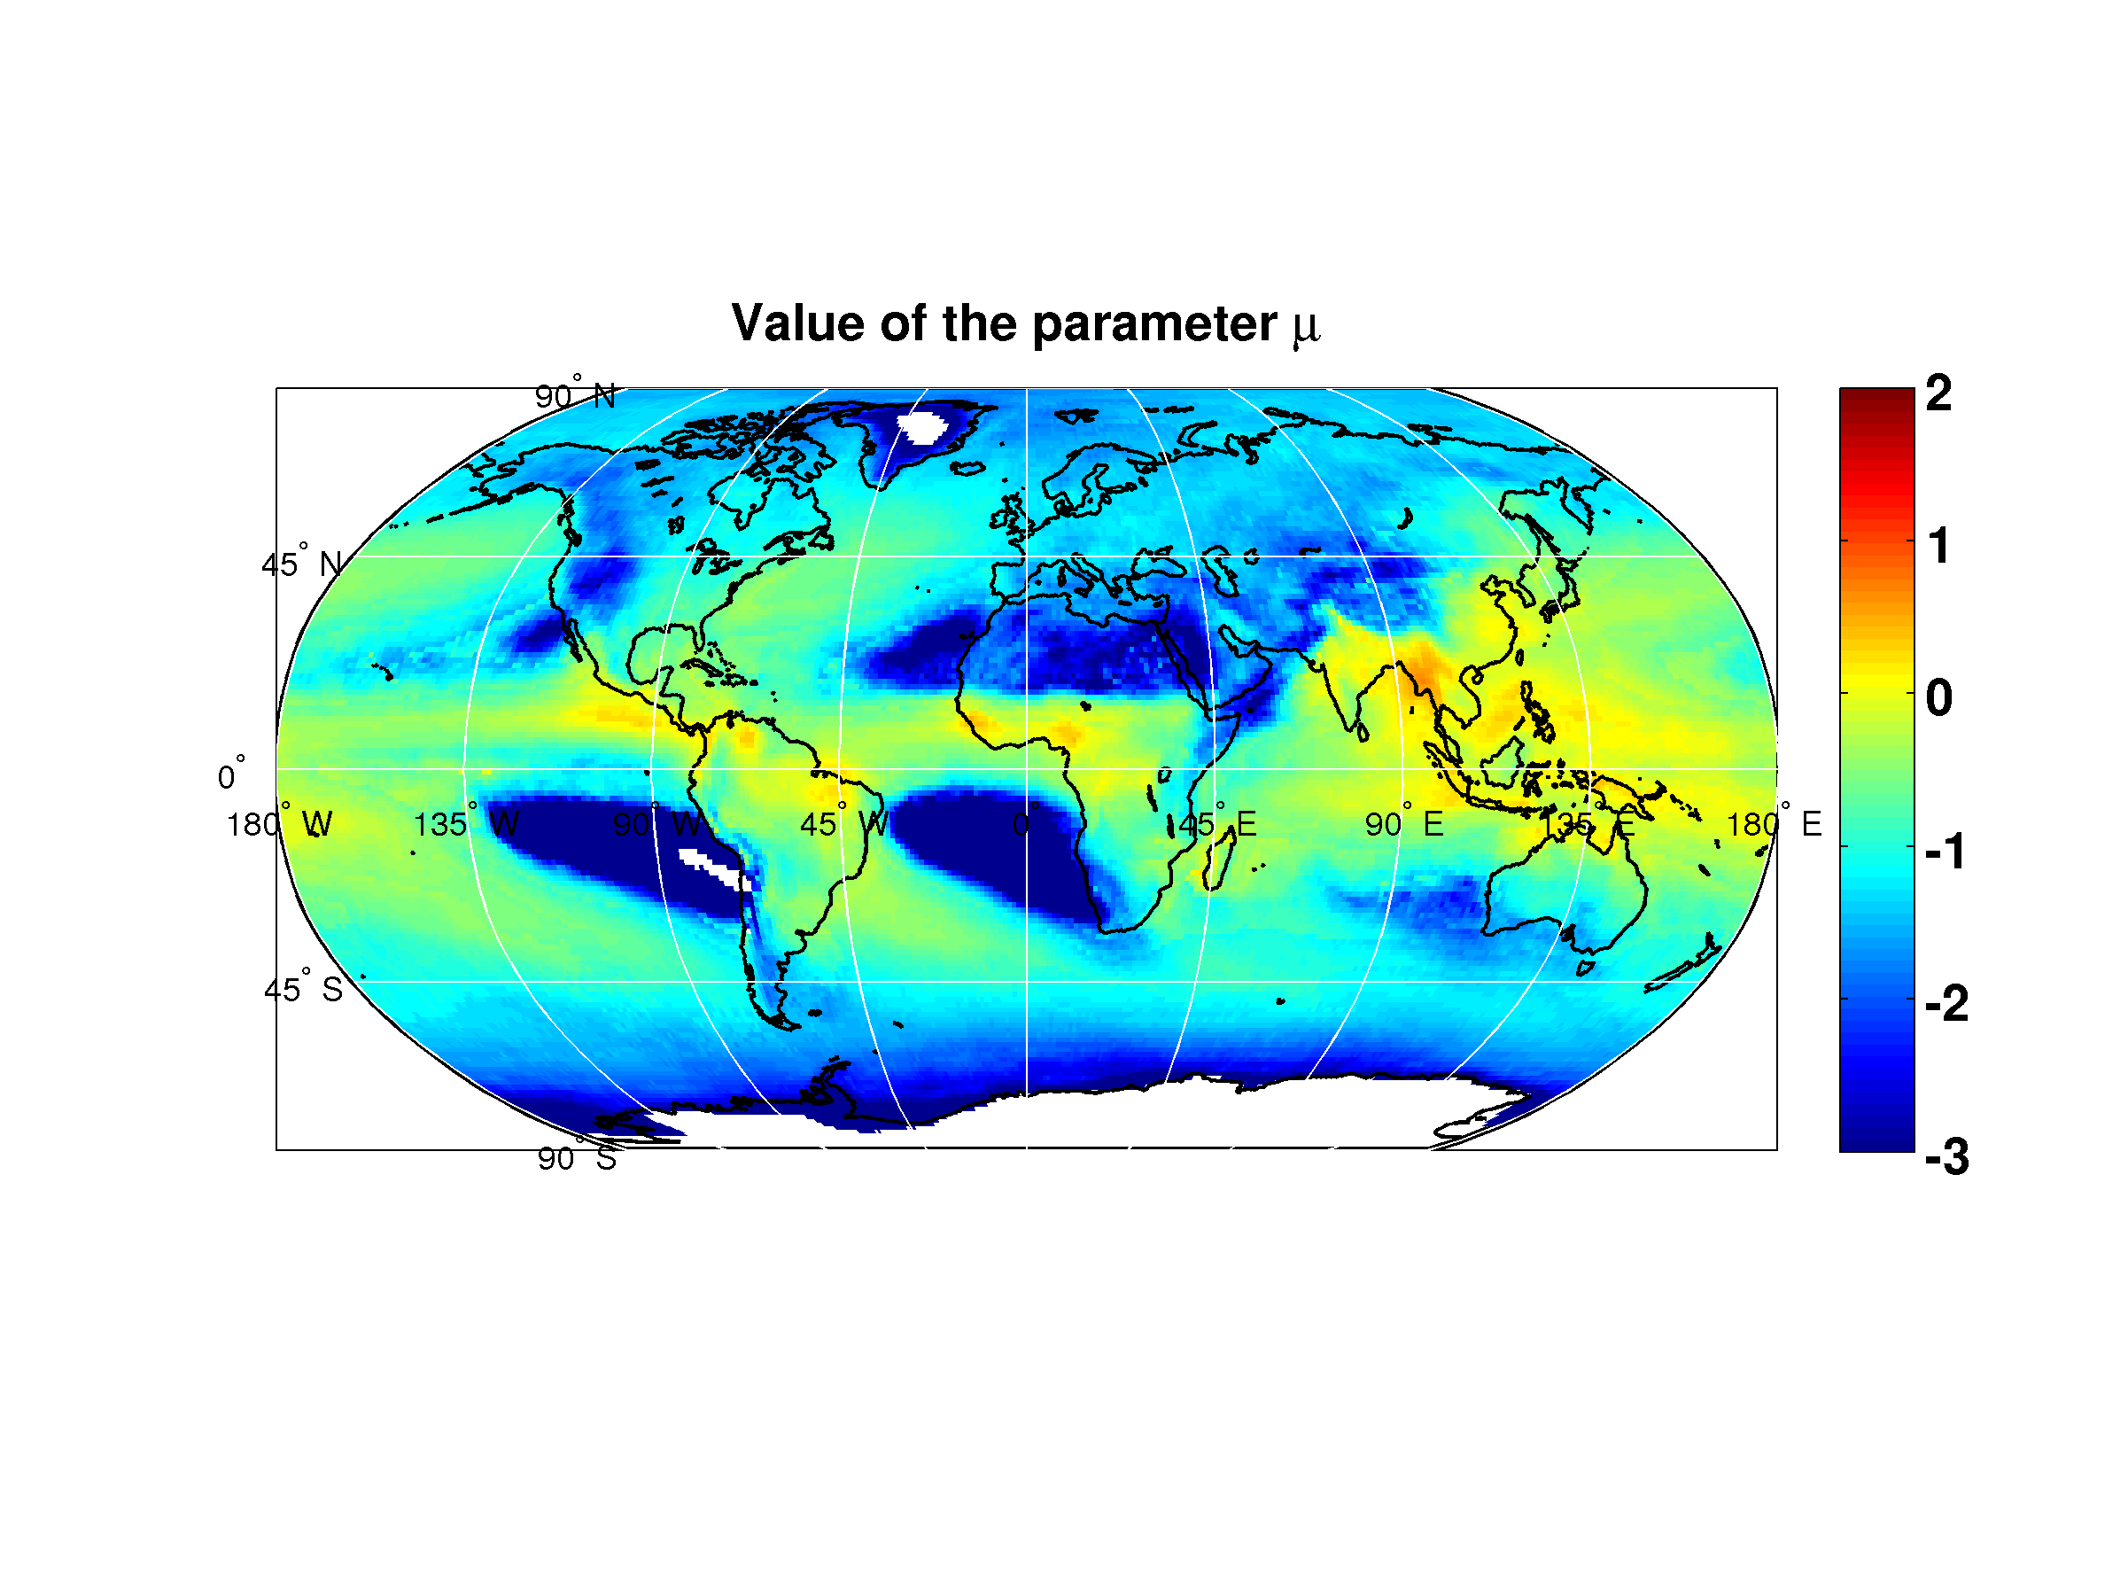

Figure 9

Spatial distribution of the ** parameter of the model for reduced   
cloud liquid distribution derived from ERA-40 maps

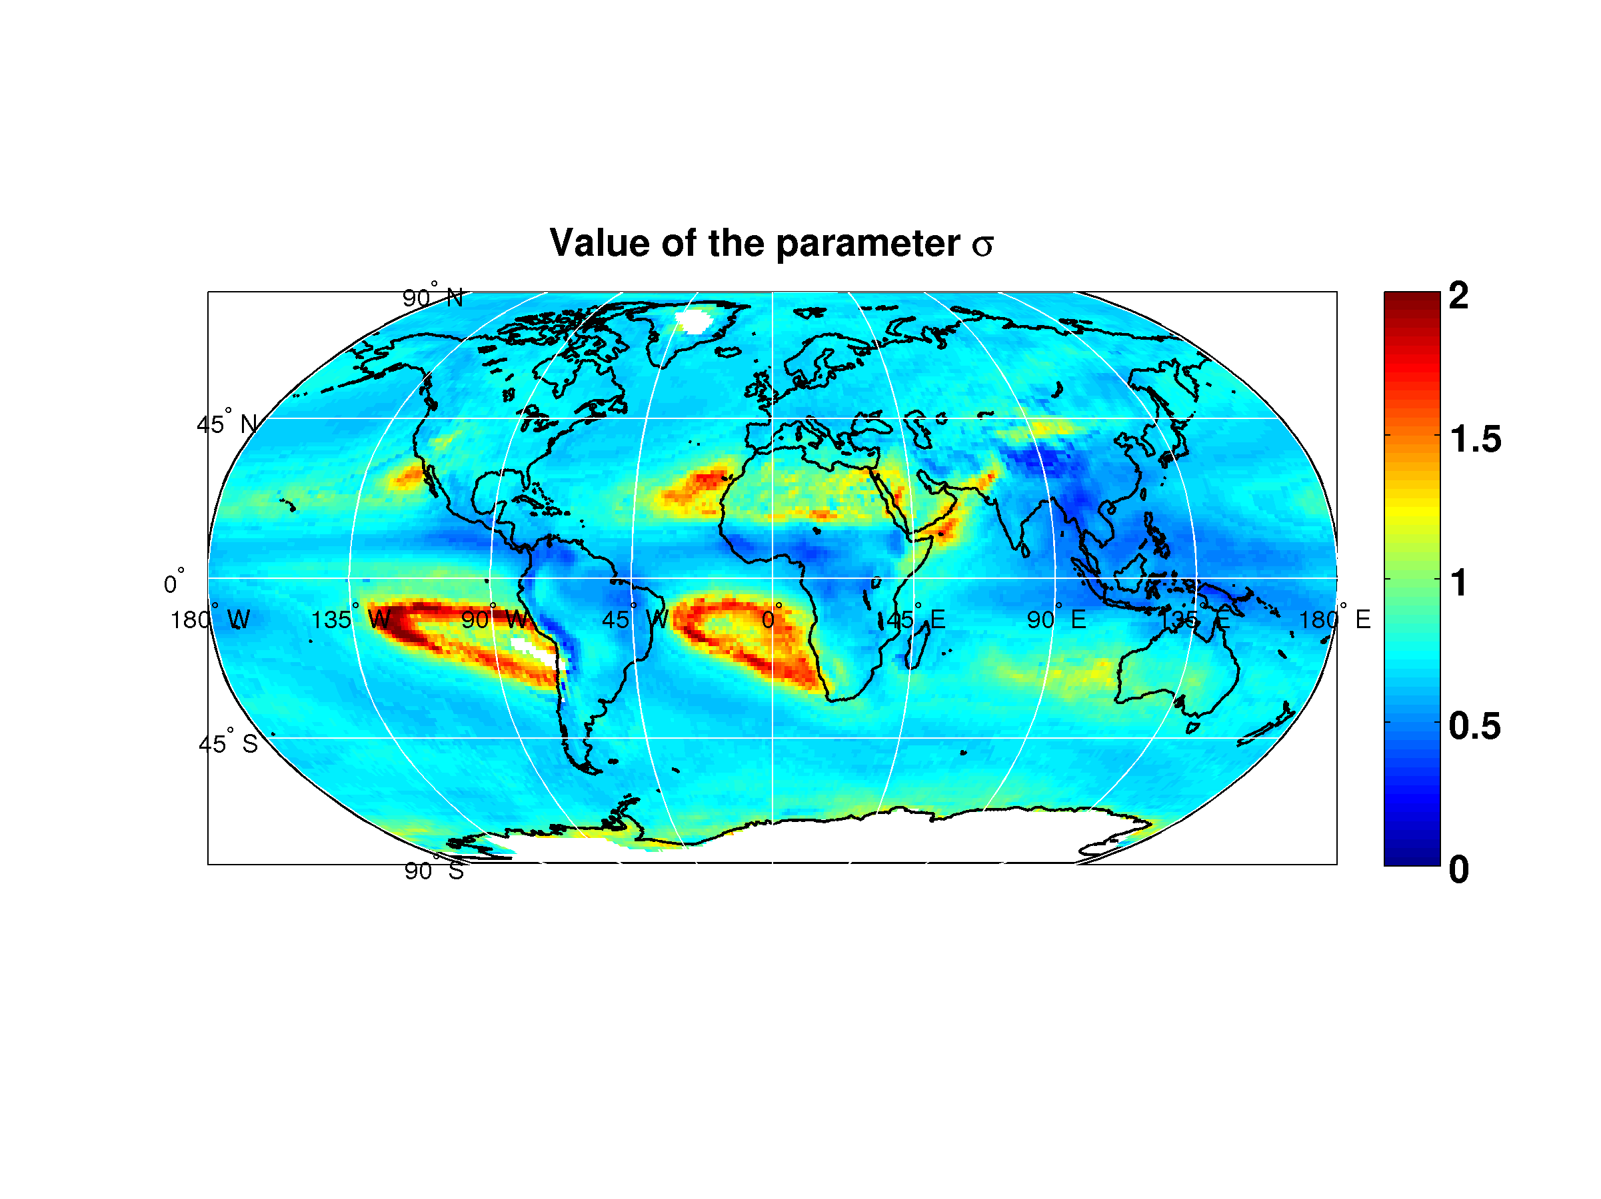

The spatial distribution of the rms error of the model for reduced cloud liquid water with respect to the original ERA-40 data is provided in Figure 10. The error is higher than the assumed precision of radiometric retrieval (0.1 mm) is along the tropical and equatorial belts.

Figure 10

Spatial distribution of the rms error of the mixed lognormal/dirac distribution derived   
from ERA-40 maps with respect to the original ERA-40 data

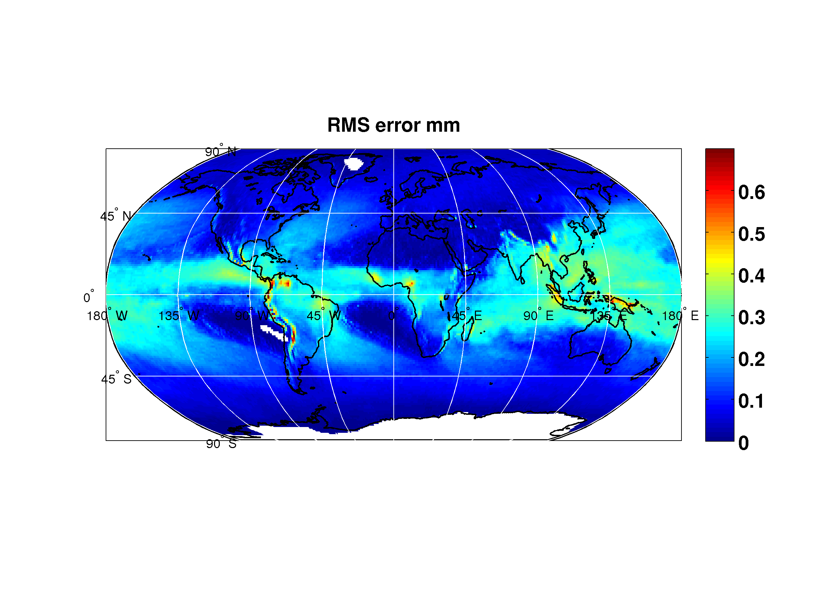

# 7 Acknowledgments

The results presented in this document have obtained in the framework of the ESA contracts 17760/03/NL/JA “Characterisation and Modelling of Propagation Effects in 20-50 GHz band”, 18278/04/NL/US “Assessment of radiowave propagation for satellite communication and navigation systems in tropical areas”, 20046/06/NL/CO “ERA-40 Statistical analysis” and 21317/07/NL/HE “Assessment of Propagation Effects in the W Frequency Band for Space Exploration” and with the support of the EU FP6 SatNex project.

# 8 References

[1] Poiares-Baptista P., Salonen E., 1998: “*Review of rainfall rate modeling and mapping*”, Proc. of URSI Commission F Open Symposium on Climatic Parameters in Radiowave Propagation Prediction (CLIMPARA’98), Ottawa, Ontario, Canada.

[2] ERA: ECMWF Re-analysis project report series, “*1. ERA-15 Description*”, Version 2, January 1999, European Centre for Medium-Range Weather Forecasts.

[3] ERA: ECMWF Re-analysis project report series, “*ERA-40 Archive*”, December 2002, European Centre for Medium-Range Weather Forecasts

[4] L. Castanet, C. Capsoni, G. Blarzino, D. Ferraro and A. Martellucci, “*Development of a new global rainfall rate model based on ERA-40, TRMM and GPCC products*”, Proceedings of ISAP07, August 20-24 2007, Niigata, Japan

[5] A. Martellucci, “*Use and development of climatological and experimental databases for radiowave propagation modelling in SatCom and SatNav systems*”, invited paper, Proceedings of 3rd European conference on antennas and propagation, EuCAP 2009, 23-27 March 2009, Berlin, Germany, pp. 2002-2006

[6] Ref. for 3D/4D variational techniques

[7] Martellucci A., Poiares Baptista, J.P.V., Blarzino, G. : “Effects of ice on slant path Earth-space radio communication links”, *Proceedings of the XXVIIth URSI General Assembly*, Maastricht, the Netherlands, 17-24 August 2002

[8] Jeannin N, L. Féral, H. Sauvageot, L. Castanet (2008): “Statistical distribution of integrated liquid water and water vapor content from meteorological reanalysis”, *IEEE Transactions on Antennas and Propagation*, 56(10), pp 3350-3355.

Annex 1

List of FERAS station used for ERA-40 maps validation

|  |  |  |  |  |
| --- | --- | --- | --- | --- |
| Station name | Country code | Latitude (° N) | Longitude (° E) | Altitude (m a.m.s.l.) |
| Sodankyla | FI | 67.22 | 26.39 | 178 |
| Jokionen | FI | 60.49 | 23.30 | 103 |
| Stornoway | UK | 58.13 | 353.41 | 14 |
| Hemsby | UK | 52.41 | 1.41 | 13 |
| De Bilt | NL | 52.06 | 5.11 | 2 |
| Uccle | BX | 50.48 | 4.21 | 104 |
| Lyon | FR | 45.44 | 5.05 | 240 |
| Berlin | DE | 52.29 | 13.25 | 46 |
| Wien | OS | 48.15 | 16.22 | 200 |
| Milan | IT | 45.26 | 9.17 | 107 |
| Brindisi | IT | 40.39 | 17.57 | 7 |
| Trapani | IT | 37.55 | 12.30 | 5 |
| Cagliari | IT | 39.15 | 9.03 | 4 |
| Moscow | RUS | 55.45 | 37.34 | 184 |
| Tabuk | SD | 28.22 | 36.35 | 771 |
| Delhi | IN | 28.35 | 77.12 | 281 |
| Hong Kong | CH | 22.19 | 114.10 | 65 |
| Singapore | SR | 1.22 | 103.59 | 14 |
| Dal-El-Beida | AL | 36.43 | 3.15 | 25 |
| Cape Town | ZA | -33.58 | 18.36 | 46 |
| San Diego | US (CA) | 32.49 | 242.52 | 124 |
| Denver | US (CO) | 39.45 | 255.08 | 1611 |
| Mexico City | MX | 19.26 | 260.55 | 2231 |
| Lihue-On-Kauai | US (HI) | 21.59 | 200.39 | 36 |

Annex 2

The Salonen-Uppala cloud detection algorithm

This algorithm uses a critical humidity function *UC*  (ranging from 0 to 1) to detect clouds:

 (1)

where ,  and *σ* is ratio between the pressure at the considered level and at the surface level. If the measured humidity is higher than the critical one at the same pressure level, the layer is assumed to be within a cloud. The estimation of the liquid water density *w* in g/m3 at each level is derived from the air temperature in the layer and its height with respect to the cloud base, according to the following relations [5]:

 (g/m3) (2)

where:

*w*0 = 0.17 (g/m3)

*c* = 0.04 (° C−1)

*t* = temperature (° C)

*hr* = 1 500 (m)

*hc* = height from the cloud base (m).

The cloud liquid and ice density water fraction *pw(t)* is approximated by the function:

 (3)

Finally, *L* is obtained by linear integration of *w* along the profile.

Part 2

Proposed update for the cloud attenuation prediction method  
in Recommendation ITU-R P.840-6

# 1 Introduction

The second part of this document presents a simple and accurate approach to calculate cloud attenuation for Earth-space communication systems operating in the 10-200 GHz frequency range that could possibly contribute to Recommendation ITU-R P.840-6. The methodology relies on the use of the mass absorption coefficient for liquid water *aW*, which is assumed to be independent of the site of interest. This finding, inferred from an extensive set of radiosonde observations in Europe, allows to devise a simple expression for *aW* as function only of frequency and, consequently, to efficiently calculate cloud attenuation. This indeed represents the main advantage of the approach, which, as a result, can take full advantage of global datasets of integrated liquid water content *W* made available, for example, by Earth Observation sensors.

The model for cloud attenuation prediction included in Recommendation ITU-R P.840-6 estimates cloud attenuation, *AC*, using as input the liquid water content reduced to a fixed temperature [1]. This prevents from taking advantage of alternative (and possibly more accurate) cloud data as the ones provided by Earth Observation sensors (e.g. MODIS and CPR on-board the Aqua and CloudSat satellites, respectively) in terms of integrated liquid water content *W*. To overcome this limitation, this information document proposes a different simplified yet accurate approach to estimate cloud attenuation that relies on the use of mass absorption coefficients and requires as input the integrated liquid water content *W*.

# 2 Calculation of cloud attenuation

## 2.1 Exact methodology

For propagation applications in the mm-/micro-wave region, cloud attenuation can be evaluated using the Rayleigh approximation to determine the extinction properties of suspended liquid water droplets. In fact, due to the small size of such droplets (assumed to be of spherical shape) with respect to the wavelength for frequencies below 300 GHz, the specific attenuation due to clouds *C* can be calculated as [2]:

 (dB/km) (1)

where *w* is the liquid water content in the cloud (g/m3), whilst, according to the Rayleigh approximation and the double-Debye model for the dielectric permittivity of water *ε*, *Kl* can be expressed as [2]:

 (dB/km)/(g/m3) (2)

In (2), , whilst  and  are the real and imaginary parts of the dielectric permittivity of water, respectively defined as:

 (3)

 (4)

where *T* is the temperature expressed in K and:

** = 300/*T*,

*fD* = 20.09 * *142 (*  *1) + 294(*  *1)2,

*fS* = 590 * *1500 (*  *1),

**1 = 5.48, **2 = 3.51 and **0 = 77.67 + 103.3 (*  *1).

As is clear from the equations above, *Kl* depends on the frequency *f* and on the temperature *T* of each layer in the cloud. As a consequence, the exact calculation of the path cloud attenuation *AC* requires the availability of full profiles of temperature and specific liquid water content. In turn, this information can be retrieved from radiosonde observations (RAOBS), typically collected worldwide at airports twice a day: whilst temperature *T* is directly measured during the radiosonde ascent, together with relative humidity *RH* and pressure *P*, the liquid water content *w* can be estimated using the already mentioned TKK model [2], which, as a first step toward the calculation of the specific attenuation due to the suspended liquid water, identifies clouds and quantifies their density from *P-RH-T* profiles (full details on the well-established model and on its application can be found in [2]).

## 2.2 Approximate solution

A viable way to simplify the calculation of *AC*, currently adopted by ITU-R in Recommendation ITU‑R P.840-6, is to employ an effective value for the vertical integral of *w* (much easier to handle than the whole profile), *Wred*, which embeds the information on the variation of temperature (and, thus, of the specific cloud attenuation) with height. As a result, the total path attenuation due to clouds can be calculated as [1]:

 (dB) (5)

where  is the coefficient in (2) calculated for the reducing temperature *TR* and *Wred*(*TR*) is the integrated liquid water content reduced to *TR*. In other words, equation (5) expresses the total path attenuation as if the temperature within the cloud were always 0 °C, regardless of the layers’ height, and this deviation from the actual values of *T* is taken into account by modifying *w* into *wred* along the whole profile as follows [1]:

 (6)

In order to ease the application of (5), statistics of Wred are attached to Recommendation ITU-R P.840-6 as calculated using the TKK model [2] applied to P-RH-T profiles extracted from the ERA-40 database with latitude/longitude grid resolution equal to 1.125°×1.125° [3]; in this case, f = 10-60 GHz and TR = 0° C were chosen. Indeed, the application of (5) is tightly linked to such database, as this simplified approach cannot readily take advantage of alternative (and possibly more accurate) inputs, such as integrated liquid water content data provided by Earth Observation sensors (e.g. MODIS and CPR on-board the Aqua and CloudSat satellites, respectively). Moreover, a change in TR (as suggested in [1] to reduce the approximation error) and/or f (e.g. to address frequencies higher than 60 GHz with minimum loss of accuracy) would require a full (and computationally heavy) reprocessing of the entire set of ERA-40 P-RH-T vertical profiles (or of any equivalent global database).

## 2.3 Alternative approximate approach

To overcome the above mentioned limitations, we propose an alternative approach to estimate cloud attenuation which involves the direct use of the mass absorption coefficient for liquid water, *aW*(*f*) in (7), widely employed in remote sensing applications to relate the integrated liquid water content *W* to the associated attenuation at a given frequency *f*, *AW* [4]:

 (dB) (7)

Figure 1, which refers to the example of Milano/Linate airport, shows that *aW* represents the slope of the black regression line obtained from data derived from the extensive set of RAOBS already presented in Annex 1 of the first part of the document. *P-RH-T* profiles are used on one side to derive the liquid water content with high vertical resolution (10 to 40 meters) by means of the TKK cloud detection algorithm [2],[4] and, on the other side, to separately calculate *AW* through the MPM93 mass absorption model proposed by Liebe *et al.* in [5]. At the moment, this procedure has been applied to RAOBS data collected only in the 14 European stations, ranging from Northern (e.g. Sodankyla, Finland) to Southern (e.g. Trapani, Italy) Europe, i.e. subject to very different climates (refer to Table 1).

Figure 1

Calculation of the mass absorption coefficient *aW* at 40 GHz using the RAOBS data collected  
at Milano/Linate airport (TKK and MPM93 models)



Table 1

Details on the sites where RAOBS data used in this work have been collected

|  |  |  |  |  |
| --- | --- | --- | --- | --- |
| Station name | Country code | Latitude  (° N) | Longitude  (° E) | Altitude  (m a.m.s.l.) |
| Sodankyla | FI | 67.22 | 26.39 | 178 |
| Jokionen | FI | 60.49 | 23.30 | 103 |
| Stornoway | UK | 58.13 | 353.41 | 14 |
| Hemsby | UK | 52.41 | 1.41 | 13 |
| De Bilt | NL | 52.06 | 5.11 | 2 |
| Uccle | BX | 50.48 | 4.21 | 104 |
| Lyon | FR | 45.44 | 5.05 | 240 |
| Berlin | DE | 52.29 | 13.25 | 46 |
| Wien | OS | 48.15 | 16.22 | 200 |
| Milan | IT | 45.26 | 9.17 | 107 |
| Brindisi | IT | 40.39 | 17.57 | 7 |
| Trapani | IT | 37.55 | 12.30 | 5 |
| Cagliari | IT | 39.15 | 9.03 | 4 |
| Moscow | RUS | 55.45 | 37.34 | 184 |

With this approach, the variation of the temperature within the cloud profile (and of the associated specific attenuation) is no more embedded in *Wred* but is taken into account by the mass absorption coefficient *aW*. This solution introduces the advantage of working with a physical quantity (*W*) instead of an effective one (*Wred*) which is of importance for applications involving low elevation links (e.g. high-latitude ground stations for GEO satellites and/or links to Earth Observation LEO satellites and deep-space probes), where the customary assumption of horizontal homogeneity for clouds (used in Recommendation ITU-R P.840-6 model as well) is no longer acceptable and, instead, the liquid water *W* integrated along the path, taking into account the full vertical and horizontal distribution of *w*, is a requisite to obtain accurate results.

The differences in *aW* that were found when repeating the exercise in Figure 1 for all the 14 different stations across Europe are negligible for the radiowave propagation applications addressed in this work. This indicates that, notwithstanding the difference both in the type and in the occurrence of clouds among the various sites, their vertical development, in terms of relationship between pressure, temperature and relative humidity, is similar. As a result, the following expression, depicted in Figure 2 and valid for temperate climate, can be used to estimate *aW* as a function of frequency:

 (dB/mm) (8)

where *a* = 1.9479×10-4, *b* = 2.308, *c* = 2.9424, *d* = 0.7436 and  
*e* = -4.9451, 10 GHz ≤ *f* ≤ 200 GHz, whilst the real and imaginary parts of the electric permittivity of water (see (3) and (4)) are calculated for *T* = 0 °C. Coefficients *a*, *b*, *c*, *d* and *e* were determined by fitting equation (8) to the average value of *aW* (over all the 14 sites) obtained from RAOBS data.

The accuracy of (8) for the considered European sites is summarized in Figure 3, which reports the highest values of the error ** as a function of *f* (associated to Sodankyla, Finland, and De-Bilt, the Netherland), being ** defined as .

Figure 2

Trend of the mass absorption coefficient  according to (8)



As a result, equation (8), which turns out to be a deviation from (2), can be used to calculate the cloud attenuation along the path *AC*, for frequencies between 10 GHz and 200 GHz, as a function of *W* values derived from different sources/models.

Figure 3

Highest values of the error ** as a function of *f* (Cagliari, Italy, and De-Bilt, the Netherlands)

# 3 Performance assessment

The accuracy of the method is tested in this Section against the set of European RAOBS measurements mentioned above. Figure 4 shows an example of the zenithal cloud attenuation statistics (Complementary Cumulative Distribution Function, CCDF) at 100 GHz calculated according to the exact (i.e. exploiting the whole *P-RH-T* profile as input to the TKK and MPM93 models) and approximate (i.e. using (7) and (8)) methods for the RAOBS data collected at Milano/Linate airport from 1980 to 1989. The accuracy is quantified by the average (E) and root mean square (RMS) values (also reported in the legend of Figure 4) of the following error figure:

 (%) (9)

where *A*\*(*P*) and *A*(*P*) are the cloud attenuation values extracted from the approximate and exact attenuation statistics, respectively, relative to the same probability level *P* ≥ 0.01%.

Figure 4

Zenithal cloud attenuation CCDF at 100 GHz calculated according to the exact (black solid line) and approximate (dashed gray line with triangles) methods for the RAOBS data collected at Milano/Linate airport

Figure 5 gives an overall hint of the accuracy of the method by reporting the mean E (**E) and mean RMS (**RMS) values as a function of frequency. Results indicate a very accurate prediction performance (overall **RMS = 3.4%), which has some dependence on the frequency (**RMS = 5.2% and **RMS = 1.4% around 60 GHz and 170 GHz, respectively). On the other hand, negligible variation of **RMS is found from site to site in Europe, which confirms the appropriateness of the site-independent expression for  defined in (8) (refer to Figure 6).

Figure 5

Mean E (**E) and mean RMS (**RMS) as a function of frequency (average over all stations)



Figure 6

Mean E (**E) and mean RMS (**RMS) as a function the site (average over all frequencies).



# 4 Acknowledgments

Dr Martellucci from the European Space Agency is acknowledged for the provision of FERAS radiosonde data.

# 5 References

[1] L. Luini, C. Riva, C. Capsoni, “Reduced liquid water content for cloud attenuation prediction: the impact of temperature,” Electronics Letters, Vol. 49, Issue 20, pp. 1259 –1261, 26 September 2013.

[2] E. Salonen, S. Uppala, “New prediction method of cloud attenuation,” Electron. Lett., vol. 27, no. 12, pp. 1106–1108, Jun. 1991.

[3] http://www.ecmwf.int, Website of the European Centre for Medium-Range Weather Forecasts, accessed on April 2014.

[4] L. Luini, C. Riva, C. Capsoni, A. Martellucci, “Attenuation in non rainy conditions at millimeter wavelengths: assessment of a procedure,” IEEE Transactions on Geoscience and Remote Sensing, pp. 2150-2157, Vol. 45, Issue 7, July 2007.

[5] H. J. Liebe, G. A. Hufford, M. G. Cotton, “Propagation modeling of moist air and suspended water/ice particles at frequencies below 1000 GHz,” in Proc. AGARD 52nd Spec. Meeting EM Wave Propag.

Overall conclusions

Tests conducted on an extensive RAOBS database covering different climates in Europe have shown that the statistics of integrated cloud liquid water content obtained from the ERA-40 database are more accurate than those extracted from the ERA-15 dataset. This translates into an improved prediction accuracy delivered by the method included in Annex 2 of Recommendation ITU-R P.840-6 for liquid water attenuation estimation. This outcome is confirmed by an additional test involving integrated liquid water statistics derived from radiometric data. Moreover, for the purpose of using probabilistic models for channel dynamics (e.g. synthetic time series generators), analytical functions and input statistical parameters can be used to reproduce the original statistical distribution of integrated liquid water content at the expense of a residual error which is comparable to the current instrumental accuracy.

The methodology described in the second part of this document represents an interesting additional element that would enhance the significance of Recommendation ITU-R P.840-6, which is devoted to the prediction of cloud attenuation *AC*. The novelty of the proposed method is a simple analytical expression to easily derive the mass absorption coefficient of liquid water, *aW*, in the 10-200 GHz frequency range. Tests on the accuracy of the method in predicting *AC* show a very good performance (overall RMS of the approximation error ** equal to 3.4%) which is slightly dependent on frequency (RMS of ** ranging between 1.4% and 5.2% in the 10-200 GHz band) but not on the site. The main advantage of the new proposal, to be possibly integrated into Recommendation ITU-R P.840-6 in the near future, lies in the possibility to exploit different datasets of integrated liquid water content directly provided, for examples, by Earth Observation sensors, or made available, with improved spatial resolution compared to the ERA-40 database, by ECMWF (e.g. ERA-Interim) and NCAR.

______________