|  |  |
| --- | --- |
| **Radiocommunication Study Groups** |  |
|  |  |
|  |  |
| Source: Document 3M/152  Subject: Air-ground channel measurement data | **Document 3M/FAS/10-E** |
| **5 October 2017** |
| **English only** |
| Working Party 3M | |
| FASCICLE | |
| INFORMATION DESCRIBING SOURCE OF AIR-GROUND CHANNEL MEASUREMENT DATA TO BE USED FOR CONTRIBuTIOnS TO STUDY GROUP 3 DATA BANKS, FORMATTED TABLES PART VII | |

**Table of Contents**

1 Introduction 1

2 Flight test measurements 1

3 Data processing 4

4 References 5

# 1 Introduction

This document contains a very brief description of the flight tests used to collect data for characterizing the air-ground channel, at two centre frequencies in the L-band and the C-band. A short description of the data processing is also included. These measurements were conducted in support of the development and testing of air-ground communications links for control and non-payload communications systems for unmanned aircraft operating in controlled (i.e., non-segregated) airspace.

# 2 Flight test measurements

Air-ground channel propagation measurement campaigns were conducted for the air-ground channel for frequencies in the L-band (centre 968 MHz) and C-band (centre 5 060 MHz), for seven different terrain environments. Detailed descriptions appear in [1] and [2]. In short, the environments were classified as over sea, over freshwater, hilly, mountainous, suburban, desert, and near-urban. For the measurements, we used the United States National Aeronautics and Space Administration (NASA) Glenn Research Center’s (GRC’s) S-3B Viking aircraft; see Figure 1. The S-3B is a medium-sized piloted aircraft, with seating for two pilots and two research engineers, and remaining space for test equipment. The ground site (GS) was deployed using a transportable tower system on a trailer, shown in Figure 2. This GS was powered by a dedicated 7 kW diesel generator, and had a pneumatically-extendable tower (~4 – 20 m) and a weatherproof cabinet for test equipment. This cabinet included the channel measurement system transmitters, mast control, GPS receiver, and associated electronics.

Figure 1

NASA GRC’s-3B Viking aircraft

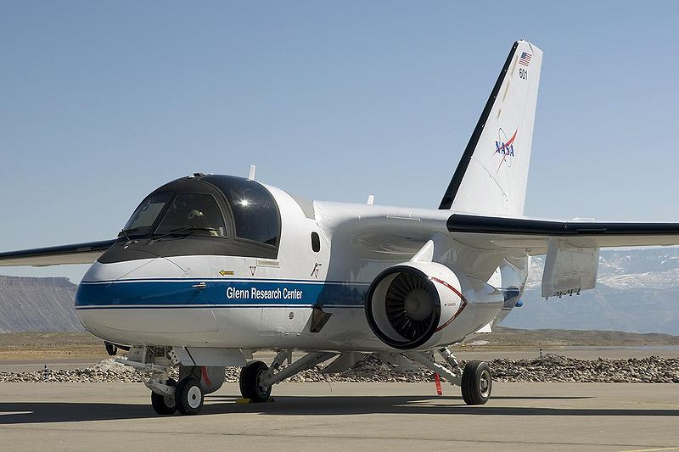

Figure 2

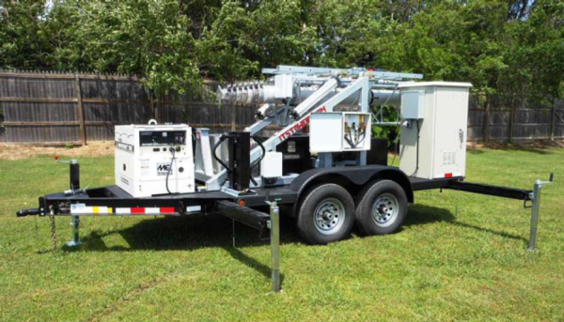NASA GRC’s transportable tower and GS system

The AG channel measurement system—termed the channel sounder—was a custom design: it consisted of two transmitters and four receivers, and hence was a single-input/multiple-output (SIMO) channel sounder with 1 transmitter (Tx) and 2 receivers (Rxs) in each band (denoted 1×2 in each band). The sounder was developed by Berkeley Varitronics Systems, Inc. [3], according to specifications developed by the project principal investigator and NASA. The sounder operated simultaneously in two frequency bands: the L-band range was from 960-977 MHz and the C-band range from 5 030-5 091 MHz. All measurements were made simultaneously in the two bands, and centre frequencies for all tests were approximately 968 MHz and 5 060 MHz.

Each transmitter unit transmitted a direct-sequence spread spectrum (DS-SS) signal; the C-band chip rate was 50 Mchips/sec, and the L-band chip rate was 5 Mchips/sec. The DS-SS sequences were *m*-sequences of length 1 023. Reception was by the two antennas in each band, which were connected to the four individual stepped-correlator receivers. For all tests, the four receivers were on the aircraft and the two transmitters at the GS. The four Rx antennas were mounted on the bottom of the S-3B fuselage, in a rectangular pattern, with the same-band antennas located on opposite corners of the rectangle of size approximately 1.32 by 1.4 m. Ground site antenna gains were 6 dB for C-band, 5 dB for L-band, with elevation/azimuth beamwidths of approximately 35º/180º for C-band and 60º/120º for L-band. The four aircraft monopole “blade” antennas are nearly omnidirectional in azimuth, with gain 5 dB. All antennas were vertically polarized. Detailed antenna patterns were reported in [4]. For all results reported, the aircraft was within the GS antenna main beam.

The sounder Tx output power for both bands was 10 watts (40 dBm). In addition, a 7 dB gain high power amplifier and a 30 dB low noise amplifier (LNA) were employed in C-band, and the L-band receivers used LNAs with gain 15.5 dB. The sounder required a minimum received signal-to-noise ratio (SNR) of approximately 10 dB. This limited the C-band maximum range to approximately 30 km, but the L-band range was nearly 200 km. Earth curvature restricted flight ranges to approximately 40 km at the flight altitudes used in most tests. The sounder’s transmitted signals were filtered using root-raised cosine responses (roll off ~0.3) for spectral containment. Hence the 50 MHz C-band signal had delay resolution approximately 20 ns, and the 5 MHz L‑band signal had delay resolution approximately 200 ns. Additional data on the measurement system appears in [1] and [2].

Because of the expense and logistical complexity of conducting flight tests in the airspace of the USA, only a representative set of GS locations was employed. These sites were selected for their local characteristics, and represent a variety of conditions. This includes hilly terrain, mountainous terrain, over-water (both freshwater and sea), suburban, desert, and near-urban. The measurements could not of course cover every possible type of GS location, but as far as we are aware, these results are the most comprehensive set of results for the AG channel to date: in total, the measurement campaign collected nearly 316 million channel impulse responses in the seven different GS settings. Detailed characteristics of the set of GS environments are provided in [1]. Figure 3 shows example flight tracks (FTs, using Google Maps®) in the suburban setting of Latrobe, PA (left), and a view of the Latrobe township (right), near the GS.

Figure 3

Google Maps® views of flight tracks (FTs) taken in suburban setting in Latrobe, PA (left),  
 and photo of Latrobe township (right).

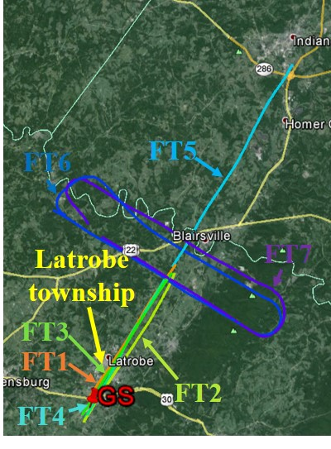

As with the GS locations, flight paths were also constrained. Flight path shapes were either straight (both toward and away from the GS) or oval-shaped, as shown in Fig. 3. Limits on minimum altitude, proximity to populated areas, flying times, and flight velocities all had to be taken into account in planning the flight tests. The specific aircraft (S-3B Viking) also had limitations on minimum flight velocity. The detailed data on all the flight paths (termed flight tracks, FTs) appears in [5]. All FTs were flown at a nearly constant altitude, which ranged from approximately 400‑1 900 m in the different sites, with link ranges for measurements ranging from 1‑40 km. Flight velocities ranged from approximately 75 m/s to 100 m/s.

# 3 Data processing

The channel sounder gathered power delay profiles (PDPs), including phases of resolved multipath components (MPCs), and this enabled estimation of channel impulse responses (CIRs). The channel “snapshot” rate was approximately 3 000 PDPs/second. The PDP is essentially the power output at time *t* vs. delay , when an impulse is input at time *t-*. The GS and aircraft also employed GPS receivers, providing position information for each PDP. From these CIRs, several channel characteristics were estimated: propagation path loss, dispersion (delay spread), Doppler effects, small-scale fading characteristics, and correlations among the signals received on the different antennas and in different bands.

For a DS-SS signal, the CIR estimate at the receiver is obtained by correlating the received sampled signal with a local copy of the transmitted *m*-sequence. The sounder operated using two thresholds: the first threshold was 25 dB below the largest received signal component, and the second was an absolute noise threshold. All sounder correlator outputs below these thresholds were removed before subsequent processing for channel parameter estimates. The largest received signal component was the line-of-sight (LOS) component, which was present for all test flights. The absolute noise threshold was employed to remove (with probability approximately 0.9995) external noise from other aircraft electronic equipment; see [2] for details on this analysis. Both thresholds were applied after DS-SS signal de-spreading, i.e., at the Rx correlator outputs. Subsequent time-domain processing of PDPs was also employed to identify and remove the rare noise spikes that remained after the prior thresholding. To summarize, all recorded PDPs employed a threshold 25 dB down from the largest component, plus the absolute power thresholds to remove aircraft electronic noise, plus processing over time to remove any remaining (rare) isolated noise spikes.

The AG channel characteristics that were estimated from the measured data include the following:

1) propagation path loss, or attenuation (dB);

2) stationarity distance (m);

3) Ricean K-factor (dB);

4) correlation coefficients (dimensionless);

5) airframe shadowing depths (dB) and durations (sec);

6) multipath component statistics.

Computational methods are described in [1] and [6]-[8]. Path loss is computed in the conventional manner, via link budget equations. Stationarity distance - being a relatively new characteristic of study in the propagation and channel modelling community - can be computed using multiple methods; in this work the methods of [9] and [10] were employed. The Ricean K-factor was also computed using both moment methods [11], [12] and the maximum-likelihood method. Results of all these K-factor estimation methods were generally in excellent agreement. The correlation coefficients were computed among the LOS components on all four antennas, thus both same-frequency/spatial correlations and different-frequency/spatial correlations were computed (see the prior section, and [1], for spatial separation information). All correlations and Ricean K-factors were computed over the stationarity distance. Airframe shadowing was computed as the relative attenuation with respect to the best-fit path loss model during a shadowing event. Shadowing events were intentionally induced by banking turns in the oval-shaped FTs. The MPC statistics include relative amplitudes (with respect to the LOS component, in dB), relative delays (also with respect to the LOS component, in sec), durations or “lifetimes” (in m), and probabilities of occurrence. The MPC statistics were combined with two-ray models that account for the LOS component and primary earth surface reflection, yielding wideband statistical tapped-delay line models for the AG channel. These models can be termed “quasi-deterministic,” or alternatively, they can be described as a hybrid of geometry-based (deterministic) and empirical statistical models.

# 4 References

[1] D. W. Matolak, R. Sun, “Air-Ground Channel Characterization for Unmanned Aircraft Systems—Part I: Methods, Measurements, and Results for Over-water Settings,” *IEEE Trans. Veh. Tech.*, online 2016 (vol. 66, no. 1, pp. 26-44, Jan. 2017).

[2] D. W. Matolak, R. Sun, “AG Channel Measurement & Modeling Results for Over-Sea Conditions,” (Report #6) NASA Grant #NNX12AR56G, 3 December 2013.

[3] Berkeley Varitronics Systems, website [www.bvsystems.com](http://www.bvsystems.com), 28 March 2017.

[4] R. Sun, D. W. Matolak, “Over-Harbor Channel Modeling with Directional Ground Station Antennas for the Air-Ground Channel,” *2014 Military Communications Conference (MILCOM 2014)*, pp. 1-6, Baltimore, MD, 6-8 Oct. 2014.

[5] D. W. Matolak, R. Sun, “AG Channel Measurement & Modeling Results for Over-Water and Hilly Terrain Conditions,” (Report #7) NASA Grant #NNX12AR56G, 26 September 2014.

[6] R. Sun, D. W. Matolak, “Air-Ground Channel Characterization for Unmanned Aircraft Systems—Part II: Hilly & Mountainous Settings,” *IEEE Trans. Veh. Tech.*, online 2016.

[7] D. W. Matolak, R. Sun, “Air-Ground Channel Characterization for Unmanned Aircraft Systems—Part III: The Suburban and Near-Urban Environments,” *IEEE Trans. Veh. Tech.*, online 2016.

[8] D. W. Matolak, R. Sun, W. Rayess, “Air-Ground Channel Characterization for Unmanned Aircraft Systems—Part IV: Airframe Shadowing,” to appear, *IEEE Trans. Veh. Tech.*, 2017.

[9] A. Gehring, M. Steinbauer, I. Gaspard, M. Grigat, “Empirical Channel Stationarity in Urban Environments,” *4th European Personal & Mobile Comm. Conf. (EPMCC 2001)*, Vienna, Austria, 20-22 February 2001.

[10] O. Renaudin, V-M Kolmonen, P. Vainikainen, C. Oestges, “Non-Stationary Narrowband MIMO Inter-Vehicle Channel Characterization in the 5 GHz Band,” *IEEE Trans. Veh. Tech.*, vol. 59, no. 4, pp. 2007-2015, May 2010.

[11] L. J. Greenstein, S. S. Ghassemzadeh, V. Erceg, D. G. Michelson, "Ricean K-Factors in Narrow-Band Fixed Wireless Channels: Theory, Experiments, and Statistical Models," *IEEE Trans. Vehicular Tech.*, vol. 58, no. 8, pp. 4000-4012, Oct. 2009.

[12] C. Tepedelenlioglu, A. Abdi, G. B. Giannakis, "The Ricean K factor: estimation and performance analysis," *IEEE Trans. Wireless Comm.*, vol. 2, no. 4, pp. 799-810, July 2003.

______________