|  |  |
| --- | --- |
| **Radiocommunication Study Groups** |  |
|  |  |
|  |  |
| Source: Document 3J/TEMP/113  Subject: Background information on Recommendation [ITU-R P.1853](https://www.itu.int/rec/R-REC-P.1853/en) | **Revision 1 of Document 3J/FAS/10-E** |
| **5 June 2019** |
| **English only** |
| Working Party 3J | |
| Fascicle  (Replaces Fascicle 3M/FAS/5) | |
| Tropospheric impairments time series synthesizers in  Recommendation ITU-R P.1853 | |

|  |
| --- |
|  |

(Questions ITU-R 204-3/3, ITU-R 206-3/3)

Preface

The fascicle contains in Annex 1 background information used to develop Recommendation ITU-R P.1853. In its current version, it presents parameterization and validation elements of the single-site and multi-site total impairments time series synthesizers for Earth-space paths adopted in the Recommendation.

Annex 1

**Table of contents**

[**Preface** 1](#_Toc10621727)

[1 Introduction 3](#_Toc10621728)

[2 Space-time correlated tropospheric attenuation time series synthesizer 3](#_Toc10621729)

[2.1 Oxygen gaseous attenuation 3](#_Toc10621730)

[2.1.1 Single-site approach in Recommendation ITU-R P.1853-1 3](#_Toc10621731)

[2.1.2 Single-site approach in Recommendation ITU-R P.1853-2 3](#_Toc10621732)

[2.1.3 Multi-site approach in Recommendation ITU-R P.1853-2 5](#_Toc10621733)

[2.2 Water vapour gaseous attenuation 6](#_Toc10621734)

[2.2.1 Single-site approach in Recommendation ITU-R P.1853-1 6](#_Toc10621735)

[2.2.2 Single-site approach in Recommendation ITU-R P.1853-2 7](#_Toc10621736)

[2.2.3 Multi-site approach in Recommendation ITU-R P.1853-2 12](#_Toc10621737)

[2.3 Cloud attenuation 15](#_Toc10621738)

[2.3.1 Single-site approach in Recommendation ITU-R P.1853-1 15](#_Toc10621739)

[2.3.2 Single-site approach in Recommendation ITU-R P.1853-2 16](#_Toc10621740)

[2.3.3 Multi-site approach in Recommendation ITU-R P.1853-2 21](#_Toc10621741)

[2.4 Rain attenuation 26](#_Toc10621742)

[2.4.1 Single-site approach in Recommendation ITU-R P.1853-1 26](#_Toc10621743)

[2.4.2 Single-site approach in Recommendation ITU-R P.1853-2 26](#_Toc10621744)

[2.4.3 Multi-site approach in Recommendation ITU-R P.1853-2 31](#_Toc10621745)

[2.5 Total attenuation 35](#_Toc10621746)

[2.5.1 Multi-site total impairments (scintillation included) time series   
synthesizer in Recommendation ITU-R P.1853-2 35](#_Toc10621747)

[2.5.2 General parameterization multi-site total impairments time   
series synthesizer in Recommendation ITU-R P.1853-2 38](#_Toc10621748)

[3 References 39](#_Toc10621749)

# 1 Introduction

This fascicle:

– Contains discussions on advantages/disadvantages of the time series synthesizers in Recommendation ITU-R P.1853-1 for each individual atmospheric component w.r.t. ITU-R P.1853-2;

– Notes that the single-site oxygen gaseous attenuation time series synthesizer in Recommendation ITU-R P.1853-1 was obsolete due to the revision of Recommendation [ITU-R P.676](https://www.itu.int/rec/R-REC-P.676/en) in 2016; it then presents the revised approach in ITU-R P.1853-2.

– Presents revised single-site water vapour gaseous attenuation, cloud attenuation and rain attenuation time series synthesizers. The first two synthesizers directly synthesize the corresponding attenuation time series instead of generating intermediate integrated water vapour content (IWVC) and integrated liquid water content (ILWC) time series;

– Presents the multi-site time series synthesizers of water vapour gaseous attenuation, cloud attenuation, and rain attenuation;

– Presents a complete methodology to synthesize space-time correlated series (useful for site diversity applications) including scintillation fading.

# 2 Space-time correlated tropospheric attenuation time series synthesizer

## 2.1 Oxygen gaseous attenuation

### 2.1.1 Single-site approach in Recommendation ITU-R P.1853-1

The single-site approach in Recommendation ITU-R P.1853-1 to synthesize a constant value of oxygen gaseous attenuation is highlighted in Figure . The mean annual surface temperature *Tm* for the location of interest is converted into mean annual oxygen gaseous attenuation *AO* following the method recommended in Annex 2 of Recommendation ITU-R P.676-10. If the experimental value of *Tm* is not available, the digital maps provided in Recommendation ITU-R P.1510 can be used to predict *Tm* at any location of interest.

Figure 1

Block diagram of oxygen attenuation time series synthesizer in Recommendation ITU-R P.1853-1

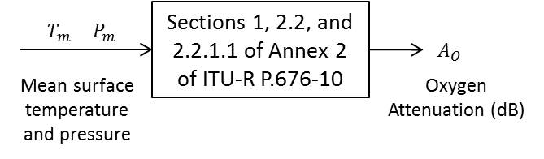

### 2.1.2 Single-site approach in Recommendation ITU-R P.1853-2

Due to the revision of Recommendation ITU-R P.676-10 in 2016, Recommendation ITU-R P.676‑11 requires surface temperature, dry surface pressure, and surface water vapour partial pressure while Recommendation ITU-R P.676-10 required only surface temperature and total surface pressure (even if pressure is often set at 1 013 hPa).

The approach in Recommendation ITU-R P.1853-2 to synthesize a constant value of oxygen gaseous attenuation is highlighted in Figure 2.

Figure 2

Block diagram of single-site oxygen gaseous attenuation time series synthesizer in  
Recommendation ITU-R P.1853-2

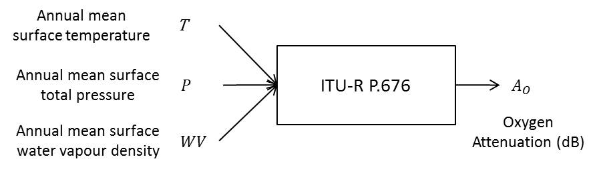

If annual mean surface temperature, annual mean surface air pressure, and annual mean surface water vapour density are not available from local data:

• The annual mean surface temperatures can be estimated using Recommendation ITU-R P.1510-1 (see Figure 3a). The digital map was derived using 36 years (1979-2014) of ECMWF ERA Interim data.

• The annual mean surface air pressure can be estimated using the digital map in Figure 3b). The digital map was derived using 36 years (1979-2014) of ECMWF ERA Interim data. It represents total pressure ($p_{dry}+e$). Note that up to now there is no recommendation for such parameter but data can be made available.

• The annual mean surface water vapour density can be estimated using the digital map in Figure 3c). The digital map was derived using 36 years (1979-2014) of the ECMWF ERA Interim data. Note that up to now there is no recommendation for such parameter but data can be made available.

Figure 3

Annual mean values of: a) Surface temperature (ITU-R P.1510-1), b) Surface pressure,   
and c) Surface water vapour density

|  |  |
| --- | --- |
| Surface_Temperature_ERA-Interim_Annual | Surface_Pressure_ERA-Interim_Annual |
| a) | b) |
| Surface_Water_Vapour_Density_ERA-Interim_Annual | |
| c) | |

From a technical point of view, by using the digital maps, surface pressure and surface water vapour density should be scaled in height above the surface, if required, to achieve the best estimates with respect to the actual altitude of the desired locations. However, oxygen gaseous attenuation has a very limited impact on the overall link budget at the current frequencies of interest (10-50 GHz) for SatCom systems. So, it is not currently proposed to perform the scaling.

### 2.1.3 Multi-site approach in Recommendation ITU-R P.1853-2

The multi-site approach to provide the mean oxygen gaseous attenuation for each site is shown in Figure 4. The spatial correlation of oxygen gaseous attenuation is directly given by the spatial correlation of the input meteorological parameters.

Figure 4

Block diagram of multi-site oxygen gaseous attenuation time series synthesizer in  
Recommendation ITU-R P.1853-2

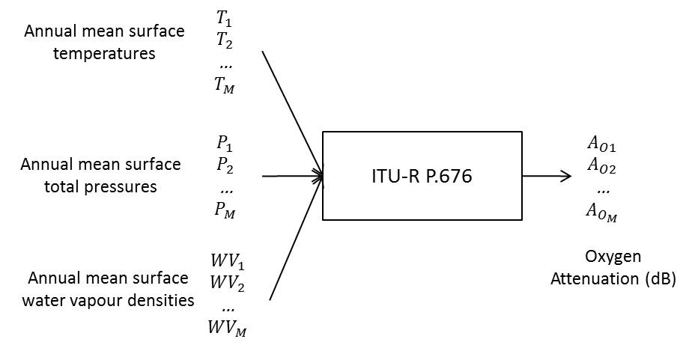

## 2.2 Water vapour gaseous attenuation

### 2.2.1 Single-site approach in Recommendation ITU-R P.1853-1

The single-site water vapour gaseous attenuation channel model in Recommendation ITU-‑R P.1853-1 is based on two observations:

• The CDF of the Integrated Water Vapour Content (IWVC) is well-approximated by a Weibull distribution with shape parameter *kIWVC* and scale parameter *λIWVC*

• The underlying correlated time series *GIWVC(t)* is a centred, reduced, first order stationary Markov process whose temporal autocorrelation function is 

Starting from these observations and defining $t=k Δt$, where $Δt$ is the sample time, the current approach in Recommendation ITU-R P.1853-1 to generate the time series of water vapour gaseous attenuation (generation of IWVC and then conversion to water vapour attenuation) is shown in Figure.

Figure 5

Block diagram of single-site water vapour attenuation time series synthesizer  
in ITU-R P.1853-1

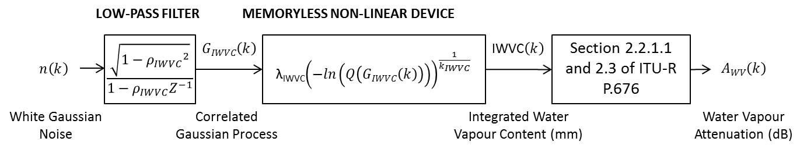

The underlying correlated Gaussian time series *GIWVC(k)* is generated by low pass filtering white Gaussian noise *n(k)* (see Figure ), , where  and *βIWVC-1* is the correlation time which should be Earth-Space links dependent. Water vapour gaseous attenuation is calculated from IWVC using equation (37) in Section 2.3 of Annex 2 of Recommendation ITU-R P.676-11.

### 2.2.2 Single-site approach in Recommendation ITU-R P.1853-2

#### 2.2.2.1 Principle

The block diagram of the single-site water vapour attenuation time series synthesizer in Recommendation ITU-R P.1853-2 is shown in Figure 6.

Figure 6

Block diagram of the single-site water vapour attenuation time series synthesizer in  
Recommendation ITU-R P.1853-2

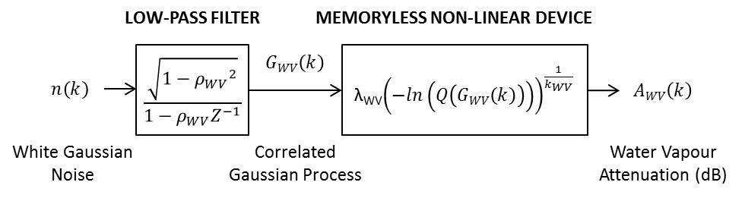

In comparison with Recommendation ITU-R P.1853-1, ITU-R P.1853-2 directly synthesizes the water vapour attenuation without first synthesizing the integrated water vapour content (IWVC) time series.

The water vapour gaseous attenuation CCDF is well-approximated by a Weibull distribution:

 (1)

where *kWV* and *λWV* are the shape and scale parameters, respectively.

In a similar way than in Section 2.2.1, the water vapour gaseous attenuation time series is synthesized using a stationary, centred, reduced, correlated Gaussian process *GWV(t)* with normal PDF and correlation function which is transformed into a water vapour attenuation process *AWV(t)* according to:

 (2)

Where *Q* is the complementary cumulative normal probability integral defined by:

 (3)

Starting from the analyses of two IWVC databases collected during the French Ka-band site diversity experiment [Boulanger et al., 2016] (see Section ‎0), the same formulation as ITU-R P.1853-1 is used, except the correlation coefficient which is now :

 (4)

where Δt is still the sampling time, and *βWV-1* is the single-site correlation time. *βWV-1* should also be Earth-Space link dependent (frequency, elevation and location dependant).

The correlated time series $G_{WV}(k)$ is synthesized using the correlation function $ρ_{WV}$ by low-pass filtering white Gaussian noise, where the low pass filter is defined by:

 (5)

i.e.



Justifications and parameterization of the new proposed water vapour attenuation time series synthesizer are proposed in the following Section.

#### 2.2.2.2 Justifications and parameterization

The water vapour attenuation time series synthesizer assumes:

• the water vapour gaseous attenuation CCDF given as input parameter is well-approximated by a Weibull distribution;

• the temporal autocorrelation of the underlying Gaussian process used to generate the water vapour attenuation process is a simple decaying exponential function.

During the French Ka-band site diversity experiment [Boulanger et al., 2016], two of the five experimental sites (Toulouse and Le Fauga) were equipped with radiometers allowing the IWVC to be inferred. The main characteristics of the radiometric data used in this study are provided in Table 1.

Table 1

Characteristics of radiometric data used in this study

|  |  |  |  |  |  |
| --- | --- | --- | --- | --- | --- |
| Locations | Latitude (°N) | Longitude (°E) | Altitude (km) | Type of radiometer | Period of measurements |
| Toulouse | 43.5710 | 1.4716 | 0.150 | Radiometrics TP/WVP 3000 | July 2013 – June 2017 (4 years) |
| Le Fauga | 43.3842 | 1.2846 | 0.190 | RPG HATPRO | January 2014 – December 2016 (3 years) |

Single-site $β_{IWVC}$ can be well-approximated by a constant value

First, the CCDFs of the IWVC data at zenith are computed for the two sites and the best Weibull distributions determined by minimizing the mean squared error between the IWVC data and the Weibull distribution. The values of $λ, k, and β$ for Toulouse Le Fauga, and Darmstadt are given in Table 2 ( s-1 in P.1853-1 was based on two years of Darmstadt data). As shown, the fixed value of $β_{IWVC}$ well-approximates $β_{IWVC}$ for several sites in Western Europe. Based the data for Darmstadt, Toulouse, and Le Fauga, it is proposed to use s-1, which is the time-weighted average of $β_{IWVC}$ for the three sites.

Single-site water vapour gaseous attenuation CCDF is well-approximated by a Weibull distribution

The IWVC CCDFs for Darmstadt, Toulouse, and Le Fauga were transformed into water vapour gaseous attenuation CCDFs for five representative frequencies (10 GHz, 20.2 GHz (ASTRA-3B), 30 GHz, 39.4 GHz (Alphasat), and 50 GHz) and two representative elevation angles (35° and zenith) using equation (37) of Annex 2 of Recommendation ITU-R P.676-11. Each derived water vapour gaseous attenuation CCDF was then fit with a Weibull distribution. The derived water vapour gaseous attenuation CCDF (“experimental”) and best-fit Weibull CCDF (“Weibull CCDF”) are shown in Figures 8 and 9 at zenith and 35°, respectively. These excellent results validate that the single-site water vapour gaseous attenuation CCDF is well-approximated by a Weibull distribution.

Note that:

• the best-fit IWVC and water vapour gaseous attenuation $β$ parameter is approximately equal for Toulouse and Le Fauga, and

• the best-fit IWVC and water vapour gaseous attenuation $λ$ and *k* parameter are approximately equal for Toulouse and Le Fauga.

Figure 7

CCDF of IWVC at zenith for Toulouse and Le Fauga

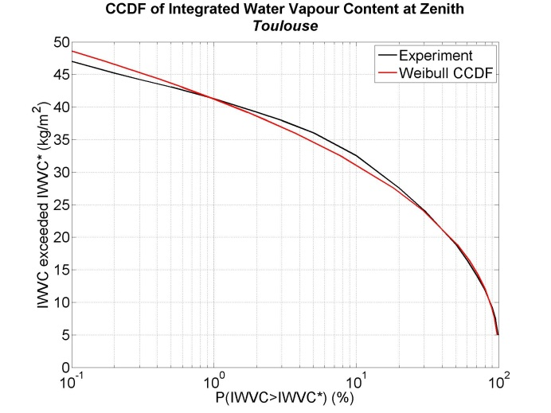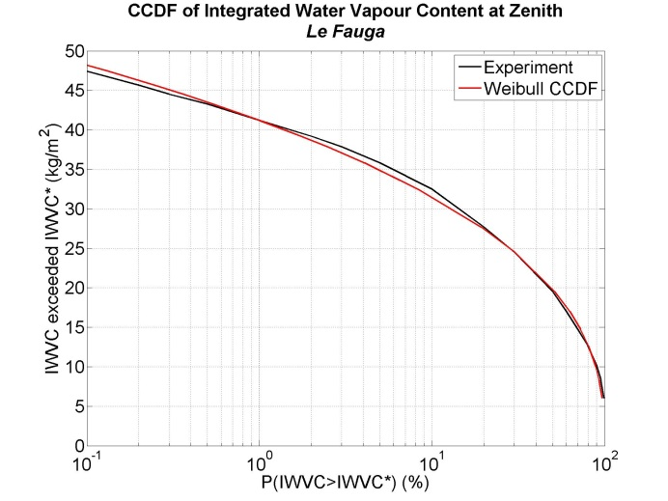

Figure 8

CCDF of Water Vapour attenuation at zenith for Toulouse and Le Fauga

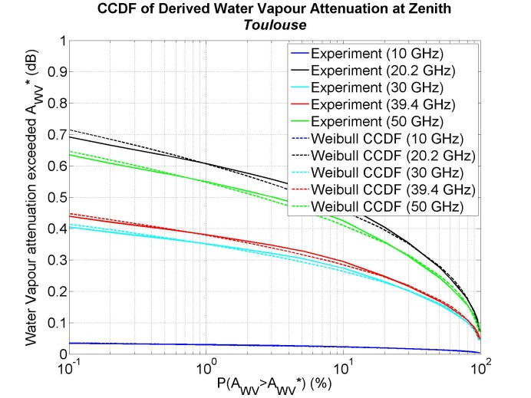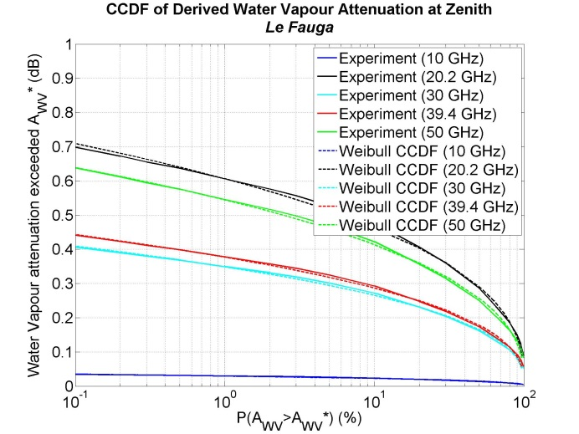

Figure 9

CCDF of Water Vapour attenuation at 35° of elevation for Toulouse and Le Fauga

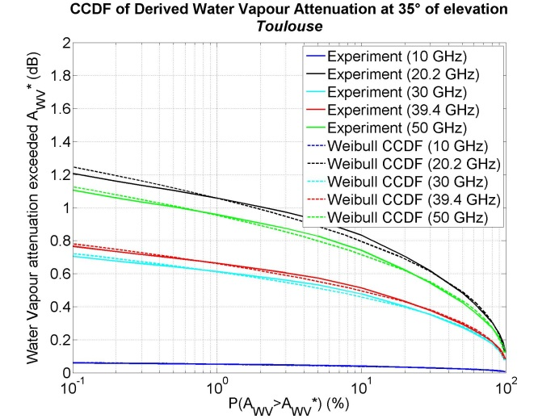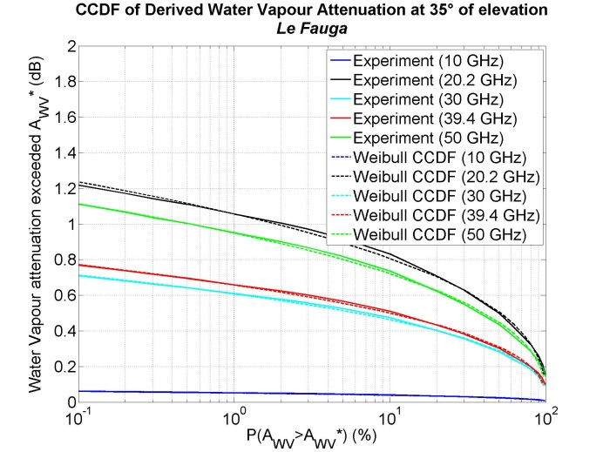

The temporal correlations $c_{G_{IWVC}}(τ)$ = $c_{G_{WV}}(τ)$

The following four temporal autocorrelation functions have been computed for Toulouse and Le Fauga:

• , the temporal autocorrelation function of the IWVC time series,

• , the temporal autocorrelation function of the Gaussian time series *GIWVC* used to generate the IWVC time series,

• , the temporal autocorrelation function of the water vapour attenuation time series, *AWV*,

• , the temporal autocorrelation function of the Gaussian time series *GWV* used to generate the water vapour attenuation time series *AWV*.

The water vapour attenuation time series *AWV* was derived from the IWVC time series using equation (37) of Annex 2 of ITU-R P.676-11, and the correlations $c_{G_{IWVC}}$ and $G_{WV}$ of the underlying Gaussian processes *GIWVC* and *GWV* were computed after inversion of the IWVC and *AWV* time series using:

 (6)

and the results are shown in Figure 10.

Note that:

• the correlation functions $c_{IWVC}(τ)$ and $c_{A_{WV}}(τ)$ of IWVC and *AWV*are identical;

• the correlation functions $c_{G_{IWVC}}(τ)$ and $c_{G_{WV}}(τ)$ of the Gaussian time-series $G_{IWVC}$ and $G_{WV}$ are identical;

• the correlation functions of the Gaussian IWVC time series and the IWVC time series are approximately equal; i.e. ;

• the correlations functions of the Gaussian water vapour gaseous attenuation time series and water vapour gaseous attenuation time-series are approximately equal; i.e. ;

• the corresponding correlations functions for Toulouse and Le Fauga are approximately equal.

The correlation functions $c_{A_{WV}}(τ)$ and $c_{G_{WV}}(τ)$ were then fit to negative exponential functions as shown in Figure 11; and the negative exponential function used to generate the IWVC time-series in ITU-R P.1853-1 is included for reference. As shown, a negative exponential function well‑approximates $c_{A_{WV}}(τ)$ and $c_{G_{WV}}(τ)$ for time lags less than 24 hours. For longer time lags, the decaying exponential function will underestimate the actual correlation. The correlation parameters $β_{IWVC}$ and $β_{WV}$ for Toulouse and Le Fauga are summarized in Table 2. Note that for a given location,  is independent of both frequency and elevation.

It is proposed to use *βWV* = 3.65 × 10-6 s-1 as a generic value that corresponds to the mean value for Darmstadt, Toulouse and Le Fauga weighted by the number of observation years.

Figure 10

Temporal correlation of water vapour processes for Toulouse and Le Fauga

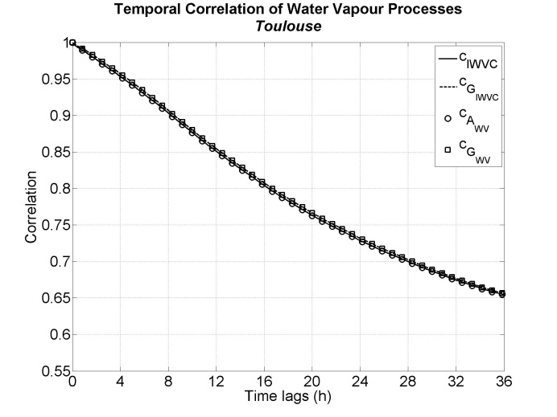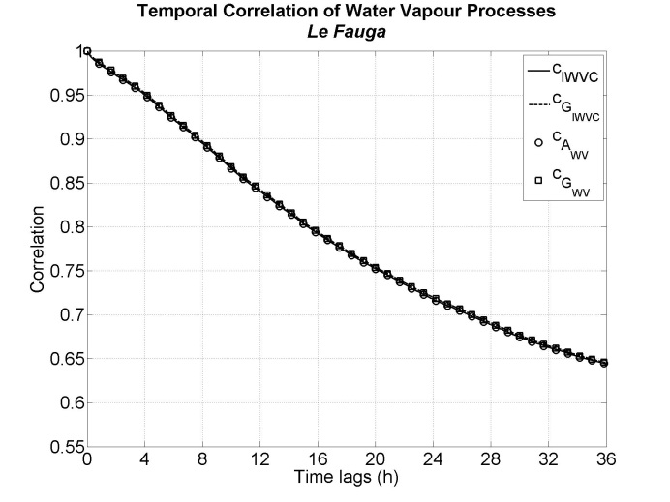

Figure 11

Temporal correlation of water vapour processes for Toulouse and Le Fauga and associated best fittings

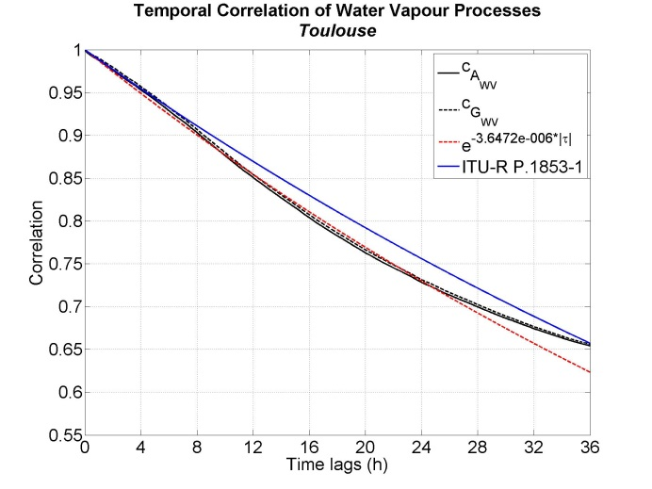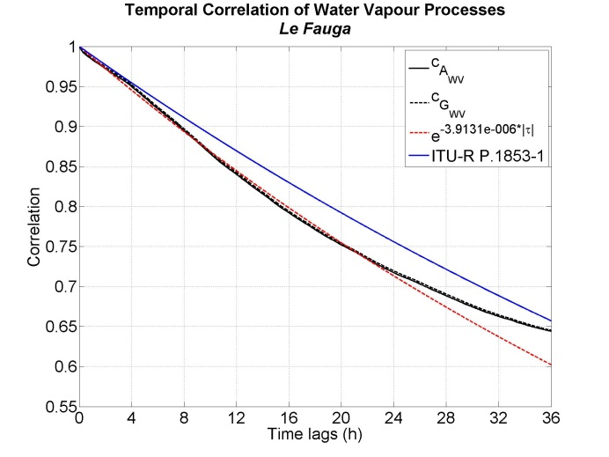

Table 2

Input parameters associated with water vapour processes

|  |  |  |  |  |
| --- | --- | --- | --- | --- |
| Locations | | *λ* | *k* | *β (s-1)* |
| Darmstadt | IWVC | 16.88 | 2.17 | 3.24e-6 (ITU-R P.1853-1) |
| Toulouse | IWVC | 22.202 6 | 2.467 7 | 3.644 5e-6 |
| Water vapour attenuation (20.2 GHz – 35° of elevation) | 0.568 9 | 2.464 5 | 3.647 2e-6 |
| Le Fauga | IWVC | 22.831 8 | 2.587 3 | 3.909 8e-6 |
| Water vapour attenuation (20.2 GHz – 35° of elevation) | 0.585 1 | 2.583 0 | 3.913 1e-6 |

### 2.2.3 Multi-site approach in Recommendation ITU-R P.1853-2

#### 2.2.3.1 Principle

The block diagram of the multi-site water vapour gaseous attenuation time series synthesizer in Recommendation ITU-R P.1853-2 is shown in Figure 12.

Figure 12

Block diagram of the multi-site water vapour gaseous attenuation time series synthesizer in  
Recommendation ITU-R P.1853-2

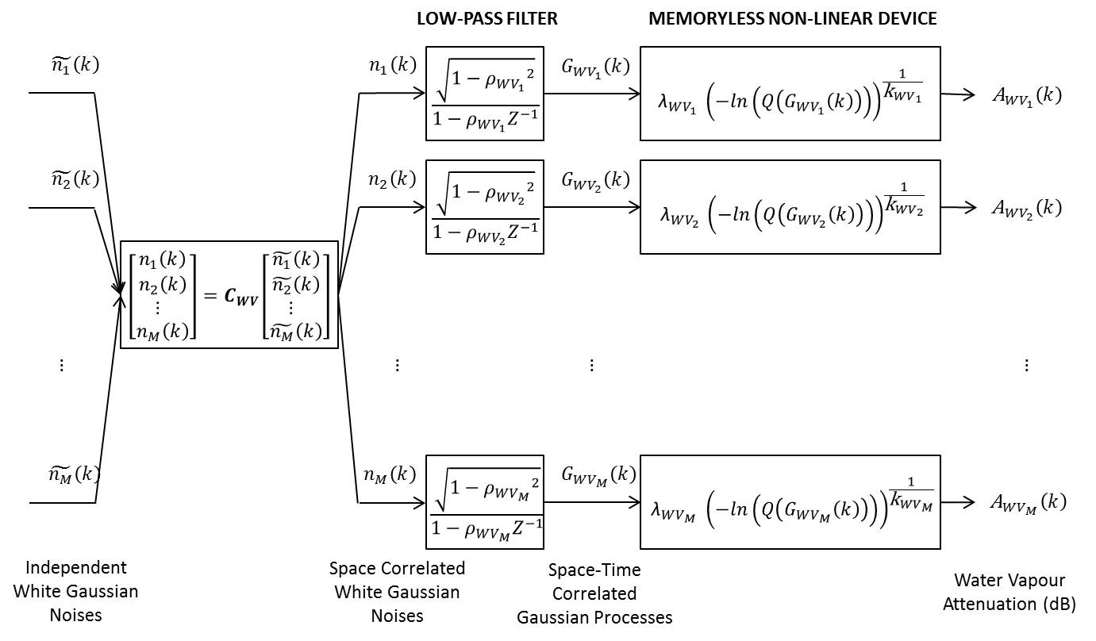

The multi-site water vapour gaseous attenuation time series synthesizer is based on the space-time correlated rain attenuation time series synthesizer of [Cheffena et al., 2009]. The objective is to generate space-time correlated water vapour gaseous attenuation time series  from the space-time correlated Gaussian time series .

Denote:

 temporal autocorrelation of the Gaussian process  on site *i*,

 where Δt the sampling time

 equivalent spatial correlation of the Gaussian noise $G_{WV}$ between site *i*and site *j*,

$\tilde{n_{i}}$ independent white Gaussian noise

$n_{i}$ correlated Gaussian noise

As shown in Figure 12,  is generated by low pass filtering *ni(t)*:

 (7)

Therefore,

 (8)

 since they are independent.

As a result:

 (9)

where  is the spatial correlation of $n_{i}$ and $n_{j}$

Solving (9),

 (10)

which agrees with [Cheffena et al., 2009].

Finally, the last step consists in generating the spatially correlated white Gaussian noises *ni(t)*. It can easily be done by choosing the Cholesky factorization of the matrix ***Rn*** = [Therrien, 1992]:

Rn=CWVCWVH (11)

where ***CWV*** is a lower triangular matrix.

Note that in the case for which  (i.e. the correlation time is the same for each site), equation (10) becomes , and so the Cholesky factorization could be directly performed on  which does not depend on correlation times.

#### 2.2.3.2 Parameterization

The space-time correlated water vapour gaseous attenuation time series synthesizer requires the following input parameters:

•  andcharacterize the CCDF of water vapour gaseous attenuation for the ith Earth-space link;

• characterizing the temporal dynamics of the water vapour attenuation time series for the ith Earth-space link under investigation;

• , which is the spatial correlation between the ith and jth Earth-space link.

 and can be derived using local data. If local data is not available,  and can be derived by a combination of the IWVC maps in Recommendation ITU-R P.836 and Annex 2 of Recommendation ITU-R P.676 when no local data are available.  can be derived from local data. If local data is not available, can be set to a fixed value of 3.65 x 10-6 s-1.

Based on an atmospheric numerical simulations of the IWVC fields (two first days of each month in 2009), [Jeannin et al., 2011] has proposed the following function for , where $D_{ij}$ is the distance between the ith and jth site:

 (12)

As explained in [Jeannin et al., 2011], this function exhibits a very slow decay vs. separation distance because the mean water vapour content is predominantly linked to large scale meteorological phenomena.

Starting from the observations made on the temporal correlations, it is assumed that .

An example of output of the space-time correlated water vapour attenuation time series synthesizer is shown in Figure 13 corresponding to the Ka-band site diversity experiment [Boulanger et al, 2016]. The input parameters  and  for each site were derived from the Recommendation ITU-R P.836 maps and Equation (37) of section 2.3 of Annex 2 of ITU-R P.676-11, and βWVi is 3.65 × 10-6 for all sites.

Figure 13

Example of output of the multi-site water vapour attenuation time series synthesizer in  
Recommendation ITU-R P.1853-2

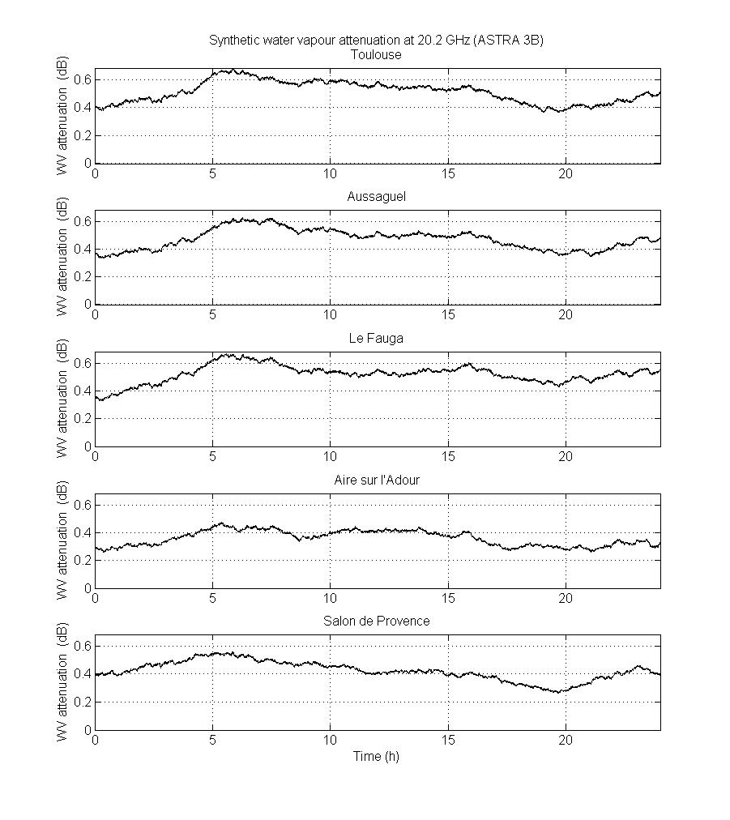

## 2.3 Cloud attenuation

### 2.3.1 Single-site approach in Recommendation ITU-R P.1853-1

The single-site approach in Recommendation ITU-R P.1853-1 is based on two strong hypotheses:

• The integrated liquid water content (ILWC) follows a Mixed Dirac-lognormal distribution with parameters:

*− PILWC* (probability of clouds);

*− mILWC* (mean parameter);

*− σILWC* (standard deviation parameter).

• The underlying process *GILWC(t)* of the ILWC process is a centred, reduced, Gaussian process whose temporal autocorrelation function is .

Starting from these hypotheses, the current approach to generate time series of cloud attenuation is highlighted in Figure 14.

Figure 14

Bloc diagram of the single-site cloud attenuation time series synthesizer in Recommendation ITU-R P.1853-1

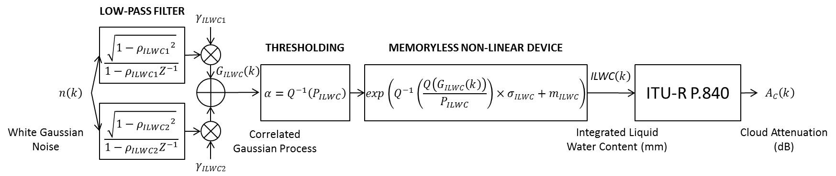

The underlying Gaussian time series *GIWVC(k)* is generated through the sum of two low pass filtering of a white Gaussian noise *n(k)* (see Figure 14) where:

 (13)

*Δt* being the sampling rate.

ILWC is transformed into cloud attenuation using Section 3.1 or 3.2 of Recommendation ITU‑R P.840.

### 2.3.2 Single-site approach in Recommendation ITU-R P.1853-2

#### 2.3.2.1 Principle

The block diagram of the single-site cloud attenuation time series synthesizer in Recommendation ITU-R P.1853-2 is shown in Figure 15.

Figure 15

Block diagram of the single-site cloud attenuation time series synthesizer in Recommendation ITU-R P.1853-2

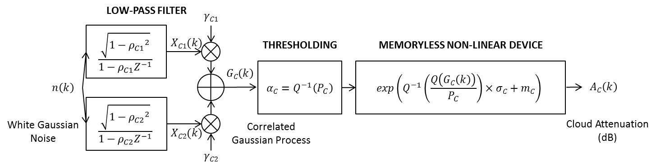

It is proposed to directly generate cloud attenuation. The absolute cloud attenuation CCDF given as input parameter is represented by a Mixed Dirac-lognormal distribution:

 (14)

where *PC* is the probability to have cloud attenuation on the link (which could be roughly equal to the probability of cloud). *mC* and *σC* are the mean and standard deviation of the cloud attenuation **conditional** PDF *p(AC/AC>0).*

To generate a synthetic cloud attenuation time series, a stationary, centred, reduced, correlated Gaussian process *GC(t)* with normal PDF and correlation function is generated and then turned into a cloud attenuation process *AC(t)* according to:

 (15)

where .

Starting from the analyses of two ILWC databases collected during the Ka-band site diversity experiment [Boulanger et al., 2016] (same database than in Section 2.2 and described in Table 1), it is proposed to use the same formulation than in Recommendation ITU-R P.1853-1 but this time for the correlation function of the underlying Gaussian process, , used to generate the cloud attenuation process:

 (16)

where *aC*, *βC1* and *βC2* should be Earth-space link dependent.

The underlying Gaussian process *GC* is then generated through the sum of two low pass filtering of a white Gaussian noise *n* (see Figure 15) where:

 (17)

*Δt* being the sampling rate.

#### 2.3.2.2 Justifications and parameterization

The first assumption of the new proposed cloud attenuation time series synthesizer is that the conditional cloud attenuation CCDF given as input parameter is assumed to follow a log-normal distribution.

Recommendation ITU-R P.840-6 provides a method to compute cloud liquid water specific attenuation coefficient *Kl*(*f*,*T*) depending on frequency, *f*, and temperature, *T*, which is used as input for the computation of cloud attenuation by:

 (18)

where *ILWCred* is the total columnar content of liquid water reduced to a temperature of 273.15 K and *φ* is the elevation angle.

As *ILWCred* is not easily available from experimental measurements, Recommendation ITU-R P.840 also provides a method to derive cloud attenuation from local data. Based on local data of ILWC (not reduced to 273.15 K), cloud attenuation could be computed as:

 (19)

where  is used in place of .

In both cases, reduced or not reduced *ILWC* are multiplied by a constant to get cloud attenuation. So, starting from the assumption that the conditional distribution of *ILWC* (or *ILWCred*) follows a lognormal distribution, it results that:

 (20)

where X is a normally distributed random variable with zero mean and unit variance.

Then, using (20) in (19) results in:

 (21)

So, the conditional distribution of *AC* follows a lognormal distribution with parameters:

 (22)

It is also straightforward in this case that  and so  validating the second assumption of the new proposed cloud attenuation time series synthesizer.

First the CCDFs of ILWC at zenith are computed for the two sites and the best Dirac-Lognormal distributions are fitted over the experimental results. The same database than in Section ‎0 and described in Table 1 has been used. The results are given in Figure 16. As observed, the assumption made in ITU-R P.1853-1 seems to be well appropriate.

Then, the CCDFs of ILWC are turned into CCDFs of cloud attenuation using the proposed revision to Recommendation ITU-R P.840. Five frequencies have been chosen, 10 GHz, 20.2 GHz (ASTRA-3B), 30 GHz, 39.4 GHz (Alphasat), and 50 GHz. The best conditional lognormal distributions are also fitted over the experimental results according to the methodology described above. The results are shown in Figure 17 and Figure 18 respectively at zenith and 35° of elevation. It can be observed that the conditional lognormal distributions are perfectly in agreement. The distributions parameters for the two locations are summarized in Table 3. For information, results derived from 2 years of radiometric data collected in Darmstadt (Germany) and reported in Recommendation ITU-R P.1853-1 are also highlighted. Two observations can be made:

• As expected, the parameter σC and σILWC are identical when using ILWC and cloud attenuation (see the methodology above).

• The results for Toulouse and Le Fauga are very close.

Table 3

Input distribution parameters associated with cloud processes

|  |  |  |  |  |
| --- | --- | --- | --- | --- |
| Locations | | *PC* (%) | *m* | *σ* |
| Darmstadt | ILWC | 49.43 | -2.43 | 1.27 |
| Toulouse | ILWC | 23.189 7 | -1.488 6 | 0.551 0 |
| Cloud attenuation (20.2 GHz – 35° of elevation) | 23.189 7 | -1.818 1 | 0.551 0 |
| Le Fauga | ILWC | 23.062 3 | -1.456 0 | 0.570 1 |
| Cloud attenuation (20.2 GHz – 35° of elevation) | 23.062 3 | -1.785 5 | 0.570 1 |

Figure 16

CCDF of ILWC at zenith for Toulouse and Le Fauga

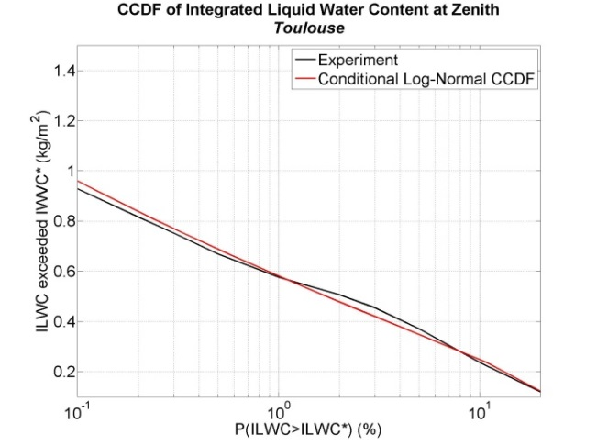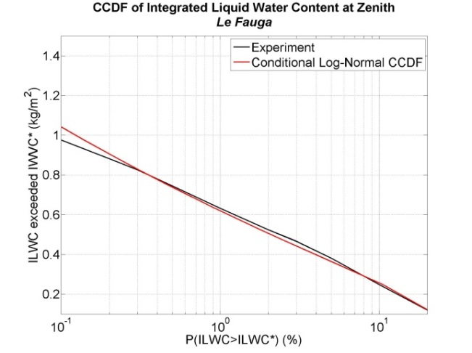

Figure 17

CCDF of cloud attenuation at zenith for Toulouse and Le Fauga

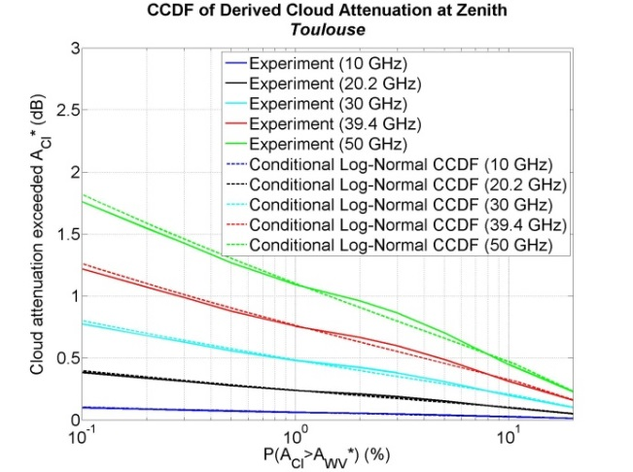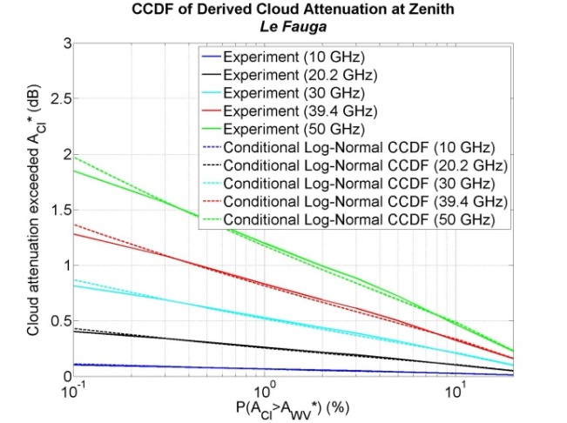

Figure 18

CCDF of cloud attenuation at 35° of elevation for Toulouse and Le Fauga

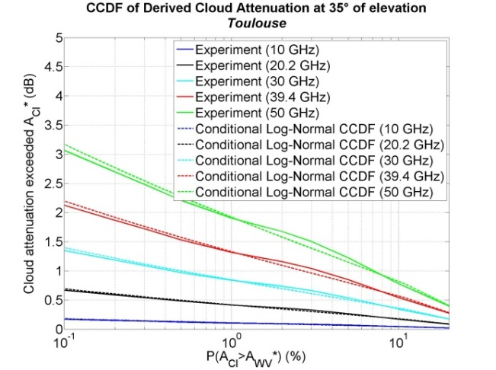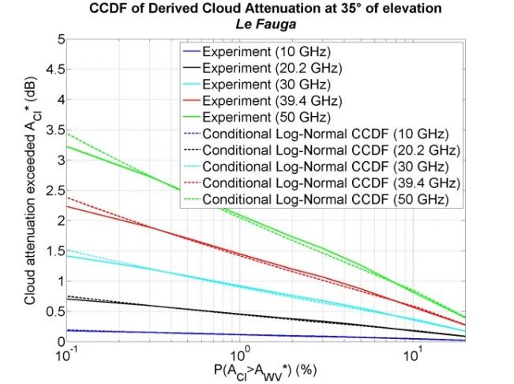

As previously mentioned, . It straightforwardly results in:

 (23)

So, only temporal autocorrelations of cloud attenuation will be investigated. The following two temporal autocorrelation functions have been computed for the two sites:

• , the temporal autocorrelation function of the cloud attenuation process *AC*,

• , the temporal autocorrelation function of the underlying Gaussian process *GC* used to generate the cloud attenuation process *AC*,

The results are shown in Figure 19. The best double exponential decaying functions are fitted over the experimental correlation functions . For information, the correlation of the underlying Gaussian process used to generate the ILWC process in Recommendation ITU-R P.1853-1 is highlighted. The double decaying exponential function seems to be well appropriate for time lags less than one day and a half. For longer time lags, the model will tend to underestimate the actual correlation. The correlation parameters for the two locations are summarized in Table 4.

As observed for the water vapour processes, the results for Toulouse and Le Fauga are very close.

Figure 19

Temporal correlation of cloud processes for Toulouse and Le Fauga and associated best fittings

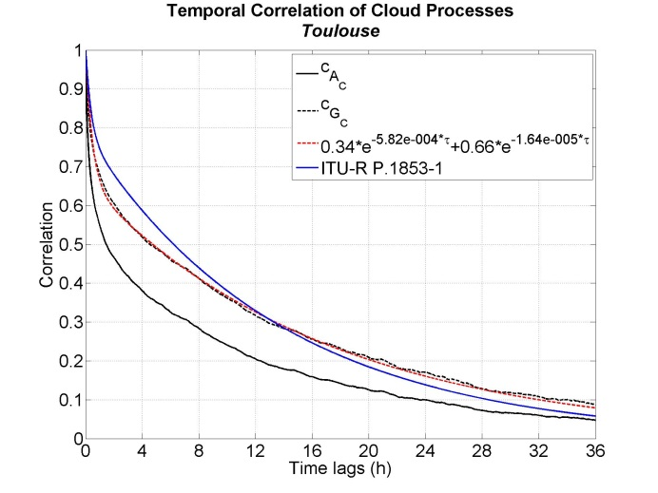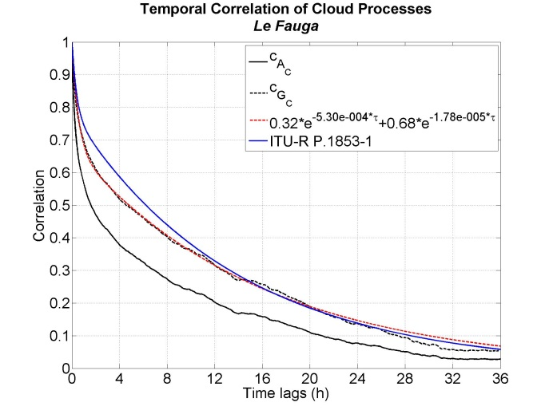

Table 4

Input correlation parameters associated with cloud processes

|  |  |  |  |  |  |
| --- | --- | --- | --- | --- | --- |
| Locations | *A* | *βC1* | *βC2* | *𝛾C1* | *𝛾C2* |
| Darmstadt  (ITU-R P.1853-1) | 0.216 | 7.14e-4 | 2.01e-5 | 0.349 | 0.83 |
| Toulouse | 0.339 2 | 5.817 9e-4 | 1.638 5e-5 | 0.474 1 | 0.739 2 |
| Le Fauga | 0.320 9 | 5.304 1e-4 | 1.775 7e-5 | 0.449 2 | 0.748 4 |

It is then proposed to use as a generic function:

 (24)

where:

 (25)

and so

 (26)

as generic values that correspond to the mean values for Darmstadt, Toulouse and Le Fauga weighted by the number of observation years.

### 2.3.3 Multi-site approach in Recommendation ITU-R P.1853-2

#### 2.3.3.1 Principle

The block diagram of the multi-site cloud attenuation time series synthesizer is shown in Figure 20.

Figure 20

Block diagram of the multi-site cloud attenuation time series synthesizer in Recommendation ITU-R P.1853-2

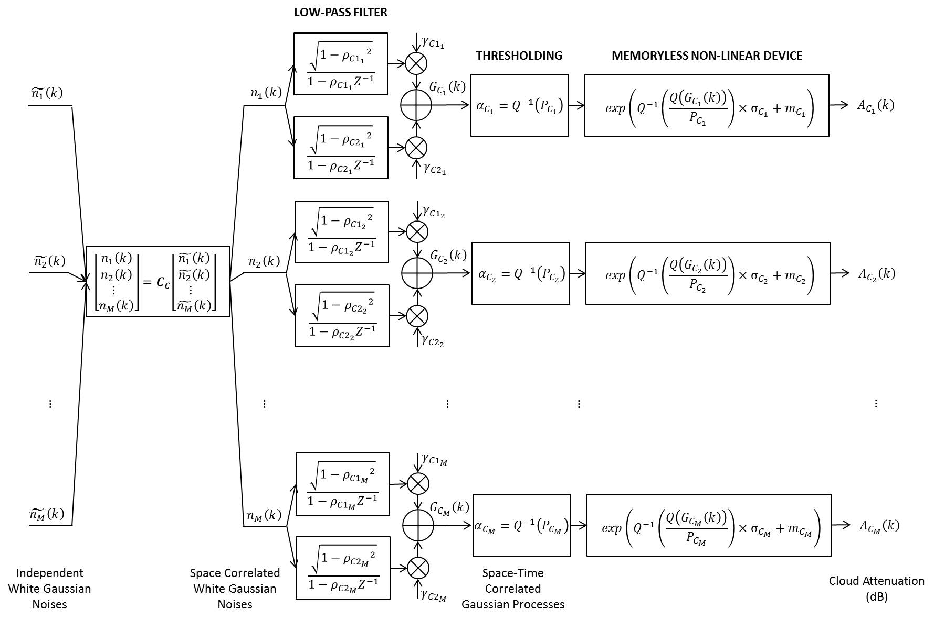

The principle of the multi-site cloud attenuation time series synthesizer is still based on a combination of the work on space-time correlated rain attenuation time series synthesizer of [Cheffena et al., 2009] and of the work in Section 2.2.

The objective is to generate space-time correlated cloud attenuation time series  from underlying space-time correlated Gaussian processes .

Denote:

•  temporal autocorrelation of the Gaussian process  on site *i*;

•  where Δt the sampling time;

•  where Δt the sampling time;

•  equivalent spatial correlation of the Gaussian processes between site *i*and site *j*.

By definition of the Gaussian time series  generated through the double low pass filtering of a white noise *ni(t)*:

 (27)

where:

 (28)

Therefore,

 (29)

Using (28), (8), (9), and (10), it results:

 (30)

where  defines the equivalent spatial correlation of the white Gaussian noises.

By analogy:



 (31)



Using (30) and (31) in (29), it becomes:

 (32)

Solving (32),

(33)

Finally, the last step consists in generating the spatially correlated white Gaussian noises *ni(t)*. It can easily be done by choosing the Cholesky factorization of the matrix ***Rn*** = [Therrien, 1992]:

**Rn**=**CCCC**H (34)

where ***CC*** is a lower triangular matrix.

Note that in the case only one generic correlation for the underlying Gaussian processes is used, i.e. if:

 (35)

(33) becomes:

 (36)

Recalling (27) and that  is a centred, reduced, Gaussian process:

 (37)

As *ni* is a white Gaussian noise, . Consequently,

 and so (36) becomes . In this special case, the Cholesky factorization could be directly performed on  which does not depend on correlation times.

#### 2.3.3.2 Parameterization

The space-time correlated cloud attenuation time series synthesizer requires as input parameters:

• the parameters sets (,)characterizing the conditional PDF of cloud attenuation for each Earth-Space link under investigation;

•  being the probability of cloud attenuation;

• characterizing the dynamics of the cloud attenuation process for each Earth-Space link under investigation;

•  being the equivalent spatial correlation of the underlying Gaussian processes.

and can be derived either using experimental measurements or using Recommendation ITU-R P.840 when no local data are available.  can be roughly approximated by  also given by Recommendation ITU-R P.840.  can be derived from experimental time series or using the generic values proposed in Section 2.3.2.

Based on atmospheric numerical simulations of the ILWC fields (two first days of each month in 2009), [Jeannin at al., 2011] has proposed a modelling of the spatial correlation of the underlying Gaussian fields of the ILWC fields, , as a function of the site separation distance:

 (38)

where *Dij* is the separation distance between sites *i* and *j*.

Starting from the observations made on the temporal correlations (Section ‎0), it is assumed that .

An example of output of the space-time correlated cloud attenuation time series synthesizer is given in Figure 21. It is supposed to simulate the Ka-band site diversity experiment. However, the input parameters , , and  were derived from Recommendation ITU-R P.840 and the dynamic parameters have been fixed to the generic values highlighted in Section 2.3.2.

Figure 21

Example of output of the multi-site cloud attenuation time series synthesizer in  
Recommendation ITU-R P.1853-2

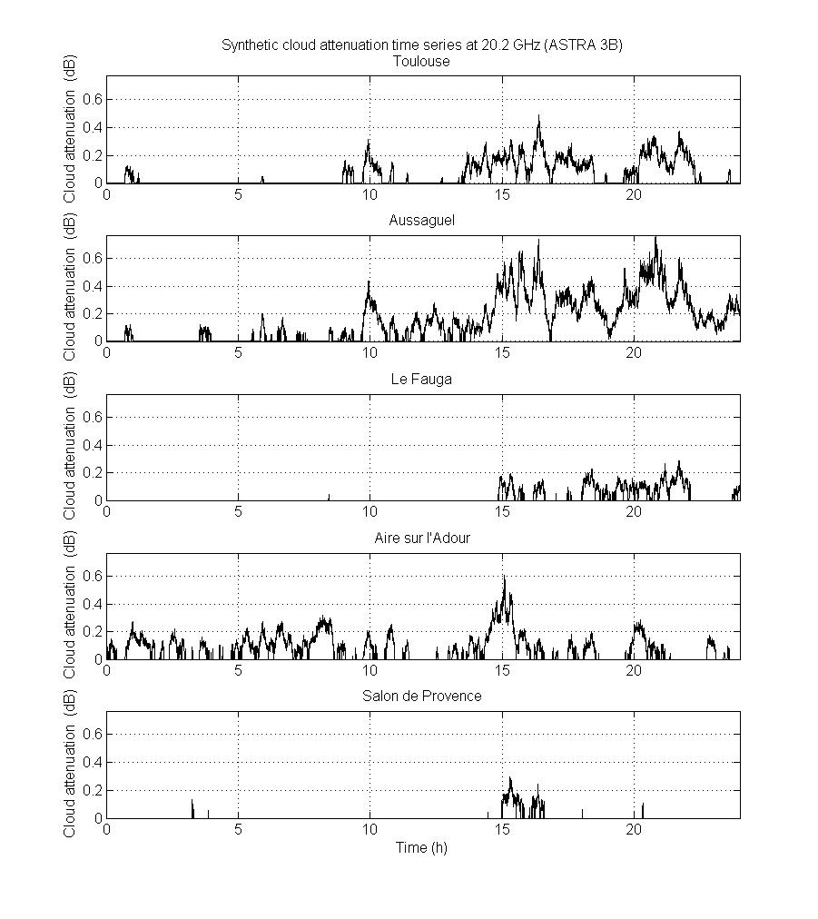

## 2.4 Rain attenuation

### 2.4.1 Single-site approach in Recommendation ITU-R P.1853-1

The single-site rain attenuation time series synthesizer in Recommendation ITU-R P.1853-1 is based on strong hypotheses:

•The ***non-conditioned*** rain attenuation follows a lognormal distribution with parameters:

*○ mR* (mean parameter);

*○ σR* (standard deviation parameter).

• The underlying process *GR* of the rain attenuation process is a centred, reduced, first order stationary Markov process of which the temporal autocorrelation function is .

An empirical offset *Aoffset* (depending on the probability of rain attenuation) is thus used to generate non-rainy periods.

Starting from these hypotheses, lock diagram of the single-site rain attenuation time series synthesizer in Recommendation ITU-R P.1853-1 is highlighted in Figure 22.

Figure 22

Block diagram of the single-site rain attenuation time series synthesizer in Recommendation ITU-R P.1853-1

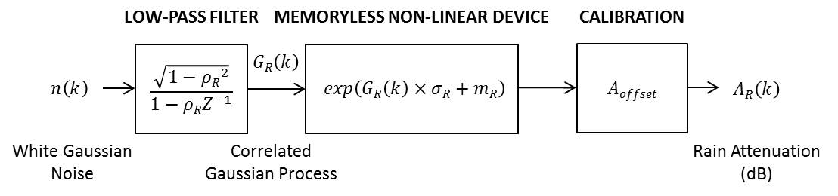

All limitations of this approach are summarized in [Boulanger et al., 2013], in particular the explanation on the inability of the model to reproduce the distribution given as input parameters.

### 2.4.2 Single-site approach in Recommendation ITU-R P.1853-2

#### 2.4.2.1 Principle

To overcome the limitations of the Recommendation ITU-R P.1853-1, a new rain attenuation synthesizer has been proposed in [Boulanger et al., 2013]. The latter has to generate rain attenuation time series *AR(t)* including rain and no rain periods. It is able to reproduce the 1st order statistics given as input parameters (which is not the case for Recommendation ITU-R P.1853-1 due to the offset parameter) and, for worldwide applications, is able to reproduce any correlation function.

The absolute rain attenuation CCDF given as input parameter is represented by a mixed Dirac-lognormal distribution:

 (39)

where PR is the probability to have rain attenuation on the link.  and  are the mean and standard deviation of the rain attenuation **conditional** PDF *p(AR/AR>0).*

To generate a synthetic rain attenuation time series, a stationary, centred, reduced, correlated Gaussian process *GR(t)* with normal PDF *pG* and arbitrary correlation function can be generated in the Fourier domain in compliance with the methodology presented in [Boulanger et al., 2013]. *GR(t)* is then turned into a rain attenuation process *AR(t)* according to:

 (40)

where .

The generation of the Gaussian process *GR(t)* in the Fourier domain tends to make the synthesizer more flexible w.r.t. Recommendation ITU-R P.1853-1.

Nevertheless, the correlation function  of the Gaussian process *GR(t)* has to be set so that, after transformation, the correlation of *AR(t)* must reproduce the correlation derived from experimental rain attenuation time series. Considering various rain attenuation experimental databases, [Lacoste et al., 2005] and then Recommendation ITU-R P.1853-1 proposed the average formulation for the correlation function of the Gaussian process :

 (41)

where *βR-1* defines the correlation time and should be Earth-space links dependent. This assumption is well convenient for system applications as it now possible to generate the correlated Gaussian process *GR(t)* by low pass filtering of a white Gaussian noise instead of using the Fourier transform which is a little bit more tricky. The low pass filter is then defined by:

 (42)

where  and Δt is the sampling time.

Finally, [Boulanger et al., 2013] shows that to be able to reproduce the dynamics of rain attenuation given by Recommendation ITU-R P.1853-1 (i.e. to not degrade the performances of the current standard model), the decaying exponential function is also applicable with a slight modification of the *βR* value.

The final block diagram of the rain attenuation time series synthesizer proposed in [Boulanger et al., 2013] is shown in Figure 23.

Figure 23

Block diagram of the single-site rain attenuation time series synthesizer proposed in [Boulanger et al., 2013]

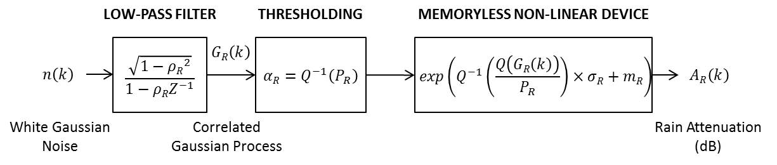

Note that at this stage, the proposed model is in line with the methodology to generate cloud attenuation but with a simple decaying exponential function for the temporal autocorrelation of the underlying Gaussian process *GR* used to generate the rain attenuation process *AR* as for water vapour attenuation. However, recent analyses of  (see Section 2.4.2.2) tend to challenge the assumption of the simple decaying exponential function with a double one leading to:

 (43)

In that case, the block diagram of the second option (selected for Recommendation ITU-R P.1853-2) would be as in Figure 24 and identical to cloud attenuation.

Figure 24

Block diagram of the single-site rain attenuation time series synthesizer in Recommendation ITU-R P.1853-2

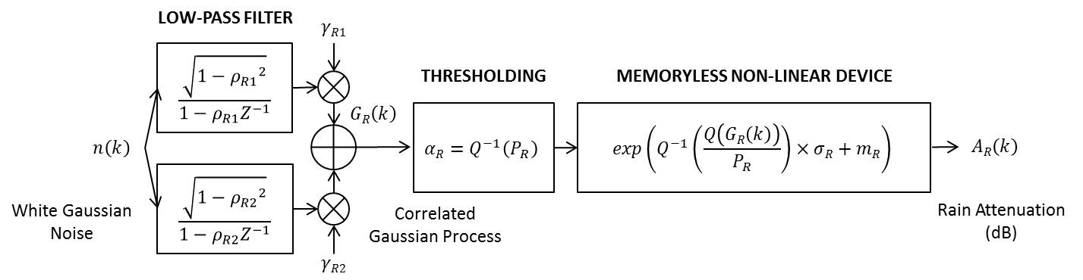

This second approach is very interesting for two reasons:

• The methodology is absolutely identical to cloud attenuation.

• The same underlying Gaussian process could be used for rain and cloud attenuation simplifying the way to generate total attenuation time series.

#### 2.4.2.2 Justifications and parameterization

 and  can be fitted over the experimental CCDF of rain attenuation. If *PR*, the probability of rain attenuation on the link, is not experimentally available, Section 2.2.1.2 of Recommendation ITU-R P.618-13 can be used.

The temporal autocorrelations of rain attenuation are investigated. The following two temporal autocorrelation functions have been computed for all the five sites of the Ka-band site diversity experiment:

• , the temporal autocorrelation function of the rain attenuation process *AR*;

• , the temporal autocorrelation function of the underlying Gaussian process *GR* used to generate the cloud attenuation process *AR*.

The results are shown in Figure 25. The best double exponential decaying functions are fitted over the experimental correlation functions . Moreover, according to the methodology described in [Boulanger et al., 2013] to derive the optimal *βR* value, the simple decaying exponential function is highlighted. For information, when available, the correlation of the underlying Gaussian process used to generate the cloud attenuation process is shown.

As observed, the double decaying exponential function seems to be more appropriate than the simple decaying exponential function. The simple decaying exponential function is only able to reproduce dynamics for time lags shorter than half an hour. This is mainly due to the retrieval routine of *βR* which is based on the second order conditional moment of *AR* [Lacoste et al., 2005]. Only short time lags are considered. The correlation parameters for the five locations are summarized in Table 5.

Figure 25

Temporal correlation of rain processes for Toulouse, Le Fauga, Aussaguel, Aire sur l’Adour, and Salon de Provence and associated best fittings

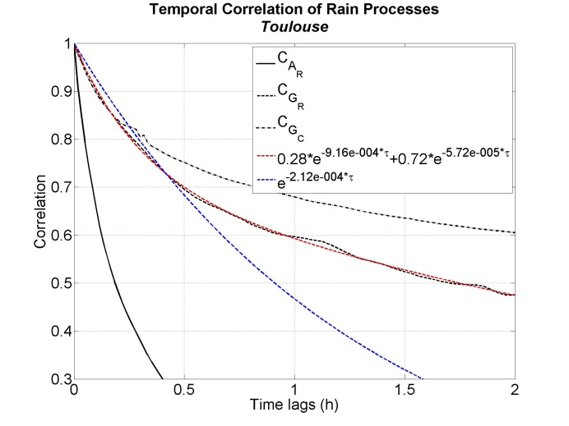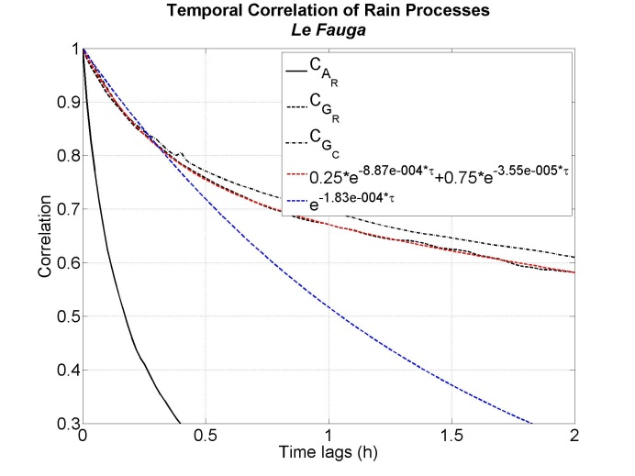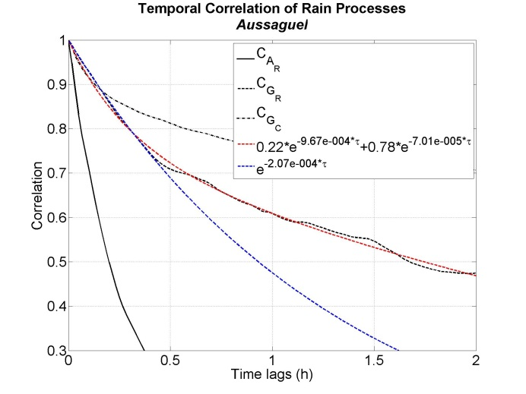

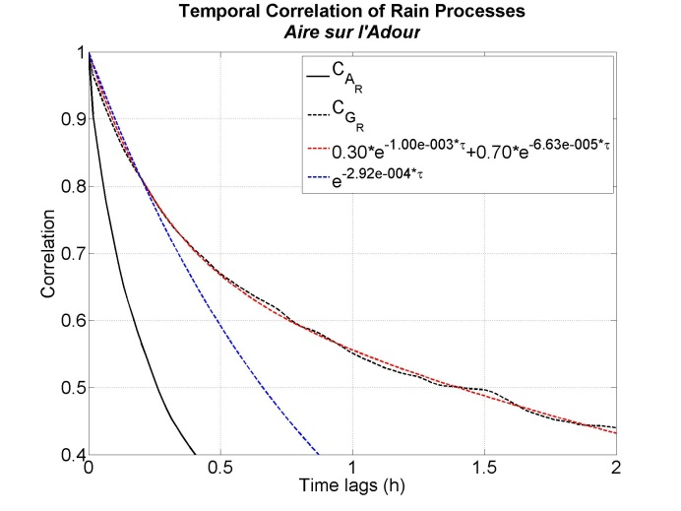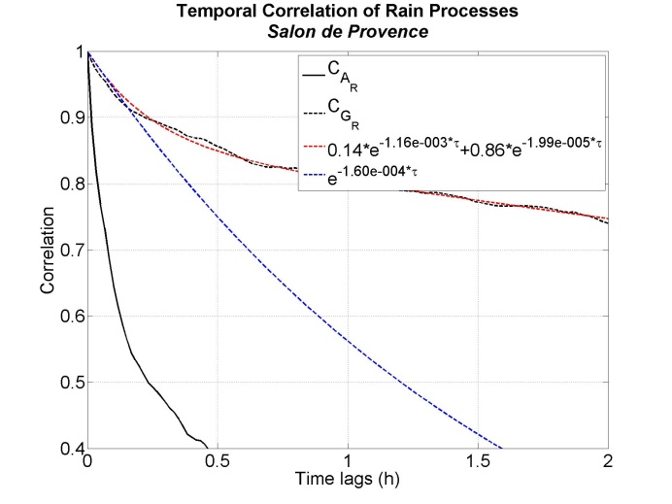

Table 5

Input correlation parameters associated with rain processes

|  |  |  |  |  |  |  |  |
| --- | --- | --- | --- | --- | --- | --- | --- |
| Locations | Durations | *βR* | *aR* | *βR1* | *βR2* | *𝛾R1* | *𝛾R2* |
| **ITU-R P.1853-1** |  | 2e-4 |  |  |  |  |  |
| **Toulouse** | 4 years (July 2013-June 2017) | 2.115 0e-4 | 0.284 6 | 9.158 9e-4 | 5.724 5e-5 | 0.383 8 | 0.760 3 |
| **Le Fauga** | 3 years (January 2014-December 2016) | 1.833 7e-4 | 0.248 9 | 8.866 1e-4 | 3.554 5e-5 | 0.368 3 | 0.798 7 |
| **Aussaguel** | 13 months between July 2013 and November 2014 | 2.066 3e-4 | 0.224 8 | 9.670 7e-4 | 7.005 8e-5 | 0.313 3 | 0.805 3 |
| **Aire sur l’Adour** | 7 months  (January 2014-July 2014) | 2.916 1e-4 | 0.304 6 | 1.000 1e-3 | 6.634 2e-5 | 0.400 9 | 0.742 7 |
| **Salon de Provence** | 1.5 year  (July 2013-December 2014) | 1.600 8e-4 | 0.137 8 | 1.156 3e-3 | 1.990 9e-5 | 0.273 4 | 0.894 0 |

It is then proposed to use the generic function:

 (44)

with:

 (45)

and so:

 (46)

as generic values that correspond to the mean values for the five sites weighted by the number of observation years (4 for Toulouse, 3 for Le Fauga, 13/12 for Aussaguel, 7/12 for Aire sur l’Adour, and 1.5 for Salon de Provence).

### 2.4.3 Multi-site approach in Recommendation ITU-R P.1853-2

#### 2.4.3.1 Principle

The objective is to generate space-time correlated rain attenuation time series from underlying space-time correlated Gaussian processes .

As for cloud attenuation, if , the principle remains exactly the same than in Section 2.3.3.1 and the associated final block diagram is shown in Figure 26.

Figure 26

Block diagram of the multi-site rain attenuation time series synthesizer in Recommendation ITU-R P.1853-2

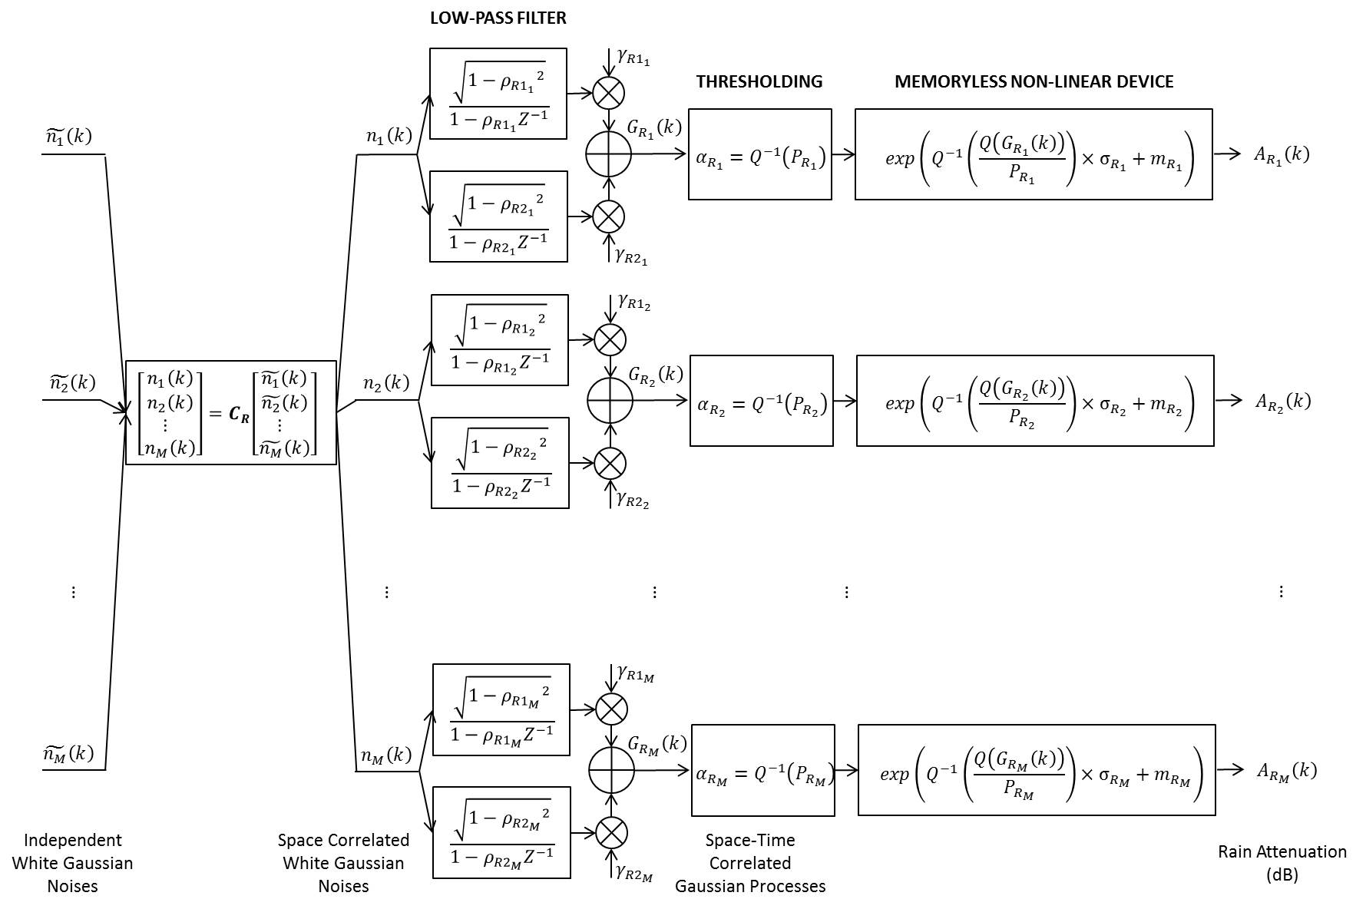

As , the Cholesky factorization has to be performed on the matrix ***Rn*** == ***CRCR****H*

where:

***• CR*** is a lower triangular matrix



•  Δt being the sampling time.

•  Δt being the sampling time.

• 

• 

•  being the equivalent spatial correlation of the underlying Gaussian processes.

#### 2.4.3.2 Parameterization

The space-time correlated rain attenuation time series synthesizer requires as input parameters:

• the parameters sets (,)characterizing the conditional PDF of rain attenuation for each Earth-Space link under investigation;

•  being the probability of rain attenuation for each Earth-Space link under investigation;

• characterizing the dynamics of the rain attenuation processes for each Earth-Space link under investigation;

•  being the equivalent spatial correlation of the underlying Gaussian processes.

(,) and  can be derived either using experimental measurements or using Recommendation ITU-R P.618 when no local data are available.  can be derived from experimental time series or using the generic function (43) with (44) and (45).

[Jeannin et al., 2011] and [Boulanger et al., 2016] have proposed a modelling of the spatial correlation of rain attenuation  as a function of the site separation distance (see Figure 27) based on the data collected during the French Ka-Band site diversity propagation experiment [Boulanger et al., 2016]:

 (47)

where *Dij* is the separation distance between sites *i* and *j*.

Figure 27

Modelling of the spatial correlation function of rain attenuation

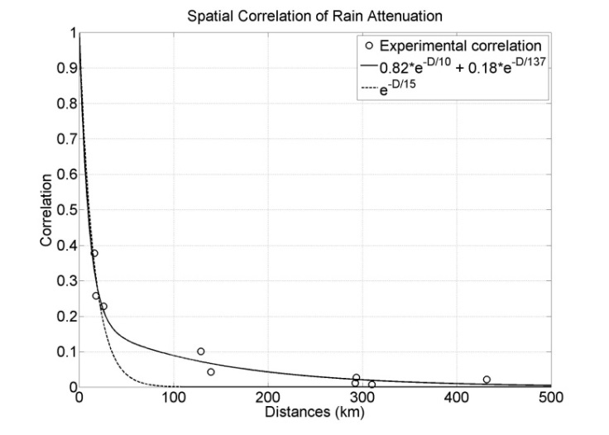

A direct comparison with correlation models of Recommendation ITU-R P.618-13 (site diversity prediction model in Section 2.2.4.1 of Recommendation ITU-R P.618-12) is not possible as it does not come from the same parameter. Indeed, in (47), all the rain attenuation process (rainy and non-rainy periods) is taken into account whereas in Recommendation ITU-R P.618-12, only the conditional process is investigated.

However, as previously demonstrated,  is not the direct input of the synthesizer. What is needed is . The link between  and  is given by:

 (48)

Where [Boulanger et al., 2013]:





 (49)

and



Using the numerical inversion of (48) and the results obtained on the data collected during the Ka-band site diversity propagation experiment [Boulanger et al, 2016], the proposed modelling of the spatial correlation of the underlying Gaussian processes is the following:

 (50)

The results are presented in Figure 28. The comparison with the spatial correlation of the underlying Gaussian fields used to generate rainfall rate fields in [Jeannin et al., 2012] is also shown for information:

 (51)

This correlation function has been established using radar maps [Jeannin et al., 2012]. The spatial correlation, , of the underlying Gaussian fields used to generate ILWC fields in [Jeannin et al., 2011] and recalled in Equation (38) is also highlighted for information. It is very interesting to notice that:

• Equation (50) is very close to the two models even if it has been set from a very limited number of points;

• The two models of spatial correlation of the underlying Gaussian fields used to generate rainfall rate and ILWC fields are very close. It could be useful to extend to total attenuation synthesis.

Figure 28

Modelling of the spatial correlation function of the underlying Gaussian processes  
used to generate rain attenuation processes

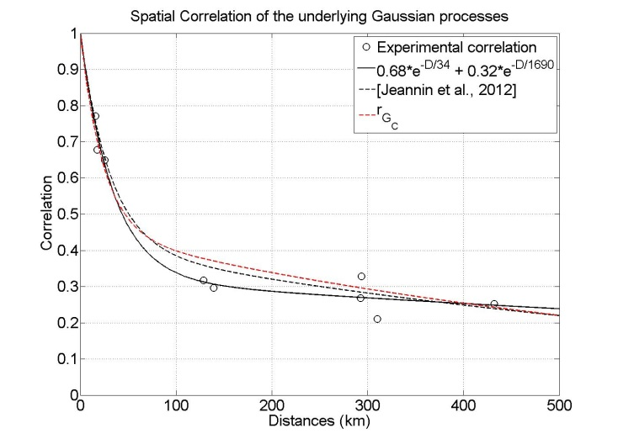

An example of output of the multi-site rain attenuation time series synthesizer in Recommendation ITU-R P.1853-2 is given in Figure 29. It is supposed to simulate the Ka-band site diversity experiment. However, the input parameters , , and were derived from Recommendation ITU-R P.618-13 and the dynamic parameters have been fixed to the generic values highlighted in Section 2.4.2.2. The spatial correlation is the same than in [Jeannin et al., 2012] and recalled in equation (51).

Figure 29

Example of output of the multi-site rain attenuation time series synthesizer in Recommendation ITU-R P.1853-2

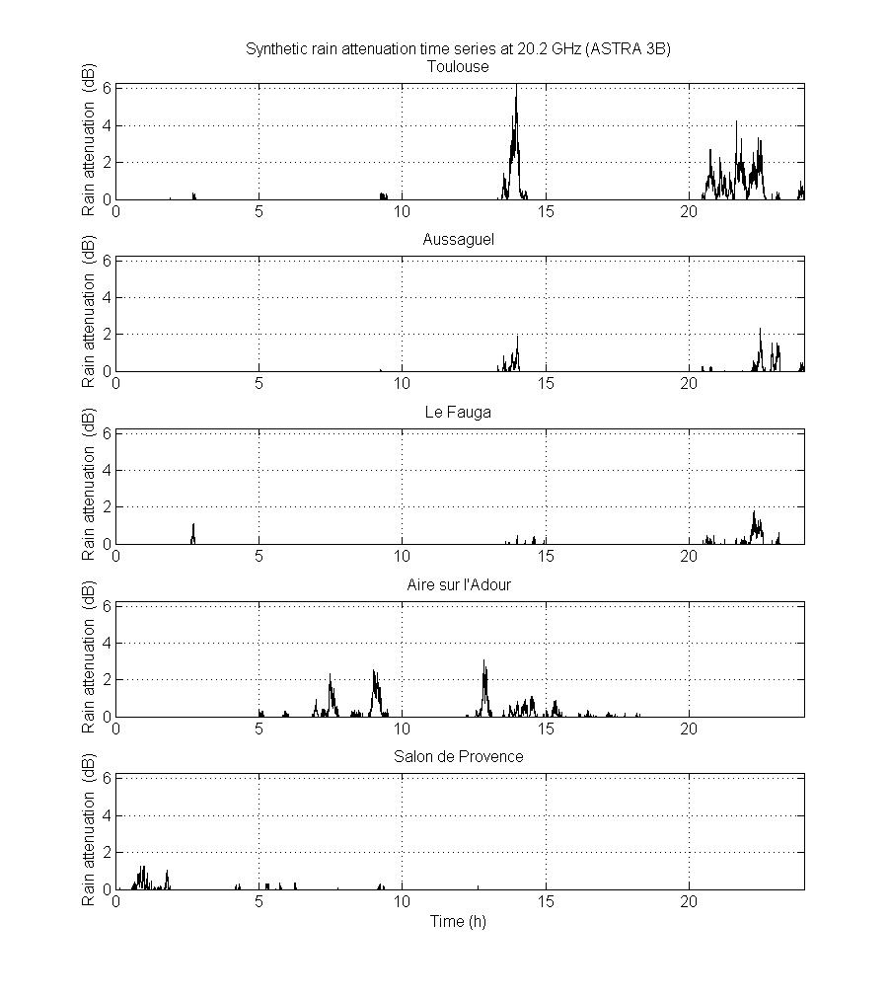

## 2.5 Total attenuation

### 2.5.1 Multi-site total impairments (scintillation included) time series synthesizer in Recommendation ITU-R P.1853-2

The main drawback of Recommendation ITU-R P.1853-1 is the fact that rain and cloud attenuations are generated separately without taking care of inter-correlation. In the current form, it is technically possible to generate rain attenuation with no-concurrent cloud attenuation because both temporal autocorrelation functions are different and even if the underlying noises are identical. To counteract this issue and starting from the observation that spatial correlations of rain and cloud attenuations are very similar, it is proposed to use the same spatial correlation to generate rain and cloud attenuations. Then, as the impact of rain is more critical, the temporal correlation used to derive rain attenuation is also used to generate cloud attenuation.

The final block diagram of multi-site total impairments (scintillation included) time series synthesizer in Recommendation ITU-R P.1853-2 is presented in Figure 30.

Figure 30

Block diagram of the space-time correlated total attenuation time series synthesizer

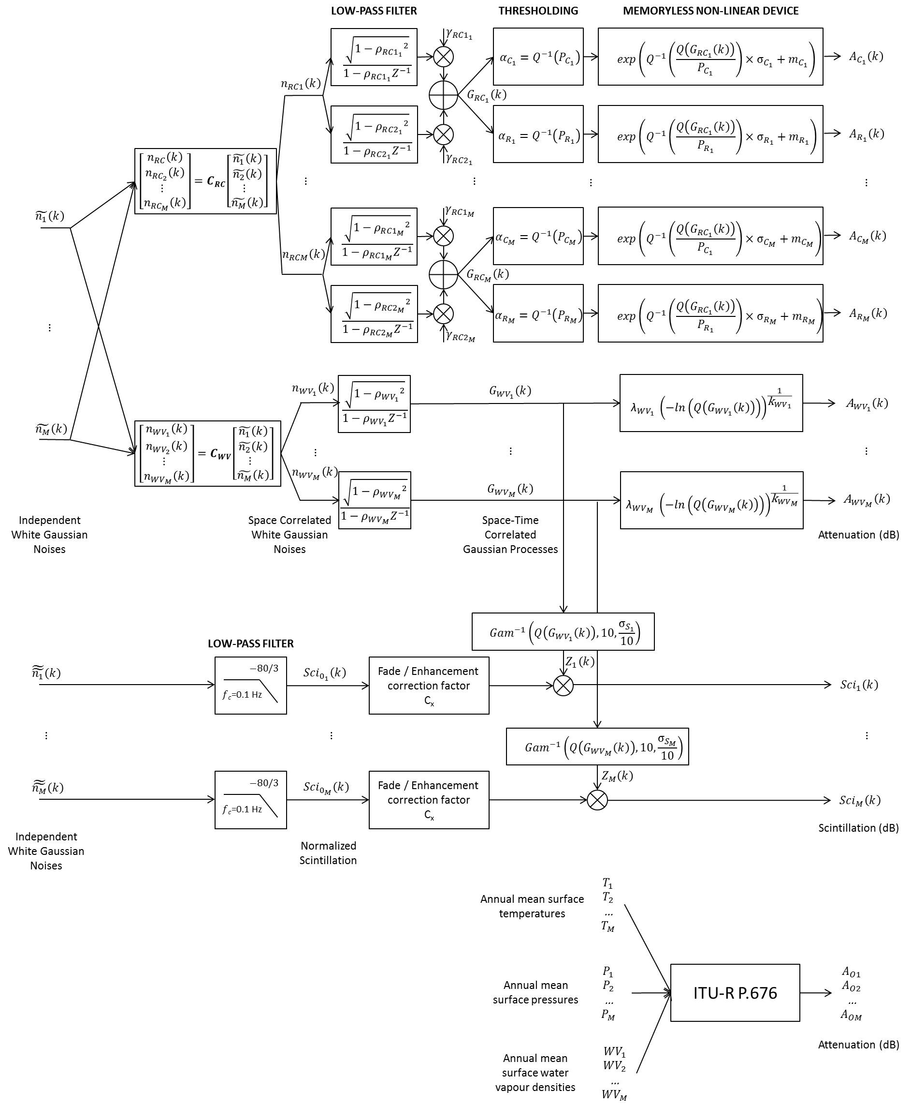

The multi-site total impairments time series synthesizer in Recommendation ITU-R P.1853-2 assumes:



An example of output of the multi-site total attenuation (scintillation excluded) time series synthesizer in Recommendation ITU-R P.1853-2 is given in Figure 31. It is supposed to simulate the Ka-band site diversity experiment. However, the input distribution parameters were derived from ITU-R Recommendations (ITU-R P.836 and P.676 for water vapour, ITU-R P.840 for cloud attenuation, and ITU-R P.618 for rain attenuation) and the correlation parameters have been fixed to the generic values highlighted in the previous Sections and summarized in Table 6.

Figure 31

Example of output of the space-time correlated total attenuation time series synthesizer

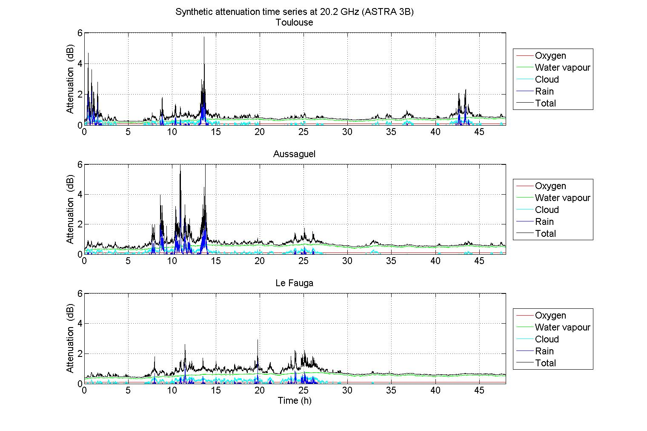

A threshold  has been applied on cloud attenuation to avoid high values occurring during rain events (so only for cloud attenuation samples for which rain attenuation samples are concurrently positive). This threshold corresponds to the value of attenuation computed for ILWC=1 mm. So, according to (18) and (19), .

**2.5.2 General parameterization multi-site total impairments time series synthesizer in Recommendation ITU-R P.1853-2**

The general parameterization of the space-time time series synthesizers is presented in Table 6.

Table 6

General parameterization of the space-time time series synthesizers

|  |  |  |  |  |  |  |  |
| --- | --- | --- | --- | --- | --- | --- | --- |
| Attenuation Synthesizer | | Distribution | | Temporal correlation | | Spatial correlation | |
| Shape | Parameters | Shape | Parameters | Shape | Parameters |
| Oxygen | | Constant value |  | Not applicable | Not applicable | Not applicable | Not applicable |
| Water Vapour | | Weibull |  |  | Experimental  or |  |  |
| Cloud | | Conditional Lognormal |  |  | Experimental  or |  |  |
| Rain | | Conditional Lognormal |  |  | Experimental  or |  |  |
| Total | Oxygen | Constant value |  | Not applicable | Not applicable | Not applicable | Not applicable |
| Water Vapour | Weibull |  |  | Experimental  or |  |  |
| Cloud | Conditional Lognormal |  |  | Experimental  or |  |  |
| **Rain** | Conditional Lognormal |  |

# 3 References

[1] [Boulanger et al., 2013] X. Boulanger, L. Féral, L. Castanet, N. Jeannin, G. Carrie, and F. Lacoste, “A Rain Attenuation Time Series Synthesizer Based on a Dirac and Lognormal Distribution”, IEEE Trans. On Antennas and Propagation, Vol. 61, n°3, March 2013.

[2] [Boulanger et al., 2016] Boulanger X., Lacoste F., and Castanet L., “Small and Large Scale Site Diversity Experiment at Ka-Band in the South of France”, Int. J. Satell. Commun. Network, Published online in Wiley Online Library (wileyonlinelibrary.com). DOI: 10.1002/sat.1190, 2016.

[3] [Cheffena et al., 2009] M. Cheffena, L.E. Braten, T. Ekman, “On the Space-Time Variations of Rain Attenuation”, IEEE Transactions on Antennas and Propagation, Vol. 57, no. 6, pp. 1771-1782, 2009.

[4] [Jeannin et al., 2011] N. Jeannin, G. Carrie, L. Castanet, “Improvement of Earth-space propagation channel modeling between 10 and 50 GHz”, Final report of R&T CNES R‑S09/TC-0005-003, document ONERA N° RF 3/16755 DEMR, July 2011.

[5] [Lacoste et al., 2005] Lacoste F., Bousquet M., Castanet L., Cornet F., and Lemorton J., “Improvement of the ONERA-CNES rain attenuation time series synthesizer and validation of the dynamic characteristics of the generated fade events”, Space Communication Journal, Vol. 20, n°1-2, 2005.

[6] [Therrien, 1992] Therrien C. W., “Discrete Random Signals and Statistical Signal Processing”, Englewood Cliffs, NJ: Prentice Hall, 1992.

*\_\_\_\_\_\_\_\_\_\_\_\_\_\_\_\_*