|  |  |
| --- | --- |
| **Radiocommunication Study Groups** |  |
|  |  |
|  |  |
| Source: Documents 3J/301 ([Annex 20](https://www.itu.int/dms_ties/itu-r/md/19/wp3j/c/R19-WP3J-C-0301!N20!MSW-E.docx)) and 3J/TEMP/22  Subject: Reference atmospheres | Fascicle 3J/FAS/11-E |
| 3 September 2024 |
| English only |
| Working Party 3J | |
| fascicle 3J/FAS/11 | |
| Background information on Annex 3 of Recommendation ITU‑R P.835 | |

Preface

This fascicle contains in the Annex background information on the digital maps provided in Annex 3 of Recommendation [ITU-R P.835](https://www.itu.int/rec/R-REC-P.835/en)-7.

**Author:** Xavier BOULANGER (France)

Annex

Table of contents

Page

[1 Introduction 4](#_Toc176272228)

[2 Description of the ECMWF ERA5 reanalysis database 4](#_Toc176272229)

[2.1 Pressure levels parameters 4](#_Toc176272230)

[2.2 Model levels parameters 5](#_Toc176272231)

[2.3 ERA5.1 re-run 6](#_Toc176272232)

[2.4 Spatial reference systems 6](#_Toc176272233)

[3 Processing of the ECMWF ERA5 model levels database 6](#_Toc176272234)

[3.1 L137 model levels definitions 6](#_Toc176272235)

[3.2 Conversion of geopotential height into geometric height 11](#_Toc176272236)

[3.3 Conversion of specific humidity into water vapour density 12](#_Toc176272237)

[4 New mean vertical atmospheric profiles 12](#_Toc176272238)

[4.1 Methodology 12](#_Toc176272239)

[4.2 Comparisons with reference maps derived from ERA5 pressure levels data 13](#_Toc176272240)

[4.3 Comparisons with Recommendation ITU-R P.835-6 (Annex 1 – Section 1) 16](#_Toc176272241)

[4.4 Test using radiosonde observations (RAOBS) 20](#_Toc176272242)

[4.5 Example of monthly results 26](#_Toc176272243)

[5 Global mean annual and mean monthly vertical profiles 30](#_Toc176272244)

[5.1 Mean annual and monthly data files description 30](#_Toc176272245)

[5.2 Interpolation of meteorological parameters 32](#_Toc176272246)

[6 Conclusions 34](#_Toc176272247)

List of variables

|  |  |  |
| --- | --- | --- |
| Variable | Definition | Unit |
|  | Latitude | ° N |
| λ | Longitude | ° E |
|  | Earth's gravitational acceleration (*g*0= 9.80665m/s2) | m/s2 |
|  | Geopotential | m2/s2 |
|  | Geopotential of the surface of the Earth | m2/s2 |
| *H* | Geopotential height above mean sea level | km |
|  | Geopotential height above mean sea level of the surface of the Earth | km |
| *Z* | Geometric height above mean sea level | km |
|  | Geometric height above mean sea level of the surface of the Earth | km |
| *P* | Total pressure | hPa |
|  | Mean of *P* for a given period (e.g. annual or monthly mean) | hPa |
| *Ps* | Total pressure at the surface of the Earth | hPa |
|  | Mean of *Ps* for a given period (e.g. annual or monthly mean) | hPa |
| *lnsp* | Logarithm of the total pressure at the surface of the Earth (*lnsp =* ln(*Ps*)) | ln(Pa) |
| *T* | Temperature | K |
|  | Mean of *T* for a given period (e.g. annual or monthly mean) | K |
|  | Temperature at the surface of the Earth | K |
|  | Mean of *Ts* for a given period (e.g. annual or monthly mean) | K |
|  | Moist air density | kg/m3 |
|  | Dry air density | kg/m3 |
|  | Water vapour density | g/m3 |
|  | Mean of for a given period (e.g. annual or monthly mean) | g/m3 |
|  | Water vapour density at the surface of the Earth | g/m3 |
|  | Mean of for a given period (e.g. annual or monthly mean) | g/m3 |
|  | Specific humidity | kg/kg |
|  | Mean of for a given period (e.g. annual or monthly mean) | kg/kg |

# 1 Introduction

The vertical atmospheric profiles provided by Annex 3 of Recommendation ITU-R P.835-6 were derived from the ECMWF 15-year dataset (ERA15). This dataset contained the mean monthly vertical profiles at 00:00, 06:00, 12:00, and 18:00 UTC of total air pressure, air temperature, and water-vapour density at 32 height levels from a reference height located around the local Earth surface up to about 30 km above the Earth’s surface. The data are from 0º to 360º in longitude and from +90º to −90º in latitude, with a resolution of 1.5º in both latitude and longitude.

Now, the fifth generation of the ECMWF reanalyses, ERA5, is available:

– The spatial resolution has been improved to 0.25° in both latitude and longitude.

– The temporal resolution is now 1 h (data available at 00:00, 01:00, 02:00, …, 23:00 UTC).

– Multiple propagation oriented meteorological parameters (pressure, temperature, humidity, wind, …) are available:

• on single levels (surface, 2 meters, 10 meters, …);

• on 37 pressure levels which extends the height levels up to more than 47 km;

• on 137 model levels which extends the height levels up to more than 78 km.

– The data are available from 1950 to the present.

Starting with the research activities conducted in [1] and [2], Correspondence Group 3J-11 (Reference Standard Atmospheres) worked on a draft revision to Annex 3 of Recommendation ITU-R P.835‑6:

– Document [3J/10](https://www.itu.int/md/R19-WP3J-C-0010/en) (2020) provided new worldwide digital maps of the mean vertical profiles on annual, seasonal, and monthly bases. These maps were derived from 29 years (1991-2019) of ERA5 pressure levels data. A summary of the results and a preliminary work plan were proposed in Annex 3 to Document [3J/61](https://www.itu.int/md/R19-WP3J-C-0061/en) (2020).

– Document [3J/140](https://www.itu.int/md/R19-WP3J-C-0140/en) (2021) extended the original analysis of Document 3J/10 (2020) to include the period 1991-2020. A summary of the results and an updated work plan were proposed in Annex 14 to Document [3J/145](https://www.itu.int/md/R19-WP3J-C-0145/en) (2021).

– Document [3J/164](https://www.itu.int/md/R19-WP3J-C-0164/en) (2022) finally proposed the results of the analyses using the ERA5 model levels data.

This fascicle gives all information on the digital maps provided in Annex 3 of Recommendation ITU‑R P.835-7 based on the use of the ERA5 model levels data.

# 2 Description of the ECMWF ERA5 reanalysis database

Reference standard atmospheres (as described in Recommendation ITU-R P.835-7) are characterized by their vertical profiles of pressure, temperature, and water vapour density with respect to geometric altitudes (from the surface of the Earth above mean sea level). As previously mentioned in the introduction, the fifth generation ECMWF reanalyses, ERA5, provides worldwide reanalyses data on pressure and model levels data. The following sections give a brief overview of the meteorological parameters of interest to derive new reference standard atmospheres.

## 2.1 Pressure levels parameters

Pressure levels data [3], [4] are available on several temporal bases:

– hourly basis

– monthly means of daily means

– synoptic monthly means by hour of the day.

Among all the parameters available in the ERA5 pressure levels data, the following four location-specific parameters are of interest in this analysis:

|  |  |  |
| --- | --- | --- |
| **Pressure** | hPa | This parameter is the **total** barometric pressure fixed at 1, 2, 3, 5, 7, 10, 20, 30, 50, 70, 100, 125, 150, 175, 200, 225, 250, 300, 350, 400, 450, 500, 550, 600, 650, 700, 750, 775, 800, 825, 850, 875, 900, 925, 950, 975, and 1 000 hPa. |
| **Temperature** | K | This parameter is the temperature at each pressure level. This parameter has units of Kelvin (K). Temperature measured in Kelvin can be converted to degrees Celsius (°C) by subtracting 273.15. |
| **Specific humidity** | kg/kg | This parameter is the mass of water vapour per kilogram of moist air at each pressure level. The total mass of moist air is the sum of the dry air, water vapour, cloud liquid, cloud ice, rain, and falling snow. |
| **Geopotential** | m2/s2 | This parameter is the gravitational potential energy of a unit mass at each pressure level, relative to mean sea level. Geopotential is also the amount of work, against the force of gravity, to lift a unit mass to the height of that location above mean sea level. The geopotential height can be calculated by dividing the geopotential by the Earth's gravitational acceleration, *g0* (= 9.80665 m/s2). The geopotential height plays an important role in synoptic meteorology (analysis of weather patterns). Charts of geopotential height plotted at constant pressure levels (e.g., 300, 500, or 850 hPa) can be used to identify weather systems such as cyclones, anticyclones, troughs, and ridges. At the surface of the Earth, this parameter shows the variations in geopotential (height) of the surface and is often referred to as the orography. |

Due to the size of data files, downloading global hourly profiles for several years is prohibitive. However, ECMWF also provides monthly averaged (monthly means of daily means and synoptic monthly means by hour of the day) pressure levels data [5]. Monthly means of daily means data have been considered in the previous analyses in [1], Document 3J/10 (2020) and Document 3J/140 (2021).

## 2.2 Model levels parameters

As for pressure levels data, model levels data [1] are available on several temporal bases:

– hourly basis

– monthly means of daily means

– synoptic monthly means by hour of the day.

Among all the parameters available in the ERA5 model levels data, the following four location-specific parameters are of interest in this analysis:

|  |  |  |
| --- | --- | --- |
| **Natural logarithm of surface pressure** | ln(Pa) | This parameter is the natural logarithm of total barometric pressure at the surface of the Earth. |
| **Temperature** | K | This parameter is the temperature at each model level. This parameter has units of Kelvin (K). Temperature measured in Kelvin can be converted to degrees Celsius (°C) by subtracting 273.15. |
| **Specific humidity** | kg/kg | This parameter is the mass of water vapour per kilogram of moist air at each model level. The total mass of moist air is the sum of the dry air, water vapour, cloud liquid, cloud ice, rain, and falling snow. |
| **Surface geopotential** | m2/s2 | This parameter is the gravitational potential energy of a unit mass at the surface of the Earth. It is an invariant parameter. |

The size of the above data for one specific hour of one specific day is around 560 megabytes (in netcdf format) leading to:

– 13.44 gigabytes for a complete day

– 4.91 terabytes for a complete year

– more than 147 terabytes for 30 years of data.

Again, the use of monthly averaged data appears to be the easiest and most efficient way to deal with reference atmospheres:

– 200 gigabytes of data for the use of 30 years of monthly means of daily means

– more than 4.8 terabytes of data for the use of 30 years of synoptic monthly means by hour of the day.

## 2.3 ERA5.1 re-run

The Copernicus Climate Change Service (C3S) at ECMWF has released ERA5.1 [6], a re-run of ERA5, for the years 2000 to 2006 only. ERA5.1 was produced to improve upon the cold bias in the lower stratosphere seen in ERA5 during this period. Moreover, ERA5.1 analyses have a better representation of the following features:

– upper stratospheric temperature

– stratospheric humidity.

The lower and middle troposphere in ERA5.1 are similar to those in ERA5, as is the synoptic evolution in the extratropical stratosphere. Therefore, for such applications, ERA5.1 will add little value compared to ERA5.

## 2.4 Spatial reference systems

The ERA5 latitude and longitude are geodetic, rather than geocentric, and are referenced to the WGS84 ellipsoid. The ERA5 geopotential height relative to mean sea level is the ERA5 geopotential (m2/s2) divided by *g*0= 9.80665m/s2, where mean sea level is defined as the geoid specified by the U.S. National Geospatial-Intelligence Agency (NGA) Earth gravitational model EGM96.

# 3 Processing of the ECMWF ERA5 model levels database

## 3.1 L137 model levels definitions

In ERA5 model levels data, the vertical variation of the dependant variables, like temperature, *T*, and specific humidity, *qw*, are represented by dividing the atmosphere into *N* = 137 layers as illustrated in Fig. 1.

Figure 1

Illustration of pressure on ERA5 model levels [7]

|  |  |
| --- | --- |
| levels_137.png | model_levels.png |

These layers are defined by the pressure at the interface between them (the “half-levels”), and these pressures are given for by [7]:

     (here in Pa)

where is the logarithm of surface pressure (i.e. ) provided in the ERA5 model levels database. The following table, extracted from [8], is the list of *ak* and *bk* coefficients defining the model levels, accompanied by the corresponding half-level, *ph*, and full-level, *pf*, values of pressure for a surface pressure of 1 013.250 hPa. Also provided are the geopotential and geometric heights, the temperature and density of the level based on the 1976 version of the International Civil Aviation Organization (ICAO) Standard Atmosphere as described in [9].

| *k* | *a* [Pa] | *b* | *ph* [hPa] | *pf* [hPa] | Geopotential altitude [m] | Geometric altitude [m] | Temperature [K] | Density [kg/m3] |
| --- | --- | --- | --- | --- | --- | --- | --- | --- |
| 0 | 0.000000 | 0.000000 | 0.000000 | – | – | – | – | – |
| 1 | 2.000365 | 0.000000 | 0.0200 | 0.0100 | 79 301.79 | 80 301.65 | 198.05 | 0.000018 |
| 2 | 3.102241 | 0.000000 | 0.0310 | 0.0255 | 73 721.58 | 74 584.91 | 209.21 | 0.000042 |
| 3 | 4.666084 | 0.000000 | 0.0467 | 0.0388 | 71 115.75 | 71 918.79 | 214.42 | 0.000063 |
| 4 | 6.827977 | 0.000000 | 0.0683 | 0.0575 | 68 618.43 | 69 365.77 | 221.32 | 0.000090 |
| 5 | 9.746966 | 0.000000 | 0.0975 | 0.0829 | 66 210.99 | 66 906.53 | 228.06 | 0.000127 |
| 6 | 13.605424 | 0.000000 | 0.1361 | 0.1168 | 63 890.03 | 64 537.43 | 234.56 | 0.000173 |
| 7 | 18.608931 | 0.000000 | 0.1861 | 0.1611 | 61 651.77 | 62 254.39 | 240.83 | 0.000233 |
| 8 | 24.985718 | 0.000000 | 0.2499 | 0.2180 | 59 492.50 | 60 053.46 | 246.87 | 0.000308 |
| 9 | 32.985710 | 0.000000 | 0.3299 | 0.2899 | 57 408.61 | 57 930.78 | 252.71 | 0.000400 |
| 10 | 42.879242 | 0.000000 | 0.4288 | 0.3793 | 55 396.62 | 55 882.68 | 258.34 | 0.000512 |
| 11 | 54.955463 | 0.000000 | 0.5496 | 0.4892 | 53 453.20 | 53 905.62 | 263.78 | 0.000646 |
| 12 | 69.520576 | 0.000000 | 0.6952 | 0.6224 | 51 575.15 | 51 996.21 | 269.04 | 0.000806 |
| 13 | 86.895882 | 0.000000 | 0.8690 | 0.7821 | 49 767.41 | 50 159.36 | 270.65 | 0.001007 |
| 14 | 107.415741 | 0.000000 | 1.0742 | 0.9716 | 48 048.70 | 48 413.94 | 270.65 | 0.001251 |
| 15 | 131.425507 | 0.000000 | 1.3143 | 1.1942 | 46 416.22 | 46 756.98 | 269.02 | 0.001546 |
| 16 | 159.279404 | 0.000000 | 1.5928 | 1.4535 | 44 881.17 | 45 199.69 | 264.72 | 0.001913 |
| 17 | 191.338562 | 0.000000 | 1.9134 | 1.7531 | 43 440.23 | 43 738.55 | 260.68 | 0.002343 |
| 18 | 227.968948 | 0.000000 | 2.2797 | 2.0965 | 42 085.00 | 42 364.93 | 256.89 | 0.002843 |
| 19 | 269.539581 | 0.000000 | 2.6954 | 2.4875 | 40 808.05 | 41 071.20 | 253.31 | 0.003421 |
| 20 | 316.420746 | 0.000000 | 3.1642 | 2.9298 | 39 602.76 | 39 850.56 | 249.94 | 0.004084 |
| 21 | 368.982361 | 0.000000 | 3.6898 | 3.4270 | 38 463.25 | 38 696.94 | 246.75 | 0.004838 |
| 22 | 427.592499 | 0.000000 | 4.2759 | 3.9829 | 37 384.22 | 37 604.95 | 243.73 | 0.005693 |
| 23 | 492.616028 | 0.000000 | 4.9262 | 4.6010 | 36 360.94 | 36 569.72 | 240.86 | 0.006655 |
| 24 | 564.413452 | 0.000000 | 5.6441 | 5.2851 | 35 389.15 | 35 586.89 | 238.14 | 0.007731 |
| 25 | 643.339905 | 0.000000 | 6.4334 | 6.0388 | 34 465.00 | 34 652.52 | 235.55 | 0.008931 |
| 26 | 729.744141 | 0.000000 | 7.2974 | 6.8654 | 33 585.02 | 33 763.05 | 233.09 | 0.010261 |
| 27 | 823.967834 | 0.000000 | 8.2397 | 7.7686 | 32 746.04 | 32 915.27 | 230.74 | 0.011729 |
| 28 | 926.344910 | 0.000000 | 9.2634 | 8.7516 | 31 945.53 | 32 106.57 | 228.60 | 0.013337 |
| 29 | 1 037.201172 | 0.000000 | 10.3720 | 9.8177 | 31 177.59 | 31 330.96 | 227.83 | 0.015012 |
| 30 | 1 156.853638 | 0.000000 | 11.5685 | 10.9703 | 30 438.54 | 30 584.71 | 227.09 | 0.016829 |
| 31 | 1 285.610352 | 0.000000 | 12.8561 | 12.2123 | 29 726.69 | 29 866.09 | 226.38 | 0.018793 |
| 32 | 1 423.770142 | 0.000000 | 14.2377 | 13.5469 | 29 040.48 | 29 173.50 | 225.69 | 0.020910 |
| 33 | 1 571.622925 | 0.000000 | 15.7162 | 14.9770 | 28 378.46 | 28 505.47 | 225.03 | 0.023186 |
| 34 | 1 729.448975 | 0.000000 | 17.2945 | 16.5054 | 27 739.29 | 27 860.64 | 224.39 | 0.025624 |
| 35 | 1 897.519287 | 0.000000 | 18.9752 | 18.1348 | 27 121.74 | 27 237.73 | 223.77 | 0.028232 |
| 36 | 2 076.095947 | 0.000000 | 20.7610 | 19.8681 | 26 524.63 | 26 635.56 | 223.17 | 0.031013 |
| 37 | 2 265.431641 | 0.000000 | 22.6543 | 21.7076 | 25 946.90 | 26 053.04 | 222.60 | 0.033972 |
| 38 | 2 465.770508 | 0.000000 | 24.6577 | 23.6560 | 25 387.55 | 25 489.15 | 222.04 | 0.037115 |
| 39 | 2 677.348145 | 0.000000 | 26.7735 | 25.7156 | 24 845.63 | 24 942.93 | 221.50 | 0.040445 |
| 40 | 2 900.391357 | 0.000000 | 29.0039 | 27.8887 | 24 320.28 | 24 413.50 | 220.97 | 0.043967 |
| 41 | 3 135.119385 | 0.000000 | 31.3512 | 30.1776 | 23 810.67 | 23 900.02 | 220.46 | 0.047685 |
| 42 | 3 381.743652 | 0.000000 | 33.8174 | 32.5843 | 23 316.04 | 23 401.71 | 219.97 | 0.051604 |
| 43 | 3 640.468262 | 0.000000 | 36.4047 | 35.1111 | 22 835.68 | 22 917.85 | 219.49 | 0.055727 |
| 44 | 3 911.490479 | 0.000000 | 39.1149 | 37.7598 | 22 368.91 | 22 447.75 | 219.02 | 0.060059 |
| 45 | 4 194.930664 | 0.000000 | 41.9493 | 40.5321 | 21 915.16 | 21 990.82 | 218.57 | 0.064602 |
| 46 | 4 490.817383 | 0.000000 | 44.9082 | 43.4287 | 21 473.98 | 21 546.62 | 218.12 | 0.069359 |
| 47 | 4 799.149414 | 0.000000 | 47.9915 | 46.4498 | 21 045.00 | 21 114.77 | 217.70 | 0.074330 |
| 48 | 5 119.895020 | 0.000000 | 51.1990 | 49.5952 | 20 627.87 | 20 694.90 | 217.28 | 0.079516 |
| 49 | 5 452.990723 | 0.000000 | 54.5299 | 52.8644 | 20 222.24 | 20 286.66 | 216.87 | 0.084916 |
| 50 | 5 798.344727 | 0.000000 | 57.9834 | 56.2567 | 19 827.95 | 19 889.88 | 216.65 | 0.090458 |
| 51 | 6 156.074219 | 0.000000 | 61.5607 | 59.7721 | 19 443.55 | 19 503.09 | 216.65 | 0.096110 |
| 52 | 6 526.946777 | 0.000000 | 65.2695 | 63.4151 | 19 068.35 | 19 125.61 | 216.65 | 0.101968 |
| 53 | 6 911.870605 | 0.000000 | 69.1187 | 67.1941 | 18 701.27 | 18 756.34 | 216.65 | 0.108045 |
| 54 | 7 311.869141 | 0.000000 | 73.1187 | 71.1187 | 18 341.27 | 18 394.25 | 216.65 | 0.114355 |
| 55 | 7 727.412109 | 0.000007 | 77.2810 | 75.1999 | 17 987.41 | 18 038.35 | 216.65 | 0.120917 |
| 56 | 8 159.354004 | 0.000024 | 81.6182 | 79.4496 | 17 638.78 | 17 687.77 | 216.65 | 0.127751 |
| 57 | 8 608.525391 | 0.000059 | 86.1450 | 83.8816 | 17 294.53 | 17 341.62 | 216.65 | 0.134877 |
| 58 | 9 076.400391 | 0.000112 | 90.8774 | 88.5112 | 16 953.83 | 16 999.08 | 216.65 | 0.142321 |
| 59 | 9 562.682617 | 0.000199 | 95.8280 | 93.3527 | 16 616.09 | 16 659.55 | 216.65 | 0.150106 |
| 60 | 10 065.978516 | 0.000340 | 101.0047 | 98.4164 | 16 281.10 | 16 322.83 | 216.65 | 0.158248 |
| 61 | 10 584.631836 | 0.000562 | 106.4153 | 103.7100 | 15 948.85 | 15 988.88 | 216.65 | 0.166760 |
| 62 | 11 116.662109 | 0.000890 | 112.0681 | 109.2417 | 15 619.30 | 15 657.70 | 216.65 | 0.175655 |
| 63 | 11 660.067383 | 0.001353 | 117.9714 | 115.0198 | 15 292.44 | 15 329.24 | 216.65 | 0.184946 |
| 64 | 12 211.547852 | 0.001992 | 124.1337 | 121.0526 | 14 968.24 | 15 003.50 | 216.65 | 0.194646 |
| 65 | 12 766.873047 | 0.002857 | 130.5637 | 127.3487 | 14 646.68 | 14 680.44 | 216.65 | 0.204770 |
| 66 | 13 324.668945 | 0.003971 | 137.2703 | 133.9170 | 14 327.75 | 14 360.05 | 216.65 | 0.215331 |
| 67 | 13 881.331055 | 0.005378 | 144.2624 | 140.7663 | 14 011.41 | 14 042.30 | 216.65 | 0.226345 |
| 68 | 14 432.139648 | 0.007133 | 151.5493 | 147.9058 | 13 697.65 | 13 727.18 | 216.65 | 0.237825 |
| 69 | 14 975.615234 | 0.009261 | 159.1403 | 155.3448 | 13 386.45 | 13 414.65 | 216.65 | 0.249786 |
| 70 | 15 508.256836 | 0.011806 | 167.0450 | 163.0927 | 13 077.79 | 13 104.70 | 216.65 | 0.262244 |
| 71 | 16 026.115234 | 0.014816 | 175.2731 | 171.1591 | 12 771.64 | 12 797.30 | 216.65 | 0.275215 |
| 72 | 16 527.322266 | 0.018318 | 183.8344 | 179.5537 | 12 467.99 | 12 492.44 | 216.65 | 0.288713 |
| 73 | 17 008.789063 | 0.022355 | 192.7389 | 188.2867 | 12 166.81 | 12 190.10 | 216.65 | 0.302755 |
| 74 | 17 467.613281 | 0.026964 | 201.9969 | 197.3679 | 11 868.08 | 11 890.24 | 216.65 | 0.317357 |
| 75 | 17 901.621094 | 0.032176 | 211.6186 | 206.8078 | 11 571.79 | 11 592.86 | 216.65 | 0.332536 |
| 76 | 18 308.433594 | 0.038026 | 221.6146 | 216.6166 | 11 277.92 | 11 297.93 | 216.65 | 0.348308 |
| 77 | 18 685.718750 | 0.044548 | 231.9954 | 226.8050 | 10 986.70 | 11 005.69 | 216.74 | 0.364545 |
| 78 | 19 031.289063 | 0.051773 | 242.7719 | 237.3837 | 10 696.22 | 10 714.22 | 218.62 | 0.378253 |
| 79 | 19 343.511719 | 0.059728 | 253.9549 | 248.3634 | 10 405.61 | 10 422.64 | 220.51 | 0.392358 |
| 80 | 19 620.042969 | 0.068448 | 265.5556 | 259.7553 | 10 114.89 | 10 130.98 | 222.40 | 0.406868 |
| 81 | 19 859.390625 | 0.077958 | 277.5852 | 271.5704 | 9 824.08 | 9 839.26 | 224.29 | 0.421790 |
| 82 | 20 059.931641 | 0.088286 | 290.0548 | 283.8200 | 9 533.20 | 9 547.49 | 226.18 | 0.437130 |
| 83 | 20 219.664063 | 0.099462 | 302.9762 | 296.5155 | 9 242.26 | 9 255.70 | 228.08 | 0.452897 |
| 84 | 20 337.863281 | 0.111505 | 316.3607 | 309.6684 | 8 951.30 | 8 963.90 | 229.97 | 0.469097 |
| 85 | 20 412.308594 | 0.124448 | 330.2202 | 323.2904 | 8 660.32 | 8 672.11 | 231.86 | 0.485737 |
| 86 | 20 442.078125 | 0.138313 | 344.5663 | 337.3932 | 8 369.35 | 8 380.36 | 233.75 | 0.502825 |
| 87 | 20 425.718750 | 0.153125 | 359.4111 | 351.9887 | 8 078.41 | 8 088.67 | 235.64 | 0.520367 |
| 88 | 20 361.816406 | 0.168910 | 374.7666 | 367.0889 | 7 787.51 | 7 797.04 | 237.53 | 0.538370 |
| 89 | 20 249.511719 | 0.185689 | 390.6450 | 382.7058 | 7 496.68 | 7 505.51 | 239.42 | 0.556842 |
| 90 | 20 087.085938 | 0.203491 | 407.0583 | 398.8516 | 7 205.93 | 7 214.09 | 241.31 | 0.575790 |
| 91 | 19 874.025391 | 0.222333 | 424.0190 | 415.5387 | 6 915.29 | 6 922.80 | 243.20 | 0.595219 |
| 92 | 19 608.572266 | 0.242244 | 441.5395 | 432.7792 | 6 624.76 | 6 631.66 | 245.09 | 0.615138 |
| 93 | 19 290.226563 | 0.263242 | 459.6321 | 450.5858 | 6 334.38 | 6 340.68 | 246.98 | 0.635553 |
| 94 | 18 917.460938 | 0.285354 | 478.3096 | 468.9708 | 6 044.15 | 6 049.89 | 248.86 | 0.656471 |
| 95 | 18 489.707031 | 0.308598 | 497.5845 | 487.9470 | 5 754.10 | 5 759.30 | 250.75 | 0.677899 |
| 96 | 18 006.925781 | 0.332939 | 517.4198 | 507.5021 | 5 464.60 | 5 469.30 | 252.63 | 0.699815 |
| 97 | 17 471.839844 | 0.358254 | 537.7195 | 527.5696 | 5 176.77 | 5 180.98 | 254.50 | 0.722139 |
| 98 | 16 888.687500 | 0.384363 | 558.3430 | 548.0312 | 4 892.26 | 4 896.02 | 256.35 | 0.744735 |
| 99 | 16 262.046875 | 0.411125 | 579.1926 | 568.7678 | 4 612.58 | 4 615.92 | 258.17 | 0.767472 |
| 100 | 15 596.695313 | 0.438391 | 600.1668 | 589.6797 | 4 338.77 | 4 341.73 | 259.95 | 0.790242 |
| 101 | 14 898.453125 | 0.466003 | 621.1624 | 610.6646 | 4 071.80 | 4 074.41 | 261.68 | 0.812937 |
| 102 | 14 173.324219 | 0.493800 | 642.0764 | 631.6194 | 3 812.53 | 3 814.82 | 263.37 | 0.835453 |
| 103 | 13 427.769531 | 0.521619 | 662.8084 | 652.4424 | 3 561.70 | 3 563.69 | 265.00 | 0.857686 |
| 104 | 12 668.257813 | 0.549301 | 683.2620 | 673.0352 | 3 319.94 | 3 321.67 | 266.57 | 0.879541 |
| 105 | 11 901.339844 | 0.576692 | 703.3467 | 693.3043 | 3 087.75 | 3 089.25 | 268.08 | 0.900929 |
| 106 | 11 133.304688 | 0.603648 | 722.9795 | 713.1631 | 2 865.54 | 2 866.83 | 269.52 | 0.921768 |
| 107 | 10 370.175781 | 0.630036 | 742.0855 | 732.5325 | 2 653.58 | 2 654.69 | 270.90 | 0.941988 |
| 108 | 9 617.515625 | 0.655736 | 760.5996 | 751.3426 | 2 452.04 | 2 452.99 | 272.21 | 0.961527 |
| 109 | 8 880.453125 | 0.680643 | 778.4661 | 769.5329 | 2 260.99 | 2 261.80 | 273.45 | 0.980334 |
| 110 | 8 163.375000 | 0.704669 | 795.6396 | 787.0528 | 2 080.41 | 2 081.09 | 274.63 | 0.998368 |
| 111 | 7 470.343750 | 0.727739 | 812.0847 | 803.8622 | 1 910.19 | 1 910.76 | 275.73 | 1.015598 |
| 112 | 6 804.421875 | 0.749797 | 827.7756 | 819.9302 | 1 750.14 | 1 750.63 | 276.77 | 1.032005 |
| 113 | 6 168.531250 | 0.770798 | 842.6959 | 835.2358 | 1 600.04 | 1 600.44 | 277.75 | 1.047576 |
| 114 | 5 564.382813 | 0.790717 | 856.8376 | 849.7668 | 1 459.58 | 1 459.91 | 278.66 | 1.062310 |
| 115 | 4 993.796875 | 0.809536 | 870.2004 | 863.5190 | 1 328.43 | 1 328.70 | 279.52 | 1.076209 |
| 116 | 4 457.375000 | 0.827256 | 882.7910 | 876.4957 | 1 206.21 | 1 206.44 | 280.31 | 1.089286 |
| 117 | 3 955.960938 | 0.843881 | 894.6222 | 888.7066 | 1 092.54 | 1 092.73 | 281.05 | 1.101558 |
| 118 | 3 489.234375 | 0.859432 | 905.7116 | 900.1669 | 987.00 | 987.15 | 281.73 | 1.113047 |
| 119 | 3 057.265625 | 0.873929 | 916.0815 | 910.8965 | 889.17 | 889.29 | 282.37 | 1.123777 |
| 120 | 2 659.140625 | 0.887408 | 925.7571 | 920.9193 | 798.62 | 798.72 | 282.96 | 1.133779 |
| 121 | 2 294.242188 | 0.899900 | 934.7666 | 930.2618 | 714.94 | 715.02 | 283.50 | 1.143084 |
| 122 | 1 961.500000 | 0.911448 | 943.1399 | 938.9532 | 637.70 | 637.76 | 284.00 | 1.151724 |
| 123 | 1 659.476563 | 0.922096 | 950.9082 | 947.0240 | 566.49 | 566.54 | 284.47 | 1.159733 |
| 124 | 1 387.546875 | 0.931881 | 958.1037 | 954.5059 | 500.91 | 500.95 | 284.89 | 1.167147 |
| 125 | 1 143.250000 | 0.940860 | 964.7584 | 961.4311 | 440.58 | 440.61 | 285.29 | 1.173999 |
| 126 | 926.507813 | 0.949064 | 970.9046 | 967.8315 | 385.14 | 385.16 | 285.65 | 1.180323 |
| 127 | 734.992188 | 0.956550 | 976.5737 | 973.7392 | 334.22 | 334.24 | 285.98 | 1.186154 |
| 128 | 568.062500 | 0.963352 | 981.7968 | 979.1852 | 287.51 | 287.52 | 286.28 | 1.191523 |
| 129 | 424.414063 | 0.969513 | 986.6036 | 984.2002 | 244.68 | 244.69 | 286.56 | 1.196462 |
| 130 | 302.476563 | 0.975078 | 991.0230 | 988.8133 | 205.44 | 205.44 | 286.81 | 1.201001 |
| 131 | 202.484375 | 0.980072 | 995.0824 | 993.0527 | 169.50 | 169.51 | 287.05 | 1.205168 |
| 132 | 122.101563 | 0.984542 | 998.8081 | 996.9452 | 136.62 | 136.62 | 287.26 | 1.208992 |
| 133 | 62.781250 | 0.988500 | 1 002.2250 | 1 000.5165 | 106.54 | 106.54 | 287.46 | 1.212498 |
| 134 | 22.835938 | 0.991984 | 1 005.3562 | 1 003.7906 | 79.04 | 79.04 | 287.64 | 1.215710 |
| 135 | 3.757813 | 0.995003 | 1 008.2239 | 1 006.7900 | 53.92 | 53.92 | 287.80 | 1.218650 |
| 136 | 0.000000 | 0.997630 | 1 010.8487 | 1 009.5363 | 30.96 | 30.96 | 287.95 | 1.221341 |
| 137 | 0.000000 | 1.000000 | 1 013.2500 | 1 012.0494 | 10.00 | 10.00 | 288.09 | 1.223803 |

### 3.1.1 Computation of pressure on model levels

The pressure on model levels, , is given by the mean of the pressures on the model half-levels immediately above and below [7]:

     (here in Pa)

### 3.1.2 Computation of geopotential on model levels

In ERA5 model levels data, geopotential is provided at the surface of the Earth, but not on individual model levels. However, geopotential on model levels can be computed from:

– geopotential at the surface of the Earth,

– logarithm of surface pressure, *lnsp*

– temperature on all the model levels, *T*

– specific humidity on all the model levels, *qw*.

The geopotential on model half-levels is given by [10]:

where:

is the geopotential at the surface of the Earth

is the virtual (moist) temperature at model level *j*

J/(kg · K)is the specific gas constant for dry air

J/(kg · K)is the specific gas constant for water vapour.

The geopotential on model levels is then retrieved by [10]:

where and, for *k* > 1:

## 3.2 Conversion of geopotential height into geometric height

The variation of gravity with height must take into account the ellipsoidal shape of the Earth and the centrifugal force due to the Earth’s rotation. The relationship between the geometric height, (km), and the geopotential height, (km), is:

and

where and *g*0= 9.80665m/s2.

, the effective radius of the Earth vs latitude, φ, in the Smithsonian tables, accounts for the variations in the radius of the Earth and centrifugal force vs latitude. It is not the actual radius of the Earth at the given latitude. The Smithsonian radius increases from the equator to high latitudes; however, the actual radius of the Earth’s ellipsoid is largest at the equator and smallest at the poles.

As the values for in the Smithsonian tables were obtained around 1949, the International Ellipsoid 1935 was used in the computations rather than the World Geodetic System 1984 (WGS84) currently used with GPS receivers. Also, the Smithsonian tables used a value for (km) and (m/s²) of:

where:

and

An alternative expression has been proposed by Mahoney[[1]](#footnote-1) (personal communication), based on the WGS84 geoid, which provides similar results to the values in the Smithsonian tables:

and

Since Mahoney’s formulation is cited in WMO reference material, it is used in the following analysis.

## 3.3 Conversion of specific humidity into water vapour density

The computation of the moist air density, ρ (kg/m3), is critically needed to convert the specific humidity, *qw* (kg/kg), into water vapour density, ρ*w* (g/m3). The moist air density, ρ (kg/m3), can be retrieved from:

with:

J/(kg · K)

J/(kg · K)

*P* is the total pressure in Pa

*T* is the temperature in K.

Consequently,

# 4 New mean vertical atmospheric profiles

## 4.1 Methodology

According to the WMO definition of the climate normal, new worldwide digital maps of the mean vertical profiles (annual, seasonal, monthly) have been derived from **30 years** (from 1991 to 2020) of monthly averaged profiles (ERA5 model levels monthly means of daily means). The block diagram of the data processing methodology is given in Fig. 2.

FIGURE 2

Block diagram of the data processing methodology

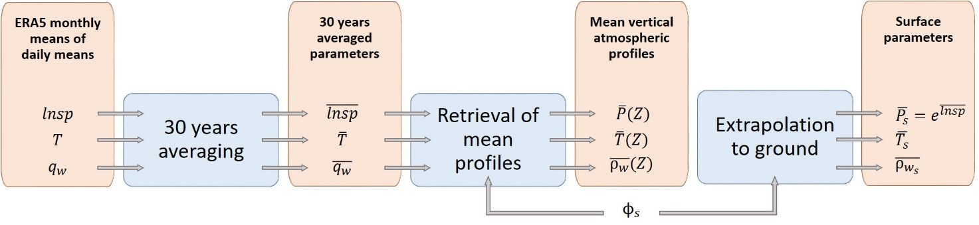

The step-by-step procedure is detailed below:

|  |  |
| --- | --- |
|  | ERA5 monthly means of daily means |
| **Step 1** | Download the ERA5 parameters of interest:  – Logarithm of surface pressure *lnsp*  – Temperature *T* (137 levels)  – Specific humidity (137 levels). |
| **Step 2** | Averaging over 30 years (1991-2020). The maps consist of weighted means (by the number of days in the considered month) of a given parameter (*lnsp*, *T*, and ) for a given model level. |
| **Step 3** | Retrieval of mean vertical atmospheric profiles using the procedures of Section 3 of this document. |
| **Step 4** | Extrapolation of surface parameters. Surface pressure and height above mean sea level of the surface of the Earth are directly given. Surface temperature is linearly extrapolated using the above two levels. Surface water vapour density is logarithmically extrapolated using the above two levels. |

## 4.2 Comparisons with reference maps derived from ERA5 pressure levels data

A brief comparison between mean (1991-2020) annual vertical atmospheric profiles derived from ERA5 pressure and model levels is shown in Fig. 3 for four specific locations: Toulouse, Kourou, New Delhi, and Svalbard. The vertical atmospheric profiles derived from ERA5 pressure levels are coming from the analyses detailed in [1] and Document 3J/140. The black circles correspond to the 37 pressure levels, while the red line highlights the complete profiles from the 137 model levels data.

FIGURE 3

Examples of mean annual vertical atmospheric profiles for four specific locations

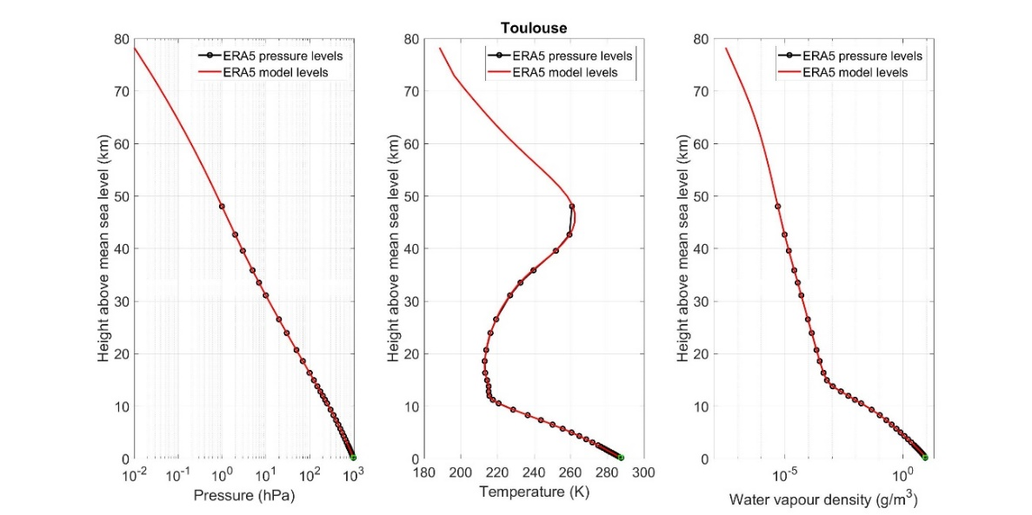

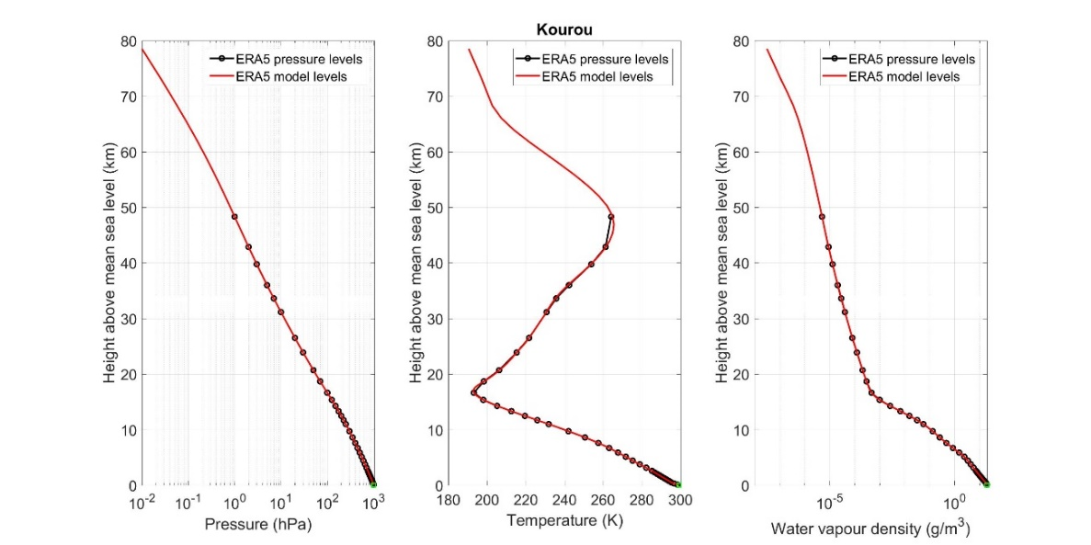  
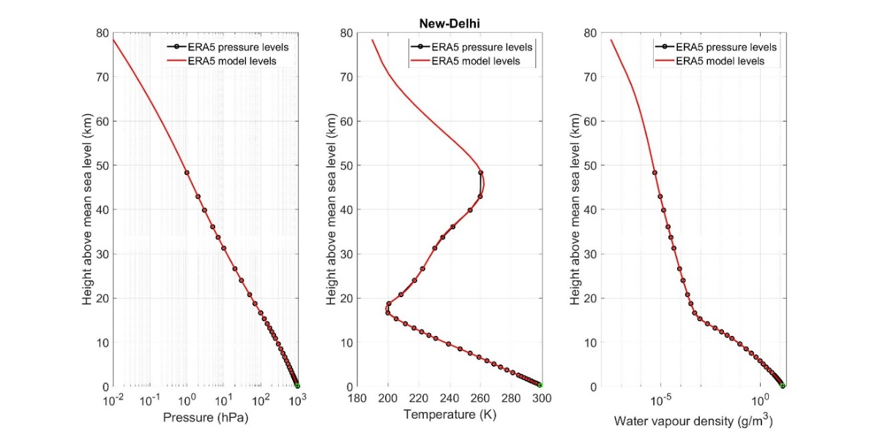

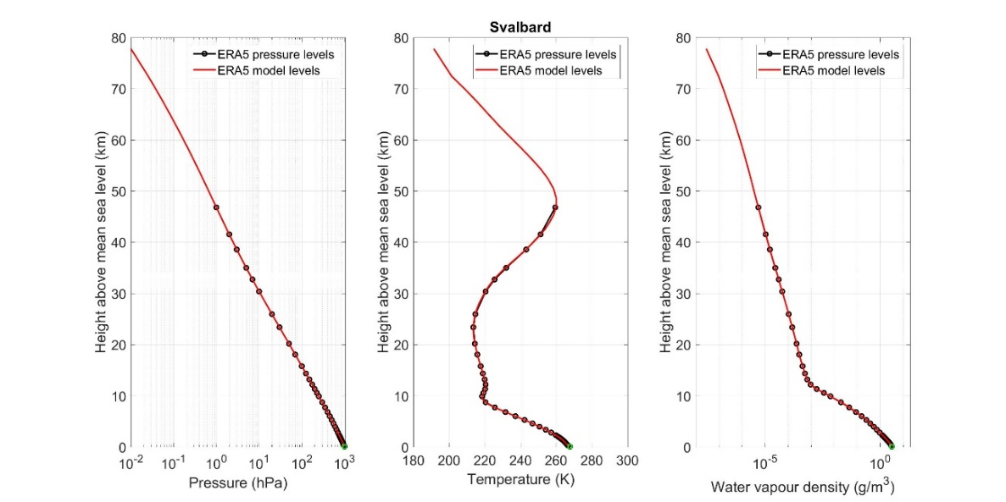

Then, the absolute differences of mean annual vertical atmospheric profiles (ERA5 model levels – ERA5 pressure levels) are shown in Fig. 4 for the sites of Toulouse, Kourou, New Delhi, and Svalbard.

Figure 4

Difference of mean annual vertical atmospheric profiles for four specific locations   
(ERA5 model levels – ERA5 pressure levels)

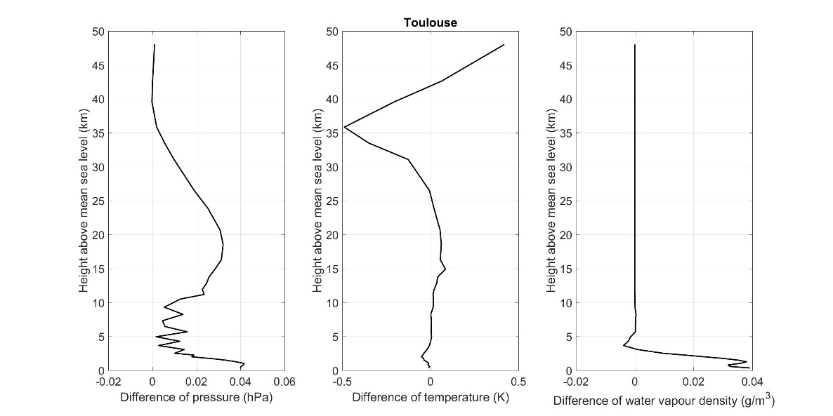  
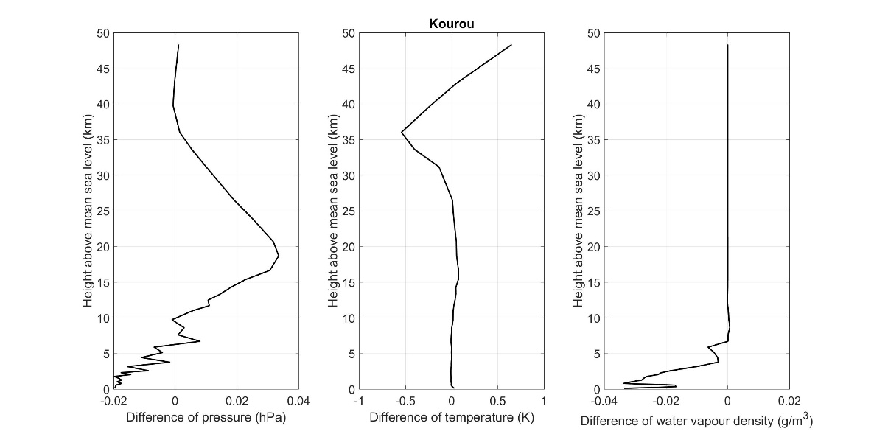  
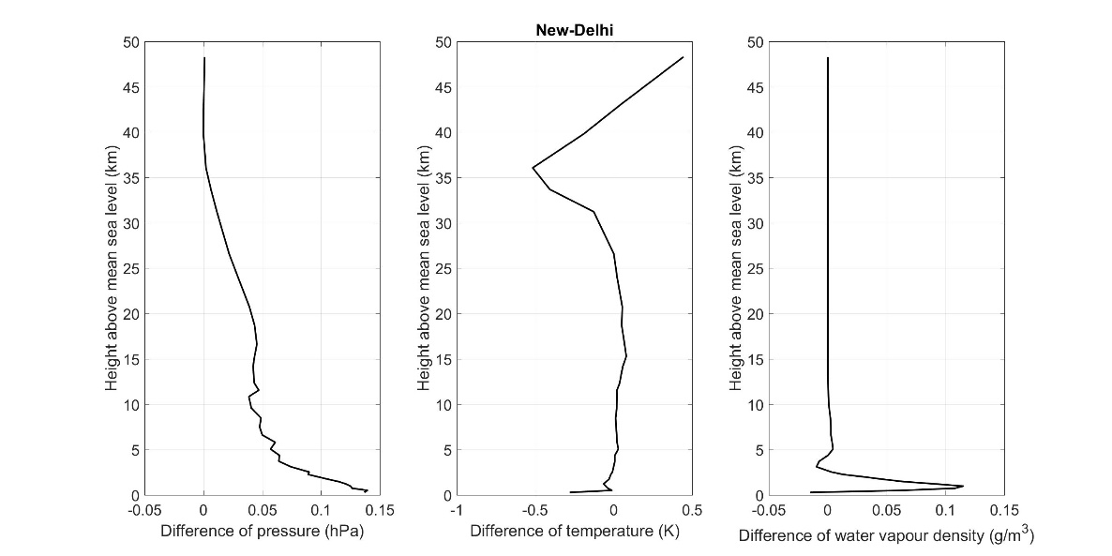

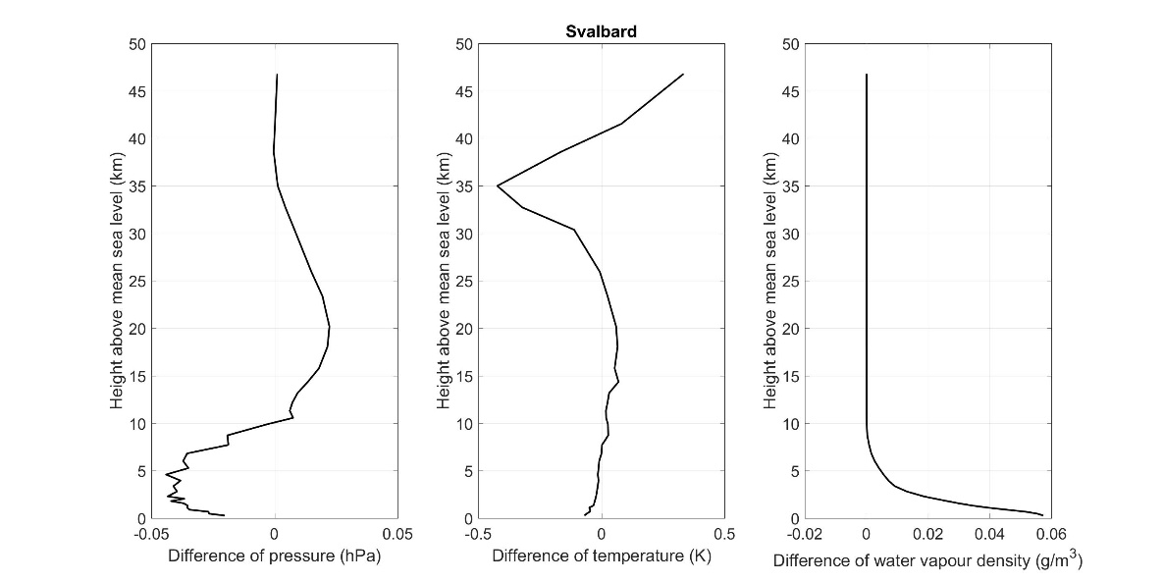

The following points might explain the differences:

– Lower values of temperature between 30 and 45 km are due to the use of ERA5.1 model levels data between 2000 and 2006 while when processing pressure levels data, ERA5 data was only used. This is in line with [6].

– Mean pressure profiles are derived from the mean of the logarithm of surface pressure when processing ERA5 model levels data. Mean pressure profiles are directly given for ERA5 pressure levels data.

– Mean water vapour density profiles are derived from the mean specific humidity profiles when processing ERA5 model levels data. Mean water vapour density profiles are derived from the averaging of monthly mean water vapour density profiles when processing ERA5 pressure levels data.

## 4.3 Comparisons with Recommendation ITU-R P.835-6 (Annex 1 – Section 1)

A brief comparison between mean (1991-2020) annual vertical atmospheric profiles derived from ERA5 model levels and Section 1 of Annex 1 of Recommendation ITU-R P.835-6 is shown in the following figures:

– Figure 5 highlights the ERA5 pressure profiles at a latitude of 45° N and the comparison of the mean pressure profile for latitudes between 42.5° N and 47.5° N and Recommendation ITU-R P.835-6 (Annex 1 – Section 1). Figure 6 highlights the absolute difference between the mean pressure profile for latitudes between 42.5° N and 47.5° N and Recommendation ITU-R P.835-6 (Annex 1 – Section 1).

– Figure 7 highlights the ERA5 temperature profiles at a latitude of 45° N and the comparison of the mean temperature profile for latitudes between 42.5° N and 47.5° N and Recommendation ITU-R P.835-6 (Annex 1 – Section 1). Figure 8 highlights the absolute difference between the mean temperature profile for latitudes between 42.5° N and 47.5° N and Recommendation ITU-R P.835-6 (Annex 1 – Section 1).

– Figure 9 highlights the ERA5 water vapour density profiles at a latitude of 45° N and the comparison of the mean water vapour density profile for latitudes between 42.5° N and 47.5° N and Recommendation ITU-R P.835-6 (Annex 1 – Section 1). Figure 10 highlights the absolute difference between the mean water vapour density profile for latitudes between 42.5° N and 47.5° N and Recommendation ITU-R P.835-6 (Annex 1 – Section 1).

Figure 5

Comparison of mean annual pressure profiles from ERA5 model levels   
and Recommendation ITU-R P.835-6 (Annex 1 – Section 1)

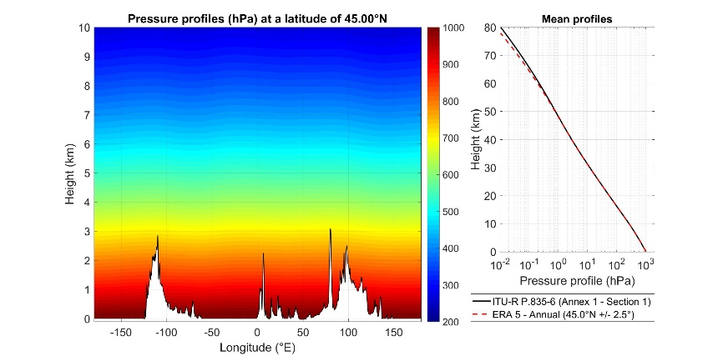

Figure 6

Absolute difference between mean annual pressure profile from ERA5 model levels   
and Recommendation ITU-R P.835-6 (Annex 1 – Section 1)

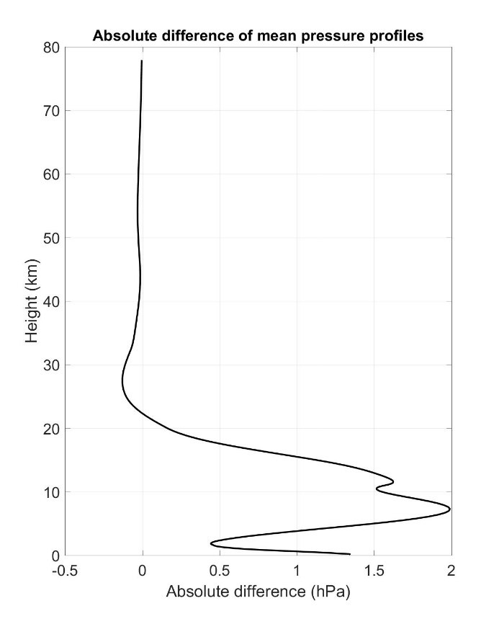

Figure 7

Comparison of mean annual temperature profiles from ERA5 model levels   
and Recommendation ITU-R P.835-6 (Annex 1 – Section 1)

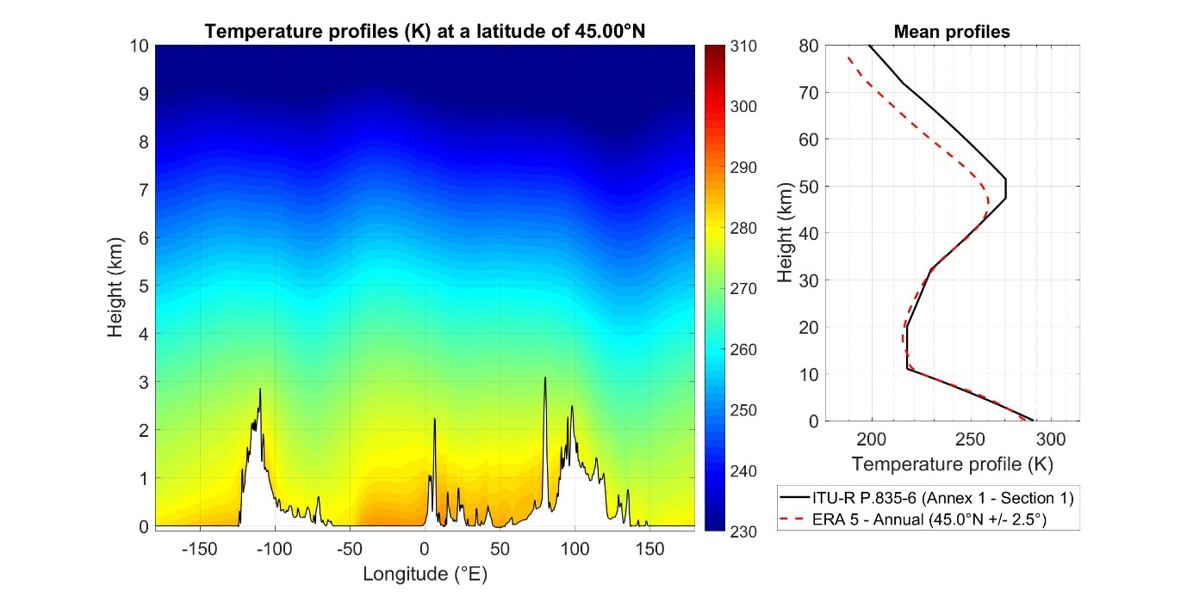

Figure 8

Absolute difference between mean annual temperature profile from ERA5 model levels   
and Recommendation ITU-R P.835-6 (Annex 1 – Section 1)

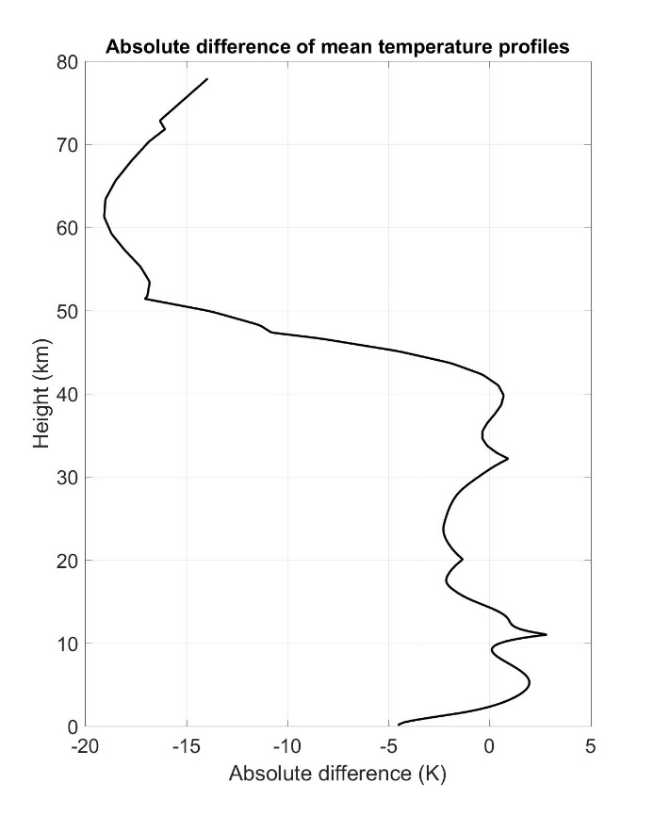

Figure 9

Comparison of mean annual water vapour density profiles from ERA5 model levels   
and Recommendation ITU-R P.835-6 (Annex 1 – Section 1)

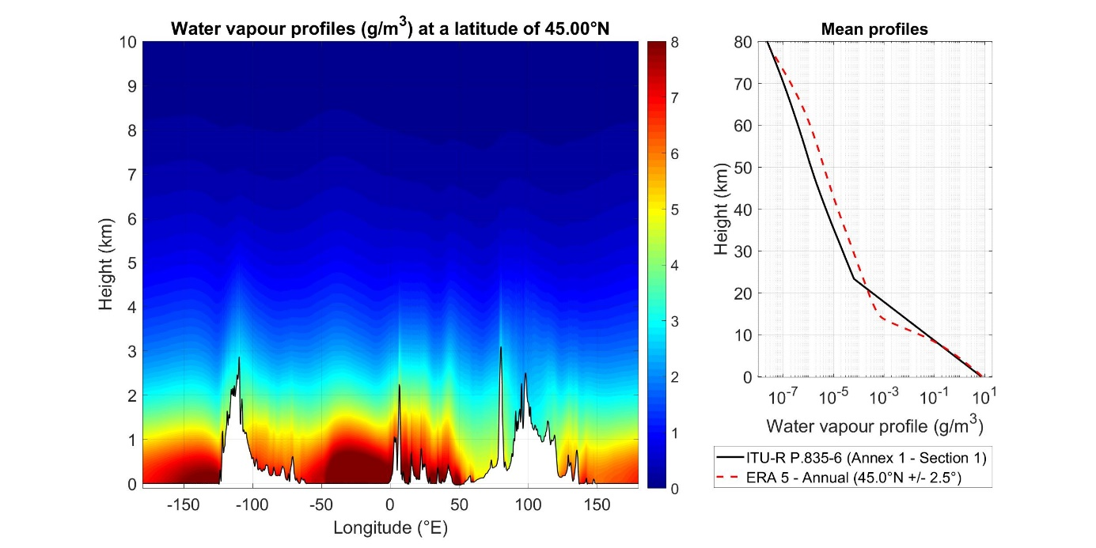

Figure 10

Absolute difference between mean annual water vapour density profile from ERA5 model levels   
and Recommendation ITU-R P.835-6 (Annex 1 – Section 1)

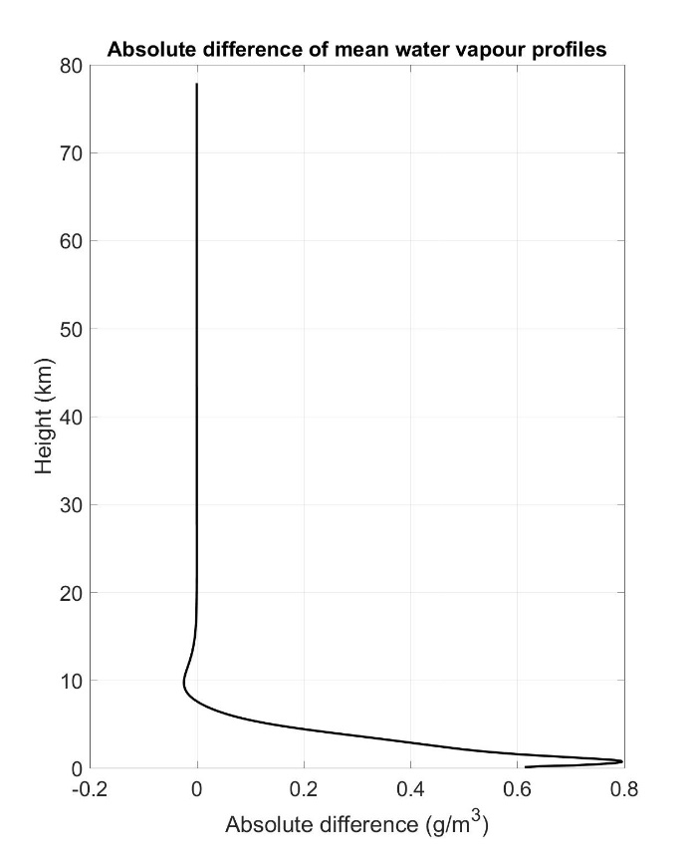

## 4.4 Test using radiosonde observations (RAOBS)

To test the accuracy of the new digital maps, the mean pressure, temperature, and water vapour density profiles have been extracted from radiosonde observations (RAOBS) data. Ten years (2011-2020) of RAOBS on 22 different locations have been taken into account. As these RAOBS data were also used to test oxygen, water vapour, and cloud attenuation prediction methods in [1], only RAOBS for which the highest altitude level is above 25 km have been considered. The table below highlights the main information on the RAOBS dataset. The total number of RAOBS used is 79 796.

| Country (NOAA ID) | Site | Latitude  (° N) | Longitude (° E) | Altitude (m) | Total number of RAOBS | Number of RAOBS with the highest level above 25 km |
| --- | --- | --- | --- | --- | --- | --- |
| AR | Buenos Aires – Ezeiza | −34.82 | −58.53 | 20 | 4 930 | 3 635 |
| AT | Graz | 47.00 | 15.43 | 347 | 3 106 | 1 254 |
| BR | Galeao – Rio | −22.82 | −43.25 | 6 | 6 650 | 1 980 |
| CI | Abidjan – Port-Bouët | 5.25 | −3.93 | 8 | 5 569 | 1 713 |
| ES | Madrid – Barajas | 40.47 | −3.58 | 638 | 6 449 | 5 637 |
| FR | Bordeaux – Merignac | 44.83 | −0.70 | 45 | 6 413 | 3 267 |
| GA | Libreville – Léon Mba | 0.45 | 9.42 | 15 | 2 206 | 1 037 |
| GF | Cayenne-Rochambeau | 4.83 | −52.37 | 9 | 6 851 | 2 728 |
| GP | Pointe-à-Pitre – Le Raizet | 16.27 | −61.52 | 8 | 4 667 | 2 247 |
| GR | Athens – Hellenkion | 37.90 | 23.73 | 14 | 2 479 | 853 |
| IN | Calcutta – Dum Dum | 22.65 | 88.45 | 6 | 8 056 | 3 774 |
| IN | Delhi – Safdarjung | 28.58 | 77.20 | 216 | 9 499 | 1 537 |
| IT | Milano – Linate | 45.43 | 9.28 | 103 | 7 447 | 6 946 |
| MX | Mexico City | 19.43 | −99.07 | 2309 | 7 353 | 5 073 |
| NO | Ny-Alesund Ii | 78.92 | 11.93 | 8 | 4 615 | 4 292 |
| PT | Lisbon – Gago Coutinho | 38.77 | −9.13 | 105 | 3 208 | 1 808 |
| RE | Saint Denis | −20.88 | 55.52 | 20 | 3 221 | 1 408 |
| SG | Singapore – Changi | 1.37 | 103.98 | 16 | 11 635 | 3 993 |
| US | Denver | 39.77 | −104.88 | 1611 | 7 270 | 6 772 |
| US | Fairbanks | 64.82 | −147.87 | 135 | 7 264 | 6 888 |
| US | Las Vegas | 36.05 | −115.18 | 693 | 7 209 | 6 553 |
| US | Miami – Intl Univ | 25.75 | −80.38 | 4 | 7 455 | 6 401 |

The complete analysis is given in Fig. 11 for all the 22 RAOBS sites.

It can be observed that pressure and temperature profiles remarkably match up to 30 km. Water vapour density profiles match up to the top of the troposphere around 10 km. It has to be noted that this first 0-10 km layer contains 99% of the total mass of water vapour. Above 10 km, values of water vapour density are lower than 0.01 g/m3 which is less critical for tropospheric propagation issues.

Figure 11

Results of the tests of the accuracy of the new digital maps of reference atmospheres   
(pressure, temperature and water vapour profiles) for all the 22 RAOBS sites

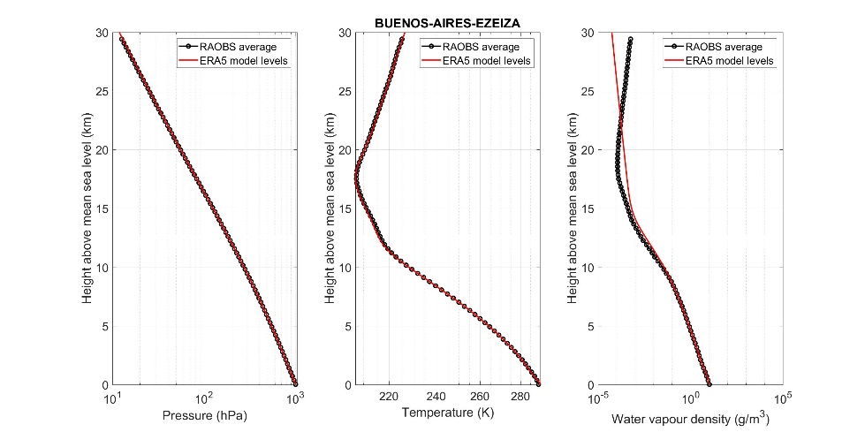  
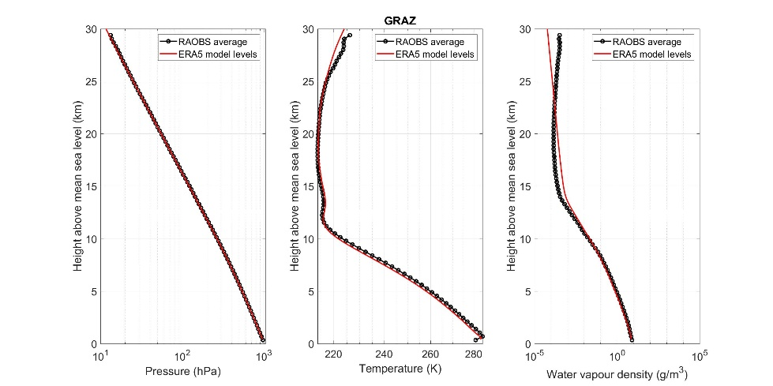  
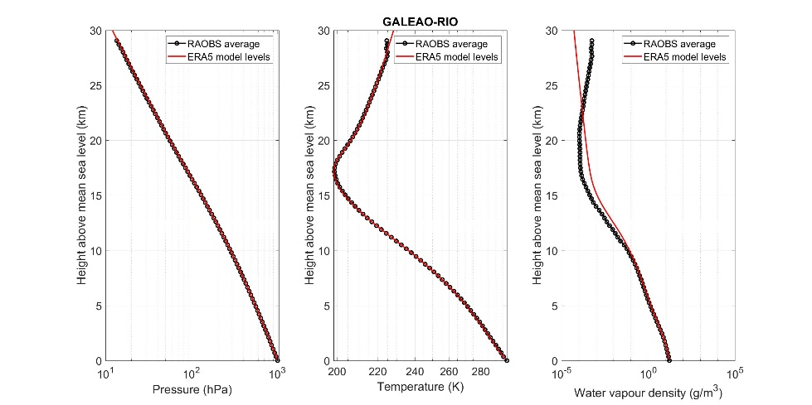  
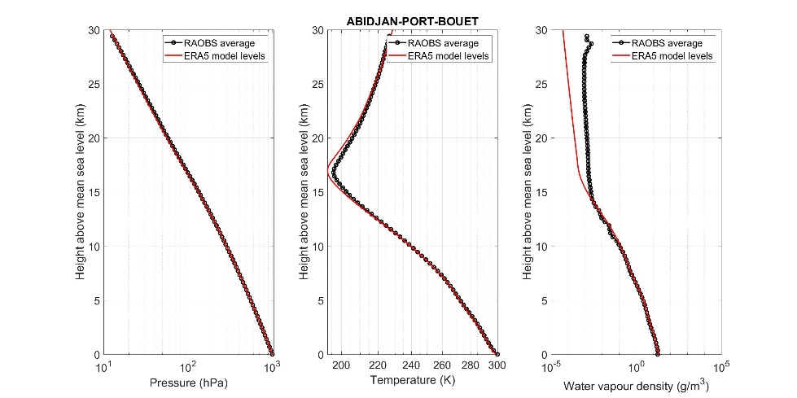  
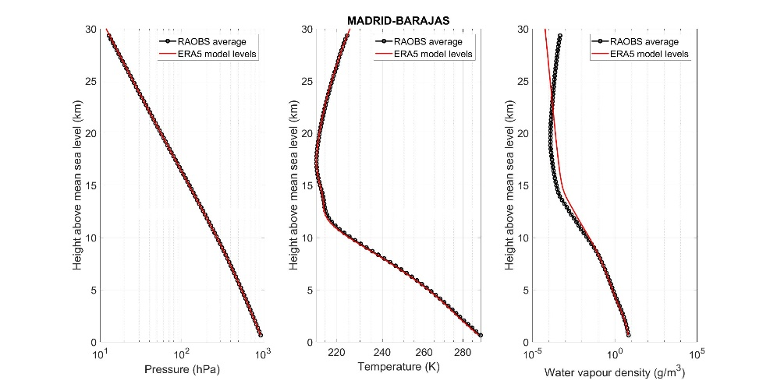  
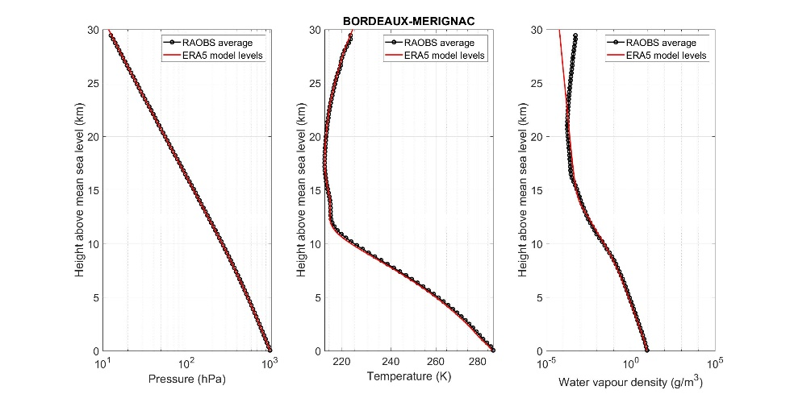  
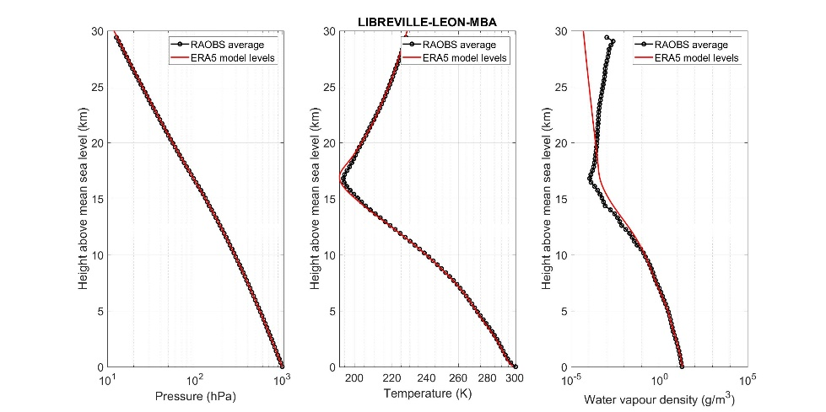  
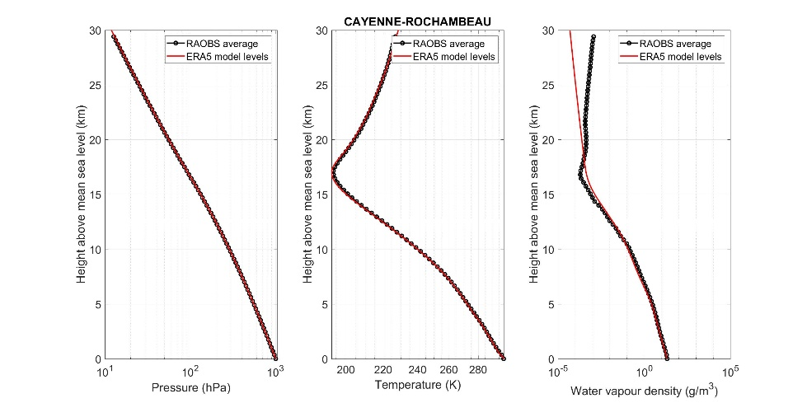  
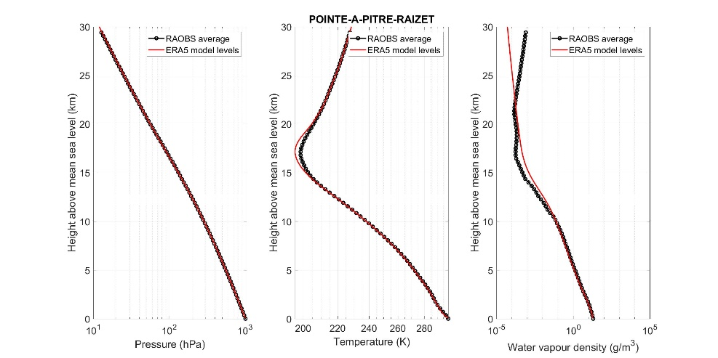  
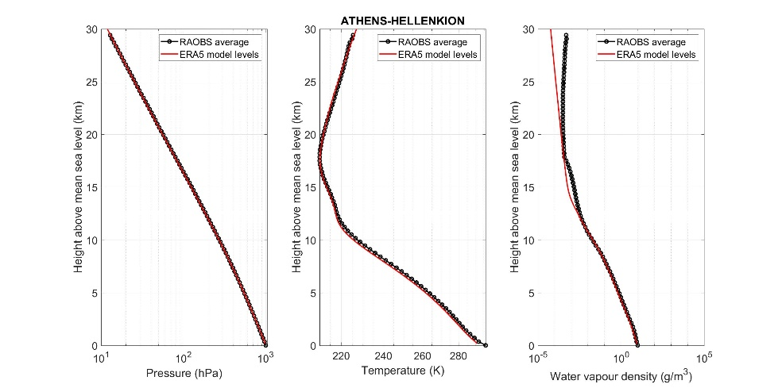  
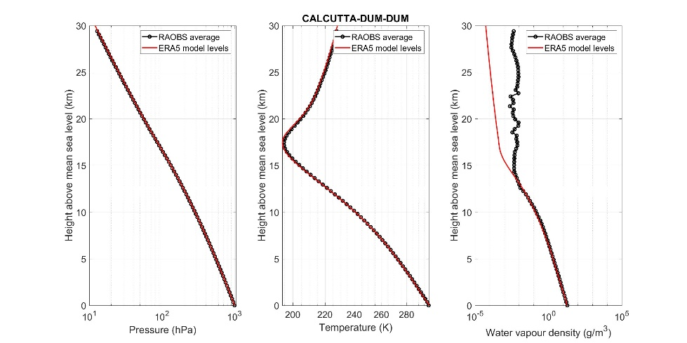  
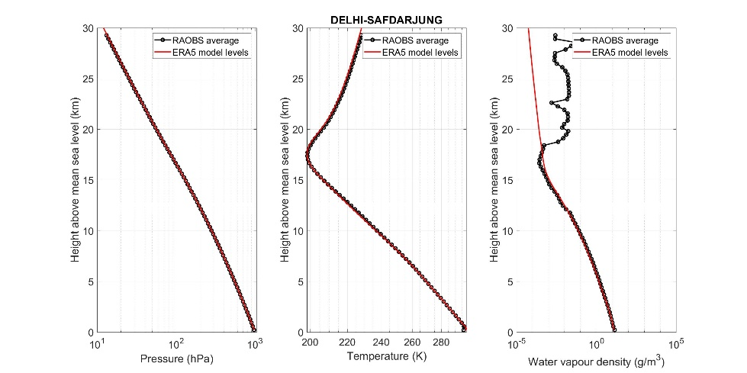  
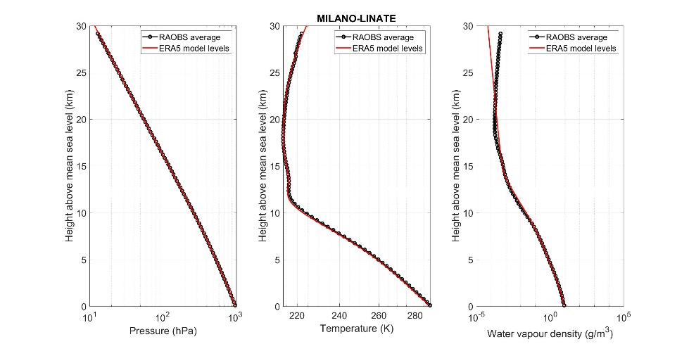  
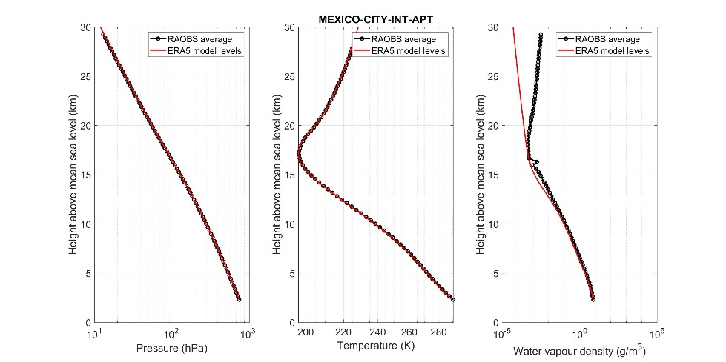  
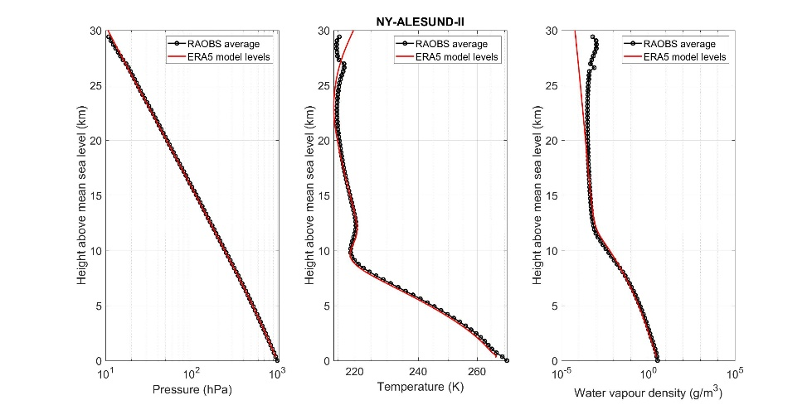  
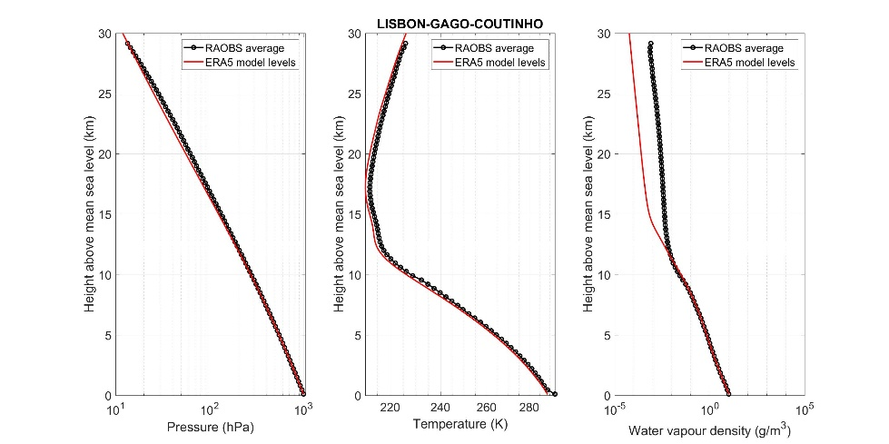  
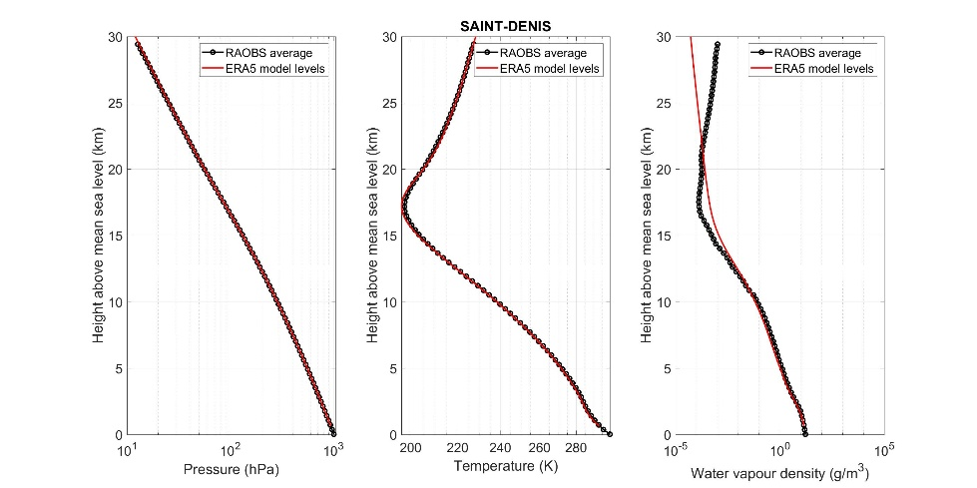  
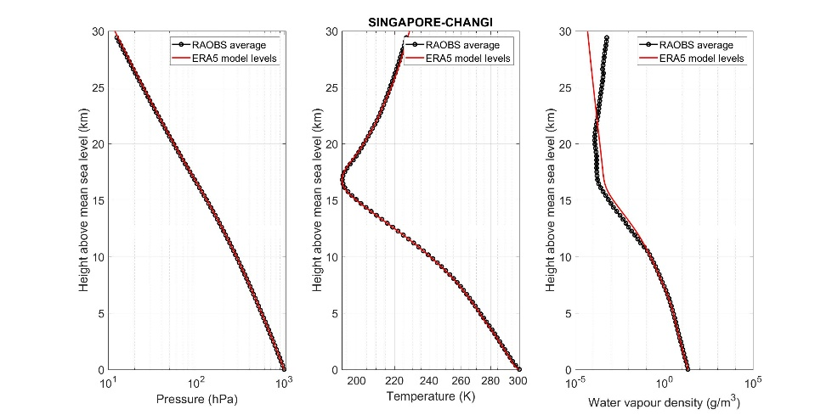  
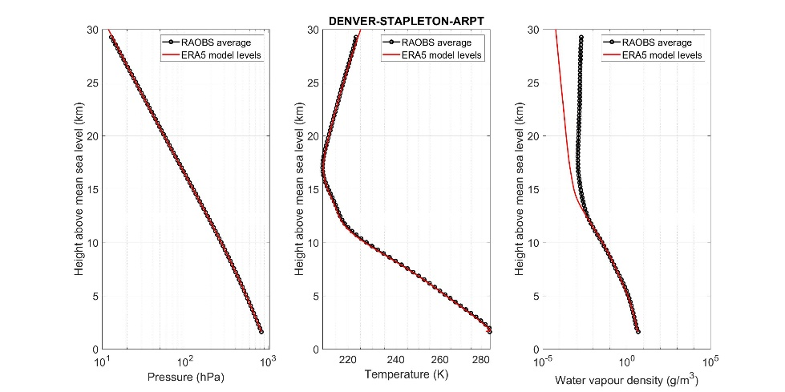  
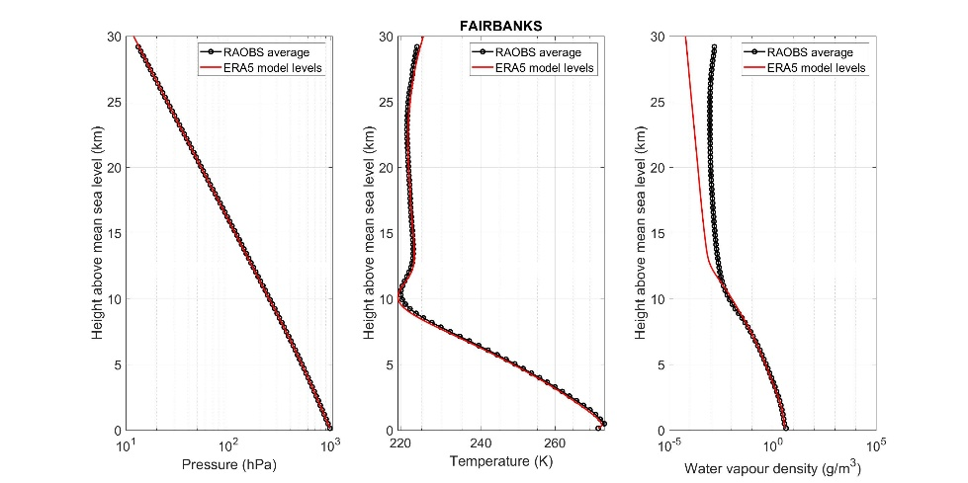  
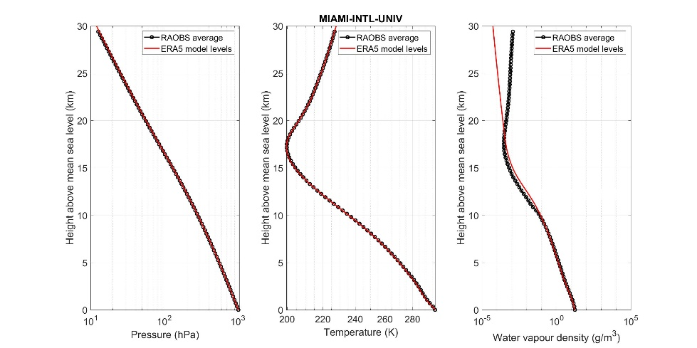  
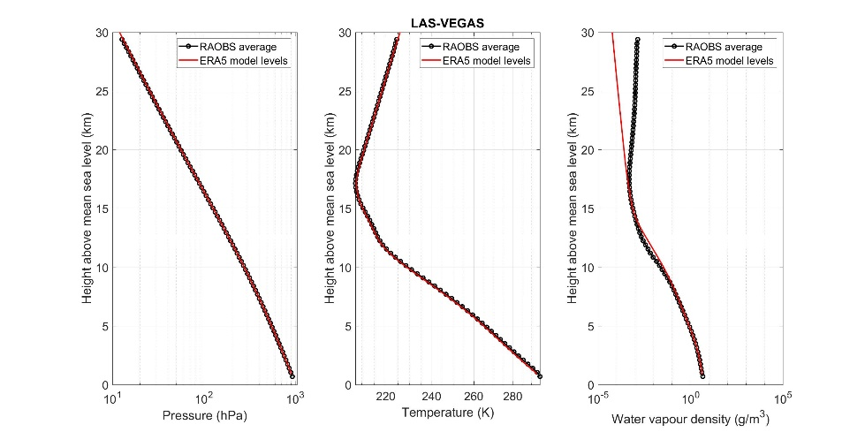

## 4.5 Example of monthly results

Some examples of mean monthly vertical atmospheric profiles derived from ERA5 model levels are shown in Figs 12, 13, 14, and 15, respectively, for the sites of Toulouse, Kourou, New Delhi, and Svalbard.

Figure 12

Mean monthly vertical atmospheric profiles using ERA5 model levels data in Toulouse

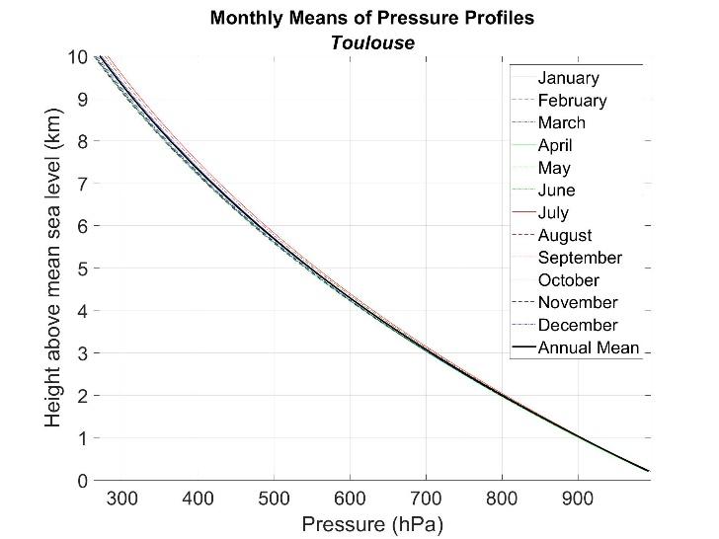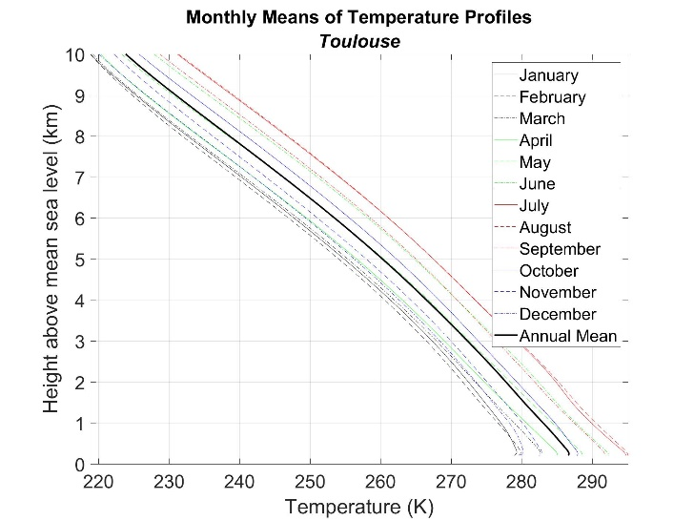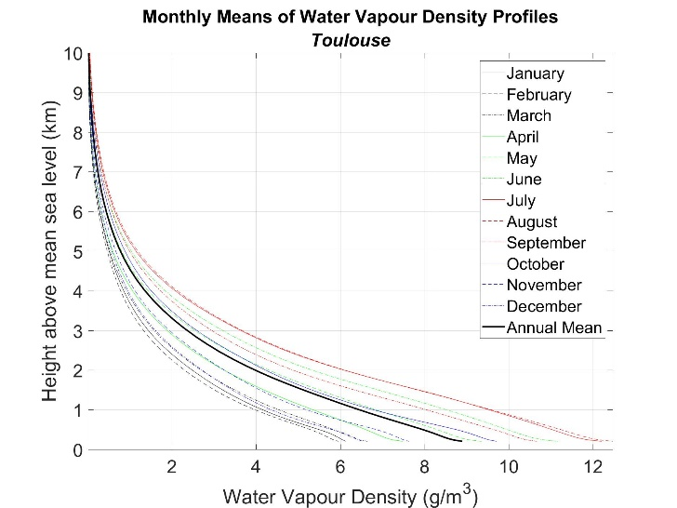

Figure 13

Mean monthly vertical atmospheric profiles using ERA5 model levels data in Kourou

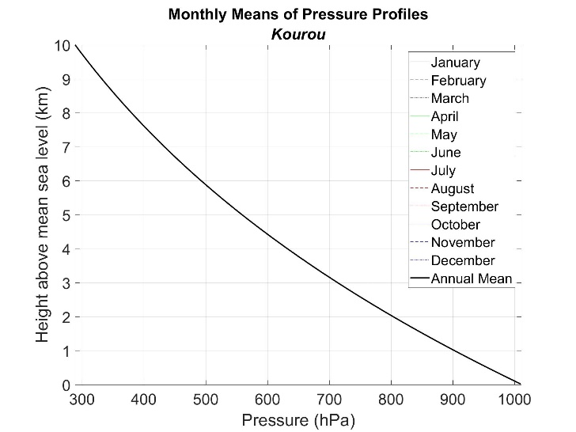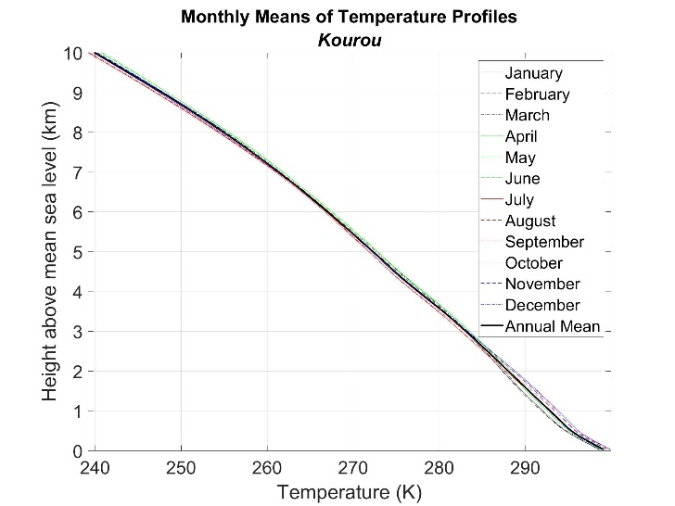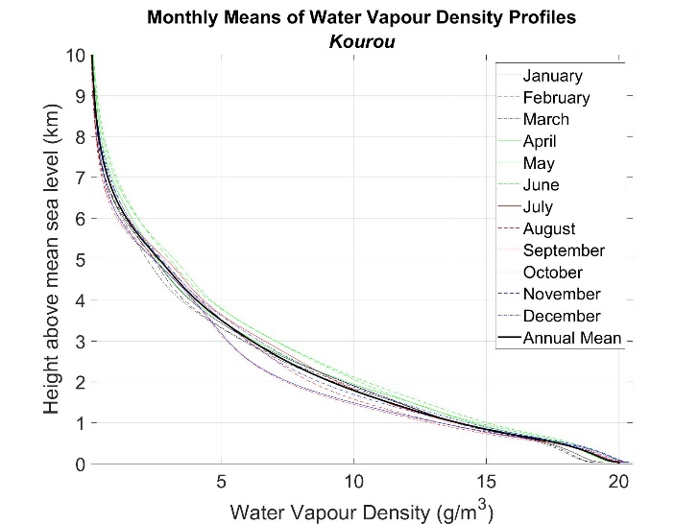

Figure 14

Mean monthly vertical atmospheric profiles using ERA5 model levels data in New Delhi

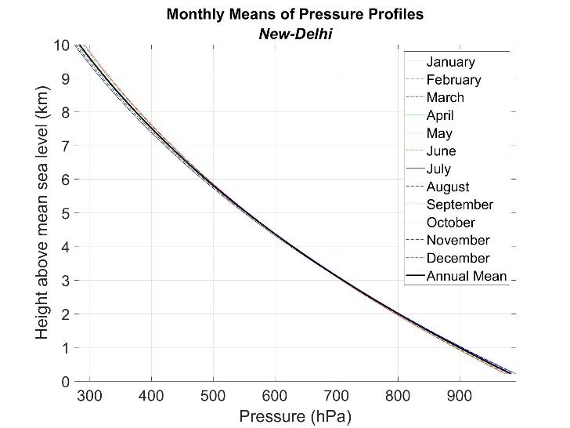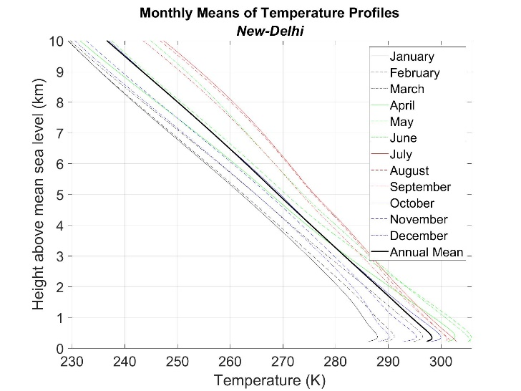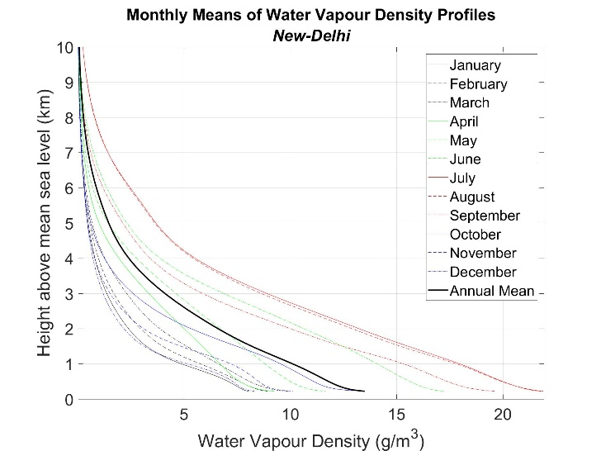

Figure 15

Mean monthly vertical atmospheric profiles using ERA5 model levels data in Svalbard

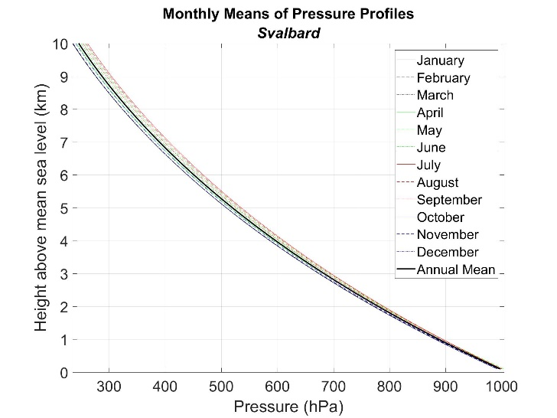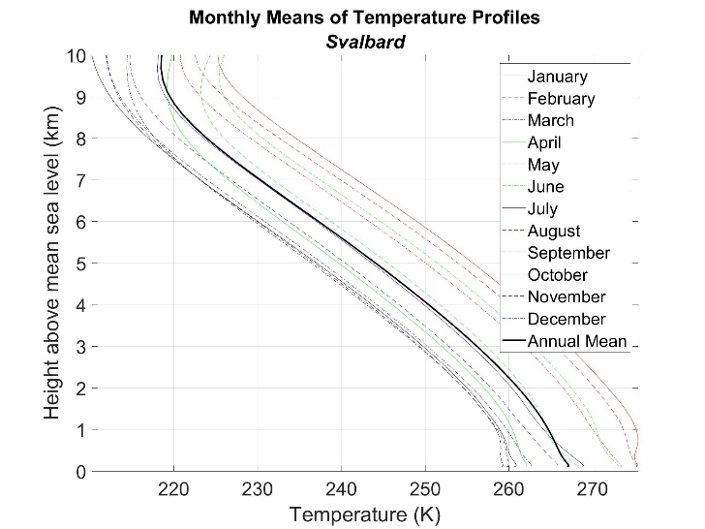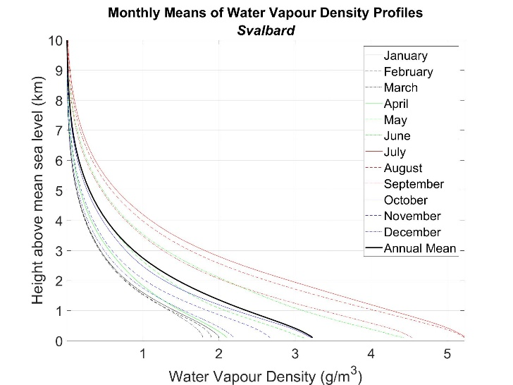

# 5 Global mean annual and mean monthly vertical profiles

## 5.1 Mean annual and monthly data files description

These files contain mean annual and mean monthly vertical profiles of total (barometric) pressure, temperature, and water vapour density at 138 altitude levels above mean sea level derived by averaging 30 years (1991-2020) of ECMWF ERA5 model level data.

These vertical profiles are integral parts of Recommendation ITU-R P.835 and are available in the form of digital maps provided as parts to this document in the 13 zip files Annual.zip, and MonthXX.zip, where XX= 01, 02, …., 11, 12, respectively, corresponding to the months Jan, Feb, …, Oct, Nov, Dec. Each zip file contains the four map files P.bin, T.bin, WV.bin, and Z.bin for the applicable annual or monthly period. P.bin contains the pressure profiles, T.bin contains the temperature profiles, WV.bin contains the water vapour density profiles, and Z.bin contains the profiles of geometric altitude above mean sea level. The characteristics of each map file are shown in Table 5-1.

Table 5-1

Map file characteristics

|  |  |
| --- | --- |
| Parameter | Value |
| Format | IEEE 754 |
| Byte ordering | Little endian |
| Precision | Single (4 bytes/value) |
| Total number of bytes | 573 506 472 |
| Latitude range | −90° N to 90° N |
| Latitude increment | +0.25° |
| Longitude range | −180° E to 180° E |
| Longitude increment | +0.25° |
| Number of latitude grid points | 721 |
| Number of longitude grid points | 1 441 |
| Number of altitude levels | 138 |
| Total pressure units | hPa |
| Temperature units | K |
| Water vapour density units | g/m3 |
| Altitude units | km, a.m.s.l. |

Each parameter is stored as a 3-dimensional matrix *parameter*(*ilevel*, *ilat*, *ilon*), where, assuming indexing starts at 1, The first byte of the four bytes corresponding to the value of total (barometric) pressure (, temperature (), water vapour density (, or geometric altitude above mean sea level ( at any grid point , ) and altitude level ( is byte number , where ranges from to .

(III-1)

where:

(III-2)

(III-3)

(III-4)

There are 138 pressure, temperature, and water vapour density levels at each grid point, where and are the values of total pressure, temperature, and water vapour density at altitude above mean sea level, . is the ERA5 altitude[[2]](#footnote-2) of the surface of the Earth above mean sea level, and is the maximum altitude above mean sea level at the associated grid point. may be different than the topographic altitude in Recommendation ITU-R P.1511, which was determined by a combination of high-resolution satellite radar altimetry augmented by local altimetry data.

## 5.2 Interpolation of meteorological parameters

If an estimate of atmospheric data is desired at locations other than the grid points of the reference atmospheres in the mean monthly and annual data files, the following interpolation method may be used. It has to noted that this estimate could differ from the actual reference atmosphere at the desired point, in terms of statistical significance, accuracy and uncertainty.

The relation between , the desired altitude above mean sea level, the altitude of the surface of the Earth above mean sea level, and , the desired height above the surface of the Earth is shown in Fig. 16.

Figure 16

Relation between , , and



### 5.2.1 Vertical and spatial interpolation for a desired location between spatial grid points

This method calculates the total pressure, (hPa), temperature, (K), and water vapour density, (g/m3), at a desired location and at either: i) the associated desired altitude above mean sea level, , or ii) the associated desired height above the surface of the Earth, (km), for a desired location between spatial grid points of the map files specified in § 1 of this annex. Refer to Fig. 17 for the interpolation procedure

Figure 17

Vertical and spatial interpolation procedure for a spatial location between grid points  
( is pressure, , temperature, , or water vapour density, )



a) If the associated desired altitude above mean sea level, , is not known, determine as follows:

i) determine the altitude of the surface of the Earth above mean sea level at the desired location, (km), from local data, or, if local data is not available, from Recommendation ITU-R P.1511;

ii) calculate the desired altitude above mean sea level at the desired location, (km), corresponding to the desired height above the surface of the Earth at the desired location as follows: ;

b) for each of the four surrounding spatial grid points, =1, 2, 3, and 4, determine , , , vs. , for the model levels, from the appropriate integral digital maps;

c) for each of the four surrounding spatial grid points, = 1, 2, 3, and 4, determine the parameter of interest, or at the altitude above mean sea level by interpolating or extrapolating , , and vs. , as follows:

i) linearly interpolate or extrapolate vs. to the desired altitude above mean sea level, ;

ii) linearly interpolate or extrapolate vs. to the desired altitude above mean sea level, ;

iii) linearly interpolate or extrapolate vs. to the desired altitude above mean sea level, ;

however, if , set and to , , and , respectively;

d) determine the parameters of interest , , or at the desired location and at the desired altitude above mean sea level or equivalent height above the surface of the Earth by interpolating the four values of , , or where and 4 to the desired location using the bilinear interpolation method in Annex 1 of Rec. ITU-R P.1144.

### 5.2.2 Vertical interpolation for a desired location at a spatial grid point

This method calculates the total pressure, (hPa), temperature, (K), and water vapour density, (g/m3), at a desired location and at either: i) the associated desired altitude above mean sea level, , or ii) the associated desired height above the surface of the Earth, (km), for a desired location at a spatial grid point of the map files.

a) If the associated desired altitude above mean sea level, , is not known, determine as follows:

i) determine the altitude of the surface of the Earth above mean sea level at the desired location, (km), from local data, or, if local data is not available, from Recommendation ITU-R P.1511;

ii) calculate the desired altitude above mean sea level at the desired location, (km), corresponding to the desired height above the surface of the Earth at the desired location as follows: ;

b) determine , , , vs. , for the model levels, from the appropriate integral digital maps;

c) determine the parameter of interest, or at the desired location and desired altitude above mean sea level by interpolating or extrapolating , , and vs. , as follows:

i) linearly interpolate or extrapolate vs. to the desired altitude above mean sea level, ;

ii) linearly interpolate or extrapolate vs. to the desired altitude above mean sea level, ;

iii) linearly interpolate or extrapolate vs. to the desired altitude above mean sea level, ;

however, if , set, , and to , , and , respectively.

d) , , or are the desired parameters of interest at the desired location and at the desired altitude above mean sea level or equivalent height above the surface of the

# 6 Conclusions

In this fascicle, the background information on the new reference mean atmospheres using 30 years (1991-2020) of ERA5 model levels data (monthly means of daily means) has been given. Annual and monthly means are available. Each of the reference mean atmospheres consists of 138 digital maps (one for each ERA5 model level + surface of the Earth) of the following parameters:

– pressure

– temperature

– water vapour density

– height above mean sea level.

The spatial resolution in both latitude and longitude is 0.25°.

These new maps could be used for possible improvements of tropospheric radio-wave and optical propagation prediction methods. They are integral parts to Annex 3 of Recommendation ITU-R P.835-7.

The results referenced by this fascicle were derived from various data products from the European Centre for Medium-Range Weather Forecasts (ECMWF) Copernicus Climate Change Service. Neither the European Commission nor ECMWF is responsible for any use that may be made of the Copernicus information or data it contains.

References

[1] X. Boulanger, “Improvement of Tropospheric Propagation Instantaneous and Statistical Models for Earth-Space Paths”, CNES technical note, DSO/RF/ITP-2020.0032915, Issue 2.1, June 2021. <https://www.comet-cnes.fr/propagation-resources>.

[2] X. Boulanger, “New Reference Atmospheres for Radio-wave and Optical Propagation studies”, CNES technical note, DTN/TPI/TCP-2023.0004431, Issue 1, March 2023.

[3] Hersbach H., Bell B., Berrisford P., *et al.*, “The ERA5 global reanalysis”. Q. J. R. Meteorol Soc. 2020; 146:1999 – 2049. <https://doi.org/10.1002/qj.3803>.

[4] Hersbach H., *et al.*, (2018): ERA5 hourly data on pressure levels from 1959 to present. Copernicus Climate Change Service (C3S) Climate Data Store (CDS), <https://doi.org/10.24381/cds.bd0915c6>.

[5] Hersbach H. *et al.*, (2019): ERA5 monthly averaged data on pressure levels from 1959 to present. Copernicus Climate Change Service (C3S) Climate Data Store (CDS), <https://doi.org/10.24381/cds.6860a573>.

[6] Simmons A. *et al.*, “Global stratospheric temperature bias and other stratospheric aspects of ERA5 and ERA5.1”, ECMWF Technical Memo, January 2020. <https://www.ecmwf.int/en/publications/search?searc_all_field=ERA5.1>.

[7] [https://confluence.ecmwf.int/display/CKB/ERA5%3A+compute+pressure+  
and+geopotential+on+model+levels%2C+geopotential+height+and+geometric+height](https://confluence.ecmwf.int/display/CKB/ERA5%3A+compute+pressure+and+geopotential+on+model+levels%2C+geopotential+height+and+geometric+height).

[8] <https://confluence.ecmwf.int/display/UDOC/L137+model+level+definitions>.

[9] <https://en.wikipedia.org/wiki/International_Standard_Atmosphere>.

[10] Ritchie H. *et al.*, “Implementation of the semi-Lagrangian method in a high resolution version of the ECMWF forecast model”, technical report n° 72, March 1994, revised June 1994.

\_\_\_\_\_\_\_\_\_\_\_\_\_\_\_\_\_\_\_

1. <https://wahiduddin.net/calc/density_altitude.htm>, equations (17) and (20).  
   (Note from Secretariat: See reference 4 for which the link is erroneous. No alternative link could be identified.) [↑](#footnote-ref-1)
2. The ERA5 geometric altitude of the surface of the Earth above mean sea level was obtained by dividing the ERA5 gravitational potential energy of a unit mass at the surface of the Earth (m2/s2) by the gravitational acceleration (9.80665 m/s2) and converting the resulting geopotential altitude of the surface of the Earth to a geometric altitude of the surface of the Earth. [↑](#footnote-ref-2)