ANNEX 5D
U.S. Mobile EAS for ATSC Mobile DTV

The ATSC Mobile Emergency Alert System (M-EAS) builds upon established ATSC Mobile Digital Television and Non Real Time standards to provide a robust and reliable alerting service for the public. It leverages the demonstrated excellent reliability of the broadcast digital television service to serve emergency needs that cannot be satisfied by other communications means that become damaged or overloaded during natural disasters. It provides means for dissemination of both national and local alerts, and significantly extends alerting capabilities to include rich media such as maps and videos.
Introduction and background
M-EAS - was designed upon existing ATSC standards, specifically the ATSC Mobile DTV standard - and Non Real Time (downloaded and stored) service standard. By the addition of a few new tables of emergency-related information to the mobile DTV signal, M-EAS capable mobile and handheld receivers can be directed to both basic and more detailed emergency information. M-EAS utilizes the international Common Alerting Protocol (CAP), which specifies how messages are structured and enables geo-targeting. CAP compliance allows ready adoption of M-EAS into the U.S. Integrated Public Alert and Warning System (IPAWS). M-EAS does not replace the legacy EAS, but extends the dissemination of emergency information. In addition, M-EAS expands the types of information that can be provided to include rich media like maps and videos.
Motivation for the development of M-EAS was centred on the broadcasters' demonstrated capability to maintain service under extreme conditions, by use of backup transmitter power; and on the one-to-many nature of broadcasting that avoids the data overload that has been the bane of cellular systems. M-EAS uses a portion of the existing broadcast data stream and therefore requires no new spectrum or transmission infrastructure. M-EAS receivers, like any handheld device, can be recharged from a variety of sources including cars in case of electric power failure.
PBS (the Public Broadcasting Service), in conjunction with LG Electronics and its U.S. subsidiary Zenith Electronics, Harris Broadcast, and Roundbox, along with additional funding from NAB Labs conducted a one-year test to assess the potential of television stations using Mobile DTV (MDTV) to distribute real-time, live broadcast emergency messages to the public. Tests were conducted at public television stations located in Boston, Las Vegas, and Alabama with support from the Corporation for Public Broadcasting. KOMO-TV, a commercial station in Seattle, helped create a tsunami alert simulation. These field trials confirmed the ability of U.S. broadcasters to make "dual use" of their new Mobile DTV transmission capability to provide rich-media emergency alerts.
The pilot led to standardization by the Advanced Television Systems Committee (ATSC) and continuing dialogue with FEMA, the National Weather Service, the FCC, and Congress, as well as state and local emergency managers.

Receiver behaviour
The M-EAS signal provides the necessary data so that a MDTV receiver can provide user-friendly notification of emergencies:
– Wake-up from standby monitoring.
– Automatic presentation of new or updated message text (with the intent to be overlaid on or below the program currently being viewed).
– Ignoring of repeated old messages to which the user has already responded.
– Listing of available emergency rich media content in the service guide.
– Deletion of canceled messages.
Example of M-EAS content - Hurricane scenario
In this example, preparedness information is made available at any time before an event. This information is not easily conveyed in a short text message, so the text is used as a pointer to richer resources (Figure 1). As shown in Figure 1, the text banner is created by the receiver with text extracted from the CAP message. In this implementation, the user taps on the banner to reach a service guide with a menu of rich media items associated with the current emergency (Figure 2). The user then selects a rich media element to view (Figure 3). Other implementations of receiver functions are possible.
The CAP standard includes an Alert message, optional Update message(s), and a Cancel message. In the example, and potentially in actual use, an initial CAP Alert message and the corresponding message banner may be an early warning. Subsequent CAP text Update messages may be of a more urgent nature. In either case, linkage can be provided to the service guide (Figure 2) and then to rich media including weather radar (Figure 3) and evacuation orders/routes (Figure 4).
Figure 1
Initial CAP text message
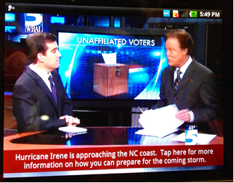

Figure 2
Service guide listing linked from CAP message
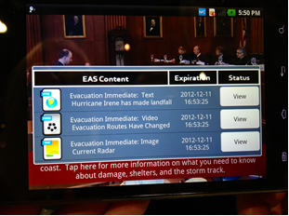
Figure 3
Weather radar map broadcast via M-EAS
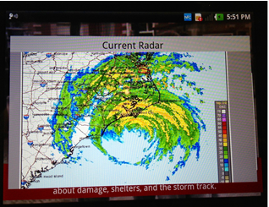
Figure 4
HTML page of current information via M-EAS
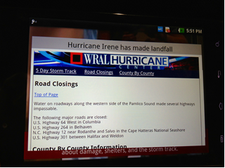
Receiver configurations
M-EAS incorporation has been demonstrated or announced for a variety of consumer devices, including:
– Cell phones.
– iOS device adapters.
– Tablet receivers.
– In-car receivers.
– PC accessory cards.
– External adapters for PCs.
Conclusion
M-EAS extends the reach of public emergency alerts by use of the existing mobile digital TV infrastructure. Compatible additions to existing digital TV broadcasts provide reliable alerting service to M-EAS capable portable and handheld devices, and are not subject to network overload due to the inherent one-to-many nature of the broadcast service. Relatively simple additions to a station's existing mobile TV equipment allow forwarding of CAP messages, plus the addition of highly useful rich media containing detailed information that can be originated locally.
References:
- [1] A/153 Part 10:2013, "Mobile Emergency Alert System" http://www.atsc.org
- [2] A/153 :2011, Parts 1 to 9, "ATSC Mobile DTV System" http://www.atsc.org
- [3] A/103:2012, Non Real Time Content Delivery http://www.atsc.org
Excerpt from "Mobile Emergency Alerting via ATSC MDTV", Jay Adrick (Harris Broadcast), Wayne Bretl (Zenith Electronics), Jim Kutzner (PBS) and Wayne Luplow (Zenith Electronics), Proceedings of the NAB Broadcast Engineering Conference, 2013.

