Information on coded timing
The information below is a supplement Recommendation ITU-R TF.583 “Time codes”.
Coded timing information is conveyed in a variety of formats and transmission media. In many cases such information is disseminated in a broadcast mode either on dedicated time and frequency services or as a part of other types of broadcasts primarily intended for other purposes. Time code broadcasts are currently available using amplitude modulation, frequency modulation and phase modulation techniques. Other forms of time codes have been developed and are in wide use for transmitting time information directly from one piece of equipment to another via hardwired or other types of connection.
In the remainder of this Annex some specific examples are provided for both the broadcast and the instrumentation time code types. While these codes are all currently available and widely used in at least some parts of the world, they are only representative of the total variety of codes that are in use.
Examples of broadcast codes include those transmitted by the time services of WWV/WWVH, WWVB, MSF, JJY, DCF 77, CHU and RBU, and the code generated by INRIM and disseminated on the AM and FM networks by the Italian broadcasting company RAI (see Figs. 1 to 9).
To illustrate the instrumentation type of codes, several of the specific formats recommended by the United States of America Inter-Range Instrumentation Group (IRIG) are shown in Fig. 10. IRIG serial time code formats have been described by the Timing Committee, Telecommunications and Timing Group, Range Commanders Council and were published by the Secretariat, Range Commanders Council, U.S. Army White Sands Missile Range, New Mexico 88002-5110.
An example of telephone time codes which shows the format of the code generally referred to as the European Telephone Time Code is given in Fig. 11. This code is now available from the primary timing centres of the following countries: Austria, Belgium, Germany, Italy, Malaysia, the Netherlands, Poland, Spain, Sweden, Switzerland, Turkey and the United Kingdom.

The information is available for download from the web site of Study Group 7 (Science services) of the ITU Radiocommunication Sector at: http://www.itu.int/oth/R0A08000004/en

Updated: 5 October 2022

FIGURE 3
MSF time code format

Second 00
0 ms
0 ms
100 ms 200 ms 300 ms
Carrier off
Carrier on
500 ms
bit A
bit B
Two bits, numbered xxA and xxB for second xx
Bit polarity: carrier on = 0, carrier off = 1
Minute marker

Seconds 01-60 †
Second marker

† Most minutes have seconds numbered 00-59; second 60 is a positive leap second in UTC

The MSF 60 kHz signal carries a time and date code which is summarised in the diagrams above. Simple on-off carrier modulation is used, with the fall of the carrier at the start of each second providing the time marker, which is controlled to Coordinated Universal Time (UTC). Every UTC second is marked by an 'off' preceded by at least 500 ms of carrier, and this second marker is transmitted with an accuracy better than ±1 ms.

The first second of the minute begins with a period of 500 ms with the carrier off, to serve as a minute marker. The other 59 (or, exceptionally, 60 or 58) seconds of the minute always begin with at least 100 ms 'off', followed by two 100 ms data bits, and end with at least 700 ms of carrier. The time and date code information is always given in terms of UK clock time and date, which is UTC in winter and UTC+1h when Summer Time is in effect, and it relates to the minute following that in which it is transmitted.

Bits 01A-16A and bits 17B-51B are currently set to '0', but may be used in the future for third-party services.
Bits 01B-16B carry information for the current minute about the difference DUT1 between UT1 and UTC.
Bits 53A-58A are all set permanently at '1', and are always preceded by bit 52A at '0', and followed by bit 59A at '0'. This sequence 01111110 never appears elsewhere in bit A, so it uniquely identifies the following second 00 minute marker.

Binary-Coded-Decimal Year (00-99)
80 | 40 | 20 | 10 | 8 | 4 | 2 | 1
17A | 18A | 19A | 20A | 21A | 22A | 23A | 24A

BCD Month (01-12) |  |  |  |  | BCD Day-of-Month (01-31) |  |  |  |  |  | Day-of-Week †
10 | 8 | 4 | 2 | 1 | 20 | 10 | 8 | 4 | 2 | 1 | 4 | 2 | 1
25A | 26A | 27A | 28A | 29A | 30A | 31A | 32A | 33A | 34A | 35A | 36A | 37A | 38A
† 0=Sunday to 6=Saturday

BCD Hour (00-23) |  |  |  |  |  | BCD Minute (00-59)
20 | 10 | 8 | 4 | 2 | 1 | 40 | 20 | 10 | 8 | 4 | 2 | 1
39A | 40A | 41A | 42A | 43A | 44A | 45A | 46A | 47A | 48A | 49A | 50A | 51A

Bit 54B-57B provide parity checks on the time and date information.

When UK civil time is subject to a one-hour positive offset during part of the year, bit 58B is set to to '1'. Bit 53B is set to '1' during the 61 consecutive minutes immediately before a change, the last being minute 59, when bit 58B changes.

0583-05
500 ms
800 ms
200 ms
8
2
20
10
4
8
80
40
100
200
M
"0"
P1
20
10
4
2
1
10
8
4
1
P2
40
20
P3
2
1
PA1
PA2
SU1
P4
SU2
80
40
20
10
8
4
2
1
P5
4
2
1
LS1
LS2
P0
M
"0"
"0"
"0"
"0"
"0"
"0"
"0"
"0"
"0"
"0"
"0"
"0"
0
10
20
30
40
50
0
8
2
20
10
4
8
80
40
100
200
M
"0"
P1
20
10
4
2
1
10
8
4
1
P2
40
20
P3
2
1
PA1
PA2
P4
P5
P0
M
"0"
"0"
"0"
"0"
"0"
"0"
"0"
"0"
"0"
"0"
"0"
"0"
0
10
20
30
40
50
0
FIGURE 4
JJY time code format
Frame reference marker
Time frame: 1 min (index count 1 s)
On time point A
M, P0-P5: position markers (carrier of 0.2 s duration)
W: weighted code digit (carrier of 0.5 s duration)
U: unweighted code digit (carrier of 0.8 s duration)
PA1: even parity for hours
PA2: even parity for minutes
"0": always binary zero
JST at point A: 269 day of 1999, 15 h 35 min, Sunday, no leap second is planned within one month
SU1 and SU2 are reserved to deal with future expansions concerning time information
Time frame: 1 min (index count 1 s)
a) Format A
Days
Hours
Minutes
Year
Day of
the week
Parity
Reserved
Leap second
information
0.2 s
W: 0.5 s
U: 0.8 s
Frame reference marker
On time point A
0.2 s
W: 0.5 s
U: 0.8 s
Days
Hours
Minutes
Call sign
Parity
Station
maintenance
information
JST at point A: 269 day of 1999, 15th, 15 h 45 min, Sunday
Mark: M, P0-P5
Mark: binary one
Mark: binary zero
10% of amplitude
Space
Space
Space
c) Wave form
b) Format B
Exact time (s)
Exact time (s)
Exact time (s)
Exact time (s)

100% of amplitude
Note 1 -
The time code format A is transmitted except in the 15th and 45th minutes when the
time code format B is transmitted.

FIGURE 5
DCF77 Time Code
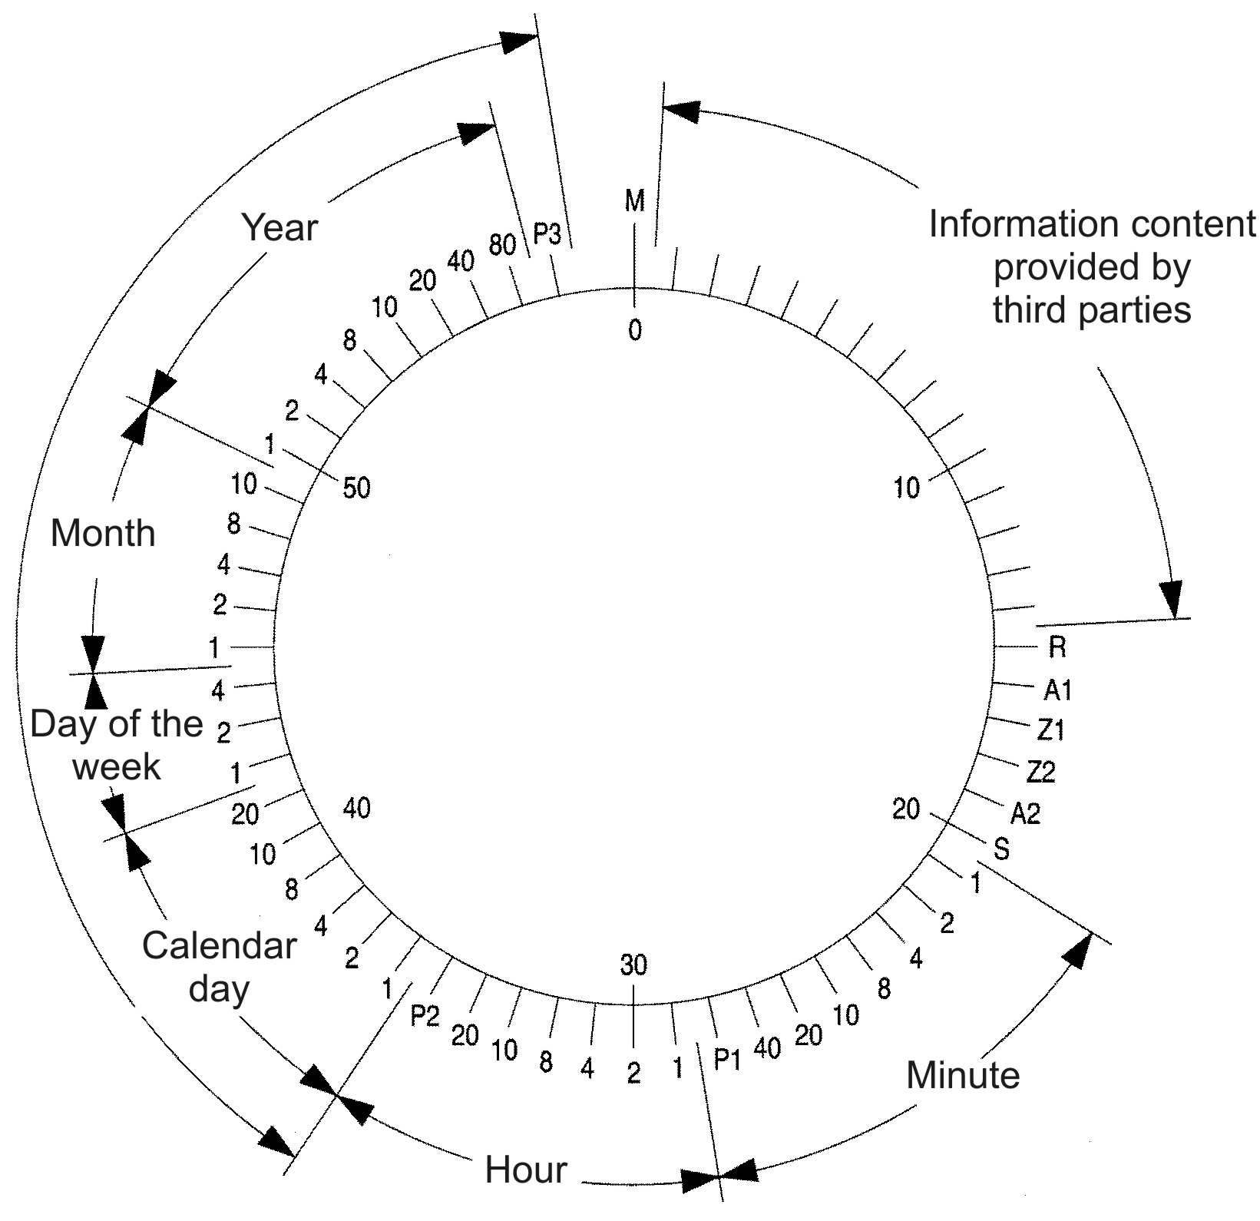

The carrier amplitude is reduced to 15% for 0.1 s (binary zero) or 0.2 s (binary one) for transmission of coded time information. The information emitted during minute n is valid for the minute n+1. The carrier amplitude reduction is omitted in the last second of each minute.

Details of the code:
M: minute marker (second marker No. 0): 0.1 s
R: second marker No. 15 indicates service request to the DCF77 signal generation system
A1: announcement of a forthcoming change from CET to CEST or vice versa
Z1, Z2: zone time indication: UTC: Z1 0.1 s, Z2 0.1 s
UTC+1 h: Z1 0.1 s, Z2 0.2 s (referred to as Central European Time CET)
UTC+2 h Z1 0.2 s, Z2 0.1 s (referred to as Central European Summer Time CEST)
UTC+3 h Z1 0.2 s, Z2 0.2 s

A2: announcement of a leap second
S: starting bit of the coded time information, 0.2 s
P1, P2, P3: parity check bits

The information transmitted using the second markers No. 1 to 14 is provided by third parties. Currently weather data are transmitted, which are supplied by the firm MeteoTime which is a subsidiary of EFR GmbH. The initial idea that these bits should be used for the purpose of public warning under the responsibility of the German Bundesamt für Bevölkerungsschutz und Katastrophenhilfe (BBK, Federal Office for Civil Protection and Disaster Relief) was later abandoned.

A forthcoming change from CET to CEST or from CEST to CET is indicated during one hour before the change by second marker No. 16 being 0.2 s. Similarly, the second marker No. 19 is 0.2 s during the hour preceding the introduction of a leap second.

When a positive leap second (the normal case) is inserted, second marker No. 59 is emitted for 0.1 s and in the following second No. 60 of that particular minute the amplitude reduction is omitted.

The three parity check bits P1, P2, and P3 complete the preceding information words (7 bits for the minute, 6 bits for the hour and 22 bits for the date, including the day of the week) to form an even number of binary ones.

To achieve a more accurate time transfer and a better use of the frequency spectrum available an additional pseudo-random phase shift keying (PSK) of the carrier is transmitted during each second. A normal PSK sequence corresponds to binary 0, an inverted PSK sequence to binary 1. During the seconds 15 to 58 the same information is coded as described for the case of the amplitude modulation. During the seconds 0 to 9 binary 1 is transmitted, during seconds 10 to 14 binary 0.
FIGURE 6

FIGURE 7

FIGURE 8
Bits 1 to 15 reserved for third party services

FIGURE 8
INRIM/RAI time code format

FIGURE 9

FIGURE 9 (continued)

FIGURE 9 (continued)

FIGURE 9 (continued)

