INTERNATIONAL TELECOMMUNICATION UNION
 | PLENIPOTENTIARY  CONFERENCE (PP-02) |  | Addendum 2 to  Document 4-E  29 July 2002  Original: English
MARRAKESH, 23 SEPTEMBER - 18 OCTOBER 2002

PLENARY MEETING
Note by the Secretary-General
CANDIDACY FOR THE POST OF DIRECTOR OF
THE RADIOCOMMUNICATION BUREAU

Further to the information contained in Document 3, I have pleasure in transmitting to the Conference, in annex, the following candidacy for the post of Director of the Radiocommunication Bureau:

Mr Malcolm JOHNSON (United Kingdom of Great Britain and Northern Ireland)

Yoshio UTSUMI
Secretary-General

Annex: 1
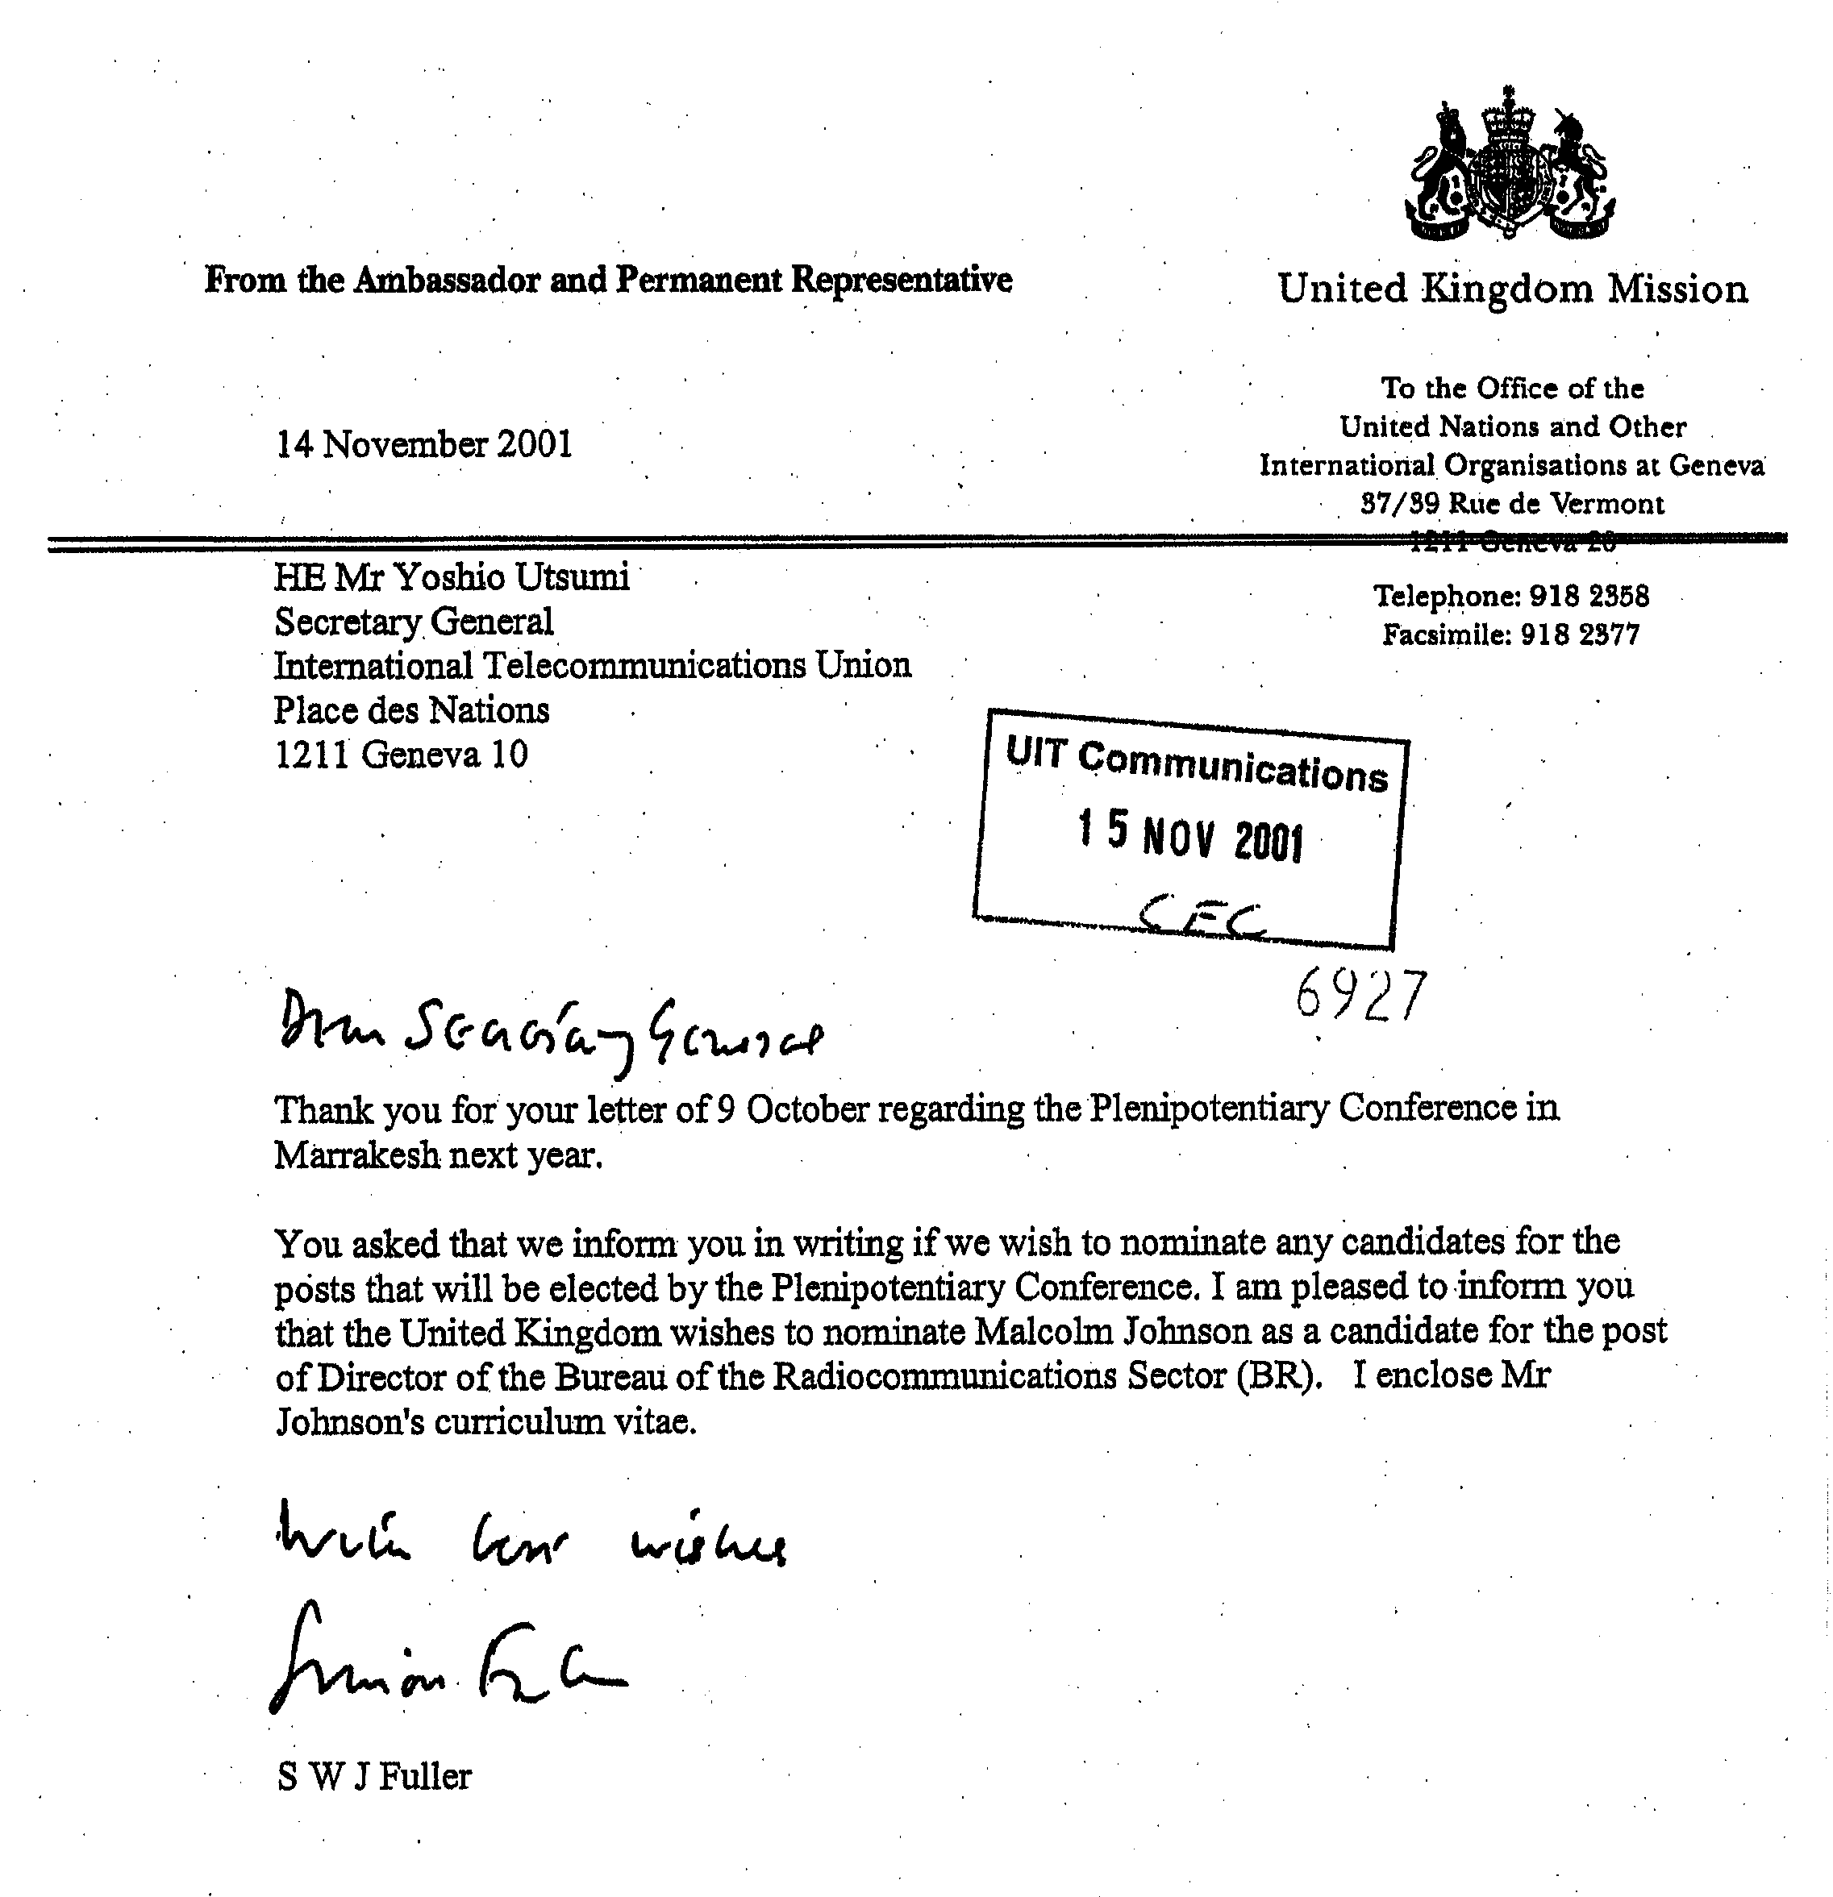



MALCOLM JOHNSON

UNITED KINGDOM CANDIDATE FOR THE POST OF
DIRECTOR OF THE INTERNATIONAL TELECOMMUNICATION UNION'S RADIOCOMMUNICATION BUREAU

SHORT CURRICULUM VITAE

Personal details

Nationality: British
Born: Trallwng, Wales, 19 June 1947
Status: Married, with one daughter
Languages: English (mother tongue), French
Qualifications: Bachelor of Science Degree with 1st Class Honours, Cardiff University; Master of Science Degree, Cardiff University; Chartered Engineer; Member of Institution of Electrical Engineers.

Since joining the United Kingdom's Radiocommunications Agency in 1991, Malcolm Johnson has had responsibility for the United Kingdom's international policy, and the co-ordination of the United Kingdom's activities in the International Telecommunication Union (ITU) and the European Conference of Postal and Telecommunications Administrations (CEPT). He has made a significant contribution to all aspects of the work of the ITU and the CEPT, including its recent reform.
Management Experience:
Mr Johnson has participated in the senior management of the Agency, with direct responsibility for the management of a large number of engineering and administrative staff, and a significant financial budget. During this period the Agency implemented a number of modern management methods, including a five-year rolling Corporate Plan, which specifies the strategic objectives and priorities for the coming five-year period, and annual Budget and Resource Plans for each Management Unit within the Agency. These Plans give the operational and specific objectives for each Unit within the context of the Corporate Plan for the following 12-month period, together with
the budget and resource requirements. Each staff member has a Personal Achievement Plan specifying personal objectives to be achieved for the following year, within the context of the Unit's objectives. This Plan also identifies the necessary training requirements for the year. Each staff member also has an annual Staff Appraisal Report on the previous 12 months, identifying strengths and weaknesses. This is discussed with the manager in order to identify any necessary action, such as training, in order to improve performance. These management methods have ensured that financial and staff resources are well managed, and that the staff are suitably trained, and are well motivated with a high morale.
Contribution to the work of ITU
Mr Johnson, as Head or Deputy Head of UK delegations, has contributed to the success of all ITU Assemblies and Conferences since 1992, including Plenipotentiary Conferences, World Radiocommunication Conferences, Radiocommunication Assemblies, World Telecommunication Standardization Conferences and Assembly, World Telecommunication Development Conferences, World Telecommunication Policy Forums, and Council.
As European Co-ordinator during the contentious World Radiocommunication Conferences in 1995 and 1997, he successfully negotiated a compromise package on a number of contentious issues to the satisfaction of all sides. He established the inter-regional informal group to prepare for World Radiocommunication Conferences (WRCs), and acted as the first chairman. During WRC-97, he promoted inter-regional co-operation in the preparation of WRCs, by proposing Resolution 72 which instructs the Director of BR to consult the regional telecommunication organisations on the means by which assistance can be given to their preparations for future world radiocommunication conferences.
During the Plenipotentiary Conference in 1998 he chaired the informal group on radio matters, which helped resolve a number of difficult radio issues. He also helped the informal negotiations related to Palestinian Authority at that conference, and again during WRC-2000.
He has acted as Head of the United Kingdom delegations to each of the advisory groups of the three ITU Sectors and has participated in the work of the study groups in all three Sectors.
He chaired the Reflection Group in preparation for World Telecommunication Development Conference in 1998, which produced a number of draft Resolutions later adopted by the conference. He proposed the establishment of a long-term spectrum review (Resolution 9, WTDC-98) to assist developing countries with their spectrum planning.
He initiated the creation of the Special Study Group on IMT-2000 and Beyond at the World Telecommunication Standardization Assembly in 2000, and the creation of the Strategy and Operational Groups of the Telecommunication Standardization Advisory Group.
He was an active participant in the ITU Reform Group, and chaired the Ad Hoc Group 1 on standardization issues, which produced an agreed report on this contentious issue in preparation for the final Reform Group meeting. He proposed a number of the Reform Group recommendations including the rolling 4-year Operational Plan, and giving the Radiocommunication Advisory Group a greater role in the approval of the Operational Plan, and an oversight of its linkage with the Strategic Plan and budget for the Radiocommunication Sector.
Involvement in Europe
Mr Johnson has acted as Head of the United Kingdom delegations to various meetings of the European Conference of Postal and Telecommunications Administrations (CEPT). He proposed and developed the CEPT Decision mechanism as a way to raise the status of CEPT outputs. He developed the Memorandum of Understanding and Framework contract between the CEPT and the European Commission. He acted as European Co-ordinator for WRC-93, and initiated the establishment of the Conference Preparatory Group (CPG) of the CEPT as a permanent group for the CEPT preparations for WRCs. He was the first chairman of the CPG, and European Co-ordinator for WRC-95 and WRC-97. He actively participated in all the CEPT preparatory meetings for ITU conferences and assemblies since 1994. He played a leading role in the reform of CEPT, which was implemented in October 2001.
He is the chairman of the first CEPT group established to co-ordinate preparations for a World Telecommunication Development Conference, (the WTDC-02 in Istanbul).
Prior to 1991:
Mr Johnson worked in the European Commission's Telecommunications Regulatory Division, where he drafted and negotiated on behalf of the European Commission, European Union legislation in the field of radiocommunications. He managed a number of European Commission projects to promote European mobile communications, and represented the European Commission in the European Telecommunications Standardisation Institute (ETSI).
He previously, participated in the work of other international bodies such as the International Maritime Organisation (IMO and formerly IMCO) where he played an active part in the development of the Global Maritime Distress and Safety System. He also participated in the work of Inmarsat, European Space Agency, and Study Group 8 of the CCIR.

More information can be found at http://www.malcolmjohnson.info/
_________________

