Note by the Secretary-General
INTERNATIONAL TELECOMMUNICATION UNION
 | PLENIPOTENTIARY  CONFERENCE (PP-02) |  | Document 9-E
 | PLENIPOTENTIARY  CONFERENCE (PP-02) |  | 28 February 2002
 | PLENIPOTENTIARY  CONFERENCE (PP-02) |  | Original: English
MARRAKESH, 23 SEPTEMBER - 18 OCTOBER 2002

PLENARY MEETING
CANDIDACY FOR THE POST OF DIRECTOR OF THE
TELECOMMUNICATION DEVELOPMENT BUREAU

Further to the information contained in Document 3, I have pleasure in transmitting to the Conference, in annex, the following candidacy for the post of Director of the Telecommunication Development Bureau:

Mr Hamadoun TOURÉ (Mali)

Yoshio UTSUMI
Secretary-General

Annex: 1
Bamako, 11 January 2002
From: Ministry of Housing Affairs and Communication, Republic of Mali
To: Secretary-General of ITU
Our Ref.: 005/MDEAFC-CAB
Subject: Candidacy of Mr Hamadoun I. Touré for the post of Director of BDT
Dear Sir,
I have the honour to acknowledge receipt of your Circular No. DM-1218, PP-02/AL/eb of 9 October 2001, announcing the forthcoming Plenipotentiary Conference of the International Telecommunication Union (ITU), to be held in Marrakesh (Kingdom of Morocco) from 23 September to 18 October 2002.
I have pleasure in informing you, on behalf of the Government of the Republic of Mali, of the candidacy of Mr Hamadoun Touré for the post of Director of the Telecommunication Development Bureau (BDT).
We have requested the candidate to provide you with an updated copy of his Curriculum Vitae.
We would request that you take all the necessary steps to register this candidacy and that you inform us accordingly.
Yours faithfully,

Ms BOUARE Fily SISSOKO
Minister

CURRICULUM VITAE
Hamadoun Ibrahim Touré
Nationality: Malian
Born: 03 September 1953
Marital Status: Married with four children
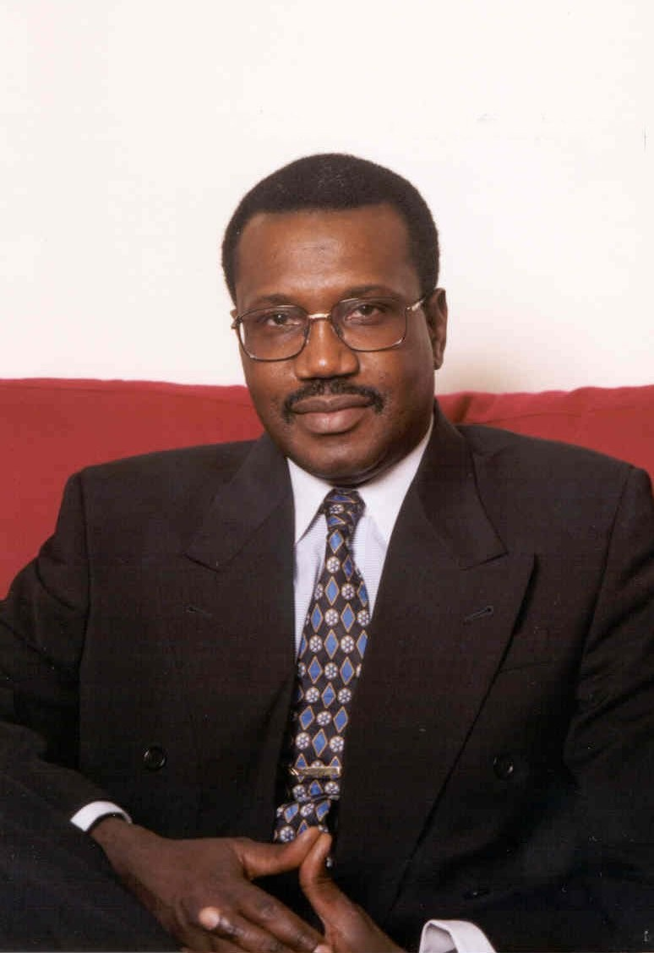
Accomplishments as Director of BDT
Mr Touré took office in February 1999 bringing to the position of Director of the BDT multi-cultural as well as public and private sector experience. Upon taking office, he addressed as a top priority his election commitment to increase transparency and improve management practices within the Bureau. During his first year in office, he restructured the Bureau to adapt to the changing telecommunication environment and to respond to the decisions of the 1998 WTDC, he instituted an annual operational planning system to facilitate management, to decentralize tasks, and to tighten Bureau accountability. He continues to strive to improve productivity and gain maximum benefit from existing resources.

Since taking office, Mr Touré has progressively improved communication with Sector Members, forged Private Sector-ITU partnerships and increased Sector membership from 185 in February 1999 to 247 today. He has also strengthened the Regional Presence of ITU, improving its visibility, responsibility and accountability. Mr Touré includes among his highest priorities sector reform, rural communication and capacity building.
Mr Touré opened up participation in TDAG, using the opportunity to improve the relationship between the ITU and Financial institutions, Regulatory Agencies and Training Institutions as well as Regional and International Organizations dealing with Telecommunications.
Under his leadership the Bureau launched the highly successful Global Symposium for Regulators and an online exchange for all regulatory and policy-makers. The purpose of this initiative is to provide a venue for the exchange of information, and to allow regulatory agencies to assist each other in their daily challenges.
Mr Touré has also made the implementation of Resolution 7 of WTDC-98 relating to Gender Issues a top priority, integrating a gender perspective into all the programs of the bureau.
His skill of adapting the BDT to the changing environment is demonstrated by a number of success stories such as his fast reaction to implement opinion D of the policy forum on IP Telephony.
Result orientated, practical in his actions, a team player who has managed to keep the focus on development bringing together the developing and developed countries. Mr. Touré is a natural optimist in spirit, yet a realist in his actions.
Career summary
1999 to date | Director of the Telecommunication Development Bureau of the ITU following his election at the Minneapolis Plenipotentiary Conference 1998
1996-1999 | Regional General Manager – Africa  ICO Global Communications, London and Pretoria
1994-1996 | Group Director – Africa & Middle East  INTELSAT, Washington DC
1990-1994 | Regional Director – Africa  INTELSAT, Washington DC
1986-1990 | Telecommunications Officer with INTELSAT's Assistance and Development Program (IADP)  INTELSAT Washington DC
December 1985 | Telecommunications Officer  INTELSAT  Business Planning Department
October 1985 | Chief of Satellite Communications Section  Coordinating activities between OPT and TELEMALI
1985 | Manager, Earth Station  Sulymanbougou II, Bamako Mali
1981-1984 | Engineer in charge of Operation and Maintenance of the Sulymanbougou II Earth Station in Bamako
1980 | International Switching Center, Bamako Mali
October 1979 | Microwave Terminal, Bamako Mali  Project Telecom1, Project PANAFTEL
Education
June 1979 | Master's Degree in Electrical Engineering
1974-1979 | Electro-technical Institute of Telecommunications Leningrad (St. Petersburg) Russia
1973-1974 | Moscow State University
1973 | Baccalaureate, Lycée Askia Mohamed Bamako Mali
Languages Songhai (mother tongue), Bambara, French, English, Russian
Hobbies Afro-Cuban/Latin Music and Martial Arts.

_____________________

