|  |  |
| --- | --- |
| **Plenipotentiary Conference (PP-14) Busan, 20 October – 7 November 2014** |  |
|  |  |
|  |  |
| **PLENARY MEETING** | **Document 12-E** |
| **15 November 2013** |
| **Original: English** |
| Note by the Secretary-General | |
| CANDIDACY FOR THE POST OF MEMBER OF THE RADIO REGULATIONS BOARD | |
|  | |
|  | |

Further to the information published in Document 3, I have pleasure in transmitting to the Conference, in annex, the candidacy of:

**Ms Lilian JEANTY (Kingdom of the Netherlands)**

for the post of member of the Radio Regulations Board.

Dr Hamadoun I. TOURÉ  
 Secretary-General

**Annex**: 1

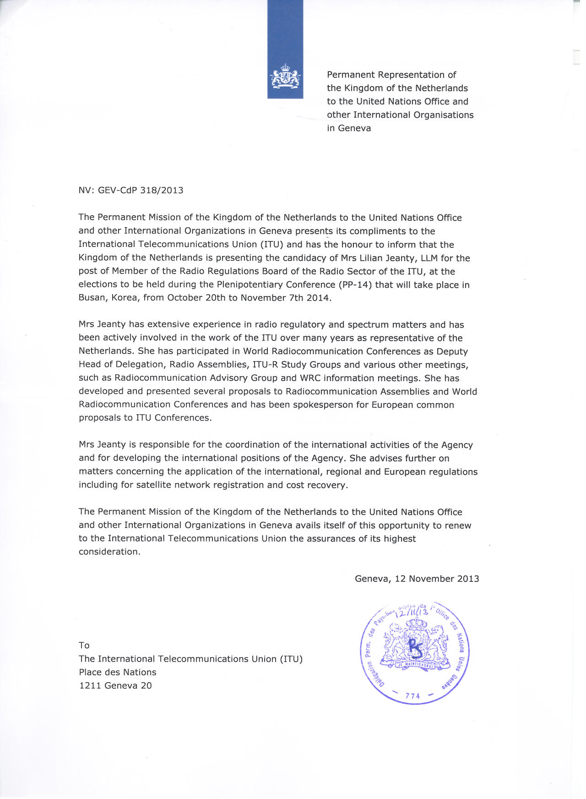

Plenipotentiary Conference 2014 of the   
International Telecommunication Union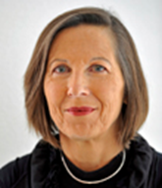  
Busan, Republic of Korea, 20 October – 7 November 2014

**Candidate of the Kingdom of the Netherlands for the   
Radio Regulations Board (Region B)**

**personal details  
___________________________________________________________________________**

**Name** Lilian Jeanty  
**Date of birth** 20 May 1951  
**Nationality** Dutch  
**Marital status** Married, one daughter  
**Languages** English, French, German, Danish, Dutch (mother tongue)  
**Contact** Tel: + 31 50 5877 163  
 Fax: + 31 50 5877 400  
 E-mail: [lilian.jeanty@agentschaptelecom.nl](mailto:lilian.jeanty@agentschaptelecom.nl)  
  
 **professional career   
__________________________________________________________________________**

**2003-ongoing** Coordinator International Affairs, Radiocommunications Agency of the Netherlands  
**1997-2003** Deputy Director, European Communications Office (ECO) of the CEPT  
**1994-1997** Spectrum Management Expert,ECO   
**1990-1994** Head of the Frequency Management and Regulatory Affairs Department,   
 Ministry of Transport and Waterworks – Directorate Telecommunications and Post  
**1985-1990** Head of the Frequency Management Department, Ministry of Transport and Waterworks –   
 Directorate Telecommunications and Post  
**1978-1985** Head of Human Resource Department within PTT, the Netherlands  
**1976-1978** Legal advisor PTT, the Netherlands  
  
  
**international activities   
___________________________________________________________________________**

Lilian Jeanty has extensive experience in radio regulatory issues and spectrum management and has been actively involved in the work of the ITU over many years as representative of the Kingdom of the Netherlands. She has participated in World Radiocommunication Conferences, Conference Preparatory Meetings and Radiocommunication Assemblies as Deputy Head of Delegation. She also participated in ITU-R Study Groups and various other meetings, such as the Radiocommunication Advisory Group and WRC information meetings.

She has developed and presented several proposals to World Radiocommunication Conferences and Radiocommunication Assemblies and has been spokesperson for European common proposals to ITU Conferences.

Some of the main activities are the following:

**2013-ongoing** ITU-R Study Group 1, vice-chair

**2012** WRC-12, chair Working Group 6A

**2012** RA-12, vice chair

**2011** ITU Inter-regional Workshop on WRC-12 Preparation, CEPT spokesperson for a number of WRC Agenda Items

**2007-2012** CEPT Coordinator WRC Agenda Item 1.2

**2007** WRC-07, chair Group 6-2 (Res. 951), CEPT Coordinator WRC Agenda Item 7.2 (Agenda WRC-12)

**2007** ITU-R Working Party 1B, acting chair

**2005-2006** Project Team on harmonisation and flexibility in spectrum management,  
CEPT Electronic Communications Committee (ECC), chair

**1994-2003** Project Team on Economic Issues of the CEPT ECC Working Group Regulatory Affairs, chair

**1989-1993** CEPT ECC Working Group Regulatory Affairs, chair

**1990-1993** GSM MoU Type Approval Group, chair

**education  
___________________________________________________________________________**

**2005-2012** Regina Coeli Language Institute, French and Spanish  
**1980-2013** Post-doctoral courses in international and European Union law  
**1990-1994** Management Course for Higher Government positions   
**1975-1980** Psychology – University of Groningen, the Netherlands   
**1977** Master degree in law – University of Groningen, the Netherlands  
  
  
**presentations and articles  
___________________________________________________________________________**

Examples:  
  
Spectrum Use in the Netherlands  
European Commission Workshop on the Spectrum Inventory 2012

Flexibility in the international spectrum regulatory framework  
European Commission – CEPT Joint Workshop on WRC-12 preparations 2010

Methods to protect communication and remote sensing system integrity   
URSI General Assembly 2008

CEPT Views on the WRC-12 agenda  
European Commission – CEPT Joint Workshop on WRC-07 preparations 2007

Flexibility is the magic word  
International Symposium on Advanced Radio Technologies (ISART) 2006

Change is in the air  
OFCOM Presidency Conference: Next Generation Regulation 2005

Regulation of Radiocommunications   
EU Telecommunications Law and Regulation 2002

Implications of the R&TTE Directive for radio equipment  
IBC Global Approvals Seminar 2001

UMTS Licensing – Beauty contests  
European Mobile/UMTS regulation and competition law 2001

Deregulation, harmonization and cooperation in Europe  
ITU-D – Regional Workshops on Introduction, Licensing and Commercialisation of GMPCS 2001

Cooperation in Europe  
ITU-D – GMPCS Regional Workshops on Licensing and Commercial Issues 1999-2000

Satellite (de)regulation in Europe   
VSAT Forum 2000

PMR licensing and charging in CEPT  
European Commission Seminar on PMR 1999

The Green Paper on Spectrum Policy  
IBC 1999

Global circulation of terminals   
IBC 1998

Radio regulatory framework in Europe   
European Commission – Seminar on Radio Communications 1997

Satellite regulations in Europe  
Adam Smith Institute – Satellite Business Forum for Russia and the CIS 1997

Frequencies and licenses for DECT  
IBC 1997

Spectrum allocations versus spectrum needs for the third generation   
GSM MoU Symposium – The Future of Mobile Communications 1997

Satellite New Gathering – Spectrum relief or more problems?   
CEPT Radio Conference 1996  
  
  
**other activities  
______________________________________________________________________**

Lilian Jeanty is a member of the following societies, for which she held presentations and wrote articles:

Dutch Society for the United Nations  
Nederlands Elektronica en Radio Genootschap (NERG)  
Pro escolendo Jure Patrio   
Academy of Government Lawyers   
  
She is active as a volunteer in local society and active in local politics.  
  
  
**summary  
______________________________________________________________________**

Within the Ministry of Transport and Waterworks of the Netherlands and the Radiocommunications Agency she has had different positions, among which Head of the Frequency Management and Regulatory Affairs department. In that capacity she was responsible for national and international matters in the area of allocation, planning, assignment, registration, coordination and use of the radio frequency spectrum and satellite orbits.

Currently she holds the position of coordinator international affairs, where she is responsible for coordinating the positions of the Agency in the different international organisations in which it participates.

Between 1994 and 2003 she worked for the European Communications Office (ECO) of the European Conference of Postal and Telecommunications Administrations (CEPT) in Copenhagen, first as an expert and subsequently as Deputy Director. The core duties of the ECO are to provide a European centre of expertise in electronic communications. During these years she directed a large number of study projects on satellite issues, licensing and spectrum management for the European Commission.

She has been active in the work of international organisations such as ITU, CEPT and EU for more than 25 years. In her contribution to the work of these organisations she has taken an active role and has chaired a number of meetings, both in the context of the regional preparation for the WRC within the CEPT as on general spectrum management and regulatory topics. Within the ITU she has chaired groups in Study Group 1 as well as during WRC-07 and WRC-12. She is currently vice-chair of ITU-R Study Group 1. She is also a member of the Radio Spectrum Committee (RSC) of the European Union.

She has presented and published articles and papers on various subjects related to spectrum management and radio regulations. She has over the years given many presentations at seminars and conferences around the world on spectrum management and satellite regulations and participated as a panelist in many conferences.