Plenipotentiary Conference (PP-14)
Busan, 20 October – 7 November 2014
PLENARY MEETING | Document 39-E
 | 1 April 2014
 | Original: English
Note by the Secretary-General
CANDIDACY FOR THE POST OF MEMBER OF
THE RADIO REGULATIONS BOARD
Further to the information published in Document 3, I have pleasure in transmitting to the Conference, in annex, the candidacy of:
Ms Joanne Cecilia WILSON (United States of America)
for the post of member of the Radio Regulations Board.

Dr Hamadoun I. TOURÉ
Secretary-General

Annex: 1

ANNEX
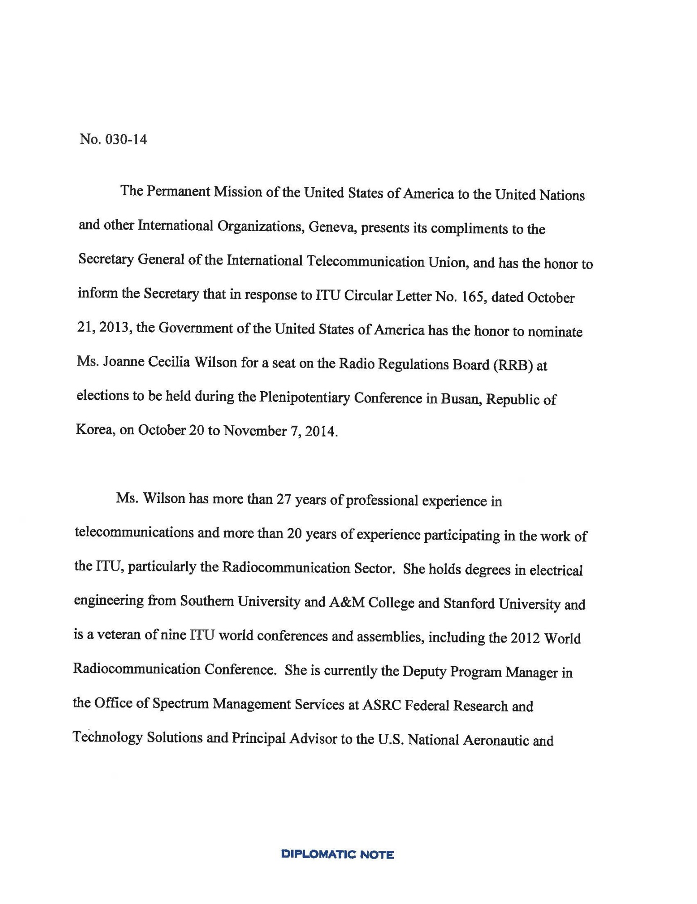

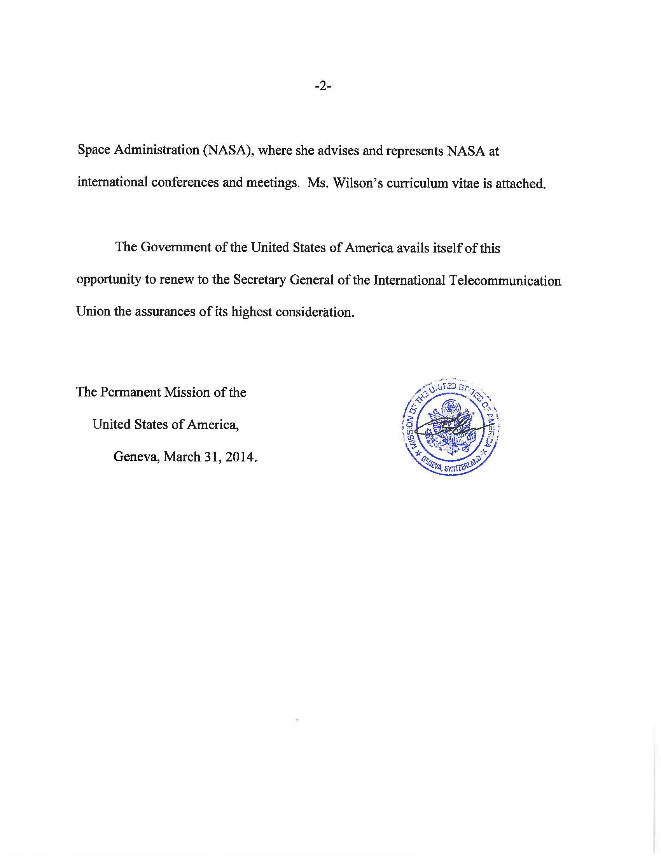

JOANNE CECILIA WILSON
CURRICULUM VITAE
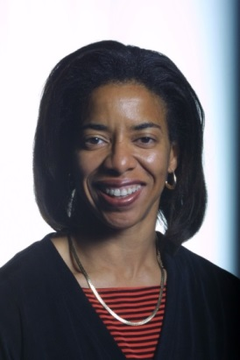
PERSONAL INFORMATION
Date of Birth: January 1, 1960
Citizenship: United States of America
Marital Status: Single, no children
Language: English

Official Address:
Office of Spectrum Management Services
ASRC Federal Research and Technology Solutions
12021 Sunset Hills Road, Suite 330
Reston, VA 20190 USA
+1 (571) 262-3146 (Office)
+1 (571) 612-5039 (Fax)
joanne.wilson@asrcfederal.com
joanne.c.wilson@nasa.gov
EDUCATION
1981 Bachelor of Science, Electrical Engineering. Southern University and A&M College, USA (Summa Cum Laude and Top Graduate)
1982 Master of Science, Electrical Engineering. Stanford University, USA
1986 Graduate Study, Electrical Engineering. Princeton University, USA
1996 Congressional Fellow, Office of Senator Paul Simon, D-Ill.
Brookings Institution, United States
QUALIFICATIONS
Joanne Wilson is an electrical engineer with more than 27 years of professional experience in the telecommunications sector and more than 20 years of experience in the ITU radiocommunication sector (ITU-R). She has participated actively in the Inter-American Telecommunications Commission (CITEL) since attending the inaugural meeting in 1994. From 1993 to 2007, she represented AT&T, Lucent Technologies, and ArrayComm LLC in the ITU-R, in U.S. domestic regulatory proceedings, and in bilateral and multi-lateral negotiations addressing spectrum management, wireless standards, and regulatory and market access issues. Ms. Wilson has developed and executed successful standardization strategies for commercial mobile broadband wireless systems in the ITU-R, ISO, and in the IEEE and other ANSI-accredited standards bodies. Ms. Wilson participated in the ITU Council Working Group on a Stable Constitution and has an expert understanding of the Basic Instruments of the Union. In 2012, she served as the Special Assistant to the Head of the United States Delegation to the 2012 World Radiocommunication Conference. She currently advises and represents the U.S. National Aeronautic and Space Administration (NASA) at conferences and meetings across all sectors of the ITU.
CURRENT POSITION
- Deputy Program Manager, Office of Spectrum Management Services
ASRC Federal Research and Technology Solutions
- Principal Advisor to the U.S. National Aeronautic and Space Administration
PROFESSIONAL EXPERIENCE
2013 – Present Deputy Program Manager, ASRC Federal Research and Technology Solutions (ARTS)
2010 – 2013 Spectrum Regulatory Specialist (Principal), ASRC Management Services/ASRC Research and Technology Solutions
2008 – 2010 Vice President, CompassRose International, Inc.
2007 – 2008 Senior Advisor, CompassRose International, Inc. and Independent Telecommunications Consultant
2001 – 2007 Vice President, Standards, ArrayComm, LLC
1996 – 2001 Global Public Affairs Director, Wireless, Lucent Technologies
1995 – 1996 Congressional Fellow, Office of U.S. Senator Paul Simon (D-Ill)
The Brookings Institution
1993 – 1995 Technical Supervisor, Government and International Affairs, Network Wireless Systems Business Unit, AT&T Bell Laboratories
1992 – 1993 Technical Manager, GSM Product Planning, Network Wireless Systems Business Unit, AT&T Bell Laboratories
1991 – 1992 Quality Consultant (Rotational Assignment), Cellular Systems Business Unit, AT&T Bell Laboratories
1986 – 1992 Member of Technical Staff, Transmission Systems Engineering and Network Performance Planning, AT&T Bell Laboratories
INTERNATIONAL ACTIVITIES
MAJOR ITU CONFERENCES AND INTERNATIONAL MEETINGS:
2013: World Telecommunication Policy Forum 2013, Geneva (Switzerland) 2013 ITU Council, Geneva
2012: World Radiocommunication Conference 2012, Geneva
2012 ITU Council, Geneva
Telecommunication Standardization Advisory Group, Geneva
World Telecommunication Standardization Assembly 2012, Dubai (UAE)
World Conference on International Telecommunication 2012, Dubai
2011: 2011 ITU Council, Geneva
2010: World Telecommunication Development Conference 2010, Hyderabad (India)

2009: World Telecommunication Policy Forum, Lisbon (Portugal)
2008: Telecommunication Standardization Advisory Group, Geneva
World Telecommunication Standardization Assembly 2008, Johannesburg (South Africa)
2000: Radiocommunication Assembly 2000, Istanbul (Turkey)
World Radiocommunication Conference 2000, Istanbul
Conference Preparatory Meeting (CPM02-1), Istanbul
1999: Conference Preparatory Meeting (CPM99-2), Geneva
1996: Global Radio Standards Collaboration (GRSC, formerly Radio Standardization (RAST)), Kyongju (Korea)

ITU AND OTHER TECHNICAL AND INTERNATIONAL ACTIVITIES:
2010 – present CITEL PCC.I: Telecommunication Networks
COM/CITEL Working Group on Preparations for Global Conferences
2009 – present ITU-R Working Party 5D – IMT Systems
2005 – 2007 ISO TC 204: Intelligent Transport Systems
2000 – 2007 ITU-R Working Party 8F – IMT Systems
ITU-R Working Party 8A – Land mobile systems
2001 – 2007 IEEE 802.16 & IEEE 802.20 – Mobile Broadband Wireless Access Systems
CITEL PCC.II: Radiocommunications including Broadcasting
Alliance for Telecommunications Industry Solutions – Wireless Technologies and Systems Committee (ATIS-WTSC)
TIA TR47 - Mobile Multimedia Multicast Systems
Project MESA: Mobile Broadband for Public Safety
1996 – 2001 CITEL PCC.I: Telecommunications Networks APEC TEL: Mutual Recognition Arrangement for Telecommunications Equipment
CITEL Mutual Recognition Agreement
US-EU Mutual Recognition Agreement for Telecommunications
Equipment, Electromagnetic Compatibility and Electrical Safety
1994 – 2000 CITEL PCC.III: Radiocommunication
1993 – 1999 ITU-R Task Group 8/1 – IMT-2000

CANDIDATE STATEMENT
I started my pursuit of an engineering career as a summer employee at Bell Laboratories in the late 1970s prior to the break-up of the Bell System. At that time, Bell Labs was the preeminent corporate research organization and leading pioneer in the field of telecommunications. Those summers at Bell Labs, whether working in the research division, or in a product development or factory support organization, shaped my view of how to be successful as an engineer and in life. The lessons were both simple and profound:
- Focus all investigations on uncovering facts and seeking truth
- Trust in science and the laws of physics
- Thoroughly prepare and work hard
- Be humble
- Work collegially – it’s both effective and fun
For my graduate study at Stanford University, my areas of depth were telecommunications and adaptive signal processing. I had the opportunity to work with Professor Bernard Widrow, co-inventor of the Widrow–Hoff least mean squares filter (LMS) adaptive algorithm, on a project team that used adaptive signal processing to create a highly directional hearing aid for people suffering with monaural hearing. In addition, at that time I worked on research projects at the Veterans Administration Palo Alto Rehabilitation Research and Development Center performing research on using adaptive processing algorithms to improve the accuracy of text detection for the early stage electronic readers for the visually impaired. Through those experiences I learned first-hand how rewarding it is to develop technology that improves peoples’ lives.
I started my professional career at AT&T Bell Laboratories as a Member of Technical Staff and systems engineer working on point-to-point microwave communications, (long distance) network performance planning and, in 1989, I moved into cellular communications, which has been a prime area of focus and expertise for 25 years. In 1993, I attended my first ITU-R Task Group 8/1 meeting, where we initiated a global discussion on the very new digital cellular networks and International Mobile Telecommunications 2000 (IMT-2000). I was captivated and, for more than 20 years, have been a regular delegate to ITU-R meetings.
From 2001 to 2007, I was the Vice President (Standards) at ArrayComm, LLC where I led a team that had the challenge of establishing an ANSl and an international standard for the High Capacity Spatial Division Multiple Access (HC-SDMA) radio interface of the iBurst ™ mobile broadband wireless access (MBWA) systems. This system, which was in commercial operation in numerous markets around the world, had been recognized as the most spectrally efficient MBWA system on the market. Our team succeeded in obtaining the adoption of ATIS-0700004.2007(R2012), which is an ANSI-accredited MBWA standard recognized in Recommendation ITU-R M.1801, “Radio interface standards for broadband wireless access systems, including mobile and nomadic applications, in the mobile service operating below 6 GHz.” Additionally, I chaired the drafting group in ITU-R Working Party 8A that developed Recommendation ITU-R M.1678, “Adaptive antennas for mobile systems” and Report ITU-R M.2040, “Adaptive antennas concepts and key technical aspects” and was actively involved in the drafting of numerous other ITU-R reports and recommendations that were developed in what are now ITU-R Working Parties 5A and 5D.

In 2007, I began attending meetings in the ITU-T and ITU-D, as well as the participating on U.S. delegations to most major ITU conferences. Among other activities, I assisted a client to obtain licenses for their Global Mobile Personal Communications by Satellite (GMPCS) system.
In 2010, I joined ASRC Federal’s Office of Spectrum Management Services as a Spectrum Regulatory Specialist and Principal Advisor to the NASA. Today, as their deputy program manager, I have responsibility for overseeing a wide variety of spectrum management services provided primarily to NASA’s Space Communications and Navigation Directorate, as well as to other U.S government agencies. Our team conducts technical compatibility studies in preparation for World Radiocommunication Conferences; represents NASA on U.S. delegations to ITU-R Working Parties in ITU-R Study Groups 1, 3, 4, 5, 7 and the Joint Task Group 4-5-6-7; conducts radio frequency interference (RFI) analyses, files and coordinates NASA satellite networks; and provides a variety of other technical spectrum management services. I have been a regular U.S. delegate to meetings of ITU-R Working Party 5D, ITU Council Working Group on a Stable Constitution (CWG-STB-CS), ITU Council, and CITEL PCC.I.
It was my honor to serve as the Special Assistant to Ambassador Decker Anstrom, Head of the United States Delegation to the 2012 World Radiocommunication Conference, where I advised him on technical and procedural matters and assisted him in delegation management. Working with Ambassador Anstrom provided me with a tremendous opportunity to see first-hand that the same habits that I learned early in my career – focusing on facts, trusting the science, thorough preparation, humility, hard work and collegiality – were equally effective in the international community and at the highest level.
SUMMARY
I am seeking election to the ITU Radio Regulation Board (RRB) because I wish to serve the global community by applying my practical and policy experience in the field of radiocommunication to help ensure the effective application of the international Radio Regulations. I ask for your support for my candidacy because I have the background, experience, and skills to execute the duties of the Board. If elected to the RRB, I would bring the same set of tenets I learned as a young engineer at Bell Laboratories:
- Focus all investigation on uncovering facts and seeking truth
- Trust in science and the laws of physics
- Thoroughly prepare and work hard
- Be humble
- Work collegially
PUBLICATIONS

- Outage probability in mobile telephony with directive antennas and macrodiversity, Yu-Shuan Yeh, Wilson, J.C. and Schwartz, S.C.
IEEE Transactions on Vehicular Technology, Volume 33, Issue 3, Aug 1984 Page(s): 123 - 127
- IEEE80220: Mobile Broadband Wireless Access for the Twenty-First Century Arnold Greenspan, Mark Klerer, Jim Tomcik, Radhakrishna Canchi, and Joanne Wilson

PRESENTATIONS
- Understanding Spectrum Issues in the Deployment of Broadband Wireless Access Networks, Columbia, SC – December 12, 2007. Presented to the hearing of the South Carolina Senate’s Broadband and Telecommunications Technology Study Committee.
(See: http://xrl.us/ord8s and http://xrl.us/ord9e )
- Broadband in Cities and Towns Conference, Columbia, SC – October 30-31, 2007. Presentation on behalf of Safe Ports, Inc. “The Economics of Broadband Wireless Access systems”.
- Project MESA Meeting, Portland, USA – May 1, 2007. “Highlights of Project MESA Proposal – A Mobile Broadband Wireless Access System for Next Generation Public Safety Networks”.
- Project MESA Meeting, Saint Paul de Vence, France – November 1, 2007. “Adaptive Antenna Tutorial – Spectral Efficiency and Spatial Processing”
(See: http://xrl.us/ord9p )
- ANSI Homeland Security Standards Panel, National Institute of Standards, Gaithersburg, USA. – December 14, 2005. “Wireless Mobile Broadband for Public Protection and Disaster Relief (PPDR) and Intelligent Transport Systems.”
- WCA Conference, Washington, DC USA. – July 1, 2005. “Status of Mobile BWA Standardization in ANSI and their Use in Intelligent Transport Systems”.
- Joint AHCIET – CITEL Broadband Wireless Access Seminar, San Salvador, El Salvador – October 20-21, 2003. Two presentations: “The Story of Personal Broadband Australia” and “iBurst Technical Presentation”.
- National Spectrum Managers’ Meeting, Washington, DC USA – May 20, 2003. “Commercial Deployment of Adaptive Antennas”.
- ISPCON Spring 2003, Baltimore, USA – April 23, 2003. “Emerging Mobile Broadband IP Services: Market Hurdles and Economic Issues.” (See: http://xrl.us/oresg )
- ITU-T Study Group 16 Multimedia Seminar, Porto Seguro, Brazil – June 5, 2001. “Technologies for Wireless Multimedia in the XXI Century”.
- Wireless World Research Forum, Helsinki, Finland – May 10-11, 2001 (paper co-authored with Arnaud Saffari, Co-founder, ArrayComm). “Portable Broadband Internet Access: Predicting and Analysing Service, Content, Network and Customer Experience Parameters”.
OTHER ACTIVITES
- Member of the Board of Directors, Youth Service America, Inc.
- (Former) Member of the Board of Directors, Program for Acceleration in Careers in Engineering – Youth Development Corporation (PACE-YDC)
- Taekwondo Instructor (Kukkiwon Certified) and sparring coach, Black Belt (2nd Dan)
___________________

The American National Standards Institute (ANSI) is a private non-profit organization that oversees the development of voluntary consensus standards for products, services, processes, systems, and personnel in the United States.

