Council 2018
Geneva, 17-27 April 2018
Agenda item: PL 3.2 | Document C18/88-E
 | 3 April 2018
 | Original: English
Note by the Secretary-General
CONTRIBUTION FROM THE UNITED STATES OF AMERICA
United States edits to the revised draft Annex 1 to Resolution 71: ITU Strategic Plan 2020-2023

I have the honour to transmit to the Member States of the Council a contribution submitted by the United States of America.

Houlin ZHAO
Secretary-General

CONTRIBUTION FROM THE UNITED STATES OF AMERICA
UNITED STATES EDITS TO THE REVISED DRAFT ANNEX 1 TO RESOLUTION 71: ITU STRATEGIC PLAN 2020-2023
The United States is pleased to provide the attached edits to the revised draft Annex 1 to Resolution 71: ITU Strategic Plan 2020-2023. Alongside minor editorial fixes and other in-line edits, the United States offers comments in the following substantive areas to further clarify and strengthen the text.

Values

The United States fully supports the bracketed values in Section 1.3. Under the value of Universality and Neutrality, however, the United States believes that the ITU’s operations and activities should reflect and be achieved “through consensus-based processes.” The United States does not see any issue with including both the phrases “preferably by consensus” under the Excellence value and “through consensus-based processes” under the Universality and Neutrality value given that the Basic Instruments of the Union, emphasize the importance of consensus in ITU decision-making.

Strategic Goals

In Goal 1 (and again in Goals 4 and 5), the United States clarifies the relationship between the WSIS Action Lines and the 2030 Agenda for Sustainable Development, using text consistent with the WSIS Resolution. To further clarify Goal 1, the United States also adds a sentence regarding stakeholder collaboration which is taken directly from the current version of Annex 1 to Resolution 71: ITU Strategic Plan 2016-2019.

In Goal 2, the proposed U.S. edits more accurately reflect the ITU’s mandate and expertise. The United States also proposes to clarify language related to women and girls and youth as well as those with lower socio-economic levels. We believe that the new formulation, suggested through the public open consultation, add useful clarity to the text.

In Goal 3, the United States proposes text that more closely aligns with WSIS Action Line C5 (Building Confidence and Security in the Use of ICTs). The United States also seeks to add language to balance out the text to focus on opportunities and challenges resulting from the growth of telecommunications/ICTs.

Targets

At the start of Section 1.5, the United States highlights the principles for setting targets by adding a sentence taken directly from the previous 2014 version of Annex 1. All of the proposed U.S. edits to Table 1 are based on these principles. For example, the United States suggests the deletion of Target 1.4 because it does not map directly to the ITU’s Strategic Goals; moreover, not all Member States have, or will have, a single overarching national digital agenda/strategy, so the target is not easily measurable.

The United States suggests the deletion of Target 1.9. Targets 1.1, 1.2, and 1.3 already help achieve increased access to digital financial services. More importantly, Target 1.9 is not relevant to the sector-specific strategic goals. There are other equally deserving e-applications and services, and the United States does not see any need to highlight one specific example of a digital application.

The United States would also prefer the deletion of Target 1.5 because it is not directly related to the ITU’s goals or activities. As an alternative, however, the ITU may to consider a “qualitative” instead of “quantitative’ target to measure ITU’s effort to promote SME connectivity.

In target 4.1 on innovation, we recommend broadening the target to consider that countries may have more than one strategy or policy associated with an enabling environment for innovation instead of one overarching one. We also question how the ITU might establish a baseline for this target to measure progress.

Finally, as written, Target 5.1 does not accurately reflect Goal 5, so the United States proposes alternative text drawn from the 2014 version of Annex 1.

Strategic Risk Management

The United States appreciates the section on ‘Strategic Risk Management’ which helps identify certain strategic risks and provides possible measures to mitigate these risks to the efficient and effective operation of the Union. The United States proposes editorial suggestions, in part based on suggestions put forward from the open consultation, to address risks related to how ITU can remain relevant in a rapidly changing ICT environment while continuing to deliver quality deliverables for members. We propose language to suggest a prioritization of ITU activities on those areas where it can provide clear value; to encourage further partnerships and collaboration with other stakeholders, and to increase transparency.

ITU Results Framework

The goal of the “Enablers” (highlighted text) is unclear in the overall implementation of the Strategic Plan.

“Non-Discriminatory International Standards”

Recalling the U.S. contribution to the recent Telecommunication Standardization Advisory Group (TSAG) meeting, the United States continues to have concerns with the bracketed term “non-discriminatory” in the phrase “non-discriminatory international standards” (in ITU-T Objectives T.1 and T.2 and in Table 6). The United States considers the term “non-discriminatory” to be redundant and unnecessary for describing international standards. The criteria and characteristics of international standards are well-defined in ITU-T procedures and guidelines for the development of ITU-T Recommendations.

The meeting of the TSAG Rapporteur Group on the Strategic and Operation Plan (RG-SOP) highlighted the continued confusion regarding the phrase “non-discriminatory international standards.” When asked by the United States to define or provide an example of a “non-discriminatory international standard,” some Member States instead cited several WTSA-16 Resolutions, namely Resolution 44 on Bridging the Standardization Gap, Resolution 54 on regional groups, and Resolution 70 on accessibility for persons with disabilities. In all of these Resolutions, however, the principle of non-discrimination applies to other areas, not to the development and characteristics of international standards themselves.

Along the same lines, the reference to PP-14 Res. 64 in footnote 2 is an incorrect association and should therefore be deleted. Res. 64 concerns “non-discriminatory access to telecommunication and information technologies, facilities, services and applications established on the basis of ITU-T and ITU-R recommendations” (emphasis added) – in contrast, ITU-T Objectives T.1 and T.2 refer to the development and characteristics of international standards themselves. The footnote perpetuates the aforementioned confusion by muddling this important distinction. To be clear, the United States fully supports non-discriminatory access to telecommunication and information technologies, facilities, services and applications; however, Res. 64 is simply not relevant where referenced.

Inter-sectoral Objectives
The added texts in Table I.6 are consistent with PP Resolution 191 on strategy for the coordination of efforts among the three Sectors of the Union. The proposed edits on “One ITU” reflect Joint Inspection Unit (JIU) recommendations.
Linkage of ITU Objectives with the Strategic Plan (Table 3)
When viewed through the lens of the specified Outcomes of Objective D.1, the Outputs mostly align with Goal 5 rather than Goal 2. We believe it is inappropriate to prioritize any single Objective under more than one Goal. Doing so could ultimately justify increased budgetary allocations for ITU-D that might have a negative budgetary impact elsewhere in the Union. None of the other sectors prioritize any of their Objectives under more than one Goal. In addition, we believe the specified Outcomes of Objective D.3 the Outputs mostly align with Goal 4: Innovation.
Enablers of ITU-R (Table 5)
The United States would like to seek clarification about the intended purpose of this table. As far as we can tell, previous versions of the Strategic Plan had a single “Enablers” table for the Union in general. We are not sure why is “enablers” being extended to each of the individual sectors? Also, there seems to be significant overlap between this table and Table 8. For that matter, that overlap seems to exist for each of the sectors. It is not clear how the Enablers tables differ from the tables presenting the Objectives, Outcomes and Outcomes for each sector. This seems likely to cause significant confusion throughout the Union.
D.4. (Inclusive Digital Society).
Proposed edits align the text with what was agreed at WTDC-17.
Table 10. Intersectoral Objectives
We are not sure what is meant by “platforms” as this is not clearly defined. In I.1.d we are not sure why the ITU is limiting collaboration and cooperation to the SMEs only. In I.2.a we believe “timely” is not measurable.
Table 11 Intersectoral Objectives I.1 and I.2
Proposed text is consistent with the WSIS Resolution linking Action Lines with the 2030 Agenda for Sustainable Development.
Implementation and Evaluation of the Strategic Plan
The United States has reviewed the previous strategic plan for 2016-2019 and would like to propose the re-insertion of the old section 5.2 on “Implementation Criteria.” We believe this section provided an excellent framework for implementation based on the results-based management framework and offers additional guidance on reporting on implementation. We believe that this text should be retained in the strategic plan, complementing the relevant Resolutions.

Council Working Group for
Strategic and Financial Plans 2020-2023
Third meeting – Geneva, 15-16 January 2018
Revision 1 to
Document CWG-SFP-3/5-E
19 January 2018
English only

ANNEX 1 to Resolution 71: ITU Strategic Plan 2020-2023

ITU Strategic Framework 2020-2023
RBM planning | Implementation | Vision & mission | Vision is the better world ITU wants to see.  Mission refers to the main overall purposes of the Union, as per the Basic Instruments of ITU. | Values: ITU's shared and common beliefs that drive its priorities and guide all decision-making processes
 |  | Strategic goals & targets | Strategic goals refer to the Union's high-level targets to which the objectives contribute, directly or indirectly. They relate to the whole of ITU.  Targets are the expected results during the period of the strategic plan; they provide an indication as to whether the goal is being achieved. Targets may not always be achieved, for reasons that may be beyond the control of the Union.
 |  | Objectives & outcomes | Objectives refer to the specific aims of the Sectoral and intersectoral activities in a given period.  Outcomes provide an indication as to whether the objective is being achieved. Outcomes are usually partly, but not entirely, within the organization's control.
 |  | Outputs | Outputs are the final tangible results, deliverables, products and services achieved by the Union in the implementation of the operational plans.
 |  | Activities | Activities are various actions/services for transforming resources (inputs) into outputs. Activities may be grouped into processes.

Vision
“An information society, empowered by the interconnected world, where telecommunication/information and communication technologies enable and accelerate social, economic and environmentally sustainable growth and development for everyone”

Mission
“To promote, facilitate and foster affordable and universal access to telecommunication/information and communication technology networks, services and applications and their use for social, economic and environmentally sustainable growth and development”

Values
The Union recognizes that achieving its mission requires that it builds and maintains trust among its membership and inspires the confidence of the public at-large. This applies to both what the Union does and how it is done.
The Union is committed to continuously building and safeguarding that trust by ensuring that its actions are guided by the following values:
[ Excellence: focusing on core strengths, make decisions on evidence and preferably by consensus, taking effective action and monitoring outputs, avoiding internal ITU duplication;
Transparency : Transparency allows accountability for decisions, actions and results. Embracing transparency, ITU communicates and demonstrates progress towards the achievement of its goals;
Openness: Being aware of and responsive to the needs of all its membership, as well as the activities and expectations of intergovernmental organizations, the private sector, civil society, technical community and academia;
Universality and neutrality: As a United Nations specialized agency, ITU reaches, covers and represents all parts of the world. Within the remit of the Basic Instruments of the Union, its operations and activities reflect the express will of its membership through consensus-based processes. ITU also recognizes the overarching pre-eminence of human rights, including the right to freedom of opinion and expression, which includes the freedom to seek, receive and impart information and ideas through any media and regardless of frontiers, and the right to not be subjected to arbitrary interference with privacy; ]
[ People-centred, service-oriented and results-based: Being people-centred, ITU is focused on people in order to deliver results that matter to each and every individual. Being service-oriented, ITU is committed to further delivering high-quality services and maximizing satisfaction of beneficiaries and stakeholders. Being results-based, ITU aims for tangible results and to maximize the impact of its work. ]
The Union expects all of its staff to faithfully adhere to the Standards of Conduct for the International Civil Service and the ITU Code of Ethics. ITU also expects that any partner will uphold the highest standards of ethical behavior.

Strategic Goals
The strategic goals of the Union are listed hereafter and are consistent with supporting the fulfilment of the WSIS Action Lines, taking into account the 2030 Agenda for Sustainable Development.
Goal 1 – Growth: Enable and foster access to and increased use of telecommunication/ICT in support of the digital economy and society
Recognizing the role of telecommunications/ICTs as a key enabler for social, economic and environmentally sustainable development, ITU will work to enable and foster access to, and increase the use of, telecommunications/ICTs. Growth in the use of telecommunications/ICTs has a positive impact on short- and long-term socio-economic development as well as on the growth of the digital economy towards building an inclusive digital society. The Union, including its members, is committed to working together and collaborating with all stakeholders in the telecommunication/ICT environment in order to achieve this goal.

Goal 2 – Inclusiveness: Bridge the digital divide and provide broadband access for all
Being committed to ensuring that everyone without exception benefits from telecommunications/ICTs, ITU will work to bridge the digital divide for an inclusive digital society and enable the provision of broadband access for all, leaving no one offline. Bridging the digital divide focuses on global telecommunication/ICT inclusiveness, fostering telecommunication/ICT access, accessibility, affordability and use in all countries and regions and for all peoples, including women and girls, youth and marginal and vulnerable populations, people with from lower socio-economic groups, indigenous peoples, older persons and persons with disabilities.

Goal 3 – Sustainability: Manage emerging risks, challenges and opportunities resulting from the rapid growth of telecommunication/ICT
To promote the beneficial use of telecommunications/ICTs, ITU recognizes the need to manage emerging risks, challenges and opportunities from the rapid growth of telecommunications/ICTs. The Union focuses on enhancing the quality, reliability, sustainability, resilience of networks and systems as well as building confidence and security in the use of telecommunications/ICTs. Accordingly, the Union will work to enable the seizing of opportunities presented by telecommunications/ICTs while working towards minimizing the negative impact of undesired collaterals, such as cybersecurity threats, including potential harm to the most vulnerable parts of society, in particular children, and negative effects on the environment, including e-waste.

Goal 4 – Innovation: Enable innovation in telecommunication/ICT in support of the digital transformation of society
The Union recognizes the crucial role of telecommunications/ICT in the digital transformation of society. The Union seeks to contribute to the development of an environment that is conducive to innovation, where advances in new technologies become a key driver for the implementation of the WSIS Action Lines, taking into account the 2030 Agenda for Sustainable Development.

Goal 5 – Partnership: Strengthen cooperation among ITU membership and all other stakeholders in support of the ITU strategic goals
In order to facilitate the achievement of the above strategic goals, the Union recognizes the need to foster engagement and cooperation among governments, private sector, civil society, intergovernmental and international organizations, and the academic and technical communities. The Union also recognizes the need to contribute to the global partnership to strengthen the role of telecommunication/ICTs as means of implementation of the WSIS Action Lines, taking into account the 2030 Agenda for Sustainable Development.

Targets
Targets represent the effect and long-term impact of ITU’s work and provide an indication of progress towards achievement of the strategic goals. The Union will work collaboratively with the full range of other organizations and entities around the world committed to advancing the use of telecommunications/ICTs. The purpose of such targets is to provide the direction where the Union should focus its attention and to materialize the ITU vision for an interconnected world for the four-year period of the strategic plan. The following targets for each of the ITU’s strategic goals reflect criteria that are specific, measurable, action-oriented, realistic, relevant, time-bound, and traceable.
Table 1. Targets
Target | Data source
Goal 1: Growth
Target 1.1: by 2023, 65% of households worldwide should have access to the Internet | ITU
Target 1.2: by 2023, 70% of individuals worldwide should have access to the Internet | ITU
Target 1.3: by 2023, Internet access should be 25% more affordable (baseline year 2017) | ITU
Target 1.6: by 2023, increase by 50% the number of broadband subscriptions [proposed target]
Target 1.7: by 2023, 40% of countries to have more than half of the broadband subscriptions more than 10 Mbit [proposed target]

Target 1.8: by 2023, 40% of population should be interacting with government services online [proposed target] | ITU
]
Goal 2: Inclusiveness
Target 2.1: by 2023, in the developing world, 60% of households should have access to the Internet | ITU
Target 2.2: by 2023, in the least developed countries, 30% of households should have access to the Internet | ITU
Target 2.3: by 2023, in the developing world, 60% of individuals should be using the Internet | ITU
Target 2.4: by 2023, in the least developed countries, 30% of individuals should be using the Internet | ITU
Target 2.5: by 2023, the affordability gap between developed and developing countries should be reduced by 25% (baseline year 2017) | ITU
Target 2.6: by 2023, broadband services should cost no more than 3% of average monthly income in developing countries | ITU
Target 2.7: by 2023, 96% of world population covered by broadband services | ITU
Target 2.8: by 2023, gender equality in broadband access should be achieved | ITU
Target 2.9: by 2023, enabling environments ensuring accessible telecommunications/ICTs for persons with disabilities should be established in all countries | ITU
Target 2.10: by 2023, improve by 40% the proportion of youth/adults with telecommunication/ICT skills [proposed target | ITU
Goal 3: Sustainability
Target 3.1: by 2023, improve cybersecurity preparedness of countries, with key capabilities: presence of strategy, national computer incident/emergency response teams and legislation | ITU
Target 3.2: by 2023, increase the global e-waste recycling rate to 50% | ITU & UNU
Target 3.3: by 2023, raise the number of countries with an e-waste legislation to 50% [proposed target] | ITU & UNU
Target 3.4: by 2023, net telecommunication/ICT-enabled Greenhouse Gas abatement should have increased by 30% compared to the 2015 baseline [proposed target] | IPCC
Target 3.5: by 2023, all countries should have a National Emergency Telecommunication Plan as part of their national and local disaster risk reduction strategies [proposed target] | ITU
Goal 4: Innovation
Target 4.1: by 2023, all countries should have policies/strategies fostering telecommunication/ICT-centric innovation [proposed target]
Goal 5: Partnership
Target 5.1: by 2023, increased effective partnerships with stakeholders and cooperation with other organization and entities in the telecommunication/ICT environment.

Strategic Risk Management
Bearing in mind the prevailing challenges, evolutions and transformations that have the most potential to impact on ITU activities during the period of the strategic plan, the list of top-level strategic risks presented in Table below has been identified, analysed and evaluated. These risks have been considered when planning the strategy for 2020-2023, and the corresponding mitigation measures have been identified as necessary. It should be emphasized that the strategic risks are not meant to represent deficiencies of ITU's operations. They represent forward-looking uncertainties that may affect efforts to fulfil the mission of the Union during the period of the strategic plan.
ITU has identified, analysed and assessed these strategic risks. Apart from the strategic planning processes, setting the overall framework on how to mitigate these risks, operational mitigation measures will be defined and implemented through the operational planning process of the Union.
Table 2. Strategic risks and mitigation strategies
Risk | Mitigation strategy
- Diminishing relevance and ability to demonstrate clear added value  - Risk of duplication of efforts and inconsistencies inside the organization that affects our ability to demonstrate added value  - Risk of conflicting efforts, inconsistencies and competition with other relevant organizations and bodies that leads to misperception of ITU’s mandate, mission and role | - Risk avoidance: by clear mandates of each structure and role in the Union;  - Risk limitation: improve the cooperation framework;  - Risk avoidance: identify and concentrate on areas with clear added value;  - Risk transfer: by establishing long term partnerships;  - Risk limitation: by an appropriate and consistent communication strategy (internal and external).
- Spreading too thin  - Risk of mission dilution and losing sight of the organization core mandate | - Risk avoidance: by prioritizing, focusing and building on the strengths of the Union;  - Risk limitation: by ensuring consistency of ITU activities / working outside of silos.
- Failure to respond quickly to emerging needs and innovate sufficiently while still providing high quality deliverables  - Risk of unresponsiveness, leading to disengagement of membership and other stakeholders  - Risk of being left behind  - Risk of lower quality deliverables | - Risk avoidance: plan for the future while being agile, responsive and innovative; focus on core activites and mandates  - Risk limitation: define, promote and implement a fit-for-purpose organizational culture;  - Risk transfer: proactively engage stakeholders.
- Concerns regarding trust and confidence  - Risk of rising concerns related to trust by membership and stakeholders  - Risk of rising concerns on confidence within membership | - Risk avoidance: adopt and implement common values – all actions guided by the adopted values;  - Risk limitation: engage with membership and other stakeholders, improve communication and transparency, commit to the values, and promote ownership of strategic initiatives; ensure adherence to the core Mission and Goals and organizational procedures.
- Inadequate internal structures, tools, methodology and processes  - Risk of structures, methods and tools becoming inadequate, failing to be effective | - Risk limitation: Optimize internal structures, improve tools, methodologies and processes;  - Risk transfer: Initiate processes for qualitycontrol;  - Risk limitation: Improve internal and external communication.
- Insufficient funding  - Risk of reduced financial contributions and sources of revenue | - Risk limitation: identify and explore new markets and players; prioritization of core activities;  - Risk limitation: ensure effective financial planning;  - Risk limitation: membership engagement strategies;  - Risk transfer: increase relevance of ITU activities.

ITU results framework
ITU will implement the strategic goals of the Union for 2020-2023 through a number of objectives to be attained in this period. Each Sector will contribute to the overarching goals of the Union in the context of its specific remit, through implementation of the Sector-specific objectives and the overarching intersectoral objectives. The Council will ensure efficient coordination and oversight of this work.
The Enablers support the overall objectives and strategic goals of the Union. The activities and support services of the General Secretariat and the Bureaux provide these Enablers to the work of the Sectors and the whole Union.
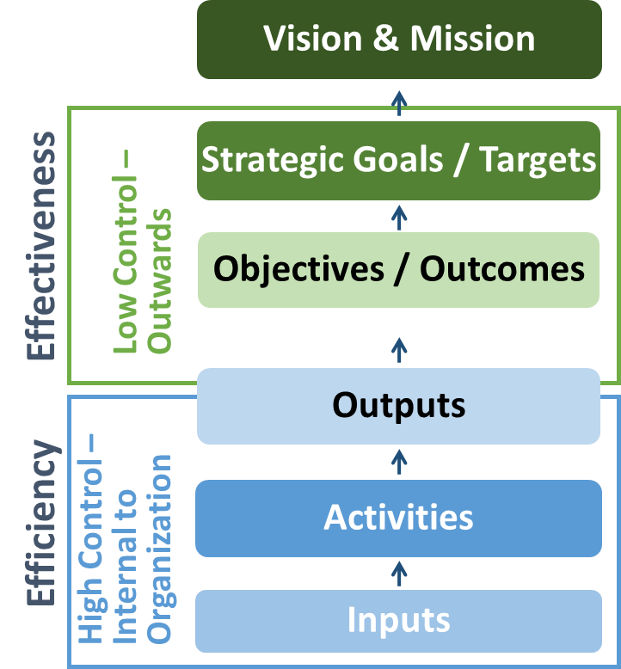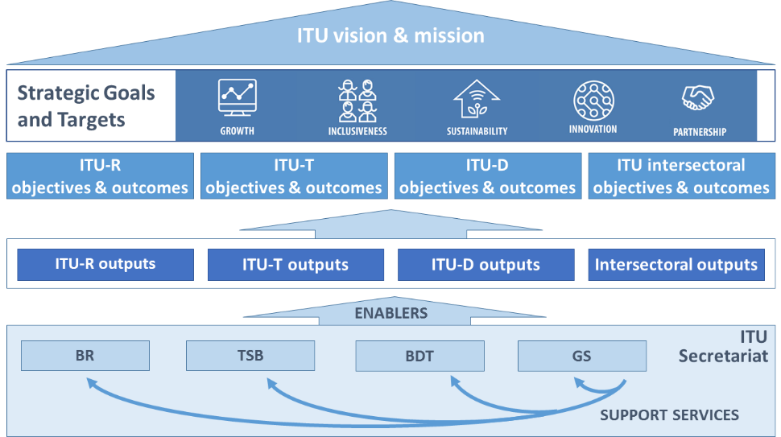

ITU-R Objectives:
- R.1 (Spectrum regulations): Meet, in a rational, equitable, efficient, economical and timely way, the ITU membership’s requirements for radio-frequency spectrum and satellite-orbit resources, while avoiding harmful interference
- R.2 (Radiocommunication standards): Provide for worldwide connectivity and interoperability, improved performance, quality, affordability and timeliness of service and overall system economy in radiocommunications, including through the development of international standards
- R.3 (Disseminate information): Foster the acquisition and sharing of knowledge and know-how on radiocommunications
ITU-T Objectives:
- T.1 (Development of standards): Develop international standards (ITU-T recommendations), in a timely manner, and foster interoperability and improved performance of equipment, networks, services and applications
- T.2 (Bridging the standards gap): Promote the active participation of the membership, in particular developing countries, in the definition and adoption of international standards (ITU-T recommendations) with a view to bridging the standardization gap
- T.3 (Telecommunication resources): Ensure effective allocation and management of international telecommunication numbering, naming, addressing and identification resources in accordance with ITU-T recommendations and procedures
- T.4 (Knowledge sharing): Foster awareness and sharing of knowledge about the standardization activities of ITU-T
- T.5 (Cooperation with standardization bodies) Extend and facilitate cooperation with other international, regional and national standardization bodies and relevant consortia and fora
ITU-D Objectives:
- D.1 (Coordination): Foster international cooperation and agreement on telecommunication/ICT development issues
- D.2 (Modern and secure telecommunication/ICT infrastructure): Foster the development of infrastructure and services, including building confidence and security in the use of telecommunications/ICTs
- D.3 (Enabling environment): Foster an enabling policy and regulatory environment conducive to sustainable telecommunication/ICT development
- D.4 (Inclusive digital society): Foster the development and use of telecommunications/ICTs and applications to empower people and societies for sustainable development
Inter-Sectoral Objectives:
- I.1 (Collaboration) Foster closer collaboration among all stakeholders in the telecommunication/ICT ecosystem
- I.2 (Emerging telecommunication/ICT trends) Enhance identification, awareness and analysis of emerging trends in the telecommunication/ICT environment
- I.3 (Telecommunication/ICT accessibility) Enhance telecommunications/ICTs accessibility for persons with disabilities and specific needs
- I.4 (Gender equality [and equity]) Enhance the use of telecommunication/ICTs for gender equality and empowerment of women and girls
- I.5. (Environmental sustainability) Leverage telecommunication/ICTs to reduce environmental footprint
- I.6 (Reducing overlap and duplication) Reduce the areas of overlap and duplication and foster closer and more transparent coordination among General Secretariat and ITU Sectors, taking into account the Union’s budgetary provisions and the expertise and mandate of each Sector.

Table 3. Linkage of ITU objectives with the Strategic Goals:
 |  | Goal 1: Growth | Goal 2: Inclusiveness | Goal 3: Sustainability | Goal 4: Innovation | Goal 5: Partnership
Objectives | ITU-R objectives
 | R.1. Spectrum regulations
 | R.2. Radiocommunication standards
 | R.3. Disseminate information
 | ITU-T objectives
 | T.1. Development of standards
 | T.2. Bridging the standards gap
 | T.3. Telecommunication resources
 | T.4. Knowledge sharing
 | T.5. Cooperation with standardization bodies
 | ITU-D objectives
 | D.1. Coordination
 | D.2. Modern and secure telecommunication/ICT infrastructure
 | D.3. Enabling environment
 | D.4. Inclusive digital society
 | Inter-Sectoral objectives
 | I.1. Collaboration
 | I.2. Emerging telecommunication/ICT trends
 | I.3. Telecommunication/ICT accessibility
 | I.4. Gender equality [and equity]
 | I.5. Environmental sustainability
 | I.6. Reducing overlap and duplication

Objectives, Outcomes and Outputs / Enablers
Table 4: ITU-R Objectives, Outcomes and Outputs
R.1 (Spectrum regulations) Meet, in a rational, equitable, efficient, economical and timely way, the ITU membership’s requirements for radio-frequency spectrum and satellite-orbit resources, while avoiding harmful interference
Outcomes | Outputs
R.1-a: Increased number of countries having satellite networks and earth stations recorded in the Master International Frequency Register (MIFR)  R.1-b: Increased number of countries having terrestrial frequency assignments recorded in the MIFR  R.1-c: Increased percentage of assignments recorded in the MIFR with a favourable finding  R.1-d: Increased percentage of countries which have completed the transition to digital terrestrial television broadcasting  R.1-e: Increased percentage of spectrum assigned to satellite networks which is free from harmful interference  R.1-f: Increased percentage of assignments to terrestrial services recorded in the MIFR which are free from harmful interference | R.1-1: Final acts of world radiocommunication conferences, updated Radio Regulations  R.1-2: Final acts of regional radiocommunication conferences, regional agreements  R.1-3: Rules of Procedure and other decisions of the Radio Regulations Board (RRB)  R.1-4: Publication of space notices and other related activities  R.1-5: Publication of terrestrial notices and other related activities
R.2 (Radiocommunication standards) Provide for worldwide connectivity and interoperability, improved performance, quality, affordability and timeliness of service and overall system economy in radiocommunications, including through the development of international standards
Outcomes | Outputs
R.2-a: Increased mobile-broadband access, including in frequency bands identified for international mobile telecommunications (IMT)  R.2-b: Reduced mobile-broadband price basket, as a percentage of gross national income (GNI) per capita  R.2-c: Increased number of fixed links and increased amount of traffic handled by the fixed service (Tbit/s)  R.2-d: Increased number of households with digital terrestrial television reception  R.2-e: Increased number of satellite transponders (equivalent 36 MHz) on communication satellites in operation and corresponding capacity (Tbit/s); Number of VSAT terminals; Number of households with satellite television reception  R.2-f: Increased number of devices with radionavigation-satellite reception  R.2-g: Increased number of satellites having Earth exploration payloads in operation, corresponding quantity and resolution of transmitted images and data volume downloaded (Tbytes) | R.2-1: Decisions of the Radiocommunication Assembly, ITU-R resolutions  R.2-2: ITU-R recommendations, reports (including the CPM report) and handbooks  R.2-3: Advice from the Radiocommunication Advisory Group
R.3 (Disseminate information) Foster the acquisition and sharing of knowledge and know-how on radiocommunications
Outcomes | Outputs
R.3-a: Increased knowledge and know-how on the Radio Regulations, Rules of Procedure, regional agreements, recommendations and best practices on spectrum use  R.3-b: Increased participation in ITU-R activities (including through remote participation), in particular by developing countries | R.3-1: ITU-R publications  R.3-2: Assistance to members, in particular developing countries and LDCs  R.3-3: Liaison/support to development activities  R.3-4: Seminars, workshops and other events

Table 5. Enablers for ITU-R
Supported Objective(s) | BR activities | Contribution to the Outcomes of the Sector | Results
R.1 | Efficient processing of frequency assignment notices | Increased certainty for planning new radiocommunication networks | Reduced processing time for publication of notices, within regulatory limits
R.1, R.2, R.3 | Development, maintenance and improvement of ITU-R software, databases and online tools  Technical, regulatory, administrative, outreach and logistical activities in support of ITU-R objectives | Increased reliability, efficiency and transparency in the application of the Radio Regulations. | New and improved ITU-R software, databases and online tools  Efficient and timely delivery of ITU-R outputs and support to ITU-R objectives  BR contributions to ITU-R meetings, conferences and events

Table 6. ITU-T Objectives, Outcomes and Outputs
T.1 (Development of standards) Develop [non-discriminatory] international telecommunication/ICT standards (ITU-T recommendations), in a timely manner, and foster interoperability and improved performance of equipment, networks, services and applications
Outcomes | Outputs
T.1-a: Increased utilization of ITU-T recommendations  T.1-b: Improved conformance to ITU-T recommendations  T.1-c: Enhanced standards in new technologies and services | T.1-1: Resolutions, recommendations and opinions of the World Telecommunication Standardization Assembly (WTSA)  T.1-2: WTSA regional consultation sessions  T.1-3: Advice and decisions of the Telecommunication Standardization Advisory Group (TSAG)  T.1-4: ITU-T recommendations and related results of ITU-T study groups  T.1-5: ITU-T general assistance and cooperation  T.1-6: Conformity database  T.1-7: Test centres and interoperability events  T.1-8: Development of test suites
T.2 (Bridging the standards gap) Promote the active participation of the membership, in particular developing countries, in the definition and adoption of international telecommunication/ICT standards (ITU-T recommendations) with a view to bridging the standardization gap
Outcomes | Outputs
T.2-a: Increased participation in the ITU-T standardization process, including attendance of meetings, submission of contributions, taking leadership positions and hosting of meetings/workshops, especially from developing countries  T.2-b: Increase of the ITU-T membership, including Sector Members, Associates and Academia | T.2-1: Bridging the standardization gap (e.g. remote participation, fellowships, establishment of regional study groups)  T.2-2: Workshops and seminars, including offline and online training activities, complementing the capacity-building work on bridging the standardization gap  T.2-3: Outreach and promotion
T.3 (Telecommunication resources) Ensure effective allocation and management of international telecommunication numbering, naming, addressing and identification resources in accordance with ITU-T recommendations and procedures
Outcomes | Outputs
T.3-a: Timely and accurate allocation of international telecommunication numbering, naming, addressing and identification resources, as specified in the relevant recommendations | T.3-1: Relevant TSB databases  T.3-2: Allocation and management of international telecommunication numbering, naming, addressing and identification resources in accordance with ITU-T recommendations and procedures
T.4 (Knowledge sharing) Foster awareness and sharing of knowledge about the the standardization activities of ITU-T
Outcomes | Outputs
T.4-a: Increased knowledge on ITU-T standards and on best practices in their implementation of ITU-T standards  T.4-b: Increased participation in ITU-T's standardization activities and increased awareness of the relevance of ITU-T standards  T.4-c: Increased Sector visibility | T.4-1: ITU-T publications  T.4-2: Database publications  T.4-3: Outreach and promotion  T.4-4: ITU Operational Bulletin
T.5 (Cooperation with standardization bodies) Extend and facilitate cooperation with other international, regional and national standardization bodies and relevant consortia and for a.
Outcomes | Outputs
T.5-a: Increased communications with other standards organizations  T.5-b: Decreased number of conflicting standards  T.5-c: Increased number of memoranda of understanding/collaboration agreements with other organizations  T.5-d: Increased number of ITU-T A.4, A.5 and A.6 qualified organizations  T.5-e: Increased number of workshops/events organized jointly with other organizations | T.5-1: Memoranda of understanding (MoUs) and collaboration agreements  T.5-2: ITU-T A.4/A.5/A.6 qualifications  T.5-3: Jointly organized workshops/events

Table 7. Enablers for ITU-T
Supported ITU-T Objective(s) | TSB activities | Contribution to the Outcomes of the Sector | Results
T.1 | - Timely and efficient provisioning of documents (WTSA Resolutions, Recs, Opinions, ITU-T Recs, SGs related documents, reports)  - Secretariat support and organization and logistical support for meetings  - Advisory services  - TSB EWM services and information services  - Operation and maintenance of C&I DBs; logistical support for interop/testing events, testbeds | - Increased quality of ITU-T recommendations | - Timely up-to-date information for delegates and standards community about ITU-T’s products and services
T.2 | - Organization of BSG hands-on training sessions; fellowship financial support; logistical support of regional groups  - Organization of workshops  - Announcements (ITU newsblog, promotional activities)  - Account management of ITU-T memberships, retention of current members and proactive acquisition of new members | - Increased ITU-T membership and participation in the standardization process | - Active participation of delegates and organizations that have so far only participated passively in ITU-T activities, or not at all
T.3 | - Processing and publication of numbering, addressing, naming and identification applications / resources | - Timeliness and accuracy in the allocation of the resources | - Timely availability of numbering information facilitates management of networks
T.4 | - ITU-T publication services  - Development and maintenance of ITU-T databases  - Outreach and promotion service (ITU newsblog, social media, web)  - Organization of workshops, CTO group meetings, Kaleidoscope, sessions at ITU Telecom, WSIS etc | - Increased knowledge and awareness on ITU-T standards, increased participation in ITU-T activities and increased Sector visibility | - Timely availability of publications (documents; databases) and easy to use services enhances the delegate experience
T.5 | - Maintenance and management of MoUs; establishment of new MoUs  - Maintenance and management of A.4/A.5/A.6 DB  - Logistical support for jointly organized WSs and events  - Support services for various collaboration activities (WSC, GSC, CITS, FIGI, WSIS, U4SSC …) | - Increased cooperation with other standardization organizations and relevant consortia and fora; reduced duplication and inconsistencies of work | - Collaboration activities avoid duplication of work and improve efficient use of limited resources

Table 8. ITU-D Objectives, Outcomes and Outputs
D.1 (Coordination) Foster international cooperation and agreement on telecommunication/ICT development issues
Outcomes | Outputs
D.1-a: Enhanced review and increased level of agreement on the draft ITU-D contribution to the draft ITU strategic plan, the World Telecommunication Development Conference (WTDC) Declaration, and the WTDC Action Plan  D.1-b: Assessment of the implementation of the Action Plan and of the WSIS Plan of Action  D.1-c: Enhanced knowledge-sharing, dialogue and partnership among the ITU membership on telecommunication/ICT issues  D.1-d: Enhanced process and implementation of telecommunication/ICT development projects and regional initiatives  D.1.e: Facilitation of agreement to cooperate on telecommunication/ICT development programmes between Member States, and between Member States and other stakeholders in the ICT ecosystem, based on requests from ITU Member States involved | D.1-1 World Telecommunication Development Conference (WTDC) and WTDC Final Report  D.1-2 Regional preparatory meetings (RPMs) and final reports of the RPMs  D.1-3 Telecommunication Development Advisory Group (TDAG) and reports of TDAG for the Director of BDT and for WTDC  D.1-4 Study groups and guidelines, recommendations and reports of study groups  D.1-5 Platforms for regional coordination, including regional development forums (RDFs)  D.1-6: Implemented telecommunication/ICT development projects and services related to regional initiatives.
D.2 (Modern and secure telecommunication/ICT Infrastructure) Foster the development of infrastructure and services, including building confidence and security in the use of telecommunications/ICTs
Outcomes | Outputs
D.2-a: Enhanced capacity of the ITU membership to make available resilient telecommunication/ICT infrastructure and services.  D.2-b: Strengthened capacity of Member States to effectively share information, find solutions, and respond to threats to cybersecurity, and to develop and implement national strategies and capabilities, including capacity building, encourage national, regional and international cooperation towards enhanced engagement among Member States and relevant players.  D.2-c: Strengthened capacity of Member States to use telecommunications/ICTs for disaster risk reduction and management, to ensure availability of emergency telecommunications, and support cooperation in this area. | D.2-1 Products and services on telecommunication/ICT infrastructure and services, wireless and fixed broadband, connecting rural and remote areas, improving international connectivity, bridging the digital standardization gap, conformance and interoperability, spectrum management and monitoring, the effective and efficient management and proper use of telecommunication resources within the mandate of ITU, and the transition to digital broadcasting, such as assessment studies, publications, workshops, guidelines, and best practices.  D.2-2 Products and services in building confidence and security in the use of telecommunications/ICTs, such as reports and publications, and to contribute to the implementation of national and global initiatives.  D.2-3 Products and services on disaster risk reduction and management, and emergency telecommunications, including assistance to enable Member States to address all phases of disaster management, such as early warning, response, relief, and restoration of telecommunication networks.
D.3 (Enabling Environment) Foster an enabling policy and regulatory environment conducive to sustainable telecommunication/ICT development
Outcomes | Outputs
D.3-a: Strengthened capacity of Member States to enhance their policy, legal and regulatory frameworks conducive to development of telecommunications/ICTs.  D.3-b: Strengthened capacity of Member States to produce high-quality, internationally comparable telecommunication/ICT statistics which reflect developments and trends in telecommunications/ICTs, based on agreed standards and methodologies.  D.3-c: Improved human and institutional capacity of the ITU membership to tap into the full potential of telecommunications/ICTs.  D.3-d: Strengthened capacity of the ITU membership to integrate telecommunication/ICT innovation in national development agendas and to develop strategies to promote innovation initiatives, including through public, private, and public-private partnerships. | D.3-1 Products and services on telecommunication/ICT policy and regulation for better international coordination and coherence, such as assessment studies and other publications, and other platforms to exchange information.  D.3-2 Products and services on telecommunication/ICT statistics and data analysis, such as research reports, collection, harmonization and dissemination of high-quality, internationally comparable statistical data, and forums of discussion.  D.3-3 Products and services on capacity building and human skills development, including those on international Internet governance, such as online platforms, distance and face-to-face training programmes to enhance practical skills and shared material, taking into account partnerships with telecommunication/ICT education stakeholders.  D.3-4 Products and services on telecommunication/ICT innovation, such as knowledge-sharing and assistance, upon request, on developing a national innovation agenda; mechanisms for partnerships; development of projects, studies and telecommunication/ICT innovation policies.
D.4 (Inclusive Digital Society) Foster the development and use of telecommunications/ICTs and applications to empower people and societies sustainable development
Outcomes | Outputs
D-4-a: Improved access to and use of telecommunication/ICT in least developed countries (LDCs), small island developing states (SIDS) and landlocked developing countries (LLDCs), and countries with economies in transition.  D.4-b: Improved capacity of the ITU membership to accelerate economic and social development by leveraging and using new technologies and telecommunication/ICT services and applications.  D.4-c: Strengthened capacity of the ITU membership to develop strategies, policies and practices for digital inclusion, in particular for the empowerment of women and girls, persons with disabilities and other persons with specific needs.  D.4-d: Enhanced capacity of the ITU membership to develop telecommunication/ICT strategies and solutions on climate-change adaptation and mitigation and the use of green/renewable energy. | D.4-1 Products and services on concentrated assistance to LDCs, SIDS and LLDCs and countries with economies in transition, to foster availability and affordability of telecommunications/ICTs.  D.4-2 Products and services on telecommunication/ICT policies supporting the development of the digital economy, ICT applications and new technologies, such as information sharing and support for their deployment, assessment studies, and toolkits.  D.4-3 Products and services on digital inclusion for girls and women and people with specific needs (elderly, youth, children and indigenous people, among others), such as awareness-raising on digital inclusion strategies, policies and practices, development of digital skills, toolkits and guidelines and forums of discussion to share practices and strategies.  D.4-4 Products and services on ICT climate-change adaptation and mitigation, such as promotion of strategies and dissemination of best practices on mapping vulnerable areas and developing information systems, metrics, and e-waste management.

Table 9. Enablers for ITU-D
Supported Objective(s) | BDT activities | Contribution to the Outcomes of the Sector | Results
D.1, D.2, D.3, D.4 | 1. Development and implementation of efficient strategies in telecommunication/ICT development towards achieving WSIS Action Lines and Sustainable Development Goals (SDGs), including communication and promotion activities | - Increased understanding and sharing of the ITU-D objectives and outputs  - Increased guidance for ITU-D activities  - Increased clarity of the programme of activities | - Measurable progress towards achieving WSIS Action Lines taking into account SDGs  - Increased level of international cooperation in the area of telecommunication/ICT development  - Increased level of satisfaction by Member States with services and products provided by BDT
 | 2. Efficient administration of and support to telecommunication/ICT development activities through coordination of and collaboration among services, finance and budget administration, event organization support and IT support. | - Clear and coordinated scheduling of events  - Provision of necessary financial, IT and manpower support within available resource limits  - Provision of reliable support to events | - Enhanced coordination and collaboration in organizing events and implementing activities  - Efficient use of financial resources  - Timely and efficient organization of events  - Increased quality and coordination of BDT’s reporting to Member States
 | 3. Efficient organization of and support to activities on telecommunication/ICT infrastructure, ICT applications and cybersecurity. | - Identification of priorities and needs of Member States  - Development of relevant products and services and their timely delivery to end users  - Effective involvement of all relevant stakeholders in the development and delivery of products and services to Member States | - Increased quality and enhanced accessibility of products, services, and expertise developed and delivered by BDT in the areas of telecommunication/ICT infrastructure, ICT applications, and cybersecurity  - Increased level of satisfaction by Member States  - Tangible improvements in ITU’s Member States as a result of BDT’s activities in areas of telecommunication/ICT infrastructure, ICT applications, and cybersecurity  - Enhanced role of telecommunications/ICTs in the social and economic development of Member States
 | 4. Efficient organization of and support to activities on projects and knowledge management through capacity building, project support, ICT data and statistics, and emergency telecommunication support. | - Identification of priorities and needs of Member States  - Development of relevant products and services and their timely delivery to end users  - Effective involvement of all relevant stakeholders in the development and delivery of products and services to Member States | - Increased quality and enhanced accessibility of products, services, and expertise developed and delivered by BDT in the areas of projects and knowledge management  - Increased level of satisfaction by Member States  - Tangible improvements in ITU’s Member States as a result of BDT’s activities in the areas of projects and knowledge management  - Successful mitigation of emergency telecommunication risks
 | 5. Efficient organization of and support to innovation and partnership activities through partnership building, innovation, and study group coordination services. | - Identification of priorities and needs of Member States  - Development of relevant products and services and their timely delivery to end users  - Effective involvement of all relevant stakeholders in the development and delivery of products and services to Member States | - Increased quality and enhanced accessibility of products, services, and expertise developed and delivered by BDT in the areas of partnership building and innovation  - Increased level of satisfaction by Member States  - Wider participation of stakeholders and partners in the development of telecommunications/ICTs in developing countries  - Increased level of resources from donors for the benefit of Member States’ efforts to develop their telecommunication/ICTs
 | 6. Efficient delivery and coordination of activities in telecommunication/ICT development through regional and area office activities | - Increased ITU outreach in various regions and areas of the world | - Effective and efficient delivery of products, services, information, and expertise of BDT and ITU to Member States  - Increased level of satisfaction by Member States with services and products provided by BDT

Table 10. Inter-Sectoral Objectives, Outcomes and Outputs
I.1 (Collaboration) Foster closer collaboration among all stakeholders in the telecommunication/ICT ecosystem
Outcomes | Outputs
I.1-a: Increased collaboration among relevant stakeholders  I.1-b: Increased synergies from partnerships on telecommunication/ICTs  I.1-c: Increased recognition of telecommunications/ICTs as a cross-cutting enabler for implementing the WSIS Action Lines taking into account the 2030 Agenda for Sustainable Development  I | I.1-1: Inter-Sectoral world conferences, forums, events and platforms for high-level debate, Kaleidoscope)  I.1-2: Knowledge-sharing, networking and partnerships  I.1-3: Memoranda of understanding (MoUs)  I.1-4: Reports and other inputs to UN inter-agency, multilateral and intergovernmental processes
I.2 (Emerging telecommunication/ICT trends) Enhance identification, awareness and analysis of emerging trends in the telecommunication/ICT environment
Outcomes | Outputs
I.2-a: Identification, awareness and analysis of emerging trends in telecommunications/ICTs | I.2-1: Intersectoral initiatives and reports on relevant emerging telecommunication/ICT trends and other similar initiatives  I.2-2: ITU News Digital format  I.2-3 Platforms to exchange information about new trends
I.3 (Telecommunication/ICT accessibility) Enhance telecommunications/ICTs accessibility for persons with disabilities and specific needs
Outcomes | Outputs
I.3-a: Increased availability and compliance of telecommunication/ICT equipment, services and applications with universal design principles  I.3-b: Increased engagement of organizations of persons with disabilities and specific needs in the work of the Union  I.3-c: Increased awareness, including multilateral and intergovernmental recognition, of the need to enhance access to telecommunications/ICTs for persons with disabilities and specific needs | I.3-1: Reports, guidelines, standards and checklists relating to accessibility of telecommunications/ICTs  I.3-2: Mobilization of resources and technical expertise, for example, through promoting greater participation in international and regional meetings by persons with disabilities and specific needs  I.3-3: Further development and implementation of the ITU Accessibility Policy and related plans  I.3-4: Advocacy, both at UN level and at regional and national levels
I.4 (Gender equality and inclusion) Enhance the use of telecommunication/ICTs for gender equality and inclusion,] and empowerment of women and girls
Outcomes | Outputs
I.4-a: Enhanced access to and use of telecommunication/ICTs to promote the empowerment of women  I.4-b: Enhanced participation of women at all level of decision making in the work of the Union and the telecommunication/ICT sector  I.4-c: Increased engagement with other UN organizations and stakeholders involved in using telecommunication/ICTs to promote the empowerment of women  I.4-d: Full implementation of UN system-wide strategy on gender parity within ITU’s remit | I.4-1: Toolkits, assessment tools and guidelines for policy development and skills development and other practices for implementation  I.4-2: Networks, collaboration, initiatives and partnerships  I.4-3: Advocacy, both at UN level and at regional and national levels  I.4-4: Support the Equals partnership
I.5 (Environmental sustainability) Leverage telecommunication/ICTs to reduce environmental footprint
Outcomes | Outputs
I.5-a: Improved efficiency of environmental policies and standards  I.5-b: Reduced energy consumption from telecommunication/ICT applications  I.5-c: Increasing number of recycled e-waste  I.5-d: Improved solutions for Smart Sustainable Cities | I.5-1: Energy efficiency policies and standards  I.5-2: Safety and environmental performance of ICT equipment and facilities (e-waste management)  I.5-3: Global platform for Smart Sustainable Cities, including development of KPIs
I.6 (Reducing overlaps) Reduce the areas of overlap and foster closer and more transparent coordination among General Secretariat and ITU Sectors, taking into account the Union’s budgetary provisions
Outcomes | Outputs
I.6-a: Closer and more transparent collaboration among the ITU Sectors, the General Secretariat and the 3 Bureaux  I.6-b: Reducing the areas of overlap and duplication among the ITU Sectors and the work of the General Secretariat and the 3 Bureaux  I.6-c: Realise savings through avoidance of areas of overlap | I.6-1: Process to identify and eliminate all forms and instances of duplication of functions and activities between all ITU structural bodies, optimizing, inter alia, management methods, logistics, coordination and support by the Secretariat  I.6-2: Implement the concept of “One ITU”, harmonizing, to the extent feasible, procedures across Sectors and regional offices/regional presence in the implementation of goals and objectives of the ITU and Sectors

Table 11. General Secretariat Enablers / Support Services
Supported Objective(s) | GS activities | Contribution to the Outcomes | Results
All | Management of the Union | - Effective and efficient governance of the organization  - Effective coordination among the Sectors of the Union | - Improved internal coordination  - Management of the strategic risks of the organization  - Decisions of the governing bodies being implemented  - Development, implementation and monitoring of the Strategic and Operational Plans  - Level of implementation of accepted Recommendations  - Application of efficiency measures  - Overall quality of support services provided
All | Event management services (including translation and interpretation) | - Efficient and accessible ITU conferences, meetings, events and workshops | - High quality of services provided for ITU events (availability of documents, courtesy and professionalism of ITU’s conference service staff, quality of interpretation, quality of documents, quality of conference premises and facilities)  - Improved financial efficiency
All | Publication services | - Ensuring the quality, availability, and cost effectiveness of the ITU publications | - High quality of ITU publications  - Expeditious publishing process  - Improved financial efficiency
All | ICT services | - Reliable, efficient and accessible information and communication technology infrastructures and services | - Users satisfied with the ICT services provided by ITU  - Availability and functionality of ICT services (high-availability, IT safety and security, library and archive services, delivery of promised services on a timely basis, help provided in using technology effectively, introduction of new and innovative ICT services, ICT services valuable to ITU staff and delegates)-  - Increased number of platforms/systems facilitating the digital transformation of the organization  - Business continuity and disaster recovery in place
All | Safety and security services | - Ensuring a safe and secure working environment for ITU staff and delegates | - Overall safety and security of organization’s premises and assets worldwide  - Reduced work related injuries or incidents  - Staff preparedness for missions
All | Human resources management services (including payroll, staff administration, staff well-being, organization design and recruitment, planning and development) | - Ensuring efficient use of human resources, in a work-conducive environment | - Develop and implement the HR framework fostering sustainable and satisfied workforce, including the elements of career development and training  - Workforce adapted to the evolving environment and the evolving needs of the organization  - Expeditious recruitment processes  - Gender parity among ITU employees / gender parity in ITU statutory committees
All | Financial resources management services (including budget and financial analysis, accounts, procurement, travel) | - Ensuring efficient planning and use of financial and capital resources | - IPSAS compliance and unqualified Annual audit of Accounts  - Procurement and Travel Services: ITU guidelines and UN good practices in place  - No overspend in budget implementation  - Cost savings from efficiency measures implemented
All | Legal services | - Provision of legal advice  - Ensuring adherence to rules and procedures | - Interests, integrity and reputation of the Union protected  - Rules and regulations applied
All | Internal audit | - Ensuring efficient and effective governance and management controls | - Internal audit recommendations being implemented
All | Ethics office | - Promoting highest standards of ethical behaviour | - Adherence to the Standards of Conduct for the International Civil Service and the ITU Code of Ethics
All | Engagement with the membership / Membership support services | - Ensuring efficient membership-related services | - Increased number of members  - Increased membership satisfaction  - Increased revenue from Sector Members, Associates and Academia
All | Communication services | - Ensuring effective communication services | - Increased regular engagement of key stakeholders on ITU digital platforms  - Improved media coverage of ITU  - Improved perception of the work of ITU  - Improved traffic on ITU multimedia channels (Flickr, YouTube, etc.)  - Increase in ITU News traffic and engagement  - Increase in Social Media engagement and referrals
All | Protocol services | - Ensuring efficient management of protocol services | - Increased satisfaction of delegates and visitors
All | Facilitation of the work of governing bodies (PP, Council, CWGs) | - Supporting and facilitating the decision-making processes of the governing bodies | - Improved efficiency of the governing bodies meetings
All | Facilities management services | - Ensuring efficient management of ITU premises | - Efficient management of the process of developing the new ITU building  - Cost savings in managing ITU facilities  - ITU to remain a Carbon Neutral organization
All | Content development and management services / Corporate strategic management and planning | - Ensuring efficient planning  - Strategic advisory to senior management | - Approval of the ITU planning instruments by membership  - Support to the development of strategic initiatives
Inter-sectoral Objectives I.1, I.2 | Coordination and cooperation in promoting telecommunication/ICTs that contribute to the WSIS Action Lines taking into account the Sustainable Development Agenda | - Increased synergies, collaboration, transparency and internal communication on the partnerships developed and the activities undertaken on international cooperation for the promotion of ICT for SDGs  - Better coordination of organization of ITU events and meetings  - Increased consistency for planning the participation in conferences and fora | - New and improved measures and mechanisms with a view to increase the efficiency and effectiveness of the organization  - Coordinated ITU work and contribution to the WSIS Action Lines, taking into account the 2030 Agenda for Sustainable Development
Inter-sectoral Objectives I.3, I.4, I.5, I.6 | Coordination and cooperation in areas of mutual interest (including accessibility, gender, environmental sustainability) | - Coordinated work in the areas of mutual interest, promoting synergies and introducing efficiencies and savings in the use of the ITU resources  - Increased consistency for planning the participation in conferences and fora  - Increased internal communication on the activities undertaken on all thematic areas.  - Better coordination of organization of ITU events and meetings | - Implementation of the consolidated Annual Work Plan per thematic area  - New and improved measures and mechanisms, with a view to increase the efficiency and effectiveness of the organization

Linkage with the WSIS Action Lines and the 2030 Agenda for Sustainable Development
Linkage with the WSIS Action Lines
ITU has a leading role in the WSIS process, where as a lead facilitator, along with UNESCO and UNDP, coordinates the multi-stakeholder implementation of the Geneva Plan of Action. Notably, ITU is the sole facilitator on three different WSIS Action Lines; C2 (Information and communication infrastructure), C5 (Building confidence and security in the use of ICTs) and C6 (Enabling environment).
Mapping ITU outputs and key activities to WSIS Action Lines (based on information from the ITU SDG Mapping Tool)
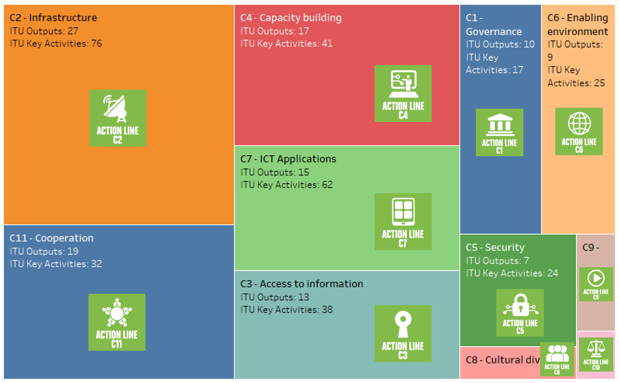

Linkage with the Sustainable Development Goals
With the adoption of the UNGA Resolution “Transforming our world: the 2030 Agenda for Sustainable Development” ITU, along with the rest of the UN family, needs to support Member States and contribute to the worldwide efforts to achieve the SDGs. The associated 17 SDGs and 169 related targets offer a holistic vision for the UN system.
The role of Information Communication Technologies (ICTs) as essential catalysts to fast-forward the achievement of the SDGs is clearly highlighted in the 2030 Agenda: “the spread of information and communications technology and global interconnectedness has great potential to accelerate human progress, to bridge the digital divide, and to develop knowledge societies”. ITU, as the UN’s specialized agency for ICTs and global connectivity, has a key role to play in promoting prosperity in our digital world.
In order to maximise ITU’s contribution to the 2030 Agenda, ITU’s primary focus is in addressing SDG 9 (Industry, Innovation and Infrastructure) and Target 9.c aiming to significantly increase access to ICTs and provide universal and affordable access to the Internet. Indeed, the infrastructure that powers our world and forms the backbone of the new digital economy is vital. It is essential to so many of the technological applications and potential solutions to the SDGs and is crucial for them to be both global and scalable.
As SDG17 (Partnership for the Goals) highlights ICTs as a means of implementation, with crosscutting transformative potential, it is imperative that ITU leverages this broad impact. Notable SDGs where ITU has a particularly strong impact include SDG 11 (Sustainable Cities and Communities), SDG 10 (Reduced Inequalities), SDG 8 (Decent Work and Economic Growth), SDG 1 (No Poverty), SDG 3 (Good-Health and Well-Being), SDG 4 (Quality Education) and SDG 5 (Gender Equality).
It is, therefore, through infrastructure and connectivity and in partnership with all stakeholders that ITU will contribute the most towards achieving the remaining SDGs.
Mapping ITU outputs and key activities to SDGs (as per the ITU SDG Mapping Tool)
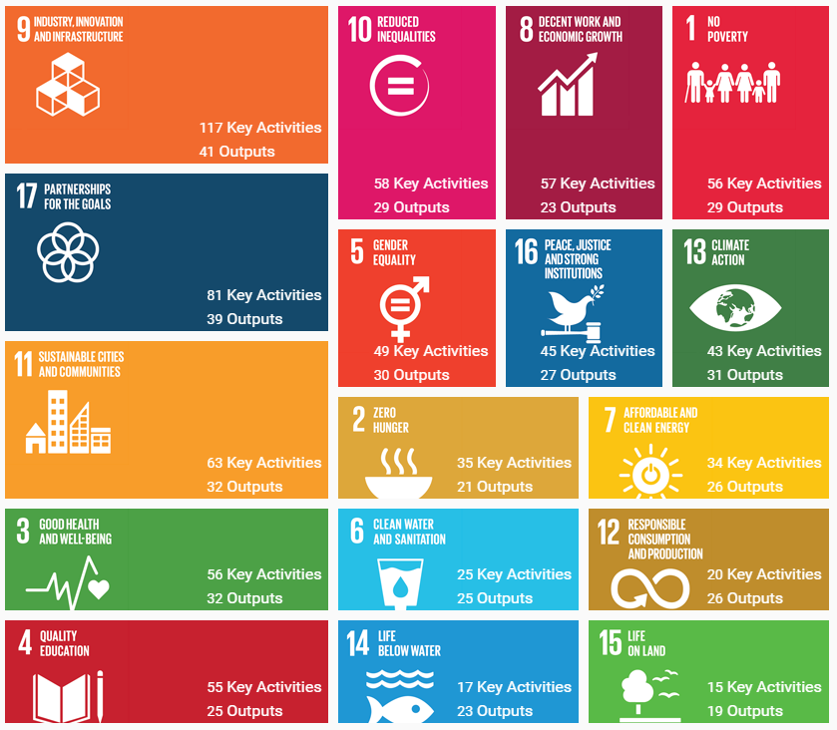
ITU is also the custodian of five SDG indicators (4.4.1, 5.b.1, 9.c.1, 17.6.2 and 17.8.1) contributing to the UNSTATS monitoring of the SDGs.

Linking ITU Strategic Goals to SDG targets
Goal 1 – Growth
SDG Target (indicator(s)): 1.4 (1.4.1), 2.4 (2.4.1), 4.1 (4.1.1), 4.2 (4.2.2), 4.3 (4.3.1), 4.4 (4.4.1), 4.A (4.A.1), 5.5 (5.5.1, 5.5.2), 5.B (5.B.1), 6.1, 6.4 (6.4.1), 7.3 (7.3.1), 8.2 (8.2.1), 8.10 (8.10.2), 9.1, 9.2, 9.3 (9.3.1, 9.3.2), 9.4 (9.4.1), 9.5, 9.C (9.C.1), 11.3 (11.3.2), 11.5 (11.5.2), 11.B (11.B.1, 11.B.2), 13.1 (13.1.2), 13.3 (13.3.2), 17.6 (17.6.1, 17.6.2)
Goal 2 – Inclusiveness
SDG Targets (indicator(s)): 1.4 (1.4.1), 1.5 (1.5.3), 2.C (2.C.1), 3.D (3.D.1), 4.1 (4.1.1), 4.2 (4.2.2), 4.3 (4.3.1), 4.4 (4.4.1), 4.5 (4.5.1), 4.6 (4.6.1), 4.7 (4.7.1), 4.A (4.A.1), 4.B (4.B.1), 4.C (4.C.1), 5.1 , 5.2 (5.2.1, 5.2.2), 5.3, 5.5 (5.5.1, 5.5.2), 5.6 (5.6.1, 5.6.2), 5.A (5.A.1, 5.A.2), 5.B (5.B.1), 5.C, 6.1, 6.4 (6.4.1), 7.1 (7.1.1, 7.1.2), 7.B (7.B.1), 8.3 (8.3.1), 8.4 (8.4.2), 8.5 (8.5.1), 8.10 (8.10.2), 9.1, 9.2, 9.3 (9.3.1, 9.3.2), 9.4 (9.4.1), 9.5, 9.A (9.A.1), 9.B (9.B.1), 9.C (9.C.1), 10.2 (10.2.1), 10.6, 10.7 (10.7.1), 10.B (10.B.1), 10.C (10.C.1), 11.1 (11.1.1), 11.2, 11.3 (11.3.2), 11.5 (11.5.2), 11.A, 11.B (11.B.1, 11.B.2), 12.1 (12.1.1), 12.A (12.A.1), 13.1 (13.1.2), 13.3 (13.3.2), 13.A(13.A.1), 13.B (13.B.1), 14.A (14.A.1), 16.2 (16.2.2), 16.8 (16.8.1), 17.3 (17.3.2), 17.6 (17.6.1, 17.6.2), 17.7, 17.8 (17.8.1), 17.9 (17.9.1), 17.18
Goal 3 – Sustainability
SDG Targets (indicator(s)): 1.5 (1.5.3), 2.4 (2.4.1), 8.4 (8.4.2), 8.5 (8.5.1), 8.10 (8.10.2), 9.1, 9.2, 9.4 (9.4.1), 9.5, 9.A (9.A.1), 11.6 (11.6.1, 11.6.2), 11.A, 11.B (11.B.1, 11.B.2), 12.1 (12.1.1), 12.2 (12.2.1, 12.2.2), 12.4 (12.4.1, 12.4.2), 12.5 (12.5.1), 12.6 (12.6.1), 12.7 (12.7.1), 12.8 (12.8.1), 12.A (12.A.1), 16.2 (16.2.2), 16.4, 17.7
Goal 4 – Innovation
SDG Targets (indicator(s)): 2.4 (2.4.1), 2.C (2.C.1), 3.6 (3.6.1), 3.D (3.D.1), 4.3 (4.3.1), 4.4 (4.4.1), 4.5 (4.5.1), 4.6 (4.6.1), 4.7 (4.7.1), 4.A (4.A.1), 4.B (4.B.1), 5.A (5.A.1, 5.A.2), 6.1, 6.4 (6.4.1), 7.1 (7.1.1, 7.1.2), 7.2 (7.2.1), 7.3 (7.3.1), 8.2 (8.2.1), 8.3 (8.3.1), 8.10 (8.10.2), 9.1, 9.2, 9.3 (9.3.1, 9.3.2), 9.4 (9.4.1), 9.5, 9.A (9.A.1), 9.B (9.B.1), 9.C (9.C.1), 10.5 (10.5.1), 10.C (10.C.1), 11.2, 11.3 (11.3.2), 11.4, 11.5 (11.5.2), 11.6 (11.6.1, 11.6.2), 11.B (11.B.1, 11.B.2), 12.3, 12.5 (12.5.1), 12.A (12.A.1), 12.B (12.B.1), 13.1 (13.1.2), 14.4 (14.4.1), 14.A (14.A.1), 16.3, 16.4, 16.10 (16.10.2), 17.7
Goal 5 – Partnership
SDG Targets (indicator(s)): 3.D (3.D.1), 4.4 (4.4.1), 4.7 (4.7.1), 4.A (4.A.1), 4.B (4.B.1), 4.C (4.C.1), 5.1, 5.2 (5.2.1, 5.2.2), 5.3, 5.5 (5.5.1, 5.5.2), 5.6 (5.6.1, 5.6.2), 5.A (5.A.1, 5.A.2), 5.B (5.B.1), 5.C, 7.B (7.B.1), 8.3 (8.3.1), 8.4 (8.4.2), 9.1, 9.2, 9.3 (9.3.1, 9.3.2), 9.4 (9.4.1), 9.5, 9.A (9.A.1), 9.B (9.B.1), 9.C (9.C.1), 10.5 (10.5.1), 10.6, 10.B (10.B.1), 10.C (10.C.1), 11.1 (11.1.1), 11.2, 11.3 (11.3.2), 11.5 (11.5.2), 11.B (11.B.1, 11.B.2), 12.3, 12.6 (12.6.1), 12.7 (12.7.1), 12.8 (12.8.1), 12.A (12.A.1), 12.B (12.B.1), 13.1 (13.1.2), 13.3 (13.3.2), 16.2 (16.2.2), 16.3, 16.4, 16.8 (16.8.1), 16.10, (16.10.2), 17.6 (17.6.1, 17.6.2), 17.7, 17.8 (17.8.1), 17.9 (17.9.1), 17.18

Implementation and evaluation of the Strategic Plan
The strong and coherent linkage between the Union’s strategic, operational and financial planning is ensured by implementing the ITU results-based management (RBM) framework in accordance with Resolutions 71, 72 and 151 (Rev. Busan, 2014) of the Plenipotentiary Conference.
Results will be the main focus of strategy, planning and budgeting in the ITU RBM framework. Performance monitoring and evaluation, together with risk management, will ensure that the strategic, operational and financial planning processes are based on informed decision-making and appropriate resource allocation.
The ITU performance monitoring and evaluation framework will be further developed according to the strategic framework outlined in the strategic plan for 2020-2023, to measure progress towards achievement of the ITU objectives and outcomes, strategic goals and targets set out therein, evaluating performance and detecting issues that need to be addressed.
The ITU risk-management framework will be further developed, to ensure an integrated approach to the ITU RBM framework set in the strategic plan for the Union for 2020-2023.

Proposal: Addition of Section 5.2 – Implementation Criteria – from the 2016-2019 strategic plan.

Appendix A. Allocation of resources (linkage with the financial plan)
(to be updated according to the Financial Plan for 2020-2023)

Boxes and ticks demonstrate primary and secondary links to goals
[Pursuant to Plenipotentiary Resolution 177.]
Within the context of the Outputs of the ITU-D contribution to the ITU strategic plan, “products and services” refers to activities within the mandate of ITU-D as defined by Article 21 of the ITU Constitution, including, among others, capacity building and dissemination of ITU expertise and knowledge
ITU SDG Mapping Tool: https://www.itu.int/sdgmappingtool
SDG indicators with a reference to ICTs are highlighted in bold.

