COUNCIL WORKING GROUP ON  CHILD ONLINE PROTECTION (COP)  14th meeting, Geneva, 23 January 2018 | 
 | Document CWG-COP-14/8-E
 | 17 January 2018
 | English only

OFFICE OF ELECTRONIC COMMUNICATIONS,
REPUBLIC OF POLAND

Contribution on the educational campaign “I click sensibly” conducted by the President of the Office of Electronic Communications (UKE)

- Introduction:
The Internet is a source of knowledge, fun and communication. Young people live in a virtual world. Sometimes the boundaries between the virtual world and the real world are blurred. The youngest smartphone users often use them without restrictions. They do not realise the consequences that may be associated with downloading games or sending premium rate text messages. They are not aware of the dangers of access to inappropriate content.
According to the statistics from the report “Parents and children towards the dangers of the Internet” (2016), , almost all children aged 10+ use the Internet on regular basis. 60% of children aged 10+ visit social media at least once a day. 37% of parents surveyed for the purpose of this report are afraid of their children developing Internet addiction, 36% are concerned about inappropriate content that their children might access online.
The Office of Electronic Communications (UKE) has launched a campaign “I click sensibly” which responds to the ever-growing scale of the dangers faced by young Internet users. UKE employees conduct classes with children in primary schools.
http://uke.gov.pl/en/wydarzenia/click-sensibly,3.html

- Educational campaign “I click sensibly”:
The campaign "I click sensibly" is addressed to primary school pupils. The classes are aimed at:
- children 6-9 years old (1st-3rd grade);
- children 10-13 years old (4th – 7th grade);
- parents, teachers, guardians.
Through fun young users are taught:
• how to use smartphones and tablets more safely;
• how to deal with hate speech on the Internet, how to respond to cyber bullying;
• how to protect ones’ personal information;
• how to avoid high bills (data transmission, premium rate services);
• how to creatively use new technologies.
During the classes, the staff of the Office of Electronic Communications presents how to safely use the Internet and telecommunications devices. We teach how to deal with cyber bulling, protect personal data and avoid high bills. Classes have a form of conversation with students - it is not just a lecture. Each class lasts 45 minutes and is free of charge. Lessons are tailored to the needs and the age of the children. Watching an educational film created for the purpose of the campaign is an integral part of the lesson. Another aim of the campaign is to shape appropriate attitudes among teachers, parents and guardians responsible for the access of minors to the Internet. We run workshops for parents and teachers, as well as distribute educational materials.
The educational package is based on materials such as posters, leaflets, lesson scripts, videos, presentations. The campaign received a favourable opinion of the experts of the Faculty of Pedagogical Sciences at the Cardinal Stefan Wyszynski University in Warsaw.

- Cooperation:
The Office of Electronic Communications cooperates with:
- primary schools taking part in the campaign where we conduct the classes;
- the Consumer Ombudsmen, the Faculty of Pedagogical Sciences at the Cardinal Stefan Wyszynski University in Warsaw, Research and Academic Computer Network (NASK), non-governmental organisations, local media (exchange of experience).
We are open to cooperation with all interested schools, the campaign is ongoing.

- Campaign “I click sensibly” in numbers:
The campaign is conducted throughout Poland. UKE's experts have already visited dozens of schools.
- in 2017 we conducted 1,478 lessons for over 41,000 children;
- in 2018 we will train 50,000 children;
- by 2021 we are planning to train a total of 300,000 children.

- Photos
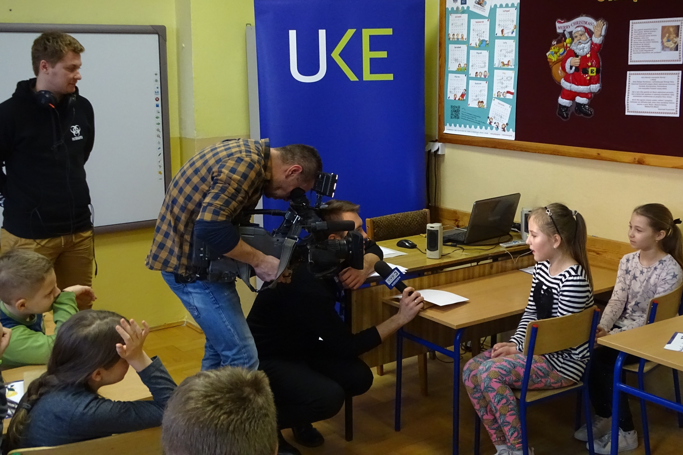
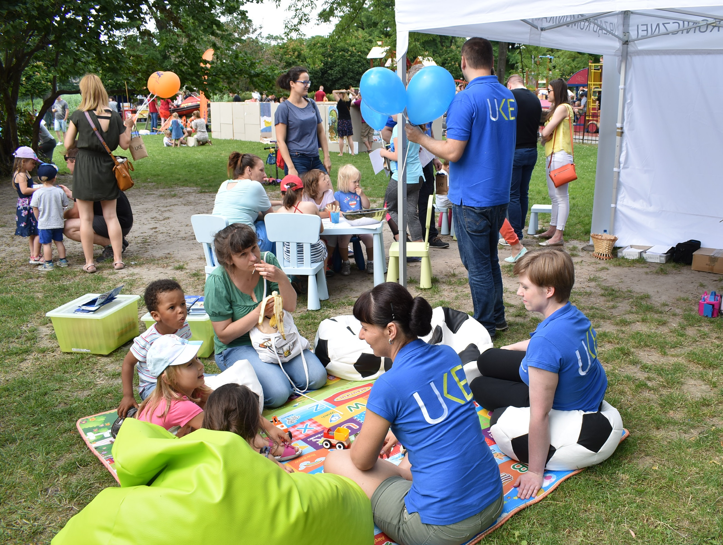

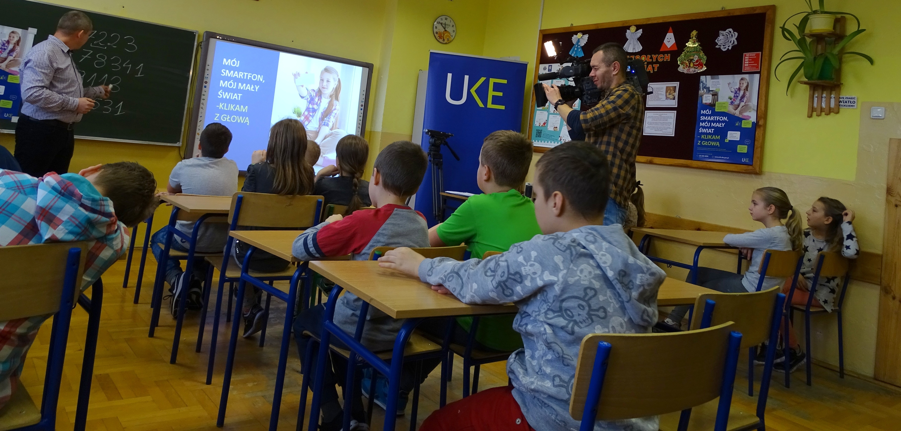
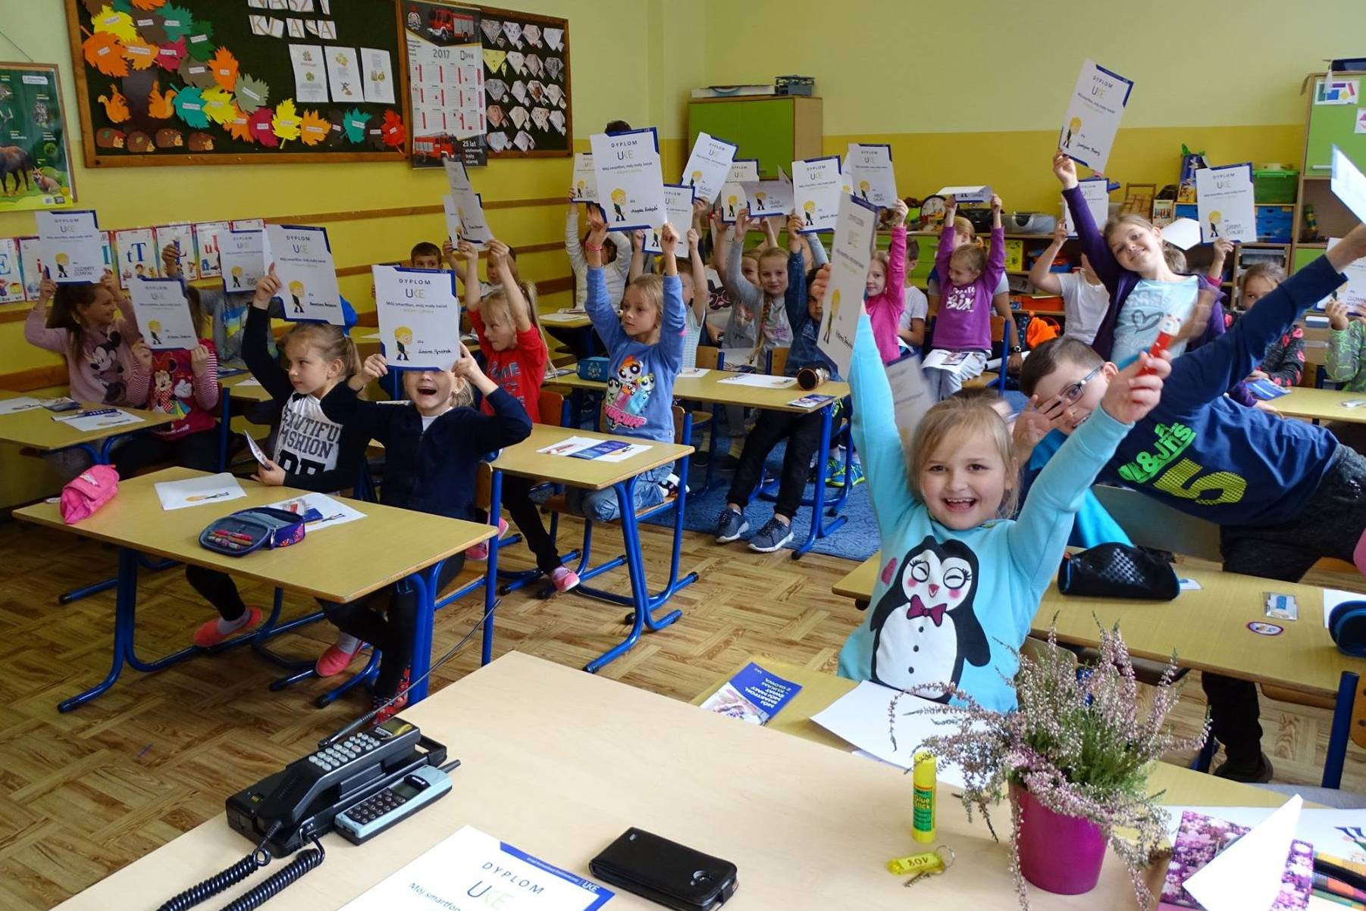
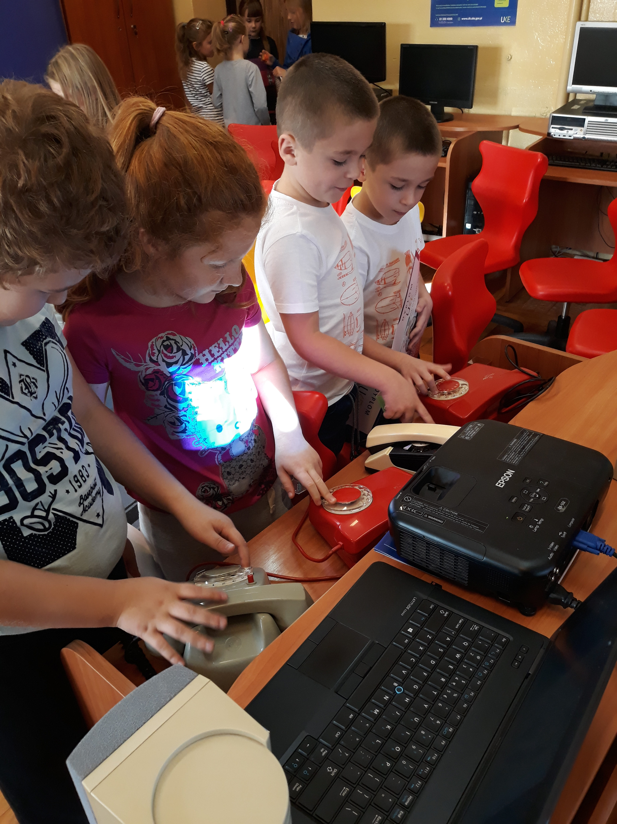

Report (in Polish) available here: https://fundacja.orange.pl/files/user_files/user_upload/badania/Rodzice_i_dzieci_wobec_zagrozen_dzieci_w_Internecie_23.09_AKv.pdf

