Plenipotentiary Conference (PP-18)  Dubai, 29 October – 16 November 2018 | 
PLENARY MEETING | Document 28-E
 | 22 May 2018
 | Original: Arabic/English
Note by the Secretary-General
CANDIDACY FOR THE POST OF MEMBER OF
THE RADIO REGULATIONS BOARD (RRB)
Further to the information published in Document 3, I have pleasure in transmitting to the Conference, in annex, the candidacy of:
Mr Tariq Alamri (Kingdom of Saudi Arabia))
for the post of member of the Radio Regulations Board.

Houlin ZHAO
Secretary-General

Annex: 1

ANNEX

Riyadh, 21 May 2018

To: | Secretary-General, ITU
From: | Communications and Information Technology Commission
Our ref.: | 10171

Dear Sir,

In reference to your letter CL-17/42 of 23 October 2017 regarding the Plenipotentiary Conference (PP-18) to be held in Dubai, United Arab Emirates, from 29 October to 16 November 2018, and the elections that will take place at the conference, including the election of members to the Radio Regulations Board (RRB), I wish to inform you that the Kingdom of Saudi Arabia has decided to run for a seat on RRB for Region E, Asia and Australasia, in the person of Mr Tariq Alamri.
Mr Alamri is currently the Director of the CITC International Frequency Coordination Division and has vast experience in the frequency spectrum field. He has comprehensive knowledge of the ITU Radio Regulations, Rules of Procedure and worldwide and regional frequency assignment and allocation plans.
The Kingdom of Saudi Arabia has every confidence that Mr Alamri will be a valuable addition to RRB, and will provide him with the necessary support to ensure that the Board succeeds in its work and achieves its goals.
Please find enclosed the curriculum vitae of the candidate of the Kingdom of Saudi Arabia.

Yours faithfully,

(signed)
Abdulaziz bin Salem Al Rwais
Governer of CITC

Bio of Tariq ALAMRI  Kingdom of Saudi Arabia's Candidate for the position of member of the ITU Radio Regulations Board (Region E) | 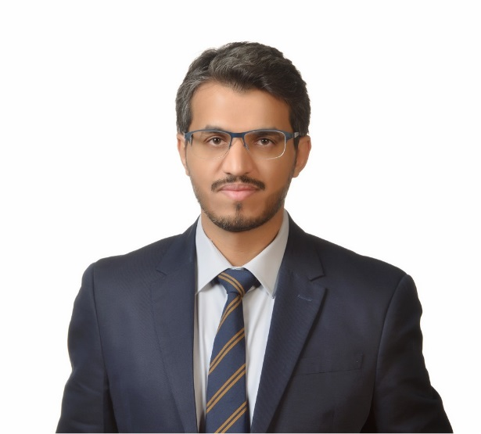
Saudi Arabia is a member of the ITU since 1949 and it has been providing support to the ITU to help it to achieve its mission and objectives. The RRB is an essential element of the ITU structure and its work has always been of critical importance in the context of constantly evolving and converging radio communications services. In recognition of this important role and the valuable objectives of the RRB, the Administration of Saudi Arabia is pleased to support its work by nominating Mr. Tariq ALAMRI to the position of RRB member.
Through his work in Saudi Arabia’s Communications and Information Technology Commission (CITC) for 15 years in the field of Spectrum Management, Mr. Tariq ALAMRI brings a rich practical experience of national regulatory activities and international cooperation involved in the assignment and utilization of frequencies for both terrestrial and satellite services. Mr. ALAMRI has a deep personal understanding of the importance of international collaboration and rule of law. He is particularly interested and personally committed to furthering of fairness and efficiency of the international planning and coordination process for utilization of radio frequencies and satellite orbital resources.
Eng. Tariq ALAMRI has been involved in many of the ITU activities, actively participated to numerous international conferences and meetings, such as at WRC, CPM, RA, RRC, ITU-R Study Group/Working Party levels, Arab Spectrum Management Group ASMG meetings. In addition, Eng. Tariq ALAMRI actively participated in Regional Radiocommunication Conference RRC-06 and to its related international and regional activities, in addition to the GCC meetings for transition plan from analogue to digital terrestrial broadcasting. He also actively participated in different FM coordination meetings with neighboring countries.
He is presently the CITC international frequency coordination department manager, responsible for all international frequency coordination for both terrestrial and space services, with comprehensive knowledge of the ITU Radio Regulations and rules of procedure, as well as ITU regional and worldwide frequency allotment and assignment plans, in addition to a range of ITU tools. Mr. ALAMRI has helped to develop the national frequency plan of Saudi Arabia, and its subsequent updating according to the WRC’s decisions. He has been involved in development of the media authority law in Saudi Arabia.
Eng. Tariq ALAMRI has a Master of Science in Telecommunications and Network Engineering, Southern Methodist University SMU, Dallas TX, USA, and he has Bachelor of Science in Electrical Engineering, King Fahd University of Petroleum and Minerals, Saudi Arabia.

