Council 2019
Geneva, 10–20 June 2019
Agenda item: ADM 18 | Document C19/7-E
 | 18 April 2019
 | Original: English
Report by the Secretary-General
Report on progress on
THE Union’s headquarters premises PROJECT

Summary
This document presents an update on the ITU HQ Premises Project. It elaborates progress since the final meeting of Council 2018 in Dubai.

Action required
The Council is invited to endorse the report and provide any further guidance as appropriate.
____________

References

Council Decision 588; Resolution 212 (Dubai, 2018); C18/123+Add 1

1 Background

1.1. Council 2016, through Decision 588, decided to replace the Varembé building by a new building that would also include the offices and facilities of the Tower building.

1.2. Council 2018 approved the establishment of a temporary fund (the “New Building Project Fund”) for the new building to be financed from budget implementation surpluses and donations.

1.3 Plenipotentiary Conference 2018, through Resolution 212, established that the above fund and any sponsorships or donations received could increase the financial envelope of the project, while Council Decision 588 remained in force.
2 Concept Design

2.1 The second message to the Host Country requires, inter alia, a concept design development to allow detailed project functional assessment against the programme, detailed cost assessment, and detailed planning authorization.

2.2 The architect has continued cost-optimizing the initial concept design that was delivered in October 2018. The candidate final version was delivered 1 April 2019.

2.3 This version has a total of ten floors: basement, lower ground (rue de Varembé side), upper ground (avenue Giuseppe Motta side), technical level, courtyard garden, and five upper office floors.

2.4 As a consequence of the elimination of one office floor from the original competition-winning design, the building height is lowered to 37.1m. ITU has received confirmation from the Council of the State and Republic of Geneva that the Local Zoning Plan need not be revised for this construction height, and that planning authorization consideration will follow the standard processes.

2.5 The new building is required to be compliant with UN-MOSS (minimum operational security standards) which applies to all UN Organizations’ buildings worldwide which are new or retro-fitted. In line with the recommendation of Council 2017, ITU has contacted the Host Country authorities to discuss threats and appropriate mitigation measures for the new building. A meeting on Threat Assessment and Security Concepts was arranged between ITU, UNDSS, the architects (CDTK), and representatives from the Host Country authorities (DFAE/FEDPOL) to share views and discuss concerns with regards to the security challenges.

2.6 In December 2018 and February 2019, a UNDSS Architect and a Blast Mitigation Expert from the Physical Security Unit in New York undertook a physical security assessment and inspection of the new building’s design and concept in relation to UN-MOSS security mitigation measures. The preliminary assessment report indicated the same concerns/challenges for the new building that were recognized by ITU secretariat, and which created risks that were unacceptable to UN-MOSS:
- insufficient vehicle stand-off distances from rue de Varembé;
- public car park entry/exit accesses from/to rue de Varembé passing under the building.

2.7 The formal report requested by ITU concurred as a best security practice with the initial concept strategy that has been designed by ITU and the architect, that of having two separate layers of perimeter security barriers, i.e. anti-vehicle barriers installed around the compound parcel as far as possible from the building to gain the maximum stand-off distance, and an anti-climb pedestrian barrier installed to channel unaccredited persons into a Screening/Accreditation Pavilion (for visitors and unaccredited delegates) which will be situated at the new entrance off the avenue Giuseppe Motta. The formal report has been shared with the Liaison Committee Security Working Group and with MSAG. The Deputy Secretary-General has written to the Swiss Ambassador to continue discussions with the Host Country authorities on incorporating appropriate mitigation measures, such as those proposed in the formal report.

2.8 Subsequent discussions within the Liaison Committee, with the Swiss Mission to International Organizations in Geneva, and with FIPOI indicate that Switzerland understands the collaboration, financial, and access issues of integrating a building secured to UN-MOSS requirements in a tight urban context, and is considering how best to achieve the result.
3 Management and Governance

3.1 The project governance has been clarified and the team reinforced as the work has grown, with the aim of avoiding duplication, ensuring sufficient visibility for all stakeholders, and minimizing the direct spend while retaining sufficient risk management. Valuable advice on this has been gratefully received from MSAG, IMAC, and the Host Country.

3.2 An updated organization chart is presented in Annex 1.
- the Steering Committee is composed of the ITU Elected Officials;
- the Liaison Committee and its operational groups form the link with the Host Country;
- the New Building Requirements Group contains focal points from the ITU business units.
4 Financing: PP Resolution 212, PP Decision 5

4.1 The 2018 Plenipotentiary Conference passed Resolution 212 (Dubai, 2018) concerning the Union’s future headquarters premises. This resolution replaces Resolution 194 (Busan, 2014).

4.2 The new resolution resolves:
- accordance with Council Decision 588 (2016), and with other relevant Council Decisions;
- that financing should primarily be from an interest-free loan over 50 years from the Swiss Confederation which should not exceed CHF 150 million, which can be supplemented by sponsorships and donations, and by the temporary fund established by Council’s 2018 ordinary session;
- that MSAG would continue meeting quarterly in general, reviewing progress and providing guidance, and that representatives of permanent missions in Geneva be provided with updates at information meetings at least twice a year.

4.3 In addition, Decision 5 (Rev. Dubai, 2018) instructs the Council:
“to authorize the Secretary-General, in the event that a surplus is achieved during the budget implementation, to allocate an appropriate amount to the New Building Project Fund to finance the costs that cannot legally be financed by the loan from the host country;”.

4.4 This means there are now the following funding sources:
- the loan from the Host Country (for items that are legally includable);
- sponsorships;
- donations;
- the New Building Project Fund established by Council 2018 (for items that are not legally includable in the loan).

4.5 It is proposed that CHF 6 million from savings in 2018 be allocated to the New Building Project Fund described above. A financing description is presented as Annex 2, including this allocation.
5 Sponsorships and Donations

5.1 As of April 2019, sponsorship of CHF 10 million and CHF 5 million has been generously committed by Saudi Arabia and the United Arab Emirates, respectively, and donations of USD 100’000 and CHF 40’000 have been generously contributed by the Czech Republic and Ghana.

5.2 Other sponsorship interest from Member States is currently being discussed. Member States and Sector Members are further encouraged to provide sponsorship and/or donations and to contact the Deputy Secretary-General for information if they have an interest.
6 Staff and External Resource

6.1 As well as the full-time Senior Construction Advisor (P5) as Project Manager, and the Senior Procurement Officer (P4) already in post, a division has been created within SGO to which two detachments have been made at 100%: Architecture and Engineering Coordinator (P3), senior assistant (G6). Other staff have project tasks as part of their existing responsibilities.

6.2 KPMG were engaged to provide a technical support consultancy until April 2019. An international procurement action was launched in November 2018 for the long-term project management, technical and risk support from April 2019 onwards, resulting in a recommendation which has been accepted by the Secretary-General. A contract is being negotiated with a provider of international renown who will be convoked to meetings of the Management Board and in particular the Requirements Subgroup.
7 Business Continuity During Demolition and Construction

7.1 ITU secretariat is working to avoid the need to rent temporary office accommodation during the transition period (between vacating the Varembé building and moving into the new building) by more efficient use of the space in the Tower and Montbrillant Buildings, and introduction of flexible working.

7.2 ITU secretariat is discussing the possible avoidance of renting meeting space during the period when the Tower and Montbrillant meetings rooms will not be usable due to the disruption caused by major works (during 2022-2023) through offers by Member States to host the meetings on the normal terms (covering the cost of ITU support staff travel and subsistence).
8 Time Line

8.1 A summarized project schedule is presented as milestones in Annex 3.

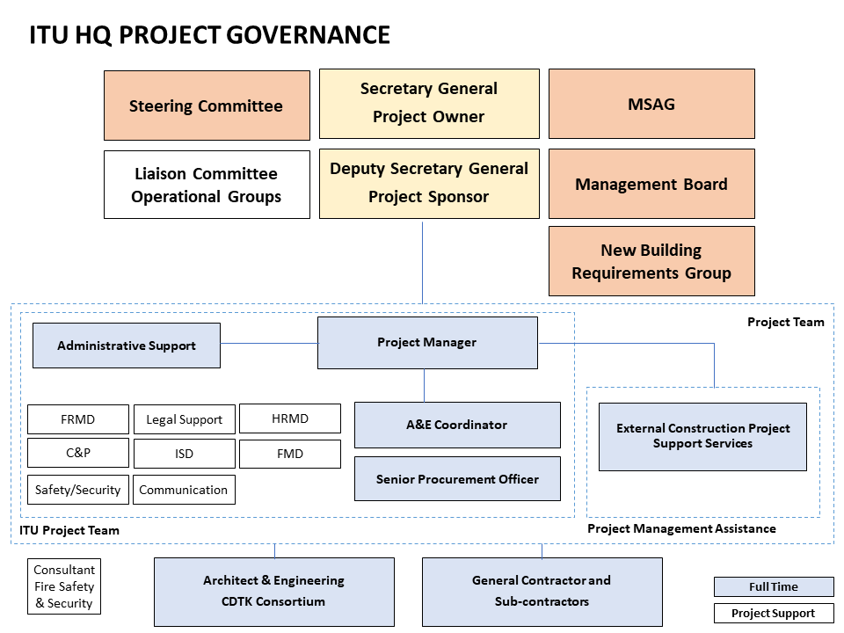
Annex 1:

Annex 2:
Financial Budgetary Details

Notes on the budgetary cost table overleaf
- Internal staff effort for the principal internal roles: senior construction project advisor (P5), architecture and engineering coordinator (P3), project assistant (G6), are financed from the regular budget. Separate from the premises project, cultural change work is financed from the regular budget.
- “includable in the loan” indicates that the items are legally includable, rather that the loan amount is guaranteed.
- The contingency of CHF 7 million is included.
- Sponsorships and donations amounting to CHF 15,140,000 are included. Further sponsorships and donations are expected.
- CHF 6 million is proposed to be allocated to the new building Fund from the surplus of the 2018 accounts of the regular budget. Council 2019 in invited to endorse this proposal. Savings in subsequent years may be possible, but are not guaranteed.
- Assuming the contingency (CHF 7 million) is fully used, the maximum estimated extra cost of UN-MOSS security (CHF 6 million) is required to be paid by ITU, that the new building fund has only the surplus of CHF 6 million from 2018, then CHF 26,442,000 would be required from further optimizations, further allocations to the new building fund, sponsorships and donations.
- Further optimizations continue to be researched.

Table: Financial detail, CFC categories: kCHF (April 2019).
Item | Cost (range) | Funding
P5, P3, G6 staff salary from ITU Budget | 4,840 | 4,840

Host Country Loan-includable Items
CFC 1-4 construction | 124,780
CFC4 Additional Safety & security for UN-MOSS | 3,000 to 6,000
CFC 5 Construction permit, taxes & insurances | 1,280
CFC 5 HQP competition | 722
CFC 5 External Support Services | 5,700
CFC 5 CDTK fees | 26,000
CFC 5 General contractor fees | 4,600
CFC 8 Staff relocation | 11,000
Total | 177,082 to 180,082
Host Country Loan |  | 147,000
Residual of loan-includable items to be funded | 30,082 to 33,082

additional non-includable items
CFC 8 Conference & meeting renting | 2,500
CFC 9 Movable furniture | 5,000
CFC 9 Active ICT | 7,000
Total to be funded outside loan before optimizations | 44,582 to 47,582

Other Funding
Donations and sponsorships agreed |  | 15,140
Dedicated Fund: Budget surplus 2018 |  | 6,000
residual funding needed: from further optimizations, further allocations to the new building fund from budgetary surpluses for the years 2019-2025, sponsorships and donations | 23,442 to 26,442

Annex 3:
FUTURE TIMELINE OF HQ PREMISES PROJECT
(Schedule is based upon deliverable
received from the architect 1 April 2019)

Completion of Pre-project delivery May 2019
Candidate Second message sent to FIPOI June 2019
Second message sent to Federal Chambers August 2019
Completion of dossier November 2019
Authorisation deposition August 2020
End of Authorisation Processes February 2021
Call for Expressions of Interest published January 2021
Shortlist established May 2021
Availability of Second Loan March 2021
Completion of detailed dossier for Call for Bids
Call for Bids published October 2021
Validation of decision May 2022
Enter contract with General Enterprise June 2022
Works open July 2022
Start dismantling Varembé building November 2022
End of major structural works September 2024
Reception of the Building June 2026

Subject to the approval of Council 2019

