Council 2019  Geneva, 10-20 June 2019 | 
Agenda item: PL 2.9 | Document C19/30-E
 | 10 May 2019
 | Original: English
Report by the Secretary-General
PREPARATIONS FOR THE
WORLD TELECOMMUNICATION DEVELOPMENT CONFERENCE 2021

Summary
Pursuant to No. 42 of the Convention, Council will be invited to fix the precise place and exact dates of the next world telecommunication development conference (WTDC) with the concurrence of the majority of the Member States.
This document informs the Council of the invitation received from the Government of the Federal Democratic Republic of Ethiopia to hold WTDC-21 in Addis Ababa (see Annex 1) and the proposed dates from 8 to 19 November 2021 (see Annex 2) and on the preparations for WTDC-21.

Action required
The Council is invited to decide on the place and dates of WTDC-21, subject to the concurrence of the majority of the Member States of the Union.
The Council is also invited to adopt the draft decision contained in Annex 3 to this document.
____________

References
No. 141 of the ITU Constitution, No. 42 of the ITU Convention, Chapter I of the General Rules of Conferences, Assemblies and Meetings of the Union and Resolution 77 (Rev. Dubai, 2018) and Resolution 111 (Rev. Busan, 2014)

1. Background
1.1 No. 141 of the ITU Constitution stipulates that there shall be a World Telecommunication Development Conference (WTDC) between two Plenipotentiary Conferences.
1.2 Resolution 77 (Rev. Dubai, 2018) of the Plenipotentiary Conference resolves that WTDC shall be held in the last quarter of 2021.
1.3 Resolution 111 (Rev. Busan, 2014) calls on the Union and its Member States to make every effort, as far as practicable, to ensure that the planned period of any ITU conference does not conflict with what may be considered a major religious period by a Member State.
1.4 No. 42 of the ITU Convention and Chapter I of the General Rules of Conferences, Assemblies and Meetings of the Union require, respectively, that, in the absence of a decision by the Plenipotentiary Conference, the precise place and the exact dates of a WTDC be approved by the Council with the concurrence of a majority of the Member States.
1.5 The ITU Secretary-General has received an invitation from the Government of the Federal Democratic Republic of Ethiopia for the hosting of WTDC-21 in Addis Ababa (see Annex 1) and the proposed dates from 8 to 19 November 2021 (see Annex 2). Consultations are under way in order to agree on the requirements for holding this conference outside Geneva.
2. Discussion at TDAG-19
2.1 The 24th meeting of Telecommunication Development Advisory Group (TDAG-19) took place from 3 to 5 April in Geneva. TDAG and its breakout session discussed preparations for WTDC-21 among other topics.
2.2 TDAG thanked Ethiopia for the kind and generous invitation and noted the importance of beginning to make concrete plans including decisions about regional preparatory meetings. Correspondence groups will begin in 2020.
2.3 Participants highlighted that during the previous WTDC the first three days were largely spent on policy statements. It was emphasized based on the experience of the last Plenipotentiary Conference that committees should start their meetings as soon as possible and preferably from day one of the conference, the policy statements could run in parallel with committee meetings. It was further suggested to consider organizing dialogue sessions/round tables one day prior to WTDC opening.
2.4 The discussions on Regional Preparatory meetings (RPMs) were focused on how these meetings could become more effective. There was general agreement that RPMs should be held back-to-back or together with other preparatory meetings organized by regional organizations. The group discussed as well that organizing informal inter-regional meetings could also facilitate discussion during WTDC, and suggested that this meeting(s) can be scheduled one day before the last TDAG prior to WTDC.
2.5 It was highlighted that there is a need to balance the work between committees (in particular committees 3 and 4), and also run committees in parallel as necessary. It was also suggested to engage more closely with other stakeholders, including academia and NGOs in the preparatory process.
2.6 The need to have a full understanding of the financial implications of conference proposals, including the regional initiatives, prior to their adoption was stressed.
3. Proposal
3.1 The Council is invited to consider the invitation of the Federal Democratic Republic of Ethiopia to hold WTDC-21 in Addis Ababa from 8 to 19 November 2021 and to decide on the precise place and exact dates of WTDC-21 by adopting the draft decision contained in Annex 3.
3.2 A consultation of ITU Member States will then be launched to secure their concurrence regarding the venue and the exact dates in accordance with No. 42 of the ITU Convention.
3. 3 The secretariat will undertake a mission to Ethiopia to assess various venues in Addis Ababa for the conference and report to the next Council session.
ANNEX 1
Invitation from the government of the Federal Democratic Republic of Ethiopia
to host WTDC-21
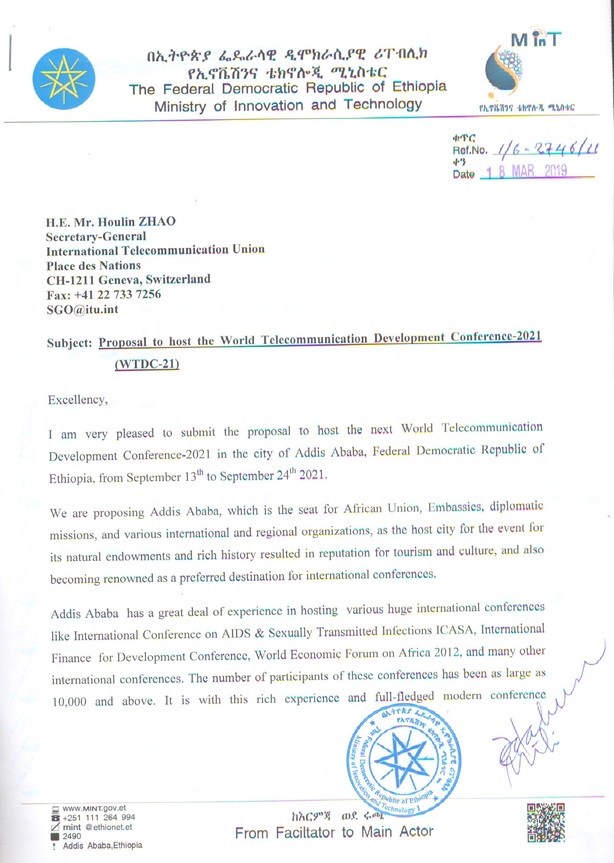

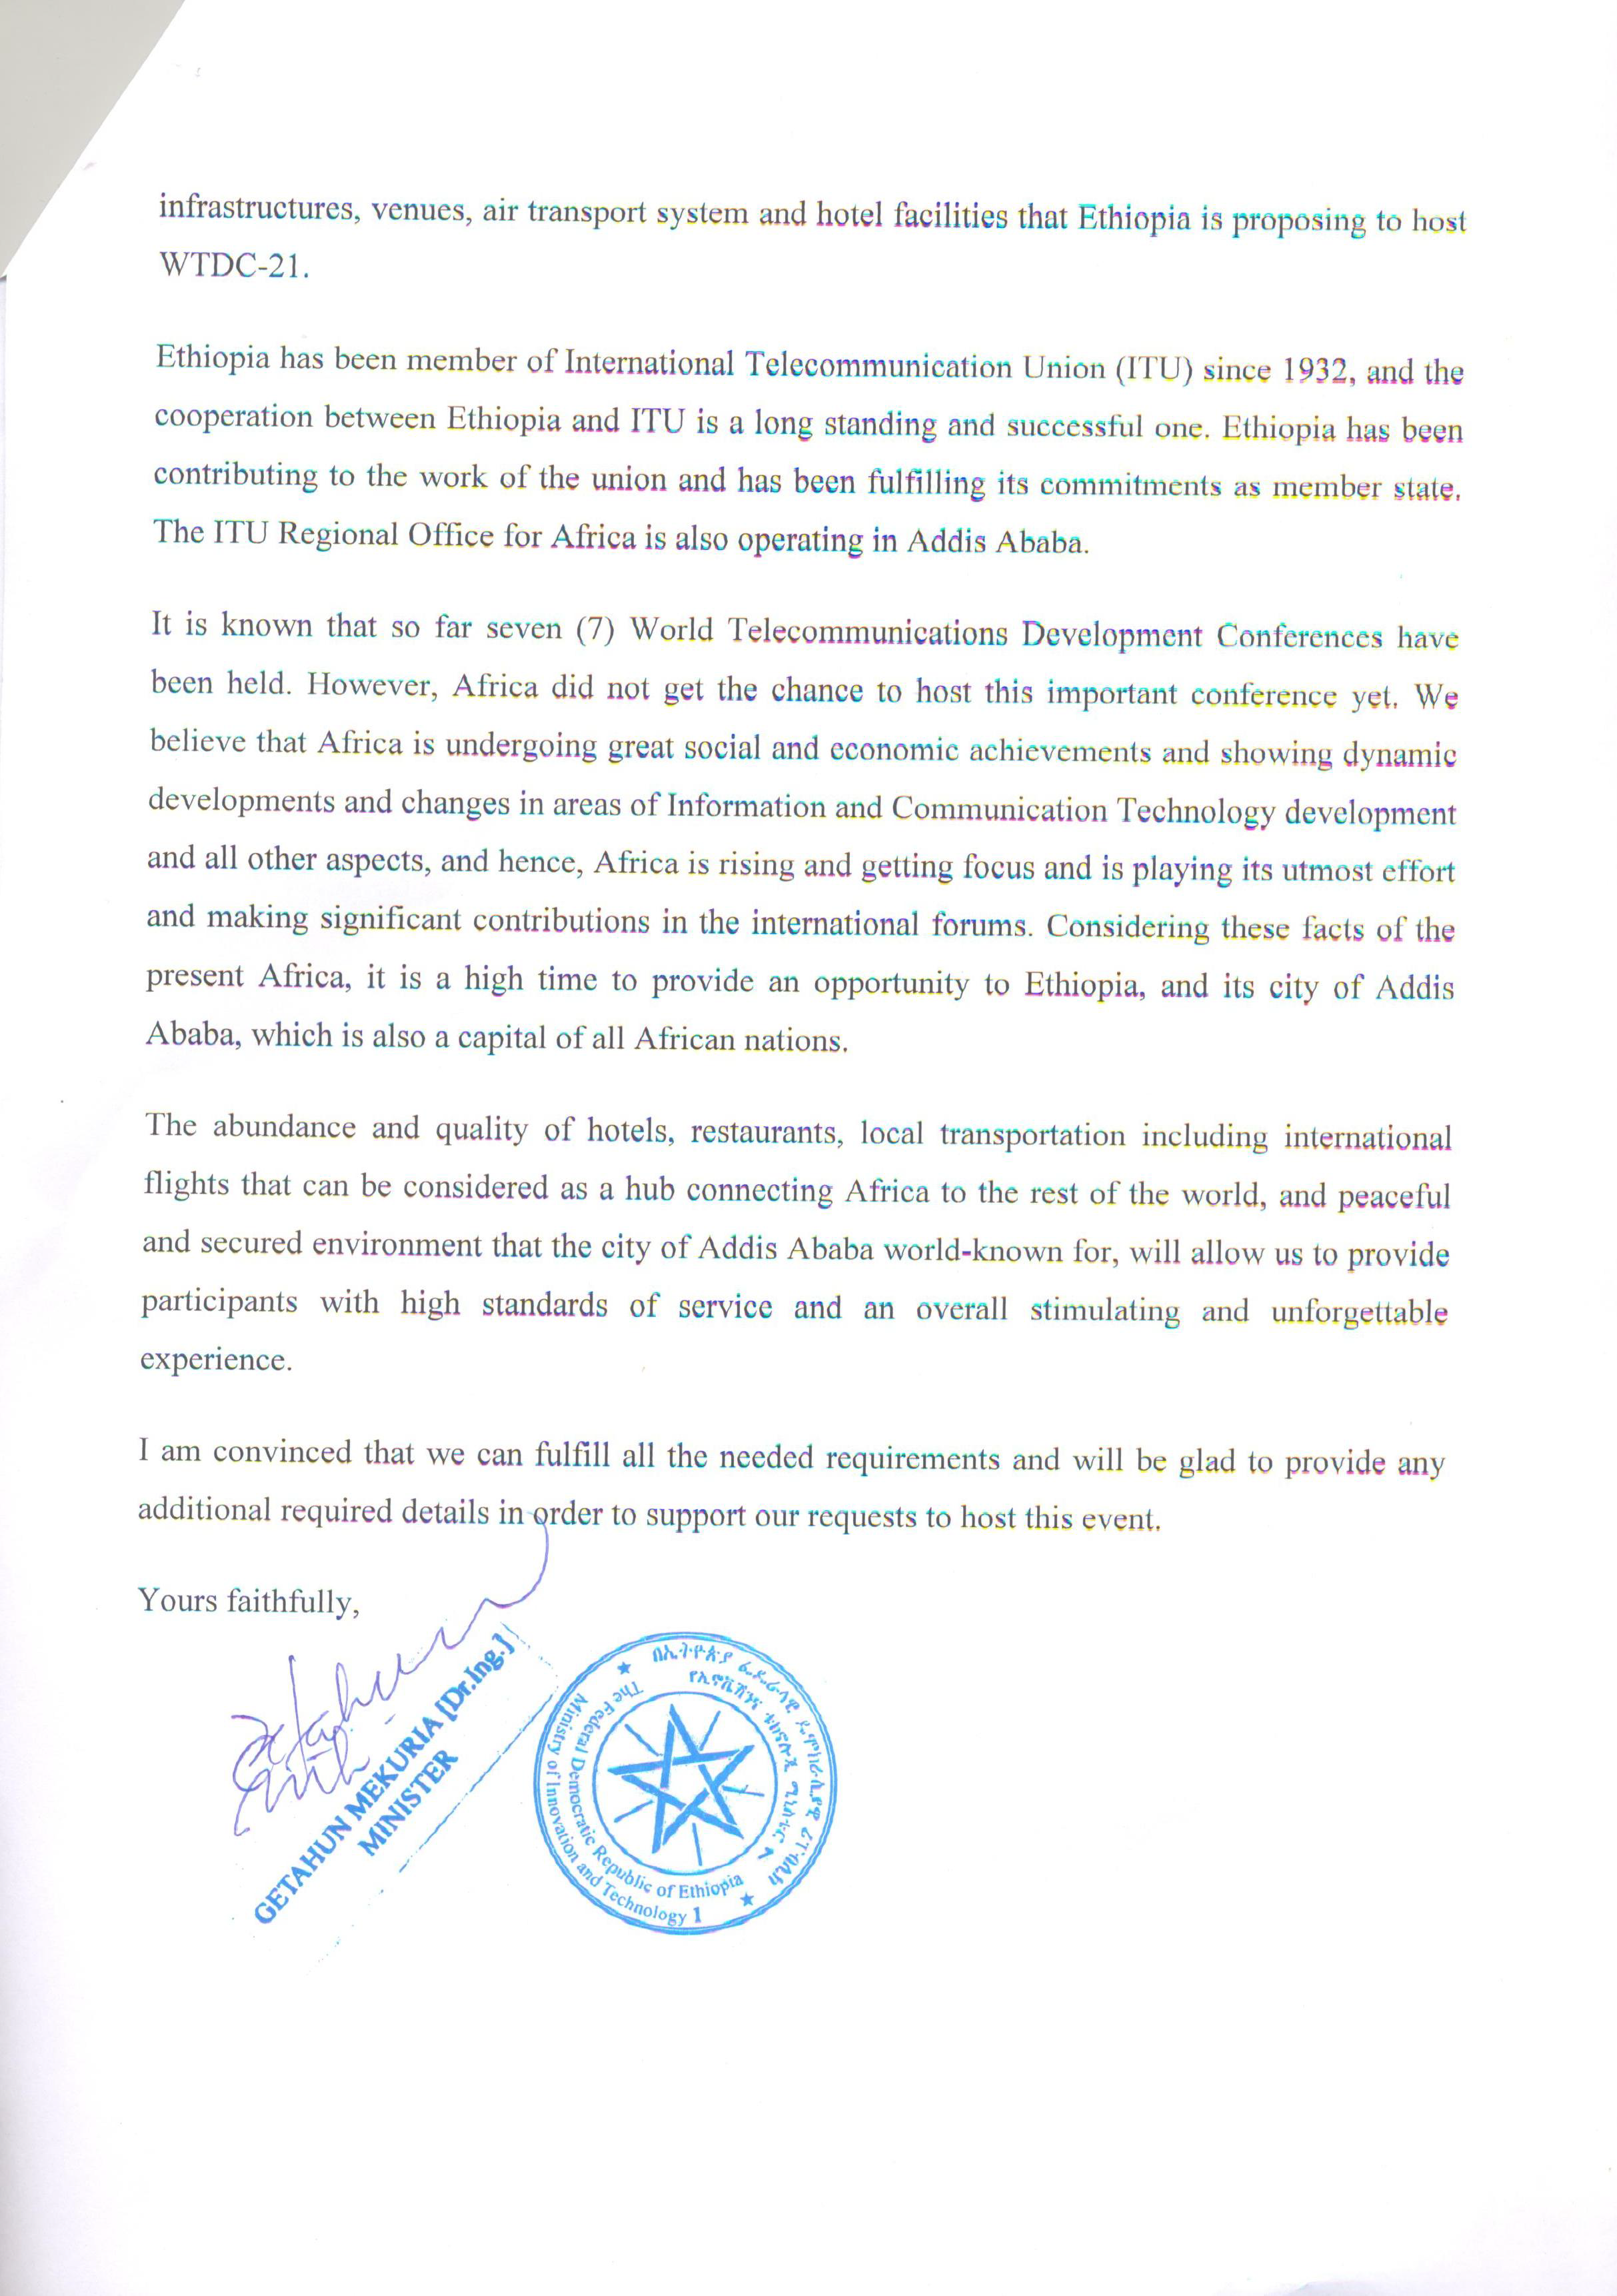
ANNEX 2
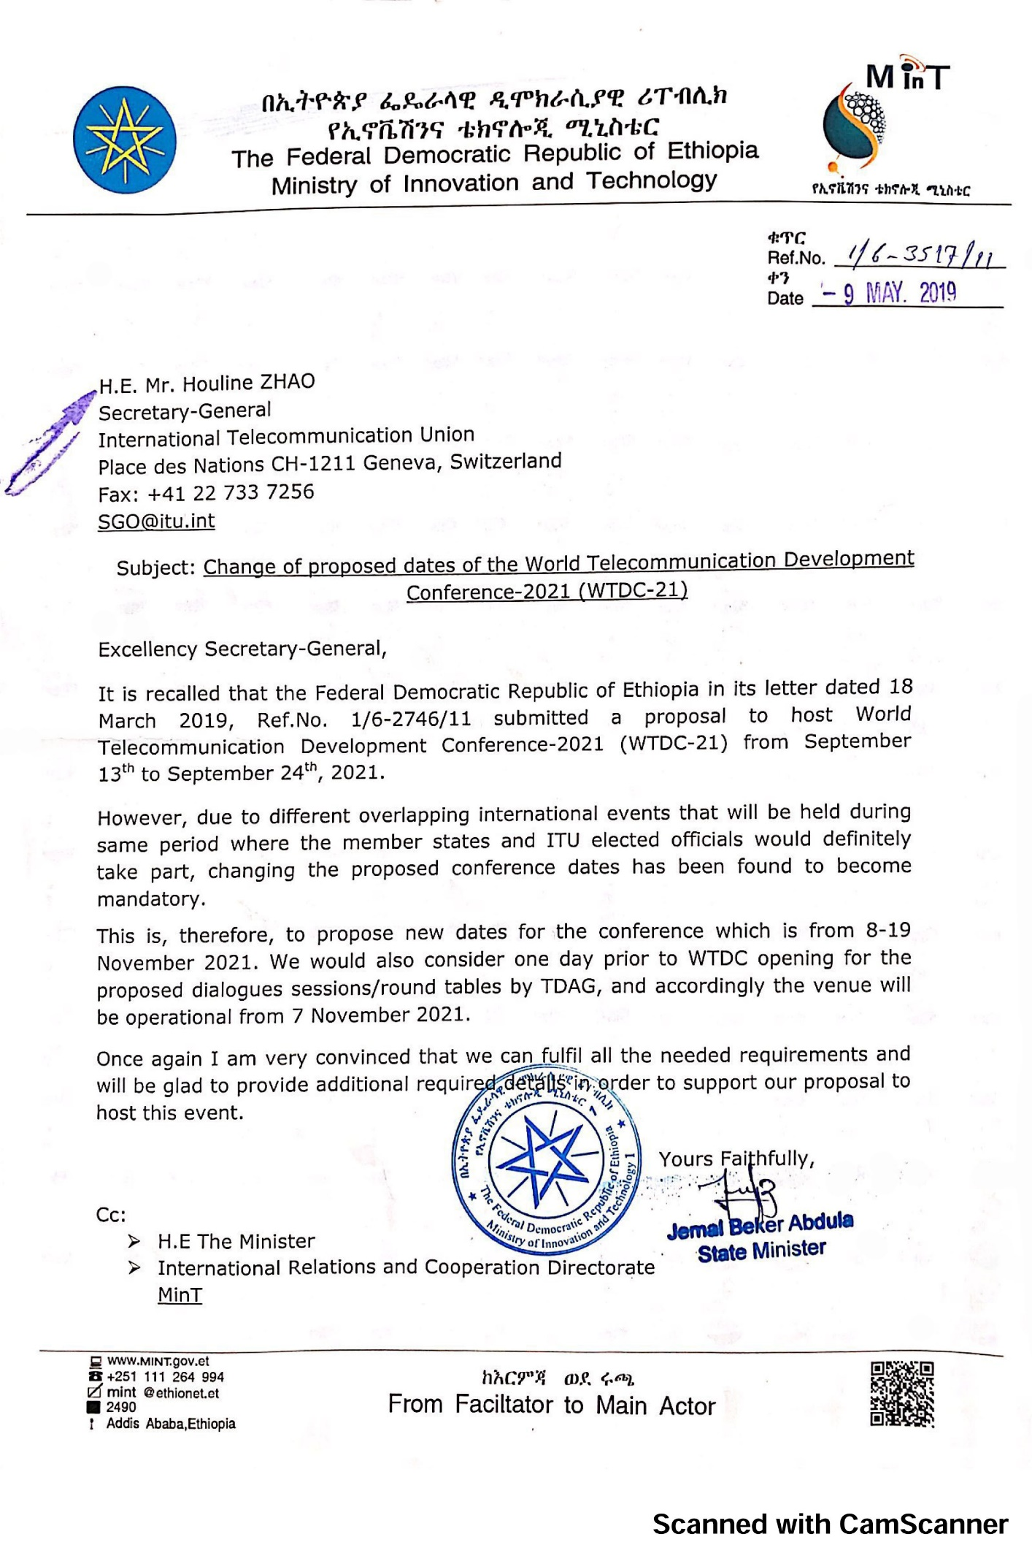
Invitation with revised proposed dates from the government of the Federal Democratic Republic of Ethiopia to host WTDC-21

ANNEX 3
DRAFT DECISION
Convening of the next World Telecommunication Development Conference (WTDC-21)
The Council,
noting
that WTDC-21 is scheduled to be held in the last quarter of 2021 in accordance with Resolution 77 (Rev. Dubai, 2018) (Scheduling and Duration of future conferences, forums, assemblies and Council sessions of the Union (2019-2023) ,
decides
that, subject to the concurrence of the majority of the Member States of the Union, the next World Telecommunication Development Conference (WTDC-21) will take place in Addis Ababa, Federal Democratic Republic of Ethiopia, from 8 to 19 November 2021,
instructs the Secretary-General
to undertake a site visit and report to the 2020 session of the Council.
______________

