Council 2019
Geneva, 10-20 June 2019
Agenda item: ADM 10 | Document C19/34
 | 13 February 2019
 | Original: English
Report by the Secretary-General
INFORMATION AND COMMUNICATION TECHNOLOGIES DEVELOPMENT FUND
(ICT-DF)

Summary
This document reports on the status of the Information and Communication Technologies Development Fund (ICT-DF) regarding its utilization for the implementation of development projects.

Action required
The Council is invited to take note of the report, and advise as deemed appropriate.
____________

References
PP Resolution 11 (Rev. Dubai, 2018); Council Resolutions 1111 and 1338.
1 Introduction
1.1 One of the functions of ITU, and the Telecommunication Development Sector (ITU-D) in particular, is to undertake the Union’s dual responsibility as a United Nations specialized agency and as an executing agency for implementing projects in accordance with the ITU Constitution.
1.2 The Information and Communication Technologies Development Fund (ICT-DF) is a special initiative launched in 1997 aiming to support the implementation of development projects leading to sustainable development based on multistakeholder partnerships entered into by ITU Member States, Sector Members, public and private sector, and multilateral organizations, foundations, financial institutions, and development agencies.
2 Main Rules and Procedures of ICT-DF
2.1 The ICT-DF is in principle used for seed funding, normally up to 25% of the total cost of a development project. The seed funding is meant to attract extra-budgetary funds raised through resource mobilization in-cash and in some cases, in-kind contributions for financing projects at national, regional, and international levels.
2.2 In accordance with this procedure, development project proposals including related contributions in-cash and in-kind can be submitted to the ICT-DF at bdtictdf@itu.int to be considered for ICT-DF financing.
2.3 Proposed development projects are administrated in compliance with the following selection and eligibility criteria, among others:
- The project beneficiary shall include one or more least developed countries (LDCs), small island developing states (SIDS), landlocked developing countries, countries with economies in transition and countries in special need.
- The project shall fall into one of the following categories/themes:
- Capacity Building
- Climate Change
- Cybersecurity
- Digital Inclusion
- Emergency Telecommunications
- ICT Applications
- Innovation
- Regulatory and Market Environment
- Statistics and Indicators
- Spectrum Management and Broadcasting
- Assistance to countries in special need
- Any other themes deemed important by the ICT-DF Steering Committee (ICT-DF SC).
2.4 Analysis and assessment of the project proposals to ensure their compliance with the selection/eligibility criteria is undertaken on a regular basis pending submission of such proposals to the ICT-DF SC.
2.5 The ICT-DF SC: a) reviews and approves the projects submitted for funding; b) approves the amount of funding to be allocated to the approved projects by the ICT-DF SC; and c) monitors the implementation and budgetary performance of the projects supported by the ICT-DF.
2.6 An annual report on the status of the ICT-DF and its funded projects approved by the ICT-DF SC is presented to ITU Council for advice and/or approval, as deemed appropriate.
3 Main Activities and Progress of ICT-DF
3.1 At its 52nd ICT-DF SC meeting held on 12 December 2017, the status of three projects approved by the 51st ICT-DF SC was reviewed and the assessment of 14 ongoing projects funded by the ICT-DF was done. The next ICT-DF SC meeting will be held upon receipt of new project proposals fulfilling the selection criteria.
Status of ICT-DF Projects
3.2 As of December 2018, ICT-DF projects were composed of 16 ongoing projects, with a total value of CHF 18,043,423 (External Cash 65%, ICT-DF 33% and Operational Plan Cash 2%). These projects are distributed on a region-by-region basis as shown in Fig. 1 with the values of the projects given for each region in Fig. 2, and being implemented in thematic areas as shown in Fig. 3. The following are some examples of projects under different thematic areas: the development of Broadband Wireless Network in Africa (Mali, Burkina Faso, Rwanda, Eswatini, Madagascar, and Djibouti), Connect Schools in Palestine, Rural Telecommunications Development in Least Developed Countries, Telemedicine in Zimbabwe, Regional Centre of ICT accessibility for persons with disabilities, Development of Satellite Communications Capacity, Monitoring of the Radio Spectrum in Cuba, Emergency Communications Solutions for the Pacific Islands, Increasing wireless broadband penetration through improved and harmonized spectrum utilization and regulations (PRIDA) in Africa and set-up IPv6 and IoT Expertise Centre, as a global project.
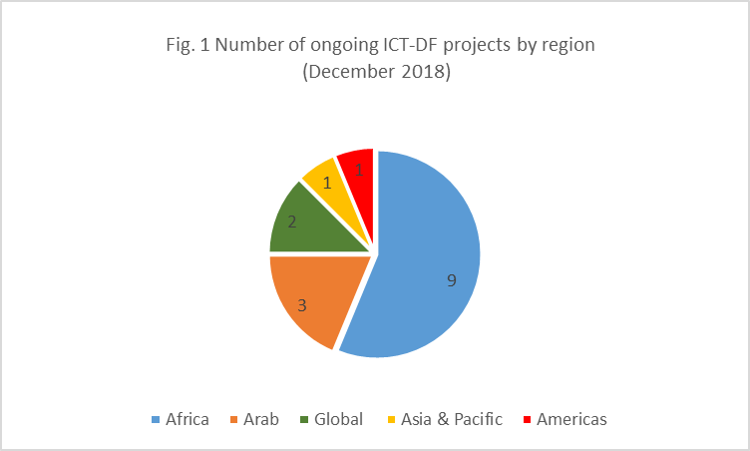

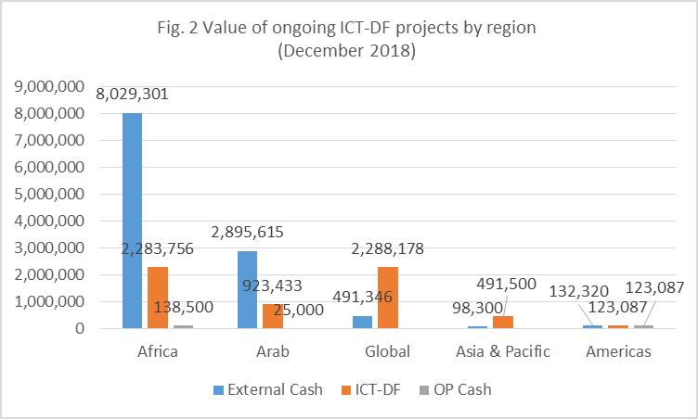
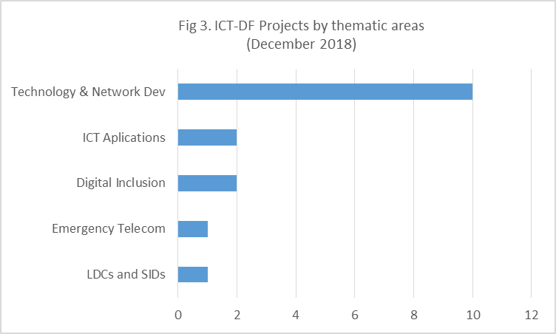
3.3 The 52nd ICT-DF SC advised to close the project(s), when appropriate, taking into account the status and duration of project implementation, and requested BDT to continue monitoring progress for the speedy implementation of these projects. The Steering Committee will continue to review project proposals and support selected projects in the various areas of action with special attention to regional initiatives approved by WTDC-17, taking into account the rules and criteria set by the ICT-DF Rules and Procedures and within the limit of the ICT-DF Capital Account.
4 Evolution of the ICT-DF Capital Accounts
4.1 Total interest income of ICT-DF Capital Account in 2018 was USD 72,468.
4.2 As of 31 December 2018, the remaining balance under ICT-DF Capital Account amounted to USD 4,375,147, while the Exhibition Working Capital Fund (EWCF) amounted to CHF 8,377,576.

4.3 It should be noted that the following ITU PP-18 Resolution 11 (Rev. Dubai, 2018) provisions may have an impact on the EWCF and in turn on the ICT-DF:
- Resolves (4): that the terms of reference, based on the contributions made by the ITU membership, for hiring the independent external management consultancy shall be submitted to the Council Working Group on Financial and Human Resources for approval, and the expenses for hiring the consultancy shall be covered by the Exhibition Working Capital Fund.
- Resolves (10): that the EWCF shall provide a minimum reserve of 5 million Swiss francs (CHF 5 000 000.)
5 Way forward
5.1 Progress on implementation of ICT-DF funded projects will be regularly analysed and updated at https://www.itu.int/en/ITU-D/Partners/Pages/ICT-DF/default.aspx.
5.2 Taking into account that the ICT-DF is demand-driven and seed funding in nature and principle, ICT-DF SC will continue to consider project proposals based on the rules and criteria while remaining within the limit of the ICT-DF Capital Account, in order to support the development of telecommunications/ICTs in ITU Member States and contribute to the Sustainable Development Goals.
5.3 In view of the relevant provisions of PP-18 Resolution 11 (Rev. Dubai, 2018) alluded to in 4.3 above, due consideration has to be given by the ICT-DF SC before considering new projects to be funded by the ICT-DF.
5.4 The Council is invited to take note of this report and advise as deemed appropriate.
__________________

These themes were adopted by the World Telecommunication Development Conference held in 2017 (WTDC-17).
ICT-DF SC is composed of the ITU Secretary-General (Chairman), the ITU Deputy Secretary-General and the Director of the BDT.

