Council 2019
Geneva, 10-20 June 2019
Agenda item: ADM 11 | Revision 1 to  Document C19/49-E
 | 5 June 2019
 | Original: English
Note by the Secretary-General
APPOINTMENT OF the members of the
Independent Management advisory committee (IMAC)

I have the honour to transmit to the Member States of the Council the report of the Selection Panel for the Independent Management Advisory Committee (IMAC).
Houlin ZHAO
Secretary-General

Report by the Selection Panel
Independent Management advisory committee (IMAC)

Summary
This report contains the outcome of the work of the Selection Panel for the appointment of IMAC members. It provides an overview of the selection process conducted in respect to the members of IMAC, and the recommendation of the selection panel for the appointment of the best qualified candidates to IMAC.

Action required
The Council is invited to note the content of this report and to adopt the draft Decision contained in Annex C of this report for the appointment of the members of IMAC.
____________

References
Resolution 162 (Rev. Busan, 2014)
- REPORT OF THE SELECTION PANEL FOR THE APPOINTMENT OF THE MEMBERS OF THE ITU INDEPENDENT MANAGEMENT ADVISORY COMMITTEE (IMAC)
THE PROCESS
- The process for the selection of the IMAC members was conducted in accordance with the procedures set out in the Annex to Resolution 162 (Rev. Busan, 2014), following the timeline presented to Member States during the Council Working Group on Financial and Human Resources (CWG-FHR 9/6) in January 2019. The process was also similar to the process followed for the appointment of the IMAC members in 2015 (Council Doc. C15/75).
- In response to the invitation by the Secretary-General to ITU Council Member States in January 2019, the ITU Council Member States nominated their representatives for the composition of the Selection Panel. The following members were nominated:
 | Region | Country | Member of the Selection Panel
A. | Americas | United States | Ms Birgitta Hoggren, Chair
B. | Europe | Italy | Mr Fabio Bigi
C. | CIS | Russian Federation | Prof. (Ms) Natalia Reznikova
D. | Africa | South Africa | Mr Silulami Doyi
E. | Asia/Australasia | Japan | Mr Yoshiyuki Kato
 | The Arab States | Kuwait | Eng. (Ms) Sameera Bilal Momen
- In accordance with the procedure set out in the IMAC Terms of Reference (ToR), the ITU secretariat invited applications for the new members of IMAC via the following methods:
- through a letter from the Secretary-General to all ITU Member States, requesting the latter to consider forwarding applications from interested candidates;
- through placement of an open advertisement on the ITU website;
- through placement of open advertisements in external publications, namely:
  - The Economist;
  - Arabian Business;
  - Rossiyskaya Gazeta;
  - Jeune Afrique.
The call for expressions of interest was also communicated to other UN agencies via the UN System Chief Executives Board for Coordination (CEB) and tweeted from the ITU account.
- For the assessment of the applications, the Selection Panel used a detailed Evaluation Matrix against which candidates were evaluated. This matrix addressed all of the requisite elements set out in the IMAC ToR that the Selection Panel was required to take into consideration in its assessment of candidates, including professional experience, areas of expertise, public/private sector experience, UN experience, independence, nationality, gender and ITU region.
- Fifty-four (54) applications were received and eligible (compared to thirty-six (36) applications in 2015), including the two current IMAC members who are eligible for reappointment. The table below shows the distribution of candidatures:
Region (group) | Female | Male | Total
A - Americas | 7 | 8 | 15
B - Europe | 3 | 16 | 19
C - CIS | - | 2 | 2
D - Africa | 2 | 3 | 5
E - Asia/Australasia | 2 | 7 | 9
The Arab States | - | 4 | 4
Total | 14 | 40 | 54
- The Selection Panel met to assess the applications resulting in a shortlist of 15 candidates for the five posts in IMAC.
- Interviews were conducted on the basis of standardized interview questions prepared by the Selection Panel with the assistance of the ITU secretariat, and with a view to assessing the qualifications, experience, availability, commitment, professionalism, integrity, and independence of the candidates.
- On the basis of the assessment of each candidate’s application and interviews, the Selection Panel identified the five candidates that it considered best met the requirements of the IMAC ToR. The candidates are recommended on the basis of their professional competency and integrity as required by the IMAC ToR to be of paramount consideration in the selection of members (Res. 162 (Rev. Busan, 2014) – paragraph 9).
- Due consideration was also given to the other requirements of the IMAC ToR (i.e. paragraphs 10 to 14), which state that no two members of the IMAC shall be from the same ITU Member State, and to the greatest extent possible, no more than one member of the IMAC shall be from the same geographical region, and membership shall be balanced with individuals from developed and developing countries, public/private sector experience, and gender. There was also a further requirement that at least one member of the IMAC be selected on the basis of his/her qualifications and experience as a senior oversight professional or senior financial manager, preferably in the UN system or in another international organization.
- In recommending members of the IMAC, the Selection Panel also had to ensure that IMAC members collectively possessed knowledge, skills, and senior-level experience in a number of areas including finance and audit, organization governance, risk management, law, senior-level management, management of UN or other international organizations, and a general understanding of the telecommunication/ICT industry.
- RECOMMENDATION OF THE SELECTION PANEL FOR THE APPOINTMENT OF THE ITU INDEPENDENT MANAGEMENT ADVISORY COMMITTEE (IMAC)
- On the basis of the above process, the Selection Panel unanimously agreed to recommend to the ITU Council the following five candidates for membership of the IMAC:
(a) Ms HAMMER Sarah, a national of United States (current member, eligible for reappointment),
(b) Mr NARUKAVNIKOV Alexander, a national of Russian Federation,
(c) Mr NDOKO Honore, a national of Cameroon,
(d) Mr SCHNEIDER Henrique, a national of Switzerland,
(e) Mr VIKAMSKEY Kamlesh, a national of India (current member, eligible for reappointment).
- The Selection Panel recommends to the ITU Council that when an offer of appointment is made to the candidates listed above, independence and availability be emphasized as essential attributes of the functions of a member of the IMAC.
- In accordance with the requirement of paragraph d) of Appendix B to the IMAC ToR, details for each of the recommended candidates (gender, nationality, qualifications, and professional experience) are set out in Annex B.
- In accordance with paragraph f) of Appendix B to the IMAC ToR, the Selection Panel also agreed following the interviews that the details of three (3) candidates be retained on file in the event there is a need to fill a vacancy arising during the term of the IMAC. This pool of three candidates has been transmitted to the secretariat for future use.
Annexes: 3

Annex A
IMAC Selection Panel 2019 in numbers
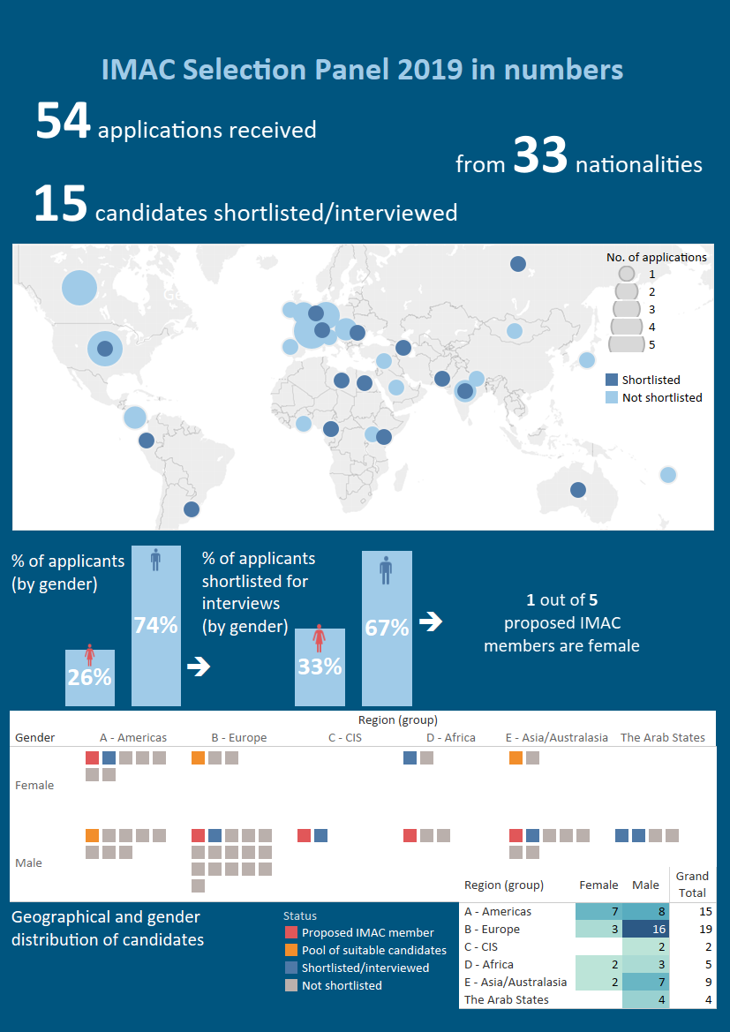

Annex B
Proposed Candidates for Appointment at IMAC
Family Name(s) | Gender | Nationality | Qualifications | Professional Experience
HAMMER, Sarah  (current member of IMAC eligible for reappointment) | Female | United States of America | - Doctor of Jurisprudence, Financial Regulation and Taxation  - Master of Studies, International Law and Human Rights  - Master of Business Administration, Finance and Statistics  - Bachelor on Political Science  - Certifications: Strategic Decision Making and Risk Management – Stanford University; Big Data Analytics – Massachusetts Institute of Technology | - Finance, law, risk management, governance, and technological innovation  - Adjunct Professor of Law at the University of Pennsylvania Law School  - Senior Director of the Alternative Investments Initiative at the Wharton School of the University of Pennsylvania  - Faculty Director of the Wharton-Lauder International Venture on Entrepreneurship  - Executive Education Instructor on Blockchain and Financial Technology
NARUKAVNIKOV Alexander | Male | Russian Federation | - PhD of Economic Science (Economics)  - Bachelor Degree in Economics and Enterprise Management, and Management | - 21 years of professional experience in economics and finance  - Director of the Department of Audit of Digital Development, Communications and Mass Communications at the Accounts Chamber of the Russian Federation  - Member of the INTOSAI Working Group on IT Audit
NDOKO Honore | Male | Cameroon | - Master on Economics, Systems and Structures  - Bachelor Degree in Economics and Law  - Certification of Expertise in Accounts | - 40 years of combined experience and expertise in auditing, monitoring evaluation and broad oversight; managerial and financial leadership; and extensive teaching experience in auditing, internal controls, compliance and fraud prevention  - Chief Administrative Officer of the World Bank for Europe, Central Asia, Middle East, North Africa and Japan  - Member of the UNHCR Independent Audit and Advisory Committee (IAOC)
SCHNEIDER, Henrique | Male | Switzerland | - PhD in Philosophy, University of Graz  - Magister Artium, Economics and Philosophy  - Bachelor of Trade and Commerce  - Bachelor of Theology | - 20 years of professional experience in economic analysis, accounting and risk management systems  - Deputy CEO & Chief Economist (Executive level, Member of the Executive Board) of the Swiss Federation of Small and Medium Enterprises of Switzerland  - Professor of Economics and Philosophy of Economics (University of Applied Sciences, Elmshorn, Germany)  - Member of several non-executive boards  - Author of several books and peer-reviewed book chapters and journal articles
VIKAMSEY, Kamlesh  (current member of IMAC eligible for reappointment) | Male | India | - Chartered Accountant, Bachelor of Commerce | - 36 years of experience as public accountant (Chartered Accountant since 1982)  - Senior Partner at KHIMJI KUNVERJI & CO.  - Chairperson of the Audit Advisory Committee of United Nations Children’s Fund (UNICEF)  - Member of the Audit Committee of World Meteorological Organization (WMO)  - Independent Director and Trustee of several organizations

Annex C
Draft Council Decision for appointment of IMAC members
DRAFT DECISION
Appointment of members to the
Independent Management Advisory Committee (IMAC)
The Council,
considering
the report of the IMAC Selection Panel for the appointment of members to the IMAC,
taking into account
the terms of reference of the IMAC contained in the Annex to Resolution 162 (Rev. Busan, 2014),
decides
1 to appoint the following five independent experts as members of the IMAC, to serve as from 1 January 2020 for a term of four years:
(a) Ms HAMMER Sarah, a national of United States of America;
(b) Mr NARUKAVNIKOV Alexander, a national of Russian Federation;
(c) Mr NDOKO Honore, a national of Cameroon;
(d) Mr SCHNEIDER Henrique, a national of Switzerland;
(e) Mr VIKAMSKEY Kamlesh, a national of India.
2 to note that the Selection Panel has transmitted to ITU secretariat the names of three (3) qualified candidates in the event there is a need to fill a vacancy arising during the term of IMAC.

____________________

The Selection Panel revised its recommendation to Council and submitted Revision 1 to Doc.C19/49, following further consideration of the requirements in paragraph 15 of the IMAC ToR which provides that IMAC members … “shall be free of any real or perceived conflict of interest” and paragraph 16 b) thereof, in particular related to the provision that members of IMAC shall not currently be employed or engaged in any capacity by a Member State delegation.

