|  |  |
| --- | --- |
| **Council 2020 Geneva, 9-19 June 2020** |  |
|  |  |
|  |  |
|  | **Document C20/INF/7-E** |
| **20 April 2020** |
| **English only** |
| Note by the Secretariat | |
| THE EXTENSIVE USE OF ICT LEADS TO NEW ACTIVITIES, NEW COMMUNITIES, A NET INCREASE IN ITU-T MEMBERSHIP, NEW ICT TOOLS, AND MORE MEETINGS | |

|  |
| --- |
| Summary  Information and communication technologies have become pervasive in all areas of life. This has led to new activities in ITU-T, with new communities joining as members. The ITU Standardization Sector has seen a significant increase in new members. New ICT tools are requested and provided by TSB.  Action required  This report is transmitted to the Council **for information**. It gives background information to Council Document 20/14.  ____________  References  [*Document C20/14*](http://www.itu.int/md/S20-CL-C-0014) |

Contents

1 Summary 2

2 New and growing areas of work in ITU-T 2

3 ITU-T membership has grown since 2016 4

4 ITU Services and tools 5

5 Communications 7

Annex 1: New ITU-T Sector Members and Associates in 2018 8

Annex 2: New ITU-T Sector Members and Associates in 2019 8

Annex 3: Examples of non-traditional members participating in ITU-T 9

Annex 4: ITU Services and Tools 11

Annex 5: Increase growth of companies applying for INRs 13

# 1 Summary

1.1 Telecom/ICTs Infrastructures have become an indispensable lifeline of our society, and digital applications such as “e-services” are pervading all areas of work and life. All industry sectors make use of ICTs. This trend of the growing intersection between ICTs and various industries is also reflected in the work programme with new activities, leading in turn to an widen the scope of the ITU-T and increase in ITU-T membership.

1.2 There has been a net increase in ITU-T Sector Members and ITU-T Associates in 2017, 2018 (0 for Sector Members) and 2019.

* New ITU-T Sector Members:
  + in 2018: 14 (net increase: 0)
  + in 2019: 20 (net increase: +11)
* New ITU-T Associates
  + In 2018: 31 (net increase: +20)
  + In 2019: 34 (net increase: +27)

1.3 The bottom of income from ITU-T Sector Members and ITU-T Associates was reached in 2017. The increase in income in 2019 compared to 2017 is about 200 kCHF from ITU-T Sector Members and about 450 kCHF for ITU-T Associates.

1.4 As the ITU-T membership has expanded, TSB continues to experience a significant increase in requests for services and support to the various activities of ITU-T. For example, the number of electronic meetings organized by TSB staff has almost doubled in the last two years, from around 1100 in 2017 to around 1900 in 2019. Using advanced technologies, TSB continues to improve its existing services, as well as alleviate some the increasing and manual labour that they will be experiencing.

# 2 New and growing areas of work in ITU-T

2.1 While ITU-T has had for a considerable time study groups (today: 11), the World Telecommunication Standardization Assembly including Regional Preparatory Meetings and TSAG, and for some time also Focus Groups (in 2019: 8); Regional Groups (today: 23); Joint Coordination Activities (JCA; in 2019: 6); IPR ad hoc group; CTO meetings (about 3 per year); workshops (often back-to-back with meetings of regional groups, focus groups, sometimes study groups), new activities were added over the last years such as:

- CxO (Chief [x] Officer) meeting (1 per year);

- Study Group Leadership Assembly (once every two years);

- Bridging the Standardization Gap workshops

- Green Standards Week

- Financial Inclusion Global Initiative (FIGI)

- Smart ABC @ ITU Telecom

- Digital African Week

- Future Networked Car/ C-ITS (Collaboration on ITS Communication Standards)

- Kaleidoscope (academic conference);

- Smart City KPIs and United for Smart Sustainable Cities (U4SSC)

- ITU Technical Journal

- AI for Good Global Summit

2.2 The number of meetings, participants and documents is displayed in Table 1.

|  |  |
| --- | --- |
| **Variable** | **Per year, rounded** |
| Events: number of study group meetings | 20 |
| Events: number of workshops (often back-to-back with study groups) | 50 |
| Events: number of regional group meetings | 20 |
| Events: number of focus group meetings | 20 |
| Events: number of BSG (Bridging the Standardization Gap) meetings | 10 |
| Participants in study groups + TSAG | 2000-2500 |
| Participants in Rapporteur group meetings | 1000 |
| Participants in regional group meetings | 400 |
| Participants in BSG meetings | 350 |
| Participants in workshops/events | 6000-9000 |
| Documents: Contributions to study groups | 2200 |
| Documents: TDs to study groups | 5000 |
|  |  |

Table 1: Number of events, participants and documents per year. Figures are 2019 or an average over 2017-2019, or a range 2017-2019.

2.3 The number of E-meetings/conference calls has exploded over the last three years (Table 2).

|  |  |  |  |  |  |
| --- | --- | --- | --- | --- | --- |
| 2017 | | 2018 | | 2019 | |
| Meetings | Participants | Meetings | Participants | Meetings | Participants |
| ~1100 | ~6000 | ~1500 | ~8300 | ~1900 | ~10500 |

Table 2: Number of E-meetings/conference calls and participation since 2017.

2.4 Some of the traditional areas have also seen a surge in demand. Of the about twenty types of International Numbering Resources (INRs) that ITU assigns, there has been an increasing number of companies applying for shared codes (E.212 and E.164). Annex 5 shows the increase growth of companies applying for INRs.

# 3 ITU-T membership has grown since 2016

## 3.1 New communities increase diversity of ITU-T membership

3.1.1 As new areas of work are started in ITU-T, ITU-T’s membership is becoming more diverse as non-traditional segments of the ICT industry pursue standards development activities in various emerging topics. In addition to new players from the ICT industry, ITU-T has seen an influx of new members from various verticals such as the automotive sector, unmanned aerial vehicle (UAV) manufacturers, and utility and energy providers. There is also a strong increase in the growth of companies applying for International Numbering Resources (INRs). Annex 3 gives examples of non-traditional members participating in ITU-T.

## 3.2 The growth of ITU-T Sector Members and Associates between 2016 and 2019

3.2.1 ITU-T’s membership is experiencing significant growth and has achieved a combined **net increase** of 71 Sector Members and Associates between 2017 and 2019 (net increase in Sector Members: +15; net increase in Associates: +56), which represents an increase of almost 19% during this period. This overall growth in membership is particularly notable, considering that ITU-T usually experiences a large member churn rate per year. In 2019 alone, 20 Sector Members and 34 Associates joined ITU-T, amounting to a net increase of 38 members for the year. ITU-T’s sharp growth in membership is being fuelled by wider changes in the ICT industry and by TSB’s proactive approach to member recruitment and retention.

3.2.2 The overall number of new Sector Members and Associates that have joined ITU-T over the last two years is unprecedented. Annex 1 and Annex 2 contains the new members for 2018 and 2019, respectively.

3.2.3 Table 3 show the total number of ITU-T Sector Members and ITU-T Associates over the last four years; Figure 1 the new admissions and Figure 2 the net increase over the same period.

|  |  |  |  |  |  |
| --- | --- | --- | --- | --- | --- |
|  | 2016 | 2017 | 2018 | 2019 |  |
| Sector Members  *(-Withdrawn +New)* | 253  (-17 +5) | 257  (-5 +9) | 257  (-14+14) | 268  (-9 +20) |  |
| Associates  *(-Withdrawn +New)* | 128  (-21 +21) | 137  (-12 +21) | 157  (-11 +31) | 184  (-7 +34) |  |
| Combined Totals  *(Net increase)* | **381**  **-12** | **394**  **+13** | **414**  **+20** | **452**  **+38** |  |

Table 3: The total number of ITU-T Sector Members and ITU-T Associates from 2016 to 2019

Figure 1: New ITU-T Sector Member and Associate admissions between 2016 and 2019

Figure 2: Net increase of ITU-T Sector Members and Associates between 2016 and 2019

# 4 ITU Services and tools

4.1 ICTs have expanded enormously in the past decade to the point where they now play a pivotal role in the automation of tasks, in-depth decision making and recording and tracking of information in secured and reliable manner. Using advanced technologies, TSB can maintain and improve its existing services, as well as alleviate some the increasing and manual labour that they will be experiencing. Requests for new services and support from TSB has increased significantly. For example, the number of electronic meetings organized by TSB staff has almost doubled in the last two years, from 1072 in 2017 to 1878 in 2019. To address the increasing demands of the Sector, it is important for TSB to have the necessary and qualified resources to support the development and maintenance of the IT tools and services that are essential to the work of the Sector.

4.2 Below please find a list of existing ITU-T tools and services provided by TSB. Details can be found in Annex 4.

1. ITU-T databases
   1. [ITU-T Work Programme](http://www.itu.int/ITU-T/workprog)
   2. [ITU-T A.4, A.5 and A.6 recognized organizations](https://www.itu.int/en/ITU-T/extcoop/Pages/sdo.aspx)
   3. [ITU-T AAP](https://www.itu.int/ITU-T/aap/AAPSearch.aspx) & [TAP](https://www.itu.int/net/ITU-T/lists/t-approval.aspx)
   4. [ITU-T Recommendations](http://www.itu.int/itu-t/recommendations)
   5. [ITU-T Liaison Statements](http://www.itu.int/net/itu-t/ls/)
   6. [ITU-T Patents and Software Copyrights](http://www.itu.int/ipr/)
   7. [ITU Product Conformity Database](http://www.itu.int/net/itu-t/cdb/ConformityDB.aspx)
   8. [ITU-T Formal descriptions and Object identifiers](http://www.itu.int/ITU-T/formal-language/index.html)
   9. [ITU-T Test Signals](http://www.itu.int/net/itu-t/sigdb/menu.htm)
   10. [ITU-T Terms & Definitions](http://www.itu.int/ITU-R/go/terminology-database)
   11. [International Numbering Resources](http://www.itu.int/ITU-T/inr/index.html)
   12. [ITS Communication Standards database](https://www.itu.int/net4/ITU-T/landscape#?topic=0.131&workgroup=1&searchValue=&page=1&sort=Revelance) (from CITS)
   13. [ICT standards landscape](https://www.itu.int/en/ITU-T/studygroups/com17/ict/Pages/default.aspx) (from SG17)
2. ITU-T MyWorkspace
   1. Remote participation service frequently used by study groups, based on an open-source tool
   2. Neural-net based machine translation prototype for documents in the six official languages (including formatting)
   3. ITU-T experts directory
   4. Chat service for real-time communication
   5. Meeting documents with the option to bookmark favourites
   6. Mailing list subscriptions
   7. Calendar of ITU-T events with filters by working group
   8. User profile management (CRM profiles) and additional preferences
   9. New ITU-T events service, fully integrated with CRM events and registered participants, including a ‘matchmaking’ feature to enhance delegate networking.
3. ITU search engine
   1. Filters to narrow searches by Sector, type of document or language
   2. New collections available:
      1. Meeting documents and websites from all ITU Sectors
      2. media (ITU Facebook and Twitter accounts) and Multimedia (ITU Flickr and YouTube accounts)
   3. New section to search resolutions and decisions of ITU governing bodies
   4. Multilingual search, support any of the six official languages
4. ITU-T services & tools announcements
5. Document Management System for Rapporteur Groups
6. ITU-T SharePoint collaboration sites
7. Meeting Documents Sync Application
8. Electronic meeting
9. AI-based SDG Mapping Tool   
   A TSB application which uses Artificial Intelligence (AI) to provide statistical analysis on the relevance of ITU-T activities (e.g., Recommendations, Technical Specifications, etc.) to UN SDGs and to map those activities from a wide range of data sources (e.g., websites, databases, etc.) to specific UN SDGs using semantic relevancy.

4.3 While the skills and knowledge that are available at ITU enable the delivery of the IT tools and services, there are existing obstacles that will hamper of its efficiency:

* ITU-T’s remote participation tool BigBlueButton (BBB) is already “WCAG 2.0 AA” (Web Content Accessibility Guidelines 2.0 AA) compliant. Enhancements are ongoing to make other applications and platforms such as MyWorkSpace, Search, ITU Translate, ITU-T Landscape and ITU-T websites to also be WCAG 2.0 AA compliant.
* An important number of tasks are being performed manually, such as the creation and support of physical and electronic meetings.
* Some of the existing activities have no system to track and record information consistently, which impacts on the quality of analysis and work being delivered. This is typically observed in meetings and events at ITU where there is no standardized tool to collect and evaluate metrics related to the ITU-T activities.

4.4 The strain on TSB’s staff becomes even more important with the increased demands of the Sector and the not increasing number of the workforce in the Bureau. Thus, TSB requires, in addition to the existing working staff, innovative tools that can take over some of the labour in order to reduce the overall amount of work.

# 5 Communications

5.1 TSB Communications

5.1.1 The overarching objective of the TSB communications strategy is to deliver the outcomes from the ITU-T to the members in right time with proper formats, to share and raise awareness of the value of ITU-T standards and the ITU-T standardization platform. The TSB Communications Unit collaborates with ITU-T standardization experts to increase the visibility and explain the relevance of ITU-T’s work, attract and retain members, and increase ITU-T member engagement and commitment.

5.1.2 The TSB Communications Unit uses the AI for Good Global Summit as a testbed for development of innovative digital marketing, communications tools and products and media outreach activities. These efforts have consistently landed ITU-T content in the top spots of ITU content, regardless of medium or platform.

5.1.3 Targeted membership, outreach and digital marketing campaigns are showing great promise in attracting and recruiting new Members. The AI for Good Global Summit achieved unprecedented media coverage, setting stage for new focus groups and related work.

5.2 Communications performance

5.2.1 Feedback from ITU’s Corporate Communication Department is that ITU-T stories are relevant, timely, clearly written and have substance of technical content driving engagement and traffic.

5.2.2 TSB content is normally on topics of great interest to readers, e.g. AI, digital financial services, connected cars, MVNOs, and other related verticals. The AI section is the most popular of all section pages on ITU News, followed by ITU-T Standards.

5.2.3 TSB produces three times more content than the other sectors combined and TSB content features in 31 of top 100 ITU news stories. 9 of top 20 LinkedIn stories from TSB, including #1 spot, 4 in top 5 & 6 in top 10, 8 of top 20 Twitter tweets from TSB, including 5 in top 10.

5.2.4 TSB is leading the way in social video production, highlights videos and Facebook live sessions and is seen as a reference on cross sector topics, fielding numerous requests from other sections in ITU and the media. In 2019, TSB produced almost 200 videos, and in the first two months of 2020 the number of videos was 90.

# Annex 1: New ITU-T Sector Members and Associates in 2018

**Sector Members**

  Image result for Tencent logo    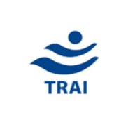 

 Image result for Hikvision logo  

**Associates**

        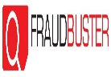

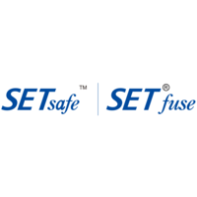 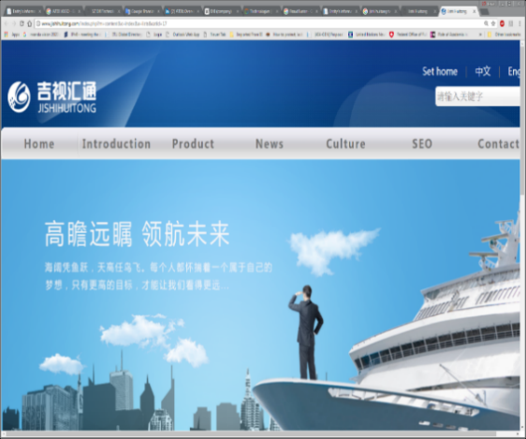   Image result for TodaCorp Inc.  Image result for Yangtze Optical Fibre and Cable Joint Stock Limited   

     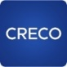    

# Annex 2: New ITU-T Sector Members and Associates in 2019

**Sector members**

       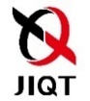

      Image result for Xperi logo   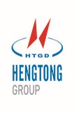

(Dusseldorf)

**Associates**

      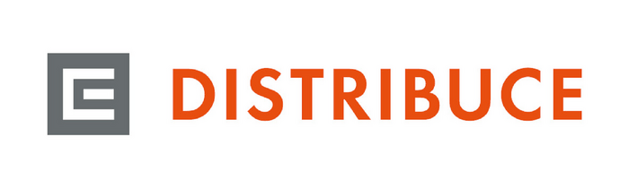 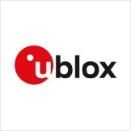

          

System Engineering Research Institute

Image result for ookla logo  Image result for Xilinx Incorporation  logo 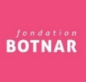   

  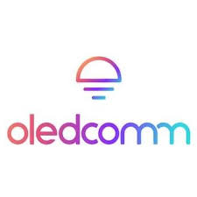  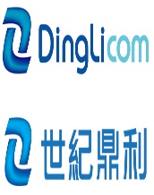 

# Annex 3: Examples of non-traditional members participating in ITU-T

**Internet of Things/Machine-to-machine**

The demand for connectivity for IoT/M2M applications operating seamlessly in multiple countries is motivating an increasing number of IoT and M2M players to join ITU-T Study Group 2 in order to apply for ITU assigned E.212 ITU-T E.212 shared Mobile Country Codes (MCC) and associated Mobile Network Codes (MNC), and E.164 International Shared Country Codes. Companies such as BICs, Cubic Telecom, OneWeb, Twilio, Plintron, Tata and Maersk are benefiting from these international numbering resources.

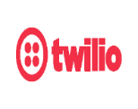      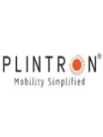   

**Quantum Information Technology**

Since 2018, several companies specializing in quantum information technology have joined ITU-T to influence the development of standards on the network architecture and security aspects of quantum communications within ITU-T Study Group 13 and ITU-T Study Group 17. In addition to Study Group activities, these members are participating in ITU-T’s Focus Group on Quantum Information Technology for Networks (FG-QIT4N).

    Image result for LG uPLUS logo 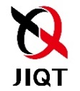 

**Internet**

Leading Internet companies are actively participating across multiple ITU-T Study Groups such as SG12, SG16, SG17 and SG20. Topics of interest include visual coding, DLT and e-services, e/Smart services, applications and supporting platforms, security architecture and framework, telecom information security management, tele biometrics, IoT architectures, management and protocols, and QoS.

  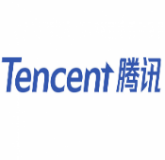  

**Distributed Ledger Technologies**

ITU-T’s concluded Focus Group on Distributed Ledger Technologies (FG-DLT) has developed a toolkit to serve all DLT innovators and practitioners, recognizing that DLT applications will take a wide variety of forms. DLT terms and definitions will provide the foundation for greater cohesion in the development and application of DLT. A number of SMEs specialized in the field of blockchain have played a key role in this group and are expected to join ITU-T Study Group 16 under the newly implemented reduced Associate fee for SMEs (Res. 209. RESOLUTION 209 (DUBAI, 2018)) in order to help develop aspects of FG-DLT’s deliverables into ITU-T recommendations.

  

**Financial technology**

The success of ITU-T’s Focus Group on Digital Financial Services (FG-DFS) has encouraged the development of globally adopted DFS technical standards and the creation of the Financial Inclusion Global Initiative (FIGI) led by ITU-T Sector Member, the Bill and Melinda Gates Foundation (BMGF), ITU, World Bank and CPMI. These activities are attracting digital payment platform providers to engage with ITU. ITU-T’s Focus Group on Digital Fiat Currency (FG-DFC) which concluded its activities in 2019 has led to ITU and Stanford University agreeing to launch a new partnership to support pilot implementations of DFC.

   

**Artificial Intelligence**

ITU-T already has a number AI/ML related work items across its Study Groups. The AI for Good Global Summit and Focus Groups on Machine Learning for 5G (FG-ML5G), Artificial Intelligence for Health (FG-AI4H), and AI for autonomous and assisted driving (FG-AI4AD) continue to attract new players from industry and academia.

 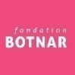      

**Intelligent Transport Systems**

ITU-T Study Group activities on security aspects of Intelligent Transport Systems (ITS), Speech and audio evaluation in vehicles, vehicle gateway platform for telecommunications/ITS services and applications have attracted some of the automotive industry’s leading players such as Hyundai, Volkswagen, Mitsubishi and Continental. Focus Groups on Vehicular Multimedia (FG-VM), AI for autonomous and assisted driving (FG-AI4AD) are also attracting new and innovative players within the industry.

     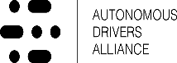  

**Smart Grid**

ITU-T Study Group 15’s activities on communications for smart grid have attracted leading utility providers such as Iberdrola and Bayernwerk.

 

# Annex 4: ITU Services and Tools

**1 ITU-T databases**

To serve ITU-T delegates and secretariat staff, the following databases are available online:

1. [ITU-T Work Programme](http://www.itu.int/ITU-T/workprog)
2. [ITU-T A.4, A.5 and A.6 recognized organizations](https://www.itu.int/en/ITU-T/extcoop/Pages/sdo.aspx)
3. [ITU-T AAP](https://www.itu.int/ITU-T/aap/AAPSearch.aspx) & [TAP](https://www.itu.int/net/ITU-T/lists/t-approval.aspx)
4. [ITU-T Recommendations](http://www.itu.int/itu-t/recommendations)
5. [ITU-T Liaison Statements](http://www.itu.int/net/itu-t/ls/)
6. [ITU-T Patents and Software Copyrights](http://www.itu.int/ipr/)
7. [ITU Product Conformity Database](http://www.itu.int/net/itu-t/cdb/ConformityDB.aspx)
8. [ITU-T Formal descriptions and Object identifiers](http://www.itu.int/ITU-T/formal-language/index.html)
9. [ITU-T Test Signals](http://www.itu.int/net/itu-t/sigdb/menu.htm)
10. [ITU-T Terms & Definitions](http://www.itu.int/ITU-R/go/terminology-database)
11. [International Numbering Resources](http://www.itu.int/ITU-T/inr/index.html) (see section below for more details)
12. [ITS Communication Standards database](https://www.itu.int/net4/ITU-T/landscape#?topic=0.131&workgroup=1&searchValue=&page=1&sort=Revelance) (from CITS)
13. [ICT standards landscape](https://www.itu.int/en/ITU-T/studygroups/com17/ict/Pages/default.aspx) (from SG17)

**2 ITU-T MyWorkspace**

MyWorkspace is a set of mobile-friendly tools and services to facilitate the work of ITU-T experts. MyWorkspace responds to WTSA Resolution 32 on strengthening electronic working methods. The first version was released in 2017 and has since welcomed 1,600 users. The site receives visits from an average of 500 users per month.

The latest version, version 3.0, was released in the second quarter of 2019. Version 3.0 includes enhances the user interface and includes a new section for ITU-T events. MyWorkspace is accessible through a responsive website and new mobile application (Android & iOS). Secure access to MyWorkspace is enabled through ITU User Account (TIES) credentials.

The following services are available from the platform:

* ITU-T experts directory
* Chat service for real-time communication
* Meeting documents with the option to bookmark favourites
* Mailing list subscriptions
* Calendar of ITU-T events with filters by working group
* User profile management (CRM profiles) and additional preferences
* New applications included in 2019:
* Neural-net based machine translation prototype for documents in the six official languages (including formatting)
* Remote participation service frequently used by study groups, based on an open-source tool
* New ITU-T events service, fully integrated with CRM events and registered participants, including a ‘matchmaking’ feature to enhance delegate networking.

Figure 3: Total number of users for MyWorkspace since end of 2017.

**3 ITU search engine**

The mobile-friendly [ITU search engine](https://www.itu.int/net4/ITU-T/search/Landing) facilitates access to ITU documents, websites, publications and other resources. 2018 saw the expansion of the tool from ITU-T resources to the resources of all ITU Sectors. An average of 15,000 searches take place each month.

The latest version of the search engine was released in December 2018. This latest version includes:

1. Filters to narrow searches by Sector, type of document or language
2. New collections available:
   1. Meeting documents and websites from all ITU Sectors
   2. Social media (ITU Facebook and Twitter accounts) and Multimedia (ITU Flickr and YouTube accounts)
3. New section to search resolutions and decisions of ITU governing bodies
4. Multilingual search, support any of the six official languages

**4 ITU-T services & tools announcements**

A service announcements platform, <http://tsbtech.itu.int/>, keeps the ITU-T community up to date with the latest enhancements to the services and tools provided to ITU-T members.

**5 Document Management System for Rapporteur Groups**

The Microsoft SharePoint-based Document Management System for ITU-T Rapporteur Group Meetings (RGMs) has been used extensively by the majority of ITU-T Study Groups, notably Study Groups 2, 3, 9, 11, 13, 15, 16 and TSAG. Feedback from Rapporteurs drives the continuous improvement of the RGM system. The RGM system is one of several services available in the ITU-T SharePoint collaboration sites. These sites are restricted to ITU-T members and can be accessed using an ITU User Account (TIES).

**6 ITU-T SharePoint collaboration sites**

The ITU-T SharePoint collaboration sites enable participants in ITU-T working groups to conduct online discussions, work on projects, schedule meetings and manage and store documents in a secure shared environment. The home of ITU-T SharePoint collaboration sites can be accessed at: <https://extranet.itu.int/sites/ITU-T/>.

**7 Meeting Documents Sync Application**

This application enables meeting participants to synchronize documents of ongoing ITU-T Study Group meetings from the ITU server to their local drive. The application is constantly enhanced and updated following feedback and suggestions from users. An improved Windows version and a new Mac version of the sync application for RGM documents are now available.

**8 Electronic meetings**

TSB continues to improve electronic meeting facilities offered to ITU-T members. 2019 saw the introduction of a new tool for ITU-T electronic meetings with the aim of providing a consistent, efficient service to the ITU-T community. This tool is now being used for all ITU-T statutory meetings. Adobe Connect will continue to be used for multilingual sessions. GoToMeeting and Zoom are used for non-statutory, fully online (virtual) and any on-demand ad-hoc meetings. Statistics on e-meetings for the last three years are indicated below.

# Annex 5: Increase growth of companies applying for INRs



