Council 2021
Virtual consultation of councillors, 8-18 June 2021
Document C21/55-E
7 April 2021
Original: English
Report by the Secretary-General
DATE AND PLACE OF the 2023 WORLD RADIOCOMMUNICATION
CONFERENCE ANd the 2023 RADIOcommunication ASSEMBLY

Summary
Resolution 811 (WRC-19) recommends agenda items for the 2023 World Radiocommunication Conference (WRC-23). Council Resolution 1399, which received the agreement of the required majority of the Member States of ITU, established the agenda of the WRC-23.
The United Arab Emirates has informed the Secretary-General of its readiness to host the WRC-23 on 20 November – 15 December 2023, to be preceded by the 2023 Radiocommunication Assembly (RA-23) on 13 – 17 November 2023, in Abu Dhabi or Dubai.

Action required
The Council is invited to decide the place and exact dates of WRC-23, preceded by RA-23, following which a consultation of the Member States should take place (CV 47), and adopt the decision in Annex B.
____________

References
CV 42, 47, 75, 118, 126; Resolution 811 (WRC-19); Council Resolution 1399
- 2023 World Radiocommunication Conference
1.1 The 2019 World Radiocommunication Conference (WRC-19), in its Resolution 811 (WRC-19) (formerly COM6/1), resolved “to recommend to the Council that a world radiocommunication conference be held in 2023 for a maximum period of four weeks”. Further, it recommended to the Council items for inclusion in the agenda of WRC-23, and also invited the Council to finalize the agenda, arrange for the convening of WRC-23, and to initiate as soon as possible the necessary consultations with the Member States.
1.2 Pursuant to No. 118 of the Convention, the Council is mandated to establish the final agenda of a world radiocommunication conference, preferably two years before the conference, with the concurrence of a majority of the Member States of the Union, subject to the provisions of No. 47 of the Convention. The precise place and exact dates have also to be decided by the Council, with the concurrence of a majority of the Member States of the Union, in accordance with Nos 42 and 47 of the Convention.
1.3 A consultation was carried out by letter DM-20/1009 of 26 June 2020 relating to the outcomes of discussions of the Virtual consultation of councillors, which was held 9-12 June 2020. The result of that consultation was that Council Member States of ITU supported the agenda of the World Radiocommunication Conference (WRC-23) and adopted Resolution 1399.
1.4 The consultation carried out by Circular Letter No. 20/33 of 3 August 2020 relating to the approval of the agenda of the World Radiocommunication Conference 2023 (WRC-23), as indicated in Resolution 1399, received the agreement of the required majority of the Member States of ITU, in accordance with Nos 47 and 118 of the ITU Convention regarding the agenda of the WRC-23.

2 2023 Radiocommunication Assembly associated with WRC-23
2.1 In accordance with the provisions of Nos 83 and 91 of the Constitution, “radiocommunication assemblies shall also normally be convened every three to four years and may be associated in place and time with world radiocommunication conferences ....”. The precise place and exact dates have to be adopted by the Council, with the concurrence of a majority of the Member States of the Union, in accordance with No. 42 of the Convention.

3 Expression of interest in hosting the WRC-23
3.1 On 31 December 2019, the ITU received an expression of interest by the Administration of the United Arab Emirates to host the WRC-23 and the RA-23 in the UAE (see Annex A)
3.2 The UAE subsequently informed the ITU of its readiness to host the WRC-23 in either Abu Dhabi or Dubai, UAE on 20 November – 15 December 2023, to be preceded by the RA-23 on 13 – 17 November 2023.
3.3 In view of the UAE’s expression of interest to host the WRC‐23 and the RA-23, the Council is invited to instruct the BR to continue to communicate to the Administration of UAE the ITU requirements for hosting RA-23 and WRC-23.

4 Request to the Council regarding the dates and place of WRC-23 and RA-23
4.1 the Council is invited to adopt the decision on the place and exact dates for WRC-23 and RA-23 (see Annex B).
Annexes: 2
Annex A
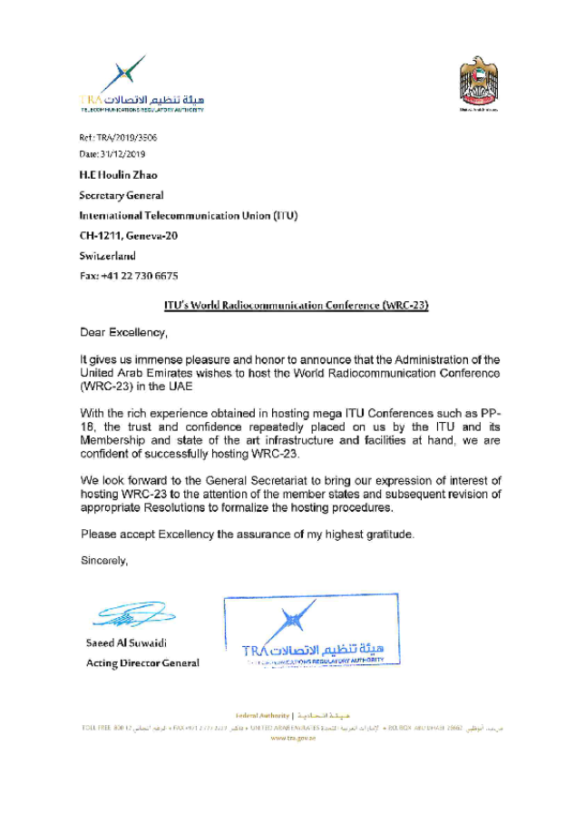
ANNEX B
DRAFT DECISION […]
Place and dates of the World Radiocommunication Conference
(WRC-23) and Radiocommunication Assembly (RA-23)
The ITU Council,
noting
that Resolution 811 of the World Radiocommunication Conference (Sharm el Sheikh, 2019):
a) resolved to recommend to the Council that a world radiocommunication conference be held in 2023 for a maximum period of four weeks;
b) recommended its agenda, and invited the Council to finalize the agenda and arrange for the convening of the 2023 World Radiocommunication Conference (WRC-23) and to initiate as soon as possible the necessary consultation with the Member States,
noting further
Council Resolution 1399, which received the agreement of the required majority of the Member States of ITU, established the agenda of the WRC-23,
decides
that, subject to the concurrence of the majority of the Member States of the Union, the next World Radiocommunication Conference will take place either in [Abu Dhabi or Dubai*], UAE from 20 November to 15 December 2023, preceded by the 2023 Radiocommunication Assembly (RA-23) from 13-17 November 2023,
instructs the Secretary-General
1 to carry out a consultation with all Member States on the exact dates and place of RA-23 and WRC-23;
2 to make all the necessary arrangements, in agreement with the Director of the Radiocommunication Bureau, for the convening of the Conference.
_______________

*.To be confirmed by UAE during the VCC in June

