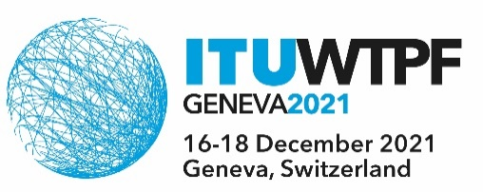
Document WTPF-21/6-E
2 December 2021
Original: English
Burkina Faso, Ghana, Kenya and Uganda
CONTRIBUTION ON THE ROLE OF DITIGIAL LITERACY IN CONSUMER EMPOWERMENT AND PROTECTION - DRAFT OPINION 3
Reference is made to draft Opinion 3 – Digital Literacy and Skilling for Inclusive Access.
Background
With due cognizance of the interests and needs of consumers in all Member States, particularly in developing ones, recognizing that consumers have comparatively lesser socio-economic and political bargaining power and bearing in mind that consumers should have the right to privacy and protection of their data, in order for them to confidently use, integrate and harness the opportunities of ICTS, we need to emphasize the contribution and role of digital literacy in protecting consumers online.
Proposed actions:
- Include a reference to the Resolution 70/186 of the United Nations General Assembly (UNGA) on “Consumer Protection”; in the “Recalling” section of the draft opinion 3
- Include a paragraph in the “is of the view” section of the draft opinion 3 that “digital literacy plays a vital role in empowering and protecting consumers online, for them to safely harness the advantages of emerging technologies”
- Include a paragraph in the “invites Member States, Sector Members and other stakeholders to work collaboratively “
“To formulate and implement digital literacy campaigns specifically aimed at empowering consumers on their rights to disclosure and transparency, and protection of privacy”
_______________

