Council 2022
Geneva, 21-31 March 2022
Agenda item: PL1.11 | Document C22/13-E
 | 23 November 2021
 | Original: English
Report by the Secretary-General
REPORT ON ITU ACCESSIBILITY POLICY AND FRAMEWORK IMPLEMENTATION

Summary
The Council 2021 endorsed the draft ITU Accessibility Policy for persons with disabilities and persons with specific needs (doc C21/72). The Policy requests that a detailed report on the implementation be presented to the 2022 Session of the Council, and regular updates to further Council sessions. This document presents the first report on the implementation of the Policy.

Action required
The Council is invited to note the report.
____________

References
PP Resolution 175 (Rev. Dubai, 2018), PP Resolution 71 (Rev. Dubai, 2018), C21/72, WTDC Resolution 58 (Rev. Buenos Aires, 2017), WTSA Resolution 70 (Rev. Hammamet, 2016) and RA Resolution 67 (2017); C13/42

- Introduction
The 2010 Plenipotentiary Conference (PP-10) adopted Resolution 175 (Rev. Dubai, 2018) (“Telecommunication/information and communication technology accessibility for persons with disabilities and persons with specific needs”). Furthermore, the ITU Strategic Plan 2020-2023, considers accessibility within its Strategic Goal 2 (Inclusiveness).
The membership’s Inter-Sector Coordination Group (ISCG) on issues of mutual interest, composed by representatives of all three Sector Advisory Groups, agreed during its meeting in March 2021 that Accessibility should be a specific theme to be followed-up within the ISCG and requested the secretariat’s Intersectoral Coordination Task Force (ISC-TF) to present regular reports to its meetings.
Besides the remarkable number of outputs produced by the ITU Sectors to make ICTs more accessible (standards, capacity building, events, toolkits, videos, projects, etc.), the ITU has undertaken, for more than ten years, a significant amount of work to provide reasonable accommodation to ITU services (which include facilities, events, documents, and corporate communication tools, among others) to persons with disabilities. To build upon the lessons learned from these experiences, and to establish well-defined solutions and procedures, the ISC-TF updated the accessibility policy, linking both dimensions of the work, external and internal, to replace the policy endorsed by the 2013 Session of the Council.
- The ITU Accessibility Policy
The ITU Accessibility Policy underpins on two main Goals: 1) Making ITU more accessible, and 2) Making ICTs more accessible (see details in doc C21/72).
They are supported by 12 Objectives including but not limited to (see full list in doc C21/72): making facilities accessible; raising awareness and increasing knowledge; providing accessible accommodations for ITU events (e.g., real-time captioning and/or remote sign language interpretation, enable delegates with disabilities and ITU members’ representatives, in particular those coming from LDCs and low-income countries, to participate in the work of ITU); ensuring that structure and contents of ITU websites, videos, publications, and whatever digital documents and digital information are digitally accessible; ensuring that accessibility is reflected in ITU Strategic Plans and sector specific plans; mainstreaming accessibility for persons with disabilities in the programmatic activities of the three Sectors and the General Secretariat; and strengthening collaboration on accessibility-related matters within the UN Common System and with relevant organizations representing PwDs. The main components of the ITU Accessibility Policy are:

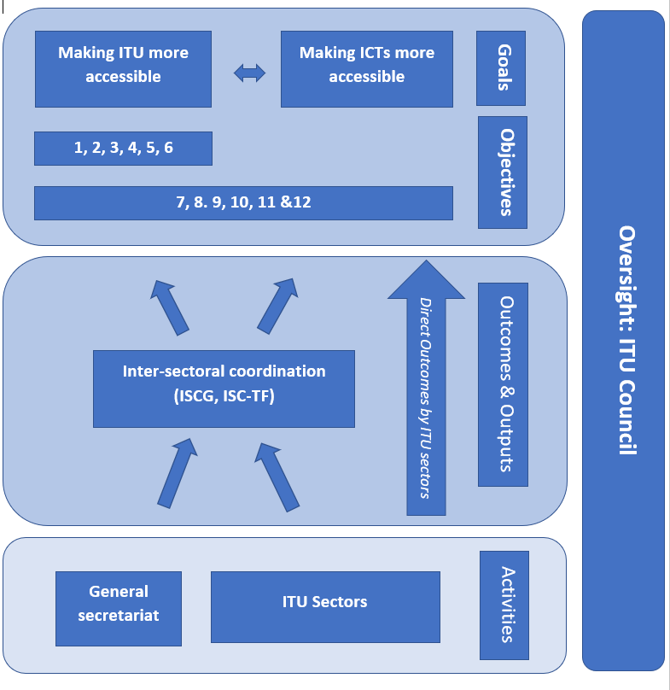
- Implementation
The ISC-TF is developing a strategy aiming to coordinate efforts to achieve the Objectives. It includes key performance indicators (KPIs) for implementation of each objective, estimation of the necessary resources, milestones and timelines, expected and achieved results, as well as evaluation of risks and proposed mitigation. The full Accessibility strategy should be ready by Q2 2022. As a first step, a series of activities have been undertaken, as follows.

3.1 Goal 1 – Activities to make ITU more accessible (since April 2021)
- To ensure that structure and contents of ITU websites, videos, publications, and whatever digital documents and digital information are digitally accessible, a series of Trainings (Workshops) will take place in February 2022: Designers; Content Authors; Developers; Project Leads; How to Create Accessible Documents and Presentations Webinar; Creating Accessible Graphics and Social Content Webinar; and How to Produce Accessible Videos Webinar.

- To undertake the necessary measures in order to provide accessible accommodations for ITU events, an invitation to bid for the provision of real-time captioning has been completed in November 2021. It was decided to extend the possibility of captioning to languages other than English (proposals were received for French, Spanish and Chinese).

- To make ITU facilities accessible, the accessibility requirements for the ITU new building project have been based on the Swiss standard SIA 500, in order to obtain the host country’s authorisation for construction. However, since this standard is relatively limited in its scope, ITU has expanded the programme requirements to encompass a more inclusive accessibility. The series of additional measures will ensure that the new building is accessible to people with a wide range of disabilities and needs

3.2 Goal 2 – Activities to make ICTs more accessible (since April 2021)

3.2.1 ITU-T
Technical work on accessibility at ITU-T is now covered by multiple groups, including SG2, SG9, SG16, SG20 and IRG-AVA. Coordination work is done at JCA-AHF.
In April 2021 at ITU-T SG16, work completed on Technical Paper ITU-T HSTP.ACC-UC “Use cases for inclusive media access services”. Collaborative work with ISO/IEC JTC1 SC35 “User interfaces” continues to develop twin texts covering guidance on audio descriptions, on the audio presentation of text in videos (including captions, subtitles and other on-screen text), on the visual presentation of audio information (including captions and subtitles), and visual presentation of audio information in sign languages. Collaboration with WHO is enhanced with a new work item on accessibility of telehealth services as a Covid-19 response. Activities supporting the Safe Listening Initiative continues in SG16, with the approval of HSTP-CONF-H870 “Testing of personal audio systems for compliance with ITU-T H.870 (2018)”, work on the 2nd edition to H.870 and investigation on safe listening requirements for e-sports.
Workshops on accessibility organized since March 2021:
- ITU Workshop “The future of television for Asia & Pacific” online, Friday, 23 April 2021(Session 2 “The Future of the Television User Experience and Applications” included accessibility aspects of future TV)
- ITU/WHO workshop “Role of industry in making telehealth accessible for persons with disabilities” online, 23 June 2021.
- Accessible media should not need to be a Right - it should be a Given, webinar organized by IRG-AVA at WSIS Forum 2021, 13 April 2021.
- Accessible ICT during the Covid-19 Pandemic, webinar organized by JCA-AHF at WSIS Forum 2021, 4 May 2021.
- ITU Workshop “The Future of Television for Europe” Fully Virtual, 19 November 2021 (Session 2: The future user experience for television includes accessibility aspects of future TV)
- ITU/WHO workshop on “Safe listening in e-sports and video gaming: identifying use-cases and requirements”, online, 2 December 2021

3.2.2 ITU-D

ITU regional knowledge development platforms/forums
Accessible Europe – ICT for ALL 2021,T (March 2021): Over 240 participants from over 40 countries and representing around 100 organizations from Europe and beyond.
Accessible Americas: ICT for ALL, 29 November - 1 December 2021 in Varadero, Cuba. The agenda encompasses interactive discussions with policy-makers and stakeholders in topics of ICT/digital accessibility in the context of the COVID-19 pandemic.
Accessible Arab region, ICT for ALL, 2-7 December in Cairo Egypt, in partnership with ESCWA.
Accessible ASP - the Regional Dialogue on Digital Transformation: Gearing Up for Inclusive and Sustainable Development, 7-10 December 2021.
Five (5) online knowledge development workshops were delivered in English and French from 12 to 15 April 2021 in an interactive format to strengthen capacity for 175 regional Focal Points from 42 African countries in the topic of ICT/digital accessibility.
Accessible CIS – The CIS Region has shown in 2021 an increased interest in ICT accessibility implementation as a catalytic driver to ensure equal and equitable digital empowerment through ICT of all people.

Assessing and monitoring ICT accessibility implementation
“ITU Self-Assessment and Toolkit for ICT Accessibility Implementation -Towards building Inclusive Digital Communities” This key ITU resource is a one of the most complete in the topic, developed to support all ITU members, policy makers and stakeholders efforts in building inclusive digital communities globally .
ICT Accessibility Assessment for the Europe Region. In particular, the ITU Assessment of Digital Accessibility Policies in Serbia.
ICT accessibility overview and assessment for Africa Region: The ICT accessibility overview and assessment for Africa Region was also developed and finalized in August 2021. The report data was collected as a result of the delivery of five online knowledge development workshops to 175 regional Focal Points from 42 African countries in the topic of ICT/digital accessibility. Over 72 per cent of the African countries that participated in the workshops developed and delivered their first self-assessment, which was shared with ITU-D for the purpose of this report.
Other resources developed included, but are not limited to, ICT accessibility overview and assessment for CIS Region, and ICT accessibility overview and assessment for ASP Region.

Training resources - Self-paced online training courses
In 2021 two of main self-paced online training courses in ICT accessibility, are available in Arabic, English, French, Russian, and Spanish) as follows:
ICT Accessibility: the key to inclusive communication
Web Accessibility - the Cornerstone of an Inclusive Digital Society; for more trainings in ICT accessibility developed by ITU-D see Resources.

Other related work to support the global implementation of ICT accessibility
The Universal Design Day ITU was invited to contributed to the first ever celebration of Universal Design Day on 28 May 2021.
In line with UNDIS, ITU contributed to the development of the Disability Inclusion Practice Note on ICT & Digital Accessibility and its Additional Resources.
One hundredth and thirty-one United Nations Country Teams engaged towards disability inclusion by implementing ICT/digital accessibility requirements: ITU shared knowledge and expertise on the topic of ICT accessibility with the United Nations Country Teams representatives during two webinars on ICT & Digital Accessibility held virtually on 1 and 9 June 2021.
Examples of other accessibility-related activities by the ITU-D during this period are: involvement in the UN emergency working group on disability and Covid19; contribution to the 14th Conference of States Parties to the CRPD – COSP14 on the Rights of Persons with Disabilities (CRPD), held from 15 to 17 June 2021; and participation in the Digital Inclusion Summit - Leaving no one behind organized by the International Training Centre in collaboration with the ILO (7 - 8 July 2021).

3.2.3 WSIS

WSIS Forum 2021: ICTs and Accessibility for Persons with Disabilities and Specific Needs
The issue of accessibility for persons with disabilities and specific needs was highlighted during the WSIS Forum. It is a cross-cutting topic that spans all the WSIS Action Lines. One of the key activities at the WSIS Forum 2021 was the ICTs and Accessibility for Persons with Disabilities and Specific Needs special track.
The ICTs and Accessibility for Persons with Disabilities and Specific Needs special track at the WSIS Forum 2021 consisted with a series of virtual workshops on various topics that highlighted innovative technologies to showcase the role of ICTs in the development of inclusive society. The special track also featured experts and stakeholders from different sectors who highlighted efforts to leverage ICTs to assist people with blindness and vision impairment, to provide inclusive education for all, and to showcase emerging assistive technologies. The full list of the special track workshops during the WSIS Forum 2021 is available here.
Some of the speakers participated in this special track were also featured in the ITU Podcast Series: Technology for Good on Episode 11: Accessibility for all. The transcript is available here. For more information on ITU Podcast please visit: https://www.itu.int/en/mediacentre/Pages/podcasts.aspx
WSIS will also organize a WSIS TalkX – an interactive talk series that is dedicated to sharing experiences and inspirational stories about ICTs for development by stakeholders all over the world – session that will mark the International Day of Persons with Disabilities on 3 December 2021. For more information, please visit www.wsis.org/forum.
_____________________

