Council 2022  Geneva, 21-31 March 2022 | 
Agenda item: ADM 21 | Document C22/52-E
 | 18 February 2022
 | Original: English
Report by the Secretary-General
Recruitment process – Reduction of the Advertisement Period

Summary
The period of advertisement for professional positions (P1 to D2) identified for external recruitment on an international competitive basis is currently established in the Staff Regulations and Staff Rules applicable to appointed staff, at 2 months. A shorter period of advertisement would allow ITU to be more efficient in acquiring and deploying talent to deliver on its mission.
The experience gained over the last years of use of an electronic e-recruitment system shows that most of the applications received for vacancy notices are submitted by applicants during the first and last weeks of the period, therefore a reduction in advertising time will not have a detrimental effect in attracting talent. The proposal is to amend the Staff Regulations to reduce this period to 1 month.
Action required
The Council is invited to approve the amendments to the Staff Regulations applicable to appointed staff and adopt the draft Decision contained in the Annex.

Recruitment processes – reduction of the advertisement period
1. The period of advertisement for professional positions (P1 to D2) identified for external recruitment on an international competitive basis is currently established in the Staff Regulations and Staff Rules applicable to appointed staff, at 2 months. A shorter period of advertisement would allow ITU to be more efficient in acquiring and deploying talent to deliver on its mission.
2. The experience gained over the last years of use of an electronic e-recruitment system shows that most of the applications received for vacancy notices are submitted by applicants during the first and last weeks of the period, therefore a reduction in advertising time to one month will not have a detrimental effect in attracting talent. Analysis of data from all external vacancy announcements closed between 2016 and November 2021 confirms this assertion.
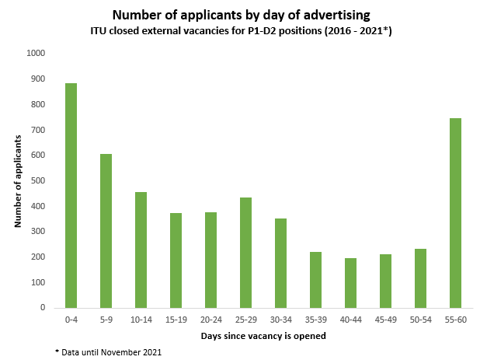
3. A closer look at this data, grouped by two-week periods, shows that 61% of applications occur in the first and last 15 days of the vacancy announcement.
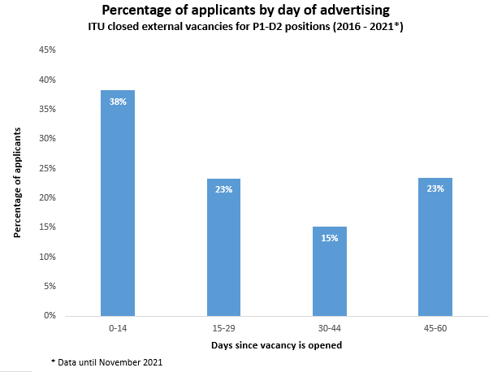
3. Benchmarking with other organizations, based on a UN review where ITU collaborated with the International Atomic Energy Agency, to survey the advertisement time taken by organizations of the United Nations shows that the majority (64%) of organizations advertise externally for a maximum of 4 weeks.
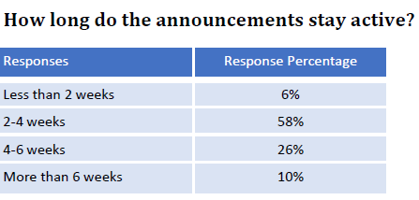
4. The average time it takes to recruit a staff member in professional positions (P1 to D2) from the day of publication of the vacancy announcement until the moment a candidate is selected is 215.3 days, i.e., 7.07 months (based on data from the 2016-2021 period). This includes 60 days in which the vacancy is open for competition. A reduction in the period of advertisement from 60 to 30 days will therefore reduce the time to select candidate to 6.07 months, representing a gain in time of 14%.

Year | Number of posts announced | Number of candidates applying | Average number of candidates per post | Days to recruit
2016 | 21 | 5739 | 273 | 198.0
2017 | 22 | 6268 | 285 | 226.9
2018 | 18 | 3898 | 217 | 238.2
2019 | 30 | 8847 | 295 | 192.9
2020 | 26 | 6715 | 258 | 237.9
2021 | 9 | 1775 | 197 | 191.6
Total | 126 | 33242 | 264 | 215.3*
*Average
5. The measure proposed is part of a comprehensive rehaul of the recruitment system that will make ITU better at deploying new talent to deliver on its mission and be more competitive in the job market. This includes new Recruitment Guidelines and the implementation of a modern electronic Recruitment Management System (RMS) going live on 28 February 2022, which includes complete automation of the recruitment process, better monitoring of timelines, as well as detailed controls and efficiencies which will support further acceleration of the recruitment process.
6. It is important to note that a reduction in the period of advertisement to one month will not prevent the organization from applying a longer period of advertisement if the job in questions necessitates wider outreach.
7. The specific proposal is to change Staff Regulation 4.8 Appointment of staff members, article f) to read “one month” instead of “two months”. To that effect, an amendment to the Staff Regulation concerned must be adopted by the Council, as Staff Regulations are falling under its authority.
8. The proposed amendment is the following:
Regulation 4.8 Appointment of staff members
f) When vacancies are advertised, in accordance with the provisions of paragraph c) above, applications from outside may be submitted through an Administration, in principle within a minimum period of two months one month; or directly to the Union on the understanding that the Secretary-General would in such cases normally consult with the Administrations of the nationals involved before making a final selection.
The Council is invited to approve the amendments to the Staff Regulations applicable to appointed staff and adopt the draft Decision contained in the Annex.

ANNEX
draft DECISION […]
Amendments to Staff Regulations
applicable to appointed Staff
The ITU Council,
in view of
No 63 of the Convention of the International Telecommunication Union and of Regulation 12.1 of Staff Regulations applicable to appointed staff,
having considered
the report submitted by the Secretary-General in document C22/36 to the Council,
decides
to approve the amendments to the Staff Regulations applicable to appointed staff contained in Annex to this Decision.

Annex to draft decision

STAFF REGULATIONS APPLICABLE TO APPOINTED STAFF
Regulation 4.8 Appointment of staff members
a) Appointment of staff members shall be made by the Secretary-General within the limits authorized by the Council. As regards the staff, of each Bureau, the Director concerned shall select the candidate to be appointed, but the final decision for appointment shall rest with the Secretary-General, who shall however report to the Council any case where his decision was at variance with the recommendation of the Director of the Bureau concerned.
b) The Secretary-General, with the agreement of the Director of the Bureau concerned, where applicable, may decide to fill any vacant post by transfer within the Union.
c) Selection for posts in grades P.1 and above shall be made on an international competitive basis; vacancies identified for external recruitment shall be advertised to the Administrations of all the Members States of the Union, to the United Nations and other specialized agencies and to the staff of the Union, indicating in detail the nature of the post to be filled, the qualifications required and the terms of appointment.
d) For vacancies at the Headquarters in grades G.1 to G.7, recruitment shall be on a competitive basis, from as near a place to Geneva as possible; where this is not possible, vacancies shall be advertised as in paragraph c) above, but recruitment shall be made having regard to its financial implications.
e) For all other duty stations, the Secretary-General shall establish a selection procedure, based on United Nations common system local conditions and practice.
f) When vacancies are advertised, in accordance with the provisions of paragraph c) above, applications from outside may be submitted through an Administration, in principle within a minimum period of two months one month; or directly to the Union on the understanding that the Secretary-General would in such cases normally consult with the Administrations of the nationals involved before making a final selection.
_______________

