|  |  |
| --- | --- |
| **Council 2022 Final meeting, Bucharest, 24 September 2022** |  |
|  |  |
|  |  |
| **Agenda item: ADM 29** | **Revision 1 to**  **Document C22/102-E** |
| **16 September 2022** |
| **Original: English** |
| Report by the Secretary-General | |
| Financial situation as of 15 September 2022 and Budget implementation forecast until 31 December 2022 | |

|  |
| --- |
| Summary  This document presents the budget 2022 financial situation as of 15 September 2022 and the budget 2022 implementation forecast until 31 December 2022.  It highlights the challenge facing the budget implementation due to greater than expected expenditure and lower than predicted cost recovery revenue, especially satellite network filings and Telecom.  This document also presents the measures and actions being undertaken by the ITU management to ensure that the budget implementation for 2022, and for the subsequent years will remain within available resources.  Action required  This document is submitted to the Council for its **consideration and guidance.**  ____________  References  [Council Resolution 1405 - Budget 2022-2023](https://www.itu.int/md/S21-CL-C-0097/en)  [*Financial Regulations of the Union*](https://www.itu.int/en/council/ties/Documents/Financial-regulations/S-GEN-REG_RGTFIN-2018-PDF-E.pdf)  [Decision 5 (Rev. Dubai, 2018)](https://www.itu.int/en/council/Documents/basic-texts/DEC-005-E.pdf)  [Article 4, Constitution](https://www.itu.int/en/council/Documents/basic-texts/Constitution-E.pdf), [Document C16/45](https://www.itu.int/md/S16-CL-C-0045/en) |

**FINANCIAL SITUATION AS OF 15 SEPTEMBER 2022 AND   
BUDGET IMPLEMENTATION FORECAST UNTIL 31 DECEMBER 2022**

**1 Introduction**

The purpose of this document is to inform the Council of the financial situation as of 15 September 2022.

The anticipated shortfall of cost recovery revenue is some -6.9 MCHF partially offset by some savings on expenses side mainly from General Secretariat. This results in a projected budget deficit of some -1.42 MCHF at end of year.

To identify expenditure savings that will ensure there is no deficit at end of year an internal group chaired by DSG composed of Deputy Directors of each Bureau and Chiefs of FRMD, HRMD, C&P and ISD has been created.

**2 Expenses**

The projected expenses level for the budget 2022 amounts to 158.5 MCHF (as compared to a budget of 163.6 MCHF) which will result in a saving of 5.1 MCHF on the approved budget, less than expected. COVID19 related expenses are included in this amount and are estimated to be 370 KCHF. A 1.5 MCHF provision for the UNSMIS annual payment is included in this forecast.

Table 1 below provides the breakdown of projected expenses by Sector until end 2022.



**3 Revenue**

The projected revenue level for the budget 2022 amounts to 157.1 M (as compared to a budget of 163.6 M), 6.5 MCHF below the approved budget.

Table 2 below provides the breakdown of projected revenue by source.



The shortfall of revenue is on account of cost recovery revenue as shown in Table 3 below.



Table 4 below presents the comparison of cost recovery revenue between financial plan, budget, and actuals and forecast. It shows the variance between budgeted amount and actual revenue by cost recovery area. The 2023 values represent the linear forecast derived from the 2020 to 2022 figures.



Chart 1 below provides a graphical view of cost recovery revenue comparison between the financial plan, the budget, and the actuals and forecast (linear projection for 2023) from 2020 until 2023.

**Chart 1 - Cost recovery revenue 2020-2023**

**Comparison between financial plan, budget, actuals and forecast**

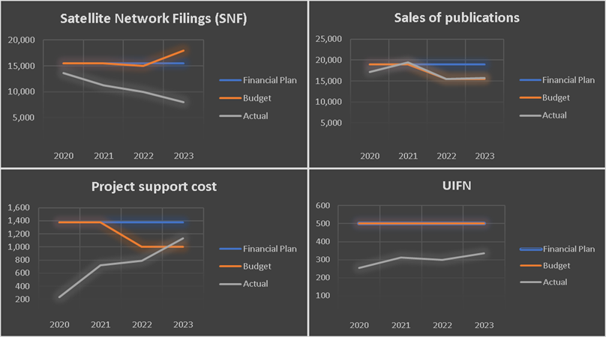

**4 2022 Planned revenue rate**

The expenses side of a budget is guaranteed by its revenue side. If the foreseen revenue in a budget does not fully materialize, the expenses budget must be proportionally reduced.

As of 15 September 2022, the projected shortfall for revenue stands at -6.558 MCHF.

The 2022 projected revenue rate as of 15 September 2022 stands at 95.99 per cent. This means that only 95.99 per cent of the expenses budgeted can be covered by the available revenue, since the budget implementation result must remain positive.

As the revenue is universal for the Union, if this rate is applied uniformly across the Union, Table 1bis shows the limits/targets (Column a) by sector for the 2022 budget implementation and Column c indicates the reductions that would need to be made until the end of 2022 to meet the limits/targets and remain within budget.

To avoid the pro-rata approach (imposing a proportional budget reduction across the board) savings will be identified based on the resources needed to implement the core and mandatory activities that are necessary to enable the ITU to achieve its mission and support its membership. Other activities will be ranked in order of priority for the membership, and resources allocated to those when and if available.

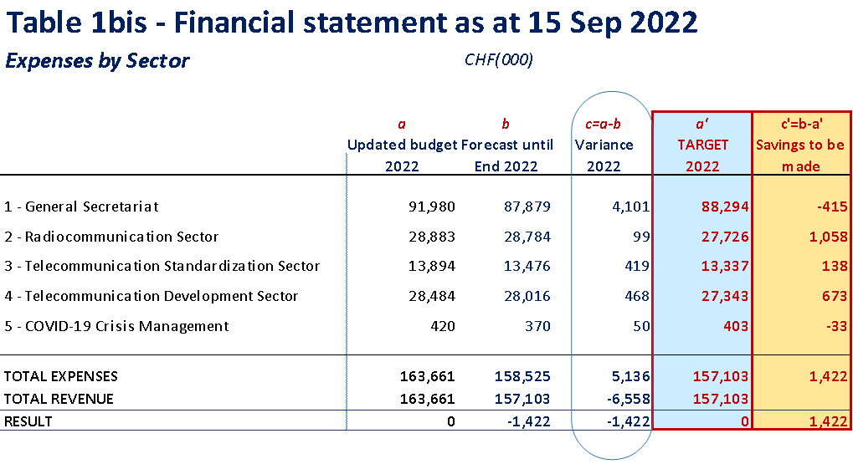

**5 Possible immediate measures to balance the budget implementation**

To avoid having a negative result (deficit) for the 2022 budget implementation, efficiency measures will be implemented to reduce expenses, for the remainder of the year, such as:

* Allowing only external recruitment under regular budget (for fixed term, short term and SSAs) that is considered critical to the continuing operations of the organization, as assessed by the Secretary-General in consultation with the appropriate elected official.
* Reducing missions under regular budget to those considered critical to the continued operations of the organization.
* All Bureaux and GS Departments apply the 5 per cent vacancy rate to the extent possible
* Where practicable and unless cancellation fees would be incurred, provide interpretation only on demand for events such as study groups, workshops, seminars, advisory group meetings, etc.
* Discontinue any non-mandatory expenses (side events, etc.) under the regular budget
* Postponement or cancellation of consultancy services under the regular budget for non-mandatory activities
* Postponement or cancellation of non-mandatory training activities under the regular budget
* Freeze on the provision of fellowships for events and activities funded through the ITU regular budget as far as possible.
* Reduce the cost of travel by revising the “Conditions Governing Official Travel” policy to increase the utilization of economy class air, specifically for those events that require extensive attendance of ITU staff.

Estimated provisions for cumulated leaves and repatriation are included in the forecast for 2022. These estimates have been calculated to our best knowledge, but the real amounts will only be known end of the year or even in January 2023. This may create some variances as compared to our forecast.

**6 Next steps**

The 2023 budget implementation as well as the forthcoming budgets will be difficult to balance. The Union will have to engage in a thorough review and optimization of its activities and working methods together with an enhancement of its revenue generation to overcome this challenge.

Some efficiency measures identified in Annex 2, Decision 5 (Rev. Dubai, 2018) remain to be fully implemented, including measure 1 on duplication and recentralization of certain activities. For example, the recentralization of the financial controllers in the Financial Resources Management Department that saved 3 posts the equivalent of some CHF 3 million for the next financial plan.

The ITU has also learned much during the COVID-19 pandemic period that should inform the further implementation of the efficiency measures in Annex 2 of Decision 5. For example, although virtual and hybrid meetings provide savings on travel and accommodation for membership they have increased the support costs of the secretariat (e.g. hiring moderators, security, access control and special equipment needed to integrate the meeting rooms).

The secretariat will present a report on the implementation of Decision 5 Annex 2 to PP-22 including suggestions for further measures including asking external auditors to assess IT developments and resources usage in ITU including the internal development of software, implementing digital transformation of activities and procedures, and Identifying opportunities to reduce overhead by outsourcing those internal support services that are available commercially.

A careful assessment will be needed to identify these future efficiency measures that would drive down overhead costs and increase the availability of resources directed toward achieving ITU's mission and support of its membership.

In parallel, ITU Member States are invited to consider increasing their contributory Units. An additional 50 Units overall would ensure the Union is able to effectively fulfill its mandate. Voluntary contributions are invited to support budget gap.

______________