Council 2022  Geneva, 21-31 March 2022 | 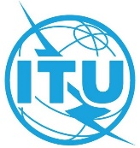
 | Document C22/INF/16-E
 | 25 March 2022
 | English only
Report by the Secretary-General
GENDER-NEUTRAL LANGUAGE

Summary
Following the discussion on gender-neutral language, this information document presents work and resources already in place and being used by other United Nations entities. The general mandate for applying gender-inclusive language in UN documents comes from the Secretary-General’s system-wide strategy on gender parity. As a result, guidelines were developed and made available along with training and a toolbox of resources, in the six official languages. An inter-agency working group developed the content and continues efforts and adds new resources.

Action required
This document is submitted to the Council for information.
____________

References
https://www.un.org/en/gender-inclusive-language/
https://www.un.org/en/gender-inclusive-language/guidelines.shtml

Using gender-inclusive language means speaking and writing in a way that does not discriminate or perpetuate gender stereotypes. Given the key role of language in shaping cultural and social attitudes, using gender-inclusive language is a powerful way to promote gender equality and eradicate gender bias.
Following the UN Secretary General’s System-Wide Strategy on Gender Parity, Guidelines were prepared and include recommendations to help United Nations staff to use gender-inclusive language in any type of communication — oral or written, formal or informal, or addressed to an internal or external audience. A Toolbox contains training materials on the practical application of the Guidelines, information on related training courses and other relevant resources.
The resources were developed by an inter-agency working group of the Department for General Assembly and Conference Management, the Department of Management, the Department of Global Communications (formerly DPI) and UN Women as part of a project entitled “Supporting gender equality in multilingual contexts”.
In keeping with the Organization’s core value of multilingualism, the Guidelines have been produced in the six official languages of the United Nations as semi-autonomous projects that comply with the principle of parity among the official languages. They reflect the specificities and unique features of each language, recommending remedies that are tailored to the linguistic context in which staff work, whether in Arabic, Chinese, English, French, Russian or Spanish.
The recommendations and resources are regularly revised and updated to reflect new feedback, suggestions, and changes in the use of language. The group is open and responds to queries and suggestions.
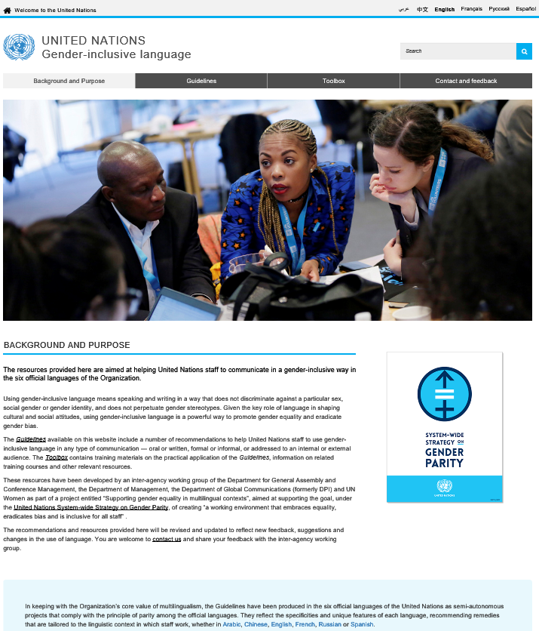
Previous to this work, there was a UN Secretariat editorial directive on gender-sensitive language from 1997 that encouraged to the greatest extent possible is to generally observe best practice in the outside world, generally, the usage adopted by respected writers and journalists.
http://undocs.org/ST/CS/SER.A/41

