Plenipotentiary Conference (PP-22)  Bucharest, 26 September – 14 October 2022 | 
PLENARY MEETING | Document 61-E
 | 11 July 2022
 | Original: English
Contribution from the Secretary General
ANALYSIS OF Membership PARTiCIPATION AND fees for entities from
least DEVELOPED COUNTRIES, LANDLOCKED DEVELOPING COUNTRIES, SMALL ISLAND DEVELOPING STATES AND COUNTRIES IN SPECIAL NEED

Summary
Following contribution C22/79 from India, regarding Private Sector and Academia Membership in ITU sectors with focus on Least Developed Countries (LDCs), Landlocked Developing Countries (LLDCs), Small Island Developing States (SIDS) and Countries in Special Need (CISN)”, the Council requested the Secretariat to study and analyse the recommendations made by India and to bring the matter to the attention of the Plenipotentiary Conference (PP-22).
This document provides some statistics on membership participation and provides the status of membership in the three Sectors, the membership fee structure, outreach initiatives by each Sector to enhance the participation of private sector and Academia membership, and an analysis of the impact of potential changes to fees for entities from these categories of countries. Additional information related to relevant programmes and activities of each of the Sectors will be presented to Council 2023 to support further consideration of the proposals made by India.

Action required
The Plenipotentiary Conference is invited to note this report.
____________

References
C22/79, WTDC-22 Resolution 16, and PP-18 Resolution 30 (Rev. Dubai, 2018)

(All data as of 31 December 2021)
Overall Membership Status and Statistics
While 47% of Member States fall within the categories LDCs (Least Developed Countries), LLDCs (Landlocked Developing Countries), SIDS (Small Island Developing States) and CISN (Countries in Special Need), only 6% of ITU’s Sector Members, Associates and Academia are from these countries.

Metric/Country Category | LDCs | LLDCs | SIDS | CISN | TOTAL
Countries represented | 20 | 16 | 11 | 6 | 36
Members | 32 | 24 | 19 | 8 | 63
Memberships | 40 | 27 | 24 | 8 | 76
Table 1: Overall Membership Status and Statistics
49 Member States are LDCs 31 Member States are LLDCs 37 Member States are SIDS 13 Member States are CISN.
In total, 91 Member States fall into one or more of these categories. 60% of these Member States have no Sector Members, Associates, or Academia.
As in Table 1 above, there are 32 members from 20 LDCs, accounting for 40 memberships. There are 24 members from 16 LLDCs, accounting for 27 memberships. There are 19 members from 11 SIDS, accounting for 24 memberships. There are 8 members from 6 CISN, accounting for 8 memberships.
For a detailed breakdown of these statistics by Sector, please see Annex 1
Evolution of Membership
As in Figure 1 below, the number of Sector Members, Associates and Academia rose steadily through to the mid-2000s, and then dropped for a few years, before picking up again from 2010 to 2016 and has been falling each year since. Sector Membership was flat between 2013 and 2017 before dropping in more recent years. The introduction of the category of Academia was the main contributor to growth 2010 to 2016.
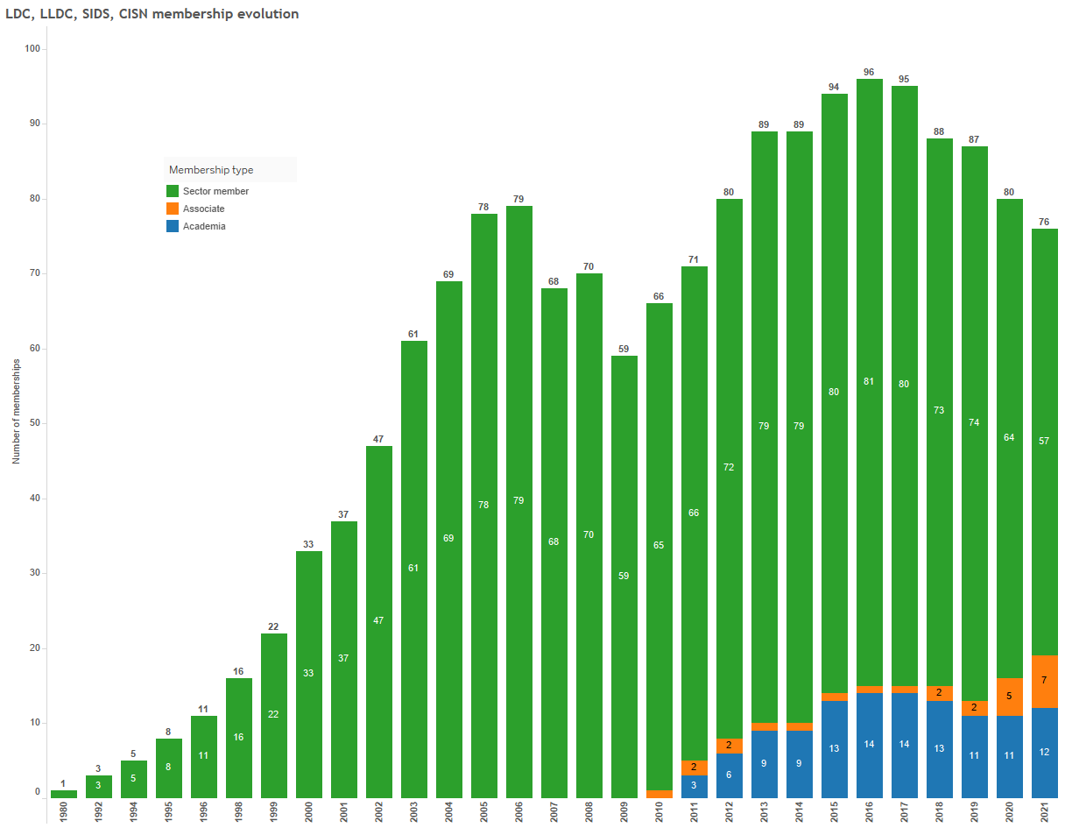
Number of memberships
Academia
Associate
Membership type
Sector member
LDC, LLDC, SIDS, CISN membership evolution
Fig.1: LDC, LLDC, SIDS, CISN membership evolution
Member Retention
Since the last Plenipotentiary Conference of 2018, ITU lost 13 Sector Members, Associates and Academia from these countries due to denunciations. Since the Plenipotentiary Conference of 2014, this figure rises to 31 entities. Currently, 15 entities representing 17 memberships, are suspended for the non-payment of their fees.
Prospective Member Applications Pending
Since 2014, ITU has 32 membership applications from companies and academia in these countries that remain pending approval by their national administration. As time passes, these prospects are largely lost.
Other Forms of Participation
Overall, 85 entities participate in ITU activities from these countries as “Admin related” within the national delegation. In addition to national regulators, public broadcasters and other government entities, this figure includes some 23 private sector companies, mainly telecommunication operators, who could potentially participate as fee paying sector members but for the moment participate without financial contributions under the national delegation.
Current provisions for reduced fees entities from developing countries
Sector Members, Associates and Academia pay fees to participate as members in ITU. An overview of these fees is available in Annex 2. There are several different provisions which offer reduced fees for entities from developing countries.
Sector Membership and Associate fees for participation in ITU-D (CHF 7,950 and CHF 3,975, respectively) are lower than those for ITU-R/T (CHF 31,800 and 10,600, respectively) overall, but in addition, entities from developing countries benefit from a 50% discount on the standard ITU-D rates (CHF 3,975 and CHF 1,978.50, respectively).
Res 170 (Guadalajara, 2010) provides for reduced fees for entities from some “low income” developing countries to participate in ITU-R/T, namely those with per capita income of less than USD 2,000 (as defined by UNDP). These entities benefit from a reduced fee of CHF 3,975 for Sector Membership in ITU-R and ITU-T. This is the same fee that entities from developing countries pay to join ITU-D as Sector Member. As of the end of 2021, 7 entities benefited from reduced fees in ITU-R and 5 in ITU-T.
As per Res 209 (Dubai, 2018), qualifying SMEs from developed countries now pay CHF 3,975 a year, and those from developing countries pay CHF 1,987.50 a year to participate in one ITU-R/T Study Group, compared to the standard fee of CHF 10,600 for ITU-R and ITU-T. Associates in ITU-D Study Groups already pay these fee amounts. Member States qualify SMEs according to national definitions, but the Plenipotentiary Conference (Dubai, 2018) set an upper limit of a maximum of 250 employees and Council at its 2019 session set the maximum revenue at CHF 15 million a year. While ITU has welcomed 51 SMEs, with 43 in ITU-T and 8 in ITU-R, only 2 of these entities are from countries that fall within the categories of LDC, LLDC, SIDS or CISN.
As per Resolution 169 (Rev Dubai, 2018), Academia can participate in the work of all 3 sectors for a single reduced fee of CHF 3,975 a year for those from developed countries and CHF 1,987.50 a year for those from developing countries. Of a total of 161 Academia members, 12 are from countries that fall within the categories of LDC, LLDC, SIDS or CISN.
Impact of potential changes to membership fees
In total, there are 76 memberships from Member States belonging to one or more of the categories of LDC, LLDC, SIDS and CISN (57 Sector members, 7 Associates, and 12 Academia). Of these, 13 Sector memberships would be impacted by a change in membership contributions from CHF 31,800 to CHF 3,975, if the Plenipotentiary Conference were to revise Res 170 to extend the eligibility for reduced fees to cover these countries. This would lead to a potential loss in revenue of CHF 361,725 per year.
Academia already benefit from reduced fees as per PP Res 169. If Academia from these countries were to be exempted from fees, as it was suggested by a delegation during the discussion of C22/79 at Council 22, the potential loss of revenue would be of CHF 23,850 per year. This would require a change by the Plenipotentiary Conference to Res 169.
Should the proposed change in membership contributions apply only to members from LDCs, 5 Sector memberships would be impacted for a potential loss in revenue of CHF 139,125 per year. For Academia, 4 memberships would be impacted for a potential loss in revenue of CHF 7,950 per year.
Engagement and Outreach Initiatives ITU-wide and by Sector
ITU secretariat has been implementing a coordinated ITU-wide strategy to reach out to new audiences to grow and diversify ITU’s membership, while applying a customer-centred approach to improve the services provided to its members, so that they are engaged, involved, and empowered by ITU activities. An important element of this coordinated outreach has been the strengthening of internal capacity and implementation of digital marketing campaigns and open webinars to reach new audiences, in areas as diverse as policy regulation, statistics, radio regulations, satellite, broadcasting, automotive, finance and more.
Each Bureau has been undertaking specific initiatives to contribute to this ITU-wide membership strategy. Here is a sample of such initiatives:
- ITU-R: Outreach activities include dissemination of information and assistance to membership, the publication of ITU-R outputs, the organization of, and the participation in, seminars and workshops, as well as communication and promotion tools. The purpose of these activities is to ensure that the outputs produced by the ITU-R Sector (regulations, recommendations, reports, and handbooks) are disseminated worldwide so that they may form the basis for the formulation of national and regional policies and decisions for the use of the radio spectrum. World and Regional Radio Seminars have been organized to disseminate updates contained in the Radio Regulations Ed. 2020 (with the decisions taken by WRC-19) along with its associated Rules of Procedure (RoP). With regional partners, BR helped developing countries achieve efficient and equitable use of analogue broadcasting and to allocate new frequencies for FM broadcasting. Together with BDT, BR developed the Spectrum Management Training Programme. BR also organized three Satellite webinars in 2021, which attracted a record 5,500 participants from 135 countries, reaching many new players from industry and academia. The webinars provided participants with an opportunity to be updated with the current technical and regulatory situation and trends in the satellite industry.
- ITU-T organizes a number of activities available to non-members such as Focus Groups, workshops, seminars, webinars, the Bridging the Standardization Gap programme, the ITU Journal on Future and Evolving Technologies and annual events such as AI for Good, ITU Kaleidoscope and the Future Networked Car Symposia. ITU-T also offers remote participation facilities for many of these activities in order to accommodate a global audience. These activities enable non-member entities to gain an understanding of ITU-T work, with a view to encouraging these entities to eventually join ITU-T as a Sector Member, an Associate or under ITU’s Academia category.
- ITU-D launched a number of engagement initiatives aimed at attracting, nurturing, and retaining Sector Members and Academia. The Industry Advisory Group on Development issues was organized to foster the exchange of information, assist in identifying priorities and regulatory barriers. The Know Your Members initiative created an opportunity and platform for private sector and academia to interact with BDT Senior Management to exchange views on coordination, engagement, and partnerships for development on a regular basis and respond to suggestions from the membership and listen to concerns if any. And TECH TALKS is an initiative introduced to engage academia and private sector where they can present their latest technology, development projects and initiatives. In addition, in TECH TALKS, BDT presents its ongoing projects and initiatives and invites academia and private sector to participate.

ANNEX 1
Membership Totals by Sector
Sector | Metric | LDCs | LLDCs | SIDS | CISN
ITU-R | Countries represented | 6 | 2 | 3 | 0
 | Members | 6 | 2 | 3 | 0
 | Memberships | 6 | 2 | 3 | 0
ITU-T | Countries represented | 7 | 4 | 5 | 1
 | Members | 8 | 4 | 7 | 2
 | Memberships | 8 | 4 | 7 | 2
ITU-D | Countries represented | 14 | 12 | 8 | 4
 | Members | 22 | 17 | 8 | 5
 | Memberships | 22 | 17 | 8 | 5
Academia | Countries represented | 4 | 3 | 4 | 1
 | Members | 4 | 4 | 6 | 1
 | Memberships | 4 | 4 | 6 | 1
TOTAL | Countries represented | 20 | 16 | 11 | 6
 | Members | 32 | 24 | 19 | 8
 | Memberships | 40 | 27 | 24 | 8
Table 2: LDC, LLDC, SIDS, CISN membership breakdown by sector
ANNEX 2
Membership Fees by Sector/Category
NOTE: CHF 63,600 = 1 unit; CHF 31,800 = 1/2 unit; CHF 10,600 = 1/6 unit; CHF 7,950 = 1/8 unit; CHF 3,975 = 1/16 unit; CHF 1,987.50 = 1/32 unit.
Sector/Category | Sector Member | Associate | Academia
ITU_R | CHF 31’800  CHF 3’975¹ | CHF 10’600  CHF 3’975³  CHF 1’987.50⁴ | CHF 3’975  CHF 1’987.50²
ITU-T | CHF 31’800  CHF 3’975¹ | CHF 10’600  CHF 3’975³  CHF 1’987.50⁴ | CHF 3’975  CHF 1’987.50²
ITU-D | CHF 7’950  CHF 3’975² | CHF 3’975  CHF 1’987.50² | CHF 3’975  CHF 1’987.50²
- Developing Countries with annual per capita income <2,000.00 USD (UNDP), not yet joined either or both Sectors and shall not be subsidiaries of a multinational corporation with HQ in a developed country.
- Developing Countries
- SMEs from Developed Countries
- SMEs from Developing Countries
______________

