General Secretariat (SG)
 |  |  | Geneva, 9 February 2022
Ref: | CL-22/4 |  | To Member States of ITU
Contact: | Ms Béatrice Pluchon
Telephone: | +41 22 730 6266
E-mail: | memberstates@itu.int
Subject: | Consultation by correspondence on the change of place and dates of the World Telecommunication Development Conference 2021 (WTDC-21)
Dear Madam/Sir,
As a follow-up to the letter DM-21/1025 sent to all Member States of the ITU Council informing that it had become necessary and urgent to examine options for the next World Telecommunication Development Conference (WTDC), Member States of the ITU Council held informal consultations on 21 January 2022.
Councillors agreed that hosting the WTDC in Addis Ababa, Federal Democratic Republic of Ethiopia, was no longer a feasible option. United in their wish to maintain the conference in Africa if possible, they sought proposals from African Member States for an alternate venue.
On 30 January 2022, the Secretary-General received an official invitation from the Government of Rwanda to hold the next WTDC in the city of Kigali from 6 to 16 June 2022, immediately preceded by the Youth Summit starting on 2 June 2022.
In accordance with No. 42 of the Convention, a consultation by correspondence of Council Member States was consequently carried out by letter DM-22/1000 of 2 February 2022.
As a result, as per DM/1001, I am pleased to inform you that Council agreed on the change of place and dates for the next WTDC to Kigali, Rwanda, from 6 to 16 June 2022.
Pursuant to No. 46 of the ITU Convention, all Member States of ITU having the right to vote are now invited to inform the Secretary-General of their concurrence with the change of place and dates of WDTC-21 as described above, by using the new online tool, or using the template in Annex 1 by e-mail to memberstates@itu.int, not later than Friday 18 February 2022. The Secretariat remains at your disposal if needed.

If your country has already responded to the first consultation sent via DM-22/1000 to Council Member States, your reply to the first consultation will also be considered as valid with regard to this consultation of all Member States, unless otherwise notified by the Councillor or the Administration Focal Point in writing by e-mail to memberstates@itu.int.
I look forward to receiving your reply.
Yours faithfully,
(signed)
Houlin Zhao
Secretary-General

Annexes: 2
Annex 1 – Consultation on the change of place and dates of the World Telecommunication Development Conference 2021 (WTDC-21)
Annex 2 – Invitation letter from Rwanda

ANNEX 1
Consultation on the change of place and dates of WTDC-21
Name of the ITU Member State:
We agree to the change of place and dates of WTDC-21 to Kigali, Rwanda, from 6 to 16 June 2022:
Yes  No   Abstention 
Focal points are kindly invited to send their reply via the online tool, or alternatively by e-mail to memberstates@itu.int not later than Friday 18 February 2022.

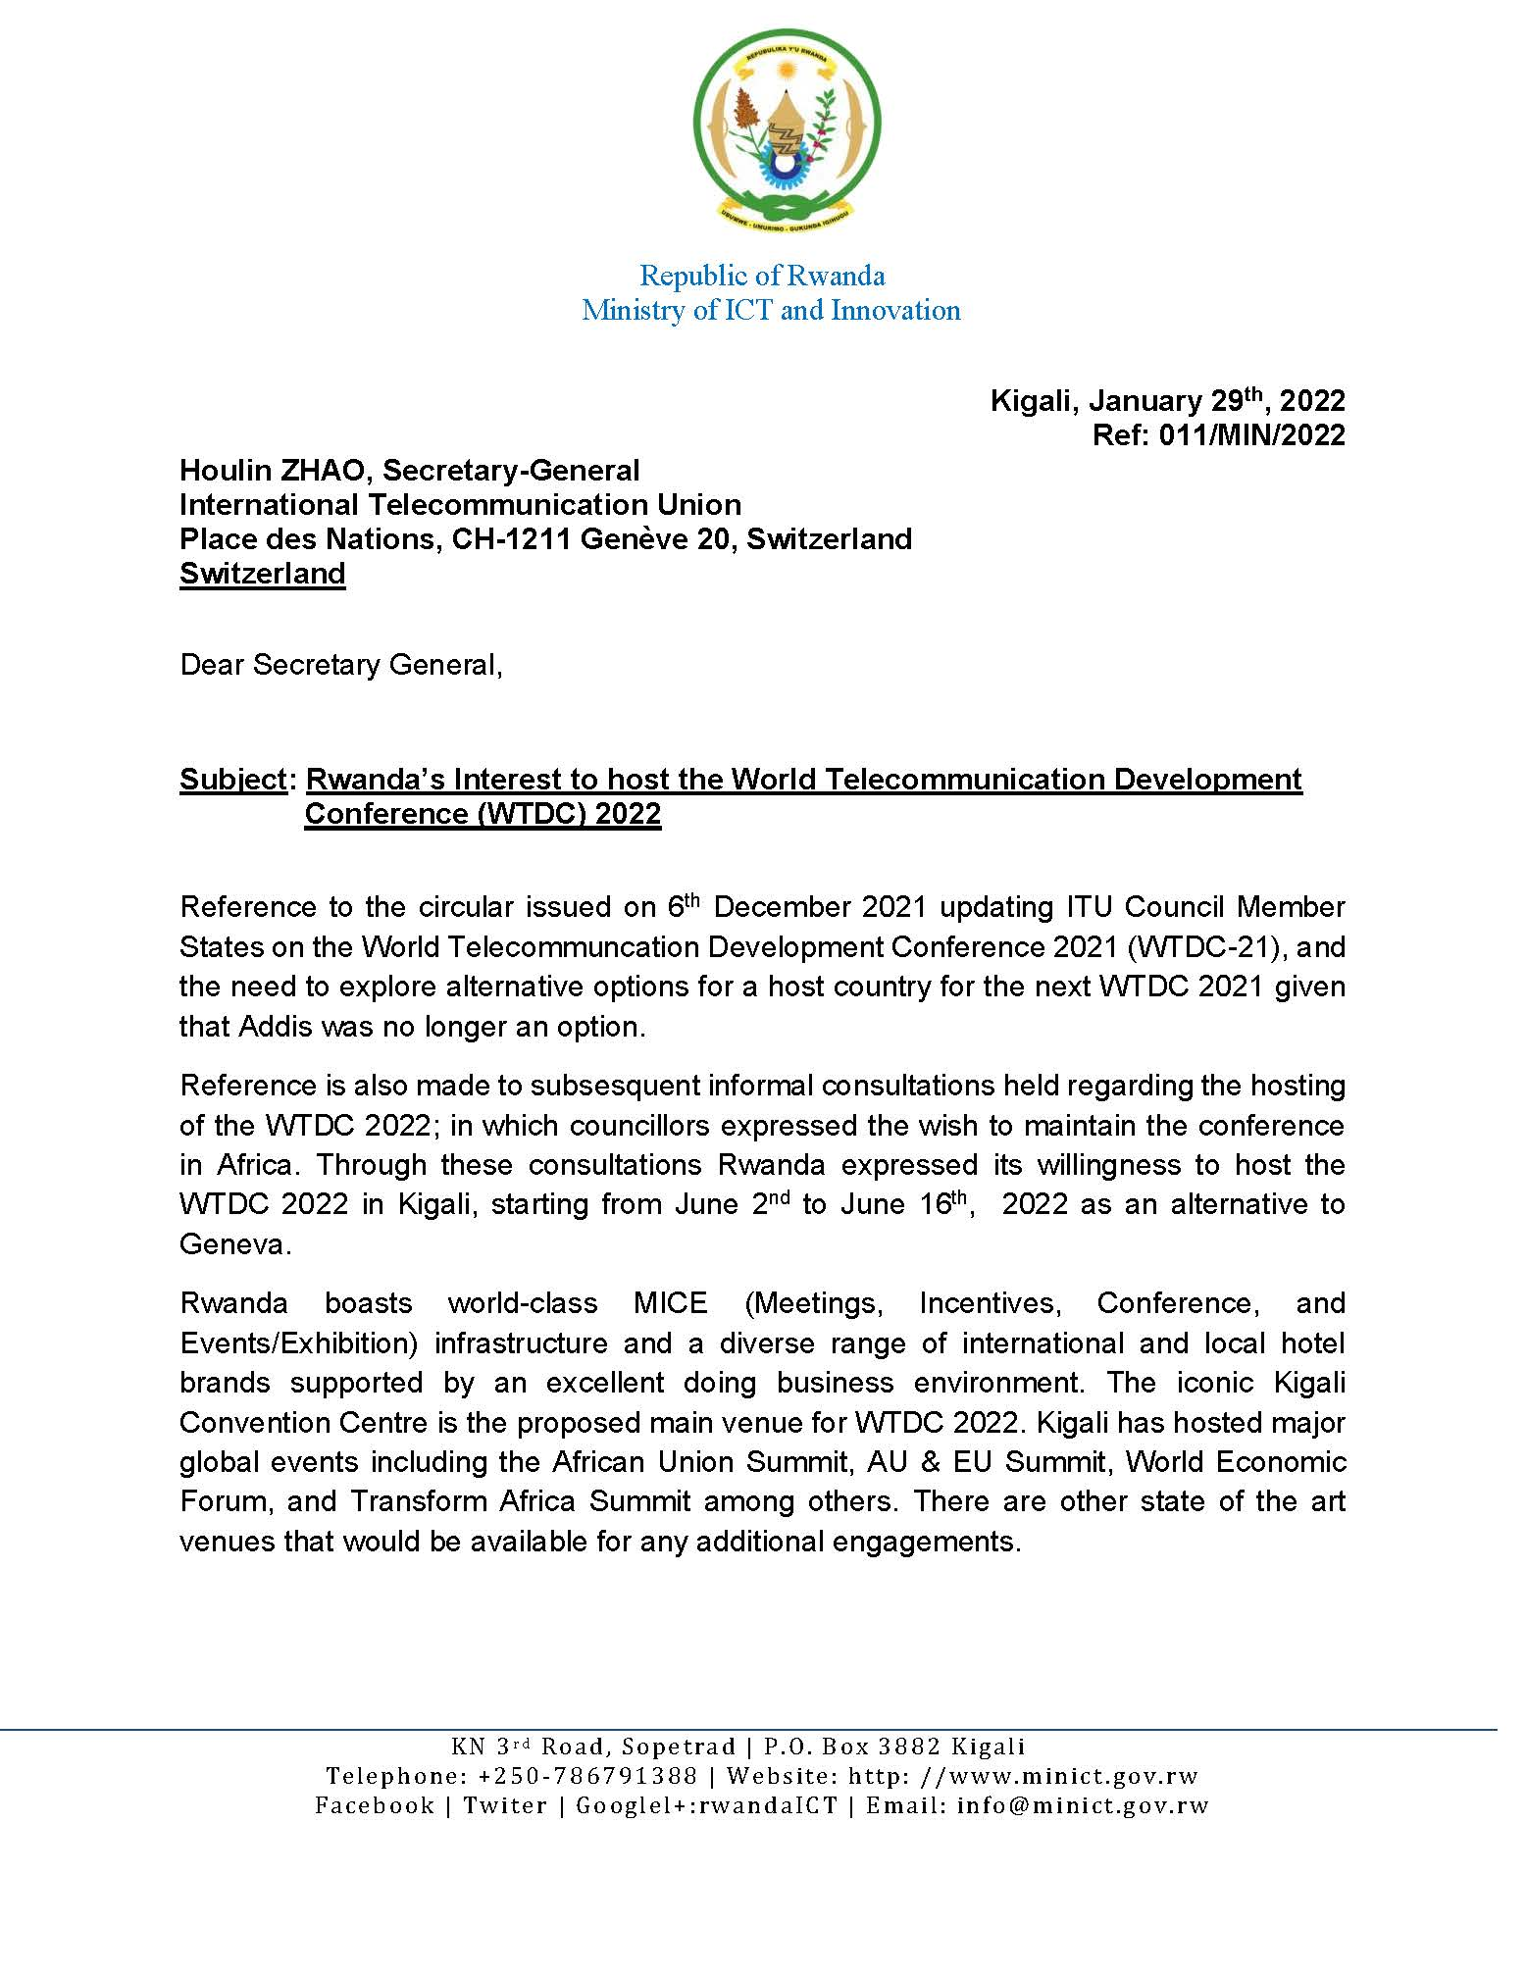

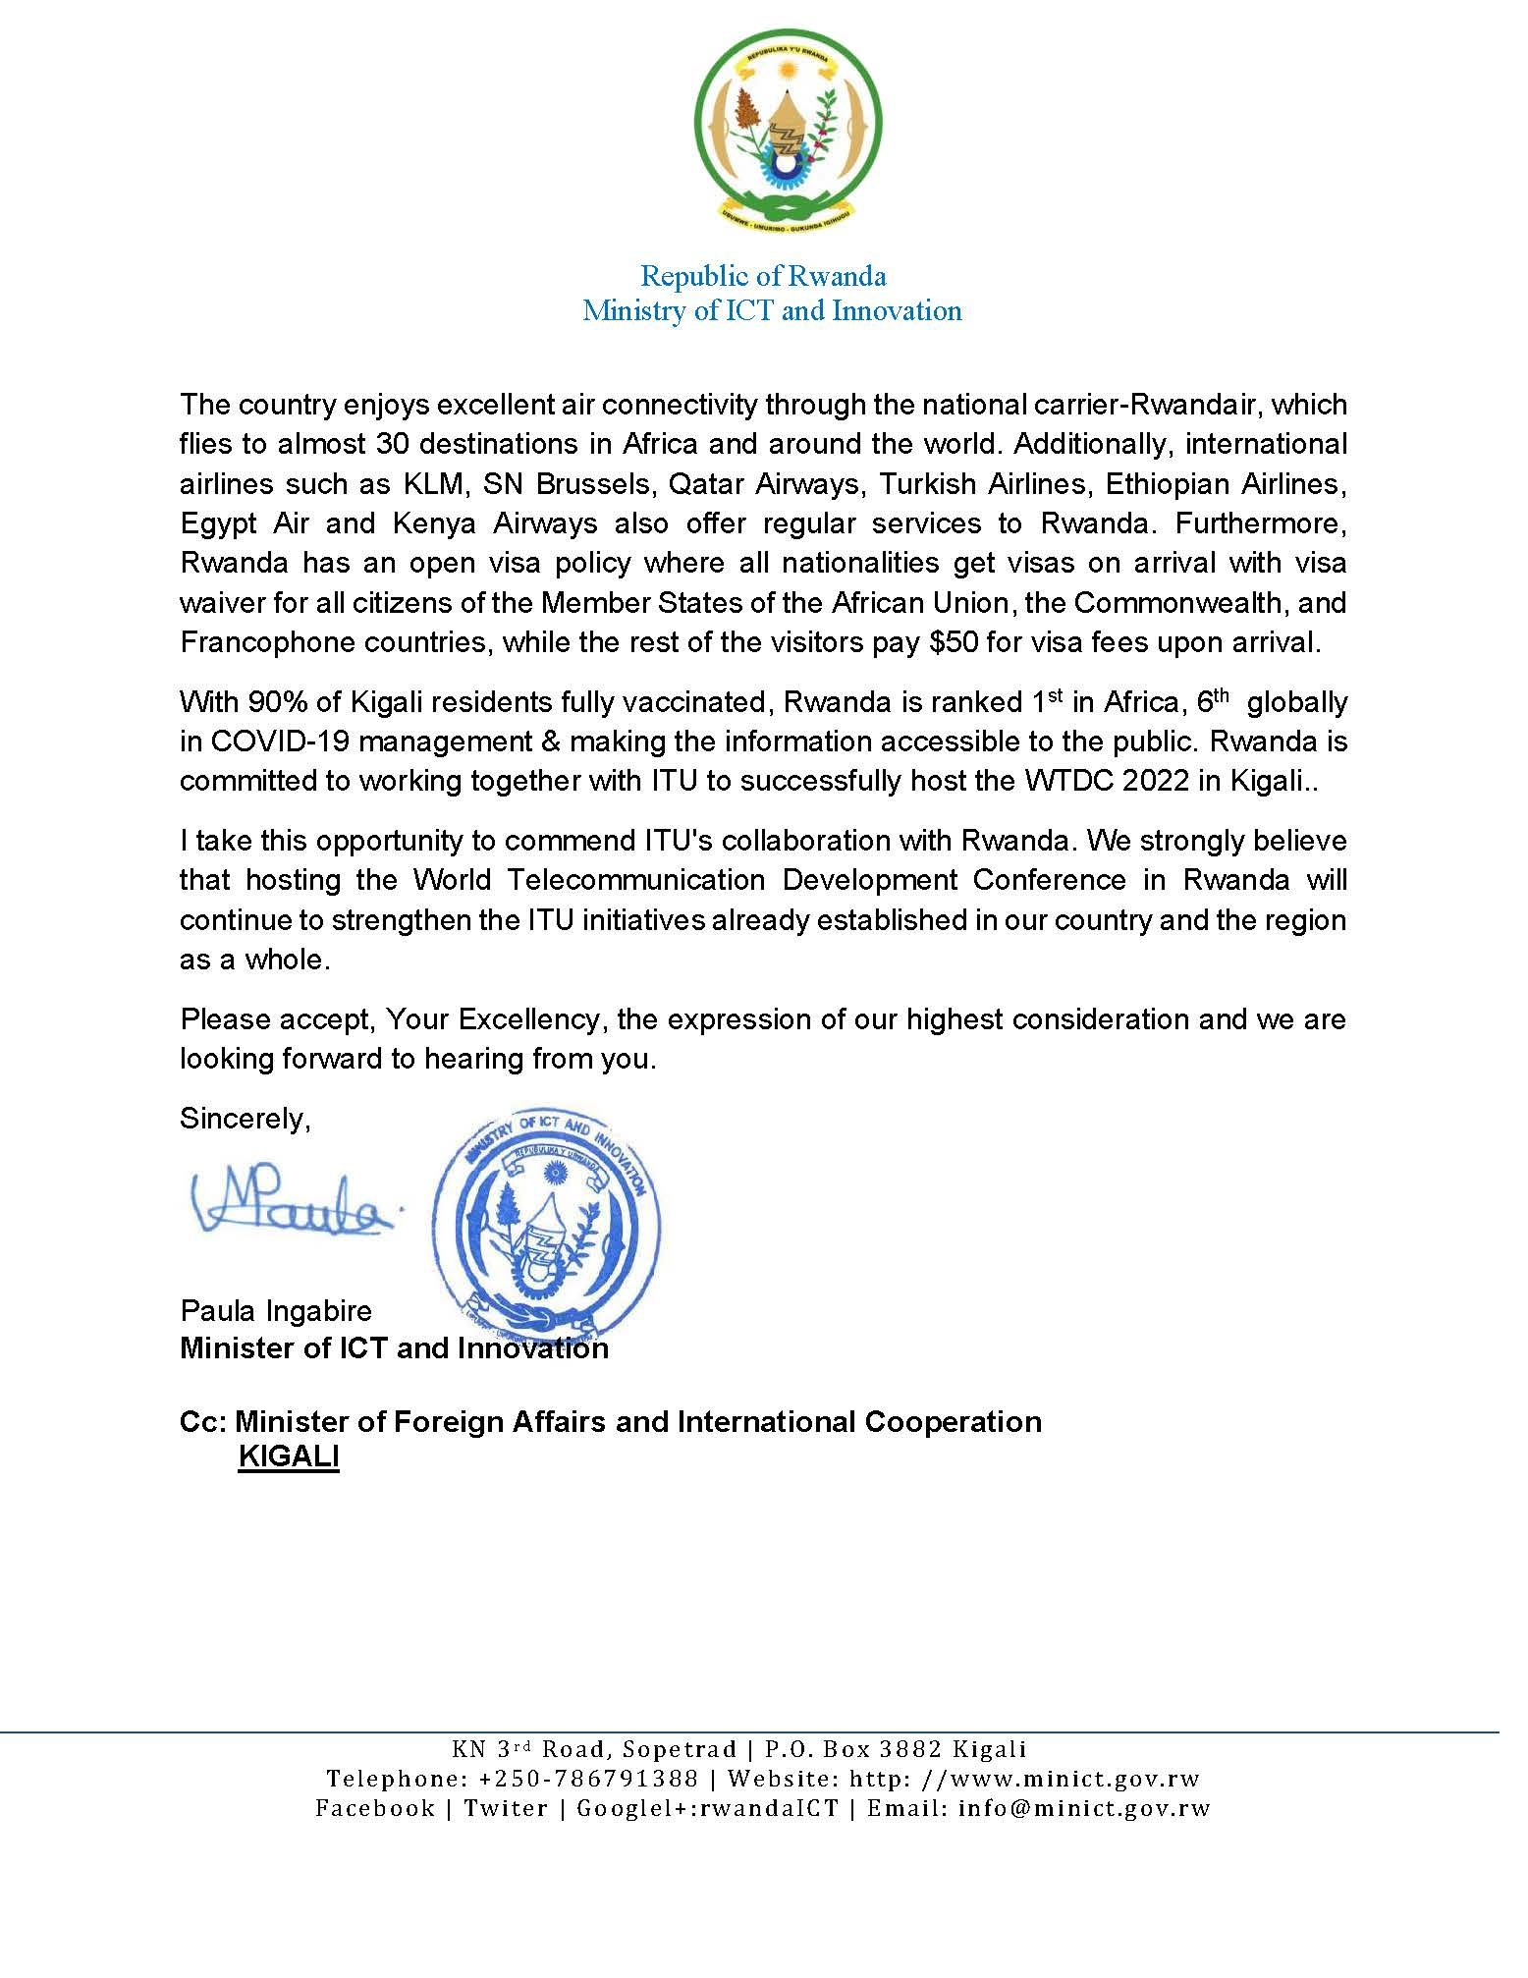

Online tool: Each Administration Focal Point can access directly the online tool by using her/his ITU User account with TIES access login details (username and password). Any Administration Focal Point wishing to designate another person to respond to the Consultation through the online tool is invited to inform ITU via memberstates@itu.int, providing the Username of that designated person. Please note that the online tool is in English only.

