Agenda item: ADM 1 | Document C23/62-E
 | 9 June 2023
 | Original: English
Report by the Secretary-General
TOWARDS A NEW “One ITU” RESOURCE MOBILIZATION STRATEGY
Purpose
The Plenipotentiary Conference (Bucharest, 2022) instructed the Secretary-General in Decision 5 (Rev. Bucharest, 2022) to develop an ITU-wide resource mobilization strategy to address the need for additional funding to meet organizational priorities and to present it to the ITU Council for review and guidance on its implementation.
This document is a first step towards that strategy. It provides baseline data and background information, along with initial plans of the secretariat and recommendations for the Council. The purpose of this document is to identify ways of strengthening both the regular budget and extra-budgetary revenues. With inputs from the 2023 session of the Council, the secretariat will then refine the concepts presented and further develop the strategy for presentation to the 2024 session.
Action required by the Council
The Council is invited to note this document.
Relevant link(s) with the Strategic Plan
Resource mobilization.
Financial implications
Potential to increase regular budget and extra-budgetary funding.
__________________
References
Decision 5 (Rev. Bucharest, 2022) of the Plenipotentiary Conference; Council documents C17/67, and C23/INF/12; Kigali Action Plan.

1. Background
1.1 The Plenipotentiary Conference (Bucharest, 2022) (PP-22) instructed the Secretary-General in Decision 5 (Rev. Bucharest, 2022) to develop an ITU-wide resource mobilization strategy to address the need for additional funding to meet organizational priorities and present it to the ITU Council for review and guidance on its implementation.
1.2 In addition, the ITU strategic plan for 2024-2027, as approved by PP-22, notes:
Accelerated resource mobilization efforts and increased financing are critical to achieving the goals of the Union and enhancing ITU support for the membership. ITU, therefore, recognizes the need to identify the most effective ways to mobilize extrabudgetary resources, build its resource mobilization capacity and enhance its current fundraising strategy while leveraging partner inputs to complement these efforts. ITU will develop long-term financial commitment frameworks in order to effectively plan, programme and deliver on projects and enhance predictability of resource flows.
1.3 At its 2017 session, the Council agreed to principles for resource mobilization, available here. In these principles, the Council agreed:
As ITU’s primary source of revenues, the top priority for Resource Mobilization is assessed contributions from ITU’s Member States. These contributions are provided to support an agreed Strategic Plan and its implementation through Operational Plans, using the ITU Regular Budget. Therefore, Member States are encouraged to prioritize their assessed contributions as their main financial support to ITU, either by maintaining or when possible, increasing these contributions before considering providing resources for activities outside of the ITU Regular Budget.
It also agreed that the secretariat will encourage members and other stakeholders, to the extent possible, to provide support for extra-budgetary, voluntary contributions to meet organizational priorities.
1.4 As a follow-up to Decision 5 (Rev. Bucharest, 2022), the secretariat raised this item for discussion during the internal ITU Visioning Exercise (Pillars I and II) from November 2022 to February 2023 and the ITU Senior Management Retreat in February 2023. Following these discussions, the secretariat engaged Boston Consulting Group (BCG) on a pro-bono basis to support ITU in the development of an ITU-wide funding and resource mobilization strategy, resulting in a first draft of an ITU-wide resource mobilization strategy that articulates ITU's value proposition and engagement model with a focus on:
- understanding ITU’s current funding situation;
- articulating ITU’s value proposition, based on membership and stakeholder interviews, in a compelling way for increased resource mobilization;
- proposing a new engagement and resource mobilization model and options for its implementation.
2. Key findings from the Visioning Exercise, Senior Management Retreat and BCG-supported resource mobilization project
2.1 ITU funding analysis: current situation and trends
a. Regular budget and extra-budgetary revenues
Revenues from Member State units have been stable over the past five years. In 2022, Member States’ assessed contributions represented 61 per cent of ITU’s total revenues.
Revenues from Sector Members’ contributions, including Associates and Academia, represent approximately 9 per cent of ITU’s total revenues. While Sector membership has grown to its highest-ever level, approaching 1 000 member entities, revenues from Sector membership fees have remained largely flat for more than a decade, hovering between CHF 16 million and CHF 17 million, as most growth has come from lower-fee-paying categories of membership, including Associates, Academia and, most recently, small and medium enterprises, and owing to fee exemptions for qualifying organizations of an international character.
Cost recovery has been applied to the processing of satellite network filings, allocation of numbering resources and BDT project support. Other extra-budgetary revenues from the sales of publications have a relatively predictable cycle based mainly on scheduled releases of key maritime radiocommunication service-related publications. The lower-revenue years in this cycle presented a challenge for ITU budget planning.
Table 1. Regular budget and extra-budgetary revenues
 | 2018 | 2019 | 2020 | 2021 | 2022
Member States | 108.6 | 109.9 | 109.3 | 109.3 | 109.2
Sector membership | 16.3 | 16.6 | 16.4 | 16.3 | 16.3
Publications | 13.9 | 15.6 | 17.1 | 19.4 | 14.6
Satellite filings | 19.1 | 12.1 | 13.6 | 11.2 | 10.2
Others (numbering, project support, ITU Telecom) | 3.4 | 2.6 | 1 | 0.9 | 1.25
Voluntary contributions | 13.8 | 14 | 10.8 | 19.9 | 12.8
b. Overview of extra-budgetary funding
In 2022, a total of CHF 12.8 million was received as extra-budgetary funding, of which 56 per cent was received for projects, 19 per cent for staff-related reasons such as secondment or loan, 15 per cent for event-related sponsorship (mainly AI for Good, WSIS, Broadband Commission and youth summit) and 10 per cent for other contributions.
Extra-budgetary funding represented approximately 8 per cent of total revenues in 2022. This share is small compared to that of many other United Nations agencies, including other specialized agencies that rely mainly on assessed contributions.
In 2022, extra-budgetary funding was distributed across ITU, with BDT receiving 64 per cent, TSB 18 per cent, BR 2 per cent and the General Secretariat 16 per cent. The list of top donors for 2022 is available in Annex 1 hereto.
In 2022, 65 per cent of extra-budgetary funding representing CHF 8.4 million came from Member States, of which a high share, some CHF 3.8 million, came from national development agencies and ministries of foreign affairs. There is the potential to deepen collaboration with official development assistance (ODA) organizations on projects and technical aid, as ITU has worked with only a few to date. See Annex 2 hereto.
In terms of private-sector extra-budgetary contributions, ITU mobilized CHF 1.9 million from industry (Members and non-members) in 2022, representing 15 per cent of extra-budgetary funding. The biggest donors from the private sector in 2022 were Huawei, ZTE Corporation, Microsoft, Meta, Technology Innovation Institute and IBM, each providing at least CHF 150 000.
ITU currently does not raise very significant funding from foundations. Recent contributions have come from the Botnar Foundation (CHF 442 000 in 2022). This represents an avenue for further exploration as ITU areas are of growing interest to foundations and philanthropic institutions.
2.2 Funding models across the United Nations system
Very different funding models exist across the United Nations system, depending on the different mandates and core activities of each organization. Some organizations, such as UNICEF, UNHCR and WFP, rely primarily on voluntary contributions which are mainly earmarked for specific projects and initiatives. Emergency-related fundraising tends to account for a significant percentage of funds raised. These organizations have developed significant professional fundraising operations, seeking contributions from governments, the private sector, foundations, high-net-worth individuals and even the general public.
On the other hand, organizations such as ITU, UPU, IAEA, ILO, IMO, UNESCO and WMO generally rely primarily on assessed contributions to fund their operations and implement agreed programmes of work, in some cases supplemented by voluntary contributions for projects and special initiatives. WIPO stands out as having developed a business model that generates the vast majority of its revenues from its patent-related services.
Several United Nations agencies have had a recent budget increase, including IOM, WHO, WMO:
• At IOM, at the 113th session of the IOM Council (October 2022), it was approved there would be an increase in the administrative part of the budget of USD 12 million per year over a period of five years, funded through assessed contributions from Member States. By 2027, this should total an additional USD 60 million per year.
• At WHO, at the 76th World Health Assembly (May 2023), the WHO programme budget for 2024-2025 was approved with an increase of 20 per cent in assessed contributions. This decision will take the WHO budget to USD 6.83 billion.
• At WMO, the World Meteorological Congress (June 2023) approved a regular budget of just over CHF 278 million for the 2024-2027 financial period, a 2.4 per cent increase over 2020-2023.
2.3 Perception assessment of ITU from key stakeholders
Since February 2023, ITU and BCG have been collecting feedback from stakeholders internally and externally, including from Member States, the private sector, the social sector and peer United Nations agencies, from over 70 interviews, and analysed over 100 documents and reports. Several key learnings that came from this exercise, which also echo the outcomes of the Visioning Exercise and Senior Management Retreat, highlight key opportunity areas for increasing ITU’s value and impact:
- Position ITU as an organization that is stronger and fit-for-purpose, demonstrating an impact;
- Increase private-sector engagement;
- Update legacy structures and simplify processes;
- Structure data better and share knowledge;
- Enhance coordinated outreach with stakeholders.
2.4 “One-ITU” positioning framework
Based on the above analysis, the ITU secretariat and BCG worked together to refine a “One ITU” positioning framework based on five key value pillars (see Table 2), in line with objectives of the ITU strategic plan and anchored in key themes for a comprehensive resource mobilization strategy. The proposed framework has the potential to also improve consistency in the external communication of ITU’s offerings to members and other stakeholders.
The five key value pillars of the “One ITU” positioning framework build on the already demonstrated capabilities of ITU:
- Creates a convening platform;
- Shapes market policy and guides investment decisions;
- Unlocks economies of scale via standardization;
- Provides trusted data and knowledge; and
- Orchestrates multistakeholder projects.
The secretariat proposes to leverage these five value pillars as the foundation for building out a “One ITU” resource-mobilization value proposition.
Table 2. “One ITU” positioning framework: five value pillars and horizontal themes
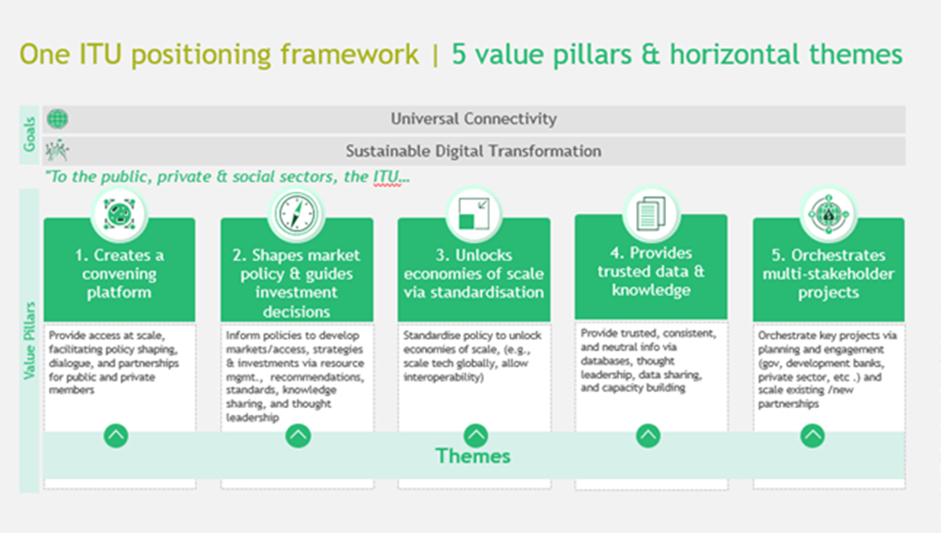
2.5 Risk management
As ITU increases efforts to raise extra-budgetary funding, and increasingly from entities outside of its membership, it is essential that steps be taken to minimize risks and protect the reputation and neutrality of the Union. To this end, ITU has implemented policies and procedures to strengthen its risk management in relation to partnerships and fundraising, including a Service Order 20/03, on ITU guidelines for event-related sponsorship, introduced in 2020 and, more recently, Service Order 22/12, on ITU guidelines on due diligence for non-member private-sector entities, introduced in late 2022, which require ITU staff to screen any non-ITU Member entity before finalizing any formal agreement. This due diligence procedure responds to recommendations from the external and internal auditors and is based on best practices within the United Nations system that have been adapted to ITU’s situation.
2.6 Potential strategies going forward
Three initial areas of focus were identified:
a. Strengthen core membership offering to increase engagement and lay the foundation for Sector membership fee structure changes.
This includes:
- Exploring options to strengthen Member engagement and value proposition;
- Implementing new measures to better coordinate account management and service to Member States, Sector Members, donors, etc.;
- Investing in internal enablers, including IT systems, building staff capacity and skills, streamlining and modernizing financial and administrative rules and processes, etc.;
- Encouraging existing Sector Members to have memberships across multiple Sectors and Associates to upgrade to full Sector membership;
- Identifying key non-member companies from under-represented parts of the digital ecosystem to join ITU.
b. Develop “One-ITU” thematic initiatives as complementary to membership, formalizing “extra-budgetary” contributions with multi-year commitments.
This includes:
- Developing and promoting “One ITU” thematic initiatives to complement activities funded by the regular budget;
- Strengthening “One ITU” coordination of outreach with Members, partners and donors;
- Strengthening capacity for project implementation.
c. Leveraging standalone offerings to better capture and synergize value and impact.
This includes:
- Leveraging major ITU events which have built communities of shared interest among Members and partners to build a more comprehensive and higher-impact value proposition;
- Reviewing the ITU-wide portfolio of products and services to explore the potential to increase revenues received from Sector Members;
- Exploring increasing minimum thresholds for sponsorship/voluntary contributions in a service order to reflect the internal administrative/staff cost of acquisition.
3. Next steps and actions planned by the secretariat
The Council is invited to note this document. Taking into account feedback from the Council, the secretariat will update/refine the draft ITU-wide resource mobilization strategy as outlined in this document. All Council participants are also encouraged to reach out to the ITU secretariat on a bilateral basis to share views and suggestions.
As an immediate action, the secretariat has established a “OneITU” implementation task force to assess, coordinate and explore the initial pilot implementation of the resource mobilization strategy. An update on the final resource mobilization strategy and its implementation status will be presented to the 2024 session of the Council.

Annexes: 2

Annex 1
Top donors in 2022

Organization | Country | Amount (CHF)
Federal Department of Foreign Affairs | Switzerland | 1 020 000
Ministry of Industry and Information Technology | China | 985 924
Norwegian Agency for Development Cooperation | Norway | 932 498
Ministry of Internal Affairs and Communications | Japan | 833 170
Department of Foreign Affairs and Trade | Australia | 826 259
UNDP MPTF | International | 697 178
Department of Communications and the Arts | Australia | 688 978
Permanent Representative of the Mission of the Republic of Korea and Ambassador | Republic of Korea | 606 916
Foreign, Commonwealth and Development Office | United Kingdom | 525 555
Botnar Foundation | Switzerland | 442 247

Annex 2
Contributions from official development assistance organizations, ministries of foreign affairs and missions in 2022

Organization | Country | Amount (CHF)
Federal Department of Foreign Affairs | Switzerland | 1 020 000
Norwegian Agency for Development Cooperation | Norway | 932 498
Department of Foreign Affairs and Trade | Australia | 826 259
Permanent Representative of the Mission of the Republic of Korea and Ambassador | Republic of Korea | 606 916
Foreign, Commonwealth and Development Office | United Kingdom | 525 555
Secretaría de Estado de Asuntos Exteriores y Globales | Spain | 394 031
Permanent Mission of Japan | Japan | 138 365
Büro Führungskräfte zu Internationalen Organisationen | Germany | 127 421
Permanent Mission of the Czech Republic | Czech Republic | 20 373
République and Canton de Genève | Switzerland | 1 500
_________________

IOM Programme and Budget for 2023. See Document C/113/7
WHO press release
WMO press release

