Agenda item: PL 3 | Revision 1 to  Document C24/30-E
 | 24 May 2024
 | Original: English
Report by the Secretary-General
PREPARATIONS FOR THE 2025 WORLD TELECOMMUNICATION DEVELOPMENT CONFERENCE (WTDC-25)
Purpose
This document informs the Council of the invitation received from the Ministry of Digital Development and Transport of the Republic of Azerbaijan to host the World Telecommunication Development Conference 2025 (WTDC-25) in Baku, from Monday, 17 November to Friday, 28 November 2025. It also includes the proposed draft agenda.
Pursuant to No. 42 and No. 212 of the ITU Convention, the Council will be invited to fix the precise place and exact dates of the next World Telecommunication Development Conference (WTDC) and to approve the draft agenda with the concurrence of the majority of the Member States.
Action required by the Council
The Council is invited:
- to decide on the precise place and exact dates of WTDC-25, subject to the concurrence of the majority of the Member States of the Union and to adopt the draft decision contained in Annex 2 to this document; and
- to approve the draft agenda of the WTDC-25 presented in Annex 3, subject to the concurrence of the majority of the Member States of the Union.
Relevant link(s) with the Strategic Plan
Convening platform; membership driven.
Financial implication
To be implemented within the allocated budget 2024-2025.
__________________
References
No. 141 of the ITU Constitution; No. 42 of the ITU Convention; Chapter I of the General Rules of Conferences, Assemblies and Meetings of the Union; Resolution 77 (Rev. Bucharest, 2022) and Resolution 111 (Rev. Busan, 2014) of the Plenipotentiary Conference; Circular letter CL-23/51

1. Background
1.1 No. 141 of the ITU Constitution provides that there shall be a World Telecommunication Development Conference (WTDC) between two Plenipotentiary Conferences.
1.2 Resolution 77 (Rev. Bucharest, 2022) of the Plenipotentiary Conference resolves that WTDC-25 shall be held in the last quarter of 2025 in Bangkok, Thailand.
1.3 Resolution 111 (Rev. Busan, 2014) calls on the Union and its Member States to make every effort, as far as practicable, to ensure that the planned period of any ITU conference does not conflict with what may be considered a major religious period by a Member State.
1.4 No. 42 of the ITU Convention and Chapter I of the General Rules of Conferences, Assemblies and Meetings of the Union require, respectively, that, in the absence of a decision by the Plenipotentiary Conference, the precise place and the exact dates of a WTDC be approved by the Council with the concurrence of a majority of the Member States.
1.5. On 7 December 2023, the Secretary-General was officially informed by the Office of the National Broadcasting and Telecommunications Commission that due to unforeseen circumstance, Thailand will unfortunately not be in a position to host the Conference. Through CL 23/51 the Secretary-General therefore invited Member States that would be interested to host the WTDC-25 to inform her accordingly.
1.6 On 15 March 2024, the ITU Secretary-General received an invitation from the Government of the Republic of Azerbaijan. Following exchanges with the BDT Director, the Minister of Digital Development and Transport has confirmed in a letter dated 3 April 2024 their intention to host the conference in Baku, at the end of November 2025. In a follow-up letter dated 26 April 2024, the period from 17 to 28 November 2025 was proposed (see Annex 1).
1.8 A draft agenda for the forthcoming WTDC-25 is presented in Annex 3 for approval by the Council subject to subject to the concurrence of the majority of the Member States of the Union.
1.9 The draft agenda is being submitted to the Telecommunication Development Advisory Group (TDAG) (20-23 May 2024) for discussion and endorsement. A revised version might be submitted after TDAG to the Council.
2. Proposal
2.1 The Council is invited:
- to consider the invitation of the Republic of Azerbaijan to hold WTDC-25 in Baku, Azerbaijan from 17 to 28 November 2025 and to adopt the draft decision in Annex 2; and
- to approve the draft agenda of WTDC-25 in Annex 3.
2.2 A consultation of ITU Member States will then be launched to secure their concurrence regarding the precise place, the exact dates and the draft agenda in accordance with Nos 42, 79 and 212 of the ITU Convention.
2.3 The secretariat will undertake a mission to assess various venues in Baku for the conference and report to the next Council session.
Annexes: 3

ANNEX 1

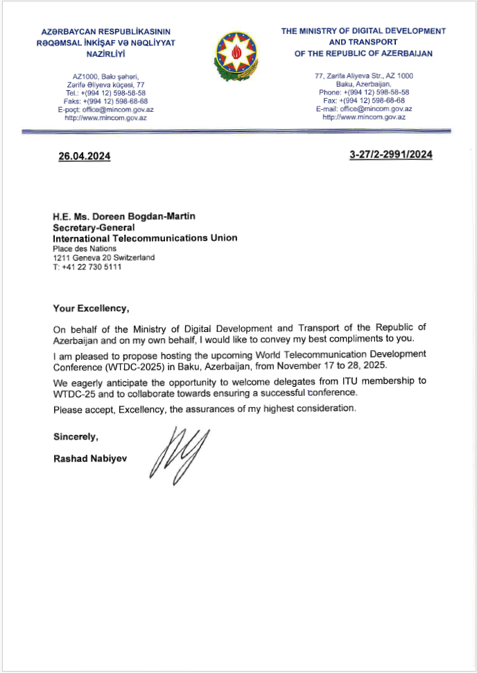
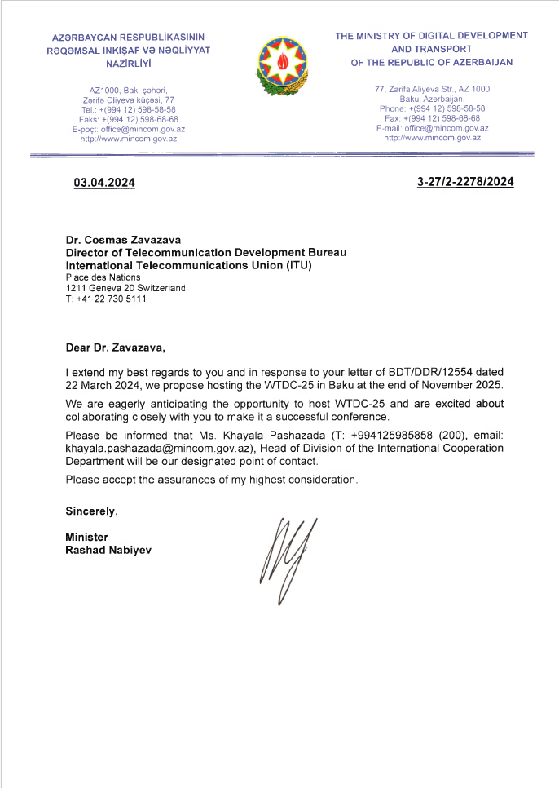
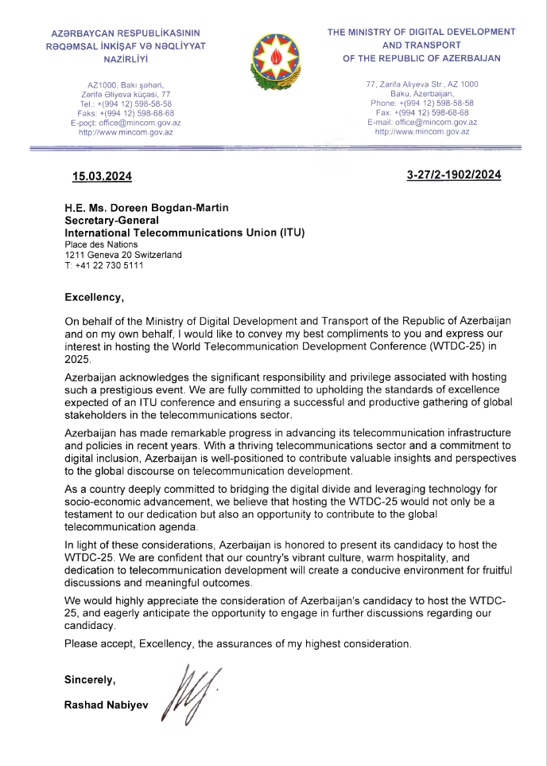
ANNEX 2
DRAFT DECISION […]
Convening of the 2025 World Telecommunication Development Conference (WTDC-25)
The ITU Council,
noting
that WTDC-25 is scheduled to be held in the last quarter of 2025, in accordance with Resolution 77 (Rev. Bucharest, 2022) of the Plenipotentiary Conference on Scheduling and duration of conferences, forums, assemblies and Council sessions of the Union (2023-2027),
decides
that, subject to the concurrence of the majority of the Member States of the Union, the next World Telecommunication Development Conference (WTDC-25) will take place in Baku, Republic of Azerbaijan, from 17 to 28 November 2025,
instructs the Secretary-General
to undertake a site visit and report to the 2025 session of the Council.

Annex 3
Draft agenda of the 2025 World Telecommunication
Development Conference (WTDC-25)

I. Report on the implementation of the ITU-D Action Plans
1. Update on global digital transformation and reporting on the implementation of the WTDC-17 Buenos Aires Action Plan and the WTDC-22 Kigali Action Plan (including the Regional Initiatives), contribution to the implementation of the WSIS Plan of Action and the Sustainable Development Goals (SDGs)
2. Report of the Telecommunication Development Advisory Group
3. Report of Study Groups
4. Report on the implementation of outcomes of other ITU Conferences, Assemblies and meetings related to ITU-D work:
a. Plenipotentiary Conference (PP-22)
b. Radiocommunication Assembly (RA-23)/World Radiocommunication Conference (WRC-23)
c. World Telecommunication Standardization Assembly (WTSA-24)

II. Policy and strategy for digital transformation
5. Ministerial and Industry leaders’ roundtables and policy statements

III. ITU-D work plan for 2026-2029
6. Outcomes of Regional Preparatory Meetings for WTDC
7. ITU-D contribution to the ITU Strategic Plan for 2028-2031
8. ITU-D Priorities
9. ITU-D Action Plan for the following cycle
10. WTDC Declaration
11. Telecommunication Development Advisory Group
a. Authorization for the Telecommunication Development Advisory Group to act between world telecommunication development conferences (Resolution 24, Rev. Dubai, 2014)
b. Structure and working methods
12. Study Groups
a. Study Questions
b. Structure and working methods
13. Regional Initiatives
14. Resolutions and recommendations
_______________

