Agenda item: ADM 1 | Document C24/38-E
 | 9 April 2024
 | Original: English
Report by the Secretary-General
STATUS REPORT ON IMPLEMENTATION OF COUNCIL DECISIONS 600 AND 601 (UIFN, IIN)
Purpose
Following the approval of Decisions 600 and 601 at the Council 2017 session, ITU has been in the process of implementing these Decisions. This report provides updates to what was reported in CWG-FHR-17/8.
Action required by the Council
The Council is invited to note this report.
Relevant link(s) with the Strategic Plan
International telecommunication numbering resources.
Financial implications
Revenue from the implementation of Council Decisions 600 and 601 are included in the 2024-2025 budget.
__________________
References
Document C17/133; C17/134; C18/100; CWG-FHR 9/14; CWG-FHR 9/15; C19/47, C19/120; C20/47; C21/47; CWG-FHR-14/6; CWG-FHR-14/7;CWG-FHR-14/12; C22/50; CWG-FHR-17/8

Background
1 Following the approval of Decisions 600 (C17/133) and 601 (C17/134) at the 2017 session of the Council, the ITU secretariat has been in the process of implementing these Decisions.
2 The Telecommunication Standardization Bureau (TSB) presented document CWG-FHR-17/8 to the seventeenth Council Working Group on Financial and Human Resources (CWG-FHR) meeting which contained the status of implementation of the Council Decisions and the revenue from Universal International Freephone Number (UIFN) and Issuer Identifier Number (IIN).
3 This document provides an update on this implementation since the CWG-FHR meeting in January 2024.

Financial updates
1 UIFN (Council Decision 600):
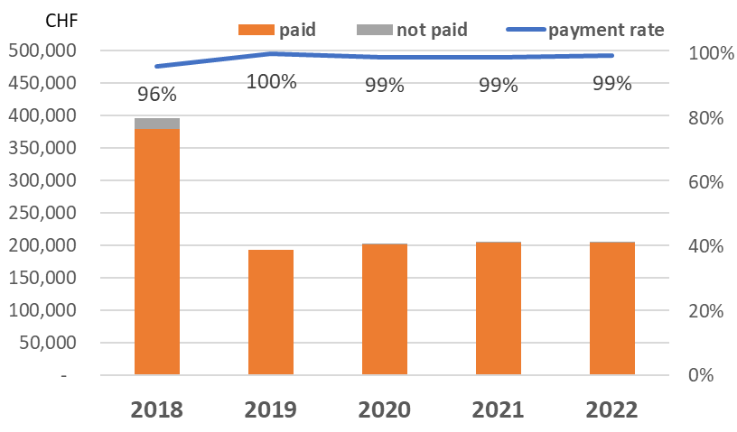
After the CWG-FHR updates provided in January 2024, the following additional payments have been made up to of 1 March 2024:
- For the annual maintenance fee for 2018, an additional CHF 700 was paid. To date 96% of the valid invoices have been paid and CHF 15 600 still needs to be recovered.
- For the unpaid annual maintenance fee for 2019, an additional CHF 100 was paid and 100% of the payments have been received.
- Regarding the annual maintenance fee for 2022, an additional CHF 55 900 was received, with a total of 99% of all payments having been received.
The unpaid fee for the period of 2018-2022 decreased to CHF 16 900.
Annex 1 lists the entities for which TSB has a valid contact, that have been billed for 2018-2023 and have not paid their bills as of 1 March 2024.
2 Revenue from UIFN and IIN
For 2023, the revenue from UIFN is CHF 266 700 (Includes one-off fee and annual maintenance fee).

Conclusion

The secretariat continues the implementation of Council Decisions 600 and 601.

Annex: 1

Annex
list of UIFN service providers pending payment for 2018, 2019, 2020, 2021, 2022 and 2023 (as of 1 March 2024)

year | Amount | currency | UIFN quantity | Company's name | Country/  Geographic Area | note
2018 | 14,000.00  [partial payment: CHF 2800] | CHF | 140 | Bezeq International | Israel
2018 | 5,600.00  [partial payment from credit:  CHF 4000] | CHF | 56 | International Telcom Ltd. | United States
2023 | 4,000.00 | CHF | 40 | POST Luxembourg | Luxembourg
2023 | 2,300.00 | CHF | 23 | TeliaSonera Finland Oyj | Finland
2023 | 1,300.00 | CHF | 13 | Slovak Telekom, a.s. | Slovakia
2018 | 1,000.00 | CHF | 10 | Eutelia S.p.A. | Italy | partially purchased by CloudItalia with no UIFN responsibility, however,  3 UIFNs are reachable
2023 | 700.00 | CHF | 7 | Cable & Wireless Panamá S.A. | Panama
2022 | 600.00 | CHF | 6 | PLANinterNET VoIP-GmbH | Germany
2023 | 600.00 | CHF | 6 | HELLENIC TELECOMMUNICATIONS ORGANIZATION S.A. | Greece
2018 | 500.00  [partial payment from credit:  CHF 200] | CHF | 5 | Telefónica S.A.  (formerly Colombia Telecomunicaciones S.A. ESP - Telecom Colombia) | Colombia
2018 | 500.00  [partial payment from credit:  CHF 400] | CHF | 5 | Kingston communications/Affiniti | United Kingdom
2021 | 500.00 | CHF | 5 | Qupra Wholesale | Netherlands
2018 | 400.00 | CHF | 4 | HKBN Enterprise Solutions HK Limited (ex-WTT HK Limited) | Hong Kong, China
2023 | 400.00 | CHF | 4 | Telia Lietuva AB | Lithuania
2018 | 300.00  [partial payment: CHF 200] | CHF | 3 | Telefonica del Peru | Peru
2018 | 300.00 | CHF | 3 | PTGI INTERNATIONAL CARRIER  (formerly PRIMUS Telecommunications Ltd.) | United Kingdom
2023 | 200.00 | CHF | 2 | EMTEX GmbH | Germany
2023 | 200.00 | CHF | 2 | Vivacom Bulgaria EAD | Bulgaria
2018 | 200.00 | CHF | 2 | Altice France  (formerly Télécom Développement) | France
2020 | 200.00 | CHF | 2 | Telefónica de Argentina S.A | Argentina
2023 | 100.00 | CHF | 1 | HGC Global Communications Limited | Hong Kong, China
2018 | 100.00 | CHF | 1 | Telecable de Asturias SA | Spain
2018 | 100.00 | CHF | 1 | Vodafone New Zealand | New Zealand
2018 | 100.00 | CHF | 1 | Empresa Hondureña de Telecommunicaciones (HONDUTEL) | Honduras
2018 | 100.00 | CHF | 1 | Telecom Itália Móbile S.p.A. (TIM)  (ex-INTELIG Telecomunicações Ltda.) | Brazil

