Agenda item: ADM 3 | Revision 1 to  Document C24/56-E
 | 21 May 2024
 | Original: English
Report by the Secretary-General
REPORT ON THE IMPLEMENTATION OF RESOLUTION 1420
Purpose
ITU Council at its 2023 session adopted Resolution 1420 accepting the amendments to the statute of the International Civil Service Commission (ICSC) adopted by the United Nations General Assembly (UNGA) at its 77th session on 30 December 2022 in Resolution 77/256 A and instructed the ITU Secretary-General to notify this acceptance to the Secretary-General of the United Nations (UN).
This report outlines the implementation of the resolution, with particular emphasis on noteworthy advancements pertaining to the Post Adjustment Multiplier (PAM) for Geneva.
Action required by the Council
The Council is invited to take note of the implementation of Resolution 1420 and the application of the PAM established by the ICSC with effect from 1 February 2024.
Relevant link(s) with the Strategic Plan
ITU as a part of the United Nations Common System.

Financial implications
The ICSC issued the outcome of the post-adjustment annual review on 14 February 2024. The financial consequences for 2024 of the implementation of the new post adjustment for Geneva amount to CHF 1 369 293 (to cover an 11-month period from 1 February 2024 until the end of the year) and CHF 1 493 774 for 2025. For the biennium 2024-2025 the total financial implication amounts to CHF 2 863 066.
In case this increase cannot be absorbed by the 2024-2025 budget, according to Council Resolution 1417, the Secretary-General is authorized, during the implementation of the budget for 2024-2025, to adjust appropriations related to expenses (such as post adjustments applicable to Geneva, as adopted by the United Nations Common System) through the use of the Reserve Account.
______________
References
Council Document C23/56; Resolution 1420 adopted by the 2023 Session of the ITU Council

1 BACKGROUND
1.1 To clarify the decision-making authority of the International Civil Service Commission (ICSC) with respect to the determination of post adjustment multipliers, the UNGA approved amendments to Articles 10 and 11 of the ICSC statute in December 2022. The UNGA invited the relevant organizations of the UN Common System to confirm formal acceptance of the amended statute.
1.2 In Resolution 1420, which was adopted at the seventh Plenary meeting of the 2023 session of the Council, the ITU Council accepted the amendments to the statute of ICSC in UNGA Resolution A/RES/77/256 A. Subsequently, the Secretary-General has notified the United Nations Secretary-General of this acceptance.
1.3 The Council also authorized the Secretary-General to explore any permissible flexibility in implementing Resolution 1420. Bearing in mind the high inflation and steep increase in the cost of living in Geneva, ITU, in collaboration with other Geneva-based specialized agencies (WHO and WIPO), and after consultation with the ICSC, decided to maintain the Post Adjustment Multiplier (PAM)for Geneva based on the 2010 Cost-of-Living (COL) survey results, in anticipation of the upcoming annual review by the ICSC, aiming to more comprehensively reflect the current living conditions.
1.4 On 14 February 2024, the ICSC issued the outcome of the post adjustment classification annual review for New York, pursuant to UNGA Resolution A/RES/70/244 (section II, para 5), which resulted in an increase in the post adjustment multiplier for New York from 80.5 to 88.4.
1.5 The post adjustment classifications review of all headquarters and other group I duty stations, on the anniversary date of the post adjustment classification review for New York, pursuant to UNGA Resolution A/RES/69/251 (Section E), led to real salary increases in 51 (out of 53) group I duty stations, whose updated post adjustment indices exceeded their prevailing pay indices, with effect from 1 February 2024.
1.6 This review, coupled with adjustments in pensionable remuneration (as of 1 February 2024 by a ratio of 188.4/180.5; see Annex 1), resulted in a net increase of approximately 1.5% in take-home pay for staff in Geneva for February 2024, when applying the ICSC established PAM for Switzerland of 89.7 (see Annex 2 for New York and Switzerland).
1.7 ITU implemented the PAM established by the ICSC, as reflected in the ICSC circular with an effective date of 1 February 2024. This adjustment brought to an end the recent history of applying two different PAMs in Geneva for Professional and higher category staff.
2 ACTION REQUESTED FROM THE COUNCIL
The Council is invited to take note of the implementation of Resolution 1420 and the application of the PAM established by the ICSC in Geneva with effect from 1 February 2024 onwards.
Annexes: 2

Annex 1
Pensionable remuneration for staff in the Professional and higher categories
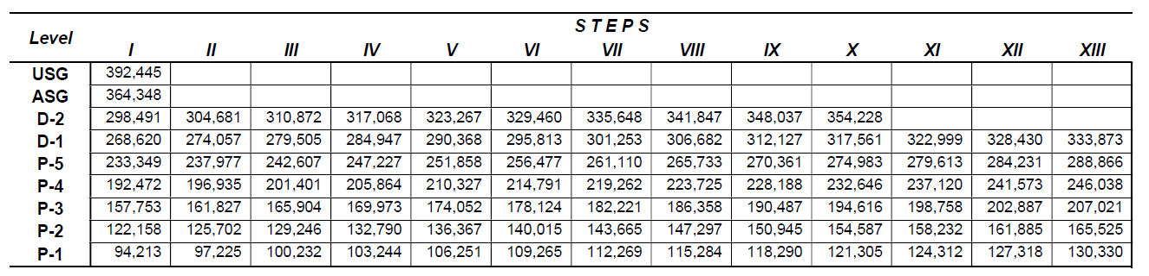
In US dollars - effective 1 February 2024

Annex 2
Post Adjustment Classification Review for Group I Duty Stations, February 2024

DUTY STATION | PAI |  | MULTIPLIER |  |  | Change in Net  Remuneration
 | Feb-24 | Feb-24 | Feb-24  0.5% rule | Feb-24 | Feb-24
 | Pre  Scaling Up | Post  Scaling Up |  | Pre  Scaling Up | Post  Scaling Up
USA, New York | 186.7 | 188.4 | 80.5 | 86.7 | 88.4 | Increase 4.4 %
Switzerland | 188.0 | 189.7 | 83.8 | 88.0 | 89.7 | Increase 3.2 %
____________________

“To authorize, during the implementation of the budget for 2024-2025, the Secretary-General to adjust the appropriations in relation to the items of expenses in a) and b) below, in accordance with changes incurred, through the use of the Reserve Account, provided that the Reserve Account is kept at the level prescribed in Decision 5 (Rev. Bucharest, 2022): a) increases in salary scales, pension contributions and allowances, including post adjustments, applicable to Geneva, as adopted by the United Nations common system; b) fluctuations in the exchange rate between the United States dollar and the Swiss franc in so far as this affects the staff costs for those staff members on United Nations salary scales.”
The aim of the 0.5 per cent rule is to stabilize net-take-home pay (NTP) in local currency by restricting its exchange rate driven fluctuations to within plus or minus 0.5 per cent from one month to the next. NTP in local currency is maintained within a range of plus or minus 0.5 per cent of an established pay level until the next review date, that is, either a full 5 per cent increase in the cost-of living index has been measured or a 12-month period has elapsed whichever comes first.

