Agenda item: PL 1 | Document C24/73-E
 | 6 May 2024
 | Original: English
Report by the Secretary-General
TRANSFORMATION ROADMAP
Purpose
Submission of the ITU Roadmap for Organizational Transformation.
Action required by the Council
The Council is invited to note the roadmap.
Relevant link(s) with the Strategic Plan
ITU Strategic Plan 2024-2027 Enabler – Excellence in human resources and organizational innovation
Financial implications
Financial and human resources related to this roadmap have been addressed in Document C24/52.
__________________
References
Council documents C20/61, C20/74, C21/INF/15, C22/INF/13, C22/40, C22/57, C23/36, C23/50, C23/63, C23/INF/11, C23/INF/13, C24/52.

- Introduction
The case for change on ITU’s organizational excellence has been highlighted in the ITU Strategic Plan for 2024-2027 and Decision 5 (Rev. Bucharest, 2022) of the Plenipotentiary Conference.
In Council document C24/52, the secretariat provided an outline of the approach that is being taken to development and execution of a Roadmap of Transformation, and measurement of the results of the transformation initiatives. This document provides the Transformation Roadmap.
- Transformation Roadmap
The roadmap for the transformation process, for the period from 2024 to 2027, comprises initiatives in several targeted processes as set out in the Gantt chart contained in Annex.
As noted in Document C24/52, the transformation roadmap is organized into four pillars that guide the sequencing and expected results for all targeted processes and initiatives:
- Governance
- Systems, processes and tools
- People and culture
- Resource optimization
Each targeted process will undergo the full transformation sequence, to be integrated into the annual workplans and performance objectives of each relevant department. The transformation sequence comprises the following steps:
- Review and update of policies, rules and regulations applicable to the initiative.
- Review and update of relevant business processes, including assessment and update of technology infrastructure.
- Review and update of organizational structure, skills and responsibilities to align with the new and revised business processes.
- Review of data outputs to assess the success of the initiative.
The transformation roadmap will also include initiatives which implement the efficiency measures outlined in Annex 2 to Decision 5 (Rev. Bucharest, 2022), as these are well aligned with the objectives of the Transformation.
Where appropriate, follow up initiatives may be designed and undertaken if the outputs do not fully achieve the desired outcomes.
It is worth noting that the transformation roadmap also includes specific initiatives related to Organizational Structure and Digital Transformation. These initiatives will continuously assess the combined impact of the reviews that are being carried out as part of the individual initiatives, to ensure a cohesive and coherent organisation wide approach.
This approach, illustrated in the following figure, is designed to ensure a comprehensive and sustainable approach to transformation.
- Agile Change Mechanisms
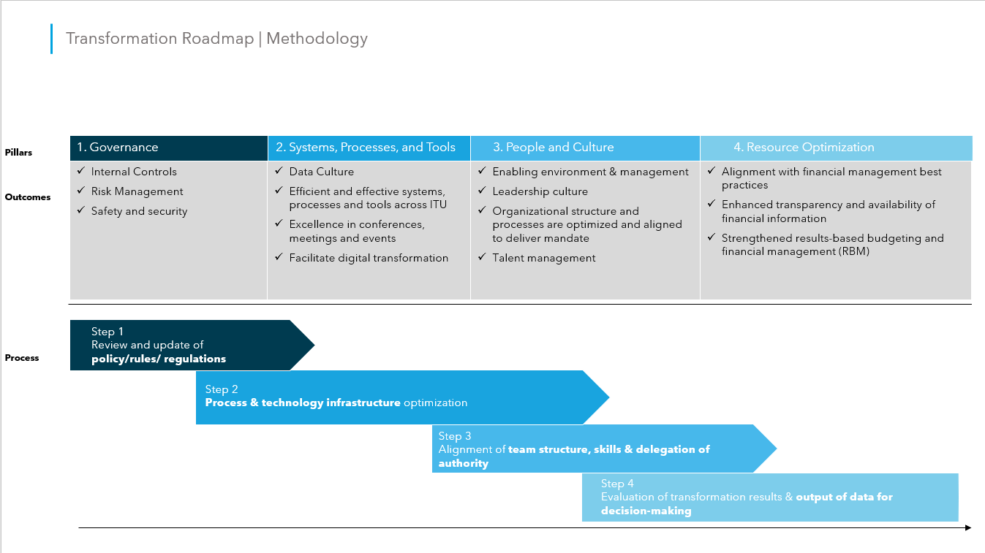
In addition to the formally scheduled initiatives that follow full sequencing, where appropriate based on the nature of the initiative, some processes have been identified as accelerated initiatives. This ensures that the transformation process does not result in stagnation where a more flexible approach is appropriate and the full sequence may not be needed, or where urgent organisational needs require an expedited approach. To date, six initiatives are included in this category. The acceleration of initiatives is based on a feasibility/impact analysis illustrated in the following figure:
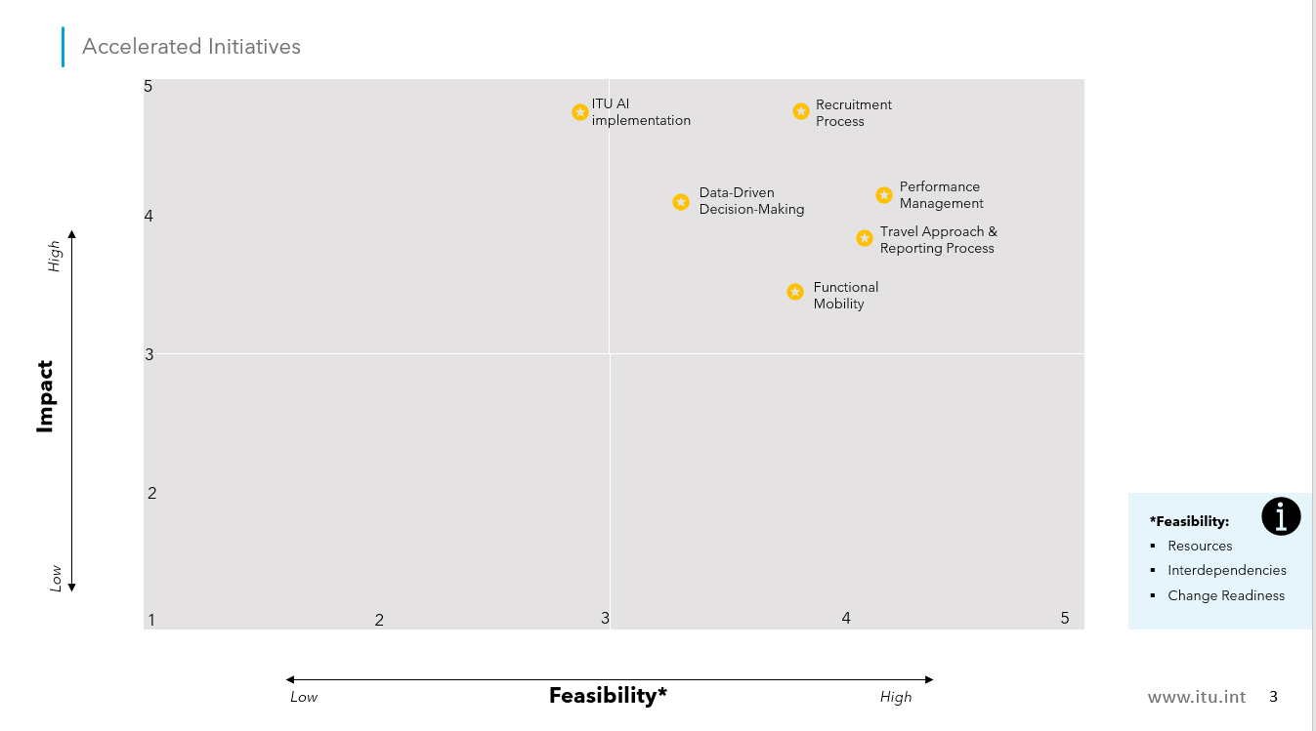

Notwithstanding this, the overall transformation planning approach will ensure that even where an expedited approach is taken, the transformation will ensure sustainable impact as ITU will remain focussed on the desired outcomes, rather than deliverable completion.
In addition, the Transformation team will establish an ITU Change Innovation environment where specific plans and initiatives can be conducted quickly and effectively, allowing for quick implementation of initiatives and ideas in a controlled, rules based, limited risk, environment. This will facilitate a safe space for quick successes or “fail fast” learning conditions, that can be applied to new and easy to implement ideas, or quick fixes of existing problems. Key use cases may include initiatives such as testing of AI tools, expedited recruitment approaches, or voluntary mobility programs.
Annex: 1

ANNEX
TRANSFORMATION ROADMAP



