# 

**Report on the   
WSIS Stocktaking 2010:**

Tracking progress

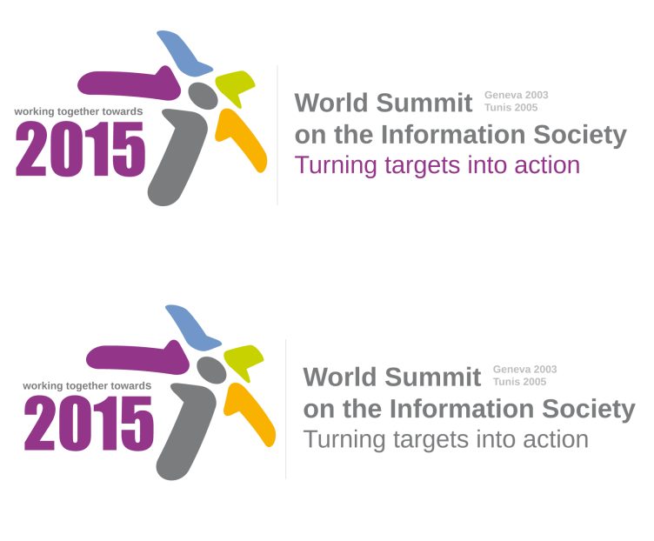

|  |
| --- |
| The version 1.2 reflects the comments collected during  WSIS Forum 2010. |

# 

# www.wsis.org/stocktaking

|  |
| --- |
| Acknowledgements The WSIS team would like to acknowledge the tremendous contributions of governments, international organizations, private sector, civil society and other stakeholders in providing information on ongoing projects and initiatives to the WSIS Stocktaking Platform. Most of the data contained in this report are extracted from the WSIS Stocktaking Database, available at [www.wsis.org/stocktaking](http://www.wsis.org/stocktaking)  The preparation of this report was coordinated by Regina Valiullina, a consultant for ITU, under the direction of Jaroslaw Ponder, Strategy and Policy Advisor, Corporate Strategy Division (CSD) and the overall direction of Alexander Ntoko, Head, Corporate Strategy Division (CSD).  The report also benefited from the contributions and insights from Phillippa Biggs, Maria Cristina Bueti, Cosmas Zavazava, Marco Obiso, Gitanjali Sah, Youlia Lozanova, Jeoung Hee Kim, Hani Eskandar, Kimberley Dureno-Tenkorang, Elizabeth Aschenbrener, Roseline Jongou, Simon De Nicola, Esperanza Magpantay, Istvan Bozsoki, Christopher Clark, Robert Shaw, Marine Souheil, Christine Sund and Amara Toure. The WSIS team would like to thank them for their contributions. |

## Disclaimer

Information contained in this publication is provided by multiple stakeholders that contributed to the WSIS Stocktaking Platform and do not engage ITU.

All rights reserved. No part of this publication may be reproduced, by any means whatsoever, without the prior written permission of ITU. Denominations and classifications employed in this publication do not imply any opinion on the part of the International Telecommunication Union concerning the legal or other status of any territory or any endorsement or acceptance of any boundary. Where the designation “country” appears in this publication, it covers countries and territories. The views expressed in this paper are those of the authors and do not necessarily reflect the opinions of ITU or of its membership.

© ITU, June 2010  
International Telecommunication Union (ITU), Geneva

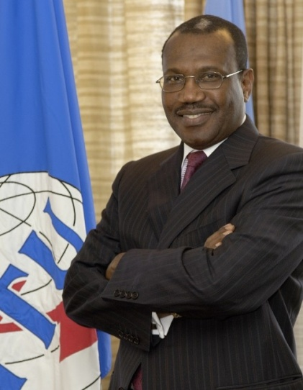Foreword by   
the ITU Secretary-General,   
Dr Hamadoun I. Touré

I am pleased to introduce the Report on the World Summit on the Information Society Stocktaking 2010: Tracking Progress in follow-up to the World Summit on the Information Society (WSIS).

The WSIS was held in two phases, with the first phase in Geneva in 2003 and the second phase in Tunis in 2005, to establish a clear vision for building an inclusive global Information Society. Since the WSIS, a strong body of empirical evidence has developed which proves conclusively that Information and Communication Technologies (ICTs) are important drivers promoting social development and economic growth. However, in 2008–09, the outbreak of the global financial crisis challenged policy-makers around the world in maintaining economic growth and preserving progress towards achieving the WSIS targets and Millennium Development Goals (MDGs) by 2015.

Genuine progress in broad-based social and economic development can best be achieved when all WSIS stakeholders – governments, international organizations, business sector, civil society and other entities – work together in partnership, focusing on concrete actions and projects in the field of ICTs to support the development of an inclusive Information Society and promote greater investment and skilled employment. I am proud that the annual WSIS Forum unites a community of dedicated partners working together to promote the use of ICTs to promote development objectives.

Following § 120 of the *WSIS Tunis Agenda for Information Society*, ITU launched the series of WSIS Stocktaking reports in 2005 as a valuable tool to track WSIS follow-up through a publicly available database of projects enriched with the latest social networking tools to better connect the development community. ITU is committed to bringing all its expertise, tools and resources to bear in advancing progress towards achieving the WSIS goals.

Towards this end, this report updates stakeholders on projects advancing the achievement of the WSIS targets from the end of 2008 to the present. As the request of Member States, it also draws attention to particular issues including the importance of broadband infrastructure, new and emerging applications, cybersecurity, social networking services and telecommunications for disaster management. Project information is structured according to the 11 WSIS Action Lines. ITU is proud to present this third edition of the *WSIS Stocktaking Report* and we look forward to an ongoing successful collaboration with all WSIS stakeholders in monitoring follow-up of the implementation of the WSIS goals by 2015.

Hamadoun I. Toure

ITU Secretary-General

Foreword by the   
ITU Deputy Secretary-General,  
Mr Houlin Zhao

The International Telecommunication Union (ITU) continues to assist in the follow-up of WSIS implementation. The WSIS remains a top priority for ITU, which is committed to implementing the WSIS targets in collaboration with UNESCO and UNDP. The WSIS Stocktaking exercise is a valuable contribution to WSIS follow-up and reporting.

Exchanging information not only makes implementation more efficient, but can create new opportunities for building partnerships. I am pleased to announce that this year, a revamped WSIS Stocktaking Platform has been launched to foster the implementation of WSIS outcomes. The platform is based on a community-building approach offering fresh options for networking, collaborating and the exchange of information. It has also been enriched with new social networking tools, so the new platform can become a new portal for project managers in ICT development programmes and connect practitioners on the ground.

During the WSIS Forum 2010 open consultation process, WSIS Stakeholders expressed their interest in project-oriented implementation of WSIS outcomes, showcasing and fostering creation of “win–win” partnerships. Analysis and best practices are new elements incorporated to the WSIS Stocktaking. In response to stakeholders’ requirements, the WSIS Stocktaking Platform and regular reports have become essential components of WSIS follow-up. We are working to develop a complete unique WSIS Stocktaking database providing project information without duplication. The number of entries is now nearing 5 000, which demonstrates the commitment of stakeholders to building the global Information Society and achieving the WSIS targets and the MDGs.

I am sure that the WSIS Stocktaking Platform will help create partnerships and provide greater visibility and added value to projects around the world. This report underlines that much has been achieved by 2010, regardless of the financial crisis. I greatly appreciate the many and diverse activities that stakeholders have contributed to the WSIS Stocktaking exercise, and encourage Member States, international organizations, the private sector, civil society and other stakeholders to continue their contributions. I hope that this report will serve as a guideline for stakeholders in building the inclusive Information Society and implementing fresh ideas to promote the use of ICTs for achieving broad and inclusive development.

zhao_sign.eps

Houlin Zhao

ITU Deputy Secretary-General

# Table of Contents

Introduction to WSIS 1

The WSIS Stocktaking Process 2

The outcomes of WSIS Stocktaking 3

WSIS Stocktaking Platform 4

WSIS Stocktaking and MDGs 5

Evolving the Information Society 7

1.1  Turning Targets into Action: WSIS and MDGs 7

1.2  Build on Broadband: Towards Tomorrow’s Applications 8

1.3  Social Networking 10

1.4  ICT for Disaster Management 12

1.5  Cybersecurity and Cyberspace 13

WSIS Implementation by Action Line 16

Action Line C1 The role of public governance authorities and all stakeholders in the promotion   
 of ICT s for development 16

C1.1  National e-strategies 16

C1.2  ICT for development in International Organizations 18

C1.3  Public–private and multistakeholder partnerships in developing and  
 implementing national e-strategies 19

C1.4  Other examples 20

Action Line C2   Information and Communication Infrastructure: An Essential Foundation   
 for the Information Society 21

C2.1  Infrastructure and Broadband 21

C2.2  ICT for all 23

C2.3  Connectivity for Public Access Institutions 23

C2.4  Adequate and affordable ICT equipment and services. 24

C2.5  International and Regional Cooperation. 25

Action Line C3 Access to Information and Knowledge 27

C3.1  Policy and Legislation 27

C3.2  Information Access 27

C3.3  Research and Development. 29

C3.4  Community Centres 29

C3.5  Software and Open access. 30

C3.6  Digital libraries and Archives. 31

Action Line C4 Capacity Building 32

C4.1  ICT Literacy 32

C4.2  National policies 32

C4.3  ICT for professionals and experts 34

C4.4  Distance Learning 35

C4.5  International and Regional Cooperation 35

Action Line C5 Building confidence and security in the use of ICTs 37

C5.1  National Approaches 37

C5.2  International and Regional Cooperation 38

Action Line C6 Enabling Environment 41

C6.1  Policy, regulatory and legal reforms. 41

C6.2  Internet-related law and governance 42

C6.3  Small and Medium-Sized Enterprises 42

C6.4  Consumer-related policy and dispute resolution 42

Action Line C7 ICT Applications: Benefits in all aspects of life. 44

C7.1  E-Government 44

C7.2  E-Business 47

C7.3  E-Health 48

C7.4  E-Employment 49

C7.5  E-Learning 50

C7.6  E-Agriculture 51

C7.7  E-Environment 52

C7.8  E-Science 53

Action Line C8 Cultural diversity and identity, linguistic diversity and local content 54

Action Line C9 Media 55

Action Line C 10 Ethical dimensions of the Information Society 56

Action Line C11 International and Regional Cooperation 58

Conclusion: Towards Connecting the World 63

List of Abbreviations and Acronyms 64

Introduction to WSIS

The World Summit on the Information Society (WSIS) is an unique two-phase UN summit that was initiated in order to create an evolving multistakeholder platform aimed at promoting the Information Society at the national, regional and international levels. The goal of WSIS is to achieve a common vision, desire and commitment to build a people-centric, inclusive and development-oriented Information Society where everyone can create, access, utilize and share information. Commitments from governments, private sector, civil society and others are important towards forging an inclusive Information Society.

Following the WSIS outcomes, §109 of Tunis Agenda for the Information Society (TAIS), ITU, UNESCO and UNDP, in their respective roles as leading facilitating organizations in the implementation of the Geneva Plan of Action as well as UNCTAD that services The Commission on Science and Technology for Development (CSTD), organize annual meeting of moderators and facilitators of action lines. This meeting serves as an exceptional multistakeholder platform for coordination of WSIS Implementation at the international level and builds upon the open consultation process.

The 2010 open consultation process on the thematic focus of the WSIS Forum has indicated that the Forum should give strong emphasis to project showcasing, win–win partnerships creation, public–private cooperation, financing issues and others. It also identified five key emerging issues that deserve particular attention in 2010, including turning targets into actions, Broadband Applications for Tomorrow, Social Networking, ICT for Disaster Management, and Cybersecurity and Cyberspace. In this context, the WSIS Stocktaking has a particular role to play during this meeting.

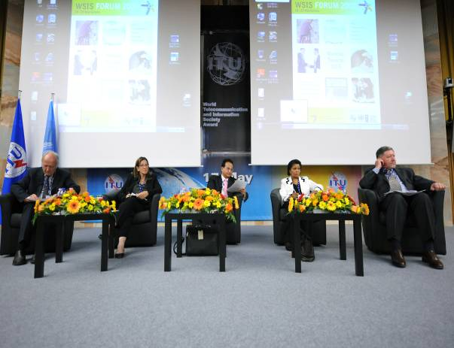WSIS Forum 2010 will be held on 10–14 May 2010 in Geneva, ITU headquarters and will bring together all types of stakeholders of the Information Society for results-oriented cooperation. More than 600 individuals from all over the world are expected to attend the Forum this year. In order to achieve the best feedback, the Forum will offer a diverse series of meetings, including High-Level Debates that will address issues critical to WSIS implementation in multistakeholder set-ups. The Forum will also feature Interac­tive WSIS Action Line Facilitation Meetings, Interactive Sessions, Thematic Work­shops, Kick-off Meetings for new initia­tives and projects, Knowledge Exchanges, Publication Releases and an Exhibition to facilitate networking among participants. It will provide an opportunity for structured networking, learning and participation in multistakeholder discussions and consulta­tions on WSIS implementation.

## The WSIS Stocktaking Process

The WSIS Stocktaking Process is a follow-up to WSIS that was initiated in 2004. Its purpose is to provide a register of activities carried out by governments, international organizations, the business sector, civil society and other entities, in order to highlight the progress made since that landmark event. Following § 120 of TAIS, ITU has been maintaining the WSIS Stocktaking database as a publicly accessible system providing information on ICT-related initiatives and projects with reference to the 11 WSIS Action Lines.

Furthermore, regular reporting on WSIS Stocktaking is the outcome of the Tunis phase of the Summit, which was launched in order to serve as a valuable tool for assisting with the WSIS follow-up. The purpose of the regular reports is to update stakeholders on the various activities related to 11 Action Lines notified in Geneva Plan of Action that was approved during First Phase of the WSIS .

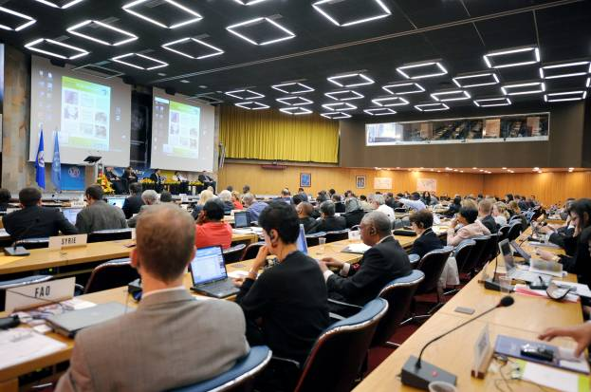The 2010 Edition of the WSIS Stocktaking Report is a continuation of the WSIS Stocktaking Report series and it is based on data contributed by stakeholders that is available at [www.wsis.org/ stocktaking](http://www.wsis.org/%20stocktaking). The third edition of the report presents an analytical overview of emerging issues identified during the 2010 Open Consultation Process on Thematic Focus of the WSIS Forum, including Build on Broadband, Turning Targets into Action, Social Networking, Cybersecurity and Cyberspace and ICT for Disaster Management. Furthermore, the report provides showcase briefings on particular actions undertaken by the global community in the implementation of WSIS goals during the period from the end of 2008 to mid-2010. Each entity that had provided information to the WSIS Stocktaking platform during this period has been reflected in the Report with at least one project.

The year 2010 is the half-way point between the successful conclusion of the Summit in Tunis and 2015, the date that the international community has committed to deliver the WSIS targets. For that reason, 2010 is a significant time to evaluate the progress achieved so far and to examine and improve upon existing cooperation and partnerships among stakeholders in order to achieve the WSIS goals and Millennium Development Goals (MDGs).

## The outcomes of WSIS Stocktaking

Figure 1 below represents an overview of entries submitted to the WSIS Stocktaking database broken down by geographic coverage, region and type of stakeholder. Based on the data relevant on 9 April 2010, a total number of 4 638 entries have been submitted by various stakeholders since the launch of the WSIS Stocktaking database.

|  |
| --- |
| Figure 1: Overview of WSIS data breakdown by geographical coverage, region and stakeholders |
|  |
| *Source*: WSIS Stocktaking database |

Considering the data broken down by type of stakeholder, the majority of entries were submitted by governments which represents 56 per cent of the total amount of submitted entries, followed by international organizations, civil society, the business sector and others.

Considering the data broken down by geographic coverage, the majority of entries were submitted at the national level – which represents 47 per cent of the total number of entries – followed by entries at the international level, with 29 per cent.

Considering the data broken down by region, Western Europe and North America is the region which contributed the most, submitting 1 228 entries, followed by the Asia and Pacific region, Africa, Latin America and the Caribbean, and Eastern Europe.

Figure 2 illustrates the number of entries submitted by stakeholders for each Action Line. The majority of submissions were related to Action Line C3 (access to information and knowledge) with 2 649 entries.

|  |
| --- |
| Figure 2 : Overview of WSIS activities broken down by action lines |
|  |
| *Source*: WSIS Stocktaking database |

## 

## WSIS Stocktaking Platform

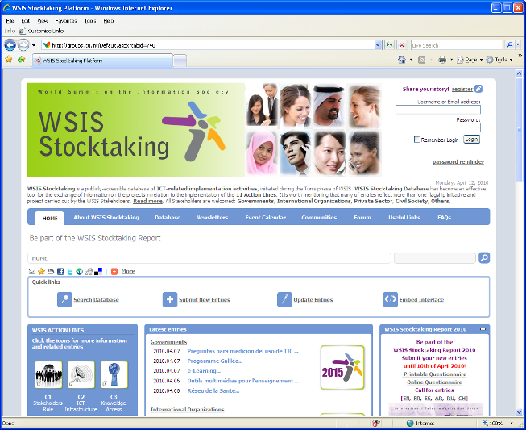WSIS Stocktaking Platform is the new initiative that was launched by Mr Zao, ITU Deputy Secretary-General and chair of ITU’s WSIS Task Force in February 2010 to improve existing functionalities, transforming the former static database into a unique portal to highlight ICT-related projects and initiatives in line with WSIS imple­mentation. The platform offers stakehold­ers exciting and interactive networking opportuni­ties via Web 2.0 applications. In the framework of the WSIS Stocktaking Platform, all types of stakeholders can benefit from “the global event calendar”, “the global publication reposi­tory”, “case studies” components and others that tend to extend networking and create partnerships in order to provide more visibility and add value to projects at the local, national, regional and international levels.

## WSIS Stocktaking and MDGs

The WSIS outcome documents, [Geneva Declaration of Principles 2003](http://www.itu.int/wsis/docs/geneva/official/dop.html)[[1]](#footnote-2) and [Tunis Agenda for the information Society 2005](http://www.itu.int/wsis/docs2/tunis/off/6rev1.html)[[2]](#footnote-3), set forth key principles for building an inclusive Information Society. The WSIS Plan of Action calls for the effective participation of governments and all stakeholders in developing an information society within a partnership framework. This can be achieved using different approaches ranging from development of national e-strategies to providing connectivity for all. The Eleven Action Lines provide a common vision and guiding principles to advance the achievement of internationally agreed development goals, including the Millennium Development Goals (MDGs). TheWSIS outcome documents recognize that education, knowledge, information and communication are at the core of human progress, endeavour and well being, there by, highlighting the relationship between the Action Lines and MDGs.

The WSIS summit was an important landmark in the global effort to eradicate poverty and achieve the MDGs by 2015. During the WSIS, all players acknowledged the vital role that ICTs can play in boosting economic growth, as well as in social development, by creating not only employment opportunities but also building human capacities and contributing to cultural identity. The summit resulted in the launch of more than 2500 projects worldwide and the multi stakeholder approach was carried forward in the implementation phase with direct involvement of the civil society, private sector, governments and international organizations.[[3]](#footnote-4) Since the WSIS Forums, governments and stakeholders have submitted several initiatives and projects to the WSIS Stocktaking database. These indicate the manifold efforts undertaken to bridge the digital divide and provide universal access to ICTs. In 2008 ,three thousand seven hundred and ninety nine (3799) [[4]](#footnote-5)project submissions were received from varied stakeholders from different parts of the world, the figure increased to four thousand six hundred and thirty eight (4638)[[5]](#footnote-6) in 2010.

Stakeholders have successfully contributed to advancing the achievement of WSIS targets on such significant matters as building infrastructure to enhance connectivity, fostering access to information services, assisting in the development of requisite capacities and skills, raising awareness on security issues in the use of ICTs, enabling the environment through the application of ICTs, and other Action Lines. All efforts facilitated the progress in assessing, monitoring and evaluating the impact of ICTs on the achievement of the internationally agreed MDGs.

|  |
| --- |
| Figure 3 : MDGs (Millennium Development Goals) |
|  |
| *Source*: WSIS Stocktaking database |

Figure 3 above shows that the 11 WSIS Action Lines correlate to all the Eight MDGs. These numbers were derived from WSIS Stocktaking Database where all MDGs are represented .The majority of entries linked to MDG 8(global partnership) with 36% of total submitted entries.

Evolving the Information Society

## 1.1 Turning Targets into Action: WSIS and MDGs

The year 2010 marks the halfway point between the successful conclusion of WSIS in Tunis in 2005, and 2015, the year by which the MDGs should be achieved. The MDGs represent the highest profile articulation of the internationally agreed development goals associated with the UN development agenda, as the culmination of various important UN summits held over the last decade of the twentieth century, including summits on important issues such as, children’s and women’s rights, sustainable development, education, and social development.

The MDGs are comprised of a set of [eight public health and social development goals](http://www.mdgmonitor.org/browse_goal.cfm)[[6]](#footnote-7) for eradicating hunger and poverty, achieving universal primary education (UPE), promoting gender equality and empowering women, reducing child mortality, improving maternal health, combating HIV/AIDS, malaria and other diseases, ensuring environmental sustainability and creating a global partnership for development. All 192 United Nations Member States and at least 23 international organizations have committed to achieving the MDGs by 2015. While the MDGs apply to all Member States, they remain most relevant for developing and least developed countries (LDCs).

Measuring progress towards achieving the MDGs is an extremely complex task, depending on the goal, region and country. Progress has proved uneven across different regions. Some countries have already achieved several goals while other countries are still struggling to meet their targets. Unfortunately, the follow-up report presented to the UN General Assembly dated 12 February 2010 concluded that “with five years to go to the target date of 2015, the prospect of falling short of achieving the Goals because of a lack of commitment is very real”. However, the Report also notes that “achievement of the MDGs remains feasible with adequate commitment, policies, resources and effort”. A further high-level plenary meeting of the General Assembly is scheduled to take place in September 2010 to review implementation of the MDGs and strengthen collective efforts and partnerships for the push to 2015.

Information and Communication Technologies (ICTs) offer enormous potential to help achieve development goals. There is growing evidence for the macroeconomic benefits of boosting ICT uptake and penetration (e.g. Qiang & Rossotto, 2009). At the macroeconomic level, if ICT-driven economic growth then translates into growth in individuals’ incomes, then genuine improvements in living standards can be achieved.

The opportunities offered by ICTs are explicitly recognized in Target 18 under Goal 8, which calls for the benefits of new technologies, especially ICTs, to be made available in cooperation with the private sector. In reality, however, the greatest contribution of ICTs towards achieving the MDGs may be in their catalytic role for empowering people and promoting grassroots development to take place, enabling people to learn about their world and take action to find answers to overcome their own challenges.

[WSIS defined and endorsed ten Targets](http://www.itu.int/wsis/docs/geneva/official/poa.html), [[7]](#footnote-8) some of which contribute directly to achieving the MDGs, including infra­struc­ture and connectivity targets for hospitals, schools and uni­versi­ties, villages and governments. Other WSIS Targets may contrib­ute indirectly to achieving the MDGs; for example, access to ICTs can promote greater awareness and provide access to informa­tion on issues that may encourage individuals to do more to preserve the environment and work to address other emerging issues.

The power and potential of ICTs are growing rapidly. Broad­band is a transformational technology that can totally reshape the way essential services are delivered from e-health to e-education to e-commerce to e-government. To date, it is the most powerful tool ever devised to drive global social and economic development and accelerate progress towards the MDGs. In its recent report, the OECD argues that cost savings of just 0.5–1.5 per cent in the four key sectors of health, education, energy and transport over ten years could justify the cost of building National Broadband Networks in some countries. [[8]](#footnote-9)

To this end, ITU and UNESCO are in the process of establishing a Broadband Commission for Digital Development, with the backing of the UN Secretary-General, Mr Ban Ki-Moon, to review the issues relating to ICT development. The Commission will seek to promote the use of high-speed broadband communication networks worldwide to help accelerate achievement of the MDGs and consider how the roll-out of broadband networks and services could help achieve the public health goals embodied in the MDGs, as we move from targets to action.

## 1.2 Build on Broadband: Towards Tomorrow’s Applications

The market for broadband Internet access continues to grow rapidly, driven by technological innovation, growing consumer demand for services, exciting new applications and falling prices, which are reducing rapidly due to competition. ITU data shows that mobile broadband subscribers exceeded fixed broadband subscribers for the first time in 2008 (Figure 4, left chart).

The number of global mobile broadband subscribers exceeded 688 million in 2009 (equivalent to 15 per cent of total number of cellular mobile subscribers) and is set to exceed 1 billion in 2010, driven by growth in smart phones, new applications and social networking services on the move. 3G phones are projected to account for 43 per cent of the total of 6.5 billion cellular mobile subscriptions by 2014 (Figure 4, right chart). Today, some 130 countries enjoy commercial 3G service, with the strongest growth in 3G deployments in the European and Asia–Pacific regions. By 2013, [mobile phones are predicted to overtake PCs as the most common Web access device worldwide](http://mtny.mobi/1qC),[[9]](#footnote-10) according to Gartner.

|  |
| --- |
| Figure 4: Growth in broadband Internet |
|  |
| *Source*: ITU World Telecommunication/ICT Indicators database (left chart), Morgan Stanley (right). |

The early leading markets of Asia–Pacific and Europe fuelled most of growth in mobile broadband subscribers (Figure 5, top right), although the Americas are catching up fast, with a growth spurt in 3G subscribers that started in 2007, but was not sustained throughout the financial crisis. Asia–Pacific’s leadership is mainly due to Japan’s huge 3G market, which accounted for 96.1 million subscribers or 30 per cent alone (nearly one third) of the total global subscribers in 2008. ITU projections suggest that 2010 could be the year in which Asia-Pacific cedes its early lead in mobile broadband subscribers to Europe, although much depends on what happens in the emerging markets of India (where 3G auctions are scheduled to take place in April 2010) and China (where all three main 3G standards are competing, since the first commercial launch in October 2009).

However, there are some drawbacks to the strong growth in mobile phones, in particular smart phones. In the past operators have struggled to keep up with the surge in demand for wireless data. In terms of traffic, global mobile data traffic is set to increase 66 times by 2013, driven by the increase in smart phones and mobile bandwidth-hungry applications (Cisco, 2009). The introduction of the iphone infamously put a severe strain on AT&T’s network in the United States and [O2’s network in the United Kingdom](http://www.tgdaily.com/mobility-features/45219-o2-blames-the-iphone-for-network-strain).[[10]](#footnote-11) In just over 18 months, wireless networks in some countries have started to experience severe congestion. In 2009 alone, US wireless networks have seen a [193 per cent growth in data transmitted over mobile networks to 400 Petabytes](http://gigaom.com/2009/11/09/with-wireless-data-smaller-carriers-must-mind-the-gap/).[[11]](#footnote-12) [AT&T has experienced a 5 000 per cent growth in data traffic over its network over the last three years](http://www.att.com/gen/press-room?pid=4800&cdvn=news&newsarticleid=30486&mapcode=).[[12]](#footnote-13) Operators are responding to the wireless data deluge in a variety of ways, including installing extra capacity and added base stations, the use of femtocells and advanced network management software, such as intelligent caching software.[[13]](#footnote-14)

|  |
| --- |
| Figure 5: Growth in 3G, by region, 2003-2009, and by subscribers, 2009 |
|  |
| *Source*: ITU World Telecommunication/ICT Indicators database |

Even if future access to broadband Internet looks set to be wireless for many end users, operators will be forced to install extra backhaul capacity and fiber networks as the most viable answer to handling such rapid growth in data traffic. The race is on to invest in broadband and fiber backhaul to be able to accommodate the explosion in demand in data and confront the bandwidth crunch.

## iStock_000005549862XLarge1.3 Social Networking

The Internet is changing. The rise of online social networking services is transforming the way people interact, both online and offline. In the 1990s, it was enough to have an online *presence,* based on one-way broadcasting of information. In 2010, people’s online *participation* is driving new forms of social interaction, dialogue, exchange and collaboration. Online communications have become less unidirectional and are now more of a “multi-party conversation”.[[14]](#footnote-15) Today, social networking services may even be changing social structures and reshaping people’s perceptions of time, distance and location.

Social media (also referred to as social networking) has been defined as a web-based facility where people can connect and share information.[[15]](#footnote-16) Wikipedia notes that “social media use Internet and web-based technologies to transform broadcast media mono­logues (one-to-many) into social media dialogues (many-to-many)”, often based on user-generated content.[[16]](#footnote-17) Over the past decade, social media and social networking capabilities have developed from simple “Web 1.0” tools (such as bulletin boards and e-mail) to more dynamic and interactive “Web 2.0” networking options. Some of these activities include adding and following friends on various social networking sites, and easily and instantly sharing articles and websites with others, all of which can all accessed over a mobile device.

A body of evidence suggests that these services and applications are transforming online consumer behavior. Facebook recently usurped the industry leader Google as the initial entry point of the Internet and now directs a greater proportion of Internet traffic (13 per cent) than both eBay (7.6 per cent) and Google (at 7 per cent).[[17]](#footnote-18) Some experts suggest that social media could increasingly come to perform the Internet’s search function. There is evidence that people are now spending less time navigating the Internet independently and instead surf the Internet based on their friends’’ recommendations or their friends’ activities in a behavior referred to as “friend-casting”.[[18]](#footnote-19) In the near future social networks are likely to become the initial starting point for the majority of users online experiences.

The future “social web” will empower users to drive innovation and the development of new applications. According to Forrester, over the next two years social networks could become more powerful than corporate websites and CRM systems with individual identities (brands) and relationships built on these platforms. [[19]](#footnote-20) In what Forrester terms “the era of social context”, sites will recognize personal identities and social relationships to deliver customized online experiences. It will no longer be necessary to inform a site about your interests and what you are looking for – the site may already ‘know’ you and be familiar with your interests through access to your online profile and activities.

Social networking sites are seeing exponential growth, especially over the last eighteen months (Figure 6). Nielson estimates that there were 307 million “unique users” of social media by the end of 2009, compared to Morgan Stanley’s estimate of 830 million unique users of social media worldwide, growing at around 25 per cent year-on-year. Based on a total Internet user population of 1.78 billion, this suggests that between 16–47 per cent of all Internet users could currently be using social media applications, a proportion that is only set to grow. Given the difficulties in defining unique users (some applica­tions have been integrated and now overlap, while many users subscribe to more than one social net­work­ing service), this is probably a representative margin of error for the accuracy of measurement involved. Since its founding in early 2004, Facebook has grown its audience to account for 400 million registered users alone, equivalent to 25 per cent or one quarter of the world’s total online audience. Twitter now sees more than 50 million messages sent every day (Figure 6). [Global time spent on social media sites grew by 82 per cent year-on-year](http://ow.ly/ZvT6) in 2008–2009, led by Facebook and Twitter usage.[[20]](#footnote-21)

|  |
| --- |
| Figure 6: Growth of social media users and Twitter |
| twitter growth |
| *Source*: ITU World Telecommunication/ICT Indicators database (left chart), Twitter (right chart). |

However, the growth of social media is also raising significant issues. Facebook’s huge online audience means that control and ownership of personal data relating to a quarter of the global online audience rest with a single service provider, raising new concerns over the influence wielded by a few service providers. Facebook’s founder, Mark Zuckerberg, triggered a lively online debate when he observed that [privacy is “no longer a social norm](http://ow.ly/UYpc)”[[21]](#footnote-22) and that people are now more willing to share information about themselves and their views online. The controversy over privacy and data confidentiality triggered by the launch of Google Buzz highlighted growing concerns in this area. ITU will continue to monitor the growth of social media applications closely, as well as the issues raised by this online revolution and the rise of the social web.

## 1.4 ICT for Disaster Management

Disasters disrupt national economies, severely affect the poor and vulnerable and are recognized as major impediments to sustainable development and reduction of poverty, especially in LDCs and Small Island Developing States (SIDS). When disasters strike, they leave a legacy of lost or broken lives and economic damage. The impact is even worse for those living in remote and isolated areas with no access to basic information and communication facilities.

ICT plays a critical role in disaster predication, monitoring, and detection. ICTs can save human lives through the timely dissemination of early warning alerts. In the immediate aftermath of disasters, ICTs play an important role in coordinating search and rescue operations, supplying food, medicine and other essential services, and in providing critical information to the victims of disasters.

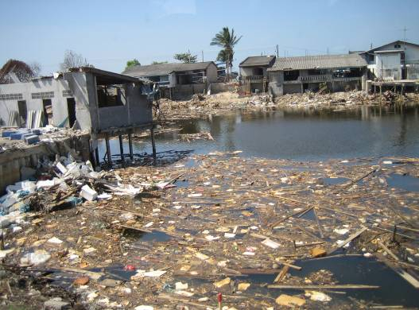Emergency Telecommunications play a critical role in the immediate aftermath of disasters by ensuring a timely flow of vital information which is essential to government agencies and other humanitarian actors that are involved in rescue operations and providing medical assistance to the injured.

One of the biggest challenges of our time is the recent upsurge and increase in the frequency and devastation of disasters as evidenced by Cyclone Nargis that hit Myanmar in May 2008, the Sichuan earthquake that affected China, also in May 2008, the 12 January 2010 earthquake in Haiti and the earthquake that took place in Chile on 27 February 2010. In March 2010, a series of disasters occured that included floods in Uganda, Zambia, and Mozambique, as well as earthquakes in Turkey, China and Sumatra, and Cyclones in Fiji.

## 1.5 Cybersecurity and Cyberspace

### 1.5.1 The Challenge of Cybersecurity

ICTs have become essential to development and economic growth. In the 21st century ICT networks will be regarded as basic national infrastructure just like transport, energy and water networks.

However, these same ICT networks and systems are at growing risk from cyberthreats that are becoming more and more sophisticated. These attacks threaten the security, integrity, reliability and confidentiality of modern communications and the networks over which they are transmitted.

Last year, cybercriminals stole up to a trillion dollars worth of intellectual property from businesses worldwide, and many millions of individuals had their privacy violated, suffered identity theft and had their hard-earned savings stolen from them.

Governments also face cyberattacks – and terrorists increasingly rely not just on physical weapons, but on the power of cyberspace technologies to sow destruction. Cyberwarfare is not, as many people think, limited to governments attacking governments; any part of the critical infrastructure may be subject to attack, from banking and telephone companies to transport or the supply of essential goods and commodities, even water systems may become a target. “Cybersecurity” includes every threat that can be carried out across the Internet and with Internet connectivity increasing worldwide, safety is an ever growing concern for citizens and governments alike.

Given the scale of the threats – and the phenomenal harm that can be caused by even a single cyberattack – we cannot rely on ad hoc solutions or hope to survive by strengthening our defences only after cyberattacks have occurred. The solution lies in setting international standards, and it must involve governments, the private sector and citizens.

### 1.5.2 Building a Safer Information Society Through International Cooperation

For a normal citizen today, it is already difficult to keep personal computers secure from spam, spyware, viruses and phishing, let alone protect all the personal data stored on their computer and other devices. Living in the digital world in 2015, users will be surrounded by pervasive devices, embedded sensors and systems, all connected to an IP-based network. Trust, privacy, and security are vital to the future development of the Information Society. Cybersecurity is a major consideration for the development of Next Generation Networks (NGN), which will require increased international cooperation as well as the involvement of governments working on harmonized legislation and mutual enforcement.

An “updated” Internet (Web 2.0) could offer new and improved services with better security against viruses, worms, denial-of-service attacks and zombie computers. Other services requiring high levels of reliability (such as medical monitoring) and services that cannot tolerate network delays (such as voice and video-streaming) would be better supported in this new environment. However, the constant ebb and flow of technological change means that we cannot just rely on technological solutions: new issues are bound to surface. To provide these advanced services, both the architecture of the Internet and the business models through which the services are delivered, need to change.

The benefits of the Information Society as a whole are at stake if networks are insecure. As no single country or entity can create trust, confidence and security in the use of ICTs, international action is needed to address cyberthreats. The protection of critical information infrastructures requires a joint effort from governments, industry, law enforcement and citizens worldwide.

Time will tell if governments, businesses and citizens are willing to undertake this challenge to ensure a positive outcome of the commitment reached at the UN Summit for the Information Society by 2015. Encouraging each participant in the Information Society to become aware of the risks involved and assume responsibility for the security of information systems is one of the main challenges we face going forward. Building confidence and security in the use of ICTs requires a coordinated and focused effort from all stakeholders in the Information Society.

 ITU has been appointed as the sole facilita­tor for WSIS Action Line C5, to assist stakeholders in building confidence and security in the use of ICTs. In this role, ITU is responsible for assisting stakeholders in the implementation process, at national, regional and international levels. For this reason, within its mandate and in consultation with the WSIS community, ITU launched the Global Cybersecurity Agenda (GCA) in May 2007 as a frame­work for international coopera­tion on cybersecurity.

|  |
| --- |
| Box 1: Curbing Cyberthreats Globally |
| ITU is collaborating with the International Multilateral Partnership Against Cyber Threats (IMPACT) to provide ITU membership with the expertise, facilities and resources to effectively address the world’s most serious cyberthreats. The partnership provides:  • Real-time analysis, aggregation and dissemination of global cyberthreat information;  • Early warning system and emergency response to global cyberthreats; and  • Training and skills development on the technical, legal and policy aspects of cybersecurity.    *Source*: <http://www.itu.int/osg/csd/cybersecurity/gca/index.html> |

WSIS Implementation by Action Line

Action Line C1 The role of public governance authorities and all stakeholders in the promotion of ICT s for development

The Geneva Plan of Action emphasizes the importance of governments and all stakeholders’ participation in the development of the Information Society. Partnerships and cooperation among all participants will maximize the benefits for stakeholders globally. Numerous national e-strategies, public–private partnerships, multisector partnerships, strategies of international organizations and financial institutions, have benefited from the result of structured dialogue among stakeholders in order to achieve the targets set out in the Plan of Action.

Below are some examples that demonstrate the role of stakeholders in the promotion of ICTs for development.

# C1.1 National e-strategies

The Federal Chancellery of Austria developed the programme “Information Society for Everyone” aimed at the creation of an Information Society incorporating digital technologies and various ICT applications.

**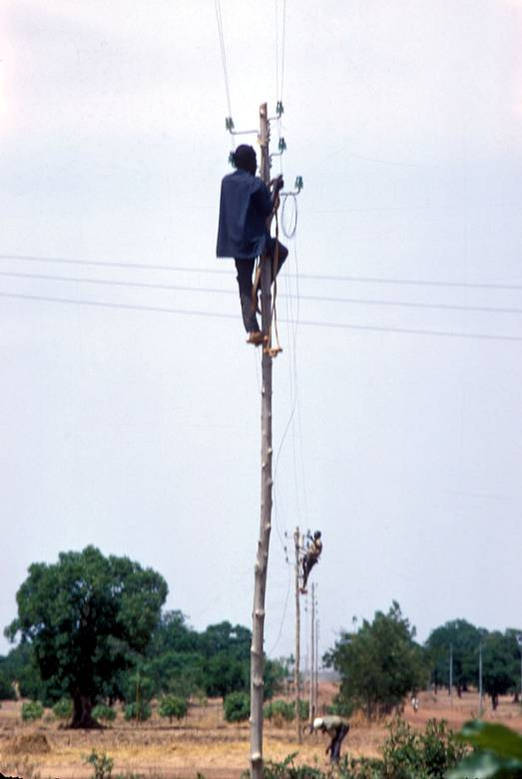**National Strategy of Azerbaijan, was designed to create and develop a legislative base for the Information Society. The strategy’s goal is to establish an environment where citizens and social institutions can easily obtain, disseminate and use information, and maximize the benefits of ICTs. In order to achieve this result, it is necessary to establish effective and transparent state and local administrations, as well as establish and develop electronic commerce. In order to enhance the country’s economic, social, and intellectual potential, the challenge is to create a competitive economy, develop an information and knowledge market and produce national software and other ICT-related products to eliminate the “digital divide” across the country.

Argentina launched the National Programme for Information Society.

The Council of Ministers of Bosnia and Herzegovina adopted a document entitled “Strategy for Information Society Develop­ment in Bosnia and Herzegovina”. This Strategy identified five pillars to be developed: e-legislation, e-education, e-governance, ICT infrastructure and the overall ICT industry in their country.

The Bulgarian Ministry of Transport, Information Technology and Communications initiated the “National Programme for Accelerated Information Society Development 2008–2010” focusing on the convergence of ICTs, electronic content, 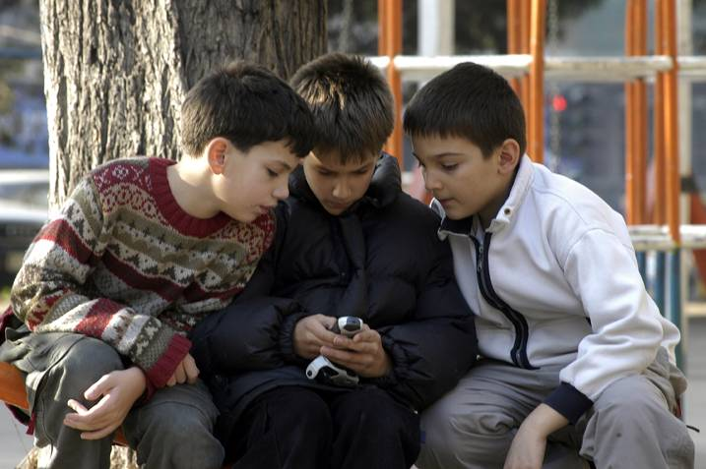public services and an improved quality of life. Six directions for development have been defined in the programme: ICT infrastructure and security, society and culture, economy and employment, research and technology development, education and training, and Information Society promotion and branding of the ICT sector.

Colombia’s goal is to create a connected society that uses ICTs in an efficient and productive way by 2019. The main objectives of the National ICT Plan are to eradicate poverty and inequality, increase competitiveness, achieve social and economic sustainable development, increase mobility within the society, improve learning, and use technologies in order to allow more mobility and transaction speed within the marketplace. The goal is to reduce transaction costs by making procedures less heavy, more interconnected, faster and more decentralized, which will ultimately facilitate integration into the global economy.

In Latvia, the Ministry of Regional Development and Local Government initiated the Guidelines for the Development of the Information Society (2006–2013) which are in line with the World Summit on Information Society (WSIS) outcome documents, EU’s Lisbon Strategy objectives and the European Initiative i2010 to achieve a vision where all Latvian citizens and businesses can fully access and use ICT-based information resources.

|  |
| --- |
| Mauritius Ministry of Information and Communication Technology launched the National ICT Strategic Plan (NICTSP) 2007–2011 which sets the framework for government and private sector interventions to make ICT the fifth pillar of the economy. The plan comprises 124 projects, as offshoots of 15 programmes and 5 strategic thrust areas. Those 124 projects constitute platforms for increased efficiency in various sectors of public life: education, tourism, health, industry, local government, internal security and agricultural industries. |

****Mexico is currently promoting the e-Mexico Digital Agenda 2010–2012 in order to integrate and focus efforts to build an Information Society. The Digital Agenda will include a comprehensive approach to tackle challenges such as connectivity speed, the digital divide and digital literacy.

The Information Technology Authority (ITA) with the Degree 52/2006 implemented the Digital Oman Strategy to transform the Sultanate of Oman into a more knowledge-based economy in order to provide social and economic benefits to all members of Omani society.

Info-communications Development Authority of Singapore (IDA) is a statutory board of the Singapore government which operates under the Ministry of Information, Communica­tions and the Arts (MICA). In its efforts to develop, promote and regulate Singapore’s information and communication industry, IDA is guided by iN2015, a ten-year infocomm Master Plan to help Singapore realize the potential of ICTs over the next decade. IDA is committed to transforming Singapore into a dynamic global information communication hub by using an integrated approach to develop ICTs in Singapore.

Q-CERT, Qatar’s national information security team was created by ictQATAR to protect the country’s information and communications systems. Q-CERT works with government agencies, businesses, and the citizens of Qatar to address cybersecurity risks, protect sensitive information and ensure the safety of children on the Internet.

ictQATAR released the inaugural Annual Report to highlight the outputs and the outcomes of the Qatari promise of e-policy. Through five policy outputs (telecoms liberalization, online government, cybersecurity, e-learning and e-health) and two policy outcomes (global gateway and free internet), the report shows the progress of Qatar in the area of ICT policies and implementation.

Vanuatu is planning to develop a national ICT strategy in 2010.

In-depth analysis on the 2010 National e-Strategies for Development: Global Status and Perspectives, has been elaborated by ITU in close cooperation with all UN Regional Commissions.

# C1.2 ICT for development in International Organizations

In accordance with its mandate, the ITU Telecommunication Development Bureau continues to foster international and regional cooperation on a broad range of activities. ITU conducted several meetings, conferences and symposiums to provide a platform to broaden international dialogue on innovative means in harnessing ICTs for advancing development. For example, ITU organized the Global Symposium for Regulators and Global Industry Leaders Forum (Beirut, November 2009), ITU TELECOM Telecommunication Development Symposium and Youth Forum (Geneva, October 2009). In addition, ITU conducted five Regional Preparatory Meetings for the 2010 World Telecommunication Conference (WTDC-2010), where one of the topics discussed was the WSIS implementation.

United Nations Economic and Social Commission for Western Asia (ESCWA) organized the Investment in the ICT Sector workshop to raise awareness of member countries and to increase their understanding of policies, mechanisms and modalities that promote ICT investment and entrepreneurship in the region. In November 2008, in preparation for the 2009 edition of the WSIS national profiles, ESCWA organized a “Consultative Workshop on the National Profiles of the Information Society in Western Asia” which was attended by representatives of ministries of communication and information technology as well as boards, councils and centres in charge of developing the Information Society and building the ICT sector in the region.

During 2009, UNCTAD launched its first ICT Policy Review for Egypt, thanks to the financial contribution of the UNDP Office in Cairo. A fact-finding mission to the country was conducted in May and a second mission took place in January 2010. The review is expected to be finalized during the first half of 2010.

****United Nations Department of Economic and Social Affairs (UNDESA) in partnership with Pan-African Par­lia­ment, African National Parlia­ments, African Regional Assemblies, Global Centre for ICT in Parliament, European Parliament, United Nations Economic Commission for Africa and other United Nations agencies officially launched The Africa Parliamentary Knowledge Network (APKN) in 2008 which is a network that supports the work of African assemblies by establishing mechanisms and procedures for exchanging information and experi­ence in areas of common interest. Major areas of cooperation include legislative processes, information and research services, ICT tools, and communication with the public.

### **C1.3. Public–private and multistakeholder partnerships in developing and implementing national e-strategies**

****Deutsche Entwicklungsdienst (DED) launched their Information and Communication Technology Assisted Development (ICTAD) programme. The Government of Ethiopia intends to utilize ICTs as enablers for implementation of the country’s development programme and has embarked on a major National ICT Capacity-Building Programme. The vision for this programme is to “develop and exploit ICTs as an accelerator for the attainment of national development objectives and global competitiveness”.

Information Technology Authority (ITA) of Oman is collaborating with CISCO in order to undertake collaborative efforts to facilitate the draft of a high-level technical architecture for eOman and to create increased opportunities to enhance technical capabilities in a move to support the county’s transformation into a knowledge society. The scope of the agreement between Oman and CISCO includes supporting the human capital development within the country through Cisco’s Net Academies, which aims to establish connected schools and offer graduate programmes. Both ITA and Cisco will undertake several initiatives to share the expertise of Cisco and to serve the Omani community through eOman activities. In order to promote a connected and educated community, selected schools in the Sultanate will be provided with the latest wireless technology as well as ICT training programmes as part of this agreement.

The Sultanate of Oman signed an E-Tendering Contract with Imtac and C1 India on 15 September 2008. This project will enhance the automated system of the Tender Board and develop a new Electronic Tendering System. The project main goal is to automate all manual processes required during the tendering stages involved and train Tender Board staff and IT professionals to ensure effective use, management and efficient monitoring of the E-Tendering System.

E-Tendering will enable all local and international vendors to use the online system to register and renew registration with the Tender Board, prepare, review and approve final tender documents online, publish tenders online, purchase tender documents online, receive and reply to queries online, send addenda/circulars to participating companies online, receive offers online, publish prices online, award projects online and pay all required fees online.

In Egypt, the ICT for Micro, Small and Medium-Sized Enterprises (M/SME) project was initiated in 2006 in partnership with Microsoft, Cisco and ELCC to provide ICT training. The project focuses on three business sectors: agro-business (food production and textile), furniture and handicrafts.

In the Middle East, Info-communications Development Authority of Singapore (IDA) aims to encourage and facilitate collaboration between the Middle East and Singapore in the areas of e-government, security, health care, education and financial services.

### **C1.4. Other examples**

In Iran, the Center for Development of Information Technology and Digital Media has been established at the Ministry of Culture and Islamic Guidance in 2006. It has the following missions: promoting and supporting digital media related activities, including digital cultural institutions and works; development of ICT applications in cultural activities; preparation and amendment of plans, regulations and laws in related fields; and creation of culture for use of digital media and development and maintenance of ICT services at the Ministry.

Microsoft plans to propose the First National Home Office Day which will be held in May, with a goal to encourage as many people as possible to work from home on that day. The advantages of working from home can include an increase in productivity, a higher quality of life for employees and a significant reduction in commuting-related pollution.

****

Action Line C2 Information and Communication Infrastructure:   
An Essential Foundation for the Information Society

The Geneva Plan of Action highlights that ICT infrastructure is critical in achieving WSIS outcomes. There were 1932 projects submitted to the WSIS Stocktaking Database under Action Line C2. The various projects focused on areas such as:

* Infrastructure and Broadband
* Universal access policies and strategies
* ICT equipment and services
* Initiatives aimed at improving connectivity, particularly in developing countries
* International and regional cooperation for ICT infrastructure development

# gpsC2.1 Infrastructure and Broadband

Over the past five years, the total amount of fixed broadband subscribers has increased from 150 million in 2004 to approximately 500 million at the end of 2009. Governments around the world are carrying out numerous activities in order to promote a competitive environment which will support necessary investment in ICT infrastructure.

In order to enhance regional connectivity in Eurasian countries, the Government of Azerbaijan set an initiative between Eurasian and neighbouring countries to jointly build and manage a Trans-Eurasian Information Superhighway. This Superhighway is expected to serve as a major element of the East–West transport corridor, which will supply 20 countries in the region with high-speed Internet, telecommunication systems, e-information resources and e-economies.

Since many countries in Eurasia and neighbouring regions are land-locked or located away from existing broadband highways, this regional connectivity solution can bring significant benefits such as reduced interconnectivity costs to all involved parties. Countries indirectly located on the planned network will also benefit by contributing to the information superhighway construction, supplying know-how and ensuring connectivity for current and future foreign investments, while enabling significant business efficiency.

|  |
| --- |
| The Ministry of Transport, Information Technology and Communications of Bulgaria initiated the “2007–2013 National Strategy for Development of Broadband Access”. According to this strategy, the basic technologies for broadband access are the following: fixed broadband access networks: Digital Subscriber Lines (DSL); Cable TV; Fiber-To-The-Home/Building/Curb; Local Area Network (LAN); Power Line Communications (PLС) and wireless broadband access networks; Fixed Wireless Access (FWA); Nomadic Wireless Access (NWA) and Mobile Wireless Access (MWA); Wireless Local Area Networks; Ultra Wideband; UMTS; CDMA; WiMAX; Digital Video Broadcasting and satellite technology. The goal is that by 2013 all Bulgarian citizens should have broadband access which can be achieved through coordinated political, regulatory, economic and other measures. By 2013, the Republic of Bulgaria plans to be part of the European fiber infrastructures with capacities, equal to those of developed European countries. The next step in the strategy includes the preparation of a framework programme for the implementation of the Strategy (National Programme) which will contain specific measures, such as a roadmap and a financial framework. |

****Departments of Motor Vehicles (DMV) in Egypt with the project Motor Vehicles Traffic System Development seeks to improve service delivery, reduce costs and implement more effective policy directives. In 2009, 18 Departments of Motor Vehicles were developed in 18 governorates. Eighteen Motor Vehicles Traffic Attorney offices in two governorates were automated. The Motor Vehicles Traffic Attorney will be further developed and merged into one central, web-enabled system in 2010. The project also focuses on Traffic Flow Development, dealing with traffic monitoring and control systems to improve traffic management, especially on main roads and squares, to ensure traffic flow and smooth transportation. The development will be performed using various methods, such as, installation of surveillance cameras, the use of Video Traffic Analysis software, the installation of automatically controlled traffic signals, the dissemination of traffic conditions as roads status and computer-generated best routes, taking into account information on congested areas sent via various channels (radio, SMS, Internet).

The Latvian Ministry of Transport initiated a project entitled “provision of equal access opportunities to electronic communications services in the whole territory of the country (development of broadband network)” aimed at increasing the number of entrepreneurs and households, which receive broadband services. The objective is to increase Latvian broadband penetration levels to the EU average levels.

A GPS/GSM-based Train tracking and Monitoring System was implemented in Sri Lanka which will use GPS devices to obtain the location coordinates of trains and use mobile technology (both GSM and GPRS) to transmit the GPS data to a central location. The purpose of this system is to improve the safety and efficiency of train operations.

|  |
| --- |
| SKYLOGIC (EUTELSAT Group) plans to launch a new satellite at the end of 2010 (KASAT at 13 degrees East on the GSO operating in the higher frequencies of Ka band 30/20 GHz) which will cover all of Europe including Eastern Europe with small focused spotbeams able to offer end users even higher speeds at no extra cost.  This satellite project intends to bridge the digital divide bringing service immediately to remote or underserved areas of any country covered by the satellite. Future generations of satellites may extend and improve service (triple play access to Internet, Voice (VoIP) and TV with only one terminal). |

ictQATAR and the Ministry of Municipality and Urban Planning in Qatar established three parks in Doha that provide wireless Internet access.

In 2008, International Telecommunication Union (ITU) launched a new partnership Wireless Broadband. ITU-Telecommunication Development Bureau (BDT) secured US$4 million from the Craig and Susan McCaw Foundation and added another US$2.4 million from the ITU ICT Development Fund to start wireless broadband projects. ITU is now working closely with the African Development Bank to build on this foundation to help meet the demand of Member States in the region, and has begun discussions with the Islamic Development Bank.

[The UniversalNet](http://www.itu.int/wsis/stocktaking/scripts/documents.asp?project=1264481598&lang=en) or “U-Net” is a new and unique wireless communications-network, based on new satellite technology that covers the entire earth, providing universal media-access directly to all users.

Zambia launched the “RANET (Radio and Internet technology for communication of weather and climate information to rural communities for sustainable development)” project, which involves the use of a small digital radios operating on a long-wave band that is capable of accessing an Internet signal directly from the world space satellite in order to receive data and information in rural settlements. The received message is translated into the local language and then broadcasted to rural communities within 40–60 km radius. Such information technologies are designed to improve infrastructure of delivering information on climate forecasts.

# C2.2 ICT for all

In line with WSIS targets, stakeholders have implemented effective universal access policies and strategies. Below are some examples of various projects:

The Mobile Internet Unit is a project initiated by the Egyptian Ministry of Communication and Technology which provides a vehicle that is equipped with computers that can travel to remote areas to provide access to technology.

With the programme “Telecommunication in rural areas in Laos”, KfW intends to provide financial and technical support for selected vocational training programmes .The approach “Sister-Scheme” will be implemented for the programme. Five excellent education facilities will be selected as IGI-Centres to support an open amount of smaller institutions (“Sisters”). This approach will guarantee sustainability and will primarily focus on poverty reduction.

In Portugal, the EESCOLA Programme objective is to promote access to laptop and broadband Internet, especially mobile access, for more than 700 000 students, trainees and teachers, as well as people with special education needs. As a result of this programme the e-readiness indicators are expected to increase and change Portugal’s digital landscape in order to be prepared for the future challenges of the global economy.

# C2.3 Connectivity for Public Access Institutions

In line with WSIS targets, for the period 2008–2010 stakeholders contributed successfully providing and improving ICT connectivity for diverse institutions accessible to the public.

The government of Georgia launched the new Georgian Governmental Network (GGN) in November 2006. The idea behind this project is to build a governmental network between state bodies by means of broadband applications and services in Georgian government structures oriented to ensure publicity and transparency of government decisions and legislative framework. The outcome of the strategy should be the development of an electronic society in Georgia.

GTZ established several telecentres in Latin America. In Amazonia, GTZ collected information gathered through surveys which focused on environmental, gender-related, ethno-ecological and ethno-economical data and transmitted this information to the geographical information system (GIS). GTZ, in partnership with the Jordanian Valley Authority, improved the Steering Competence in the Water Sector by using ICTs. The objective was to create information products such as maps, plans and satellite images on the basis of a GIS database.

**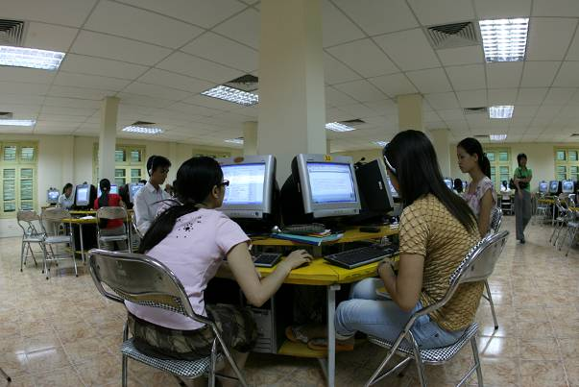**The Convergent Government Network agreement was signed between the Information Technology Authority (ITA) of Oman and Oman Telecom­munication Company (Omantel) to connect governmental sites across the Sultanate.

DED launched the “EDET Expansion of Dual Education and Training” project which offers quality education to software programmers and system administrators for use in schools.

Within the framework of the Connect the World initiative, the ITU launched [Connecting Villages Initiative](http://www.itu.int/ITU-D/connect/flagship_initiatives/connecting_villages/index.html) and [Connect a School, Connect a Community](http://www.itu.int/ITU-D/connect/flagship_initiatives/connecting_children/index.html).

With the Connecting Villages Initiative, ITU entered into an agreement with the Nokia-Siemens Network (NSN) to implement up to 30 sites of Village Connection Solution worldwide, of which the first sites have been undertaken in the Asia–Pacific region

|  |
| --- |
| The [Connect a School, Connect a Community](http://www.itu.int/ITU-D/connect/flagship_initiatives/connect_school/index.html) initiative aimed to improve access to broadband in schools and enable them to serve as community broadband centres. It operates through the creation of an online toolkit to share best practices and advice to ITU Members on developing national school connectivity plans and the implementation of pilot projects. The project will also assist beneficiary countries in the preparation of their National Plans to connect schools.  Through Connect a School, Connect a Community, ITU is working with a range of partners to identify and compile best practices on policies, regulation, applications, services and practical experiences to be shared with interested countries through the development of an online Toolkit and related capacity-building activities. Building on this Toolkit, ITU is also implementing projects with various partners which apply, test and report the results of innovative, replicable and scalable models of broadband school connectivity in different countries. |

# C2.4 Adequate and affordable ICT equipment and services

In order to turn WSIS Targets into Action, stakeholders actively participated in the design and production of ICT equipment and services to guarantee affordable access for all. Below are some examples of various projects that demonstrate this goal.

The Ministry of the Interior of the Czech Republic in collaboration with ITU, WHO, UNESCO, and the Netherland Ministry of Economy launched the “Basic PC and Internet Course” project in order to contribute to “bridging the digital divide” in Africa.

|  |
| --- |
| The School Net Project was initiated by the Central Informatics Bureau (Government department under the Ministry of Information and Communication Technology of Mauritius) in order to provide PCs to 275 primary schools in Mauritius and Rodrigues. To date, 175 state-owned and private secondary schools have been provided with broadband Internet access free of charge. |

# C2.5 International and Regional Cooperation

Examples of projects related to Action Line C2 made possible through international and regional cooperation are highlighted below:

ITA of OMAN signed an MoU with IDA of Singapore, which aims to strengthen the bilateral relationship between the two countries and promote the exchange of information and experience on ICT matters by recommending companies based in Oman and Singapore to implement specific ICT projects. The goal of the MoU is to increase cooperation on projects to be implemented by public and private sectors. This is a significant milestone for ITA in the acceleration of its projects to implement the national IT strategy.

ITA of Oman is working with BSEEN International Organization Ltd., the leading distributor for Adobe Enterprise Solutions in the Middle East and North Africa, by providing training programmes on ways to implement the Adobe LiveCycle solutions as part of the e-government and e-education initiatives. Under the sponsorship of ITA, BSEEN will provide training on the Adobe LiveCycle solutions to government IT personnel to extend their electronic e-government services with new applications such as span data capturing, process orchestration and document generation – inside and outside the firewall.

The National Telecommunications Commission (NTC) of Thailand in partnership with ITU has approved the Master Plan for Telecommunication Services, No. 2 (2008–2010). This project was initiated with the aim of achieving specific targets of the master plan relating to universal service for basic telecommunication and social services.

Public–private partnership between USAID’s West Africa Trade Hub and Intel will provide broadband Internet connectivity to small businesses which need to improve their competitiveness.

****ictQATAR (representing the State of Qatar) and Eutelsat Communications (Euronext Paris: ETL) intend to respond to the fastest growing applications in the Middle East and Africa through a satellite launch. The satellite structure has been built by a partnership between ictQATAR and Eutelsat Communications with the aim of supplying ICT infrastructure by providing superior coverage and power for those regions.

ITU in close collaboration with the Ministry of Internal Affairs and Communications(MIC) of Japan will carry out a feasibility study on low-cost wireless broadband infrastructure for developing countries.

|  |
| --- |
| With the aim of mobilizing additional funds and new partnerships to attain the WSIS goals including the development of infrastructure ITU initiated the [Connect Summit](http://www.itu.int/ITU-D/connect/index.html) series in 2007. Building upon the success of its first Summit, Connect Africa, held in Kigali, Rwanda, in October 2007, that resulted in commitments of 55 billion US Dollars from various stakeholders, ITU organized the second Summit, [Connect CIS](http://www.itu.int/ITU-D/connect/cis/index.html) with partners on 25–27 November 2009 in Minsk, Belarus. The Summit gathered 353 participants from 18 Member States (ten from CIS Region), including five Heads of State (Republic of Armenia, Republic of Belarus, Republic of Kazakhstan, Kyrgyz Republic and Republic of Tadjikistan) and Government and one First Deputy Prime Minister. The administrations of ten countries from the region were represented, including seven at the Ministerial level. Some 40 leading ICT companies, development banks, international organizations and other stakeholders participated in the Summit. The Heads of State addressed participants of the Summit in a special session entitled, “Leaders Statements and Summit Declaration: Towards a Sustainable Information Society “, in which each Head of State outlined their vision for the Summit and pledged their full support to the Connect CIS Initiative. The Summit concluded with the [Connect CIS Declaration](http://www.itu.int/ITU-D/connect/cis/documents/Final_Declaration_APPROVED-RCC_24nov.pdf).  3239Within the framework of the Connect the World initiative the ITU launched several initiatives relevant for the WSIS Action Line C2, including [Wireless Broadband Partnership](http://www.itu.int/ITU-D/connect/flagship_initiatives/wireless_broadband/index.html), [Connecting Villages Initiative](http://www.itu.int/ITU-D/connect/flagship_initiatives/connecting_villages/index.html), [Connect a School, Connect a Community](http://www.itu.int/ITU-D/connect/flagship_initiatives/connecting_children/index.html). |

Action Line C3 Access to Information and Knowledge

In order to maximize the benefits from various knowledge bases, stakeholders have taken actions to develop policy guidelines ,provide public access points and create digital public libraries and archive services to promote research on the Information Society .

# C3.1 Policy and Legislation

Many governments have expressed concerns regarding establishing legislation on access to information and the preservation of public data. In response to these concerns, many governments have taken steps to enhance security within the Information Society.

Electronic Transactions Law of the Sultanate of Oman is helping to usher in a new era in Oman where a truly e-enabled society can evolve from the realization of the digital society of Sultanate. This is the first law for legalizing electronic transactions in Oman which can be defined as any contract, agreement or communication in this regard to be fully or partially implemented by electronic means as electronic messages. The e-transactions law of Oman legalizes the use of digital signatures in electronic commerce and communications through letters, e-mails etc. Organizations wishing to introduce digital signatures must be approved by the Information Technology Authority through a formal process. Furthermore, in order to assure adequate protection to both businesses and the public, this law provides for penalties in the case of electronic crimes involving e-transactions.

|  |
| --- |
| In Morocco, the National Agency of Telecommunications Regulation (ANRT) implemented the programme “PACTE” aimed at providing access to ICT to 9 200 rural localities during the period 2008–2011. PACTE will provide more than two million citizens with access to ICT services. |

ITU assists its Members to develop policies to ensure ICT accessibility for persons with disabilities. In May 2009, ITU together with its partner G3ict launched an online toolkit to share best practices with policy makers and regulators on promoting accessible ICTs for persons with disabilities. ITU has shared best practices and provided capacity building on the e-Accessibility toolkit in two events in 2009, one held for the Asia–Pacific region and one for African countries.

# C3.2 Information Access

Access to information can occur through a number of varied activities, from geographic information systems to the creation of government portals. The following examples illustrate different activities undertaken by numerous countries to provide public access to governmental websites and other specific services.

The Ministry of the Interior of the Czech Republic launched the project Central Registers (Registers of Persons, Registers of Inhabitants, Registers of Rights and Responsibilities, Registers of Territorial Identification, Addresses and Real Estates) which represents a collection of data that will be shared by the public administration authorities and serve as a source for other registers.

The Egyptian Judicial Services Development project is aimed at enhancing judicial procedures and the overall work environment. The project achieved numerous successes including re-engineering judicial public service processes and developing a case management system for different court categories which was deployed in 12 different courts.

Information system (Infothek) was set up by GTZ in cooperation with the Hungarian consumer organization OFE (Országos Fogyasztóvédelmi Egyesületnek) focusing on diverse issues such as, sales law, district heating, health and nutrition and patients’ rights for strengthening competitiveness and dismantling technical trade barriers.

****Geographical Information System (GIS) was initiated by GTZ in order to create a land register for land management and securing property.

Turkey has undertaken various activities to provide the public with information access. The IT depart­ment of the Ministry of Justice of Turkey im­­ple­men­ted the SMS Information System which allows citizens and lawyers to receive SMS messages containing legal information on ongoing cases, dates of court hearings, etc.

The National Productivity Centre of Turkey (MPM) initiated Online Productivity Statistics in order to calculate the productivity indices of Turkey. MPM performs this work based upon its No. 580 Establishment Law in which some of the MPM’s duties are given to measure the national productivity, to compare the results with other countries and to publish the indices periodically.

Oman launched several projects during the period 2008–2010. Some examples are: the official online donations portal and Oman’s National Data Centre.

In an effort to create a more inclusive information society and to provide universal access, ictQATAR upgraded its website to make it more accessible to everyone regardless of visual, hearing, motor and cognitive impairments.

****In Egypt, Ministry of State for Administrative Development, in cooperation with Ministry of Foreign Affairs and Consulates, is working on availing services for expatriates online, so they will no longer need to be physically present at the consulates. The project encompasses: developing and maintaining the current portal, availing online services and developing e-archiving and e-mailing system between the ministry and the consulates.

Uzbekistan has launched WWW.UZ which functions as a mechanism of fast access to the information from a national segment of the Internet network. The basic features of the WWW.UZ system contain a multilingual information search (Uzbek, Russian) and close integration with other national information systems and databases.

“Ghana Development Information Systems” (GhanaInfo/DevInfo) is a national supervising and evaluation programme for data acquisition and data transmission. It is used by ministries, regional planning coordination units and the local administrative authorities.

UNESCO’s Memory of the World Programme has contributed to the protection of and access to original documentary material and to sensitizing the public and decision-makers to the importance of heritage and memory. Together with World Digital Library, this will serve as a framework for national development and possible regional cooperation, including also the provision of diverse and multilingual content on the Internet.

# 3C3.3 Research and Development

Stakeholders executed diverse projects related to research in order to facilitate accessibility of ICT for everyone, in particular for disadvantaged groups.

National Centre for Information Development (CENADI) in Cameroon implemented the Government Action Programme for the Information Society and knowledge with goals to conduct extensive research in order to identify equipment faults and other imperfections, which impair the functioning of the administrative system.

In Oman, ITA, in association with the Ministry of National Economy, launched the ICT Business indicators survey. The main purpose of the survey is to gather data related to ICTs at the national level and to explore the use of IT by Omani businesses, such as, e-mail, information searches, procurement, banking and electronic payments, research, public sector liaisons, customer service and provision of products or services online.

# C3.4 Community Centres

In line with WSIS targets, stakeholders were encouraged to establish community public access points which could provide Internet access in libraries, public places, educational institutions and, in particular, in rural areas.

In Bangladesh, Dhaka Resource Centre (DRC)was launched asa district coordinating body located in a district headquarters, which is designed to be the official institution which promotes and supports entrepreneurs and institutions in establishment and operation of telecentres and other types of public access to information and knowledge through ICTs.

In Bangladesh, BIID, in partnership with Pacific Bangladesh Telecom Ltd., has introduced the Batighar business modelfor scaling up all over the country. BIID will work to establish a network of 500 Batighar centres by 2011 and then up to 5000 Batighar centres by 2015.

**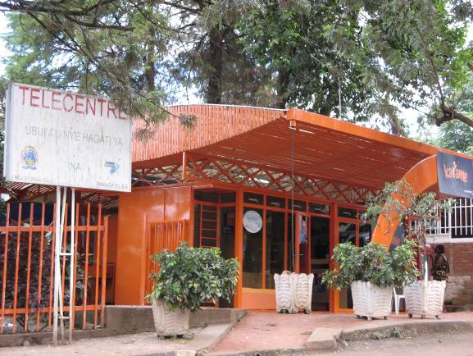**ITU together with the United States Department and Government of Malawi launched the “Malawi multipurpose community telecentres project” which focuses on extending ICT access and services to rural communities by providing basic sets of accessible ICT equipment, facilities and training to rural areas in Malawi.

During July 2009, ESCWA joined with Telecentre.org in organizing the “Telecentres’ Leaders Forum” (Project: Knowledge Networks for Disadvantaged Communities) in Amman, Jordan.

ITA of Oman aims to establish several Community Knowledge Centres (CKC) in different parts of the Sultanate. Each CKC will be provided with the required equipment to access the Internet.

|  |
| --- |
| Telecentre.org is a civil society organization that aspires to build support structures to help sustain millions of established telecentres around the world. As part of its global programme, Telecentre.org has recently launched its Telecentre.org academy. |

With a special focus on women in rural areas, InWEnt enhances vocational training in partnership with the Ministry for Vocational Education of Algeria and the Ministry for Education of Tunisia and other NGOs. The goal of this project is to build and manage telecentres in rural areas.

National Culture Network Project: multi-purpose community public access points was launched in Iran. This project will be implemented, in five years (2015) at 5 000 digital culture sites and complexes, serving as multi-purpose community public access points throughout the country, especially in such public centres as libraries and mosques.

In Egypt, the IT Clubs project is available to the mass population. There are approximately 300 IT clubs established every year. MCIT is working on activities for those with special needs and children who have dropped out of the formal school system.

# C3.5 Software and open access

In order to foster the awareness of different software models and licences, stakeholders have undertaken various activities.

Oracle in association with the Information Technology Authority of Oman hosted several hundred of the region’s chief information officers (CIOs) in Muscat.

|  |
| --- |
| ICT solutions based on free and open source software (FOSS) are of increasing interest to Southeast Asian countries for advancing their development in administration, education, health, or business promotion. Fostering capacities and networking, FOSS goes well in line with the overall mission of InWEnt aimed at strengthening local human capacities and empowering people to develop their own solutions for social and economic development. |

DEG signed BEN Academic Partnership Programme where several universities will be provided with specialized software for architecture, engineering and construction as well as networking infrastructure and teaching material.

The Ministry of Culture and Islamic Guidance of Iran launched the project in order to support the establishment and development of special tools and technologies for people with disabilities. Special softwares using new technologies to serve such applications as turning voice to text and vice-versa, especially in the Farsi language, have been introduced during digital media festivals and will be distributed in the future with the support of the Ministry.

# C3.6 Digital libraries and archives

Stakeholders supported the establishment of digital public libraries and archives services including free or affordable access to open access journals, books and archives.

The e-archiving system was initiated by MSAD in Egypt in order to promote secure documents and information flow between different government sectors and organizations. The system incorporates the necessary tools to provide authenticity and smooth flow of documents through secure networks.

In Togo, cyberlibraries were created in the form of buses in order to serve in the maritime regions and central plateau areas of the Kara and Savannas. The specialized buses are equipped with computers with Internet access.

Regarding the importance of preserving and offering various value-added services for the contents referred to by the Ministry in the supervision and supportive procedures, Iran has put into operation a digital archive in a bid to receive related contents (books, periodicals, music, film, written arts works, and so on) in digital form.

Action Line C4 Capacity Building

In line with the WSIS targets, capacity building and ICT literacy are essential elements in order to benefit fully from the Information Society. There are 2 063 entries in the WSIS Stocktaking database related to Action Line C4.

# c4-c3C4.1 ICT Literacy

Stakeholders developed and promoted various programmes in order to eradicate illiteracy using ICTs. Particularly, there is a need to eradicate adult illiteracy. Facilities such as libraries, multipurpose community centres and various public access points were taken into consideration as possible locations to establish ICT training centres.

The Government Digital Literacy Training Pilot project was launched by ITA of Oman in order to provide the training for 400 civil service employees. This pilot project is part of ITA’s National IT Training and Awareness Initiative. It aims to provide IT training op­portu­nities to government and community citizens in Oman, to build IT literacy among Omani citizens and to equip them with the required skills for sustaining the knowledge society of Oman.

In addition, ITA signed the Civil Service Employees Digital Literacy Training agreement with Certiport (IC3) to train 93 507 civil employees. Through this agreement, Certiport will provide learning and certification on the global digital literacy standards of Certiport Internet and Computing Core Certification (IC3) curriculum and will train civil service staff.

Egypt instigated the ICT for Illiteracy Eradication programme which produced electronic content for teaching Arabic letters and words and elementary mathematics based on the General Authority for Literacy and Adult Education (GALAE) curriculum for illiteracy eradication.

Qatar created the Centre for Women and Technology for the Arab Region (CWTAR) in order to increase women’s involvement in the knowledge society. The first one resulted in the development of strategic objectives for CWTAR in the fields of education, workforce entrepreneurship and leadership.

# C4.2 National policies

National education policies were approved by numerous countries to ensure that citizens could be equipped with the knowledge and skills to use ICTs.

In Egypt, MSAD is working with different relevant authorities and organizations on trapping compulsory education dropouts in an attempt to reduce dropouts rate through Egypt, and especially in remote areas. MSAD works on linking and integrating different databases within relevant authorities to ensure accurate, smooth and updated dataflow. The Ministry of Education’s database can be used effectively to define schools attendence rates. Another project named School management system (SMS) has been developed aimed at including families in the education process.

In Spain, the Ministry of Industry, Tourism and Trade, International Affairs and State Secretariat for Telecommunications and the Information Society launched three Capacity Building Initiatives for Spanish- and Portuguese-speaking countries: centres of excellence, Internet training centres and youth scholarships.

|  |
| --- |
| To improve Human Capacity in Zambia, the Ministry of Education launched Enhancing the Visual and Presentation of Educational Content (ENEDCO) project. The project focuses on visual representation of content of existing teaching materials. The ENEDCO project is specifically aimed at improving national performance levels through a relevant and diverse curriculum which develops appropriate skills and knowledge for employment. |

**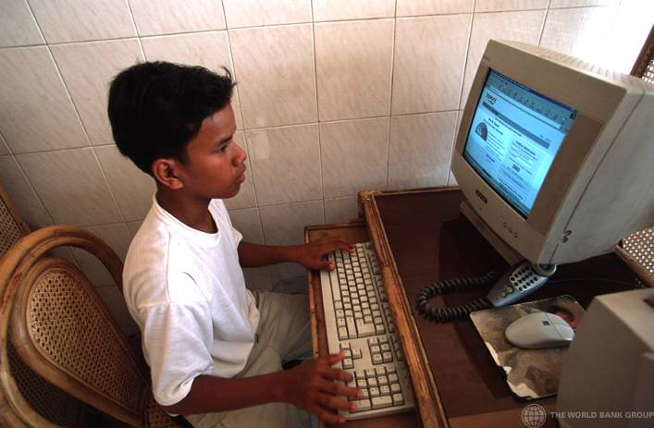**Oman signed an agreement with Microsoft to launch the world’s first collaborative learning solution for high school students. The agreement will bring advanced online services to 650 000 students in Oman. It will provide a free e-mail service messaging services with 5GB of storage and up to 1GB of password-protected online storage space, automatic e-mail reply and IP address.

The GITTC is a project under the National IT Training & Awareness (NITTA). The GITTC initiative aims to provide ICT training opportunities to civil service employees in order in enable them to offer electronic services to the public. During the first phase of the training project, over 300 centres were established at government schools under the Ministry of Education. About 7 000 government employees have been assessed for digital literacy training needs in the Muscat, Al Batinah and As’Sharqiya regions of the Sultanate.

In Qatar, MADA (Qatar Assistive Technology Centre) will be a Centre of Excellence connecting people with disabilities to ICTs as a way of fostering greater equity and empowerment, and creating public awareness of best practices in Assistive Technology (AT). MADA will be a collaborative effort between key ICT industry partners, Disability Service Providers (DSPs), and different governmental bodies. The Resource Centre in Doha will feature interactive environments for the visually impaired, hearing impaired, learning disabled, intellectually challenged and the mobility impaired, with an information resource library highlighting the latest developments and best practices in the field of Assistive Technology.

Uzbekistan created the ZiyoNET information educational network to introduce information technology in educational process.

A national programme named “Information and communication technologies for quality of education” was approved by the Latvian government in order to create an ICT environment, which will lead to improved efficiency and quality of general and vocational education systems. IKTIK programme is a scope of projects that are important for the development of the Latvian education system. It consists of four action tracks as defined in the programme: improvement of ICT skills for teachers, development of e-study materials, development of educational information systems and providing schools with hardware infrastructure.

|  |
| --- |
| In Morocco, the “Genie” programme was established by the Government through the introduction and integration of ICTs in national education providing widespread access to the Internet in Morocco. The idea is to promote and expand access to ICTs, particularly multimedia applications and Internet access to all schools. |

# C4.3 ICT for professionals and experts

Stakeholders initiated various specific training projects for professionals. The trainings were focused on management skills, as well as new methods and techniques for better development and provision of information.

DEG set up different initiatives such as an IT training centre on the university campus in Salatiga and the establishment of a centre of excellence which provides vocational training to marine mates in accordance with STWC 95. Mobile training facilities for private Philippine marine schools provided vocational training for 1 200 ship engineers and marine mates, and contributed towards the build-up of an IT academy in cooperation with C.I.D.A. University in Johannesburg.

The Global e-schools and Communities Initiative (GeSCI) has developed an ICT-Teacher Professional Development (TPD) Matrix toolkit to enable organizations to identify the object of ICT integration in their current TPD programme. The matrix provides a roadmap in order to increase teacher’s capacity in use of ICTs as a tool to enhance the quality of learning.

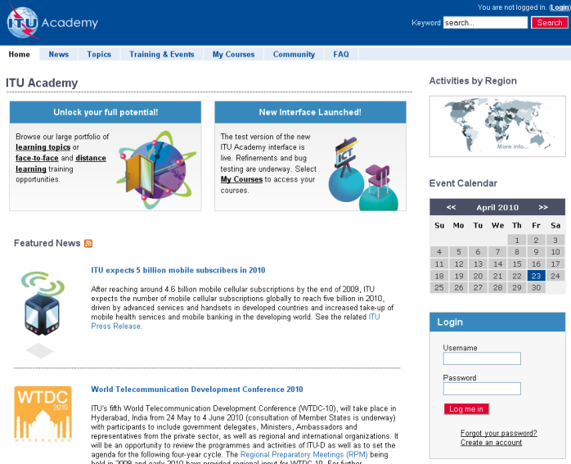In the WSIS Forum 2009, ITU officially launched the ITU Academy, that includes a web-based portal that allows for a single access point to all ITU training interventions, whether delivered face-to-face – or through instructor-led and self-paced e-learning.The overall vision of ITU Academy is to strengthen the human, institutional and organizational capacity of developing countries by making available ICT learning and development opportunities at the highest possible levels of quality. With that goal in mind, the ITU Academy initiative needs to pull together the diverse education, training and information efforts of the ITU Development Sector in order to develop a harmonized and streamlined approach to capacity building, and to ensure that what gets delivered to the end-user is fully evaluated as to its quality, relevance and delivery.

# capacity-buildingC4.4 Distance Learning

According to Geneva Action Plan, the Stakeholders developed distance-learning projects focused on deve­lop­ing countries, in particular LDCs.

For InWEnt, the focus of the project “Ch@t der Welten” (Chat of the worlds) is to develop capcity-buidling skills. This project supports critical dialogues about global issues in schools. It offers teaching staff professional training programmes, with a broad variety of topics and contents.

In Iran, pedagogy.ir was established as an Open Educational Resources (OER) initiative.

# C4.5 International and Regional Cooperation

The assistance of international and regional organizations is important in order to promote capacity-building initiatives at the international, regional and national levels. Below are some examples of countries that are supporting the implementation of national programmes.

Workshop on the Management and Sustainability of Knowledge Hubs (Project: Knowledge Networks for Disadvantaged Communities) organized by ESCWA was held in January 2010 in Khartoum, Sudan. Its main objectives were to bring together telecentre managers from various parts of the ESCWA region in order to familiarize telecentre managers with concepts and methods that are relevant to the goals of the Knowledge Networks project and to train them on the establishment and management of small business ventures.

Deutsche Gesellschaft für Technische Zusammenarbeit (GTZ), on behalf of the Federal Ministry for Economic Cooperation and Development (BMZ) and in collaboration with partner organizations in the Balkan region, aims to promote employment and improve education of young people in the ICT sector. In addition, GTZ strengthens the advisory capacity of the United Nations Economic Commission for Africa (UNECA) with ICT trainings.

Employees of the Slovenian Ministry of Telecommunications, broadcasting corporation and postal authority receive advanced training from GTZ in the use of ICTs.

|  |
| --- |
| Deutsche Gesellschaft für Technische Zusammenarbeit (GTZ), on behalf of the Federal Ministry for Economic Cooperation and Development (BMZ) and in collaboration with partner organizations in the Balkan region, aims to promote employment and improve education of young people in the ICT sector. In addition, GTZ strengthens the advisory capacity of the United Nations Economic Commission for Africa (UNECA) with ICT trainings.  Employees of the Slovenian Ministry of Telecommunications, broadcasting corporation and postal authority receive advanced training from GTZ in the use of ICTs.  Two training centres in Hanoi were installed by GTZ with an Internet-based training system consisting of a multimedia-based ”teachware” and an interactive experiment area which enables the simultaneous teaching of theory and practical experience.  The Yemenite Ministry of Education was supported and consulted by GTZ to initiate their Basic Education Improvement Programme. Planning, monitoring and reporting are based on complete, precise and up-to-date statistical data, generated by a national Education Management System (EMIS). |

****DED supports Vocational and Educational Training in Botswana through the deployment of qualified personnel in areas where local expertise is not available. Specific focus lies on skills transfer. In addition, DED supports the Bureau for IT services Kantor Pengelkolah Data Elektronik (KPDE) in order to develop and implement a networking concept for the public administration in the district of Sragen, to select appropriate data processing software and to train the authority staff in database management.

A capacity-building workshop for e-government was organized by ITA of Oman in partnership with UNDESA. The workshop sessions include objectives and aims at having government information online (Government Online), with the goal of improving web presence, by introducing Knowledge Management (KM) within public offices.

With vocational training programmes in Uganda (communications platform and teacher trainings), KfW enhances the opportunities to find work and derive income for young school graduates and dropouts, as well as individuals presently unemployed or those interested in developing new skills. The system of vocational training should be structured and oriented on the demand of the labour market.

The Egyptian Education Initiative (EEI) is a public–private partnership between GoE, the World Economic Forum’s IT member community and various multinationals. The initiative supports Egypt’s overall education reform efforts and maximizes the potential for collaborative partnership to achieve its goals.

ITU carried out several activities through its Human Capacity Building (HCB) programme, including regional and international trainings, workshops, e-learning toolkits, networks of experts, etc. In 2009 ITU launched a series of ITU Regional Human Capacity Development Forums, with the objective to promote excellence in human capacity development in the information and communications technology (ICT) and telecoms sector.

The aim of Digital Communications Literacy Forumis to address the issue of digital literacy which “requires being empowered with information on how to best use digital communications to succeed both economically and socially”. In the framework of a partnership forum hosted by ictQATARand IIC1, several issues, such as a clear definition of digital communications literacy and its importance, were discussed.



Action Line C5 Building confidence and security in the use of ICTs

Confidence and security in the use of ICTs is one of the main pillars of the Geneva Plan of Action. With an increase in the availability of e-government services, growth in businesses’ adoption of e‑commerce solutions and online financial transaction, and surging numbers of people and businesses connecting through collaborative and social networking platforms, building trust in the use of ICTs continues to be a concern amongst governments and other stakeholders. Stakeholders around the world are taking the steps necessary to secure online privacy and protect privacy in the real world, and work towards ensuring the security, availability, and reliability of these ICTs that are increasingly important for economic growth, innovation and productivity globally. In order to respond to the growing number of cyberchallenges, and enable citizens to take full advantage of the opportunities that ICTs offer, all stakeholders are encouraged to contribute their experience and expertise in the field of cybersecurity.

# C5.1 National Approaches

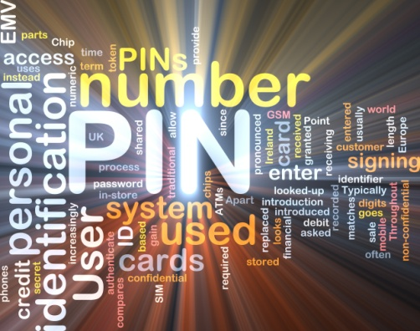The legal, technical and institutional challenges posed by the issue of cybersecurity and cybercrime are global and far-reaching, and can only be addressed through a coherent strategy taking into account the roles of different stakeholders and existing initiatives, within a framework of international cooperation. With this in mind, governments together with the private sector and businesses, civil society, academia and end users are together taking action in their national context to advance the knowledge economy, promote innovation and growth while promoting a safe and secure environment for its citizens. Governments encourage the domestic assessment of national laws in order to achieve effective use of electronic documents and transactions through the use of electronic authentication.

In Egypt, the Ministry of State for Administrative Development, in partnership with the Information Technology Industry Development Agency (ITIDA), is working on the project “digital signature to government portal” facilitating service transactions online, especially for those which need authentication and validation through a number of steps that include definition services requiring authentication, applying of digital signature for the selected services and integration with mobile digital signature for WAP services.

****In Morocco, ENSA launched a project aimed at providing tailored and adaptive protocols for NGN to ensure security and quality of service.

In Mauritius, the National Computer Board created a Computer Emergency Response Team (CERT-MU) which was set up in May 2008 as the main national body for coordination of information security incidents at the national level. CERT-MU’s mission is to provide information and assistance to its constituents in implementing proactive measures to reduce the risks of information security incidents as well as responding to such incidents.

|  |
| --- |
| The Korean Communication Commission (KCC) launched its Master Plan for Online Information Protection in order to improve the overall national level of information protection. KCC has revised relevant laws to minimize the collection of national registration numbers to lower potential infringement and has initiated a policy to encrypt collected personal information. Under this plan, 50 security tasks in four different fields, including intrusion response, protection of online privacy, illegal or harmful information on the Internet and information security infrastructure have been implemented. |

The United Arab Emirates Computer Emergency Response Team (aeCERT) is the cybersecurity coordination Centre in the UAE that has been established by the TRA as an initiative to facilitate the detection, prevention and response of cybersecurity incidents on the Internet.

ITA signed a contract with E-COP PTE Ltd., Singapore (E-Cop) to establish the Omani National Computer Emergency Response Centre (CERT). Through this contract E-COP will establish and operate the National CERT of Oman and transfer knowledge to the Omani team in the next 20-month period. The National CERT is a vital component of the nation’s IT strategy aimed at creating cybersecurity awareness as well as responding to security incidents in a timely manner. The National CERT will serve as a trusted focal point of contact for any ICT security incidents.

In Qatar, Safe Space project is based on a website targeting Internet access on one hand, and Internet security on other hand. Therefore, the website is designed to educate children on how to use Internet in a safer manner. It also targets other groups such as teenagers, teachers and parents.

****ictQATAR’s Keep Them Safe, Keep Them Curious Campaign aimsto make Qatari children aware of the potential dangers surrounding the Internet world without scaring them in accordance with the ITU’s COP Guidelines2. For this purpose, the Qatari government has launched various actions through the media to raise awareness of the importance of cybersecurity for children.

In Iran, “Cybercrimes Law” specifically asserts security and confidentiality of private information in the digital environment and considers any sort of unauthorized access to private information of individuals or their publication, distortion, omission and use to be a crime.

# C5.2 International and Regional Cooperation

In order to progress in the field of security and confidence in the use of ICTs, cooperation among stakeholders at the global level is vital.

|  |
| --- |
| The ITU Global Cybersecurity Agenda (GCA) was launched in 2007 by ITU Secretary-General, Dr Hamadoun I. Touré for international cooperation aimed at enhancing confidence and security in the Information Society. The GCA was designed to enhance cooperation and efficiency, encourage collaboration with and between all relevant partners and build on existing initiatives to avoid duplicating efforts. [[22]](#footnote-23)  The GCA is made up of seven main strategic goals and builds upon the following five work areas or pillars: (1) Legal Measures; (2) Technical and Procedural Measures; (3) Organizational Structures; (4) Capacity Building; and (5) International Cooperation. It builds on existing national and regional initiatives to avoid duplication of work and encourage collaboration amongst all relevant partners. GCA benefits from the advice of a [High-Level Experts Group (HLEG)](http://www.itu.int/osg/csd/cybersecurity/gca/hleg/index.html) composed by world-renowned specialists in cybersecurity, representing expertise from across a broad range of backgrounds in policy-making, government, academia and the private sector.  cop-brochure The WSIS outcomes in 2009 specifically recognized the needs of children and young people and their protection in cyberspace. The Tunis Commitment recognized “the role of information and communication technologies (ICTs) in the protection of children and in enhancing the development of children” as well as the need to “strengthen action to protect children from abuse and defend their rights in the context of ICT”. On the same occasion within the framework of the Child Online Protection (COP) initiative, the first release of the “[Guidelines for Policy-Makers, Industry, Parents, Guardians, Educators, and Children on Child Online Safety](http://www.itu.int/osg/csd/cybersecurity/gca/cop/guidelines/)*”* was presented. |

ESCWA developed and published in March 2009 a study entitled “Building Trust in E-Services in the ESCWA Region.” The study identified various levels of cybersecurity, reviewed relevant national and regional policies and shed light on the legal elements that need to be developed in order to build trust and confidence among ICT users and to encourage them to use e-services.

The initiative of Regional Harmonization of Cyber Legislation to Promote the Knowledge Society in the Arab World was launched by ESCWA in order to bridge regional legislative gaps to prevent the illicit and illegal use of cyberspace while mapping out a course of action that will foster the creation of a legislative enabling environment in EMCs.

|  |
| --- |
| ITU Cybercrime Legislation Resources  The purpose of ITU's dedicated Cybercrime Legislation Resources is to assist countries in understanding the legal aspects of cybersecurity and to help harmonize legal frameworks. These address the first of the seven strategic goals of the ITU Global Cybersecurity Agenda (GCA), which calls for the elaboration of strategies for the development of cybercrime legislation that is globally applicable and interoperable with existing national and regional legislative measures.  The adoption by all countries of appropriate legislation against the misuse of information and communi­ca­tion technologies for criminal or other purposes, including activities intended to affect the integrity of national critical information infrastructures, is central to achieving global cybersecurity. Since threats can originate anywhere around the globe, the challenges are inherently international in scope and require international cooperation, investigative assistance, and common substantive and procedural provisions. Thus, it is important that countries harmonize their legal frameworks to combat cybercrime and facilitate international cooperation.  ITU’s Cybercrime Legislation Resources include the ITU publication Understanding Cybercrime: A Guide for Developing Countries[[23]](#footnote-24) and the ITU Toolkit for Cybercrime Legislation[[24]](#footnote-25) . A revised version of the ITU Toolkit for Cybercrime Legislation has been made available on the ITU website in April 2010. This version reflects the feedback received since the launch of the Toolkit in May 2009.  Stakeholders who have additional input and feedback on the Toolkit, are invited to share this information with ITU at: cybmail@itu.int. The deadline for input is 31 July 2010.  cop-brochure  cop-brochure  More information on the ITU Cybercrime Legislation Resources can be found on the website at: [www.itu.int/ITU-D/cyb/cybersecurity/legislation.html](http://www.itu.int/ITU-D/cyb/cybersecurity/legislation.html) |

Action Line C6 Enabling Environment

Governments undertook numerous initiatives in order to create a trustworthy, transparent and non-discriminatory legal, regulatory and policy environment.

# C6.1 Policy, regulatory and legal reforms

Governments continue to facilitate national and regional Internet Exchange Centres to promote awareness of the Internet and online privacy, to update domestic consumer protection laws and to develop national strategies, including e-government strategies.

ITA of Oman signed an MoU with Huawei Tech Investment Oman LLC (Huawei) where Huawei contributes to the development of the educational system in the Sultanate by providing modern communication technology (LAN-Wireless Network) to 100 schools in Sultanate of Oman. ITA acts as a facilitator between government institutions and the private sector to enhance ICT facilities in the Sultanate under eOman vision.

The main objective of the workshop Investment in the ICT Sector organized by ESCWA was to raise the awareness of member countries and to increase their understanding of policies, mechanisms and modalities that promote ICT investment and entrepreneurship in the region.

ITU participated actively to build the enabling environment:

The 9th edition of [Trends in Telecommunication Reform 2008: Six Degrees of Sharing](http://www.itu.int/ITU-D/treg/publications/trends08.html) was published in November 2008. The 10th edition focusing on *Stimulating Growth through Effective ICT Regulation* was published in April 2010. The forthcoming edition addressed the challenges of convergence, the new expectations of stakeholders and the changing role of the regulator.The [ICT Regulation Toolkit](http://www.ictregulationtoolkit.org)*,* developed by ITU and its partner, *infoDev*, includes seven modules on key regulatory issues. The Toolkit, which is updated on a continuous basis, assists regulators in the design of effective and enabling regulatory frameworks by sharing analysis and information on key regulatory 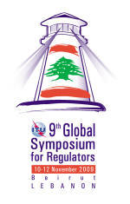issues as well as best practices.

The 9th Global Symposium for Regulators (GSR) was held in Beirut, Lebanon, on 10–12 November 2009. The overall theme of the event was “Hands-on or hands-off? Stimulating Growth through Effective ICT Regulation”. With the purpose to better engage industry in the planning of future policy and regulatory reforms, the GSR was accompanied by the Global Industry Leaders Forum on 9 November 2009.

[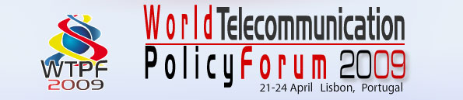](http://www.itu.int/osg/csd/wtpf/wtpf2009/index.)In 2009, ITU hosted the [World Telecommunication Policy Forum (WTPF)](http://www.itu.int/osg/csd/wtpf/wtpf2009/) in Lisbon, Portugal, to exchange views on the key policy issues arising from today’s fast-changing ICT environment. In ac­cord­an­ce with Decision 9 of the ITU Plenipoten­tiary Conf­er­ence 2006, WTPF-09 examined the implications of convergence, including Internet-related public policy issues, and new emerging telecommunications policy and regulatory issues.

# C6.2 Internet-related law and governance

In order to promote security within the Information Society, governments and other stakeholders need to establish and secure the enabling environment.

The study, Internet Governance: Challenges and Opportunities for the ESCWA Member Countries was implemented with the purpose of increasing the knowledge and understanding of Internet governance issues while promoting the role of Arab countries in the global Internet society.

Korea Internet and Security Agency (KISA) established a sustainable Internet Environment promoting further application of IPv6, Future Internet, and revitalization of wireless Internet for a secure Internet environment.

# C6.3 Small and Medium-Sized Enterprises

The role of small and medium-sized enterprises (SMEs) is vital for the economic development of ICTs. Stakeholders undertook various initiatives to facilitate administrative procedures, to encourage investments and foster SME participation in ICT-related projects.

In Bangladesh, the project Shikor was launched with a vision of empowering and up-streaming the capacity of Micro, Small and Medium Enterprises (MSMEs) of Bangladesh through ICTs. BIID has introduced a web based interface designed to provide rural MSMEs with information and services about markets for their products and services..

In remote areas in the north of Namibia, an insufficient system for monetary transactions hinders business activity and rural–urban transmittances. KfW established a system for monetary transactions in Namibia where the Namibian government considers the support of local SMEs as a crucial element to the generation of employment.

The Rural Financial System Development Programme was launched by GTZ to provide access to advanced financial services with a management information system that has improved banking services and the financial sector.

In Kenya, the Digital Villages (PaSha) Project was implemented to provide ICT facilities to local entrepreneurs.

# C6.4 Consumer-related policy and dispute resolution

New challenges in the Information Society require all stakeholders to update domestic consumer protection laws. Various countries achieved WSIS targets through establishing arbitration institutions and the development of consumer protection policies.

In partnership with the Ministry of Investment, MSAD of Egypt works on developing investment services to enhance the business environment in Egypt. The project aims at simplifying investment procedures as well as accelerating different investment services. The projects aims also at improving investment services through the Internet in order to achieve greater accessibility. The project encompasses the Investment Authority services and Guarantee and Subsidiary Fund (GSF) services.

In partnership with Ministry of Finance and Egyptian Customs Authority, MSAD works on developing customs services to facilitate accessing them via different channels. The project aims at adding extra channels for delivering customs’ services through the Custom Authority portal.

Action Line C7 ICT Applications: Benefits in all aspects of life

ICT applications play a crucial role to support the sustainable development related to various aspects of life. ICT applications such as e-government, e-business, e-learning, e-health, e-employment, e-environment, e-agriculture and e-science are all part of national e-strategies. The overview below illustrates examples of ICT applications.

# C7.1 E-Government

In South Africa, the main project which facilitates ICTs in rural areas is called Cape Access which provides free connectivity, capacity building, e-learning and access to government services.

The Governmental portal of the Republic of Uzbekistan is the official online state information resource.

In Egypt, the Establishing portals for interactive services project covers a number of portals for different ministries, including the Ministry of Tourism, the Ministry of Transport, the Ministry of Manpower, the Ministry of Health and the Ministry of Foreign Affairs.

MSAD works on the deployment of an E-Inventory system throughout Egypt, within the framework of the Enterprise Resource Planning programme. The system enables the government to optimize resource utilization, monitor current stock and its transactions.

The deployment of the E-Procurement system promotes transparency in the government’s procurement process, providing a central registration of suppliers, optimizing the procurement cycle throughout all government entities.

e-Complain was launched in Bangladesh as an initiative to provide citizens with a platform to voice their complaints and concerns. Through this mechanism citizens are able to lodge complaints about specific issues such as consumer rights, women’s rights, children’s rights, environmental protection or migration issues.

In Benin, an E-Government Project was initiated to develop and deploy an integrated platform for the administration of Benin.

****With the e-government services portal, ITA will introduce a number of essential integration components that will facilitate the linking of government applications and online delivery of services. The e-government services portal is intended to become the main entry point for citizens accessing government information and services online whether provided directly via the portal or indirectly via other government portals, websites and applications. Access will not be limited to web access but extended to cover various access channels such as mobile phones, small-screen handheld devices and personal digital assistants (PDAs).

In Suriname, the Government is now starting to set up a Public Sector Management Strengthening Programme (PSMSP) in order to improve the transparency, efficiency, and accountability of the public sector in Suriname. The programme will provide assistance to the Government for redefining legal regulations and for technically strengthening the institutions related to civil service, civil registry and procurement in order to enhance these public managerial systems.

Hukoomi e-government portal serves in order to provide citizens who live and work in Qatar with government information and services at their fingertips. Hukoomi is one element of the government’s efforts to create a modern, super-efficient public sector. Over the next four years, more than 50 initiatives from the government will become part of Hukoomi.

Development of a system of m-government in the Dominican Republic could provide citizens with the ability to obtain government services through messages on mobile phones.

In Korea, the G4F is a comprehensive Web Portal supporting foreigners operated jointly by the Ministry of Commerce, Industry and Energy, the Ministry of Justice and the Ministry of Labour. It was designed to provide foreigners (either residing in Korea or other countries) the information required on immigration policies, investment and employment opportunities. It was also designed as a way of constructing an e-government to embody a consolidated terminal process related to civil services and issues online.

In the area of e-government, ITU is focused on enabling and assisting governments to com­municate efficiently with citizens, businesses and among its different entities at the local, regional and national levels. To this end, ITU, through its Telecommunication Development bureau ITU-D, is developing an e-Government Imple­mentation Toolkit for deploying e-Government services in developing countries. The Toolkit, to be developed in several modules, will examine key dimensions of the e-government environment to help decision-makers identify priority areas for action, based on their level of readiness and national development strategies. The first module of the Toolkit is on e-Government Readiness Assessment Framework. The e-Government Readiness Assessment Framework aims to determine the condition of e-government in developing countries, comparing it to the status of e-government in other economies, and identifying priority areas for further action.

To further facilitate the assessment of national e-government readiness, the framework includes an “e-Government Readiness Quick-check Tool”, a hands-on IT-tool, developed by ITU, that assembles data from recognized indices and a pragmatic choice of indicators discussed in this framework.

**** MSAD has developed the CRM system for the Egyptian government that integrates several channels (phone calls, paper messages, e-mails, and faxes) into a single database through a unique phone number 19GOV (19468) which is linked to the Egyptian Government Portal.

Using the framework of integrating several service delivery channels, the CRM system works by assisting non-Internet users to execute and track different electronic services on the Egyptian Government Portal. The CRM system also collects public complaints and inquires, redirects them to relevant institutions for resolution, follows up on the response and then communicates the results back to citizens.

CRM includes more than 28 government organizations that encompass ministries, governorates and utilities services. It maintains and manages citizens’ complaints and inquires, dealing with more than one million complaints annually.

In Egypt, the Ministry of State for Administrative Development launched the project M-services in order to work on providing government services through different mobile channels (WAP, SMS, IVR, etc.), mainly targeting citizens who are on the go and need information on the fly. Services will not be limited to public services, but will also include services provided by the private sector. Service selection criteria will be based on those relevant to the target segment, as well as the size of input and output (screen size limitation).

|  |
| --- |
| In the Russian Federation, the programme of ICT implementation in the Ministry of Culture was accomplished in 2009 per the request of the Main Data Centre of the Ministry of Culture of Russian Federation. IIS analysed ICT use in the operations of the Ministry and proposed a revision of current goals and objectives of ICT implementation.  In 2009 in the Russian Federation, IIS worked on the methodology of examination (monitoring) of official websites of subjects concerning the Russian Federation with respect to their compliance with provisions of a federal law “on providing access to information regarding the work of public and local authorities” (dated 9 February 2009), including methods of examination. IIS specialists elaborated questionnaires for examining official web sites of regional government authorities. A group of experts examined the web sites, processed the results and prepared an analytical report for the Russian Ministry of Economic Development.  The Analysis of Main Trends in ICT Development until 2030 was accomplished in 2009 as per the request of the Ministry of Communications of the Russian Federation. Long-term problems and challenges as well as major factors of the development ofcommunications and IT sectors in Russia and in leading industrial countries have been determined. IIS experts outlined a hierarchy of most important goals and objectives for an innovative development of the above sector in the medium- and long-term perspectives. They also designed a technological road map of the sector’s development in the Russian Federation till 2030.  IIS analysed laws and regulations in the sphere of communications with respect to introduction of changes in effective forms of federal statistical monitoring.  In Russia, Developing Forecast Indicators for Information Society Development based on the State Statistics and Administrative Reports was completed in 2008 according to the state contract between the Federal Education Agency and the Institute of the Information Society as part of implementing the “Electronic Russia 2002–2010” Programme. The Institute developed a system of indicators describing the key directions and factors of information society development at the federal and regional levels and also created methodology and tools for collecting primary data required for calculating these indicators. The IIS tested these methods and tools during the final stages of the project using the 2007 data and also prepared a forecast of the key information society development indicators annually up to 2015 |

# C7.2 E-Business

Belarus started a pilot project focused on the development of national mobile payment systems based on the wireless telecommunication networks. The next steps of this activity will be expanded the project to other CIS countries.

In Colombia, thanks to the Donations Management System, individuals, private companies, public agencies, international organizations and international companies can access a diverse amount of donated raw materials.

Contributing to a stable business environment in Egypt, MSAD works on automating commercial registration offices to simplify different commercial registration procedures.

Another important project, Accounting Units Automation launched by MSAD in partnership with the Ministry of Finance aims at integrating and linking the 1 600 accounting units throughout Egypt to facilitate and expedite different accounting processes with better quality, accuracy and less paper.

The Delivery of e-services in Civil Society workshop took place in December 2009. It aimed at increasing the awareness, capacities and capabilities of selected NGOs in the ESCWA region to provide and to use e-commerce services that are based on the priorities and development needs of citizens and communities.

With the [“Good Governance” Programme in Ghana](http://intweb/wsis/editproject.asp?projectid=1241529339), a website for tax administration was set up .

In Italy, ISAE developed an information system for business statistics that contains classifications, nomenclature, directory statistics, data warehouses and investigations.

The development of a digital economy in Mexico aims to enable business processes, such as production, marketing and supply through the use and development of information technologies. In 2009, the Digital Economy Agenda contributed to the development of the IT sector in Mexico by implementing strategies that have allowed the synergy of different industry stakeholders : federal government, state governments, chambers, associations and IT companies.

In Korea, MOPAS promoted a national fiscal management system (Digital Public Budget and Accounting System) which is based on advanced accounting systems and fiscal administration policies such as double-entry bookkeeping and programme budgeting.

ITA in partnership with the Royal Oman Police (ROP) signed a MoU with the Bank Muscat and Gemalto for the implementation of the first phase (pilot phase) of the ePurse application which will be integrated with the National Identity and Resident Card of the Sultanate. The aim of ePurse is to permit both citizens and residents to store and to load money on to their National ID and Resident Card. Both the National Identity Card and the Resident Card are a mandatory requirement for all citizens and residents of Oman. As a result, even non-banking citizens and residents of Oman, who do not carry debit or credit cards can pay electronically. This programme will bring greater benefits for all government entities that will be able to collect payment for their services using the credit and debit cards and the ePurse application.

Another important agreement of ITA was signed with MasterCard Worldwide and Bank Muscat in order to launch the national e-Payment Gateway to provide an e-governance infrastructure and full e-commerce facilities that allow secure online payments.

The Turkish unit price and analysis application is a system which includes unit prices and analysis of more than 16 000 construction materials and processes, that is a valuable information source for companies that allows companies to calculate the approximate cost of any type of construction project.

A central register for Namibia was launched in order to monitor and update all economic information.

# C7.3 E-Health

In Algeria, an e-health project helps to develop health care facilities located in areas without access to specialists by telemedicine health institutions.

DEG implemented a computer-based patient management system to improve health care for patients with HIV/AIDS or other chronic diseases in a rural region close to the border with Mozambique. The project was implemented in three hospitals and included data collection on working processes, development of the management system, trainings for personnel and transfer to District Health Information System.

The Egyptian government has developed several ICT projects related to e-health that were launched by different bodies to advance the healthcare system in Egypt. Among these projects are: IT Health Master Plan, Family Smart Card, electronic medical archive system, National Cancer Registry Programme, National PACS Project, Emergency Medical Call Centre and Ambulance Service, Women’s Mobile Health Unit Project, and the Suzanne Mubarak Centre for Women’s Health in Alexandria.

|  |
| --- |
| Women’s Mobile Health Unit Project  whc map.jpgThe national campaign for early detection of breast cancer received a boost in October 2007 when Egypt’s First Lady, Mrs Suzanne Mubarak, inaugurated the “Women’s Mobile Health Unit Project” in Cairo as part of a joint collaboration between the Ministry of Health and Population and MCIT. Egyptian women over the age of 45 can visit the Units for mammography scans for the early detection of breast cancer. The units can also measure blood pressure and blood sugar levels.  The national project encompasses a high-tech communications network, mobile units equipped with advanced medical equipment, fixed units and a main centre in Kasr Al-Aini hospital as well as a main location in the centre of Excellence in Fom El Khalij staffed by specialists, where data and images from all the units can be sent electronically, via satellites and high-speed lines. The network transmits breast scans to specialized physicians who review the scans and report back to the mobile units where recommended treatment or any medical advice is passed on.  By providing remote diagnosis, the project is expanding the spectrum of healthcare provision nationwide and saves time, cost and effort of moving patients to specialized medical centres for examination or follow-up treatment. |

GTZ developed a tool to evaluate and analyse health insurance systems worldwide. InfoSure promotes the direct exchange of information between health insurance companies, governments and international research and donor institutions. Further integration of this tool into other knowledge management tools is planned.

The ITU Telecommunication Development Bureau (ITU-D), through its Study Groups, is facilitating the establishment of collaboration platforms that bring together e-Health experts from the industry, academic institutions and NGOs to stimulate cooperation and knowledge sharing. The Study Group 2 Question 14-2/2 on Telecommunications for e-health, in particular, in collaboration with the ITU Telecommunication Development Bureau (ITU-D) Programmes, is taking further steps to assist in raising the awareness of decision-makers, regulators, telecommunication operators, donors and customers and disseminate experiences, best practices and recommendations about the role of information and telecommunications technologies and especially mobile communication in improving health-care delivery in developing countries.

**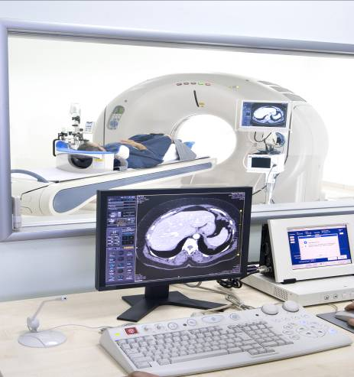**The Latvian Ministry of Health adopted a plan for the implementation of guidelines for e-health 2008–2010 in order to start the implementation of various innovative measures. The main objectives are to centralize data storage and access to patients medical data, prepare an integration platform providing a safe information exchange between the health sector and information systems of other sectors, develop an electronic prescription information system and facilitate safe data transmission channels between main information systems within the health sector.

Mauritius built an operational Information Systems for the Blood Transfusion Service and Cardiac Centre that can significantly improve healthcare services offered to the population.

In Mexico, the National Health System was developed with the use of ICTs.

The vision of Slovak e-health Programme is to implement modern ICTs to support the improvement of quality and efficiency of medical services and to reduce errors and duplicity of medical services.

# C7.4 E-Employment

****Lebanon launched the “Time Attendance for various agencies” project with the aim to manage the attendance of employees at various ministries and public agencies. This project was achieved through a turnkey automated solution which implemented a biometric geometry-based recognition system capable of managing attendance.

The main goal of the Advancement of vocational training in the ICT sector project initiated by DED is to redesign the training of ICT professions in a way that the students from Uzbekistan who have completed their course can be successfully integrated into the labour market.

In Mauritius, the Labour Market Implementation System will help in reducing the mismatch that exists between demand and supply in the labour market.

The Recruitment Solution through SMS Applications of the Royal Court of Oman is a novel solution that uses mobile technology and an integrated system between the RCA and the Ministry of Manpower to enable Omani citizens to apply for job advertisements by sending an SMS and receive a first response within seconds.

The Egyptian Government launched a “Government recruitment portal” with the aim of combating unemployment and pursuing better job opportunities and improving and preserving the environment in Egypt. The core policy is to put government job vacancies online so that the job seeker can also apply online. At the same time, selection is been published online to assure transparency of the procedures.

# C7.5 E-Learning

Egypt undertook several initiatives such as the e-Tansik and E-Learning Competence Centre (ELCC). MSAD led the e-Tansik initiative with the purpose of replacing the old paper process with a comprehensive web-based application and launching the service on the Egyptian Government Portal to accept student’s university enrollment application, backed by a 24/7 call centre for student support.

ELCC is intended to act as a hub for the integration, development and dissemination of e-learning content of relevance to the Egyptian market. ELCC serves as the central vehicle in Egypt for bridging the gap among Egyptian SMEs, knowledge workers and the global economy.

In the Philippines, DEG introduced an e-learning system at universities that provided high-quality design software.

DEG established two competence centres in North and South Vietnam to provide students and faculty with e-learning materials

Teaching and Learning Materials, Information and Consultancy (CRYSTAL), an e-learning initiative was launched by GTZ to establish e-learning competence centres and sector networks. CRYSTAL provides partner institutions with a Learning Content Management System, free of licence charges. The e-learning courses created with this tool are immediately published on the CRYSTAL e-learning website and made available to all participants and interface organizations of the German government.

****Productivity Management e-training Programme is one of the outputs of the EU Leonardo da Vinci Project. Development of an e-learning programme on produc­tivity has been coordinated by the National Productivity Centre of Turkey. The Euroductivity Project provided access to the following e-courses: Introduction to Productivity, In­tro­­duction to Productivity Measurement, Diagnosing Produc­ti­vity Problems, Productivity Improvement Programme Design, Case Study: 5S and Layout Planning.

The Higher Education Admissions Centre (HEAC) is the brainchild of the Ministry of Higher Education (MoHE) of Oman that launched an e-admission system that is designed to modernize the operations of the Ministry in the interest of the public.

There are 500 local centres throughout the country where trained staff will help students apply online, and students can also apply by SMS on their mobile phones.

|  |
| --- |
| InWEnt Initiatives:  The Global Campus 21® is InWEnt’s online learning platform that is based on e-learning management system using modern web technology. Participants from all over the world use online courses and virtual workrooms to learn together by sharing their experiences and collaborating on projects.  Through an intense cooperation with other development organizations and public and private institutions, InWent seeks to increase the efficiency and quality of Internet-based solutions for capacity building and training infrastructure. Management and tutorials of e-learning Skills courses on behalf of InWEnt aim at improving local capacities. The joint participation and organization of international e-learning conferences like OnlineEduca or eLearning Africa have also had positive effects on expanding knowledge. |

OneWorld Foundation India launched LifeLines project amied at providing continued academic and curricular guidance to teachers from experts via telephone in the local language.

****Tunisian Association for Scientific Research Assistance over the Net (Atars’net) and the International Centre for Science and High Technology of the United Nations Industrial Development Organization (ICS-UNIDO) organized a thematic seminar on 23 November 2009 on “E-learning on high technology and science for Developing Countries Strategy and synergies”.

ictQATAR launched a revamped e-learning portal which offers more than 2 500 online courses to government employees. The courses provided by the portal are certified and able to help Qatari citizens to advance their careers. They also offer opportunities to all employees to progress via a personal National Development Plan.

# C7.6 E-Agriculture

FAO launched e-Agriculture Community of Practice which is a global initiative to enhance sustainable agricultural development and food security by improving the use of information, communication and associated technologies. The Community is active on three levels: through an online platform, at selected face-to-face events, and with in-country interventions.

Deutsche Investitions- und Entwicklungsgesellschaft mbH (DEG) established a GIS/GPS based material flow management system for an agricultural cooperative as a reference for Tunisian authorities.

GTZ initiated several projects such as the national agricultural market information system with direct access and information systems for rural dev­elop­ment in Peru and Bolivia where information on agricultural methods of production and market­ing are gathered and are available through various media outlets and the Internet.

BIID’s agricultural service for rural farmers, e-Krishok campaign: Advancing ICT in Agriculture was launched in Bangladesh, aiming to help farmers maximize their economic gain and enable them to achieve income growth through agricultural activities.

# C7.7 E-Environment

DEG implemented a database for recycling and waste management for the private sector to increase knowledge of the laws for protecting the environment and develop a sound framework for industrial enterprises.

|  |
| --- |
| GTZ activities in e-environment include:  Global Water Information Network (GLOBWINET) is a forum in the field of integrated water resource management based on IKON software. The software was developed by GTZ as part of an EU project. With the aid of this software users of GLOBWINET can analyse and compare information and find business partners in the water resources management sector.  Sustainable resource management “Mekonginfo” is an Internet-based information system developed by GTZ which aims at exchanging data on participatory resource management in the area of the lower Mekong basin. “Mekonginfo” has more than 900 registered users. The online library gives access to more than 2 000 documents on various subjects, such as, forests, natural resource management and land management.  Geographic Information System for local disaster risk management in the catchment area of Rio San Pedro.  The Instituto Brasileiro do Meio Ambiente e dos Recursos Naturais Renováveis (IBAMA) is supported by the development of a set of monitoring and control instruments based on a geographical information system (GIS) for management of natural resources in Varzea.  A monitoring and management information system (MIS) was set up to support the forest protection programme “Drei-Norden”.  The establishment of a virtual platform for knowledge management in the sector of water catchment area management in a joint venture with partner organizations.  Establishment of a MIS to increase transparency in the state water supply company NWSC and to create a more complete database for the pending involvement of the private sector. |

****In Korea, KCC held a conference on 16 March 2010 entitled “The Council for the Promotion for Green Communi­ca­tions”. The carbon pollution reduction scheme was discussed at the conference. KCC confirmed the “Green Communications Promotion Plan” on 8 April 2010. This plan includes several parts: converting into the green network, developing green communica­tions technology, activating green communi­cations services and creating green jobs.

The sea along the coast of Mauritania is considered to be one of the most abundant in fish stocks worldwide and has a major impact on the country’s economic performance (around 50 per cent of export income). With KfW support, the fishery observation authority is now equipped with radio technology to gather information on the identification and positioning of ships. Localized objects via radar monitoring can be assigned to fishing licences, in order to optimize the efficiency of observation units.

[The 2nd Crisis and Emergency Management Conference 2010](http://groups.itu.int/Default.aspx?tabid=740) (CEMC) is a pioneering initiative of the UAE’s National Crisis and Emergency Management Authority, the National Centre of Meteorology and Seismology and the Health Authority as well as others. The conference aimed to raise awareness and educate both key industry authorities and the community of the systems and processes which will be employed during an emergency or crisis.

ITU launched e-Environment Readiness Index (EERI), a tool for evaluating the e-environment readiness of a country to use ICTs for mitigating and adjusting to the impacts of climate change.

World Meteorological Organization (WMO) created the WMO Information system (WIS) which is a single WMO-coor­dinated global infrastructure respon­sible for telecommunications and data man­age­­ment functions. It is the pillar of the WMO strategy for managing and moving weather, water and climate info­rmation in the 21st century.

# C7.8 E-Science

The ESCWA Technology Centre for Development aims at supporting national and regional capacity building in science, technology and innovation and building links between supply and demand in Western Asia. In 2008, ESCWA solicited the cooperation of all member countries to determine where to build the next Technology Centre for Development. Jordan, Oman, Qatar, Saudi Arabia and the Syrian Arab Republic all expressed interest. In 2009, it was decided that Jordan’s offer was the most appropriate for the needs of the project.

**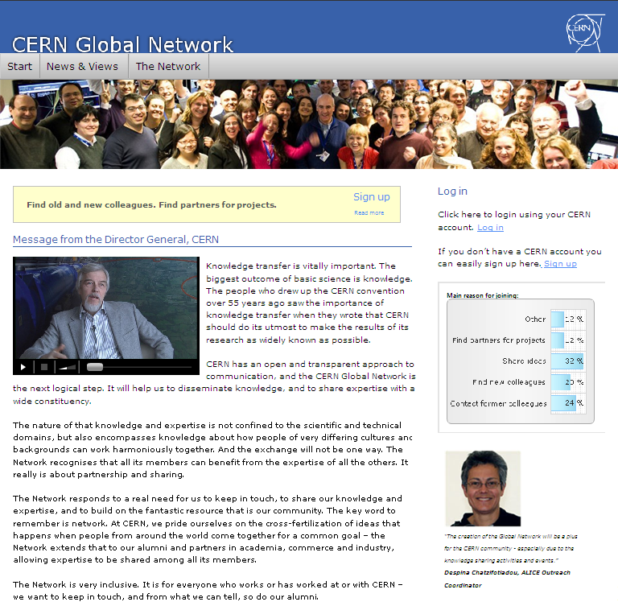**Emirates Telescope is five-year project for establishing a National Astronomical Telescope for the UAE under the technical and scientific supervision of the Emirates Institution for Advanced Science and Technology (EIAST).

In 2010,CERN’s Knowledge and Technology Transfer (KTT) Group launched the CERN Global Network, a tool whose aim is to facilitate knowledge exchanges inside and outside CERN. The Network will be opened to research institutes from all over the world, and to companies in the Member States.



Action Line C8 Cultural diversity and identity, linguistic diversity   
and local content

Respect of cultural identity, traditions and religions is crucial to the development of the Informa­tional Society. Stakeholders actively participated in initiatives to create policies in order to support the preservation and enrichment of cultural and linguistic heritage within the Information Society.

|  |
| --- |
| Egypt established various initiatives to preserve the cultural and linguistic heritage in the country. The Fekr Rama webportal was launched by the Ministry of Communications and Information Technology in order to provide rich Arabic content in fields of culture, education, heritage, religion, sport and the arts for the Arab and Western world. The portal also includes e-books, magazines, directories, news, audio files and animations for children and youth.  Another initiative entitled CULTNAT, an Egyptian Folklore programme, was created to build a comprehensive and inclusive library of scientific and audiovisual material. The library is designed to include a rich array of material that covers ethnological and analytical activities, popular themes, traditional feasts, celebrations, folktales and proverbs, cycles of life, as well as local traditions.  The Egypt Memory Online Shop is the first portal of its kind in the Middle East. It offers a unique e-commerce model for cultural heritage that provides visitors and shoppers worldwide with a variety of cultural and heritage products like books, CDs, atlases and high resolution images.  CULTNAT’s Architectural Heritage programme uses GIS technologies to document the nineteenth and early twentieth century architectural heritage of Egypt including extensive photographic documentation.  In view of regional differences in Arabic ICT terminology, and in order to enhance the readability of ICT documents written in the Arabic language, ESCWA and other international agencies and organizations, in particular ITU, have felt the need to develop a unified Arabic ICT dictionary that could be used and understood in various parts of the Arabic-speaking world. During 2009, ESCWA compiled ICT terms from various documents that it had published in English and Arabic and submitted the compiled terms for review by language experts. |

KISA (Korea) began the Activation of National Domains project which involves research and reformation of policies related to national domains and hosts. KISA also participates in the annual meetings of ICANN and actively participates in the international policy development process.

****The Ministry of Communications and Technology of Syria in partnership with ITU launched the ICT-ARB terminology project which is intended to unify the efforts being deployed to translate ICT terminology by developing a trilingual (English–French–Arabic) e-glossary for ICT terminology.

ITU donated the ICT Indigenous Global Portal to the Indigenous ICT Task Force (IITF) in August 2009 for use by indigenous people worldwide.

Action Line C9 Media

Media is an important contributor for freedom of expression and plurality of information. The examples below illustrate the media participation in the Information Society.

DEG initiated the Multimedia and Online Journalism programme which supports the set up and advancement of online editorial offices in developing countries in order to contribute towards transparency and participation and support democratic processes. Participating journalists received an intense education (short-time training in Germany) in online journalism, including various aspects of politics on the WWW, costs and benefit of online publications, web design and multimedia applications for online journalism and web research and writing. After introductive speeches and demonstrations, the participants expand their knowledge in working groups and design their own web projects.

|  |
| --- |
| Iran  Since 2007,the Ministry of Iran has been holding national digital media festival to select and introduce top digital works.  In Iran, “The amendment to the Press Law” was conveyed in January 2010 to improve electronic news agencies and promote their activities. |

ITU carried out various studies for Internet Protocol TV (IPTV) that will enable enhanced, media-rich delivery of content to users around the world, as well as Next Generation Networks (NGN) to reduce international imbalances affecting the media, particularly as regards infrastructure and technical resources.

Furthermore, ITU is in the process of implementing a project on Transition from Analogue to Digital Broadcasting aiming to assist the developing and LDCs, especially in the African Region, to smoothly shift to digital terrestrial broadcasting.

With the support from the International Programme for the Development of Communication (IPDC), UNESCO implemented more than 250 media development partnership projects worldwide and enhanced journalism education with model curricula. Journalism education institutions in Africa were supported in their efforts to reach the agreed criteria of training excellence and media instructors all over the world were trained on reporting sustainable development issues.

The SWITCH Junior Web Award initiative is aimed at promoting know-how on the Internet. The website competition takes place every year starting in August .

Action Line C 10 Ethical dimensions of the Information Society

Stakeholders made efforts to advance the promotion of awareness of ethical dimensions in the use of ICTs. According to the Geneva Plan of Action, all stakeholders should protect privacy and personal data against abuse, which could include racism, racial discrimination, related intolerance, xenophobia, violence and all forms of child abuse.

The Bangladesh NGOs Network for Radio and Communication ([BNNRC](http://www.itu.int/wsis/stocktaking/scripts/documents.asp?project=1254212340&lang=en)) is working to implement a Poverty Reduction Strategy (PRS), based on the WSIS Action Plan, UNESCO Declaration for Cultural Diversity and the Millennium Development Goals.

In Belgium, the [Destree Institute Millennia 2015](http://www.itu.int/wsis/stocktaking/scripts/documents.asp?project=1263246377&lang=en) is working to increase the potential of women to reinforce their capacities and to encourage their investment and fully recognize their potential in technological development.

In Russia, ICO Information for All launched ICT for Un­challenged Capabilities project.

InWent together with the Asian Women in Cooperatives Development Forum (AWCF), created the it@coops network that brings together cooperative umbrella organizations in Indonesia, the Philippines, and Thailand. Southeast Asian cooperatives have proved to be a successful form of economic organization for marginalized people, especially for female entrepreneurs, who make up the main target group of these ICT trainings.

In Iran, Pure Computer and Network Project aims to empower people, especially families, in order to prevent access to harmful and obscene information in the digital environment.

The Prague Declaration was adopted at the “Safer Internet for Children” Ministerial conference in Prague on 20 April 2009 to create guidelines for future steps in the area of protection of children online. The Declaration aims to improve the process of cooperation between all stakeholders in the field of promoting safer Internet and mobile communications use, especially for children.

****ictQATAR and Qtel Partner launched a Pilot Project with the aim of enabling women to work from home. The “Women Working from Home” policy programme enables Qatari women to cope with professional aspirations and family life challenges. It makes possible for those women to work in an innovative way through ICT tools.

In 2009, the Korean Ministry of Gender Equality and Family (MOGE) launched the APEC Women with IT Training project providing women officials involved in the IT sector in Indonesia with local customized IT trainings in an effort to bridge the information gap between genders and to improve the status of women in Indonesia. This idea was proposed at the APEC Summit Talk held in Shanghai, China in 2001 to expand the opportunity of utilizing IT for women and handicapped persons and to realize the promotion of women’s rights.

TaC-Together against Cybercrime Organization launched a project related to vulnerable groups/people with migrant background in the Information Society.

Syria launched ICT for Inclusion and Development of Students with Disabilities project.

Action Line C11 International and Regional Cooperation

International cooperation is particularly important to promote universal access and bridge the digital divide. Over the past two years, developed countries and international financial institutions have reflected ICTs in their work programmes to assist developing countries and LDCs. The information below is an overview of such initiatives.

|  |
| --- |
| Cisco projects:  In September 2006, the Partnership for Lebanon was established to support post-conflict reconstruction .Cisco committed US$20 million in support of the Partnership, and Cisco’s end of engagement is planned for the end August 2010.  shutterstock_35253346In September 2007, Cisco made a four-year, US$10 million commitment to the Clinton Global Initiative to eradicate poverty in five Sub-Saharan African countries: Cameroon, Ethiopia, Kenya, Nigeria and Rwanda. Cisco and its NGO partners such as Habitat for Humanity, Inveneo, One Global Economy, and Teachers Without Borders have focused on providing affordable housing, community connectivity, online content and tools, and hands-on training.  In January 2008, Cisco announced a three-year, US$10 million investment to help establish a sustainable model of job creation and economic development in the Palestinian territories, in cooperation with President Mahmoud Abbas of the Palestinian Authority.  Cisco China Public–Private Partnership is a multifaceted initiative whose ultimate goal is to improve economic and living conditions in China’s Sichuan Province. |

DEG implemented the “Direct assistance to Benin and Sierra Leone for transposition of ECOWAS Supplementary Acts on the Harmonization of policies and regulatory Framework for the ICTs” initiative which aims at providing direct assistance to Benin and Sierra Leone in order to increase the effectivness of their new legislation.

****The GCC e-Government Conference and Exhibition was organized in 2009 aimed at providing opportunities for GCC e-government authorities to share their experiences, discuss the challenges of implementing e-governance and to link the e-government portals of member states. The quality and importance of the conference attracted CEOs from e-government authorities in the Gulf as high profile speakers and also include leaders from some of the world’s top ICT organizations, as well as academics from selected institutions.

|  |
| --- |
| GTZ carried out numerous activities with various partners to assist developing countries in the use of ICTs:  - GTZ, with its partner SAP in South Africa, developed Blended Learning Strategies, which combine traditional and computer-based teaching methods.  - GTZ in partnership with the World Bank created Innovative approaches to rural development.  GTZ and its partners provide support in the area of innovation and technology for SMEs. The launch of the Met@logo Internet portal facilitates communication between public authorities and SMEs in four Latin American countries. |

**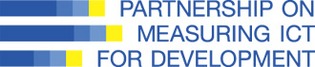**Partnership on Measuring ICT for Developmentis a partnership that includesITU, OECD, UNCTAD, the UNESCO Institute for Statistics, the UN Regional Commissions (UNECLAC, UNESCWA, UNESCAP, UNECA, the World Bank, EUROSTAT and UNDESA, In 2009, the Partnership refined its methodological work and provided technical assistance to strengthen the capacity in developing countries to produce ICT data based on internationally agreed standards.

[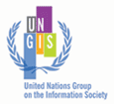](http://www.ungis.org/Default.)UNGIS (United Nations Group on the Information Society) serves as an inter-agency mechanism to coordinate substantive policy issues facing the United Nations system’s implementation of the Geneva Plan of Action and Tunis Agenda for the Information Society adopted by the World Summit on the Information Society, thereby contributing to improving policy coherence in the UN system, as requested by the 2005 World Summit. Following an ECOSOC resolution 2008/3, the ITU hosted the Open Consultations on Financial Mechanisms for Meeting the Challenges of ICT for Development, which was held in October 2009 and was organized jointly by UNGIS Chair and Vice-Chairs, i.e. ITU, UNESCO, UNCTAD, UNDP, and UNECA. Results of the consultations were the basis for the several meetings addressing the issue of Financial Mechanisms, including CSTD intersessional Panel, held in November 2009 in Geneva, as well as a briefing meeting during Forum ICT4All+4, November 2009 in Hammamet.

|  |
| --- |
| 092677 martITU Telecom World 2009 was held in Geneva on 5–9 October 2009.The thematic underpin­ning of the entire event was Open Networks - Connected Minds setting the aspirational ambitions of World 2009. The theme highlighed the importance of World 2009 in developments of the telecommunications and ICT industries. Linking the concepts open and connected convey diversity in approaches to innovation, problem solving, collaboration and cooperation with all stakeholders. These notions of openness and connection also convey common purpose, as well as the ability and willingness of stakeholders to listen, share, experiment and learn from the broader community. This shared vision is more than a reference to technical standards; it is most importantly a focus on modes of dialogue that bring peoples of the world together. |

In 2000, InWEnt, in cooperation with reputed IT consulting firms, IT training institutions, business promotion agencies and universities, established it@ab in the SADC region (Angola, Malawi, Mosambique, Namibia, Tanzania, South Africa, Zambia) that provides state-of-the-art know-how in the field of ICT, promotes local business development and regional business cooperation, offers business contacts and cooperation opportunities with companies and institutions in South East Asia and Europe for IT specialists

In 2008, KCC signed a cooperation agreement with- ITU-D on “ICT Cooperation and partnership”. The main theme of this project is to establish a roadmap for transition to digital broadcasting in Africa. The agreement consisted of a feasibility study on the digital broadcasting roadmap in Africa including an analysis of the current broadcasting situation. It also developed a plan for digital broadcasting transition, identification of pilot countries for roadmap projects and the development of a project document. In 2009, ITU and KCC signed another cooperation agreement entitled “Roadmap for transition from analogue to digital terrestiral television broadcasting and mobile television in Asia and Pacific region”.

In Nigeria, the African Information, Communication and Technology Foundation launched the Digital Connects Africa project in order to connect communities in rural and urban areas.

|  |
| --- |
| Oman’s partnerships:  - In 2009, ITA and Microsoft joined together to sponsor the Oman leg of the Gulf’s premier student technology competition, the Gulf Imagine Cup.  - Another example of international cooperation is the MoU between ITA of Oman and the National Digital Certification Agency (Agence Nationale de Certification Electronique - ANCE) of Tunisia for cooperative efforts in Digital Certification. The main objective of the MoU is to strengthen the cooperation between the two countries in the field of security and validation of electronic exchanges and to exchange experience and expertise in the field of secure digital signatures and the role of a certification authority. The scope also covers exploring opportunities to create favorable conditions in order to promote electronic signature validation through mutual cooperation. |

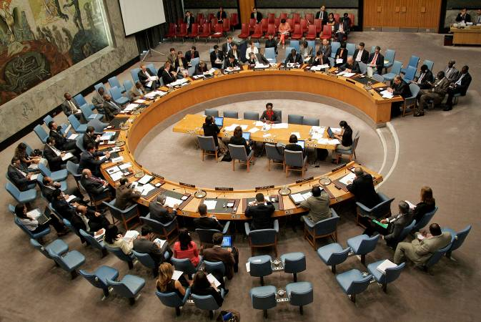The HINARI Programme initiated by WHO, in partnership with UNICEF, UNDP, the World Bank, Microsoft, the US National Library of Medicine, the Food and Agriculture Organization (FAO), Cornell University, Mann Library, the United Nations Environment Programme (UNEP) and others, was launched to enable developing countries to gain access to one of the world’s largest collections of biomedical health literature. Over 7 000 journal titles are now available to health institutions in 109 countries, areas and territories.

In Qatar, the ICTD Conference 2009 focused on Assistive Technologies in developing countries by targeting best practices from other countries as well as increasing research and potential for commercialization .

The Online Access to Research in the Environ­ment (OARE) is an international public-private consortium led by the UNEP in partnership with Yale University and leading science and technology publishers which enables developing countries to gain access to one of the world’s largest collections of environmental science research. Over 3 000 journal titles are now available to environmental institutions in 109 countries.

In June 2009, ESCWA together with ITU, UNESCO, the Syrian Ministry of Communi­cations and Technology, IDRC, Microsoft, Cisco, Syrian Telecom and the Syrian Computer Society organized a conference entitled “Regional Follow-up to the Outcome of the World Summit on the Information Society” which was attended by more than 275 participants. This conference allowed WSIS stakeholders to discuss and review the progress made towards the implementation of the 11 WSIS Action Lines, the Regional Plan of Action (RPoA), the Arab ICT Strategy as well as various national ICT strategies and plans of action. The main outcomes of the conference included an update of the RPoA and the adoption of the “Damascus Proclamation for the Promotion of the Arab Knowledge Society for Sustainable Economic and Social Development.”

During the 2008–2009 period, ESCWA continued to maintain and update its Information Society Portal (ISPER) which was created and developed to serve as a regional online tool for following up on the RPoA as well as various other WSIS issues. The Arabic and English portal features updated versions of the Regional and National Profiles of the Information Society and provides real-time discussion forums to WSIS stakeholders.

The Global Water Operators’ Partnerships Alliance is an international network of partners hosted by UN-HABITAT to develop a tool for presenting utility performance data in a searchable, mapped format online, called the Geo-Referenced Utility Benchmarking System (GRUBS).

[The World Summit Award (WSA)](http://www.itu.int/wsis/stocktaking/scripts/documents.asp?project=1270108743&lang=en) is a global activity to select and promote the world’s best e-Content and ICT applications. WSA was initiated within the framework of WSIS and is organized by a global partner network, coordinated by the International Centre for New Media. WSA partners come from governments, private sector and civil society in over 160 UN Member States. WSA implements the UN agenda for the development of the Information Society and supports the MDGs.

Conclusion: Towards Connecting the World

In order to achieve the vision of the Information Society defined in the WSIS outcome documents, WSIS stakeholders continue to work together towards making the WSIS Stocktaking Process a success. The Stocktaking database is proof of the activities carried out by WSIS Stakeholders towards the progress made since the land mark event. An increase in the entries on the database highlights that stakeholders are working together to: improve access to ICTs; build capacity; increase confidence and security in the use of ICTs; create an enabling environment at all levels; develop and widen ICT applications; foster and respect cultural diversity; recognize the role of the media; address the ethical dimensions of the Information Society; and encourage international and regional cooperation.

As a follow up to the stocktaking process, an upgraded stocktaking platform was launched in February 2010 as an interactive and collaborative database for all WSIS Stakeholders to work on the implementation of the WSIS outcomes. The upgraded WSIS stocktaking platform integrates improved features, such as the application of web 2.0 tools and a searchable database. Introduction of new components, including an events calendar, the ability to create communities of practice and forums for discussion might serve as effective instruments of information circulation and communication among stakeholders. Future plans include developing evaluation and monitoring tools for WSIS Stocktaking.

The WSIS Stocktaking Platform is also an unique platform for project managers to extend the network and create new win-win partnerships. The platform is based on a community-building approach, which allows the collection of more information on ICT projects globally and increases stakeholders collaboration. Showcase briefings illustrated in the report permit the generation of the overall picture of ICT development and share the best practices. Further evaluation of stakeholder participation regarding governments, private sector, international organizations, civil society and others will provide more information regarding the strengths and weaknesses of particular regions. Based on stakeholders contributions, it becomes possible to estimate the inclusiveness of the Information Society where private sector and civil society start to participate actively in the project implementation.

We would like to thank all stakeholders who contributed to the WSIS Stocktaking Database. For the period (mid-2008-mid-2010), the number of submitted entries increased 80 per cent compared to 2008. The increase in contributions has advanced the achievement of WSIS targets on significant matters such as building the broadband, focusing on ICT applications, raising awareness on cybersecurity issues and assisting developing and least developed countries. Numerous entries focus on more than one Action Line pursuing the realization of several objectives within one project, thus undertaking a multidimensional approach in achieving WSIS targets.

It is desired that in the future, WSIS Stocktaking would serve as a tool to respond to the needs of stakeholders through analysis and recommendations. Success stories registered and showcased in the WSIS Stocktaking will encourage stakeholders to be involved in building together a development-oriented Information Society together.

List of Abbreviations and Acronyms

aeCERT **The United Arab Emirates Computer Emergency Response Team**

ANRT **National Agency of Telecommunications Regulation**

ANCE **Agence Nationale de Certification Electronique**

APEC **Asia-Pacific Economic Cooperation**

APKN **The Africa Parliamentary Knowledge Network**

AWCF **Asian Women in Cooperatives Development Forum**

BNNRC **Bangladesh NGOs Network for Radio and Communication**

CEMC **Crisis and Emergence Management Conference**

CEO **chief executive officer**

CERT-MU **Computer Emergency Response Team**

CIOs **chief information officers**

CIS **Commonwealth of Independent States**

CKC **Community Knowledge Centres**

CoE **Center of Excellence**

COP **The Child Online Protection**

CRM **Customer relationship management**

CRYSTAL **Teaching and Learning Materials, Information and Consultancy eLearning Initiative**

CWTAR **Centre for Women and Technology for the Arab Region**

DED **Der Deutsche Entwicklungsdienst**

DEG **Deutsche Investitions- und Entwicklungsgesellschaft mbH**

DMV **Departments of Motor Vehicles**

DRC **Dhaka Resource Centre**

DSL **Digital Subscriber Lines**

ECOWAS **Economic Community Of West African States**

EEI **The Egyptian Education Initiative**

EMIS **Education Management System**

ELCC **E-Learning Competence Centre**

ENEDCO **Enhancing the Visual and Presentation of Educational Content**

FAO **Food and Agriculture Organization of the United Nations**

FOSS **free and open source software**

FWA **Fixed Wireless Access**

GCA **Global Cybersecurity Agenda**

GCC **Gulf Cooperation Council**

GeSCI **The Global e-Schools and Communities Initiative**

GIS **Geographical Information System**

G4F **Government for foreigner**

GGN **Georgian Governmental Network**

GGN **The Convergent Government Network**

GLOBWINET **Global Water Information Network**

GPS **Global positioning system**

**GRUBS Geo-Referenced Utility Benchmarking System**

GSF **Guarantee and Subsidiary Fund**

GSM **Global system for mobile communications**

GTZ **Gesellschaft für Technische Zusammenarbeit (GTZ) GmbH on behalf of Federal Ministry for Economic Cooperation and Development (BMZ)**

HEAC **The Higher Education Admissions Centre**

IBAMA **The Instituto Brasileiro do Meio Ambiente e dos Recursos Naturais Renováveis**

ICANN **Internet Corporation for Assigned Names and Numbers**

ICT **Information and communication Technologies**

ICTAD **Information and Communication Technology Assisted Development**

IDA **Info-communications Development Authority of Singapore**

IDRC **International Development Research Centre**

IIS **Institute of the Information Society**

IKTIK **Information and communication technologies for quality of education**

IMPACT **International Multilateral Partnership Against Cyber Threats**

Infothek **Information system**

InWEnt **Internationale Weiterbildung und Entwicklung gGmbH on behalf of Federal Ministry for Economic Cooperation and Development (BMZ)**

ISAE **L’Istituto di Studi e Analisi Economica**

ISPER **Information Society Portal**

IT **Information Technologies**

ITA **The Information Technology Authority of Oman**

ITU **International Telecommunication Union**

ITU-D **International Telecommunication Union-Development**

KCC **Korean Communications Commission**

KISA **Korea Internet and Security Agency**

KfW **Kreditanstalt für Wiederaufbau**

KM **Knowledge Management**

KPDE **Kantor Pengelkolah Data Elektronik**

LAN **Local Area Network**

LDC **Least Developed Countries**

MADA  **Qatar Assistive Technology Centre**

MDGs **Millennium Development Goals**

MIC **Ministry of Internal Affairs and Communications of Japan**

MICA **Ministry of Information, Communications and the Arts**

MIS **A monitoring and management information system**

MCIT **Egyptian Ministry of Communications and Information Technology**

M/SME **Micro, Small and Medium-Sized Enterprises**

MOGE **Ministry of Gender Equality and Family**

MoHE **Ministry of Higher Education**

MOPAS  **Ministry of public administration and security**

MoU **Memorandum of Understanding**

MPM **National Productivity Centre of Turkey**

MSAD **Ministry of State for Administrative Development, Egypt**

MWA **Mobile Wireless Access**

NGO **Non-governmental organization**

NITTA **National IT Training & Awareness Framework Initiative**

NICTSP **National ICT Strategic Plan**

NTC **National Telecommunication Commission of Thailand**

NWA **Nomadic Wireless Access**

OARE **Online Access to Research in the Environment**

OFE **Hungarian consumer organization (Országos Fogyasztóvédelmi Egyesületnek)**

Omantel **Oman Telecommunication Company**

PC **Personal Computer**

PLС **Power Line Communications**

PRS **Poverty Reduction strategy**

PSMSP **Public Sector Management Strengthening Programme**

QoS **security and guaranteed quality of service**

RPoA **Regional Plan of Action**

RCA **Radio Corporation of America**

ROP **Royal Oman Police**

SAARC **South Asian Association for Regional Cooperation**

SADC **Southern African Development Community**

SKYLOGIC  **(EUTELSAT Group)**

SME **Small and Medium-Sized Enterprises**

SMS **Short message service**

SMS **School Management System**

STI **Science, technology and innovation**

TPD **ICT-Teacher Professional Development**

UAE **United Arab Emirates**

UN **United Nations**

UNECA **United Nations Economic Commission for Africa**

UNESCWA **United Nations Economic and Social Commission for Western Asia**

UNCTAD **United Nations Conference on Trade and Development**

UNDESA **United Nations Department of Economic and Social Affairs**

UNDP **United Nations Development Programme**

UNESCO **United Nations Educational, Scientific and Cultural Organization**

US **United States**

WHO **World Health Organization**

WIS  **WMO Information system**

WMO **World Meteorological Organization**

WSA **World Summit Award**

WSIS **World Summit on the Information Society**

RANET **Radio and Internet technology for communication of weather and climate information to rural communities for sustainable development**

1. <http://www.itu.int/wsis/docs/geneva/official/dop.html> [↑](#footnote-ref-2)
2. <http://www.itu.int/wsis/docs2/tunis/off/6rev1.html> [↑](#footnote-ref-3)
3. WSIS 2008- Stocktaking Report , <http://www.itu.int/wsis/stocktaking/docs/2008/WSIS-Stocktaking2008-e.pdf> [↑](#footnote-ref-4)
4. WSIS 2008- Stocktaking Report , <http://www.itu.int/wsis/stocktaking/docs/2008/WSIS-Stocktaking2008-e.pdf> [↑](#footnote-ref-5)
5. http://www.wsis.org/stocktaking [↑](#footnote-ref-6)
6. <http://www.mdgmonitor.org/browse_goal.cfm> [↑](#footnote-ref-7)
7. The ten targets of the of the Geneva Plan of Action are detailed in Section B6 and WSIS Action Line C7 on p.44 of the Geneva Plan of Action, available at: <http://www.itu.int/wsis/docs/geneva/official/poa.html>. [↑](#footnote-ref-8)
8. Network Developments in Support of User Needs, OECD, December 2009 [↑](#footnote-ref-9)
9. <http://mtny.mobi/1qC> [↑](#footnote-ref-10)
10. <http://www.tgdaily.com/mobility-features/45219-o2-blames-the-iphone-for-network-strain> [↑](#footnote-ref-11)
11. <http://gigaom.com/2009/11/09/with-wireless-data-smaller-carriers-must-mind-the-gap/> [↑](#footnote-ref-12)
12. <http://www.att.com/gen/press-room?pid=4800&cdvn=news&newsarticleid=30486&mapcode>= [↑](#footnote-ref-13)
13. “Wireless Carriers Try New Tricks to Handle Data Flood”, Wall Street Journal, 2 February 2010, available at: <http://online.wsj.com/article/SB10001424052748704343104575033742491521742.html?mod=WSJ_Tech_RIGHTTopCarousel> [↑](#footnote-ref-14)
14. “Breaking through the noise of social media”, 15 February 2010, LA Times, available at: <http://www.latimes.com/news/opinion/la-oe-rodriguez15-2010feb15,0,1858097.column?track=rss> [↑](#footnote-ref-15)
15. “Social Media for Economists: Part I”, available at: <http://caps.fool.com/Blogs/ViewPost.aspx?bpid=340288&#38;t=01005302436808413080&utm_source=twitterfeed&utm_medium=twitter> [↑](#footnote-ref-16)
16. <http://en.wikipedia.org/wiki/Social_media>, accessed 16 February 2010. [↑](#footnote-ref-17)
17. <http://www.sfgate.com/cgi-bin/article.cgi?f=/c/a/2010/02/14/BUU51C0AMN.DTL> [↑](#footnote-ref-18)
18. Dave Yovanno, CEO of Gigya Inc., quoted in “Facebook directs more online users than Google”, San Francisco Times, 15 February 2010, quoted at: <http://www.sfgate.com/cgi-bin/article.cgi?f=/c/a/2010/02/14/BUU51C0AMN.DTL#ixzz0fiEGrSKU> [↑](#footnote-ref-19)
19. Quoted in “Social Media: The Five-Year Forecast”, [Jessica Tsai](http://www.destinationcrm.com/Authors/2270-Jessica-Tsai.htm), 27 April 2009, available at: <http://www.destinationcrm.com/Articles/CRM-News/Daily-News/Social-Media-The-Five-Year-Forecast-53635.aspx> [↑](#footnote-ref-20)
20. <http://ow.ly/ZvT6> [↑](#footnote-ref-21)
21. “Privacy no longer a social norm, says Facebook founder”, Bobbie Johnson, the UK Guardian, 11 January 2010, available at: <http://ow.ly/UYpc> [↑](#footnote-ref-22)
22. <http://www.itu.int/osg/csd/cybersecurity/gca/> [↑](#footnote-ref-23)
23. Understanding Cybercrime: A Guide for Developing Countries, available at: www.itu.int/ITU-D/cyb/cybersecurity/projects/crimeguide.html [↑](#footnote-ref-24)
24. ITU Toolkit for Cybercrime Legislation, available at: www.itu.int/ITU-D/cyb/cybersecurity/projects/cyberlaw.html [↑](#footnote-ref-25)