Geneva, 5 April 2002
INTERNATIONAL TELECOMMUNICATION UNION
Telecommunication
Standardization Bureau

Ref: | TSB Collective-letter 3/5
Tel:  Fax:  E-mail: | +41 22 730 5780  +41 22 730 5853  tsbsg5@itu.int | - To Administrations of Member States of the Union, to ITU-T Sector Members and to ITU-T Associates participating in the work of Study Group 5

Subject: | Meeting of Working Parties 1 and 2 of Study Group 5  (24-27 June 2002)  Budapest, Hungary

Dear Sir/Madam,
1 At the request of the Chairman of Study Group 5, and in accordance with the decision taken at the last Study Group 5 meeting (11-14 December 2001), I would like to inform you that, at the kind invitation of MATAV, Hungary, Working Parties 1 and 2 of Study Group 5 (Protection against electromagnetic environment effects) are to meet in Budapest, Hungary, from 24 to 27 June 2002 inclusive.
The venue of the meeting will be the Hotel Mercure Buda, Budapest, Hungary.
The meeting will open at 9³⁰ hours on the first day.
2 The discussions will be held in accordance with decisions taken with reference to the provisions in force.
3 The draft agenda, as prepared by agreement with the Chairmen of Working Parties 1 and 2/5, is set out in Annex 1 hereto.
4 The draft work programme is set out in Annex 2 hereto.
5 Annex 3 gives practical information provided by the host organization. Particular attention is drawn to the hotel booking form, which must be submitted as soon as possible (see Annex 4).
6 Pursuant to the provisions of Recommendation A.1 of WTSA (Montreal, 2000), contributions to the work of the study group shall be submitted to the Telecommunication Standardization Bureau (TSB).
a) Contributions received at least two months before the meeting shall be published and mailed to the Administrations of Member States of the Union, to ITU-T Sector Members and to ITU-T Associates registered in this study group who have requested paper copies, and will be available on the Study Group 5 website.
b) Contributions received by TSB less than two months but not less than seven working days before the date set for the opening of the meeting shall be published as "delayed contributions" and shall be posted to the Study Group 5 website and shall be distributed at the beginning of the meeting to only the participants present. Therefore, such contributions must be received by TSB not later than 12 June 2002.
Participants are encouraged to submit contributions by electronic mail to the following address:
tsbsg5@itu.int. Detailed instructions can be found on the ITU-T website.
With a view to settling any questions which might arise concerning contributions, the name, the fax and telephone numbers and the e-mail address of the person to be contacted should be indicated on contributions. Accordingly, please give those details on the cover page of all documents.
7 In order to enable TSB to make the necessary arrangements concerning the documentation and organization of the meeting, I should be grateful if you would send me, by letter or fax (No.: +41 22 730 5853), as soon as possible, but not later than 24 May 2002, the list of people who will be representing your Administration, Sector Member, Associate, regional and/or international organization or other entity. Administrations are requested also to indicate the name of their head of delegation (and deputy-head, if applicable). The registration form in Annex 5, duly completed (one per participant), should be attached to the above-mentioned list and should indicate the form in which you wish to receive the documentation during the meeting (paper form or direct downloading from the web).
Yours faithfully,

H. Zhao
Director of the Telecommunication
Standardization Bureau
Annexes: 5

annex 1
(to TSB Collective-letter 3/5)
Draft agenda for the meeting of Working Parties 1 and 2 of Study Group 5
(Budapest, 24-27 June 2002)
- Opening session of the meeting of Working Party 1/5
  - Review of documentation, allocation of incoming liaison statements
  - Review of the status of Questions 4, 5, 6, 9, 10, 11 and 13/5
- Opening session of the meeting of Working Party 2/5
  - Review of documentation, allocation of incoming liaison statements
  - Review of the status of Questions 1, 2, 3, 7, 8 and 12/5
- Ad-hoc meetings on Questions of Working Party 1/5
- Ad-hoc meetings on Questions of Working Party 2/5
- Closing session of the meeting of Working Party 1/5
  - Review of the Rapporteurs’ reports on each Question
  - Consent on Recommendations in accordance with the rules of Recommendation A.8
  - Approval of Handbooks/informative texts
  - Approval of outgoing liaison statements
  - Review of the work programme of Working Party 1/5
5.6 Miscellaneous
- Closing session of the meeting of Working Party 2/5
  - Review of the Rapporteurs’ reports on each Question
  - Consent on Recommendations in accordance with the rules of Recommendation A.8
  - Approval of outgoing liaison statements
  - Review of the work programme of Working Party 2/5
6.5 Miscellaneous
annex 2
(to TSB Collective-letter 3/5)
Draft timetable
for the meeting of Working Parties 1 and 2 of Study Group 5
(Budapest, 24-27 June 2002)

 | Morning |  | Afternoon
Monday  24 June | Opening of  Working Party 1/5 |  | Opening of  Working Party 2/5
Tuesday  25 June | Ad-hoc meetings on Questions of WP 1/5 |  | Ad-hoc meetings on Questions of WP 2/5
Wednesday  26 June | Ad-hoc meetings on Questions of WP 1/5 |  | Ad-hoc meetings on Questions of WP 2/5
Thursday  27 June | Closing of  Working Party 1/5 | Closing of  Working Party 2/5

annex 3
(to TSB Collective-letter 3/5)
Additional information on the meeting of Working Parties 1 and 2
of Study Group 5
(Budapest, Hungary, 24-27 June 2002)

1 Venue of the meeting
Hotel Mercure Buda
Budapest I. Krisztina krt 41-43
Hungary
Tel: +36 1 488-8100
Fax: +36 1 355-6964
E-mail: mercurebuda@pannoniahotels.hu

2 Accommodation
For the convenience of the participants, bloc reservation has been made in the hotels listed.
Please send your hotel reservation form directly to Matáv.

2.1 Hotel Mercure Buda (Budapest I. Krisztina krt. 41-43)
Phone:+ 36 1 488-8100
Fax: + 36 1 355-6964
This 4 star hotel is situated in the business centre of Buda.
All rooms are with bath, minibar, colour TV with satellite program, telephone.
Other services: swimming pool, sauna (both free of charge), solarium, massage, laundry, souvenir shop, rent-a-car.
The hotel is about 30 minutes drive from the Airport.
Room rate:
114 Euro/night single room
127 Euro/night double room.
The prices include VAT and breakfast.

2.2 Charles Apartments House (Budapest I. Hegyalja u 23)
Phone:+ 36 1 201-1796
Fax: + 36 1 212-2584
This 3 star apartment hotel is situated in Buda side of the city, the meeting venue is only 5-6 minute distance from this hotel.
All rooms are with fully equipped kitchen (including minibar), bath, colour TV with satellite program, telephone. The hotel is about 30 minutes drive from the Airport.
Room rate:
60 Euro/night/for one person
68 Euro/night/for two person
The prices include VAT and breakfast.
How to go from Charles Apartment House to the meeting venue ?
Take the bus No 78 at the Apartment House going direction „Baross tér/Keleti pu.” and get off at stop „Mészáros utca”. Go straight on and at Krisztina körút turn left.
After 100 m on your left you will see the Hotel Mercure Buda.

3 Hotel booking
For hotel booking please fill in the attached "Hotel booking form" and send it back to Matáv not later than 24 May 2002.

4 Social event
On 25 June 2002 Matav kindly invite you and your accompanying person to a sightseeing tour with dinner starting at 6 p.m.

5 Transportation

5.1 Air Travel
The international airport in Budapest is the Ferihegy Airport with terminals 2A and 2B.
Terminal 2A receives Malév flights.
Terminal 2B receives all airlines other than Malév.

5.2 Airport Minibus Service
Operates as a shuttle bus between Ferihegy Terminals 2A or 2B and the required destination with several stops depending on the destination of the passengers. It costs HUF 1.800/person (approx. 7 EURO). Far cheaper than taking a taxi (approx. 13 EURO). Minibus can be ordered and the ticket purchased either at the transit area or in the arrival hall of the airport.

5.3 Public Transport in Budapest
The network is extensive, reliable and relatively cheap. Tickets for bus, tram and metro (underground) can be bought at metro stations, newsagents, tobacco shops.

Type of tickets | Price (HUF) | Remark
Single ticket | 106 | Its validity covers one uninterrupted journey.
Metro transfer ticket | 175 | Valid for as many stops as you like, with one line change if necessary.
Block of 10 single tickets | 1,000
Block of 20 single tickets | 1,950
One-day travel card | 850
Three-day travel card | 1,700
Season tickets for 7 days | 2,100
More information: http://www.budapestinfo.hu

6 Immigration requirements
Citizens of most countries do not require a prior entry visa, in accordance with the bilateral agreements between Hungary and the interested country.
For information on entry visas to Hungary, participants are requested to contact the Hungarian Diplomatic/Mission in their country.
You can find updated information at: http://www.kum.hu/kulugy
Matáv will issue an invitation letter for the visa application of participants upon receipt of this request.

7 Local Time
GMT + 1 hours

8 Currency
The legal tender of Hungary is Forint (Ft). For money changing, banks and money changes are conveniently located over the city and at the airport, as well as at the hotels. One US$ is approximately equal to 270 Ft, one EUR is equal to 235 Ft.
Major banks are open from 9 a.m. to 4.00 p.m., Monday to Friday.
All main credit cards are welcome, such as VISA, MASTER, AMEX etc.

9 Climate
During the day the temperature in June in Budapest ranges between 25⁰C- 30⁰C.
It is recommended to bring an umbrella for outdoors.

10 Electric power
230 V; 50Hz.

11 Language
The official language is Hungarian, but English/ German/French are spoken mostly among the youngsters.

12 Telecommunication services
Telephone and facsimile facilities are available in hotels and outside.
The telephone cabines work with phone card or coins. You can buy phone cards for 800 Ft and 1800 Ft at tobaccos, post offices, kiosks.

13 Insurance
All participants are requested to make any necessary arrangements for their insurance and medical coverage before travelling.

14 Contact at Matáv
László Nagy
Event manager
Matáv
Budapest I. Krisztina krt 55.
Tel: +36 1 457-4114
Fax: +36 1 458-7656
E-mail: nagy.laszlo3@ln.matav.hu

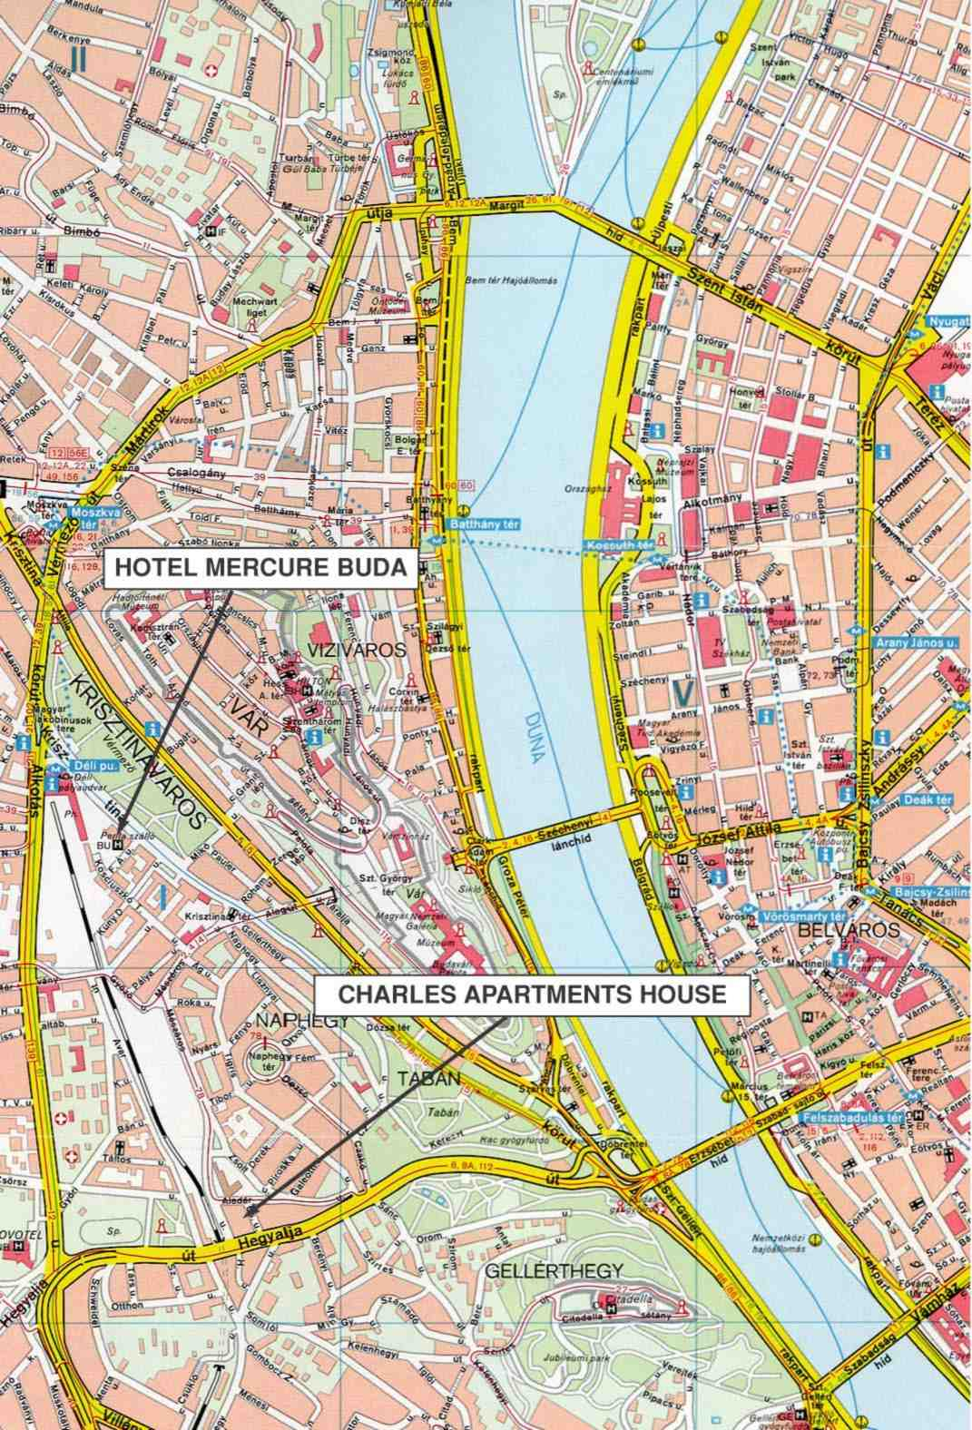

annex 4
(to TSB Collective-letter 3/5)
Meeting of Working Parties 1 and 2 of Study Group 5
(Budapest, Hungary, 24-27 June 2002)
Hotel booking form

Surname: First name:

Company:

Fax:
Phone:
E-mail:

HOTEL ACCOMMODATION

1./ Hotel Mercure Buda (Budapest I. Krisztina krt 41-43)
❑ Single room (114 EURO/night )  Double room (127 EURO/night )

2./ Charles Apartment House (Budapest I. Hegyalja u 23)
❑ Single room (60 Euro/night )  Double room (68 Euro/night )
All prices include VAT and breakfast.
(Please tick off the relevant.)

Arrival on ......................................

Departure on .................................

Date: .......................................... Signed: ...................................

Please return this form at your earliest convenience, but not later than 24 May
to Mr. László Nagy, Matáv Telefax: + 36 1 458-7656 or e-mail:
nagy.laszlo3@ln.matav.hu

REGISTRATION FORM (PDF Format)

ANNEX 5
(to TSB Collective-letter 3/5)

 | ITU-TSB | Working Parties 1 and 2/5 Meeting  (Budapest, 24-27 June 2002)
 | REGISTRATION FORM
 | To be returned to TSB (Fax: +41 22 730 5853) by 24 May 2002
 |  |  |  |  |  |  | WP1 |  | WP2
I participate in the following Working Parties:

Mr. Mrs. Miss |  |  |  |  | _______________________________________________  Country
____________________________________________  Family Name |  |  |  |  | ______________________________________________  Name of Administration of Member State*
____________________________________________  First Name |  |  |  |  | ______________________________________________  Name of Sector Member / Associate / Other
Complete address of Administration or Organization:
______________________________________________ |  |  |  | Tel: _____________________________________________
______________________________________________ |  |  |  | Fax: _____________________________________________
______________________________________________ |  |  |  | E-mail: __________________________________________
*For delegates of Member States: Function at the meeting |  |  |  |  | Hotel/Address in Budapest
 |  |  |  |  | Hotel: __________________________________________
(C) Head of delegation |  |  |  |  | Address: ________________________________________
(CA) Deputy Head |  |  |  |  | ___________________________________________
(D) Delegate |  |  |  |  | Tel: ____________________________________________
During the meeting:
I wish to download the documents from the Web (TIES account required): Yes No
OR
I wish to receive the documents in paper form : Yes No
Date: ___________________________ | Signature: ______________________________________

For TSB Secretariat use only
Pigeon-hole

