 | INTERNATIONAL TELECOMMUNICATION UNION |  |  |  |  | Focus Group On "From/In/To Cars Communication II"
 | TELECOMMUNICATION  STANDARDIZATION SECTOR  STUDY PERIOD 2005-2008 |  |  |  |  | FG CarCom-ADM-3
English only
Original: English
 | Question(s): |  |  |  |  | Lannion, 8-9 September 2008
 | ADMIN DOCUMENT
 | Source: |  |  | FG Chairman
 | Title: |  |  | Invitation to the 2nd Meeting of Focus Group CarCom
Aachen, 30 July 2026
Invitation to the 2nd Meeting of Focus Group CarCom
to be held on 8-9 September 2008, Lannion, France
Link to registration & meeting documents
http://www.itu.int/ITU-T/studygroups/com12/fgcarcom/index.html
Dear Colleague,
On behalf of the ITU-T Focus Group CarCom I have the pleasure of informing you about the arrangements for the above-mentioned meeting hosted by France Telecom / Orange Labs .
Note that the Focus Group meeting will be followed by a workshop on "From Speech to Audio: bandwidth extension, binaural perception". Lannion, France, 10 – 12 September 2008: http://www.itu.int/ITU-T/worksem/speechaudio/index.html
Address of the meeting |  |  |  |  | France Telecom / Orange Labs  2 avenue Pierre Marzin  22307 Lannion Cédex  Jean-Yves Monfort  Jeanyves.monfort@orange-ftgroup.com  Nadine Lancelot  +33299123930  Nadine.lancelot@orange-ftgroup.com
mEETING SCHEDULE |  |  |  |  | The meeting will start on 8 September 2008 at 14.00.  The meeting will end on 9 September 2008 at 17.00.
REGISTRAtion |  |  |  |  | Please register at the Focus Group Website before September 4, 2008
Documents for the meeting |  |  |  |  | Please send meeting documents in advance to the meeting to TSB for uploading to the focus group Website.
I look forward to seeing you in Lannion
Yours sincerely
Hans W. Gierlich
Annex 1
Practical information
MEETING VENUE
The venue will be in Lannion, at the France Telecom R&D site. Delegates are requested to use the main entrance of the premises.

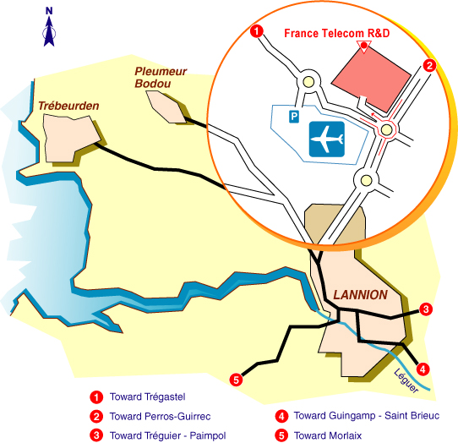

ACCESS TO MEETING VENUE
For security reasons, once registered, it is imperative to provide the following information by email or fax to: Nadine Lancelot, Fax: +33 2 96 05 35 30, Email: Nadine.lancelot@orange-ftgroup.com
- PARTICIPANT'S SURNAME:
- FIRST NAME:
- COMPANY:
- Mailing address:
- Telephone:
- Fax:
- E-mail:
- Passport n° and Country
HOTEL INFORMATION
No block hotel reservations have been made. As such, delegates are requested to make their hotel reservations directly with the hotel of their choice in Lannion or Perros-Guirec using the following URL: http://www.sites-hotels.com/bretagne/hotels_cotes_d_armor.htm
TRANSPORTATION
NOTE: No transport arrangements will be made. It is suggested to rent a car.

How to reach Lannion and Perros-Guirec ?
Apologies, some websites are in French. For flight timetables, please see: http://www.amadeus.net/

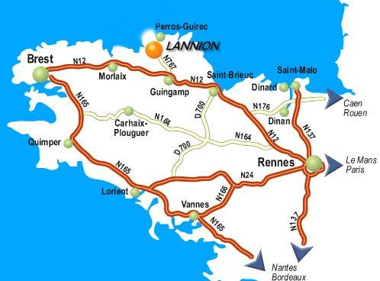

- By plane to Lannion
There are two or three flights a day between Paris Orly West airport and Lannion (except on Saturday). Please see:
http://www.lannion.aeroport.fr/recherche-vols/
For those who will arrive in Paris Roissy Charles-de-Gaulle airport (CDG) and have to transfer to Orly West, there are three possibilities:
- An Air France bus shuttle from Roissy to Orly West airport. This bus leaves every 30 minutes. The journey lasts approximately 60 minutes (possibly a little more depending on the traffic). Note: Do not forget that you will have to reclaim your luggage in Charles-de-Gaulle airport so plan to allow at least 3 hours between your two flights.
- Take a taxi: Costs between 40 and 50 euros (minimum time: 50 minutes - max depending on the traffic, generally busy).
- Public transportation in Paris: RER Line B + Orlyval (with connection in Antony), it will take more than 60 minutes.
At your arrival in Lannion airport, you can take a taxi or rent a car to go to Perros-Guirec (about 7 kms).
- By train to Lannion
Once in Paris, you need to go to Montparnasse SNCF train station. More information with timetables is available at:
http://www.voyages-sncf.com/dynamic/_SvTermCommVoySaisie?_TMS=1203512030844&_DLG=SvTermCommVoySaisie&_LANG=FR&_AGENCY=VSC
There is an Air France shuttle bus between Paris Roissy Charles-de-Gaulle airport and Montparnasse station. The journey time is approximately 60 minutes and this bus leaves every half an hour.
The same from Paris Orly airport to Montparnasse. The journey time is approximately 45 minutes and this bus leaves every 12 minutes.
The journey by train between Paris and Lannion takes 4 hours by TGV with a quick change either in Guingamp or in Plouaret. This way of travelling will allow you to fully appreciate the French landscape.
Warning: Reservation is mandatory for the TGV !
In Lannion station, you can take either a cab (about 25 euros) or a bus to go to Perros-Guirec.
- By plane via Brest
There are several flights a day between Paris Roissy, Charles-de-Gaulle airport and Brest airport http://www.airport.cci-brest.fr/
From there, 2 possibilities: either rent a car to go to Lannion. In this case, the journey between Brest and Lannion lasts 1 hour on an easy road; take the N12 road and after the Morlaix bridge take the direction of Lannion (see map).
Or take a train from Brest (15 km between Brest airport to Brest railway station) to Lannion. At your arrival in Lannion station, take a cab (about 25 euros) or a bus.

_____________

