INTERNATIONAL TELECOMMUNICATION UNION |  | Focus Group On "From/In/To Cars Communication II"
TELECOMMUNICATION  STANDARDIZATION SECTOR  STUDY PERIOD 2005-2008 |  | FG CarCom-C-6
English only
Original: English
 |  | Lannion, 8-9 September 2008
CONTRIBUTION
Source: | QNX Software Systems (Wavemakers)
Title: | ASR-based method for measuring Double-Talk Performance

Abstract
This contribution describes an Automatic Speech Recognition (ASR)-based approach to measuring Double-Talk Performance of speech communications systems. An ASR system is used to recognize speech sounds transmitted over the communications system during double-talk. Raw recognition results are transformed into a measure that reflects the ability of both ends of the connection to simultaneously talk and be heard.

- Introduction
An important aspect of transmission performance in speech communications systems (e.g., hands-free system in automobile) is the ability to simultaneously talk and hear the other end of the connection. This is sometimes referred to as “Duplexness” or “Double-Talk Performance”. When Hands-Free (HF) phones were first introduced duplexness was a major issue. If one end of the call was talking the other end would often not be able to interrupt or was unintelligible. Most early hands-free phones were considered “half-duplex” or “three-quarter duplex”; meaning that one end could not be heard or only partially heard during double-talk. Today, HF phones span the entire range of performance from “half-duplex” to “duplex”. A repeatable and valid measurement of duplexness is needed for comparing the ability of HF systems to support simultaneous two-way speech communications. It is also important that this be an automated objective measurement because of the time and resources involved with subjective (i.e., perceptual) testing.

The term “Double-talk performance” can mean different things to different people. Here, Double-talk performance is considered to be made up of several aspects of transmission performance (e.g., intelligibility, quality). Duplexness is just one aspect of Double-talk performance and is defined as the ability to simultaneously talk and hear the other end of the connection. In other words, it reflects the intelligibility during double-talk—not “quality” of the communications system.

A distinction between “intelligibility” and “comprehensibility” should also be made. Intelligibility refers to the ability to detect individual speech sounds where comprehensibility refers to the ability to understand the overall meaning of the message. It is possible for systems to have perfect intelligibility, yet lack in the area of comprehensibility. For example, this has been shown to be the case with some Text-To-Speech (TTS) systems. It may be that listeners focus so much attention on identifying individual speech sounds that they cannot attend to the overall meaning. Another possibility is that comprehending the overall meaning is disrupted by incorrect prosodic cues. Regardless, the current definition of duplexness refers to the successful transmission of individual speech sounds only (i.e., intelligibility)—it is not intended to measure comprehensibility.

There are already several studies in the research literature that support the use of ASR-based methods for predicting speech intelligibility. A list of references is provided in Appendix 1. To summarize, early studies indicate that ASR-based methods correlate well with intelligibility and are robust against a wide variety of impairments (e.g., low bit-rate speech coders, channel conditions), different voices, and test material. One study found that they do not predict intelligibility very well under very low SNR conditions (~0dB SNR). However, this is not definitive proof that ASR-based methods will not work in low SNR conditions. For example, training of the acoustic model or differences in the constraint set used by the ASR system vs. listeners could have played a role in this study. What is clear is that ASR-based methods look very promising.

ASR-based methods still need to be developed and validated for use in automotive hands-free applications. This paper describes just one possible test method and preliminary results. The intent of this document is to describe the basic approach in enough detail to solicit input and encourage other labs to independently confirm the viability of this approach.

Section 2 describes the ASR-based test methodology currently being explored by QNX. Section 3 presents preliminary test results, and Section 4 discusses the conclusions. Finally, Section 5 makes recommendations.

- Test Method
This test makes use of an Automatic Speech Recognition (ASR) engine to recognize words from the Diagnostic Rhyme Test (DRT) set and the Diagnostic Alliteration Test (DALT) set that have been processed through the Device Under Test (DUT).

2.1 ASR system
The Hidden Markov Model Toolkit (HTK) was used as the ASR engine (go to http://htk.eng.cam.ac.uk/ for more information). The main reason behind using HTK was that it is freely available to anyone who wants to use it for research purposes.

For this work we used Hidden Markov Models (HMM) based on monophone transcriptions. The monophone models were trained using all of the DRT and DALT data that had been recorded (see Section 2.2 for more information). Although this was a limited set of data it proved more than sufficient for these initial tests. In the near future the test set will be expanded to include more data. The data were originally recorded at 44kHz and were down-sampled to 8kHz to better simulate the testing environment. The training was carried out on clean data that was not processed through a network simulator. In the future more tests will be performed with various types of processing of the training data.

Different grammars were used for each pair of words and were constrained such that only the two words that made up the word pair could be selected by the ASR engine. For example, “fast” or “vast” were the only possible responses for the “fast-vast” word pair. This was done to replicate human-based intelligibility tests. In most intelligibility tests, pairs of words that only differ in a single speech sound are visually presented (e.g., “fast” and “vast”) and listeners have to indicate which of the two words (e.g., “fast” or “vast”) was played through the DUT. Therefore, the available responses in human-based intelligibility tests are constrained to two options as well.

2.2 Test stimuli
Test stimuli consisted of source speech recordings of DRT and DALT words that had processed through a HF signal processing algorithm (e.g., AEC, NR, etc.).

The source speech recordings were made in a sound room. In total there were 31 speakers, 12 female and 19 male. 21 of the speakers recited the entire DRT and DALT word lists while 10 of the speakers recited only a limited set of the DRT words. DRT and DALT words are used to measure speech intelligibility with an emphasis on consonant sounds. The tests use monosyllabic words that generally have three sounds in a consonant-vowel-consonant sequence. The words were arranged into pairs as described in the previous section.

Source speech material was processed in such a way to simulate what would be recorded at the output of the HF algorithm in the send direction (i.e., corresponding to recording tap point DI-S1 of Draft ITU-T Recommendation P.1100) during a double talk scenario. Vehicle side speech (i.e., driver or passenger) consisted of DRT and DALT words while the far side speech (i.e., far end talker received through phone) was simulated using the Composite Source Signal (CSS). The CSS is defined in ITU-T Recommendation P.501. Figure 1 shows the spectrogram of a DRT source speech recording.

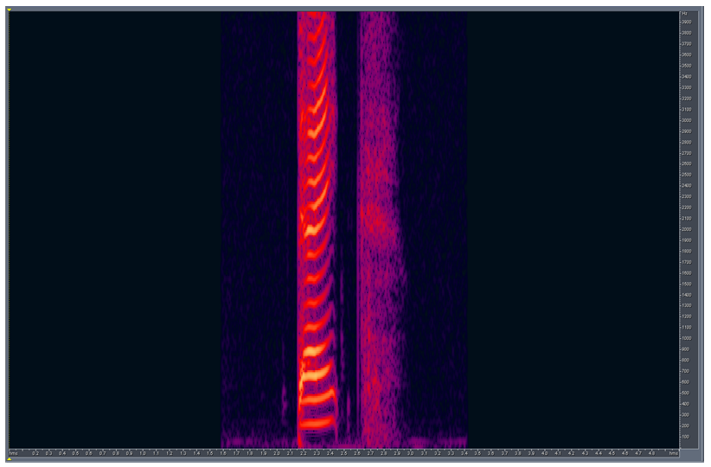
Figure 1. Spectrogram of an example DRT word before mixing.

First, DRT and DALT source speech files were mixed with a simulated echo of the CSS. This was done for several different levels of echo. Figure 2 shows how the speech signal looked after being mixed with the CSS.

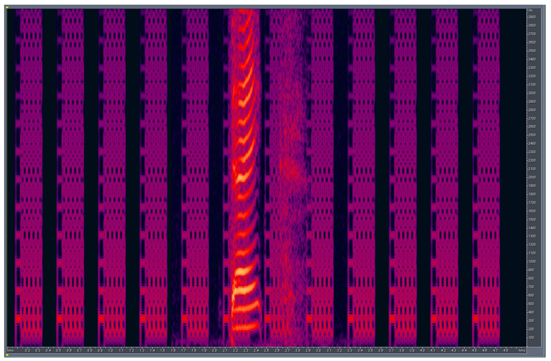
Figure 2. Spectrogram of a DRT word mixed with a simulated echo of the CSS.

Second, vehicle noise recordings were then mixed in at 10dB below the Active Speech Level. All speech and noise measurements were made using the ITU-T P.56 algorithm. The combined speech, echo, and noise signal is shown in Figure 3. This represents the signal as it looks going to the input of the HF algorithm in the send direction (i.e., corresponding to recording tap point DI-S2inadd of Draft ITU-T Recommendation P.1100) during a double talk scenario.

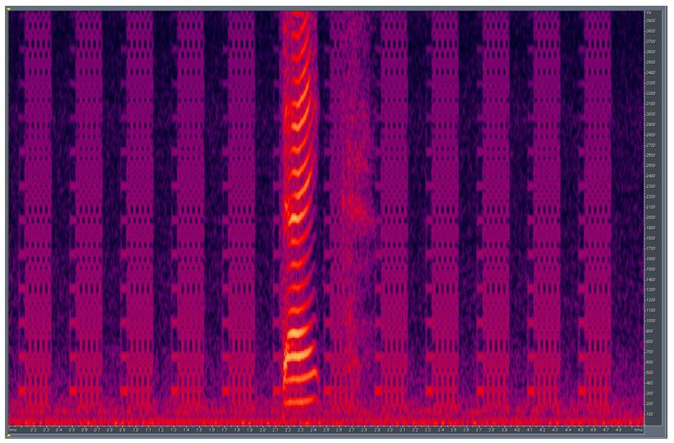
Figure 3. Spectrogram of a DRT word mixed with a simulated echo and vehicle noise.

Third, the CSS and DRT word with simulated echo and vehicle noise were simultaneously presented (i.e., double-talk) to the HF algorithm in the Receive and Send directions, respectively. Figure 4 shows the output recording after processing by the HF algorithm in the send direction (i.e., corresponding to recording tap point DI-S1 of Draft ITU-T Recommendation P.1100). It is evident from the recording that the HF algorithm has removed the majority of echo and noise. These recordings were then presented to ASR system for recognition which is described in the next section in more detail.

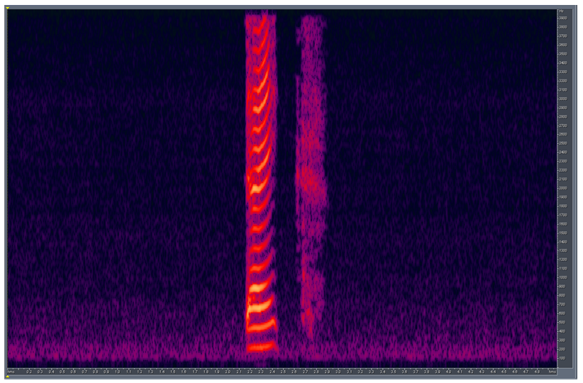
Figure 4. Spectrogram after processing through the HF algorithm.

2.3 Test procedure
The test stimuli generated in the previous section was used as the input to the ASR engine. Test scripts written in Perl and Matlab were used to automate test execution. For each recording, the following procedure was performed:
- Create constrained grammar for current test word
- Initialize ASR system
- Run recognition attempt on current recording
- Save recognition result for current recording in log file

Raw recognition results were then analyzed as described in the next section.

2.4 Data analysis
A new measure called the Duplex Capability Index (DCI) was calculated for each test condition. A test condition was defined by the unique combination of simulated echo level, noise, and HF algorithm settings; which the full set of DRT and DALT words were tested with. In the current testing only echo level was varied.

The DCI is simply the percentage of correct responses during double-talk after being adjusted for guessing. The adjustment for guessing is needed because even if the ASR system responded randomly it would be correct 50% of the time. A DCI value of 0% means that the DUT has no duplex capability (i.e., it is “half-duplex”). A DCI of 100% means the DUT is completely duplex (i.e., “full-duplex”). A DCI around 50% means the DUT is partially duplex (i.e., “three-quarter-duplex”). The DCI was calculated using the following formula:

$$\text{DCI}=\text{100}×\left(\frac{T−\left(i+\left(\frac{i}{a−1}\right)\right)}{T}\right)$$
Where:
DCI= Duplex Capability Index (i.e., % correct during double-talk adjusted for guessing)
T=Total number of recognition attempts
i=Number of incorrect responses
a=Number of response alternatives (a=2 for the current study)

- Preliminary Results
Results from the current testing are shown in Figure 5. DCI is shown as a function of simulated Echo Level. It can be seen that duplexness decreases as the echo level increases. Note that a DCI value of 0% corresponds to a half-duplex system. By listening to the recordings it appears that the impairment responsible for the decrease in duplexness is attenuation introduced by the echo control strategy.

Figure 5. Duplexness by Echo level. The Duplex Capability Index (DCI) is simply the % of correct responses during double-talk after adjusting for guessing. Echo level is expressed in dB relative to an arbitrary reference level.

- Conclusions
Previous work has established that ASR-based measurement methods are capable of predicting intelligibility scores from human participants across a wide range of impairments. The current study provides preliminary support for the use of ASR-based methods as a measure of Double-talk performance for automotive HF systems. However, there is still a lot of work that must be done to optimize the measurement method and validate it for use in automotive HF systems.

The Double-talk performance measures currently specified in Draft New ITU-T Recommendation P.1100 (Narrowband hands-free communication in motor vehicles) are intended to reflect quality. However, there is at least anecdotal evidence from industry that they sometimes give misleading results. If an ASR-based measure of duplexness is adequately validated by future studies, then it may make sense to replace some of the current Double-talk measures with this new measure. Although the duplexness measure does not directly measure quality, neither do the current measures in P.1100. Duplexness may prove an adequate indicator of poor quality since intelligibility degradations rarely happen without some quality impact as well. As more repeatable and valid measures of quality become available they can be added to better characterize the “quality” aspect of transmission performance during double-talk. In the meantime, intelligibility measures alone may be sufficient for practical purposes.

- Recommendations
There are many advantages to an ASR-based approach:
- Directly measures important aspects of speech communication
- Highly correlated with quality; when intelligibility becomes an issue then quality is also clearly an issue
- Large diagnostic potential (e.g., garbage models to capture specific impairments, pattern of recognition failures across source stimuli, etc.)
- High Face validity
- Measurement values easily interpreted as the ability to break-in and be heard
- No reference signal required

Therefore, it is recommended that further development and validation of this approach be done. QNX is interested in any comments and invites other laboratories to independently evaluate the viability of this approach.

Appendix 1-Bibliography

- Y. Teng, R.F. Kubichek, and J.E. Schroeder, “Objective Speech Intelligibility for Low Bit-Rate Speech Codecs Operating in Noisy Channels,” IEEE Int. Military Comm. Conf. (MILCOM), 2007.
- W. M. Liu, K.A. Jellyman, J.S.D. Mason, and N.W.D. Evans, “Assessment of Objective Quality Measures for Speech Intelligibility Estimation,” IEEE ICASSP, 2006.
- C.M. Chernick, S. Leigh, K.L. Mills, and R. Toense, “Testing the Ability of Speech Reconizers to Measure the Effectiveness of Encoding Algorithms for Digital Speech Transmission,” IEEE Int. Military Comm. Conf. (MILCOM), 1999.
- W. Jiang, H. Schulzrinne, “Speech Recognition Performance as an Effective Perceived Quality Predictor,” IEEE Int. Workshop on Quality of Service, pp. 269-275, 2002.
- C. Michael Chernick, Stefan Leigh, Kevin L. Mills, and Robert Toense, “Can Speech Recognizers Measure the Effectiveness of Encoding Algorithms for Digital Speech Transmission?”, National Institute of Standards and Technology,January 1999.
- G. Talwar, “HMM-BASED NON-INTRUSIVE SPEECH QUALITY AND IMPLEMENTATION OF VITERBI SCORE DISTRIBUTION AND HIDDENNESS BASED MEASURES TO IMPROVE THE PERFORMANCE OF SPEECH RECOGNITION”, PhD. Thesis, Department of Electrical Engineering, University of Wyoming, 2006.
_____________

“Double-talk” refers to the situation where both ends of connection are talking at the same time
“Duplex” means that both ends of the communications channel can simultaneously transmit and receive; this is also sometimes referred to as “full-duplex” which is redundant, but helpful in emphasizing the difference with “half-duplex”

