INTERNATIONAL TELECOMMUNICATION UNION |  | Focus Group on ICT&CC
TELECOMMUNICATION  STANDARDIZATION SECTOR  STUDY PERIOD 2005-2008 |  | FG ICT&CC-C-5
English only
Original: English
 |  | Geneva, 1-3 September 2008
CONTRIBUTION
Source: | NTT, JAPAN
Title: | Proposed definitions concerning estimating method for CO2 emissions reduction through ICTs

1. Introduction
This contribution introduces definitions concerning the methodology for evaluating environmental impact through ICTs.

2. Proposal
This contribution presents basic definition related to Deliverable 3, "Methodology". Therefore, this contribution will be reflected to the final report of the discussion on Deliverable 1.

ANNEX A
Proposed Draft text of the Deliverable 1
Definitions

A.1. Scope
This document is a draft of the standard for definitions of “ICTs and climate change”.
The purpose of standardizing the definitions is to supply for the other deliverables (Gap Analysis, Methodology, Direct and indirect impact of ITU-T standards).

A.2. References
The following ITU-T Recommendations and other references contain provisions, which, through reference in this text, constitute provisions of this Recommendation. At the time of publication, the editions indicated were valid. All Recommendations and other references are subject to revision; users of this Recommendation are therefore encouraged to investigate the possibility of applying the most recent edition of the Recommendations and other references listed below. A list of the currently valid ITU-T Recommendations is regularly published.
The reference to a document within this Recommendation does not give it, as a stand-alone document, the status of a Recommendation
[1] "Final Report on Focus Group on ICT and Climate Change, Volume I, Definitions"
[2] "Final Report on Focus Group on ICT and Climate Change, Volume II, "Gap Analysis"
[3] "Final Report on Focus Group on ICT and Climate Change, Volume IV, "Direct and Indirect impact of ITU-T standards"
[4] ISO 14040, "Environmental management – Life cycle assessment – Principles and frame work"
[5] ISO 14041, "Environmental management – Life cycle assessment – Goal and scoope definition and life cycle inventory analysis"

A.3. Definitions

A.3.1 Definitions for using "Gap Analysis"
(To be added)

A.3.2 Definitions for using "Methodology"

A.3.2.1 Energy consumption reduction through the use of ICTs
The difference between the energy consumption reduction by utilizing ICTs and the energy consumption through the use of ICTs.

A.3.2.2 Energy consumption reduction effect by utilizing ICTs
Utilizing ICTs brings about the effects of “enhancing the efficiency of energy use,” “enhancing the efficiency of and reducing the production and consumption of goods,” and “reducing the movement of people and goods,” and specifically produces the eight effects given A3.2.3-A3.2.10.

A.3.2.3 Consumption of goods
By reducing goods consumption (consumption of paper etc.), energy consumption related to goods production and disposal as well as waste generation can be reduced.

A.3.2.4 Power consumption /energy consumption
By enhancing the efficiency of power and energy use to reduce consumption, energy consumption related to power generation, power transmission, etc. can be reduced.

A.3.2.5 Movement of people
By reducing the movement of people, energy consumption required for transportation means can be reduced.

A.3.2.6 Movement of goods
By reducing the movement of goods, energy consumption required for transportation means can be reduced.

A.3.2.7 Improved efficiency of office space
By using office space efficiently, power consumption for lighting, air conditioning, etc. can be reduced, thus reducing energy consumption.

A.3.2.8 Storage of goods
By reducing storage space of goods, power consumption for lighting, air conditioning, etc. can be reduced, thus reducing energy consumption.

A.3.2.9 Improved work efficiency
By enhancing work efficiency, resource and energy consumption can be reduced.
A.3.2.10 Waste
By reducing waste emissions, energy consumption required for environmental preservation as well as for waste disposal etc. can be reduced.
A.3.2.11 Energy consumption through the Use of ICTs
It includes resources and energy consumed in the process, such as the production and installation of ICT devices and networks, electric power consumed in their use stage, and energy consumed in the process of their disposal and recycling.

A.3.2.12 CO2 emission intensity
The numerical value of CO2 emission per unit. (Ex. 0.4 kg-CO2/kWh)

A.3.2.13 Functional Unit
The quantified performance of a product system for use as a reference unit in life cycle assessment study (ISO14040. 3.5). (Ex. Yearly electronic application/settlement cases at Company A: 5 million cases; yearly Internet shopping cases at Company B: 100 million cases)

A.3.2.14 Reduction potential effect
Though video conference and teleworking (telecommuting) systems do not require people to move, no energy consumption will be reduced if trains and buses operate according to the existing timetable. However, the development of video conference and teleworking (telecommuting) systems in the future will change lifestyles and the social structure, which is expected to substantially reduce the traffic volume. Based on this assumption, such energy consumption reduction, while not immediately achievable, is now being evaluated for its future reduction potential effect of reducing energy consumption.

A.3.2.15 Comparative assertion
Environmental claim regarding the superiority or equivalence of one ICT versus a competing product which performs the same function (3.2, ISO 14040)

A.3.3 Definition using "Direct and indirect impact of ITU-T standards"
(To be added)

A.4 Abbreviations
ICT Information and Communication Technology
GHG Green House Gas
ASP Application Service Provider
SaaS Software as a Service

A.5 Energy Consumption Reduction
A.5.1 Basic Concept
With the progress of ICTs, ICT equipment/infrastructure will widely develop and its use will possibly cause an increase in energy consumption. Conversely, the use of ICTs is expected to reduce energy consumption through “enhancing the efficiency of energy use,” “enhancing the efficiency of and reducing the production and consumption of goods,” and “reducing the movement of people and goods.”
Here, in this Focus Group, the energy consumption reduction through the use of ICTs is defined as the difference between the energy consumption reduction effect by utilizing ICTs and the energy consumption through the use of ICTs.

Reduction effect of energy
consumption by utilizing ICTs
＝
－
Energy consumption
reduction
Energy consumption
through the use of ICTs

A.5.2 Energy Consumption Reduction Effect by Utilizing ICTs
Utilizing ICTs brings about the effects of “enhancing the efficiency of energy use,”enhancing the efficiency of and reducing the production and consumption of goods,” and “reducing the movement of people and goods,” and specifically produces the eight effects given below.

Table 1 Energy consumption reduction effects through utilizing ICT

Category | Effects
Consumption of goods | By reducing goods consumption (consumption of paper etc.), energy consumption related to goods production and disposal as well as waste generation can be reduced.
Power consumption /  energy consumption | By enhancing the efficiency of power and energy use to reduce consumption, energy consumption related to power generation, power transmission, etc. can be reduced.
Movement of people | By reducing the movement of people, energy consumption required for transportation means can be reduced.
Movement of goods | By reducing the movement of goods, energy consumption required for transportation means can be reduced.
Improved efficiency of office space | By using office space efficiently, power consumption for lighting, air conditioning, etc. can be reduced, thus reducing energy consumption.
Storage of goods | By reducing storage space of goods, power consumption for lighting, air conditioning, etc. can be reduced, thus reducing energy consumption.
Improved work efficiency | By enhancing work efficiency, resource and energy consumption can be reduced.
Waste | By reducing waste emissions, energy consumption required for environmental preservation as well as for waste disposal etc. can be reduced.

A.5.3 Energy Consumption through the Use of ICTs
Energy consumption is increased through the use of ICT systems, and it includes resources and energy consumed in the process, such as the production and installation of ICT devices and networks, electric power consumed in their use stage, and energy consumed in the process of their disposal and recycling.
A.5.4 Issues of CO2 Emissions Calculation Aiming to Realize International Standardization
We will propose to using Energy (J: Joule) as a unit instead of CO2 emissions because of the significant difference in CO2 emissions depending on each country even from the same power consumption. Conversion to CO2 shall be based on CO2 emission intensity reflecting the electric power situation of each country.
Energy (J) is used as a unit to develop this document referring to the calculation procedures in the Study Group Report of the Ministry of Internal Affairs and Communications.
[Note:
One of the most important environmental issues which we now face and should tackle is the climate change, especially global warming caused mainly from GHG emissions. Then should we assess ICT impacts in GHG emissions unit? It is answered "No" to this question. One of the main environmental impacts of ICT is a electric power consumption. GHG emissions originated in electric power consumption depend on sources of electric power generations such as coals, oils, gasses, nuclear and so on. Conditions of the electric power generations are quite different among each country, which differences of the CO2 intensity in each country as an example are shown in the following figure. Therefore, we shall assess ICT impacts in energy unit for the sake of performing objective and fair ICT energy assessments, in particular, when we will compare the results of quantifying ICT impacts between countries. (However, this requirement to assess ICT impacts in energy units is NOT indicated to permit a comparative assertion.)
In addition, when we will intend to assess ICT impacts of GHG emissions without comparison, otherwise to make a comparison of ICT impacts between regions which are no dependence on the conditions other than ICT (e.g. regions which is supplied from the same electric power generation), we can convert the ICT impact in energy unit to one in GHG emission unit multiplied by each GHG emission intensity of energy resources.]
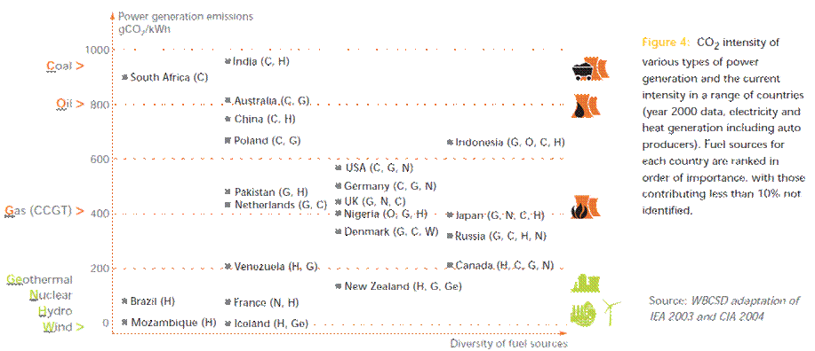

A.5.5 Procedure for Calculating CO2 Emissions Reduction
Since CO2 emissions even by the same power consumption significantly vary depending on the method of power generation, energy (J) consumption reduction shall be calculated first, and then the energy consumption reduction is converted into CO2 emissions reduction reflecting the situation in each country.

