INTERNATIONAL TELECOMMUNICATION UNION |  | Focus Group on ICT&CC
TELECOMMUNICATION  STANDARDIZATION SECTOR  STUDY PERIOD 2005-2008 |  | FG ICT&CC-C-16
English only
Original: English
 |  | Geneva, 1-3 September 2008
CONTRIBUTION
Source: | Republic of Korea
Title: | USN: an ICT Solution against Climate Change

- Overview
FG ICT&CC has been launched to study the ICT impact against climate change, and one of its rationales is
- ICTs can also be used to monitor climate parameters (e.g. networks for environmental monitoring, Ubiquitous Sensor Networking)
As the rationale mentions, Ubiquitous Sensor Network (USN) can be a good ICT solution to monitor climate parameters in terms of both direct monitoring of climate changes and indirect learning of climate features.

USN is not a new item in the ITU-T. It already has started its standardization as followings:
- ITU-T Draft Recommendation Y.USN-reqts, Requirements for support of USN applications and services in NGN environment, in Q.2/13
- ITU-T Draft Recommendation F.usn-mw, Service description and requirements for USN middleware, in Q.21,Q.22/16
- ITU-T Draft Recommendation X.usnsec-1, Security Framework for Ubiquitous Sensor Networks, in Q.9/17
Other SDOs such as ISO/IEC JTC 1, IEEE, and IETF also have been launching the study related to the USN. The section 3 will give more details.
However, their work targets of USN do not specifically concern the use of USN against climate change. ITU-T FG ICT&CC is a good place to study how to use USN for the climate change issues; to analyse special requirements for monitoring climate change, to derive technical issues to be solved to meet the requirements, and to introduce USN use-cases targeted on climate change.
ITU-T FG ICT&CC can input the study results to the relevant ITU-T SGs and SDOs in order to make them consider climate change issues on their USN study.

With this viewpoint, this contribution briefly introduces USN and proposes some perspective work items on behalf of FG ICT&CC.

- Introduction of Ubiquitous Sensor Network
Ubiquitous Sensor Network (USN) is used in many civilian application areas, including environment and habitat monitoring, healthcare applications, home automation, traffic control, and many other application areas. Figure 1 depicts examples of USN applications and services.
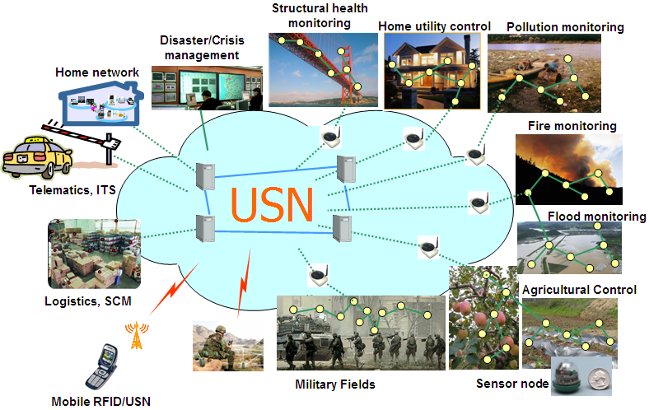
Figure 1 – Sensor network applications
USN is built on wireline sensor networks and/or Wireless Sensor Networks (WSNs). WSN, a wireless network consisting of spatially distributed autonomous devices using sensors to cooperatively monitor physical or environmental conditions, such as temperature, sound, vibration, pressure, motion or pollutants, at different locations, has been studied and implemented as isolated networks for the sensor applications. The isolated sensor network applications have been as simple as they captured and transmitted the sensed data only to the designated application systems.
Such isolated simple applications have been changing with network evolution, network and service integration, enhancing data processing scheme by business logics and data mining rules, context awareness scheme, development of hardware and software technologies, etc. These technical developments enable to build an intelligent information infrastructure of sensor networks connected to the existing network infrastructure. Resulting context-aware information and knowledge services, the integrated sensor networks are opening wide possibilities for sensor network services to various customers such as human consumers, public organizations, enterprises, government, etc. This information infrastructure has been called Ubiquitous Sensor Network (USN) in the ITU-T. USN delivers ubiquitous user-oriented information and knowledge services to end users where the information and knowledge is developed by using context awareness with detecting, storing, processing and integrating situational and environmental information gathered from sensor devices.
Combining various capabilities in support of USN applications and services, a USN infrastructure provides the integration of ubiquitous sensor network services into everyday life in an invisible way as everything is virtually linked by pervasive networking between users and sensor devices, relayed through intermediate networking entities such as application servers, middleware entities, access network entities, and sensor network gateways.
USN applications have usually some service characteristics which are specific to the application, implying specific service requirements and a specific profile of functional requirements. So, architectural configurations of hardware, software components and related implementations may be specific to each USN application. Figure 1 shows domains for development and standardization common to all USN applications. Other domains may be USN application specific.

Figure 2 – USN domains for development and standardization

- Current Standardization Activities related to the USN
This section explains SDOs activities on USN including ITU-T. This brief outlook about the ongoing USN standardization works will help to build up the position of FG ICT&CC in USN work.

  - ITU-T Activities
ITU-T sees various sensor network applications and services as an information service infrastructure called USN. That is, all the sensed information is not used simply but integrated, processed by filtering, data mining, context rules, etc., and produced into a variety of USN services. This approach differed from the previous approaches of other SDOs which had been working on the standard work on sensor networks, such as IETF and IEEE. All those standardization works focus on specific technical targets such as PHY/MAC for wireless sensor networking (IEEE 802.15.4, IEEE 1451), IPv6 networking (IETF), etc. or closed domain applications such as patient monitoring (IEEE BAN), industrial monitoring (ISA), etc.
At its meeting held in Geneva, February 2007, ITU-T TSAG reached a conclusion to ask the relevant Study Groups to urgently initiate the study of USN. The followings are considered to be the relevant Study Groups including JCA-NID (Joint Coordination Activity on Network aspects of identification systems including RFID) as a coordinating entity:
- Study Group 13: Functional requirements and architectures including NGN view points;
- Study Group 16: Multimedia service descriptions and requirements aspects;
- Study Group 17: Security and Object Identifier aspects; and
- JCA-NID: Overall coordination on USN standardization activities within ITU-T Study Groups including relevant SDOs outside ITU-T. For this the Terms of References of JCA-NID should be extended to cover USN issues appropriately.
After the TSAG decision, the relevant ITU-T SGs has immediately started USN standardization works as followings:

- ITU-T SG 13
Q.2/13 started a new draft Recommendation work, Y.USN-reqts (Requirements for support of USN applications and services in NGN environment), at its September 2007 meeting. This draft recommendation is based on Y.2201 (NGN Release 1 Requirements) and covers extended features and additional services and functions to existing NGN services and functions in order to support Ubiquitous Sensor Network (USN) applications and services. This draft deals with USN applications and services and its scope includes:
- General characteristics of USN;
- Description of USN applications and services to identify service requirements, to support USN applications and services;
- Requirements of extended or new NGN capabilities based on the service requirements to support USN applications and services

- ITU-T SG16
ITU-T SG 16 also initiated F.usn-mw (Service description and requirements for USN middleware). This draft Recommendation introduces USN services which use USN middleware and their service scenarios. Also, requirements for USN middleware to support various USN services are described. This draft Recommendation covers:
- Features of USN services
- USN service scenarios which use USN middleware
- Functional model of USN middleware
- Requirements for USN middleware

- ITU-T SG 17
ITU-T SG17 has initiated X.usnsec-1 (Security framework for USN) at its September 2007 meeting. This draft Recommendation describes security threats and security requirements to the Ubiquitous Sensor Network. In addition, this draft recommendation categorizes security technologies by security functions that satisfy above security requirements and by the place to which the security technologies are applied in the model of the Ubiquitous Sensor Network. Finally, the security function requirements for each entity in the network and possible implementation layer for security function are presented.

- ITU-T JCA-NID
JCA-NID plays a role of coordination among relevant ITU-T Study Groups and other SDOs on USN. Currently JCA-NID is elaborating on building up the common Terms and Definitions among the ITU-T draft recommendations about USN.

  - ISO/IEC JTC 1 Activities
ISO/IEC JTC 1/SC 6 and ISO/IEC JTC 1/SC 31 are working on standardization of USN related topics. In addition, The ISO/IEC JTC 1 plenary meeting, 13 October 2007, made the resolution 19, which determines that the developing and implementing a consistent strategy to standardization in the area of sensor networks is important to adequately address the diverse requirements of different application areas and agrees on building Study Group on Sensor Networks (SGSN).

- ISO/IEC JTC 1/SC 6
Since SC 6 discussed about sensor network issues initially from its meeting held in Orlando, USA, November 2004, SC 6/WG 1 had contributions on and studied MEU (Mesh-Enabled USN) at its meetings held in Frankfurt, Germany, February 2005; Saint Paul De Vence, France, August 2005; and Prague, Czech, June 2006.
SC 6 and its WGs have considered sensor network matters for its future standardization initiative. SC6 has included sensor networks in its business plan in 2007 and has circulated two NPs to develop a reference architecture model and a security framework for sensor networks and corresponding applications/services from July 2008. The proposed reference model will cover a review of existing sensor networking specifications; clarification of sensor network functionalities from operation layer’s and operation relationship’s points of view; integration and interworking among various sensor network standards; and, reference model to show interface relationship among a variety of sensor network functionalities.
SC 6 coordinated the sensor network standardization initiative with SC 31 by clarifying that SC 6 would cover general sensor network issues and SC 31 would deal with only sensor-assisted RFID and sensor interfaces specified by IEEE 1451. Not only within the ISO/IEC JTC 1, SC 6 actively coordinates the sensor network standardization works with ITU-T. It sent a liaison statement, SC6 N13351, to ITU-T SGs 13, 16, 17 and JCA-NID to ask collaborations on USN from September 2007. The statement summarized a motivation for collaboration and suggested possible common work items between SC 6/WGs and ITU-T SGs/Questions. It proposed to develop common standards. Positive responses have been exchanged.

- ISO/IEC JTC 1/SC 31
At its June 2007 meeting, Pretoria, South Africa, SC 31 endorsed the MIIM (Mobile Item Identification and Management) ad-hoc group to study standardization items of MIIM and make the proposal about how SC 31 has to handle the work items. The MIIM studied two work areas: tag-based identification applications and services; and, sensor interface issues.
The MIIM ad-hoc group has reached to the resolution at its last meeting, Seoul, Korea, 30-31 October 2007, which SC 31 was recommended to establish a new working group, WG 6, to deal with relevant standardization items for sensor interface and tag-based identification. The ad-hoc group had overwhelming affirmative votes from SC 31 members for the new group, WG 6. SC 31 will take a decision at its plenary meeting in June 2008. The expected WG 6 would adopt IEEE 1451 results with regard to sensor interface issues.

- ISO/IEC JTC 1 SGSN(Study Group on Sensor Networks)
JTC 1 establishes a Study Group on Sensor Networks (SGSN) with the following Terms of Reference:
- Review the current definitions, visions and requirements for target applications of Sensor Networks within JTC1 and outside JTC1 in connection with different application areas (e.g. home, medical informatics, transport informatics, industrial communications, RFID etc) as well as JTC 1 SCs roles in these application areas;
- Review and identify
- the unique characteristics of Sensor Networks and the commonalities and differences with other networks
- the system architectures of Sensor Networks in terms of functionalities
- the entities that together comprise Sensor Networks and their characteristics
- existing protocols that can be used for Sensor Networks and the elements of protocols that are unique to Sensor Networks
- the scope of infrastructure that can be considered to be a Sensor Network
- the types of data that need to be handled (acquired, processed, transported, stored, rendered etc) by Sensor Networks and any specific QoS attributes required by those categories
- the interfaces that need to be supported by Sensor Networks
- the services that need to be supported by Sensor Networks
- aspects such as security, privacy, identification that may be relevant to specific Sensor Networks;
- Monitor other activities in international standardization bodies and consortia and fora where specifications related to Sensor Networks are being developed;
- Produce a report covering 1) and 2) above and information on other relevant standardization activities;
- In the light of published SC scopes and work programmes and the results of 1) to 3) recommend potential areas of work to JTC 1 and appropriate SCs to ensure that all necessary aspects of Sensor Networks within the scope of JTC 1 are standardized;
- Recommend how the work on Sensor Networks can be efficiently coordinated in JTC 1;
- Hold workshops to gather requirements or publicize the results; and
- Meetings of the group may be physical or via electronic means
The SGSN had contributions about use cases, service requirements, expected standardization topics, technical study points, and relevant activities of other SDOs. After a lot of discussions with the contributions, following consensuses were reached:
- The sensor networks shouldn’t be taken into account from a simple networking and monitoring application perspective. But they should be considered as a service environment to enable sophisticated sensor network applications incorporating various sensor networks and different application domains; and
- A reference architecture model should be an urgent work item for standards development because sensor networks and relevant applications/service are involved with a lot of functional elements and a common architectural view is highly required to analyze functional elements and their interfaces for a certain sensor network application/service.

  - IEEE Activities
IEEE handles PHY/MAC issues on sensor networks. Series of IEEE 802.14, such as IEEE 802.15.4, 802.15.3 (UWB: Ultra Wide-Band), 802.15.1 (Bluetooth), etc. are used for sensor networks as physical networking technologies, and IEEE 1451 provides various smart transducer interfaces. The followings explain IEEE activities on related to USN.

- IEEE 802.15
The official home page of IEEE 802 says IEEE 802.15 has focused on development of consensus standards for Personal Area Networks (PAN) or short distance wireless networks. These Wireless PANs address wireless networking of portable and mobile computing devices such as PCs, Personal Digital Assistants (PDAs), peripherals, cell phones, pagers, and consumer electronics; allowing these devices to communicate and interoperate with one another.
Among these example solutions, IEEE 802.15.4 is the most promising one in the current market. Its initial standard was published in 2003 but the second version was published in 2006. Currently a few PHY alternatives are being developed. IEEE 802.15.3 is another widely-deployed solution. The uID center of Japan has a number of use cases of IEEE 802.15.3-based sensor networks and claimed the standard was more robust against radio interference.
IEEE 802.15 alternatives have been adopted widely for wireless sensor networking technologies. But they had lack of considerations on outdoor sensor network applications which have different operation conditions such as difficulty in maintenances, long-chained network in tunnels or bridges, interference by moving cars on the street and seasonal changes in mountains, etc. IEEE 802.15.4e is launched to develop the enhancement of 802.15.4.

- IEEE 1451
It provides various smart transducer interfaces which make it easier for transducer manufacturers to develop and to interface smart transducer devices to networks, systems, and instruments by incorporating existing and emerging sensor- and networking technologies. So it works within the sensor networks area in Figure 1. Its logical relationship is depicted in Figure 3 and Figure 4 (Source: Kang Lee, NIST). These family standards are planned to be adopted as International Standards by ISO/IEC JTC 1/SC 31.
IEEE 1451 is a family of smart transducer interface standards consisting of 8 work items [Source: NIST]:
- On-going projects:
- IEEE P1451.0 defines a set of common commands, common operations, and TEDS (Transducer Electronic Data Sheet) for the family of IEEE 1451 smart transducer standards;
- IEEE P1451.5 defines a transducer-to-NCAP (Network Capable Application Processor) interface and TEDS for wireless transducers. Wireless communication protocol standards such as 802.11 (WiFi), 802.15.1 (Bluetooth), 802.15.4 (ZigBee) are being considered as some of the physical interfaces for IEEE P1451.5.
- IEEE P1451.6 defines a transducer-to-NCAP interface and TEDS using the high-speed CANopen network interface. It defines a mapping of the 1451 TEDS to the CANopen dictionary entries as well as communication messages, process data, configuration parameter, and diagnosis information.
- IEEE P1451.7 defines a standard for a smart transducer interface for sensors and actuators, transducers-to-RFID-systems-communication protocols, and transducer electronic data sheet formats.
- Finished projects:
- IEEE 1451.1 defined a common object model describing the behavior of smart transducers. It defines a measurement model that streamlines measurement processes. It also defined the communication models used for the standard, which included the client-server and publish-subscribe models.
- IEEE 1451.2 defined a transducers-to-NCAP interface and TEDS for a point-to-point configuration. Transducers are part of a Transducer Interface Module (TIM).
- IEEE 1451.3 defined a transducer-to-NCAP interface and TEDS for multi-drop transducers using a distributed communications architecture. It allowed many transducers to be arrayed as nodes, on a multi-drop transducer network, sharing a common pair of wires.
- IEEE 1451.4 defined a mixed-mode interface for analog transducers with analog and digital operating modes.
Figure 3 – IEEE 1451 standards relationship
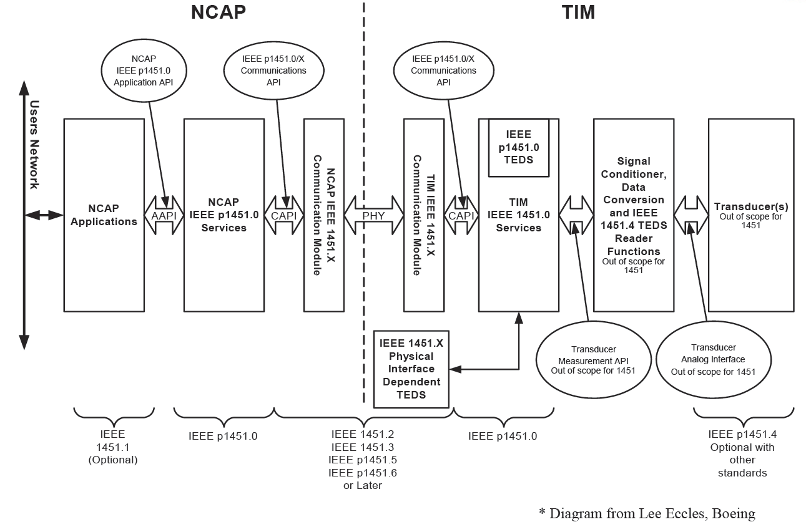
Figure 4 – IEEE 1451 reference model

  - IETF Activities
IETF has two Working Groups (WGs) related to sensor networks; IPv6 over Low power WPAN (6LoWPAN) WG and Routing Over Low power and Lossy networks (ROLL) WG.

- 6LoWPAN WG
It focuses on IPv6 over IEEE 802.15.4. That is, 6LoWPAN deals only with networking issues. Application- and service-perspective issues are out of scope.
It developed:
- RFC 4919 (IPv6 over Low-Power Wireless Personal Area Networks (6LoWPANs): Overview, Assumptions, Problem Statement, and Goals) to define the problem statement and goals of 6lowpan networks; and
- RFC 4944 (Transmission of IPv6 Packets over IEEE 802.15.4 Networks) to define the basic packet formats and sub-IP adaptation layer for transmission of IPv6 packets over IEEE 802.15.4. This includes framing, adaptation, header compression and address generation. Furthermore, IEEE 802.15.4 devices are expected to be deployed in mesh topologies.
After the two RFCs, 6LoWPAN is now started new work items as followings:
- Enhancement of RFC 4944
- Bootstrapping and neighbour discovery;
- Problem statement of stateful header compression;
- 6LoWPAN architecture (spin off: 6LoWPAN routing requirements);
- 6LoWPAN use-cases;
- 6LoWPAN security analysis;
- Implementation considerations; etc.

- ROLL WG
IETF ROLL WG handles routing issues on sensor networks. It only focuses on industrial, connected home/building and urban sensor networks and it determines the routing requirements for these scenarios. The Working Group will provide an IPv6 only routing architectural framework for these application scenarios. The Framework will take into consideration various aspects including high reliability in the presence of time varying loss characteristics and connectivity while permitting low-power operation with very modest memory and CPU pressure in networks potentially comprising a very large number (several thousands) of nodes.
Its current work items are as followings:
- Routing requirements for industrial, connected home, building and urban sensor networks.
- Survey of the applicability of existing protocols to Low-power Lossy Networks (LLNs)
- Specification of routing metrics used in path calculation
- Architectural framework for routing and path selection lat layer 3

  - Zigbee Alliance Activities
Zigbee Alliance develops a total solution for a non-IP multi-hop wireless sensor network, covering network-layer to application-layer issues based on IEEE 802.15.4 as shown in Figure 5 (Source: ZigBee Alliance). Its scope about the network layer to application layer resides within the sensor networks area in Figure 1. For example, home security and appliance control applications are a typical application area of ZigBee and have to deal with the network to application layer issues.
ZigBee is one of enablers of non-IP wireless sensor networking solutions. TinyOS is another enabler and many other proprietary solutions have been adopted. Figure 6 shows the functional configuration of Zigbee from physical layer to application layer, which shows its standardization domains.
Figure 5 – ZigBee protocol stack

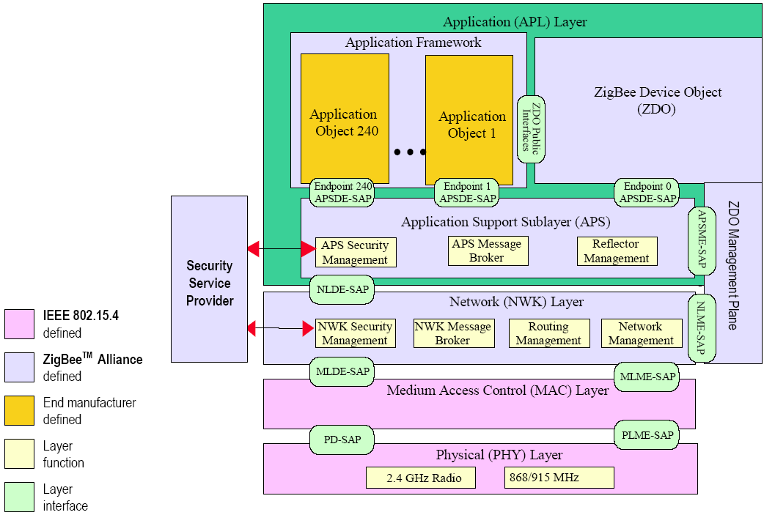
Figure 6 – ZigBee functional configuration

- Perspective USN work items on behalf of FG ICT&CC activities
As we see in the section 3, each SDO has developed or been developing its standards within its work scope. However, there are other work items to realize a vision of USN applications and services in a viewpoint of monitoring climate change.
This section discusses the perspective USN work items on behalf of monitoring climate change. These items can be discussed with close collaboration between FG ICT&CC and the relevant ITU-T SGs and SDOs.
- Development of USN use-cases for monitoring climate changes
- Analysis of the functional requirements on behalf of monitoring climate changes from the use-cases
- Build-up reference models using USN for monitoring climate changes
- Build-up early-warning models and decision support models based on the USN
- In addition to the items, FG ICT &CC may give the relevant ITU-T SGs input of the necessary work items for the reference models
- Inter-networking between sensor networks and the existing network infrastructure: especially consider harsh outdoor environments
- Self-configurable networks
- Remote network management
- Power supply for the harsh remote environment
- Service registration and discovery (context-awareness service discovery)
- Management of vast of database
- QoS for emergency data
- Security issues, etc.

- Proposal
It proposes to consider USN as a good solution to monitor climate change, and FG ICT&CC deliverables include the USN works. In addition, it proposes to initiate the work on the proposed work items suggested in the section 4 within the appropriate deliverables of FG ICT&CC. (e.g. deliverable 3: methodology)

