1. Introduction
INTERNATIONAL TELECOMMUNICATION UNION |  |  |  | Focus Group On IPTV
TELECOMMUNICATION  STANDARDIZATION SECTOR  STUDY PERIOD 2005-2008 |  |  | FG IPTV-C-0113
 |  |  | English only
WG(s):WG 1 |  | 2nd FG IPTV meeting:  Busan, 16-20 October 2006
CONTRIBUTION
Source: | China Telecom
Title: | Proposal on Requirement and Framework for Content Provision
The working document on requirements for IPTV notes that content provider requirements (REQ_Arch_13) would wait to be discussed. Because IPTV content operation and management are very different from those of traditional radio and television, we propose a series of items on this aspect in this document. And we give a table of contents in the annex of this document for further study on content provision.
2. Discussion
2. 1. Requirements of IPTV Content Provision
Requirements are the most important parts of IPTV content provision. A set of featured characteristics of IPTV content provision will be helpful to describe the difference of content operation and management between IPTV and traditional radio and television industry.
The sub-topics relevant to this item are:
1) Requirements of content operation
2) Requirements of content management
3) Content and management model

2. 2. Definitions of concepts in IPTV content provision
Some important concepts should be defined in order to make the interface clear between IPTV content provision layer and services operation layer.
Some of the concepts should be:
- Content
- Content Assets,
- Lifetime of assets
- Lifecycle of assets,
- Other attributes of assets
- Difference between contents and services.

2. 3. Framework of IPTV Content Operation and Management in Content Provision
To meet the demand for content and management of IPTV, a framework should be established to define the functional modules, control flows, information flows and reference points etc.
The following is a proposed framework of content provision layer and there are 2 reference interfaces at least to services operation layer.
The function of each module may be defined as:
1) Content acquisition module: to fulfill putting the content into the layer. The content here may include audio metadata, video metadata, audio-visual metadata, text and picture metadata.
2) Content processing module: to convert the content metadata to specific format and converge kinds of content metadata into IPTV featured content assets. So it should also do the EPG metadata processing and storage of all data.
3) Content management module: to manage all the content or assets. It should classify the content according with the material and quality and assign labels for all the contents or assets.
4) content operation module: to be responsible for the content operation. It should do some functions relevant to content business, such as content-based billing, content-based charging and introducing third-party content provider.

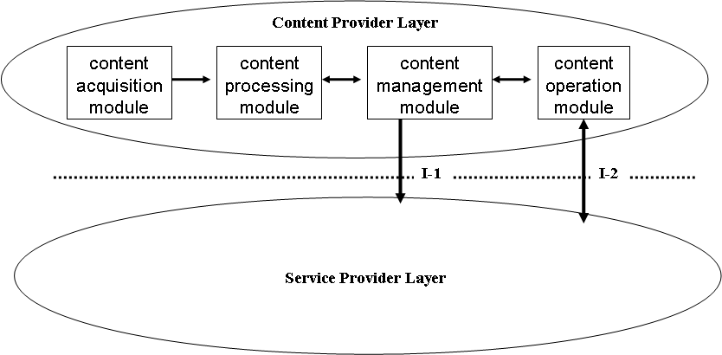
A possible reference framework of IPTV content provision layer

2. 4. Management and Supervision of audiovisual Content quality
The audiovisual content quality is the most important parts of IPTV’s QoE. Because of “best-effect” of IP network, maintaining quality of audiovisual content is a big challenge for IPTV. A set of effective management and supervision mechanism will be quite helpful to maintain and improve the quality.
The sub-topics relevant to this item are;
1) Classification of audiovisual content quality;
2) Subjective assessment methods of audiovisual content quality;
3) Objective assessment methods of audiovisual content quality;
4) Audiovisual content quality control, reference point, the supervision target collection.

2. 5. Interfaces between content provision layer and service operation layer
It is clear that there are interfaces between two layers. As shown above, there seem to be two interfaces, one is about content or assets management and another is about content or assets operation. A set of well-defined parameters will help to turn the contents or assets in content provision layer effectively into actual services in services operation layer.
The sub-topics relevant to this item are;
1) Content management interface
2) Content operation interface

3. Proposal
According to actual deployment of IPTV by China Telecom, the proposed items described above are relevant for IPTV Content provision layer and we propose it as a single output document of WG1.

The proposed table of items is listed in Annex of this document. The proposed table of contents also contains some items not discussed above. These items are Introduction, Scope, Reference, Definition, Abbreviation, and Conventions These items can generally be found in ITU-T documents and will be described in a usual way.

Annex
The proposed table of contents of IPTV Content Provision
1 Introduction
2 Scope
3 Reference
4 Definition
5 Abbreviation
6 Conventions
7 Requirements of IPTV Content Provision
7.1 Requirements of content operation
7.2 Requirements of content management
7.3 Content and management model
8 Definitions of concepts in IPTV content provision
8.1 Content
8.2 Content Assets,
8.3 Lifetime of assets
8.4 Lifecycle of assets,
8.5 Other attributes of assets
8.6 Difference between contents and services.
9 Framework of IPTV Content Operation and Management
9.1 Content acquisition
9.2 Content processing
9.3 Content management
9.4 Content operation
10 Management and Supervision of audiovisual Content quality
10.1 Classification of audiovisual content quality;
10.2 Subjective assessment methods of audiovisual content quality;
10.3 Objective assessment methods of audiovisual content quality;
10.4 Audiovisual content quality control, reference point, the supervision target collection.
11 Interfaces between content provision layer and service operation layer
11.1 Content management interface
11.2 Content operation interface
_________

