Abstract
INTERNATIONAL TELECOMMUNICATION UNION |  |  |  | Focus Group On IPTV
TELECOMMUNICATION  STANDARDIZATION SECTOR  STUDY PERIOD 2005-2008 |  |  | FG IPTV-C-0168
 |  |  | Original: English
WG(s): 4 |  | 2nd FG IPTV meeting:  Busan, 16-20 October 2006
CONTRIBUTION
Source: | ZTE Corporation
Title: | Multicast user authentication and authorization function and procedure for IPTV network
This contribution provides an overview of Multicast user authentication and authorization function and procedure for IPTV network.

discussion
As the current multicast protocol(i.e IGMP) does not consider Multicast user authentication and authorization , it is a little difficult for us to develop the IPTV services efficiently . So it is very necessary for the IPTV bearer network to restructures the multicast and make it easy to provide authentication function for the multicast users.
Multicast User authentication function controls the authority for users to receive multicast flows. and Through authentication of multicast users, the network can distinguish legal multicast users from the illegal ones and then distribute the multicast traffic to the reasonable receivers.
i) The network components for IPTV Multicast User authentication and authorization function
There are three function modules which are relative to Multicast user management, they are Multicast duplication point, Multicast Authentication Point and Account Information Database . The location of the three components in the IPTV network are illustrated and described in the following figure (figure 1):
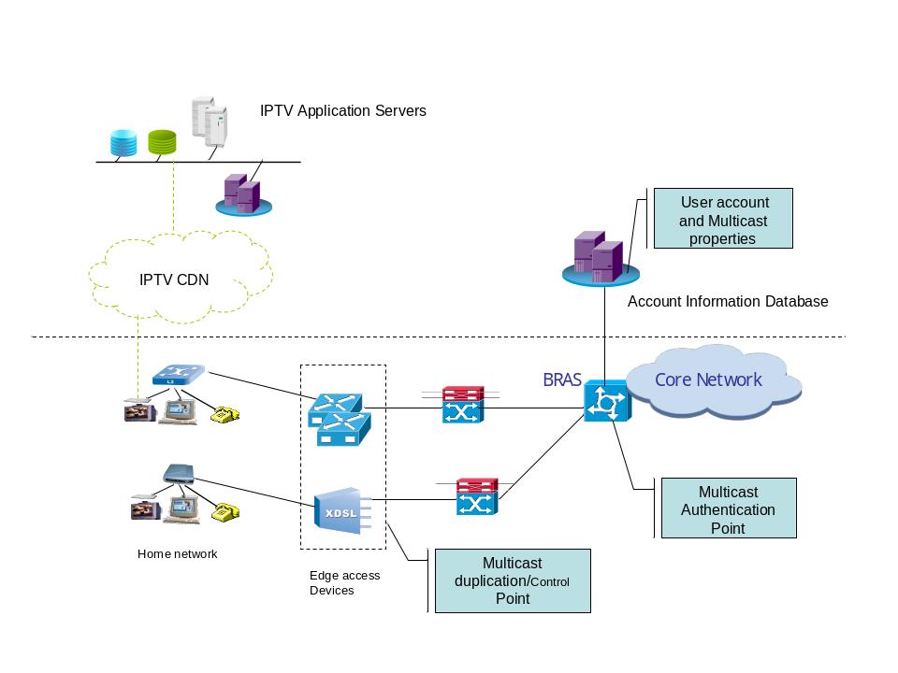
figure 1: Multicast user management function components
- Multicast duplication Point. This function module contains the multicast traffic distribution table, which can control direction of the duplication traffic and be used to avoid forwarding the multicast traffic to the illegal users. Only the users who have passed authentication can exist in this table .
- Multicast Authentication Point. This function module will inquire the Account information Database and return the result to Multicast duplication Point, the Multicast duplication Point will use the result to construct distribution table.
- Account Information Database. this function module has all the accounts, which contain the user’s multicast properties. Especially, the values of multicast properties may depend on the result of the service layer authentication.
- Procedure of IPTV multicast user authentication and authorization
- When a user initiates a multicast “join” request to join a certain multicast group with a account, the duplication point will not accept the request and make him join the group at once, it will sent the request to the authentication point.
- The authentication point inquire the Account information Database and return the result to Multicast duplication Point. The value of the user’s multicast property in the account could be set by the service layer system.
- According to the authentication result returned from the authentication point, the Multicast duplication Point will decide whether it allow the user to join the group or not. If allow the user to join the group , the duplication will add it to distribution table. Whereas it will refuse the user to join the group.

Proposal
According to the features of the IPTV service and the discussion above, there are two proposals as follows:
  - the IPTV network should support multicast user authentication function.
  - The procedure of multicast user authentication discussed in this contribution could be take into consideration.
_______________

