INTERNATIONAL TELECOMMUNICATION UNION |  |  |  | Focus Group On IPTV
TELECOMMUNICATION  STANDARDIZATION SECTOR  STUDY PERIOD 2005-2008 |  |  | FG IPTV-C-0194
 |  |  | English only
WG(s): 1 |  | 2nd FG IPTV meeting:  Busan, 16-20 October 2006
CONTRIBUTION
Source: | ETRI, Republic of Korea
Title: | Proposed text for T-communication service in Working Document on Service Scenario for IPTV
1. Introduction

T-communication is a convergence service of telecommunication and broadcasting that provides phone services (VoIP, video phone, multiple video conference, etc.) and internet-based communication services (Instant Messaging, Short-Messaging Service, Email, Web, etc.) with classical television services. It is usually provided by controlling multiple sessions for a phone service, an internet-based communication service and a television service. Therefore consumers can use the converged services simultaneously.
This document proposes a new text for definition, use case and services scenario flows of T-communication Service included in “Working Document on Service Scenario for IPTV” output document which was made at the 1st FG IPTV meeting.

2. Proposal

It is proposed that the text below is inserted in “Working Document on Service Scenario for IPTV”.

_______________

- Definitions/descriptions of IPTV services

7.x T-communication

T-communication is a convergence service of telecommunication and broadcasting that compounds phone services (VoIP, video phone, multiple video conference, etc.) and internet-based communication services (Instant Messaging, Short-Messaging Service, Email, Web, etc.) with classical television services. It is usually provided by controlling multiple sessions for a phone service, a internet-based communication service and a television service. T-communication has a few combinations. Thus consumers can use the converged services that provide “a phone service and a TV service” or “a communication service and a television service” or “a phone service and a communication service and a television service” simultaneously.

- Use cases for IPTV Services

10.x T-communication

A consumer will want to send (or receive) an instant message to another consumer simultaneously while he is watching TV.

A consumer will want to make (or get) a phone call to another consumer simultaneously while he is watching TV.

A consumer will want to send (or receive) an instant message to another consumer simultaneously while he is watching TV. At the same time, he can get (or make) a phone to another consumer.

- Services scenarios with flows between functions of players

15.x T-communication

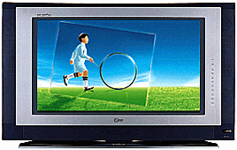
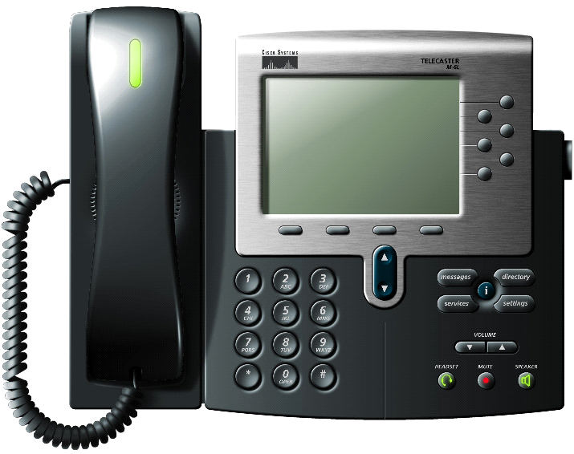
Content Provider
Service Provider
Network Provider
Consumer
Broadcast Server
Instant Messaging Server
Consumer 1
Consumer 2
4
6
8
7
5
2
VoIP Server
Consumer 3
10
9
Convergence Service Control Server
Subscriber Management Server
1, 3

Figure 1. T-communication service scenario

1. Consumer1 turns on TV set
2. Concumer1 receives service lists available like EPG from Subscriber Management Server
3. Consumer1 selects T-communication service among the service lists
4. After Subscriber Management Server checks the authentication and billing of Consumer1 for the selection, it requests the Convergence Service Control Server to process T-communication service. So consumer1 watches TV channel provided from Broadcast Server which is triggered by the Convergence Service Control Server.
5. Consumer2 sends an instance message to Consumer1 via Instant Messaging Server
6. Consumer1 receives the instance message from Consumer2 watching TV simultaneously
7. Consumer1 sends a reply message to Consumer2 watching TV simultaneously
8. Consumer2 receives the reply message from Consumer1 via Instant Messaging Server
9. Consumer3 makes a phone call to Consumer1 via VoIP Server
10. Consumer1 gets the phone call from Consumer3 via VoIP Server watching TV simultaneously

__________

