INTERNATIONAL TELECOMMUNICATION UNION |  |  |  | Focus Group On IPTV
TELECOMMUNICATION  STANDARDIZATION SECTOR  STUDY PERIOD 2005-2008 |  |  | FG IPTV-C-0227
 |  |  | English only
WG(s): 4 |  | 2nd FG IPTV meeting:  Busan, 16-20 October 2006
CONTRIBUTION
Source: | ETRI, Republic of Korea
Title: | Multicast Control Function for IPTV Services

1. Introduction
Considering the information delivery pattern and service requirements for IPTV applications, the multicast for IPTV is key function to support various applications for IPTV services. This contribution proposes multicast control function and requirement to support the IPTV multicast services in the network, and the following section 2 will be a major text section of WG3 document.

2. Multicast Control Functions for IPTV Service
Based on In order to enhance and optimize service capability in mobile VPN multicast function, its multicast function will be required to perform at transport stratum, service stratum or both.
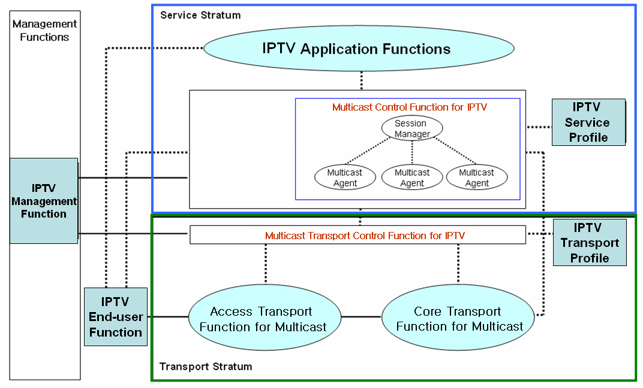
Figure 1 IPTV Multicast Function Framework

2.1 IPTV Multicast Control Function at the Transport Stratum

- Identifications of IPTV multicast group and service

A IPTV multicast group and service should be identified by the relevant mapping mechanisms with physical or logical identifiers of mobile IPTV users.

- Multicast session management for IPTV Services

The multicast transport control function for IPTV services manages the multicast session information including multicast tree information, which includes the number of multicast IPTV users, multicast domain, the QoS levels per multicast group, and accounting information per user, etc. It supports a multicast tree configuration for a specific multicast group. The multicast tree can be dynamically updated when joining and leaving IPTV customers. Depending on network topology and physical media, multicast tree path can be constructed by physical media (e.g., FTTH/PON and wireless LAN).

- Multicast Domain Management
A multicast domain is a set of multicast routing and forwarding instances than can send multicast traffic to each other. These multicast routing and forwarding instances are referred to as IPTV multicast domain. Thus, multicast domains map all of a customer’s multicast groups that exist in particular IPTV service members to a single unique global multicast group. This is achieved by existing or specific group routing and forwarding capability in the network.

2.2 IPTV Multicast Function at the Service Stratum
Service level multicasting aims to support various kinds of group applications for IPTV service, some of which are categorized in the according to the ways of communication and the characteristics of data delivery. In order to provide mobile IPTV multicast at the service stratum in the network (e.g., NGN), two major functional entities, ISM (IPTV Session Manager) and IMA (IPTV Multicast Agent), are introduced to perform multicast function at the service stratum in the network.

2.2.1 Functional Requirements for IPTV Service Level Multicast
Service level IPTV multicast includes service control functions (including IPTV Session Manager and IPTV Multicast Agents) and IPTV application functions, IPTV service user Profiles.
IPTV Service control functions include session control, session membership management and service user profile management at the service level. They can also include functions for controlling media resources -- i.e., specialized resources and gateways at the service-signaling level.
IPTV application function includes a lot of functions for various IPTV multicast services. Therefore, they could be implemented specific functions dependent on the each service and could provide an interface to user to notice the IPTV service information and accept the service request of user. IPTV Application function support functions include functions such as the gateway, registration, authentication, and authorization functions at the service level. And IPTV Application Function support functions work in conjunction with the Service Control Functions to provide users with the value added services they request.
IPTV Service User Profile functions are based on the user subscription data and network data. It is a database based on a service user and shall be provided in support of:
- IPTV Multicast user authentication and authorization
- IPTV Multicast service subscription information
For IPTV service level multicast over converged network platforms (e.g., wired, wireless and broadcast networks), each multiple IMAs will handle their functionalities of multicast functions at each IMA.

2.2.2. Control Framework for IPTV Service Level Multicast
Service Level Multicasting constructs and manages relayed multicasting functions to support internet group application services over the unicast-based network. After control messages of a service level multicasting are exchanged, a multicast data delivery path is constructed by using multiple end hosts even such as personal desktop computer. Along the delivery path, real-time or reliable data transport channels are inter-connected between upstream and downstream IMAs. Only after the data delivery path and data channel are established, group applications can work as if they were in a native IPTV multicast network.
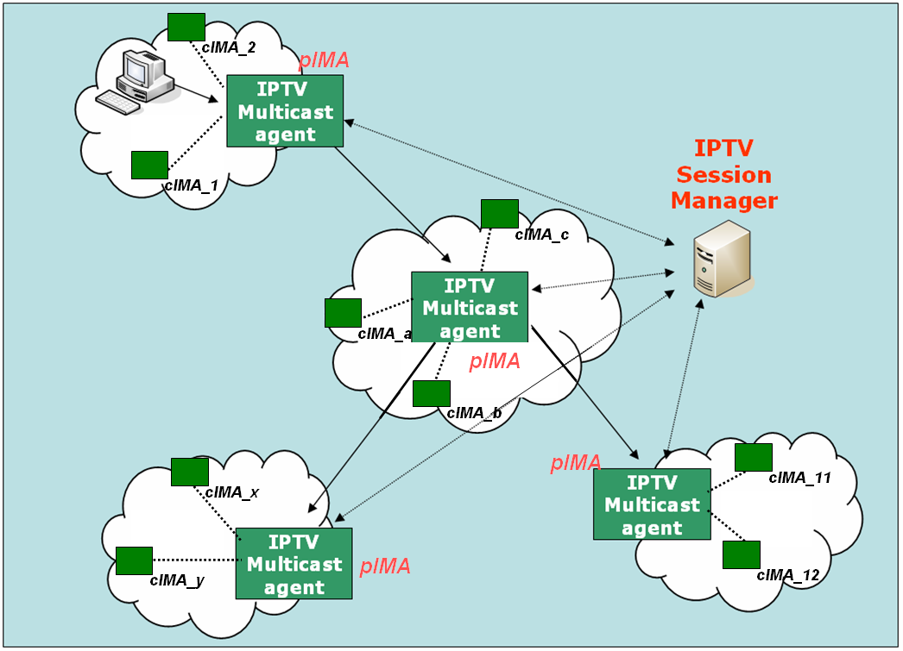
Figure 2. Functional Architecture for Service Level Multicast Capabilities for IPTV

2.2.2.1 IPTV Session Manager ( ISM)
ISM is involved in session configuration and maintenance for IPTV service flows. A single ISM can handle one or multiple sessions simultaneously, and it can provide the following functionalities:
- Session initialization: ISM allocates ISID (IPTV Session ID) for new session.
- Session release: Session can be released as needed.
- Session membership management
- Session status monitoring:
- report the status of data channel
- data throughput
- multicasting protocol topology information gathering
- multicasting protocol membership management

2.2.2.2 IPTV Multicast Agent ( IMA )
IMA constructs relayed multicast delivery path and forwards data along the constructed path from pIMA ( parent IPTV Multicast Agent ) and to cIMA ( child IPTV Multicast Agent). An MA consists of control module and data transport module. The main function of former is to establish relayed data delivery path and that of latter to setup data channel along the path constructed by control module and relay data through the channel. IMA performs the control functions to exchange control messages with other entity. Its major functions are as follows.
- Session join: each IMA contacts with Session Manager.
- Session leave: when an IMA wants leave the session, it gives notice to pIMAs and cIMAs
- Session maintenance: relay request and its response will be exchanged between the two IMAs periodically.
- Loop detection & avoidance, partitioning detection & recovering, Parent switching
- IPTV Session status reporting
In order to perform service level multicasting of streaming application for IPTV service, the functional box of service control can be described into few functional blocks in detail as shown in Figure 3.
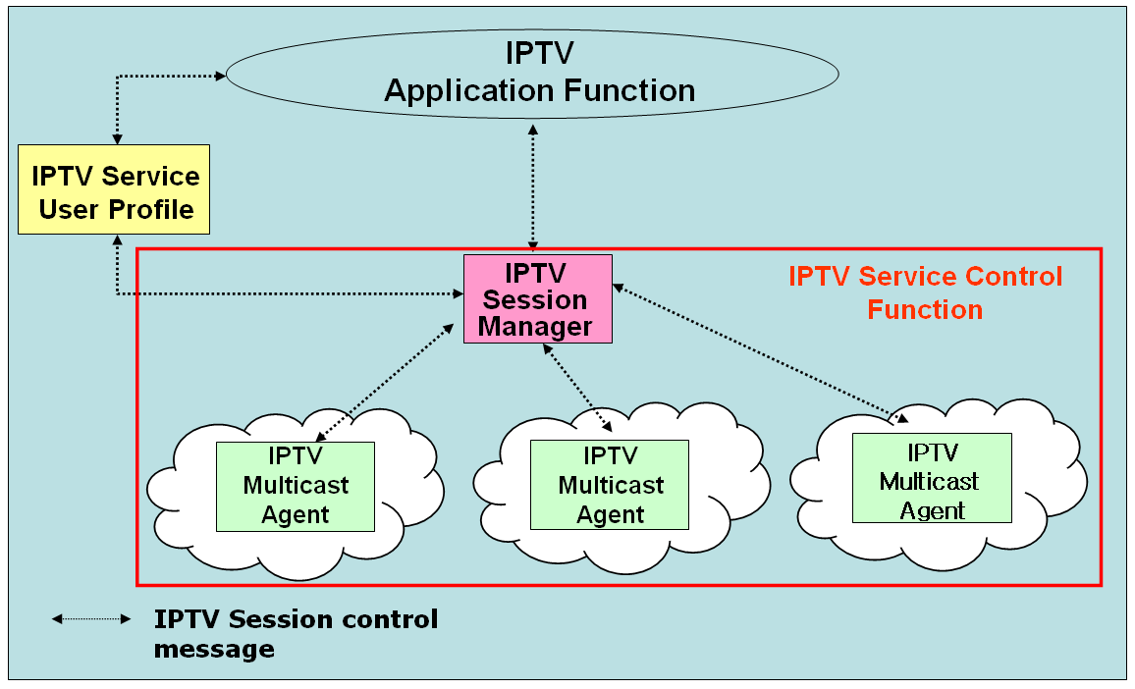
Figure 3 Functional Blocks of IPTV Session Control for IPTV Application Services

    - Overlay Multicast Control for IPTV Services
Current reliable multicast transport mechanisms have unresolved problems including scalability, flow control, congestion control and etc. Until the related reliable multicast transport mechanism settles down, group communications requiring reliable data transfer are actually clinging to replicated unicast method based on servers. Although IP multicast has not deployed globally, a lot of local networks have already been equipped with IP multicast transport. For example, Ethernet-based LANs and private networks such as corporate and campus networks substantially provide the multicast transport capability within their local subnet or administrative domains.
Recognizing these observations, there is a crucial need to develop an alternative multicast delivery scheme, service level multicasting approach. It makes good use of existing unicast, multicast and/or multicast tunneling schemes. In addition, service level multicast is designed as several separate forms to support any kinds of group service type well. Service level multicasting is expected to provide a substantial solution for group applications for IPTV service.
Figure 4 shows an architecture for “Overlay IPTV Service Multicast Functions” for IPTV service. The overlay service control function performs a IPTV session control to provide multicast capability for diverse IPTV service capabilities.
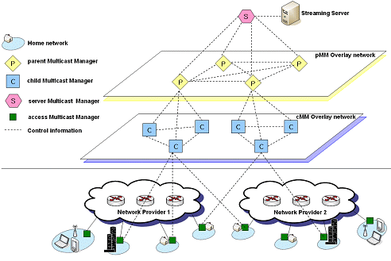
Figure 4 Overlay IPTV Service Multicast Control
3. Proposal
This contribution proposes the above section 2 be included as a major text section of WG3 document.
----------------------------------------------

