INTERNATIONAL TELECOMMUNICATION UNION |  |  |  | Focus Group On IPTV
TELECOMMUNICATION  STANDARDIZATION SECTOR  STUDY PERIOD 2005-2008 |  |  | FG IPTV-C-0228
 |  |  | English only
WG(s): 1, 4 |  | 2nd FG IPTV meeting:  Busan, 16-20 October 2006
CONTRIBUTION
Source: | ETRI, Republic of Korea
Title: | Overlay Service Control Architecture for IPTV Services
1. Introduction
An overlay service network has given an impact on existing overlay service due to resource sharing. Shared resources may be at the business, service (e.g., application and service data) and networking level. From the above facts, overlay service network has been introduced in internet.
Considering overlay service control paradigm will exacerbate the service feature interaction problems due to continuous layering of IPTV service networks over a common set of resource. And overlay IPTV service control affects networks to be managed through either traditional network management systems or policy based management systems. The challenges on overlay service control of multiple IPTV service control informations include managing interference and dependency across different types of services to require different treatment from the same set of resources. The approach will require different configuration and assurance policies that may be create conflicts. The challenge to implement overlay service control paradigm for IPTV will also provide a managing capability to interwork between existing and new elements, e.g., applications, services and terminals. And the overlay service control will also solve the problem of different security requirements especially involving mobility across different network partitioned and administrative domains for IPTV services.

2. Requirements for Overlay Service Control for IPTV Services
To date the limitations of transport capability in existing networks are often blamed for poor end-to-end performance and prolonged connectivity interruptions for application services requesting higher capabilities. For well provisioning of IPTV services with higher capability, it needs another approach to led their work focusing on the end-systems, overlooking the design and development of new solutions for IPTV service providers. Therefore, intelligent features for IPTV application services are necessarily provided in overlay IPTV service networking.
Based on the consideration, it is necessary to aim at building and dynamically configuring IPTV service networking with intelligent features. At some case some adaptive configuring features will be very helpful to provide user controllable IPTV services. To provide these flexibilities and intelligent features to IPTV service users, an overlay service control networking for IPTV will have to consider the following issues:
- For each new host that joins the network, a new connection that connects it to a IPTV overlay networking control point is created, and the topology is then updated with new channel and routing tables are re-computed. For more dynamic running on IPTV service networking in transport network, some IPTV service features will be interacted with each other to be connected to the other appropriate IPTV service control point.
- the configuration of the particular (or virtual) mesh, among allowed hosts, that connects all hosts in order to satisfy the best approach in IPTV service;
- QoS-capable IPTV service is very important features to provide a tailored diverse IPTV application services that could be differentiated in terms of performance and QoS, accounting, security and privacy.
- Application-aware networking for multiple IPTV applications is requested to reflect its application service specific features.
- Provision of active and intelligent service networking features for adaptive users requirements of IPTV group users.

- Overlay Control Framework for IPTV Services
As shown in Figure 1, an overlay network for IPTV service control has a feature interaction capabilities to analyze, tradeoff and generate option for IPTV application services. In addition, few service control nodes will perform policy management, configuration and monitoring service components. And the overlay processing entities will perform service processing for user’s requirements and information with dynamic.
Figure 1 shows an example of IPTV service control structure, overlay control framework.

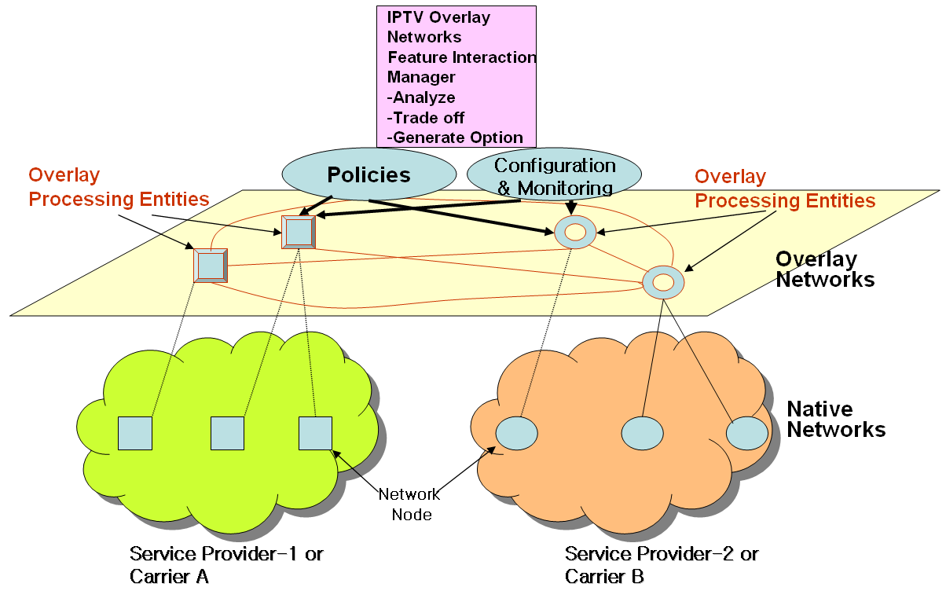

Figure 1 Overlay Network Framework for IPTV Service Controls

4. Case Study: Hierarchical Architecture for Overlay IPTV Service Multicast
There is a crucial need to develop an alternative multicast control scheme, overlay IPTV multicasting control approach. It makes good use of existing unicast, multicast and/or multicast tunneling schemes. In addition, service level multicast is designed as several separate forms to support any kinds of group service type well. Thus, overlay control structure of IPTV services will be a promising approach of IPV service control mechanisms, and it is expected to provide a substantial solution for group applications for IPTV services.
Figure 4 shows an architecture for “Overlay Service Control Functions” for IPTV service. The overlay service control function performs a IPTV session control to provide multicast capability for diverse IPTV service capabilities.
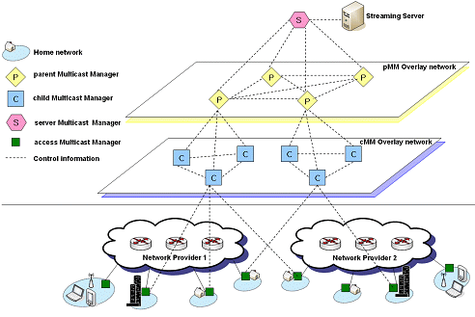
Figure 2 An Example of Overlay Control: Hierarchical Architecture for Overlay IPTV Service Multicast Control

5. Conclusion
Considering applicability of the versatile IPTV features and efficiency in overlay networks for IPTV clients, it is necessary to define the network control architecture and framework of IPTV service capabilities. In particular, IPTV overlay service network in mobile environment will be also very useful in for the diverse IPTV service deployments. The future work scopes on overly IPTV service control framework are needed as follows.
● define control actions (sub-goals in configuration and monitoring, etc) performed on a set of service dependent resources for different sub-goals for sub-goals of IPTV service.
● define IPTV service and network management process.
● define resource interaction models for IPTV service
● define interactions between network management system and service control options
● define security considerations for IPTV service clients in fixed and mobile environment
● define interfaces to overlay networks feature interaction manager

The contribution proposes the framework for feature interactions in overlay networks for IPTV services control, and IPTV service control framework over premium network and existing IP networks. Thus, it is also proposed the architecture be included in the main text of IPTV architecture document of WG1 and WG4.
______________

