INTERNATIONAL TELECOMMUNICATION UNION |  |  |  | Focus Group On IPTV
TELECOMMUNICATION  STANDARDIZATION SECTOR  STUDY PERIOD 2005-2008 |  |  | FG IPTV-C-0229
 |  |  | English Only
WG(s): 3 |  | 2nd FG IPTV meeting:  Busan, 16-20 October 2006
CONTRIBUTION
Source: | ETRI, Republic of Korea
Title: | Adhoc Results of the Service Security
- Introduction

Service providers want to provide efficient services to subscribers approved by legal process so as to provide IPTV service. Therefore we should consider the implementation of service security to protect the illegal use of IPTV service by unauthorized subscribers.
In this adhoc group, we tried to analyse the input documents of FG-IPTV WG3 which was held in Geneva on 7th, September of 2006 and then we deeply deal with the requirements and architecture for service security. Therefore, this document does not include all related issues, and we welcome any requirements, contributions, additional comments, and etc.
FG-IPTV WG3 is classified into four categories related to IPTV. First is service security, second is content security, third is network security, and last is device security. It is hard to make accurate classification because four securities are interrelated with each other. Most especially, service security and content security have very high relevancy and connectivity. Network security can be dealt with an independent issue because it deals with the security on the physical or logical network. Device security is related with the content security because the device is the final destination of the content for consumption.

- Definition of Service Security

In this group we defined the service security as a security needed in the delivery procedure between service provider (IPTV station) and the subscribers.

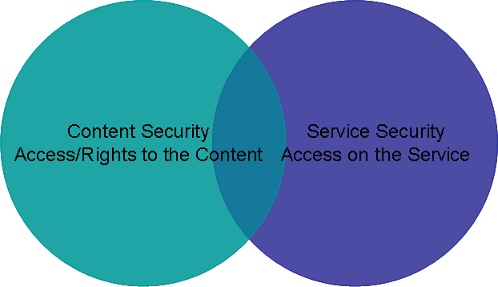
Fig 1. Service Security and Content Security (from OMA)

- Review of Input Document for Service Security

In the meeting held in Geneva, many input documents have dealt with several security issues. In this section, we would like to abstract the results of the review related to service security among the input documents. If you need more detail reviews and details, please refer to Geneva Output Document of WG3 and input documents.
Many documents explain that the service security is a security to secure connection of service provider and subscribers to provide the IPTV service. Service providers should provide the service to the subscribers according to the terms of the contract. Moreover, the service should be provided in accordance with the service rule being subscribed to. Most importantly, service security should protect the service from theft and illegal subscribers to respect the rights of the legal subscribers.
When we provide service security, most documents show the subscriber authentication which is the basic necessity and the CAS is regarded as a method for service security. Subscriber authentication is a process to determine whether the subscribers are legal or not, and whether they have the rights to use the service or not. In this case, the process of subscriber authentication requires the help of device. Thus we need a device authentication equipment to confirm its authenticity.
The document of ID-0063 explained the security in the service provider layer, and the needs of security for EPG (Electronic Programming Guide) server, streaming media server, and etc. When we deal with service from the viewpoint of the content delivery, content delivery involves two methods, download service and streaming service. Therefore we should support two delivery methods.
The document of ID-0078 deals with the DRM as a content security and CAS (Conditional Access System) as a service security. They suppose that this mixed architecture can support stepwise architecture. This architecture has considered service security and content security.
As mentioned in the document of ID-0086, there are many CAS and DRM technologies. Therefore we deal with the selection by user or content provider not service provider. The documents, ID-0023, ID-0086, and ID-0078 deal with the interoperability. We should consider a method to implement the interoperability to minimize the device cost.

- Conclusions

In this document, we reviewed the input documents submitted during the meeting at Geneva from the viewpoint of the service security. We can not protect the IPTV service by one technology because IPTV has a feature of broadcasting and communications. Thus we need to classify the application layer, then investigate and apply security method for IPTV service. Maybe there are many attacks against IPTV service because IPTV use the Internet and the Internet is open network.
Service security should have flexibility and feasibility because service providers have several service models. For this, WG3 should discuss continuously the following features and other contributions.
  - We should define service security.
  - We should determine whether we use current CAS technologies or not.
  - If we choose to use the CAS for service security, we should consider the architecture for interoperability of CAS
  - We should consider the method of subscriber authentication.
  - We should consider the method of device authentication.

________________

